C:\Users\JHrcak\AppData\Local\Microsoft\Windows\Temporary Internet Files\Content.IE5\2CTPUWPL\MC900445706[1].wmf

UNIDAD 1

¡BIENVENIDOS!

El paquete de tarea

UNIDAD 1

Nombre: \_\_\_\_\_\_\_\_\_\_\_\_\_\_\_\_\_\_\_\_\_\_\_\_\_

Base: \_\_\_\_\_\_\_\_\_\_\_\_\_\_\_\_\_\_\_\_\_

Clase: \_\_\_\_\_\_\_\_\_\_\_\_

**WHY STUDY SPANISH?**

Think about some things we have talked about in class, that you saw in the DVD or that you have discussed with your parents. List at least five ways studying Spanish can help YOU!

* \_\_\_\_\_\_\_\_\_\_\_\_\_\_\_\_\_\_\_\_\_\_\_\_\_\_\_\_\_\_\_\_\_\_\_\_\_\_\_\_\_\_\_\_\_\_\_\_\_\_\_\_\_\_\_\_\_\_
* \_\_\_\_\_\_\_\_\_\_\_\_\_\_\_\_\_\_\_\_\_\_\_\_\_\_\_\_\_\_\_\_\_\_\_\_\_\_\_\_\_\_\_\_\_\_\_\_\_\_\_\_\_\_\_\_\_\_
* \_\_\_\_\_\_\_\_\_\_\_\_\_\_\_\_\_\_\_\_\_\_\_\_\_\_\_\_\_\_\_\_\_\_\_\_\_\_\_\_\_\_\_\_\_\_\_\_\_\_\_\_\_\_\_\_\_\_
* \_\_\_\_\_\_\_\_\_\_\_\_\_\_\_\_\_\_\_\_\_\_\_\_\_\_\_\_\_\_\_\_\_\_\_\_\_\_\_\_\_\_\_\_\_\_\_\_\_\_\_\_\_\_\_\_\_\_
* \_\_\_\_\_\_\_\_\_\_\_\_\_\_\_\_\_\_\_\_\_\_\_\_\_\_\_\_\_\_\_\_\_\_\_\_\_\_\_\_\_\_\_\_\_\_\_\_\_\_\_\_\_\_\_\_\_\_
* \_\_\_\_\_\_\_\_\_\_\_\_\_\_\_\_\_\_\_\_\_\_\_\_\_\_\_\_\_\_\_\_\_\_\_\_\_\_\_\_\_\_\_\_\_\_\_\_\_\_\_\_\_\_\_\_\_\_

**INTRODUCTIONS**

**Translate the dialog to English.**

**Maria:** ¡Buenos días! ¿Cómo te llamas?

Jose: Me llamo Jose. ¿Y tú?

**Maria:** Me llamo Maria. Mucho gusto.

Jose: ¿Cómo estás?

**Maria:** Estoy cansada gracias. ¿Y tú?

Jose: Estoy muy bien. Maria, te presento

a Rosa. Rosa, te presento a Maria.

Rosa: Encantada.

**Maria:** El gusto es mío.

Jose: Nosotros debemos salir. Hasta luego.

**Maria:** Hasta pronto.

Rosa: Hasta mañana.

\*\*\*Nosotros debemos salir. = We must leave.

**A. Answer the questions in Spanish.**

**1. ¿Cómo te llamas? \_\_\_\_\_\_\_\_\_\_\_\_\_\_\_\_\_\_\_\_\_\_\_\_\_\_\_\_\_\_\_\_\_\_\_\_\_\_**

**2. ¿Cómo estás? \_\_\_\_\_\_\_\_\_\_\_\_\_\_\_\_\_\_\_\_\_\_\_\_\_\_\_\_\_\_\_\_\_\_\_\_\_\_\_**

**B. Write the English.**

**1. enfermo \_\_\_\_\_\_\_\_\_\_\_\_\_\_\_\_\_\_\_\_\_**

**2. triste \_\_\_\_\_\_\_\_\_\_\_\_\_\_\_\_\_\_\_\_\_**

**3. así así \_\_\_\_\_\_\_\_\_\_\_\_\_\_\_\_\_\_\_\_\_**

**4. contento \_\_\_\_\_\_\_\_\_\_\_\_\_\_\_\_\_\_\_\_\_**

**5. cansado \_\_\_\_\_\_\_\_\_\_\_\_\_\_\_\_\_\_\_\_\_**

**C. Matching.**

**1. \_\_\_\_ estoy a. I introduce to you**

**2. \_\_\_\_\_ me llamo b. magnificent**

**3. \_\_\_\_\_ excelente c. nice to meet you**

**4. \_\_\_\_\_ encantado d. you’re welcome**

**5. \_\_\_\_\_ fantástico e. my name is**

**6. \_\_\_\_\_ lo siento f. enchanted**

**7. \_\_\_\_\_ gracias g. good**

**8. \_\_\_\_\_ el gusto es mío h. I’m sorry**

**9. \_\_\_\_\_ magnífico i. thank you**

**10. \_\_\_\_ bien j. excellent**

**11. \_\_\_\_ mucho gusto k. please**

**12. \_\_\_\_ te presento a l. bad**

**13. \_\_\_\_ de nada m. fantastic**

**14. \_\_\_\_ mal n. the pleasure is mine**

**15. \_\_\_\_ por favor o. I am**

**16. \_\_\_\_ igualmente p. What's up?**

**17. \_\_\_\_ ¿Qué tal? q. likewise**

**Answer the following questions in complete Spanish sentences. Refer to your notes.**

1. ¿Cómo te llamas? \_\_\_\_\_\_\_\_\_\_\_\_\_\_\_\_\_\_\_\_\_\_\_\_\_\_\_\_\_\_\_\_\_\_\_\_\_\_\_\_\_\_\_\_\_\_

2. ¿Cómo se llama tu madre (*your mother*)?

Ella se llama .

3. ¿Cómo se llama tu padre (*your father*)?

Él se llama .

4. ¿Cómo se llama tu maestra\* (*teacher*) de español?

\_\_\_\_Ella se llama Sra. .\_\_\_\_\_\_\_\_\_\_\_\_\_\_\_\_\_\_\_\_

5. ¿Cómo se llama tu maestro/a de ciencias (*Science*)?

\_\_\_\_\_\_\_\_\_\_\_\_\_\_\_\_\_\_\_\_\_\_\_\_\_\_\_\_\_\_\_\_\_\_\_\_\_\_\_\_\_\_\_\_\_\_\_\_\_\_\_\_\_\_\_\_\_\_\_

6. ¿Cómo se llama tu maestro/a de matemáticas?

\_\_\_\_\_\_\_\_\_\_\_\_\_\_\_\_\_\_\_\_\_\_\_\_\_\_\_\_\_\_\_\_\_\_\_\_\_\_\_\_\_\_\_\_\_\_\_\_\_\_\_\_\_\_\_\_\_\_\_

7. ¿Cómo se llama tu maestro/a de inglés (*English*)?

\_\_\_\_\_\_\_\_\_\_\_\_\_\_\_\_\_\_\_\_\_\_\_\_\_\_\_\_\_\_\_\_\_\_\_\_\_\_\_\_\_\_\_\_\_\_\_\_\_\_\_\_\_\_\_\_\_\_\_

8. ¿Cómo se llama tu maestro/a de estudios sociales (*SS*)?

\_\_\_\_\_\_\_\_\_\_\_\_\_\_\_\_\_\_\_\_\_\_\_\_\_\_\_\_\_\_\_\_\_\_\_\_\_\_\_\_\_\_\_\_\_\_\_\_\_\_\_\_\_\_\_\_\_\_\_

9. ¿Cómo se llama el director (*principal*) de la escuela?

\_\_\_\_\_\_\_\_\_\_\_\_\_\_\_\_\_\_\_\_\_\_\_\_\_\_\_\_\_\_\_\_\_\_\_\_\_\_\_\_\_\_\_\_\_\_\_\_\_\_\_\_\_\_\_\_\_\_\_

10. ¿Cómo se llama tu amigo (*friend*) favorito o amiga favorita?

\_\_\_\_\_\_\_\_\_\_\_\_\_\_\_\_\_\_\_\_\_\_\_\_\_\_\_\_\_\_\_\_\_\_\_\_\_\_\_\_\_\_\_\_\_\_\_\_\_\_\_\_\_\_\_\_\_\_\_

11. If you forgot your teacher’s name, how should you respectfully ask it?

\_\_\_\_\_\_\_\_\_\_\_\_\_\_\_\_\_\_\_\_\_\_\_\_\_\_\_\_\_\_\_\_\_\_\_\_\_\_\_\_\_\_\_\_\_\_\_\_\_\_\_\_\_\_\_\_\_\_\_

\**Profesor(a)* is another way to say “teacher” in Spanish. *Maestro* refers to teachers of younger students and *profersor,* older students.

**Write the following in Spanish.**

1. Pardon me. \_\_\_\_\_\_\_\_\_\_\_\_\_\_\_\_\_\_\_\_\_\_\_
2. You’re welcome \_\_\_\_\_\_\_\_\_\_\_\_\_\_\_\_\_\_\_\_\_\_\_
3. Thank you very much \_\_\_\_\_\_\_\_\_\_\_\_\_\_\_\_\_\_\_\_\_
4. Please \_\_\_\_\_\_\_\_\_\_\_\_\_\_\_\_\_\_\_\_\_\_\_\_\_\_\_\_
5. I’m sorry \_\_\_\_\_\_\_\_\_\_\_\_\_\_\_\_\_\_\_\_\_\_\_\_\_\_\_\_
6. Excuse me \_\_\_\_\_\_\_\_\_\_\_\_\_\_\_\_\_\_\_\_\_\_\_\_\_\_\_\_

**Write an appropriate comment or question for each situation below in Spanish. Use your notes for correct vocabulary and spelling!**

1. You teacher says “¡No hay tarea!” (nada) at the end of class.
2. You stepped on the teacher’s foot.
3. Your help your partner and he/she says “Thank you.”
4. Your teacher is talking to another teacher. You need to interrupt in order to ask her a very important question.

Una Canción - ¡Gracias a Sra. Wirth!

Hola, María. ¿Qué tal?

Yo estoy muy bien, gracias.

Tengo que irme.

MCj01048360000[1]

Hasta luego.

Hasta mañana.

¡Adiós!

***Cuaderno de Ejercicios:* Para Empezar páginas 1, 2 y 11.**

**GREETINGS**! How would you greet each person below? Write an appropriate greeting in Spanish for each person listed.

pe00693_

Examples:

Buenos días Sr. Lillick. ¿Cómo está usted?

or

¡Hola Paco! ¿Qué tal?

1. Mr. Rebmann \_\_\_\_\_\_\_\_\_\_\_\_\_\_\_\_\_\_\_\_\_\_\_\_\_\_\_\_\_\_\_\_\_\_\_\_\_\_\_\_\_\_\_\_\_\_
2. Miss Sosnowski \_\_\_\_\_\_\_\_\_\_\_\_\_\_\_\_\_\_\_\_\_\_\_\_\_\_\_\_\_\_\_\_\_\_\_\_\_\_\_\_\_\_\_\_
3. your brother or sister \_\_\_\_\_\_\_\_\_\_\_\_\_\_\_\_\_\_\_\_\_\_\_\_\_\_\_\_\_\_\_\_\_\_\_\_\_\_\_
4. Dr. Gomez \_\_\_\_\_\_\_\_\_\_\_\_\_\_\_\_\_\_\_\_\_\_\_\_\_\_\_\_\_\_\_\_\_\_\_\_\_\_\_\_\_\_\_\_\_\_\_
5. Mrs. Weiss \_\_\_\_\_\_\_\_\_\_\_\_\_\_\_\_\_\_\_\_\_\_\_\_\_\_\_\_\_\_\_\_\_\_\_\_\_\_\_\_\_\_\_\_\_\_\_
6. Mr. President \_\_\_\_\_\_\_\_\_\_\_\_\_\_\_\_\_\_\_\_\_\_\_\_\_\_\_\_\_\_\_\_\_\_\_\_\_\_\_\_\_\_\_\_
7. Mr. Dolce \_\_\_\_\_\_\_\_\_\_\_\_\_\_\_\_\_\_\_\_\_\_\_\_\_\_\_\_\_\_\_\_\_\_\_\_\_\_\_\_\_\_\_\_\_\_\_\_
8. Mr. Kalenik\_\_\_\_\_\_\_\_\_\_\_\_\_\_\_\_\_\_\_\_\_\_\_\_\_\_\_\_\_\_\_\_\_\_\_\_\_\_\_\_\_\_\_\_\_
9. Mr. Raz \_\_\_\_\_\_\_\_\_\_\_\_\_\_\_\_\_\_\_\_\_\_\_\_\_\_\_\_\_\_\_\_\_\_\_\_\_\_\_\_\_\_\_\_\_\_\_\_\_
10. your best friend \_\_\_\_\_\_\_\_\_\_\_\_\_\_\_\_\_\_\_\_\_\_\_\_\_\_\_\_\_\_\_\_\_\_\_\_\_\_\_\_\_\_
11. Miss America \_\_\_\_\_\_\_\_\_\_\_\_\_\_\_\_\_\_\_\_\_\_\_\_\_\_\_\_\_\_\_\_\_\_\_\_\_\_\_\_\_\_\_\_\_
12. Mrs. Scaccia \_\_\_\_\_\_\_\_\_\_\_\_\_\_\_\_\_\_\_\_\_\_\_\_\_\_\_\_\_\_\_\_\_\_\_\_\_\_\_\_\_\_\_\_\_\_
13. Mrs. Hrcak \_\_\_\_\_\_\_\_\_\_\_\_\_\_\_\_\_\_\_\_\_\_\_\_\_\_\_\_\_\_\_\_\_\_\_\_\_\_\_\_\_\_\_\_\_\_
14. Miss Kaul \_\_\_\_\_\_\_\_\_\_\_\_\_\_\_\_\_\_\_\_\_\_\_\_\_\_\_\_\_\_\_\_\_\_\_\_\_\_\_\_\_\_\_\_\_\_\_
15. Mrs. Wellington\_\_\_\_\_\_\_\_\_\_\_\_\_\_\_\_\_\_\_\_\_\_\_\_\_\_\_\_\_\_\_\_\_\_\_\_\_\_\_\_\_\_\_
16. tu compañero/a \_\_\_\_\_\_\_\_\_\_\_\_\_\_\_\_\_\_\_\_\_\_\_\_\_\_\_\_\_\_\_\_\_\_\_\_\_\_\_\_\_\_\_
17. Judge Judy \_\_\_\_\_\_\_\_\_\_\_\_\_\_\_\_\_\_\_\_\_\_\_\_\_\_\_\_\_\_\_\_\_\_\_\_\_\_\_\_\_\_\_\_\_\_\_

j0398131j0435989¡Buenas tardes señorita!

Sr. Catalano is introducing himself to a new teacher at the Middle School. Can you fill in the missing words in Spanish? Use your notes for correct spelling.

Señor: Buenas tardes señorita. ¿Cómo \_\_\_\_\_\_\_\_\_\_\_\_\_\_\_\_

\_\_\_\_\_\_\_\_\_\_\_\_\_\_\_\_\_\_\_\_\_\_?

Señorita: Buenas \_\_\_\_\_\_\_\_\_\_\_\_\_\_\_\_ señor. Me \_\_\_\_\_\_\_\_\_\_\_\_\_\_

Señorita Rodriguez. ¿Y \_\_\_\_\_\_\_\_\_\_\_?

Señor: Me \_\_\_\_\_\_\_\_\_\_\_\_\_\_\_\_\_\_ señor Catalano. Encantado.

Señorita: \_\_\_\_\_\_\_\_\_\_\_\_\_\_\_\_\_\_\_\_\_ señor.

¿Cómo\_\_\_\_\_\_\_\_\_\_\_\_\_\_\_usted?

Señor: \_\_\_\_\_\_\_\_\_\_\_\_\_\_\_\_\_\_\_\_\_\_\_\_\_\_\_ gracias.

¿Y\_\_\_\_\_\_\_\_\_\_\_?

Señorita: \_\_\_\_\_\_\_\_\_\_\_\_ muy contenta, \_\_\_\_\_\_\_\_\_\_\_\_.

Señor: \_\_\_\_\_\_\_\_\_\_\_\_\_\_\_\_ mañana señorita.

Señorita: Nos \_\_\_\_\_\_\_\_\_\_\_\_\_\_\_\_ señor.

FRIENDLY

A. Greet a classmate.

\_\_\_\_\_\_\_\_\_\_\_\_\_\_\_\_\_\_\_\_\_\_\_

B. Classmate greets back.

\_\_\_\_\_\_\_\_\_\_\_\_\_\_\_\_\_\_\_\_\_\_

A. State your name.

\_\_\_\_\_\_\_\_\_\_\_\_\_\_\_\_\_\_\_\_\_\_\_

Ask classmate.

\_\_\_\_\_\_\_\_\_\_\_\_\_\_\_\_\_\_\_\_\_\_\_

B. Classmate states name.

\_\_\_\_\_\_\_\_\_\_\_\_\_\_\_\_\_\_\_\_\_\_\_\_\_\_\_\_\_

Says, “Nice to meet you”.

\_\_\_\_\_\_\_\_\_\_\_\_\_\_\_\_\_\_\_\_\_\_\_

A. Ask how your classmate is.

\_\_\_\_\_\_\_\_\_\_\_\_\_\_\_\_\_\_\_\_\_\_

B. Classmate says how he/she is.

\_\_\_\_\_\_\_\_\_\_\_\_\_\_\_\_\_\_\_\_\_\_\_

Says, “and you?”

\_\_\_\_\_\_\_\_\_\_\_\_\_\_\_\_\_\_\_\_\_\_\_

A. Say how you are.

\_\_\_\_\_\_\_\_\_\_\_\_\_\_\_\_\_\_\_\_\_\_\_

Say, “see you later”.

\_\_\_\_\_\_\_\_\_\_\_\_\_\_\_\_\_\_\_\_\_\_

B. Say, “Bye!”

\_\_\_\_\_\_\_\_\_\_\_\_\_\_\_\_\_\_\_\_\_\_

# FORMAL

A. Greet a teacher.

\_\_\_\_\_\_\_\_\_\_\_\_\_\_\_\_\_\_\_\_\_\_\_

B. Teacher greets back.

\_\_\_\_\_\_\_\_\_\_\_\_\_\_\_\_\_\_\_\_\_\_

A. State your name.

\_\_\_\_\_\_\_\_\_\_\_\_\_\_\_\_\_\_\_\_\_\_\_

Ask teacher.

\_\_\_\_\_\_\_\_\_\_\_\_\_\_\_\_\_\_\_\_\_\_\_

B. Teacher states name.

\_\_\_\_\_\_\_\_\_\_\_\_\_\_\_\_\_\_\_\_\_\_\_\_\_\_\_\_\_\_

A. Ask how your teacher is.

\_\_\_\_\_\_\_\_\_\_\_\_\_\_\_\_\_\_\_\_\_\_

B. Teacher says how he/she is.

\_\_\_\_\_\_\_\_\_\_\_\_\_\_\_\_\_\_\_\_\_\_\_\_\_

Says, “and you?”

\_\_\_\_\_\_\_\_\_\_\_\_\_\_\_\_\_\_\_\_\_\_\_

A. Say how you are.

\_\_\_\_\_\_\_\_\_\_\_\_\_\_\_\_\_\_\_\_\_\_\_

B. Says, “see you tomorrow”.

\_\_\_\_\_\_\_\_\_\_\_\_\_\_\_\_\_\_\_\_\_\_

Says, “Nice to meet you”.

\_\_\_\_\_\_\_\_\_\_\_\_\_\_\_\_\_\_\_\_\_\_\_

A. Say, “I’ts my pleasure. Goodbye ma’am!”

\_\_\_\_\_\_\_\_\_\_\_\_\_\_\_\_\_\_\_\_\_\_\_\_\_\_\_\_\_

**Vocabulario**

cero \_\_\_\_\_\_\_\_\_\_\_\_\_

uno \_\_\_\_\_\_\_\_\_\_\_\_\_ once \_\_\_\_\_\_\_\_\_\_\_\_\_\_\_

dos \_\_\_\_\_\_\_\_\_\_\_\_\_ doce \_\_\_\_\_\_\_\_\_\_\_\_\_\_\_

tres \_\_\_\_\_\_\_\_\_\_\_\_\_ trece \_\_\_\_\_\_\_\_\_\_\_\_\_\_\_

cuatro \_\_\_\_\_\_\_\_\_\_\_\_\_ catorce \_\_\_\_\_\_\_\_\_\_\_\_\_\_\_

cinco \_\_\_\_\_\_\_\_\_\_\_\_\_ quince \_\_\_\_\_\_\_\_\_\_\_\_\_\_\_

seis \_\_\_\_\_\_\_\_\_\_\_\_\_ dieciséis \_\_\_\_\_\_\_\_\_\_\_\_\_\_\_

siete \_\_\_\_\_\_\_\_\_\_\_\_\_ diecisiete \_\_\_\_\_\_\_\_\_\_\_\_\_\_\_

ocho \_\_\_\_\_\_\_\_\_\_\_\_\_ dieciocho \_\_\_\_\_\_\_\_\_\_\_\_\_\_\_

nueve \_\_\_\_\_\_\_\_\_\_\_\_\_ diecinueve \_\_\_\_\_\_\_\_\_\_\_\_\_\_\_

diez \_\_\_\_\_\_\_\_\_\_\_\_\_ veinte \_\_\_\_\_\_\_\_\_\_\_\_\_\_\_

1. Write the missing number in each sequence. Write the number out in Spanish.
2. uno, \_\_\_\_\_\_\_\_\_\_\_\_\_\_, tres, cuatro
3. doce, \_\_\_\_\_\_\_\_\_\_\_\_\_\_\_, dieciséis, dieciocho
4. veinte, quince, \_\_\_\_\_\_\_\_\_\_\_\_\_\_\_, cinco
5. nueve, doce, quince, \_\_\_\_\_\_\_\_\_\_\_\_\_\_\_\_\_
6. once, \_\_\_\_\_\_\_\_\_\_\_\_\_\_, quince, diecisiete, diecinueve
7. cero, \_\_\_\_\_\_\_\_\_\_\_\_\_\_\_\_\_, ocho, doce, dieciséis
8. \_\_\_\_\_\_\_\_\_\_\_\_\_\_\_, ocho, seis, cuatro, dos
9. Write the missing vowels.

c­­\_\_r\_\_ \_\_n­­\_\_ d\_\_s tr\_\_s c\_\_\_\_tr\_\_

c\_\_nc\_\_ s\_\_\_\_s s\_\_\_\_ t\_\_ \_\_ch\_\_ n\_\_\_\_v\_\_

d\_\_\_\_z \_\_nc\_\_ d\_\_c\_\_ tr\_\_c\_\_ c\_\_\_\_t\_\_rc\_\_

q\_\_\_\_nc\_\_ d\_\_\_\_c\_\_s\_\_\_\_s d­­­­­­­­­\_\_\_\_c\_\_s\_\_\_\_t\_\_

d\_\_\_\_c\_\_\_\_ch\_\_ d\_\_\_\_c\_\_n\_\_\_\_v\_\_ v\_\_\_\_nt\_\_

1. Write the Spanish number.

18 12

15 20

3 16

10 8

17 1

4 13

6 2

19 5

0 15

9 7

11 14

**Escriban los números en español.**

1. 9 \_\_\_\_\_\_\_\_\_\_\_\_\_\_\_\_\_\_\_\_\_\_\_\_\_\_\_\_\_\_\_\_\_\_\_\_\_\_\_\_\_\_\_\_\_\_\_\_\_\_\_\_\_\_

2. 19 \_\_\_\_\_\_\_\_\_\_\_\_\_\_\_\_\_\_\_\_\_\_\_\_\_\_\_\_\_\_\_\_\_\_\_\_\_\_\_\_\_\_\_\_\_\_\_\_\_\_\_\_\_\_

3. 10 \_\_\_\_\_\_\_\_\_\_\_\_\_\_\_\_\_\_\_\_\_\_\_\_\_\_\_\_\_\_\_\_\_\_\_\_\_\_\_\_\_\_\_\_\_\_\_\_\_\_\_\_\_\_

4. 5 \_\_\_\_\_\_\_\_\_\_\_\_\_\_\_\_\_\_\_\_\_\_\_\_\_\_\_\_\_\_\_\_\_\_\_\_\_\_\_\_\_\_\_\_\_\_\_\_\_\_\_\_\_\_

5. 7 \_\_\_\_\_\_\_\_\_\_\_\_\_\_\_\_\_\_\_\_\_\_\_\_\_\_\_\_\_\_\_\_\_\_\_\_\_\_\_\_\_\_\_\_\_\_\_\_\_\_\_\_\_\_

6. 2 \_\_\_\_\_\_\_\_\_\_\_\_\_\_\_\_\_\_\_\_\_\_\_\_\_\_\_\_\_\_\_\_\_\_\_\_\_\_\_\_\_\_\_\_\_\_\_\_\_\_\_\_\_\_

7. 17 \_\_\_\_\_\_\_\_\_\_\_\_\_\_\_\_\_\_\_\_\_\_\_\_\_\_\_\_\_\_\_\_\_\_\_\_\_\_\_\_\_\_\_\_\_\_\_\_\_\_\_\_\_\_

8. 6 \_\_\_\_\_\_\_\_\_\_\_\_\_\_\_\_\_\_\_\_\_\_\_\_\_\_\_\_\_\_\_\_\_\_\_\_\_\_\_\_\_\_\_\_\_\_\_\_\_\_\_\_\_\_

9. 12 \_\_\_\_\_\_\_\_\_\_\_\_\_\_\_\_\_\_\_\_\_\_\_\_\_\_\_\_\_\_\_\_\_\_\_\_\_\_\_\_\_\_\_\_\_\_\_\_\_\_\_\_\_\_

10. 1 \_\_\_\_\_\_\_\_\_\_\_\_\_\_\_\_\_\_\_\_\_\_\_\_\_\_\_\_\_\_\_\_\_\_\_\_\_\_\_\_\_\_\_\_\_\_\_\_\_\_\_\_\_\_

11. 18 \_\_\_\_\_\_\_\_\_\_\_\_\_\_\_\_\_\_\_\_\_\_\_\_\_\_\_\_\_\_\_\_\_\_\_\_\_\_\_\_\_\_\_\_\_\_\_\_\_\_\_\_\_\_

12. 15 \_\_\_\_\_\_\_\_\_\_\_\_\_\_\_\_\_\_\_\_\_\_\_\_\_\_\_\_\_\_\_\_\_\_\_\_\_\_\_\_\_\_\_\_\_\_\_\_\_\_\_\_\_\_

**¿Qué número es?**

13. siete \_\_\_\_\_\_\_\_\_\_\_\_\_\_ 19. cuatro \_\_\_\_\_\_\_\_\_\_\_\_\_\_

14. veinte \_\_\_\_\_\_\_\_\_\_\_\_\_\_ 20. diecinueve \_\_\_\_\_\_\_\_\_\_\_\_\_\_

15. catorce \_\_\_\_\_\_\_\_\_\_\_\_\_\_ 21. trece \_\_\_\_\_\_\_\_\_\_\_\_\_\_

16. ocho \_\_\_\_\_\_\_\_\_\_\_\_\_\_ 22. dos \_\_\_\_\_\_\_\_\_\_\_\_\_

17. once \_\_\_\_\_\_\_\_\_\_\_\_\_\_ 23. doce \_\_\_\_\_\_\_\_\_\_\_\_\_

18. dieciséis \_\_\_\_\_\_\_\_\_\_\_\_\_\_ 24. cero \_\_\_\_\_\_\_\_\_\_

**Alphabet Practice**

**A. Practice saying the following letters in Spanish:**

**a e i o u b t s g f j z**

**c h k y w l m**

**B. Using the same letters make up 5 English words. You will use these words to play hangman with a partner.**

**1. \_\_\_\_\_\_\_\_\_\_\_\_\_\_\_\_\_\_**

**2. \_\_\_\_\_\_\_\_\_\_\_\_\_\_\_\_\_\_**

**3. \_\_\_\_\_\_\_\_\_\_\_\_\_\_\_\_\_\_**

**4. \_\_\_\_\_\_\_\_\_\_\_\_\_\_\_\_\_\_**

**5. \_\_\_\_\_\_\_\_\_\_\_\_\_\_\_\_\_\_**

**C. Practice saying the following letters in Spanish:**

**a e i o u b t s g f j z**

**c h k y w l m**

**D. Using the same letters make up 5 English words. You will use These words to play hangman with a partner.**

**1. \_\_\_\_\_\_\_\_\_\_\_\_\_\_\_\_\_\_**

**2. \_\_\_\_\_\_\_\_\_\_\_\_\_\_\_\_\_\_**

**3. \_\_\_\_\_\_\_\_\_\_\_\_\_\_\_\_\_\_**

**4. \_\_\_\_\_\_\_\_\_\_\_\_\_\_\_\_\_\_**

**5. \_\_\_\_\_\_\_\_\_\_\_\_\_\_\_\_\_\_**

**E. Practice saying the following letters in Spanish:**

a e i o u b t s g f j z

c h k y w l m d n p ñ q

r v x rr

**F. Using the same letters make up 5 Spanish words. You will use these words to play hangman with a partner.**

1. \_\_\_\_\_\_\_\_\_\_\_\_\_\_\_\_\_\_

2. \_\_\_\_\_\_\_\_\_\_\_\_\_\_\_\_\_\_

3. \_\_\_\_\_\_\_\_\_\_\_\_\_\_\_\_\_\_

4. \_\_\_\_\_\_\_\_\_\_\_\_\_\_\_\_\_\_

5. \_\_\_\_\_\_\_\_\_\_\_\_\_\_\_\_\_\_

Practice pronouncing the following Spanish words *out loud*. Remember to pay special attention to the vowels. Have fun!

Argentina Gerardo

jamón bien

Humberto Honduras

gracias seis

hoja ella

México diez

Usted Colombia

**Match the English meaning with the Spanish word.**

1. \_\_\_\_\_\_ el papel A. folder

2. \_\_\_\_\_\_ el lápiz B. student

3. \_\_\_\_\_\_ la carpeta C. pen

4. \_\_\_\_\_\_ el cuaderno D. partner

5. \_\_\_\_\_\_ la tarea E. professor

6. \_\_\_\_\_\_ el estudiante F. agenda

7. \_\_\_\_\_\_ la profesora G. pencil

8. \_\_\_\_\_\_ la pluma H. homework

9. \_\_\_\_\_\_ la agenda I. notebook

10. \_\_\_\_\_\_ el compañero J. paper

**Classroom objects: *Cuaderno de Ejercicios:* Para Empezar página 6.**

**Write the command that would be given next to the picture.**

***word bank:*** *Silencio, Levántense, Escuchen, Saquen el papel, Siéntense*, *Abran los libros, Miren, Cierren los libros, Pongan, Escriban*



1.

\_\_\_\_\_\_\_\_\_\_\_\_



2.

\_\_\_\_\_\_\_\_\_\_\_\_

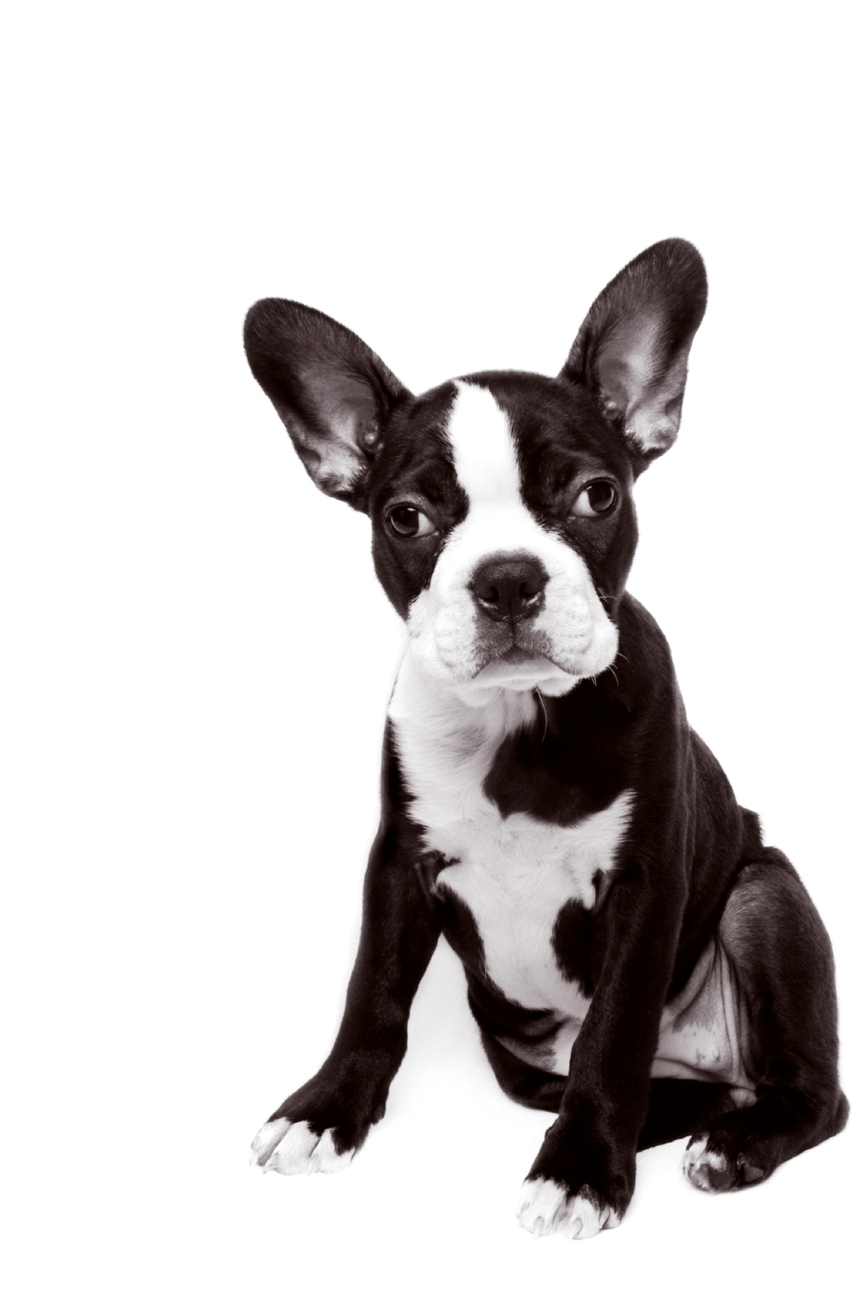

3.

\_\_\_\_\_\_\_\_\_\_\_\_

C:\Users\jhrcak\AppData\Local\Microsoft\Windows\Temporary Internet Files\Content.IE5\XPUBTLDS\MC900187159[1].wmf

4.

\_\_\_\_\_\_\_\_\_\_\_\_

C:\Users\jhrcak\AppData\Local\Microsoft\Windows\Temporary Internet Files\Content.IE5\MM5C5Q2A\MC900435546[1].wmf

5.

\_\_\_\_\_\_\_\_\_\_\_\_\_\_

C:\Users\jhrcak\AppData\Local\Microsoft\Windows\Temporary Internet Files\Content.IE5\MM5C5Q2A\MC900383832[1].wmf

6.

\_\_\_\_\_\_\_\_\_\_\_\_

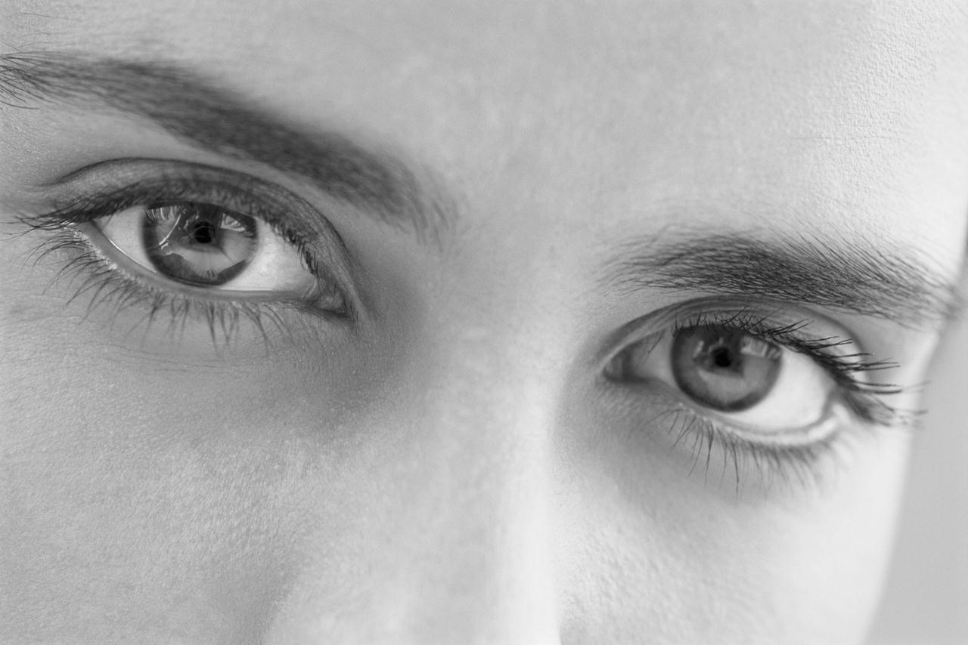

7.

\_\_\_\_\_\_\_\_\_\_\_

8.

Put.... \_\_\_\_\_\_\_\_\_\_\_\_

C:\Users\jhrcak\AppData\Local\Microsoft\Windows\Temporary Internet Files\Content.IE5\FNCODIW1\MC900437803[1].wmf

9.

\_\_\_\_\_\_\_\_\_\_\_\_

**Write the classroom request next** **to each picture. Refer to your notes**!!

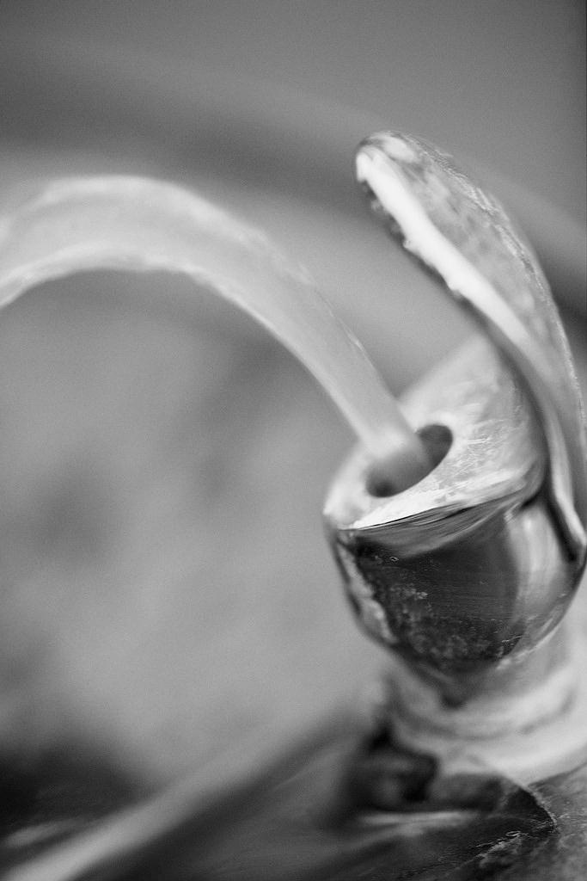

1.

\_\_\_\_\_\_\_\_\_\_\_\_\_\_\_\_\_\_\_\_\_\_\_\_\_\_\_\_\_\_\_\_\_\_\_\_\_\_\_\_\_

C:\Users\jhrcak\AppData\Local\Microsoft\Windows\Temporary Internet Files\Content.IE5\X36JY1A9\MC900280512[1].wmf

2.

\_\_\_\_\_\_\_\_\_\_\_\_\_\_\_\_\_\_\_\_\_\_\_\_\_\_\_\_\_\_\_\_\_\_\_\_\_\_\_\_\_

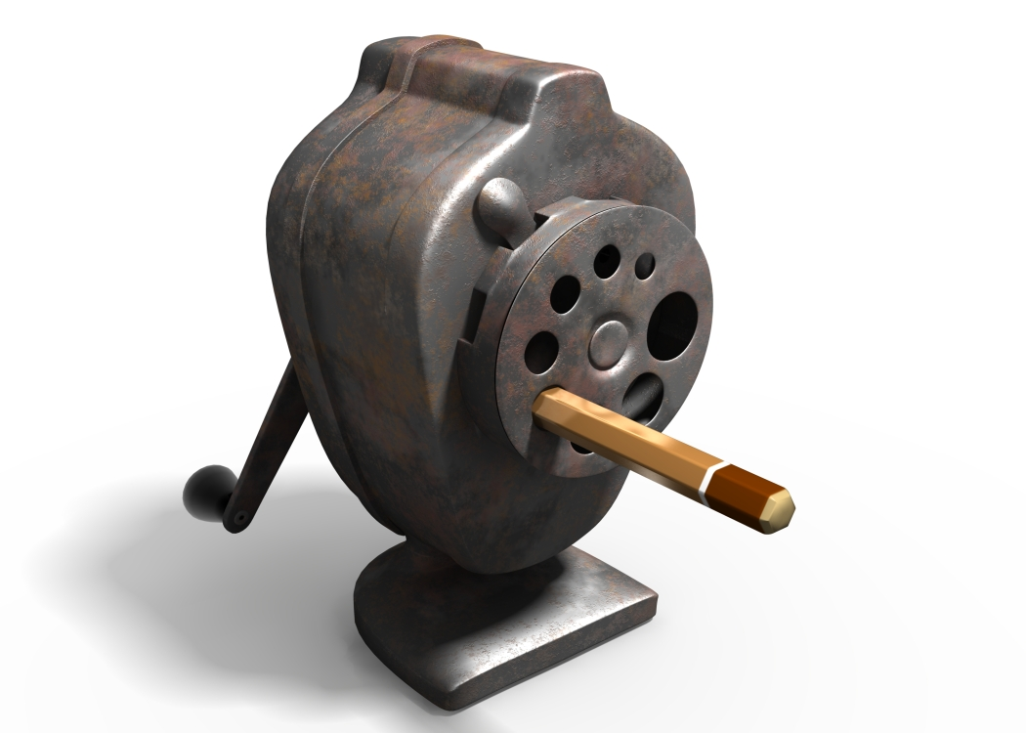

3.

\_\_\_\_\_\_\_\_\_\_\_\_\_\_\_\_\_\_\_\_\_\_\_\_\_\_\_\_\_\_\_\_\_\_\_\_\_\_\_\_\_

C:\Users\jhrcak\AppData\Local\Microsoft\Windows\Temporary Internet Files\Content.IE5\MM5C5Q2A\MC900292094[1].wmf

4.

\_\_\_\_\_\_\_\_\_\_\_\_\_\_\_\_\_\_\_\_\_\_\_\_\_\_\_\_\_\_\_\_\_\_\_\_\_\_\_\_\_

5.



\_\_\_\_\_\_\_\_\_\_\_\_\_\_\_\_\_\_\_\_\_\_\_\_\_\_\_\_\_\_\_\_\_\_\_\_\_\_\_\_\_

**How would you say…?**

1. “I don’t know!” \_\_\_\_\_\_\_\_\_\_\_\_\_\_\_\_\_\_\_\_\_\_\_\_\_\_\_\_\_\_\_\_\_\_\_\_\_\_\_\_\_\_\_\_\_

2. “I’m sorry. I don’t understand the question.”

\_\_\_\_\_\_\_\_\_\_\_\_\_\_\_\_\_\_\_\_\_\_\_\_\_\_\_\_\_\_\_\_\_\_\_\_\_\_\_\_\_\_\_\_\_\_la pregunta.

**Write how to ask "where is...?"**

1. the bathroom? \_\_\_\_\_\_\_\_\_\_\_\_\_\_\_\_\_\_\_\_\_\_\_\_\_\_\_\_\_\_\_\_\_\_\_\_\_\_\_\_\_\_\_\_\_\_

2. the office? \_\_\_\_\_\_\_\_\_\_\_\_\_\_\_\_\_\_\_\_\_\_\_\_\_\_\_\_\_\_\_\_\_\_\_\_\_\_\_\_\_\_\_\_\_\_\_\_\_

3. the pencil sharpener? \_\_\_\_\_\_\_\_\_\_\_\_\_\_\_\_\_\_\_\_\_\_\_\_\_\_\_\_\_\_\_\_\_\_\_\_\_\_\_\_

4. the garbage can (*el basurero*)? \_\_\_\_\_\_\_\_\_\_\_\_\_\_\_\_\_\_\_\_\_\_\_\_\_\_\_\_\_\_\_\_\_\_\_\_\_

5. the water fountain (*la fuente*)? \_\_\_\_\_\_\_\_\_\_\_\_\_\_\_\_\_\_\_\_\_\_\_\_\_\_\_\_\_\_\_\_\_\_

6. the nurse's office? \_\_\_\_\_\_\_\_\_\_\_\_\_\_\_\_\_\_\_\_\_\_\_\_\_\_\_\_\_\_\_\_\_\_\_\_\_\_\_\_\_\_\_

7. your (tu) locker? \_\_\_\_\_\_\_\_\_\_\_\_\_\_\_\_\_\_\_\_\_\_\_\_\_\_\_\_\_\_\_\_\_\_\_\_\_\_\_\_\_\_\_\_

8. my book? \_\_\_\_\_\_\_\_\_\_\_\_\_\_\_\_\_\_\_\_\_\_\_\_\_\_\_\_\_\_\_\_\_\_\_\_\_\_\_\_\_\_\_\_\_\_\_\_\_

9. my pencil? \_\_\_\_\_\_\_\_\_\_\_\_\_\_\_\_\_\_\_\_\_\_\_\_\_\_\_\_\_\_\_\_\_\_\_\_\_\_\_\_\_\_\_\_\_\_\_\_\_

10. the teacher (F)? \_\_\_\_\_\_\_\_\_\_\_\_\_\_\_\_\_\_\_\_\_\_\_\_\_\_\_\_\_\_\_\_\_\_\_\_\_\_\_\_\_\_\_\_

**¿Dónde está...?**

***Banco***

*está a la derecha, está a la izquierda, está aquí*, *está allí*

MCj03983170000[1]

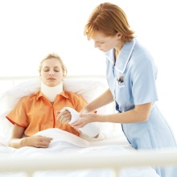

***Ejemplo:***The bathroom is to the right of the office.

el baño:  *El baño está a la derecha de la oficina.*

1. The pencil sharpener is there.

el sacapuntas: \_\_\_\_\_\_\_\_\_\_\_\_\_\_\_\_\_\_\_\_\_\_\_\_\_\_\_\_\_\_\_\_\_\_\_\_\_\_\_\_\_\_\_\_\_\_

2. The nurse’s office is to the right of the bathroom.

la oficina de la enfermera: \_\_\_\_\_\_\_\_\_\_\_\_\_\_\_\_\_\_\_\_\_\_\_\_\_\_\_\_\_\_\_\_\_\_\_\_\_

\_\_\_\_\_\_\_\_\_\_\_\_\_\_\_\_\_\_\_\_\_\_\_\_\_\_\_\_\_\_\_\_\_\_\_\_\_\_\_\_\_\_\_\_\_\_\_\_\_\_\_\_\_\_\_\_\_\_

3. The locker is to the left of the water fountain (*la fuente)*.

el armario: \_\_\_\_\_\_\_\_\_\_\_\_\_\_\_\_\_\_\_\_\_\_\_\_\_\_\_\_\_\_\_\_\_\_\_\_\_\_\_\_\_\_\_\_\_\_\_\_\_

\_\_\_\_\_\_\_\_\_\_\_\_\_\_\_\_\_\_\_\_\_\_\_\_\_\_\_\_\_\_\_\_\_\_\_\_\_\_\_\_\_\_\_\_\_\_\_\_\_

4. The office is here.

la oficina: \_\_\_\_\_\_\_\_\_\_\_\_\_\_\_\_\_\_\_\_\_\_\_\_\_\_\_\_\_\_\_\_\_\_\_\_\_\_\_\_\_\_\_\_\_\_\_\_\_\_

\_\_\_\_\_\_\_\_\_\_\_\_\_\_\_\_\_\_\_\_\_\_\_\_\_\_\_\_\_\_\_\_\_\_\_\_\_\_\_\_\_\_\_\_\_\_\_\_\_\_

5. The bathroom is over there, to the right.

los servicios: \_\_\_\_\_\_\_\_\_\_\_\_\_\_\_\_\_\_\_\_\_\_\_\_\_\_\_\_\_\_\_\_\_\_\_\_\_\_\_\_\_\_\_\_\_\_\_

\_\_\_\_\_\_\_\_\_\_\_\_\_\_\_\_\_\_\_\_\_\_\_\_\_\_\_\_\_\_\_\_\_\_\_\_\_\_\_\_\_\_\_\_\_\_\_

6. The water fountain is here, to the left.

la fuente (fountain): \_\_\_\_\_\_\_\_\_\_\_\_\_\_\_\_\_\_\_\_\_\_\_\_\_\_\_\_\_\_\_\_\_\_\_\_\_\_\_\_\_\_

\_\_\_\_\_\_\_\_\_\_\_\_\_\_\_\_\_\_\_\_\_\_\_\_\_\_\_\_\_\_\_\_\_\_\_\_\_\_\_\_\_\_

**¿Dónde está ?**

1. Fill in the chart. Write the English meaning and then write the Spanish word or phrase two times. Be neat!!

|  |  |  |  |
| --- | --- | --- | --- |
| Spanish | English Meaning | Spanish | English |
| allí |  |  |  |
| dónde |  |  |  |
| a la derecha |  |  |  |
| el lápiz |  |  |  |
| aquí |  |  |  |
| Está aquí. |  |  |  |
| a la izquierda |  |  |  |
| el papel |  |  |  |
| ¿Dónde está ? |  |  |  |

1. **Fill in the missing word (s). Refer to your notes!**

1. ¿\_\_\_\_\_\_\_\_\_\_\_\_\_\_\_ están los servicios? *Where are the bathrooms?*

2. Los servicios \_\_\_\_\_\_\_\_\_\_\_\_\_\_\_ a la derecha. *The bathrooms are to the right.*

3. El cuaderno está \_\_\_\_\_\_\_\_\_\_\_\_\_\_\_. *The notebook is over there.*

4. \_\_\_\_\_\_\_\_\_\_\_\_\_\_\_ aquí. *It is here.*

5. ¿Dónde está \_\_\_\_\_\_\_\_\_\_\_\_\_\_\_? *Where is the book?*

6. El armario está \_\_\_\_\_\_\_\_\_\_\_\_\_\_\_. *The locker is to the left.*

7. ¿ \_\_\_\_\_\_\_\_\_\_\_\_\_\_\_ \_\_\_\_\_\_\_\_\_\_\_\_\_\_\_ mi papel? *Where is my paper?*

8. El teléfono está \_\_\_\_\_\_\_\_\_\_\_\_\_\_\_. *The telephone is here.*

9. Las agendas \_\_\_\_\_\_\_\_\_\_\_\_\_\_\_ a la izquierda. *The agendas are to the left.*

**Where is Spanish spoken?**

Spanish is the official language of \_\_\_\_\_ countries in the world. Additionally, it is widely spoken in \_\_\_\_\_\_ other countries. Spanish is spoken (as a native language) by approximately \_\_\_\_\_ million people.

Spanish is spoken in the following areas and regions. List the names of the countries found in that area below its title, and then color in the Spanish speaking countries on the map as indicated.

***North America*** *(verde)*

1. \_\_\_\_\_\_\_\_\_\_\_\_\_\_\_\_\_\_\_\_\_\_\_\_

***Central America*** *(amarillo)*

1. \_\_\_\_\_\_\_\_\_\_\_\_\_\_\_\_\_\_\_\_\_\_\_\_ 2. \_\_\_\_\_\_\_\_\_\_\_\_\_\_\_\_\_\_\_\_\_\_\_\_

3. \_\_\_\_\_\_\_\_\_\_\_\_\_\_\_\_\_\_\_\_\_\_\_\_ 4. \_\_\_\_\_\_\_\_\_\_\_\_\_\_\_\_\_\_\_\_\_\_\_\_

5. \_\_\_\_\_\_\_\_\_\_\_\_\_\_\_\_\_\_\_\_\_\_\_\_ 6. \_\_\_\_\_\_\_\_\_\_\_\_\_\_\_\_\_\_\_\_\_\_\_\_

***Caribbean*** *(rojo)*

1. \_\_\_\_\_\_\_\_\_\_\_\_\_\_\_\_\_\_\_\_\_\_\_\_ 2. \_\_\_\_\_\_\_\_\_\_\_\_\_\_\_\_\_\_\_\_\_\_\_\_

3. \_\_\_\_\_\_\_\_\_\_\_\_\_\_\_\_\_\_\_\_\_\_\_\_

***South America*** *(anaranjado)*

1. \_\_\_\_\_\_\_\_\_\_\_\_\_\_\_\_\_\_\_\_\_\_\_\_ 2. \_\_\_\_\_\_\_\_\_\_\_\_\_\_\_\_\_\_\_\_\_\_\_\_

3. \_\_\_\_\_\_\_\_\_\_\_\_\_\_\_\_\_\_\_\_\_\_\_\_ 4. \_\_\_\_\_\_\_\_\_\_\_\_\_\_\_\_\_\_\_\_\_\_\_\_

5. \_\_\_\_\_\_\_\_\_\_\_\_\_\_\_\_\_\_\_\_\_\_\_\_ 6. \_\_\_\_\_\_\_\_\_\_\_\_\_\_\_\_\_\_\_\_\_\_\_\_

7. \_\_\_\_\_\_\_\_\_\_\_\_\_\_\_\_\_\_\_\_\_\_\_\_ 8. \_\_\_\_\_\_\_\_\_\_\_\_\_\_\_\_\_\_\_\_\_\_\_\_

9. \_\_\_\_\_\_\_\_\_\_\_\_\_\_\_\_\_\_\_\_\_\_\_\_

***Europe*** *(azul)*

1. \_\_\_\_\_\_\_\_\_\_\_\_\_\_\_\_\_\_\_\_\_\_\_\_ (Including the Balearic Islands)

***Africa*** *(morado)*

1. \_\_\_\_\_\_\_\_\_\_\_\_\_\_\_\_\_\_\_\_\_\_\_\_

2. \_\_\_\_\_\_\_\_\_\_\_\_\_\_\_\_\_\_\_\_\_\_\_\_ (a territory of Spain)

***Other*** *(negro)*

Spanish is also widely spoken in several other countries although it is not the official language. These countries include:

1. \_\_\_\_\_\_\_\_\_\_\_\_\_\_\_\_\_\_\_\_\_\_\_\_

**Sobre mi/About me**

**Answer the following questions about yourself in complete Spanish sentences.**

•¿Cómo te llamas? \_\_\_\_\_\_\_\_\_\_\_\_\_\_\_\_\_\_\_\_\_\_\_\_\_\_\_\_\_\_\_\_\_\_\_\_\_\_\_\_\_\_\_\_

•¿De dónde eres?

\_\_\_\_\_\_\_\_\_\_\_\_\_\_\_\_\_\_\_\_\_\_\_\_\_\_\_\_\_\_\_\_\_\_\_\_\_\_\_\_\_\_\_\_

•¿Cuál es tu nacionalidad?

•¿Dónde vives?

\_\_\_\_\_\_\_\_\_\_\_\_\_\_\_\_\_\_\_\_\_\_\_\_\_\_\_\_\_\_\_\_\_\_\_\_\_\_\_\_\_\_\_\_

•¿Cuál es tu dirección?

\_\_\_\_\_\_\_\_\_\_\_\_\_\_\_\_\_\_\_\_\_\_\_\_\_\_\_\_\_\_\_\_\_\_\_\_\_\_\_\_\_\_\_\_

•¿Cuántos años tienes? \_\_\_\_\_\_\_\_\_\_\_\_\_\_\_\_\_\_\_\_\_\_\_\_\_\_\_\_\_\_\_\_\_\_\_\_\_\_\_\_\_\_\_\_

•¿Cuál es tu número de teléfono? \_\_\_\_\_\_\_\_\_\_\_\_\_\_\_\_\_\_\_\_\_\_\_\_\_\_\_\_\_\_\_\_\_\_\_\_\_\_\_\_\_\_\_\_

•¿Cuál es tu color favorito? \_\_\_\_\_\_\_\_\_\_\_\_\_\_\_\_\_\_\_\_\_\_\_\_\_\_\_\_\_\_\_\_\_\_\_\_\_\_\_\_\_\_\_\_

•¿Cuál es tu número favorito? \_\_\_\_\_\_\_\_\_\_\_\_\_\_\_\_\_\_\_\_\_\_\_\_\_\_\_\_\_\_\_\_\_\_\_\_\_\_\_\_\_\_\_\_

•¿Cuál es tu ciudad favorita? \_\_\_\_\_\_\_\_\_\_\_\_\_\_\_\_\_\_\_\_\_\_\_\_\_\_\_\_\_\_\_\_\_\_\_\_\_\_\_\_\_\_\_\_

**DOCUMENTOS ESCOLARES**

Most students in Spanish-speaking countries have a student ID card. This card has a lot of advantages; such as reduced ticket prices or free admission to museums, club or sport centers, etc. Look at the ID card below. What information do you find on it? \_\_\_\_\_\_\_\_\_\_\_\_\_\_\_\_\_\_\_\_\_\_\_\_\_\_\_\_\_\_\_\_\_\_\_\_\_\_\_\_\_\_\_\_\_\_\_\_\_\_\_\_\_\_\_\_\_\_\_\_\_\_\_\_\_\_\_\_\_\_\_\_\_\_\_\_\_\_\_\_\_\_\_\_\_\_\_\_\_\_\_\_\_\_\_\_\_\_\_\_\_\_\_\_\_\_\_\_\_\_\_\_\_\_\_\_\_\_\_\_\_\_\_\_\_\_\_\_\_\_\_\_\_\_\_\_\_\_\_\_\_\_\_\_\_\_\_\_\_\_\_\_\_\_\_\_\_\_\_\_\_\_\_\_\_\_\_\_\_\_\_\_\_\_\_\_\_\_\_\_\_\_\_\_\_\_\_\_\_\_\_\_\_\_\_\_\_\_\_\_\_\_\_\_\_\_\_\_\_\_\_\_\_\_\_\_\_\_\_\_\_\_\_\_\_

*FRONT* *BACK*



**FIRMA DEL ALUMNO**

María Gonzalez

Documento personal e intransferible; Valido para la visita a monumentos nacionales, museos, bibliotecas, casas de la cultura y toda clase de centros artísticos y culturales.

**COLEGIO SAN MARTIN**

Año académico 2009-2010

Apellidos Gonzalez Lopez

Nombre María

Dirección c/ Guevara 65

Ciudad Monterrey

Estado León

Edad 12

\*Another word in Spanish for "escuela" is \_\_\_\_\_\_\_\_\_\_\_\_\_\_\_\_\_\_\_. Both mean \_\_\_\_\_\_\_\_\_\_.

\*\*Another word in Spanish for "estudiante" is \_\_\_\_\_\_\_\_\_\_\_\_\_\_\_\_. Both mean \_\_\_\_\_\_\_\_\_\_.

**Now make your own student ID card!!**

*Colegio \_\_\_\_\_\_\_\_\_\_\_\_\_\_\_\_\_\_\_\_\_\_\_\_\_\_\_\_\_\_\_*

*Año académico \_\_\_\_\_\_\_\_\_\_\_\_\_\_\_\_\_\_*

*Apellido(s): \_\_\_\_\_\_\_\_\_\_\_\_\_\_\_\_\_\_\_ Fotografía*

*Nombre: \_\_\_\_\_\_\_\_\_\_\_\_\_\_\_\_\_\_\_*\_\_

*Edad: \_\_\_\_\_\_\_\_\_\_\_*

*Dirección: \_\_\_\_\_\_\_\_\_\_\_\_\_\_\_\_\_\_\_\_\_\_\_\_\_\_\_\_\_*

*Ciudad/Pueblo: \_\_\_\_\_\_\_\_\_\_\_\_\_\_\_\_\_\_\_\_\_\_\_\_\_*

*Estado: \_\_\_\_\_\_\_\_\_\_\_\_ Código Postal: \_\_\_\_\_\_\_\_\_\_*

*País: \_\_\_\_\_\_\_\_\_\_\_\_\_\_\_\_\_\_\_\_\_\_\_*

*Nacionalidad: \_\_\_\_\_\_\_\_\_\_\_\_\_\_\_\_\_*

*Número de teléfono: \_\_\_\_\_\_\_\_\_\_\_\_\_\_\_\_\_\_\_\_\_*

*Firma: \_\_\_\_\_\_\_\_\_\_\_\_\_\_\_\_\_\_\_\_\_\_\_*

Win a Piece of Candy!

**Fill in the information requested below to enter the contest to win a piece of Candy. The form must be filled out correctly and completely!**

Nombre\_\_\_\_\_\_\_\_\_\_\_\_\_\_\_\_\_\_\_\_\_\_\_\_\_\_\_\_\_\_\_\_\_\_\_\_\_\_\_\_\_\_\_\_\_

Apellido\_\_\_\_\_\_\_\_\_\_\_\_\_\_\_\_\_\_\_\_\_\_\_\_\_\_\_\_\_\_\_\_\_\_\_\_\_\_\_\_\_\_\_\_\_

Dirección\_\_\_\_\_\_\_\_\_\_\_\_\_\_\_\_\_\_\_\_\_\_\_\_\_\_\_\_\_\_\_\_\_\_\_\_\_\_\_\_\_\_\_\_

Ciudad\_\_\_\_\_\_\_\_\_\_\_\_\_\_\_\_\_\_\_\_\_\_\_\_\_\_\_\_\_\_\_\_\_\_\_\_\_\_\_\_\_\_\_\_\_\_

Estado \_\_\_\_\_\_\_\_\_\_\_\_\_\_\_\_\_\_\_\_\_\_\_\_\_\_\_\_\_\_\_\_\_\_\_\_\_\_\_\_\_\_\_\_\_

Código postal \_\_\_\_\_\_\_\_\_\_\_\_\_\_\_\_\_\_\_\_\_\_\_\_\_\_\_\_\_\_\_\_\_\_\_\_\_\_\_\_\_

País \_\_\_\_\_\_\_\_\_\_\_\_\_\_\_\_\_\_\_\_\_\_\_\_\_\_\_\_\_\_\_\_\_\_\_\_\_\_\_\_\_\_\_\_\_\_\_\_

Nacionalidad \_\_\_\_\_\_\_\_\_\_\_\_\_\_\_\_\_\_\_\_\_\_\_\_\_\_\_\_\_\_\_\_\_\_\_\_\_\_\_\_\_

Número de teléfono \_\_\_\_\_\_\_\_\_\_\_\_\_\_\_\_\_\_\_\_\_\_\_\_\_\_\_\_\_\_\_\_\_\_\_\_

Edad \_\_\_\_\_\_\_\_\_\_\_\_\_\_\_\_\_\_\_\_\_\_\_\_\_\_\_\_\_\_\_\_\_\_\_\_\_\_\_\_\_\_\_\_\_\_\_

Firma\_\_\_\_\_\_\_\_\_\_\_\_\_\_\_\_\_\_\_\_\_\_\_\_\_\_\_\_\_\_\_\_\_\_\_\_\_\_\_\_\_\_\_\_\_\_\_