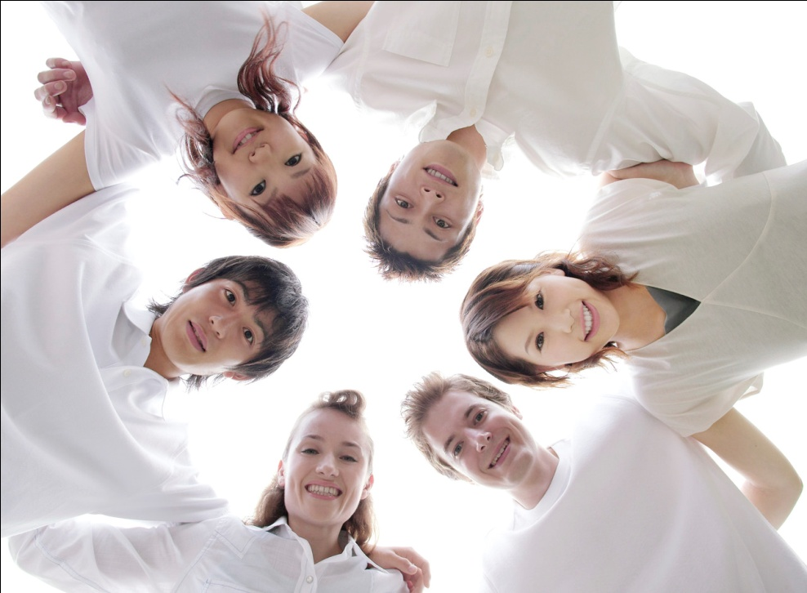

UNIDAD 2

¿Qué te gusta hacer?

El paquete de tarea

Nombre: \_\_\_\_\_\_\_\_\_\_\_\_\_\_\_\_\_\_\_\_\_\_\_\_\_

Base: \_\_\_\_\_\_\_\_\_\_\_\_\_\_\_\_\_\_\_\_\_

Clase: \_\_\_\_\_\_\_\_\_\_\_\_

Me llamo \_\_\_\_\_\_\_\_\_\_\_\_\_\_\_\_\_\_\_\_\_\_\_ Unidad 2

Use page 18 in your *libro* to write the Spanish of the following:

**The Weather** \_\_\_\_\_\_\_\_\_\_\_\_\_\_\_\_\_\_\_\_\_\_\_\_\_\_\_

What is the weather like? \_\_\_\_\_\_\_\_\_\_\_\_\_\_\_\_\_\_\_\_\_\_

It’s sunny. \_\_\_\_\_\_\_\_\_\_\_\_\_\_\_\_\_\_\_\_\_\_\_\_\_\_\_\_\_\_\_\_\_

C:\Users\Dale\AppData\Local\Microsoft\Windows\Temporary Internet Files\Content.IE5\SPVMVMZ3\MC900391082[1].wmf

It’s hot. \_\_\_\_\_\_\_\_\_\_\_\_\_\_\_\_\_\_\_\_\_\_\_\_\_\_\_\_\_\_\_\_\_\_\_

It’s cold. \_\_\_\_\_\_\_\_\_\_\_\_\_\_\_\_\_\_\_\_\_\_\_\_\_\_\_\_\_\_\_\_\_\_

It’s windy. \_\_\_\_\_\_\_\_\_\_\_\_\_\_\_\_\_\_\_\_\_\_\_\_\_\_\_\_\_\_\_\_\_

It’s raining. \_\_\_\_\_\_\_\_\_\_\_\_\_\_\_\_\_\_\_\_\_\_\_\_\_\_\_\_\_\_\_\_

It’s snowing. \_\_\_\_\_\_\_\_\_\_\_\_\_\_\_\_\_\_\_\_\_\_\_\_\_\_\_\_\_\_\_\_

**The Seasons** \_\_\_\_\_\_\_\_\_\_\_\_\_\_\_\_\_\_\_\_\_\_\_\_\_\_\_\_\_\_

the spring \_\_\_\_\_\_\_\_\_\_\_\_\_\_\_\_\_\_\_\_\_\_\_\_\_\_\_\_\_\_\_\_\_\_

the summer \_\_\_\_\_\_\_\_\_\_\_\_\_\_\_\_\_\_\_\_\_\_\_\_\_\_\_\_\_\_\_\_\_

the fall \_\_\_\_\_\_\_\_\_\_\_\_\_\_\_\_\_\_\_\_\_\_\_\_\_\_\_\_\_\_\_\_\_\_\_\_

the winter \_\_\_\_\_\_\_\_\_\_\_\_\_\_\_\_\_\_\_\_\_\_\_\_\_\_\_\_\_\_\_\_\_\_

1

What do you think the following mean?

¿Qué estación es? \_\_\_\_\_\_\_\_\_\_\_\_\_\_\_\_\_\_\_\_\_\_\_\_\_\_\_\_\_\_\_

Hace buen tiempo. \_\_\_\_\_\_\_\_\_\_\_\_\_\_\_\_\_\_\_\_\_\_\_\_\_\_\_\_\_\_

Hace mal tiempo. \_\_\_\_\_\_\_\_\_\_\_\_\_\_\_\_\_\_\_\_\_\_\_\_\_\_\_\_\_\_\_

Hace fresco. \_\_\_\_\_\_\_\_\_\_\_\_\_\_\_\_\_\_\_\_\_\_\_\_\_\_\_\_\_\_\_\_\_\_\_

Está nublado. \_\_\_\_\_\_\_\_\_\_\_\_\_\_\_\_\_\_\_\_\_\_\_\_\_\_\_\_\_\_\_\_\_\_

¿Qué tiempo hace en la primavera? \_\_\_\_\_\_\_\_\_\_\_\_\_\_\_\_\_\_\_\_

¿Qué tiempo hace en diciembre? \_\_\_\_\_\_\_\_\_\_\_\_\_\_\_\_\_\_\_\_\_\_

¿Hace calor en el invierno? \_\_\_\_\_\_\_\_\_\_\_\_\_\_\_\_\_\_\_\_\_\_\_\_\_\_

¿Hace frío en junio? \_\_\_\_\_\_\_\_\_\_\_\_\_\_\_\_\_\_\_\_\_\_\_\_\_\_\_\_\_\_

Answer the question: *¿Qué tiempo hace en los dibujos?*

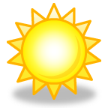 C:\Documents and Settings\APikula\Local Settings\Temporary Internet Files\Content.IE5\HCO57Y91\MC900233094[1].wmf C:\Documents and Settings\APikula\Local Settings\Temporary Internet Files\Content.IE5\RU5B72N6\MC900233059[1].wmf

\_\_\_\_\_\_\_\_\_\_\_ \_\_\_\_\_\_\_\_\_\_ \_\_\_\_\_\_\_\_\_\_

 C:\Documents and Settings\APikula\Local Settings\Temporary Internet Files\Content.IE5\HCO57Y91\MC900078822[1].wmf C:\Documents and Settings\APikula\Local Settings\Temporary Internet Files\Content.IE5\NEG5HKHX\MC900286894[1].wmf

\_\_\_\_\_\_\_\_\_\_\_ \_\_\_\_\_\_\_\_\_\_\_ \_\_\_\_\_\_\_\_\_\_\_\_

***Cuaderno de Ejercicios:* Para Empezar página 9.**

2

**¿Qué tiempo hace?**

**Write a sentence in Spanish describing the weather pictured.**

**Use your notes for spelling.**

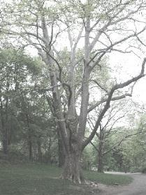MCPE07665_0000[1]

**\_\_\_\_\_\_\_\_\_\_\_\_\_\_\_\_\_\_\_\_\_**

**\_\_\_\_\_\_\_\_\_\_\_\_\_\_\_\_\_\_\_\_\_**

**\_\_\_\_\_\_\_\_\_\_\_\_\_\_\_\_\_\_\_\_\_**

**\_\_\_\_\_\_\_\_\_\_\_\_\_\_\_\_\_\_\_\_\_**

**\_\_\_\_\_\_\_\_\_\_\_\_\_\_\_\_\_\_\_\_\_**

**\_\_\_\_\_\_\_\_\_\_\_\_\_\_\_\_\_\_\_\_\_**

Description: na01064_



**\_\_\_\_\_\_\_\_\_\_\_\_\_\_\_\_\_\_\_\_\_**



**\_\_\_\_\_\_\_\_\_\_\_\_\_\_\_\_\_\_\_\_\_**

MCj03983150000[1]

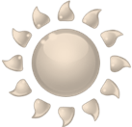

**\_\_\_\_\_\_\_\_\_\_\_\_\_\_\_\_\_\_\_\_\_**

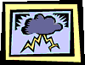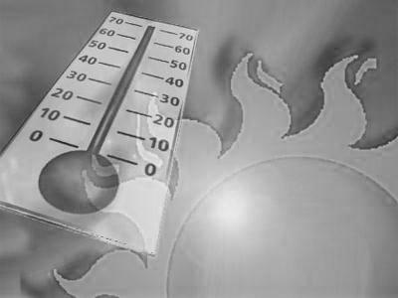

**\_\_\_\_\_\_\_\_\_\_\_\_\_\_\_\_\_\_\_\_\_**

3

**Escriban el número del tiempo indicad**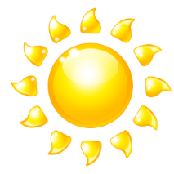**o.**

MCj01863600000[1]MCPE07665_0000[1]

MCj03983150000[1] **\_\_\_\_\_\_ \_\_\_\_\_\_ \_\_\_\_\_\_\_ \_\_\_\_\_\_ \_\_\_\_\_\_**

C:\Documents and Settings\LKRESS\Local Settings\Temporary Internet Files\Content.IE5\UNEZQTE7\MCj02330940000[1].wmf

**\_\_\_\_\_\_ \_\_\_\_\_\_ \_\_\_\_\_\_ \_\_\_\_\_\_ \_\_\_\_\_\_**

*PROYECTO: ¿CÓMO TE AFECTA EL TIEMPO?*

**Follow the directions below in order to show how the weather affects you in each season.**

1. Fold a plain piece of white paper into quarters.

**Write out the following information in Spanish!!**

2. Write the name of each season in the top center of each square.

3. Write two complete sentences describing the weather in each season.

4. Write one complete sentence stating what you like to do in each season.

5. Write one sentence stating a place you love to go to in each season.

6. Draw a picture to illustrate each season.

4

Nombre: \_\_\_\_\_\_\_\_\_\_\_\_\_\_\_\_\_\_\_\_\_\_\_\_\_\_\_\_

LLENO: los deportes

|  |  |  |  |
| --- | --- | --- | --- |
|  |  |  |  |
|  |  |  |  |
|  |  |  |  |
|  |  |  |  |

5

***Cuaderno de Ejercicios:* Capítulo 4B página 76.**

**los deportes– Escriba una lista de deportes en español.**

* En el verano mis deportes favoritos son: \_\_\_\_\_\_\_\_\_\_\_\_\_\_\_\_\_\_\_\_\_\_\_\_

\_\_\_\_\_\_\_\_\_\_\_\_\_\_\_\_\_\_\_\_\_\_\_\_

\_\_\_\_\_\_\_\_\_\_\_\_\_\_\_\_\_\_\_\_\_\_\_\_

* En el otoño mis deportes favoritos son: \_\_\_\_\_\_\_\_\_\_\_\_\_\_\_\_\_\_\_\_\_\_\_\_

\_\_\_\_\_\_\_\_\_\_\_\_\_\_\_\_\_\_\_\_\_\_\_\_

\_\_\_\_\_\_\_\_\_\_\_\_\_\_\_\_\_\_\_\_\_\_\_\_

* En el invierno mis deportes favoritos son: \_\_\_\_\_\_\_\_\_\_\_\_\_\_\_\_\_\_\_\_\_\_\_\_

\_\_\_\_\_\_\_\_\_\_\_\_\_\_\_\_\_\_\_\_\_\_\_\_

\_\_\_\_\_\_\_\_\_\_\_\_\_\_\_\_\_\_\_\_\_\_\_\_

* En la primavera mis deportes favoritos son: \_\_\_\_\_\_\_\_\_\_\_\_\_\_\_\_\_\_\_\_\_\_\_\_

\_\_\_\_\_\_\_\_\_\_\_\_\_\_\_\_\_\_\_\_\_\_\_\_

\_\_\_\_\_\_\_\_\_\_\_\_\_\_\_\_\_\_\_\_\_\_\_\_

¿Cuál deporte es? – Escriba en español e inglés.

1. stine 🡺 \_\_\_\_\_\_\_\_\_\_\_\_\_\_\_\_\_\_\_\_=\_\_\_\_\_\_\_\_\_\_\_\_\_\_\_\_\_\_\_\_

2. flog 🡺 \_\_\_\_\_\_\_\_\_\_\_\_\_\_\_\_\_\_\_\_\_=\_\_\_\_\_\_\_\_\_\_\_\_\_\_\_\_\_\_\_\_

3. ricardo ed oosrt 🡺 \_\_\_\_\_\_\_\_\_\_\_\_\_\_\_=\_\_\_\_\_\_\_\_\_\_\_\_\_\_\_\_\_

4. iaj aila 🡺 \_\_\_\_\_\_\_\_\_\_\_\_\_\_\_\_\_\_\_=\_\_\_\_\_\_\_\_\_\_\_\_\_\_\_\_\_\_\_\_

5. lóeblovi 🡺 \_\_\_\_\_\_\_\_\_\_\_\_\_\_\_\_\_\_=\_\_\_\_\_\_\_\_\_\_\_\_\_\_\_\_\_\_\_\_

6. bflotú 🡺 \_\_\_\_\_\_\_\_\_\_\_\_\_\_\_\_\_\_\_\_=\_\_\_\_\_\_\_\_\_\_\_\_\_\_\_\_\_\_\_\_

7. éslboib 🡺 \_\_\_\_\_\_\_\_\_\_\_\_\_\_\_\_\_\_=\_\_\_\_\_\_\_\_\_\_\_\_\_\_\_\_\_\_\_\_

8. sconlbetao 🡺 \_\_\_\_\_\_\_\_\_\_\_\_\_\_\_\_\_=\_\_\_\_\_\_\_\_\_\_\_\_\_\_\_\_\_\_

6

Unidad 2 Fecha: \_\_\_\_\_\_\_\_\_\_\_\_\_\_\_\_\_\_\_\_\_\_\_\_\_\_\_\_\_\_

TAREA: Los deportes y gustar

*Which sports do you like? Which sports don’t you like?*

**Direcciones:** Write how you feel about each sport pictured in a complete Spanish sentence.

**¿Te gusta el / la ....?**

j0079260

*Ejemplo:* **Sí, me gusta el boliche.**

*or*  **No, no me gusta el boliche.**

j0079251

1.

\_\_\_\_\_\_\_\_\_\_\_\_\_\_\_\_\_\_\_\_\_\_\_\_\_\_\_\_\_\_\_\_\_\_\_\_\_\_\_\_\_\_\_\_\_

so00581_

2.

\_\_\_\_\_\_\_\_\_\_\_\_\_\_\_\_\_\_\_\_\_\_\_\_\_\_\_\_\_\_\_\_\_\_\_\_\_\_\_\_\_\_\_\_\_

bd00012_

3.

\_\_\_\_\_\_\_\_\_\_\_\_\_\_\_\_\_\_\_\_\_\_\_\_\_\_\_\_\_\_\_\_\_\_\_\_\_\_\_\_\_\_\_\_\_

pe01778_

4.

\_\_\_\_\_\_\_\_\_\_\_\_\_\_\_\_\_\_\_\_\_\_\_\_\_\_\_\_\_\_\_\_\_\_\_\_\_\_\_\_\_\_\_\_\_

j0079256

5.

\_\_\_\_\_\_\_\_\_\_\_\_\_\_\_\_\_\_\_\_\_\_\_\_\_\_\_\_\_\_\_\_\_\_\_\_\_\_\_\_\_\_\_\_\_

7

**¿Te gusta el / la....?**

*Ejemplo:*  **Sí, me gusta la gimnasia.**

*or*  **No, no me gusta la gimnasia.**

j0079259

1.

\_\_\_\_\_\_\_\_\_\_\_\_\_\_\_\_\_\_\_\_\_\_\_\_\_\_\_\_\_\_\_\_\_\_\_\_\_\_\_\_\_

j0079261

2.

\_\_\_\_\_\_\_\_\_\_\_\_\_\_\_\_\_\_\_\_\_\_\_\_\_\_\_\_\_\_\_\_\_\_\_\_\_\_\_\_\_

pe01776_

3.

\_\_\_\_\_\_\_\_\_\_\_\_\_\_\_\_\_\_\_\_\_\_\_\_\_\_\_\_\_\_\_\_\_\_\_\_\_\_\_\_\_

4.

j0198156

\_\_\_\_\_\_\_\_\_\_\_\_\_\_\_\_\_\_\_\_\_\_\_\_\_\_\_\_\_\_\_\_\_\_\_\_\_\_\_\_\_

5.

MCj03579930000[1]

\_\_\_\_\_\_\_\_\_\_\_\_\_\_\_\_\_\_\_\_\_\_\_\_\_\_\_\_\_\_\_\_\_\_\_\_\_\_\_\_\_

6. ¿Cuál es tu deporte favorito?

\_\_\_\_\_\_\_\_\_\_\_\_\_\_\_\_\_\_\_\_\_\_\_\_\_\_\_\_\_\_\_\_\_\_\_\_\_\_\_\_\_\_\_\_\_\_\_\_\_\_\_\_\_\_\_\_\_

***fyi:*** "No me gusta ni el tenis ni el fútbol."

8

Práctica con los deportes

**Use your notes to write the following sentences or questions in Spanish. Be careful to use correct spelling and grammar (upside question marks ¿ ¿ ¿ ¿ and exclamation points ¡ ¡ ¡ ¡).**

j0078629

1. Do you like soccer?
2. Do you like boxing?
3. I don’t like swimming!
4. I like baseball.
5. The baseball game is here.
6. Good luck!
7. I do not like golf.
8. Do you like the hockey team?
9. What do you need for tennis?
10. Do you like sports?
11. What is your favorite sport?
12. My favorite sport is tennis.

9

Español-\_\_\_\_\_\_\_\_\_\_\_\_\_ \_\_\_\_\_\_\_\_\_\_\_\_\_\_\_\_\_\_\_\_\_\_\_\_\_\_\_\_\_\_\_\_

Español 7 Unidad 2 \_\_\_\_\_\_\_\_\_\_\_\_\_\_\_\_\_\_\_\_\_\_\_\_\_\_\_\_\_\_\_\_

1. Bullfighting originated in a) México, b) España c) Argentina. (Circle one.)

2. In Spanish the word “bullfighting” is translated \_\_\_\_\_\_\_\_\_\_\_\_\_\_\_\_\_\_\_\_\_\_\_\_\_\_\_\_\_.

3. In Mexico, the bullfighting season is from \_\_\_\_\_\_\_\_\_\_\_\_\_\_\_\_ to \_\_\_\_\_\_\_\_\_\_\_\_\_\_\_.

4. Where is the largest **plaza de toros** located? \_\_\_\_\_\_\_\_\_\_\_\_\_\_\_\_\_\_\_\_\_\_\_\_\_

How many people does it seat? \_\_\_\_\_\_\_\_\_\_\_\_\_\_\_\_\_\_\_\_\_\_\_\_\_\_\_\_

5. Which tickets are most expensive?

\_\_\_\_\_\_\_\_\_\_\_\_\_\_\_\_\_\_\_\_\_\_\_\_\_\_\_\_\_\_\_\_\_\_\_\_\_\_\_\_\_\_\_\_\_

Why do you think this is so?

\_\_\_\_\_\_\_\_\_\_\_\_\_\_\_\_\_\_\_\_\_\_\_\_\_\_\_\_\_\_\_\_\_\_\_\_\_\_\_\_\_\_\_\_

6. There are one / two/ three parts in the bullfight. (Circle one.)

7. The \_\_\_\_\_\_\_\_\_\_\_\_\_\_\_\_\_\_\_\_ are darts, which are stuck into the bull.

8. The bullfighter is called the \_\_\_\_\_\_\_\_\_\_\_\_\_\_. This word comes from the Spanish

word **matar**, which means to kill.

9. Everyone in Spain thinks bullfighting is a great idea. True / False

Explain why you would or would not go to a bullfight if you had the opportunity.

\_\_\_\_\_\_\_\_\_\_\_\_\_\_\_\_\_\_\_\_\_\_\_\_\_\_\_\_\_\_\_\_\_\_\_\_\_\_\_\_\_\_\_\_\_\_\_\_\_\_\_\_\_\_\_\_\_\_\_\_\_\_\_\_\_\_\_\_\_\_\_\_\_\_\_\_\_\_\_\_\_\_\_\_\_\_\_\_\_\_\_\_\_\_\_\_\_\_\_\_\_\_\_\_\_\_\_\_\_\_\_\_\_\_\_\_\_\_\_\_\_\_\_\_\_\_\_\_\_\_\_\_\_\_\_\_\_\_\_\_\_\_\_\_\_\_\_\_\_\_\_\_\_\_\_\_\_\_\_\_\_\_\_\_\_\_\_\_\_\_\_\_\_\_\_\_\_\_\_\_\_\_\_\_\_\_\_\_\_\_\_\_\_\_\_\_\_\_\_\_\_\_\_\_\_\_\_\_\_\_\_\_\_\_\_\_\_\_\_\_\_\_\_\_\_\_\_\_\_\_\_\_\_\_\_\_\_\_\_\_\_\_\_\_\_\_\_\_\_\_\_\_\_\_\_\_\_\_\_\_\_\_\_\_\_\_\_\_\_\_\_\_\_\_\_\_\_\_\_\_\_\_\_\_\_\_\_\_\_\_\_\_\_\_\_\_\_\_\_\_\_\_\_\_\_\_\_\_\_\_\_\_\_\_\_\_\_\_\_\_

j0198155

10

***Cuaderno de Ejercicios:* Capítlo 1A páginas 13, 14, 15, 16, 17,18, 19, 20, 21.**

TAREA: Las Actividades

*Which activities do you enjoy? Which activities do you not enjoy?*

**Direcciones:** Write how you feel about each activity shown in complete Spanish sentences.

Use each expression, *Me gusta / No me gusta / Me encanta / Odio*, at least once.

**¿Qué te gusta hacer?**

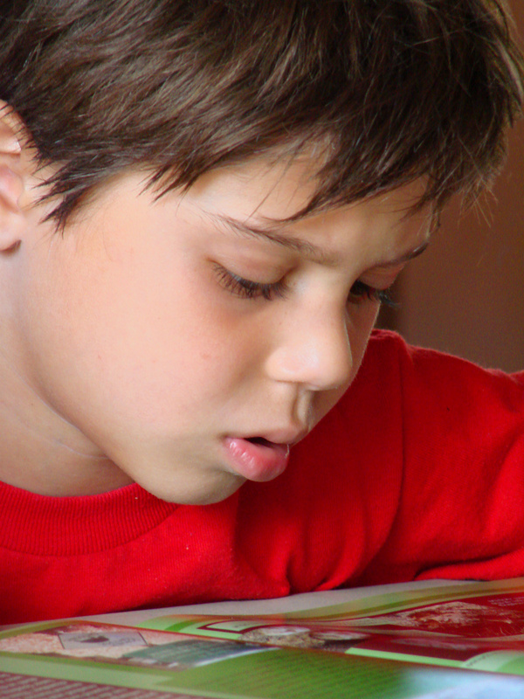

*Ejemplo*: **Me gusta estudiar./ Me encanta estudiar.**

*or*  **No me gusta estudiar./ Odio estudiar.**

MCj04379900000[1]

1. \_\_\_\_\_\_\_\_\_\_\_\_\_\_\_\_\_\_\_\_\_\_\_\_\_\_\_\_\_\_\_\_\_\_\_\_\_\_\_\_\_\_

MCj04404300000[1]

2. \_\_\_\_\_\_\_\_\_\_\_\_\_\_\_\_\_\_\_\_\_\_\_\_\_\_\_\_\_\_\_\_\_\_\_\_\_\_\_\_\_\_

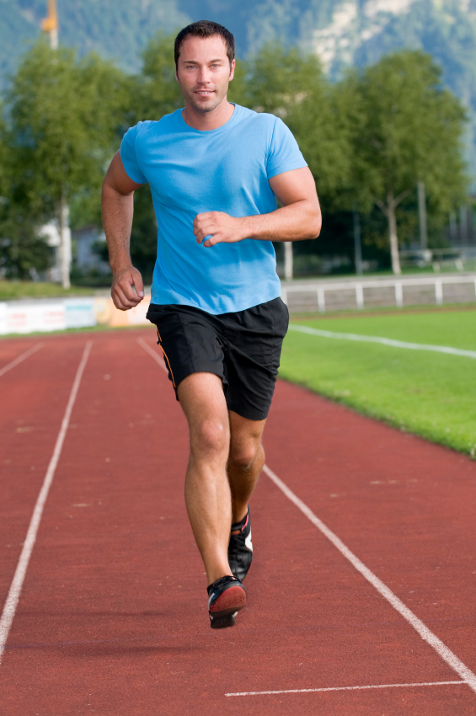

3.

\_\_\_\_\_\_\_\_\_\_\_\_\_\_\_\_\_\_\_\_\_\_\_\_\_\_\_\_\_\_\_\_\_\_\_\_\_\_\_\_\_\_



4.

\_\_\_\_\_\_\_\_\_\_\_\_\_\_\_\_\_\_\_\_\_\_\_\_\_\_\_\_\_\_\_\_\_\_\_\_\_\_\_\_\_\_

MCj04079820000[1]

11

5. \_\_\_\_\_\_\_\_\_\_\_\_\_\_\_\_\_\_\_\_\_\_\_\_\_\_\_\_\_\_\_\_\_\_\_\_\_\_\_\_\_

6.

MCj04415760000[1]

\_\_\_\_\_\_\_\_\_\_\_\_\_\_\_\_\_\_\_\_\_\_\_\_\_\_\_\_\_\_\_\_\_\_\_\_\_\_\_\_\_\_

MCj03974480000[1]

7.

\_\_\_\_\_\_\_\_\_\_\_\_\_\_\_\_\_\_\_\_\_\_\_\_\_\_\_\_\_\_\_\_\_\_\_\_\_\_\_\_\_\_

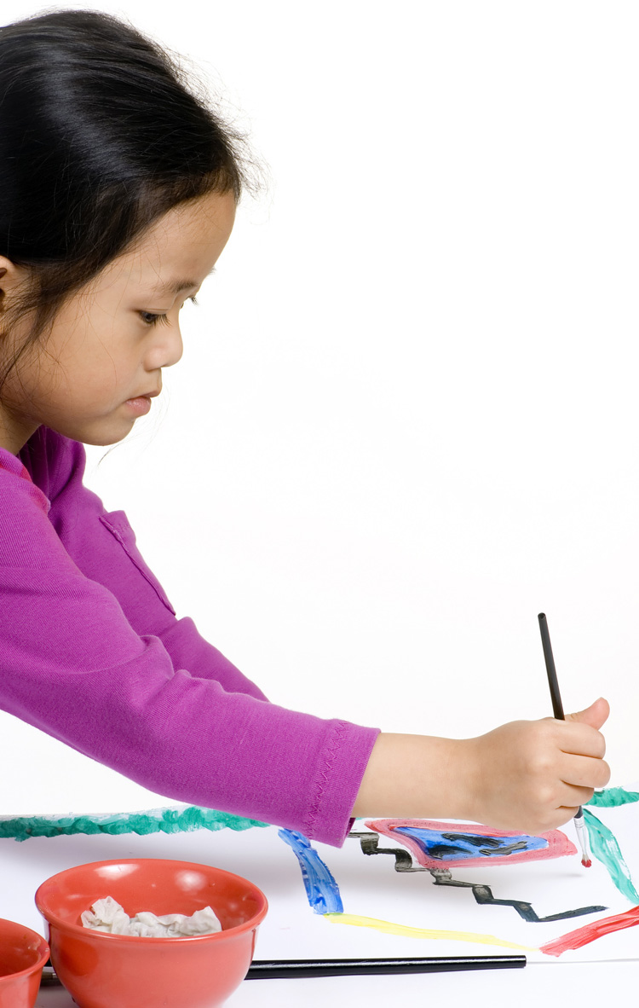

8.

\_\_\_\_\_\_\_\_\_\_\_\_\_\_\_\_\_\_\_\_\_\_\_\_\_\_\_\_\_\_\_\_\_\_\_\_\_\_\_\_\_\_

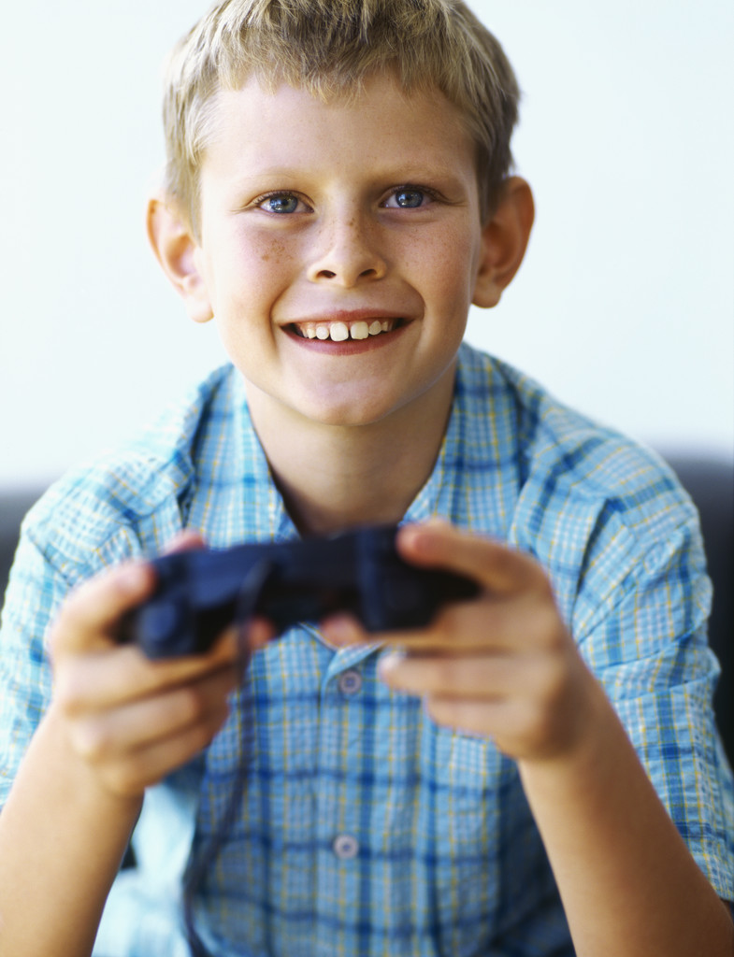

9.

\_\_\_\_\_\_\_\_\_\_\_\_\_\_\_\_\_\_\_\_\_\_\_\_\_\_\_\_\_\_\_\_\_\_\_\_\_\_\_\_\_\_

MCj01549380000[1]

10.

\_\_\_\_\_\_\_\_\_\_\_\_\_\_\_\_\_\_\_\_\_\_\_\_\_\_\_\_\_\_\_\_\_\_\_\_\_\_\_\_\_\_

C:\Users\Dale\AppData\Local\Microsoft\Windows\Temporary Internet Files\Content.IE5\PTOFWBYE\MC900237510[1].wmf

11.

\_\_\_\_\_\_\_\_\_\_\_\_\_\_\_\_\_\_\_\_\_\_\_\_\_\_\_\_\_\_\_\_\_\_\_\_\_\_\_\_\_\_

MCj02959450000[1]

12.

\_\_\_\_\_\_\_\_\_\_\_\_\_\_\_\_\_\_\_\_\_\_\_\_\_\_\_\_\_\_\_\_\_\_\_\_\_\_\_\_\_\_

12

Unidad 2 Fecha: \_\_\_\_\_\_\_\_\_\_\_\_\_\_\_\_\_\_\_\_\_\_\_\_\_\_\_\_\_\_

Una Entrevista

We are going to interview our classmates to find out what is the most popular sport and after school activity in our class. Ask as many students as possible what their favorite sport is and then ask them what they like to do after school. Record their responses with a tally mark.

¿Cuál es tu deporte favorito?

Mi deporte favorito es….

**Record tallies *aquí***:

|  |  |
| --- | --- |
| el fútbol |  |
| el fútbol americano |  |
| el volibol |  |
| el béisbol |  |
| el baloncesto |  |
| el hockey |  |
| la natación |  |
| el tenis |  |
| el golf |  |
| el lacrosse |  |
| la lucha libre |  |
| el boxeo |  |
| OTROS: | el boliche  el monopatín  la gimnasia  el surf de nieve  la equitación  el esquí  3  la pesca |

13

¿Qué te gusta hacer después de las clases?

Mi actividad favorita es….

**Record tallies *aquí***:

|  |  |
| --- | --- |
| dibujar |  |
| practicar deportes |  |
| leer |  |
| bailar |  |
| jugar videojuegos |  |
| ver la televisión |  |
| hablar por teléfono |  |
| correr |  |
| nadar |  |
| cantar |  |
| esquiar |  |
| usar la computadora |  |
| pasar tiempo con amigos |  |
| escuchar música |  |
| montar en bicicleta |  |
| montar a caballo |  |

***Cuaderno de Ejercicios:* Capítulo 4A páginas 67 y 68?**

14

TAREA: Los lugares

*Which of the following places do you like or dislike going to?*

**Direcciones:** Label each picture, and then write how you feel about going to the places pictured using complete Spanish sentences.

[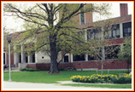](http://www.opschools.org/middleschool.cfm)

**¿Te gusta ir a …..?**

**🡸1. No, no me gusta ir a la escuela.**

**\_\_la escuela\_**

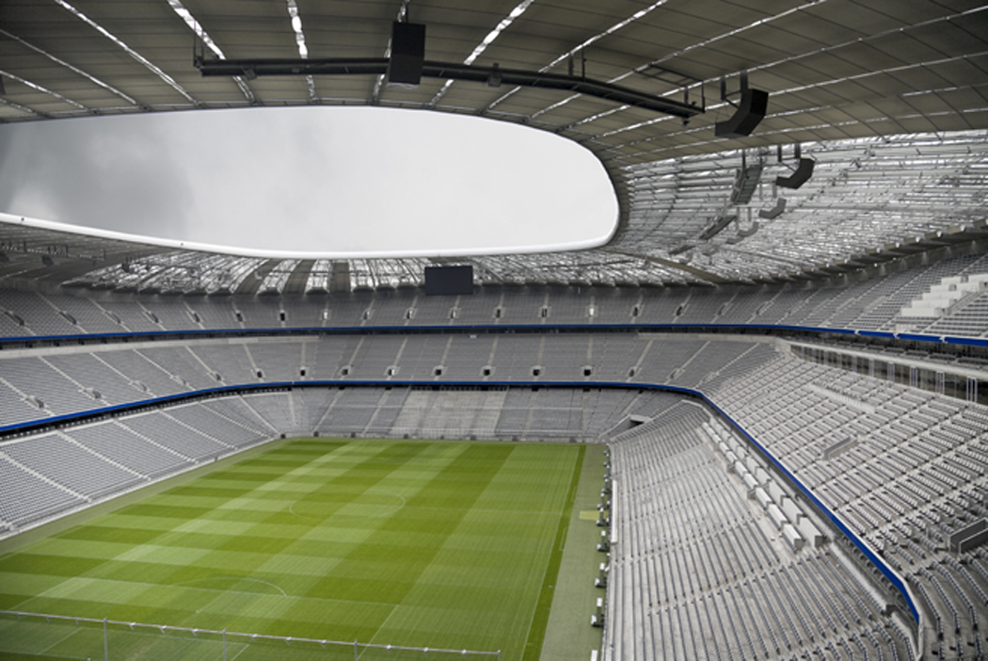

**2. 🡺**

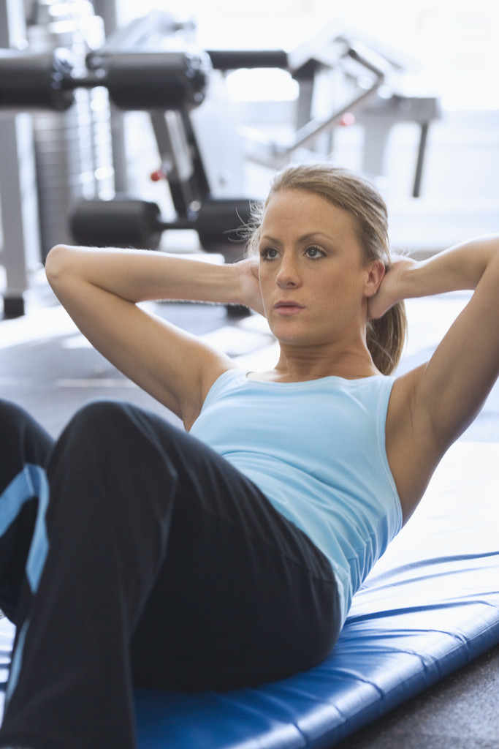

**\_\_\_\_\_\_\_\_\_\_\_**

**🡸3.**

**\_\_\_\_\_\_\_\_\_\_\_**

MCj02959450000[1]

**4. \_\_\_\_\_🡺**

**\_\_\_\_\_\_\_\_\_\_\_**

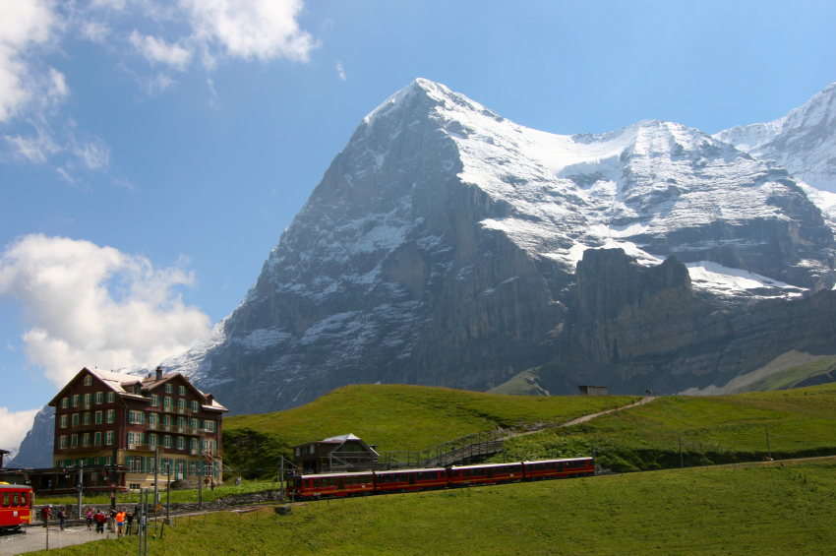

**🡸5. \_\_\_\_\_\_**



**\_\_\_\_\_\_\_\_\_\_\_**

**6. 🡺**

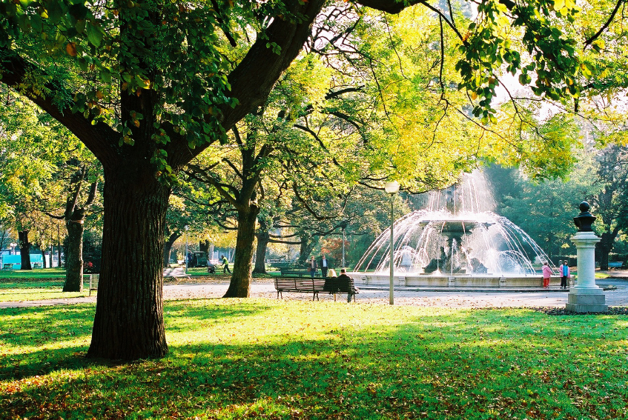

**\_\_\_\_\_\_\_\_\_\_**

**🡸7. \_\_\_\_\_ \_\_\_\_\_\_**

**\_\_\_\_\_\_\_\_\_\_\_\_\_**

15

**Read the following questions. Respond by providing a place you would go in order to do the activity in question. Answer each in a complete Spanish sentence.**

*Ejemplo:* ¿Adónde vas para estudiar el español?

Voy a la escuela.

1. ¿Adónde vas para esquiar?

\_\_\_\_\_\_\_\_\_\_\_\_\_\_\_\_\_\_\_\_\_\_\_\_\_\_\_\_\_\_\_\_\_\_\_\_\_\_\_\_\_\_\_\_\_\_\_\_\_\_\_\_\_\_\_\_\_

2. ¿Adónde vas para hacer compras?

\_\_\_\_\_\_\_\_\_\_\_\_\_\_\_\_\_\_\_\_\_\_\_\_\_\_\_\_\_\_\_\_\_\_\_\_\_\_\_\_\_\_\_\_\_\_\_\_\_\_\_\_\_\_\_\_\_

3. ¿Adónde vas para ver una película?

\_\_\_\_\_\_\_\_\_\_\_\_\_\_\_\_\_\_\_\_\_\_\_\_\_\_\_\_\_\_\_\_\_\_\_\_\_\_\_\_\_\_\_\_\_\_\_\_\_\_\_\_\_\_\_\_\_

4. ¿Adónde vas para hacer un picnic?

\_\_\_\_\_\_\_\_\_\_\_\_\_\_\_\_\_\_\_\_\_\_\_\_\_\_\_\_\_\_\_\_\_\_\_\_\_\_\_\_\_\_\_\_\_\_\_\_\_\_\_\_\_\_\_\_\_

5. ¿Adónde vas para jugar al vóleibol?

\_\_\_\_\_\_\_\_\_\_\_\_\_\_\_\_\_\_\_\_\_\_\_\_\_\_\_\_\_\_\_\_\_\_\_\_\_\_\_\_\_\_\_\_\_\_\_\_\_\_\_\_\_\_\_\_\_

6. ¿Adónde vas parar ver un partido de fútbol americano?

\_\_\_\_\_\_\_\_\_\_\_\_\_\_\_\_\_\_\_\_\_\_\_\_\_\_\_\_\_\_\_\_\_\_\_\_\_\_\_\_\_\_\_\_\_\_\_\_\_\_\_\_\_\_\_\_\_

¿Cuál es tu lugar (place) favorito?

\_\_\_\_\_\_\_\_\_\_\_\_\_\_\_\_\_\_\_\_\_\_\_\_\_\_\_\_\_\_\_\_\_\_\_\_\_\_\_\_\_\_\_\_\_\_\_\_\_\_\_\_\_\_\_\_

7.

¿Qué te gusta hacer en tu lugar favorito?

\_\_\_\_\_\_\_\_\_\_\_\_\_\_\_\_\_\_\_\_\_\_\_\_\_\_\_\_\_\_\_\_\_\_\_\_\_\_\_\_\_\_\_\_\_\_\_\_\_\_\_\_\_\_\_

16

Español 7 - \_\_\_\_\_\_\_\_\_\_ \_\_\_\_\_\_\_\_\_\_\_\_\_\_\_\_\_\_\_\_\_\_\_\_\_\_\_\_\_\_\_\_

Unidad 2 \_\_\_\_\_\_\_\_\_\_\_\_\_\_\_\_\_\_\_\_\_\_\_\_\_\_\_\_\_\_\_\_

JH

You are going to write a letter to your new Spanish-speaking pen pal to introduce yourself and tell him about some of your interests. You must include the following:

¶·introduce yourself

·inquire about your pen pal's health and state how you are

·state where you are from (town, state and country)

·state your age and ask his

¶·tell your pen pal 2 of your favorite things (other than a sport/activity)

·tell about one sport you like

·tell about one sport you don't like

·ask what sport your pen pal likes

¶·tell about one activity you like

·tell about one place you like to go

·ask what your pen pal likes to do

Use the format for a friendly letter; be sure to include the date, a greeting, and a closing. You need to do a scrap copy first and have your partner check it. Attach it to your good copy. Be neat, and use your notebook and textbook to check your work.

\_\_\_\_\_\_\_\_\_\_\_\_\_\_\_\_\_\_\_\_\_

\_\_\_\_\_\_\_\_\_\_\_\_\_\_\_\_\_,

\_\_\_\_\_\_\_\_\_\_\_\_\_\_\_\_\_\_\_\_\_\_\_\_\_\_\_\_\_\_\_\_\_\_\_\_\_\_\_\_\_\_

\_\_\_\_\_\_\_\_\_\_\_\_\_\_\_\_\_\_\_\_\_\_\_\_\_\_\_\_\_\_\_\_\_\_\_\_\_\_\_\_\_\_\_\_\_\_\_\_\_\_\_\_\_\_\_\_\_\_\_\_\_\_\_\_\_\_\_\_\_\_\_\_\_\_\_\_\_\_\_\_\_\_\_\_\_\_\_\_\_\_\_\_

\_\_\_\_\_\_\_\_\_\_\_\_\_\_\_\_\_\_\_\_\_\_\_\_\_\_\_\_\_\_\_\_\_\_\_\_\_\_\_\_\_\_

\_\_\_\_\_\_\_\_\_\_\_\_\_\_\_\_\_\_\_\_\_\_\_\_\_\_\_\_\_\_\_\_\_\_\_\_\_\_\_\_\_\_\_\_\_\_\_\_\_\_\_\_\_\_\_\_\_\_\_\_\_\_\_\_\_\_\_\_\_\_\_\_\_\_\_\_\_\_\_\_\_\_\_\_\_\_\_\_\_\_\_\_

\_\_\_\_\_\_\_\_\_\_\_\_\_\_\_\_\_\_\_\_\_\_\_\_\_\_\_\_\_\_\_\_\_\_\_\_\_\_\_\_\_\_\_\_\_\_

\_\_\_\_\_\_\_\_\_\_\_\_\_\_\_\_\_\_\_\_\_\_\_\_\_\_\_\_\_\_\_\_\_\_\_\_\_\_\_\_\_\_

\_\_\_\_\_\_\_\_\_\_\_\_\_\_\_\_\_\_\_\_\_\_\_\_\_\_\_\_\_\_\_\_\_\_\_\_\_\_\_\_\_\_\_\_\_\_\_\_\_\_\_\_\_\_\_\_\_\_\_\_\_\_\_\_\_\_\_\_\_\_\_\_\_\_\_\_\_\_\_\_\_\_\_\_\_\_\_\_\_\_\_\_

\_\_\_\_\_\_\_\_\_\_\_\_\_\_\_\_\_\_\_\_\_

\_\_\_\_\_\_\_\_\_\_\_\_\_\_\_\_\_\_\_\_\_

firma de compañero: \_\_\_\_\_\_\_\_\_\_\_\_\_\_\_\_\_\_\_\_\_\_\_\_\_

17

FOLLOW THESE STEPS!! Check them off as you accomplish them!!

*ROUGH DRAFT:*

\_\_\_\_\_ 1. Write out the date (do not use abbreviated form).

\_\_\_\_\_ 2. Write the greeting.

Dear = Querido(a)\_\_\_\_\_\_\_,

*example:* Dear John, - Querido Juan,

Dear Ann, - Querida Ana,

\_\_\_\_\_ 3. Write the body of the letter. Be sure to include everything outlined

in the directions. You may include extra information if you wish.

*Do not use a dictionary! Use what we learned in class. Refer to*

*your notebook and textbook for ideas.*

\_\_\_\_\_ 4. Write the closing. Possible choices include:

Atentamente, (Sincerely)

Con cariño, (Fondly)

Besos, (Kisses)

Hasta luego,

\_\_\_\_\_ 5. Sign your name.

*EDIT:*

\_\_\_\_\_ 6. Check and correct punctuation (¡ !, ¿ ?) and spelling

**using your notebook/textbook**.

\_\_\_\_\_ 7. Have your partner check and sign your rough draft.

\_\_\_\_\_ 8. Write a good copy in **blue/black pen**, on clean notebook paper.

\_\_\_\_\_ 9. Design and make a stationary border of construction paper

shaped to represent your favorite sport or activity.

\_\_\_\_\_10. Trim off the margin of your good copy and mount it onto your

stationary border using glue.

18