En Ville

Paquet de Vocabulaire

[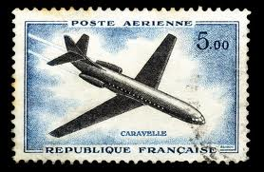](http://www.google.com/imgres?q=market+in+france&start=99&um=1&hl=en&safe=active&sa=N&biw=1280&bih=693&tbm=isch&tbnid=Myy2BJvFuU2moM:&imgrefurl=http://www.tnooz.com/2011/12/14/data/groupon-enters-top-ten-top-france-travel-sites-december-10-2011/&docid=3RMTw_VzLTsXmM&imgurl=http://www.tnooz.com/wp-content/uploads/2011/12/france-site-data-new.jpg&w=500&h=326&ei=bo5nT5-QLYTn0QHIqsXoCA&zoom=1) Nom_______________________________

Nom de Classe_____________________

[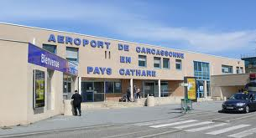](http://www.google.com/imgres?q=aeroport&start=95&um=1&hl=en&safe=active&biw=1280&bih=693&tbm=isch&tbnid=7fMG3BSpf1SB0M:&imgrefurl=http://languedoc.frenchestateagents.com/&docid=tVHFqhrEsTzaAM&imgurl=http://languedoc.frenchestateagents.com/wp-content/uploads/2012/01/Carcassonne_aeroport_Salveza2.jpg&w=800&h=435&ei=q45nT8nFOaTl0QGugoDrCA&zoom=1)

[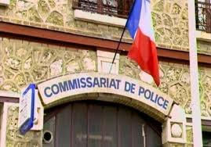](http://www.google.com/imgres?q=commissariat&um=1&hl=en&safe=active&sa=X&biw=1280&bih=693&tbm=isch&tbnid=hGklLpj9-rPCCM:&imgrefurl=http://hurlu7700.wordpress.com/2011/05/30/au-commissariat-de-son-quartier-un-homme-declare-qu-on-lui-a-vole-sa/&docid=fcVHx0pcsVXACM&imgurl=http://hurlu7700.files.wordpress.com/2011/05/devanture-commissariat-clairieres-1038644a472.jpg&w=570&h=398&ei=go9nT8yLJcPw0gGAv6jBCQ&zoom=1) [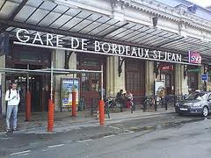](http://www.google.com/imgres?q=gare&um=1&hl=en&safe=active&biw=1280&bih=693&tbm=isch&tbnid=lrtzx3J4o3U1cM:&imgrefurl=http://en.wikipedia.org/wiki/Gare_de_Bordeaux-Saint-Jean&docid=XiSkWwQiOkbFGM&imgurl=http://upload.wikimedia.org/wikipedia/commons/thumb/4/45/Gare-st-jean-bordeaux-france.jpg/300px-Gare-st-jean-bordeaux-france.jpg&w=300&h=225&ei=q49nT6viMsXz0gHc26iSCA&zoom=1)

[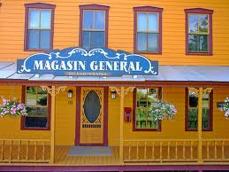](http://www.google.com/imgres?q=magasin+general&um=1&hl=en&safe=active&biw=1280&bih=693&tbm=isch&tbnid=tPWyPr94JzGfgM:&imgrefurl=http://www.flickr.com/photos/adhour/2094523715/&docid=-igqouvydydNXM&imgurl=http://farm3.staticflickr.com/2249/2094523715_7699dbe4ec_z.jpg&w=640&h=480&ei=XJBnT53cI-fj0QGH08y4CA&zoom=1)

Révision des Sports

les sports ____the sports______ le tennis __tennis __________

le hockey ____hockey________ le baseball ___baseball________

le volley ____volleyball______ le golf ___golf____________

la course ____track__________ le basket ___basketball______

le ping pong____ping pong______ le ski ___skiing__________

la natation ___swimming_______ le foot ___soccer__________

le football américain le cyclisme ___biking_________

___football _________ le skateboarding_skateboarding_

l'equitation ___horseback riding__

Révision des Activités

faire un voyage__to take a trip_______ faire du camping__to go camping__

faire du ski ____to go skiing__________ faire un match____to play a game___

faire du vélo___to go biking___________ faire du shopping__to go shopping__

faire une promenade__to take a walk__ nager ___to swim_____________

skier ___to ski ________________ jouer aux cartes_to play cards______

jouer aux échecs__to play chess______ jouer aux dames__to play checkers__

jouer les jeux vidéo_to play videogames jouer les jeux d'ordinateur

patiner _to skate_________________ _to play computer games

lire __to read__________________ aller à la pêche__to go fishing_____

Révision des Endroits

l'endroit ____the place________ le gymnase ___the gymnasium___

la rivière ____the river________ le théatre ___the theater_______

le cinéma ____the cinema______ le terrain ___the field__________

la montagne___the mountain____ la plage ___the beach__________

la bibliothèque__the library_____ le parc ___the park __________

le lac ___the lake__________ la campagne___the country________

le musée ___the museum_______ la piscine ____the pool __________

la maison ___the house________ le centre commercial__the mall____

la pharmacie___the pharmacy____

le stade ____the stadium_____

1.

**Les Nouveaux Endroits**

la place ____the place_________ l'hôtel ___the hotel _________

l'église ____the church________ l'aéroport ___the airport________

le supermarché__the supermarket la banque ___the bank _________

le bureau ___the office _________ l'université___the university_____

le lycée __the high school_____ le zoo ___the zoo ___________

le magasin __the store __________ le commissariat the police station

la gare __the train station___ le fleuve __the river____________

le quartier __the neighborhood___ l'endroit __the place ___________

le grand magasin_the department store la poste __the post office_____

le centre ville_downtown _______ le petit village __the small town___

le lieu __the place __________ l’office de tourisme _the tourism office

le parc d’attractions la grande ville _the big city ___

__the amusement park __________ la crémerie __the dairy shop _____

la confisserie__the candy shop___ la boucherie__the butcher shop___

l'épicerie the (small) grocery store

la boulangerie__the bakery _____ la charcuterie__the deli __________

la librairie the bookstore (only books) la papeterie__the bookstore ______

**Aller**

aller____to go_____________

je ___vais____________ nous ___allons__________

tu ___vas______________ vous ___allez___________

il, elle, on__va____________ ils, elles__vont__________

Aller + infinitive ___________________________________________________

Je vais nager à la piscine. ________________________________________________

**2.**

**Related Expressions**

Tu veux...? _____Do you want….? _____________________

Je veux.... _____I want ….. ___________________________

Tu peux...? _____Can you….?___________________________

Je peux... _____I can … _______________________________

avec moi ___with me________ avec toi ___with you_________

C’est fermé._____It’s closed.______________

C’est ouvert.____It’s open.________________

allons ____Let’s go____________________

**à + definite article**

à la au aux

**de + definite article**

de la du des

**Les Verbes Irréguliers**

boire ___to drink__________

je ___bois_____________ nous __buvons__________

tu ___bois_____________ vous __buvez____________

il, elle, on__boit___________ ils, elles__boivent________

-----------------------------------------------------------------------------------------------------------------------------------------

vouloir__to want________

je ___veux_____________ nous __voulons_________

tu ___veux_____________ vous __voulez__________

il, elle, on__veut__________ ils, elles__veulent________

3.

prendre__to order, to take

je __prends____________ nous ___prenons________

tu __prends____________ vous ___prenez_________

il, elle, on___prend________ ils, elles__prennent______

--------------------------------------------------------------------------------------------------------------------

pouvoir__to be able to____

je ___peux____________ nous __pouvons________

tu ___peux____________ vous __pouvez__________

il, elle, on__peut_________ ils, elles__peuvent_______

-------------------------------------------------------------------------------------------------------------------- devoir___to must, to ought to

je ___dois____________ nous ___devons_________

tu ___dois_____________ vous ___devez__________

il, elle, on__doit__________ ils, elles__doivent_______

---------------------------------------------------------------------------------------------------------------------------------------------

venir___to come__________

je __viens____________ nous __venons_________

tu __viens____________ vous ___venez___________

il, elle, on___vient_______ ils, elles__viennent_______

**Les Prépositions**

dans ___in___________ à côté de __next to _______

sur ___on_top of____ à gauche de __to the left of__

sous ___under________ à droite de __to the right of_

devant ___in front of____ entre __between_______

derrière ___behind_______ en face de __facing_____

autour de ___around______

4.

**More regular *ER Verbes**

arriver __to arrive______ rester __to remain, to stay

rentrer __to return______

**rester**

je ___reste__________ nous __restons_________

tu ___restes__________ vous __restez___________

il, elle, on__reste________ ils, elles__restent_______

**À La Poste**

la lettre ___the letter__________ le paquet ___the package_______

par avion ___air mail__________ la télécarte ____the phone card___

l'envelope ___the envelope______ le timbre ___the stamp________

envoyer ___to send ___________ recevoir ___to receive ________

la carte postale __the post card____

**Les Moyens de Transport**

la voiture ___the car____________ l’avion ___the plane__________

le taxi ___the taxi____________ le train ___the train__________

l’autobus ____the bus___________ le camion ___the truck__________

le vélo ____the bicycle________ la bicyclette___the bicycle________

la moto ___the motorcycle_____ le métro ___the subway________

le pied ___the foot____________ le bateau ___the boat___________

les moyens de transport _____the means of transportation_____________

en + transport (except à pied & à vélo)

5.

**Les Directions**

C'est loin. _____It’s far.__________ C'est près. ___It’s close by.______

allez _____go ______________ tournez ___turn______________

prenez _____take____________ continuez ___continue__________

la carte _____the map_________ tout droit ___straight___________

à gauche _____t0 the left_______ à droite ___to the right________

la rue _____the street_______ l'avenue ___the avenue________

le pays _____the country_____ l'état ___the state__________

la ville _____the city_________ le village ___the town__________

Où est...? _____Where is? _______ Je suis perdu.___I am lost.________

Aide-moi! _____Help me!________ Où vas-tu? _Where are you going?

Allons-y! _____Let’s go!_________ Vas-y! _____Let’s go!_______

nord _____north ___________ sud _____south___________

est ______east____________ ouest _____west____________

le plan ___the map/itinerary_

nord

ouest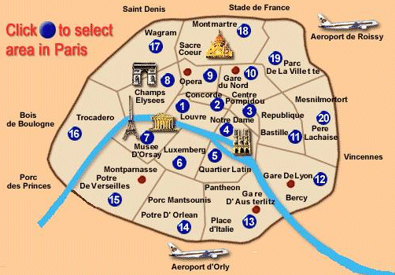est

sur

[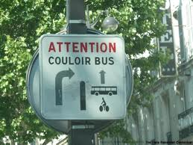](http://www.google.com/imgres?q=street+signs+in+france&start=85&um=1&hl=en&safe=active&biw=1280&bih=693&tbm=isch&tbnid=-DksUrX7I6hDOM:&imgrefurl=http://www.paris-savannah.com/tag/france/&docid=38vSv-6LaHGKjM&imgurl=http://www.paris-savannah.com/wp-content/gallery/signs/the-sign.jpg&w=800&h=600&ei=V4VnT-r0OYXw0gGCxNTHCA&zoom=1)[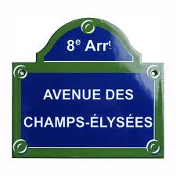](http://www.google.com/imgres?q=street+signs+in+france&um=1&hl=en&safe=active&biw=1280&bih=693&tbm=isch&tbnid=pqu7R9PfNv75zM:&imgrefurl=http://www.souvenirsofparis.com/french-enamel-signs/avenue-des-champs-elysees-enamel-street-sign-158.html&docid=NK_IZNn12BH8LM&imgurl=http://www.souvenirsofparis.com/images_finales/street-signs/avenue-champs-elysees.jpg&w=450&h=450&ei=NoVnT_3IHcHm0QGg15SdCA&zoom=1)[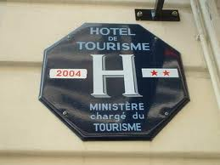](http://www.google.com/imgres?q=street+signs+in+france&um=1&hl=en&safe=active&biw=1280&bih=693&tbm=isch&tbnid=a-i6y11r5nFrOM:&imgrefurl=http://gofrance.about.com/b/2008/08/13/learn-french-street-signs.htm&docid=YcCQgECU_ENMlM&imgurl=http://z.about.com/d/gofrance/1/5/9/E/hotel-sign-france.jpg&w=400&h=300&ei=NoVnT_3IHcHm0QGg15SdCA&zoom=1)

**6.**

**Useful French Phrases**

*Il y a un accident.*  
There is an accident.

*La limite de vitesse est 90 km.*  
The speed limit is 90 km.

*Le rond point est sur la gauche.*  
The roundabout is on the left.

[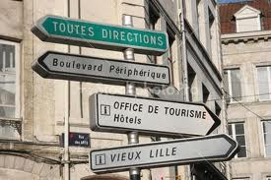](http://www.google.com/imgres?q=street+signs+in+france&um=1&hl=en&safe=active&biw=1280&bih=693&tbm=isch&tbnid=1q3W9F59cgMtJM:&imgrefurl=http://www.stockphotopro.com/photo_of/Lille/AM12J4/Street_signs_Lille_France&docid=WK5zHNW7KoLViM&itg=1&imgurl=http://www.stockphotopro.com/photo-thumbs-2/AM12J4.jpg&w=450&h=300&ei=NoVnT_3IHcHm0QGg15SdCA&zoom=1) [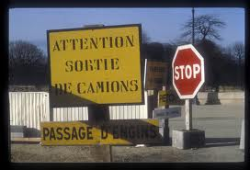](http://www.google.com/imgres?q=driving+signs+in+france&um=1&hl=en&safe=active&biw=1280&bih=693&tbm=isch&tbnid=jvFaAJeCfyI9UM:&imgrefurl=http://www.earthphotos.com/Countries/France/4263972_6WpTpj/3/336504697_ggLUX&docid=E6upIXiGx5cEmM&imgurl=http://www.earthphotos.com/Countries/France/France001/336504697_ggLUX-L.jpg&w=800&h=546&ei=a4ZnT7q1CYrl0QGTtvyfCA&zoom=1) [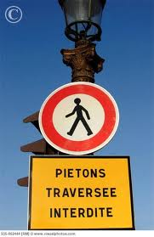](http://www.google.com/imgres?q=driving+signs+in+france&um=1&hl=en&safe=active&biw=1280&bih=693&tbm=isch&tbnid=g4jf0IWdqity7M:&imgrefurl=http://www.visualphotos.com/image/1x7622084/traffic_signs_on_a_lump_post_in_place_de_la&docid=2wpDSpDc-Wzw8M&imgurl=http://www.visualphotos.com/photo/1x7622084/traffic_signs_on_a_lump_post_in_place_de_la_s35-662444.jpg&w=466&h=720&ei=a4ZnT7q1CYrl0QGTtvyfCA&zoom=1)

**La Place**

A town square is an open area in the middle of a village or town. Large cities may have several such squares, and over time as a city expands, a town square may shift to a location other than the center geographically, although it remains the heart of the town psychologically. Town squares usually become the hub of the community, with numerous groups taking advantage of the open space to hold events which can vary from political rallies to concerts. Visitors often enjoy visiting the town square as well, to get a taste for the community.

The tradition of creating a common open space in a town is ancient, as has been discovered on numerous archaeological digs. The Romans, for example, had the forum, a space which was often designated for political activities such as debates.

[**Suggest Edits**](http://www.wisegeek.com/what-is-a-town-square.htm#suggestEditForm)

Town squares are known by a number of alternate names. In France, a town square is a *place*, while Italians prefer *piazza*. You may also hear a town square referred to as a market square, city square, public square, or a civic center. A typical town square has some landscaping, especially around the edges and the middle, along with a statue or two and possibly fountains, trees, and other amenities.

**7.**

Sometimes, civic institutions such as a city hall, courthouse, etc are located on the edges of a town square; Civic Center in San Francisco, for example, is laid out in front of City Hall. In other cases, a town square is simply surrounded by local shops offering a variety of items. In fair weather, vendors may also set up in the square for farmers' markets and other marketing events. Historically, town squares were used for open-air executions and gibbeting, although these practices are much less common today.

[**Suggest Edits**](http://www.wisegeek.com/what-is-a-town-square.htm#suggestEditForm)

Some notable town squares around the world include Times Square in New York, Red Square in Moscow, and Trafalgar Square in [London](http://www.wisegeek.com/what-is-somerset-house-london.htm). Many communities greatly value their town squares, appreciating the open space and the opportunities it provides to hold events and interact with other residents of the town. As a general rule, town squares are controlled by city hall, with public works being responsible for keeping the square in order, and people who wish to hold events at a town square must apply to city hall for a permit.

(<http://www.wisegeek.com/what-is-a-town-square.htm>)

**Public Squares of Paris**

**Paris is known for its majestic squares, often with tall monuments at the center and lined with grand buildings. The city's most famous squares, inluding the** [**Place de la Concorde**](http://www.aviewoncities.com/paris/placedelaconcorde.htm) **and** [**Place des Vosges**](http://www.aviewoncities.com/paris/placedesvosges.htm)**, are located in the historic center.  
  
Below is an overview of some of the most famous and/or interesting public squares in Paris, listed in alphabetical order. You can move the mouse over the map on the right to see where they are located.**

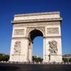

|  |  |
| --- | --- |
| **Place Charles de Gaulle** |  |

Until the death of former president Charles de Gaulle this square was aptly named l'Etoile (star) as twelve avenues radiate from the square, often resulting in traffic chaos. At the center is the [Arc de Triomphe](http://www.aviewoncities.com/paris/arcdetriomphe.htm), which can be accessed via an underground tunnel. One of the streets leading to the square is the famous [Champs-Elysées](http://www.aviewoncities.com/paris/champselysees.htm).

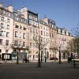

|  |  |
| --- | --- |
| **Place Dauphine** |  |

The Place Dauphine is a quiet public square which, despite being located on the [Île de la Cité](http://www.aviewoncities.com/paris/iledelacite.htm) near famous landmarks such as the [Pont Neuf](http://www.aviewoncities.com/paris/pontneuf.htm), [Sainte Chapelle](http://www.aviewoncities.com/paris/saintechapelle.htm) and [Notre Dame](http://www.aviewoncities.com/paris/notredame.htm), has kept a low-key character. The triangular shaped square was laid out in the early 17th century and is one of the oldest in Paris.

**8.**

|  |  |
| --- | --- |
| Place de Furstenberg **Place de Furstenberg** |  |
|  |  |

Tiny Place de Furstenberg, in the attractive Saint-Germain-des-Prés quarter, is one of the most romantic squares in Paris. Eugène Delacroix lived in an apartment at the Place de Furstenberg until his death in 1863. His apartment is now home to the Musée Delacroix, a museum dedicated to the artist.

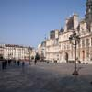

|  |  |
| --- | --- |
| **Place de l'Hôtel de Ville** |  |

This square in front of the city hall was originally named Place de Grève, rougly translatable as 'sandy beach square'. It was renamed in 1830 to Place de l'Hôtel de Ville, for the [city hall](http://www.aviewoncities.com/paris/hoteldeville.htm) that dominates the square. Once the site of public executions, the pedestrianized square now regularly hosts events; depending on the time of the year you can find an ice rink or even a volleyball beach.

[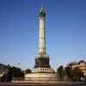](http://www.aviewoncities.com/paris/placedelabastille.htm)

|  |  |
| --- | --- |
| [**Place de la Bastille**](http://www.aviewoncities.com/paris/placedelabastille.htm) |  |

Nothing is left of the bastille fortress after which the square is named. Originally built to protect Paris and later turned into a prison, it was destroyed during the French Revolution. The column at the center of the square commemmorates another revolution in 1830.

**DRIVING IN FRANCE**

The minimum driving age is 18 for most categories of vehicles. Learner drivers must be 18 before they can pass the practical driving test for cars.

***Mopeds***

A moped or scooter up to 50cc must be registered and have certain certificates displayed:

* If the driver is between 14 and 16 years of age, they must participate in a seven-hour training course to obtain a license.
* A certificate of insurance stating: the name of the insurance company, the identification number of the insurance holder and the engine number of the vehicle
* The proof of insurance certificate

**9.**

***Microcars***

Microcars (also known as *voiturettes* or *quadricycles*) require a license. This is available after a seven-hour training course to drivers over 16 years old. Microcars have:

* a maximum of two seats, an engine size up to 50cc (petrol engines)
* a maximum power of 1 KW (electric cars) or 4 KW (other forms of propulsion, including diesel)
* a maximum speed of 45 Km/h, a maximum unladen kerb weight of 350 Kg
* a maximum load capacity of 200 Kg

***Motorcycles***

Motorbikes of 50cc to 125cc require a licence, obtainable from the age of 16.

[***http://brittany.angloinfo.com/information/transport/driving-licences/french-driving-licences/***](http://brittany.angloinfo.com/information/transport/driving-licences/french-driving-licences/)

---------------------------------------------------------------------------------------------------------------------- **French Street Names**

French street names are traditionally displayed printed in white on blue panels, attached to buildings or walls near the street corners.

In Paris and Lyon, cities which have “arrondissements” or numbered suburbs, they indicate which “arrondissement” or district of the city are in. This one is in the 6th “arrondissement” of Paris.

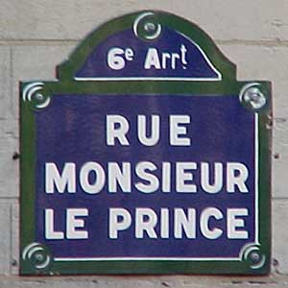

**Origins of the street names**

The street names have their derivation from a variety of sources: They may be blatantly patriotic, for example: Rue de la République, Place de la Libération, or Boulevard de la Paix.

**10.**

They may commemorate local history, or people who died for the country. Street names may relate to an important historical event, or even dates.

* Boulevard du quatorze juillet (Storming of the Bastille - French National Day)
* Rue de la Révolution
* Rue du huit mai (Victory in Europe after World War II)
* Avenue du onze novembre (Armistice Day, end of World War I)
* Place du six juin (D Day)

Some streets may have a traditional name, handed down over centuries. These names related to who lived, or what took place in the streets, or a dominant feature:

* rue des petits puits - lots of little wells in this street
* cour de corbeau - crows must have been a nuisance
* rue des juifs - laws in the Middle Ages forced all Jewish people to live in the same street.

Other streets commemorate a famous person (political, artist, writer, scientist etc) Here are some people who can be found in just about every French town.

* Place [**Victor Hugo**](http://www.caloundracity.asn.au/Francofiles/famous_people/hugo.htm)(France's greatest writer; Hugo wrote plays, poetry, books (The Hunch Back of Notre Dame, Les Misérables) and even found time to be a prominent politician.
* Boulevard Jean Jaurès   
  (M. Jaurès was a socialist politician who was assassinated for his political views at the outbreak of World War I)
* Rue Jules Ferry  
  (He was the first Minister of Education who established free primary schooling in the 1870s. Many thouroughfares bearing his name are near schools).

Street names may relate to an important building or place in the street. Often the names of these streets date back hundreds of years.

* Place de la Gare,
* Avenue de l’Église,
* Rue du Marché

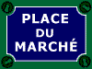

[*http://www.caloundracity.asn.au/Francofiles/larue/noms_des_rues.html*](http://www.caloundracity.asn.au/Francofiles/larue/noms_des_rues.html)

**11.**