Name: _________________ Date: _____________ Period: _______

**TBB and Water Quick Check**

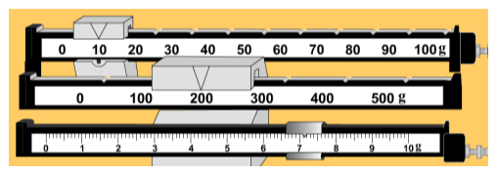

1.

2. What 3 states of matter can water be in? ____________, ____________, ________

3. What is the solid form called? ____________

4. What percent of the Earth is FRESH water? ____%

5. What is the continuous movement of water through the living and non-living parts of the environment called? The ________________ ______________

6. What is the chemical formula for water: _________

Explain what this means: __________________________________________

7. They call water the “ _____________ _________________ because it can dissolve many substances

8. Water freezes at _______oC and __________oF

9. Water boils at _______oC and __________oF