Las vacaciones y el tiempo libre

El paquete de tarea

Me llamo_____________________

Base y Clase: _________________

C:\Users\JHrcak\AppData\Local\Microsoft\Windows\Temporary Internet Files\Content.IE5\7DCYNL4D\MC900446334[1].wmf C:\Users\JHrcak\AppData\Local\Microsoft\Windows\Temporary Internet Files\Content.IE5\ESKDUZ6Q\MC900446354[1].wmf

**Español 8 Unidad 12 Fecha: _______________________**

**Actividades y el equipo deportivo**

1.

**Match the following activities with the corresponding items in the box, and write a sentence with each pair. Follow the model.**

el traje de baño la tabla a vela la tabla de surf arena

el velero el frisbi la red los remos el monoesquí

el protector solar los esquís ~~el esnórquel~~

1. bucear Para bucear necesito el esnórquel.
2. navegar ________________________________________________
3. nadar __________________________________________________
4. tomar el sol _____________________________________________
5. jugar al voleibol _________________________________________
6. remar __________________________________________________
7. hacer el esquí acuático ____________________________________
8. hacer surf _______________________________________________
9. jugar al frisbi ____________________________________________
10. hacer tabla a vela _________________________________________
11. hacer monoesquí _________________________________________
12. jugar con la arena ________________________________________

**¿Qué es?**

2.

**Write the correct word or phrase for each definition.**

1. Si quieres patinar sobre hielo necesitas dos. los patines
2. Son para tus ojos cuando hace sol. ______________________________

1

1

1

1

1. Para practicar este departe necesitas la nieve y el monoesquí. __________
2. Es una piscina natural en las montañas. ___________________________
3. Para practicar este deporte necesitas un velero. _____________________
4. Se llaman el Atlántico y el Pacífico. _____________________________

3.

**Write the correct article for each noun.**

1. las aletas 5. _______ lentes de sol 9. _______ piscina
2. ______esquís 6. _______ protector solar 10. ______océano
3. ______sombrilla 7. _______toalla 11. ______ ríos
4. ______ bote 8. _______ mar 12. ______ frisbi

4.

**¿Qué te gusta hacer en vacación?**

**Write sentences saying what you like to do on vacation.**

1. Me gusta nadar.
2. **_________________________________________________________**
3. **_________________________________________________________**
4. **_________________________________________________________**

**Write sentences saying which water or winter sports you do not know how to do.**

1. No sé hacer tabla a vela.
2. **_________________________________________________________**
3. **_________________________________________________________**
4. **_________________________________________________________**

**Write sentences saying which water or winter sports you want to learn how to do.**

1. Quiero aprender a navegar.
2. **_________________________________________________________**
3. **_________________________________________________________**

**4. _________________________________________________________**

2

**¿Qué quieres hacer en vacación?**

5.

**Using the verb *querer*, write sentences saying whether or not the people listed below want to do the following activities.**

1. Ella / hacer tabla a vela

Ella no quiere hacer tabla a vela.

1. Andrés y sus amigos / jugar con la arena

_______________________________________________________

1. Yo / navegar en el lago ________________________________________________________
2. Luisa y yo / hacer surf ________________________________________________________
3. Juan / tomar el sol

________________________________________________________

1. Mis hermanas / patinar sobre hielo _________________________________________________________

**¡Hay bendito!**

6.

**Rearrange the words listed below, and use the appropriate form of *querer* to write a complete sentence.**

1. querer / yo / en el río / nadar

Yo quiero nadar en el río.

1. Marta / aprender a / querer / hacer tabla a vela

_______________________________________________________

1. tomar el sol / querer / ella / sus amigos / pero / querer / hacer jet ski

________________________________________________________

1. hacer tabla a vela / yo / ¡Me encanta! / querer / todo el día ________________________________________________________
2. mis primos y yo / jugar al frisbi / querer

________________________________________________________

1. querer / el sábado / nosotros / esquiar _________________________________________________________

3

**¿Qué llevas a la playa?**

7.

**Put the words below into one of three categories and write the correct article for each noun.**

pelota sándwich refresco esquís limonada toalla

cámara lentes de sol manzana gorra esnórquel taco

red el protector solar peine libro papas fritas dinero

jugo frisbi helado revista máscara de bucear

**Things you carry in your *mochila***

__________________________________________________________________________________________________________________________________________________________________

**Foods you can buy or bring**

__________________________________________________________________________________________________________________________________________________________________

**Sports equipment**

__________________________________________________________________________________________________________________________________________________________________

**¿Qué opinas?**

8.

**Complete each sentence with the correct from of the appropriate adjective/expression from the list.**

**1.** El mar es transparente .

* ideal
* peligroso
* ~~transparente~~
* delicioso
* favorito
* ¡Ay bandito!
* chévere
* ¡Ayúdame!
* bastante bien

**2.** La temperatura es ____________________.

**3.** ¡_________________! ¡No tengo mi traje de baño!

**4.** Hacer surf es una actividad un poco ____________.

**5**. En Puerto Rico, las frutas son _________________.

**6**. Nadar es mi deporte _________________________.

**7**. Yo puedo jugar al voleibol ___________________.

**8**. ¡___________________! ¡No puedo nadar!

4

C:\Documents and Settings\RLOFTUS\Local Settings\Temporary Internet Files\Content.IE5\WHAZG92V\dglxasset[2].aspx

C:\Documents and Settings\RLOFTUS\Local Settings\Temporary Internet Files\Content.IE5\JY5FX1G6\dglxasset[1].aspx

**El tiempo**

**Actividad A: Match the English meaning with the Spanish word. Write in capital letters. Not all of the choices will be used.**

1. ________ la lluvia A. sun X. degrees
2. ________ Hace fresco. B. snow Y. It is hot out.
3. ________ Va a llover. C. clouds Z. temperature
4. ________ Hace buen tiempo. D. fall
5. ________ el verano E. It is nice out.
6. ________ el sol F. autumn
7. ________ la temperatura G. spring
8. ________ Hace frío. H. the seasons
9. ________ el huracán I. It is bad out.
10. ________ la tormenta J. rain
11. ________ las nubes K. It’s going to snow.
12. ________ Hace calor. L. It is cloudy.
13. ________ los grados M. It is raining.
14. ________ Nieva. N. It is cool out.
15. ________ el otoño O. winter
16. ________ la nieva P. It’s going to rain.
17. ________ la primavera Q. It is windy.
18. ________ el invierno R. There are showers.
19. ________ Llueve. S. summer
20. ________ las estaciones T. hurricane
21. ________ Hace viento. U. It is cold out.
22. ________ Va a nevar. V. It is snowing.
23. ________ Hace mal tiempo. W. storm

5

**Actividad B: Answer each question in a complete Spanish sentence.**

1. ¿Qué tiempo hace hoy? ______________________________________________
2. ¿Qué tiempo hace en el invierno? _______________________________________
3. ¿Qué tiempo hace en la primavera? _____________________________________
4. ¿Qué tiempo hace en el verano ? ________________________________________
5. ¿Qué tiempo hace en el otoño? ________________________________________
6. ¿Cuál es la temperatura? _____________________________________________

C:\Documents and Settings\RLOFTUS\Local Settings\Temporary Internet Files\Content.IE5\GV1RIYFT\MC900235377[1].wmf

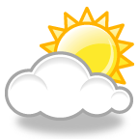

C:\Users\Owner\AppData\Local\Microsoft\Windows\Temporary Internet Files\Content.IE5\HYM7C0FV\MC900232180[1].wmf

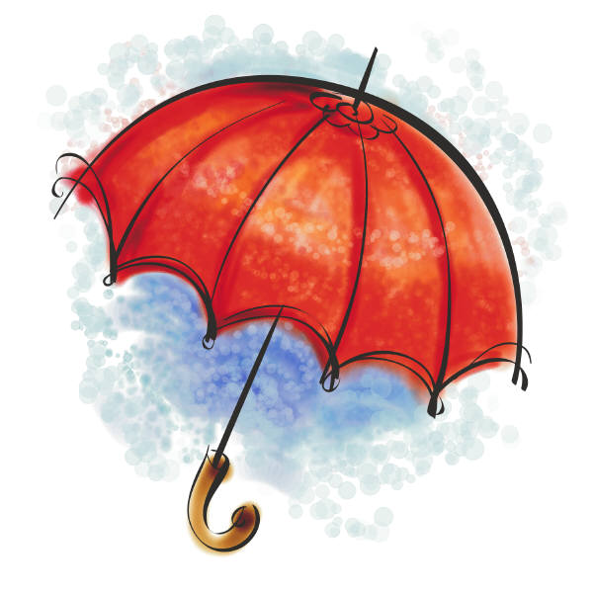

**Actividad C: Escriban en español**.

1. What is the weather like? ________________________________________
2. It is nice out. _________________________________________________
3. It is bad out. _________________________________________________
4. It is cloudy. __________________________________________________
5. There are storms. ______________________________________________
6. There are showers (*lluvias*). _______________________________________
7. There is a hurricane. ____________________________________________
8. in spring _____________________________________________________
9. in summer ____________________________________________________
10. in fall _______________________________________________________
11. in winter _____________________________________________________
12. What is the temperature? ________________________________________
13. It is cool out. _________________________________________________
14. It is sunny. ___________________________________________________
15. It is windy. ___________________________________________________
16. It is raining. __________________________________________________
17. It is going to rain. ______________________________________________
18. It is snowing. _________________________________________________
19. It is going to snow. ___________________________________________

6

**El Tiempo: NOW & LATER**

j0293828

Happening NOW: GOING to Happen:

(present) (future)

Llueve. Va a llover.

___________________ ___________________

MCj04124640000[1]

Nieva. Va a nevar.

___________________ ___________________

Hace frío. Va a hacer frío.

___________________ ___________________

MCj04136240000[1]

Hace calor. ___________________

___________________ ___________________

Hace fresco. ___________________

C:\Documents and Settings\RLOFTUS\Local Settings\Temporary Internet Files\Content.IE5\JY5FX1G6\MCj04127480000[1].wmf

___________________ ___________________

___________________ Va a hacer viento.

___________________ ___________________

C:\Users\Owner\AppData\Local\Microsoft\Windows\Temporary Internet Files\Content.IE5\1XYQXJ6C\MC900233094[1].wmf

Hace sol. ___________________

___________________ ___________________

Hace buen tiempo. ___________________

___________________ ___________________

C:\Documents and Settings\RLOFTUS\Local Settings\Temporary Internet Files\Content.IE5\CNAX6F49\MCj04244840000[1].wmf

___________________ Va a hacer mal tiempo.

*Está nublado. ___________________

7

___________________ ___________________

*PROYECTO: ¿CÓMO TE AFECTA EL TIEMPO?*

**Follow the directions below in order to show how the weather affects you in each season.**

1. Fold a plain piece of white paper into quarters.

**Write out the following information in Spanish!!**

2. Write the name of each season in the top center of each square.

3. Describe the weather in each season in at least 2 ways in a complete sentence. You may want to use the phrases *a veces, nunca, siempre* and *todos los días*.

4. Advise the reader of what s/he should wear/use for the weather in each season.

5. Write one complete sentence stating what you like to do in each season (use *a mí*....).

6. Draw a picture to illustrate each season.

**Open your textbook to page 381. Answer the following questions in English:**

1. What can you learn at the *Flor del mar* school? _______________________________
2. Where is the school located?_________________________________________
3. How many classes do you need to take in order to learn?__________________
4. What can you see in the sea? _____________________________________________
5. This is described as a ______________ and ________________ sport that allows you to _____________________________________ in a fantastic place.
6. What is the number you should call for more information? ________________
7. What are the hand signals for? ____________________________________________
8. Draw the hand signal for “Danger!” 9. Draw the hand signal for “Stop”.

**Open your textbook to page 390, 391 and read about a vacation in Perú.**

8

**Español 8 Unidad 12 Fecha: ______________________**



**ESTACIONES INVERSAS**

Es el mes de diciembre. En España es el invierno. La gente va a las montañas a esquiar y practicar el monoesquí. En la Argentina y Chile, la gente va a la playa a nadar. ¿Cómo es que nadan en diciembre? ¿No hace demasiado frío? Pues, el mes de diciembre es verano en la Argentina y Chile. En el hemisferio sur las estaciones son inversas de las estaciones del hemisferio norte.

**Contestan las preguntas siguientes in inglés.**

1. In December, what season is it in Spain? ___________________

2. Name two activities people in Spain do in December.

3. What do people in Argentina and Chile do in December?

___________________________________________________

4. In December, what season is it in Chile? ___________________

5. What is the main idea of this reading passage? _________________________________________________________________________________________________________________________________________________________

9

Español 8 Unidad 12 Fecha ___________________________

**Una tarjeta postal para tu maestra**

***Writing a post card***

**Write a postcard in Spanish, from a Spanish-speaking country of your choice, to your FL teacher. You must include:**

* Date and city you are writing from
* A greeting (Dear Señora,)
* A closing and your signature

**You may include:**

* What the weather is like there
* Places you visited while on vacation
* Sports or other activities you participated in (water or snow) while on vacation on different days
* Foods you ate
* Your opinions

**Be sure to write out the address. You will send the post card to the school.**

**The body of the note must be at least 50 words.**

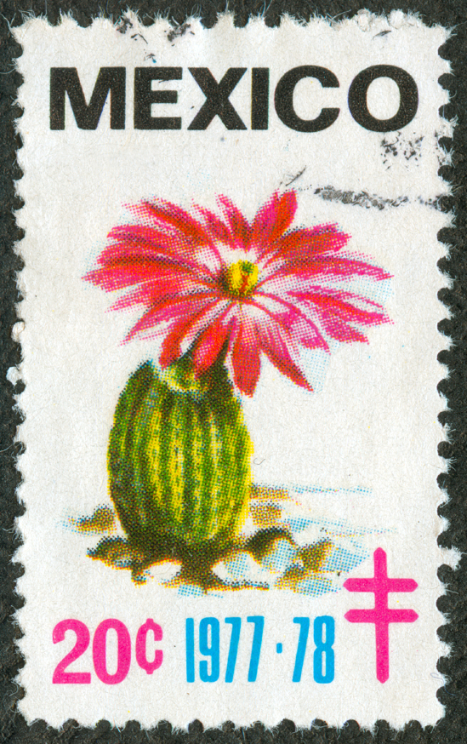

_____________________

_____________________,

_________________________________

_________________________________

_________________________________

_________________________________

_________________________________

_________________________________

_________________________________

_____________________,

_____________________

Sra. Hrcak

Orchard Park Middle School

_____________________

_____________________

_____________________

10

**Weather forecast website. Read and answer the questions below.**

**El Tiempo en Houston Texas**

**HOY** - el 15 de abril

Parcialmente Nublado  
59° F / 13.5°C

Temperatura real: 59° F / 13.5° C

Humedad: 57%  
Vientos: 0.0 mph / 0.0 kph CM  
Presion: 30.01 pulgadas  
Visibilidad: 10.00 millas

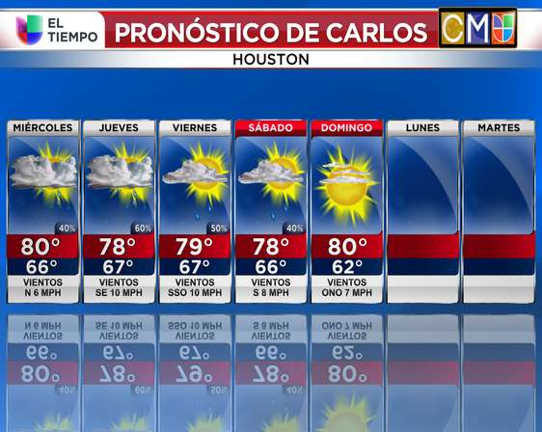

Contestan las preguntas en español.

1. ¿Qué tiempo hace el viernes?_____________________________

2. ¿Cuál es la temperatura máxima el domingo?_________________

3. En inglés, ¿Qué es *parcialmente nublado*?____________________

4. ¿Va a hacer sol el sábado?_________________________________

11.

**Weather forecast website. Read and answer the questions below.**

|  |
| --- |
| Condiciones Actuales en San Antonio, TX |
| http://s.univision.com/www/fsync/clima/12.png |

Hoy - el 15 de abril

Parcialmente Nublado  
 61° F / 14.5°C

Temperatura real: 61° F / 14.5° C

Humedad: 51%  
 Vientos: 3.0 mph / 4.8 kph NE  
 Presion: 29.98 pulgadas  
 Visibilidad: 10.00 millas

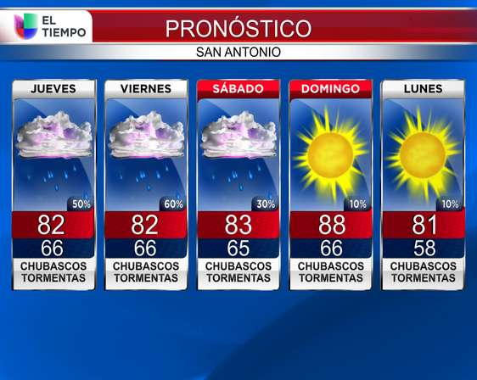

**Contestan en español**.

1. ¿Qué tiempo hace hoy?____________________________________

2. ¿Qué va a llover el viernes?_________________________________

3. ¿Cuál es la temperatura mínima el lunes?

_______________________________________________________

4. ¿ ¿En que día es lo más posible tener la lluvia?

________________________________________________________

5. ¿Para qué ciudad y estado es el pronóstico del tiempo?

________________________________________________________

12.

**This is a website used to find types of TV programs. Read and answer the questions below.**

[Programación](http://www.entutele.com/programacion/tv-abierta/)  [Canales](http://www.entutele.com/canales/tv-abierta)  [Programas](http://www.entutele.com/programas/tv-abierta)  [Apps](http://www.entutele.com/apps) [Entutele en Twitter](http://twitter.com/entutele) [Entutele en Facebook](http://www.facebook.com/entutele)

**Programas del día en Tu Tele**

**Elige tu proveedor:**

**Categoría de Programas**

* [Concursos](http://www.entutele.com/recomendaciones)
* [Películas](http://www.entutele.com/programas/tv-abierta/peliculas/2015-04-15+14%3A00)
* [Series](http://www.entutele.com/programas/tv-abierta/series/2015-04-15+14%3A00)
* [Deportes](http://www.entutele.com/programas/tv-abierta/deportes/2015-04-15+14%3A00)
* 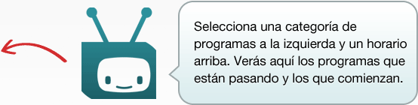[Infantiles](http://www.entutele.com/programas/tv-abierta/infantiles/2015-04-15+14%3A00)
* [Culturales](http://www.entutele.com/programas/tv-abierta/culturales/2015-04-15+14%3A00)
* [Música](http://www.entutele.com/programas/tv-abierta/musica/2015-04-15+14%3A00)
* [Noticias](http://www.entutele.com/programas/tv-abierta/noticias/2015-04-15+14%3A00)
* [Política y Negocios](http://www.entutele.com/programas/tv-abierta/politica-y-negocios/2015-04-15+14%3A00)
* [Revistas](http://www.entutele.com/programas/tv-abierta/magazine/2015-04-15+14%3A00)
* [Hogar, Salud y Cocina](http://www.entutele.com/programas/tv-abierta/hogar-salud-y-cocina/2015-04-15+14%3A00)
* [Turismo](http://www.entutele.com/programas/tv-abierta/turismo/2015-04-15+14%3A00)
* [Telenovelas](http://www.entutele.com/programas/tv-abierta/telenovelas/2015-04-15+14%3A00)
* [Dibujos Animados](http://www.entutele.com/programas/tv-abierta/humor/2015-04-15+14%3A00)
* [Educativos](http://www.entutele.com/programas/tv-abierta/variedades/2015-04-15+14%3A00)

1. What program category should you click on to find sports programs?___________________________

2. What category should you click on for movies? _____________________________________________

3. Which category should you click on for news programs?______________________________________

4. Which category should you click on for soap operas?________________________________________

5. Which category should you click on for home, health, and cooking?____________________________

6. Which category should you click on for cartoon programs?___________________________________

7. Which category should you click on for educational programs?________________________________

8. Which category should you click on for game show programs?_________________________________

13.

**Listening activity**. You are listening to the radio and hear an announcement about tonight’s T.V. programs. Write the number of the statement next to the corresponding T.V. Program.

______ **un anuncio**

______ un programa deportivo

______ las noticias

______ un documentario

**Una Entrevista**

**Ask your partner the following questions. Write their responses.**

1. ¿Cuál es tu libro favorito? __________________________________

2. ¿Qué tipo de película te gusta más? ciencia ficción? romántica? de horror?

____________________________________

3. ¿Qué tipo de programa te gusta ver más en la tele?____________________________

4. ¿Qué tipo de música prefieres más? ____________________________

5. ¿Te gusta leer las revistas? _______________________________

6. ¿Lees tú el periódico todos los días? ________________________

7. ¿Te gusta ir a los conciertos de música? _______________________________

8. ¿Cuál programa viste tú en la televisión ayer? ___________________________

9. ¿Cuál es el último libro que tú leiste? __________________________________

10. ¿Cuál es la última película que tú viste en el cine?________________________

11. ¿Qué te gusta hacer en vacación? __________________________________ 14.

Now write a paragraph about the person you interviewed based on the information you wrote down.

some helpful vocabulary:

**El/Ella le gusta** = he/she likes **El/Ella ví** = He/she saw **El/Ella leyó** = He/she read

______________________________________________________________________________________________________________________________________________________________________________________________________________________________________________________________________________________________________________________________________________________________________________________________________________________________________________________________________________________________________________________________________________________________________________________________________________________________________________________________________________________________________________________________________________________________________________

15.

* [Mi](https://www.ticketmaster.com.mx/member?tm_link=tm_ql_1)
* [A[Ubicación de Centros Ticketmaster](http://www.ticketmaster.com.mx/h/stateselecttcenters.html?tm_link=tm_ql_2)yuda](http://www.ticketmaster.com.mx/h/help.html?tm_link=tm_ql_3)

**Tres Obras de Teatro**

**Domingo**

**el primero de septiembre**

La primera obra empieza a las 13:00.

La segunda obra empieza a las 17:00.

La tercera obra empieza a las 21:00.

Desafortunadamente no detectamos el plugin de Flash en tu navegador. Para ver el contenido de este sitio necesitas instalar Flash. Para bajar la última versión, [**clic aquí**](http://www.adobe.com/products/flashplayer).

Para editar tus favoritos o personalizar tus preferencias de correo, ve a [Mi Ticketmaster](https://www.ticketmaster.com.mx/member?tm_link=).

[Política de privacidad](http://www.ticketmaster.com.mx/h/privacy.html?tm_link=).

Personaliza tus preferencias de correo electrónico y mucho más, en [Mi Ticketmaster](https://www.ticketmaster.com.mx/member?tm_link=).

La lista está sujeta a cambios sin previo aviso y no representa el orden de presentación en el evento.



**Musicales**

**Los Boletos en Venta - lunes, el 6 de agosto**

**En el Estado Municipal de Barcelona**

**Para reservar los asientos por 25є - llame: 204 23 75 98**

**-------------------------------------------------------------------------------------------------------------------------------------**

**Read the authentic document above and answer the questions below accordingly. Answer in Spanish.**

**1. ¿Dónde está la obra de teatro? __________________________________________________________**

**2. ¿En qué día se puede empezar comprar los boletos?_________________________________________**

**3. ¿Qué día de la semana empieza la obra de teatro? __________________________________________**

**4. ¿A qué hora es la primera obra? ________________________________________________________**

**5. ¿A qué hora es la segunda obra?_________________________________________________________**

**6. ¿A qué hora es la tercera obra? __________________________________________________________**

**7. ¿Cuánto cuestan los boletos reservados?___________________________________________________**

**8. ¿Cuál es la fecha de la obra de teatro? ____________________________________________________**

**9. ¿En qué ciudad está el teatro?___________________________________________________________**

**10. ¿Qué significa *El Rey León* en inglés?_____________________________________________________**

**16.**