**Historical Skills for reading, note taking, and writing**

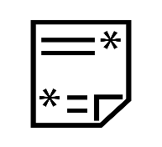**Annotate**

Annotation is the act of using symbols and notes to show what you are thinking while you read. When you annotate, you interact with the source by underlining sections of the text, circling words, phrases, or images, and writing notes to yourself in the margins.

Annotation helps the reader focus their attention when reading a source and record their thoughts as they read.

Whenever you annotate, you should have a purpose, like a question, that guides you.

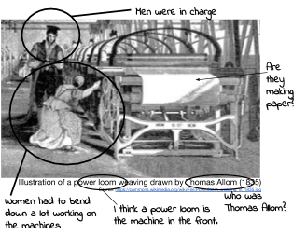**Example of annotation of an image**

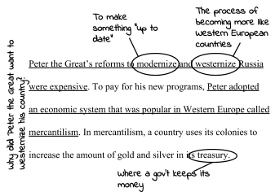

**Example of annotation of text**

 **Close Read**

Close Reading is the act of reading a source to identify the author’s argument and how he/she is making it.

When close reading, the goal is to answer questions such as:

|  |  |
| --- | --- |
| What **claims** does the author make? | What **evidence** does the author use? |
| What **language** (words, phrases, images, symbols) does the author use to persuade the document’s audience? | How does the document’s language indicate the author’s perspective? Bias? |

**Sourcing**

Sourcing is the act of determining who created a document, when the document was created, where it was created and why it was created.

Historians source in order to determine whether the document is a reliable (trustworthy) source. To source, historians ask themselves these questions whenever they investigate a source:

|  |  |  |  |  |  |  |  |  |  |  |  |  |  |  |
| --- | --- | --- | --- | --- | --- | --- | --- | --- | --- | --- | --- | --- | --- | --- |
| |  |  |  |  | | --- | --- | --- | --- | | **Who** wrote this? | **When** was it written? | **Where** was it written? | What **type of source** is this? | | **Why** was it written? | What is the author’s **perspective/**  **point of view**? | How is the **source useful**? | How is the **source not useful**? |   https://lh4.googleusercontent.com/DFJA5SiCpUqq_R34cmylgrNChANXbyLkVBNdIgOrO-8OmV7gFY62zXO7EwOQesbDEe1HbLyHQHFWlSqHLJv3M0-8A61auhFd4ifKC3sCSzY9ph-Hw8eQEA_mkiRjtTQF-GPC4ML1 **Contextualize**  **Contextualizing** a historical event is the act of describing where the event it took place, what led to it, and why.  To contextualize an event historians try to answer these questions:   |  |  | | --- | --- | | **When** did it happen? | **Where** did it happen? | | What **led** to it? | **Why** did it happen **when** and **where** it took place? | | | |
|  |  |  |

**Corroborate**

**Corroboration** is the act of comparing pieces of evidence to see where they agree or disagree.

Historians **corroborate** to understand multiple perspectives of an event to get closer to uncovering what actually happened.

|  |  |
| --- | --- |
| What do other documents say? | Do the documents **agree**? If not, why? |
| What **other documents** may clarify our understanding? | What is the **perspective** of the author of the statement? What is the author’s **bias**? |

**Constructing Arguments**

Constructing Arguments is the act of creating persuasive understandings of the past by using relevant evidence from primary and secondary sources.

**A historical argument IS NOT:**

* supported by opinions.
* made up on the spot.
* won by the person who can yell the loudest.

**A historical argument IS:**

* supported by information from reliable sources.
* researched and carefully put together.

**Historians construct arguments through claims, evidence, and reasoning/explanation.**

|  |
| --- |
| **The Components of a Historical Argument** |
| **CLAIM:** The claim is the answer to your research question or response to the prompt you are addressing. It should be based on the evidence you have collected. |
| **EVIDENCE:** Evidence is information that supports your claim. We collect evidence from sources like texts, videos, and knowledgeable people to support our reasons. |
| **REASONING/EXPLANATION:** Reasoning is the explanation for why the evidence supports the claim. In history we contextualize, compare, corroborate, connect cause and effect, and use geography and economic ideas to explain our reasoning. |