# ¿Adónde vas?

El paquete de apuntes

bd05150_

Nombre: \_\_\_\_\_\_\_\_\_\_\_\_\_\_\_\_\_\_\_\_\_\_\_\_\_\_\_\_

Base: \_\_\_\_\_\_\_\_\_\_\_\_\_\_\_\_\_\_\_\_\_\_\_\_

Clase: \_\_\_\_\_\_\_\_\_\_\_\_

# 

la vecindad/el vecindario - the neighborhood

los lugares en la ciudad:\_\_\_the places in the neighborhood

el almacén\_\_\_\_\_\_\_\_\_\_\_\_\_\_\_\_\_\_\_\_\_\_\_\_\_\_\_\_\_\_\_\_

el aeropuerto\_\_\_\_\_\_\_\_\_\_\_\_\_\_\_\_\_\_\_\_\_\_\_\_\_\_\_\_\_\_

el banco\_\_\_\_\_\_\_\_\_\_\_\_\_\_\_\_\_\_\_\_\_\_\_\_\_\_\_\_\_\_\_\_\_\_

el café\_\_\_\_\_\_\_\_\_\_\_\_\_\_\_\_\_\_\_\_\_\_\_\_\_\_\_\_\_\_\_\_\_\_\_

la casa \_\_\_\_\_\_\_\_\_\_\_\_\_\_\_\_\_\_\_\_\_\_\_\_\_\_\_\_\_\_\_\_\_\_

el centro \_\_\_\_\_\_\_\_\_\_\_\_\_\_\_\_\_\_\_\_\_\_\_\_\_\_\_\_\_\_\_\_\_

j0079237

bd10044_

la ciudad \_\_\_\_\_\_\_\_\_\_\_\_\_\_\_\_\_\_\_\_\_\_\_\_\_\_\_\_\_\_\_\_\_

la comisaría de policía \_\_\_\_\_\_\_\_\_\_\_\_\_\_\_\_\_\_\_\_\_\_

el correo\_\_\_\_\_\_\_\_\_\_\_\_\_\_\_\_\_\_\_\_\_\_\_\_\_\_\_\_\_\_\_\_\_\_

la discoteca\_\_\_\_\_\_\_\_\_\_\_\_\_\_\_\_\_\_\_\_\_\_\_\_\_\_\_\_\_\_\_

la estación\_\_\_\_\_\_\_\_\_\_\_\_\_\_\_\_\_\_\_\_\_\_\_\_\_\_\_\_\_\_\_\_

la estación de bomberos \_\_\_\_\_\_\_\_\_\_\_\_\_\_\_\_\_\_\_\_\_

la gasolinera\_\_\_\_\_\_\_\_\_\_\_\_\_\_\_\_\_\_\_\_\_\_\_\_\_\_\_\_\_\_\_

el hotel\_\_\_\_\_\_\_\_\_\_\_\_\_\_\_\_\_\_\_\_\_\_\_\_\_\_\_\_\_\_\_\_\_\_\_

el hospital\_\_\_\_\_\_\_\_\_\_\_\_\_\_\_\_\_\_\_\_\_\_\_\_\_\_\_\_\_\_\_\_\_

la iglesia\_\_\_\_\_\_\_\_\_\_\_\_\_\_\_\_\_\_\_\_\_\_\_\_\_\_\_\_\_\_\_\_\_\_

la mezquita\_\_\_\_\_\_\_\_\_\_\_\_\_\_\_\_\_\_\_\_\_\_\_\_\_\_

el templo\_\_\_\_\_\_\_\_\_\_\_\_\_\_\_\_\_\_\_\_\_\_\_\_\_\_\_\_

la sinagoga\_\_\_\_\_\_\_\_\_\_\_\_\_\_\_\_\_\_\_\_\_\_\_\_\_\_

el jardín zoológico\_\_\_\_the zoo\_\_\_\_\_\_\_\_\_\_\_\_\_\_\_

**los animales - \_\_\_\_the animals\_\_\_\_\_\_\_\_\_\_\_\_\_\_\_\_\_\_**  
los leones - \_\_\_\_the lions\_\_\_\_\_\_\_\_\_\_\_\_\_\_\_\_\_\_\_\_\_\_\_  
los tigres -\_\_\_\_\_the tigers\_\_\_\_\_\_\_\_\_\_\_\_\_\_\_\_\_\_\_\_\_\_\_  
los elefantes -\_\_the elephants\_\_\_\_\_\_\_\_\_\_\_\_\_\_\_\_\_\_\_\_  
los monos -\_\_\_\_the monkeys\_\_\_\_\_\_\_\_\_\_\_\_\_\_\_\_\_\_\_\_\_  
las jirafas -\_\_\_\_the giraffes\_\_\_\_\_\_\_\_\_\_\_\_\_\_\_\_\_\_\_\_\_\_\_  
los osos -\_\_\_\_\_the bears\_\_\_\_\_\_\_\_\_\_\_\_\_\_\_\_\_\_\_\_\_\_\_\_  
los serpientes -\_\_the snakes\_\_\_\_\_\_\_\_\_\_\_\_\_\_\_\_\_\_\_\_\_\_

1

C:\Users\JHrcak\AppData\Local\Microsoft\Windows\Temporary Internet Files\Content.IE5\H5KZNQXR\MC900060306[1].wmf

1

el lugar \_\_\_\_\_\_\_\_\_\_\_\_\_\_\_\_\_\_\_\_\_\_\_\_\_\_\_\_\_\_\_\_\_\_

el mercado\_\_\_\_\_\_\_\_\_\_\_\_\_\_\_\_\_\_\_\_\_\_\_\_\_\_\_\_\_\_\_

el supermercado\_\_\_\_\_\_\_\_\_\_\_\_\_\_\_\_\_\_\_\_\_\_\_\_\_\_\_

el museo\_\_\_\_\_\_\_\_\_\_\_\_\_\_\_\_\_\_\_\_\_\_\_\_\_\_\_\_\_\_\_\_\_

el teatro\_\_\_\_\_\_\_\_\_\_\_\_\_\_\_\_\_\_\_\_\_\_\_\_\_\_\_\_\_\_\_\_\_

la tienda\_\_\_\_\_\_\_\_\_\_\_\_\_\_\_\_\_\_\_\_\_\_\_\_\_\_\_\_\_\_\_\_\_

la universidad\_\_\_\_\_\_\_\_\_\_\_\_\_\_\_\_\_\_\_\_\_\_\_\_\_\_\_\_\_

la carnicería\_\_\_\_\_\_\_\_\_\_\_\_\_\_\_\_\_\_\_\_\_\_\_\_\_\_\_\_\_\_\_

la frutería\_\_\_\_\_\_\_\_\_\_\_\_\_\_\_\_\_\_\_\_\_\_\_\_\_\_\_\_\_\_\_\_\_



la librería\_\_\_\_\_\_\_\_\_\_\_\_\_\_\_\_\_\_\_\_\_\_\_\_\_\_\_\_\_\_\_\_\_

la panadería\_\_\_\_\_\_\_\_\_\_\_\_\_\_\_\_\_\_\_\_\_\_\_\_\_\_\_\_\_\_\_

la peluquería\_\_\_\_\_\_\_\_\_\_\_\_\_\_\_\_\_\_\_\_\_\_\_\_\_\_\_\_\_\_

la pastelería\_\_\_\_\_\_\_\_\_\_\_\_\_\_\_\_\_\_\_\_\_\_\_\_\_\_\_\_\_\_\_

\_\_\_\_\_\_\_\_\_\_\_\_\_\_\_\_\_\_\_\_\_\_\_\_\_\_\_\_ the fish market

la zapatería\_\_\_\_\_\_\_\_\_\_\_\_\_\_\_\_\_\_\_\_\_\_\_\_\_\_\_\_\_\_\_

la papelería \_\_\_\_\_\_\_\_\_\_\_\_\_\_\_\_\_\_\_\_\_\_\_\_\_\_\_\_\_\_

***FYI*:**

*la juguetería\_\_\_the toy store\_\_\_\_\_\_\_\_\_\_\_\_\_\_\_*

*la mueblería \_\_the furniture store\_\_\_\_\_\_\_\_\_\_\_\_\_\_\_*

*la joyería \_\_\_\_the jewelry store\_\_\_\_\_\_\_\_\_\_\_\_\_\_\_\_*

*los edificios \_\_the buildings\_\_\_\_\_\_\_\_\_\_\_\_\_\_\_\_*

*el parque de diversiones \_\_the amusement park\_\_\_\_\_\_\_\_\_\_\_\_\_\_\_\_\_*

**Repaso:**

el centro comercial el cine

la escuela la playa

el estadio el restaurante

la farmacia la papelería

el parque las montañas

la plaza de toros la biblioteca

la piscina el gimnasio

el lago

2

¿Qué puedes hacer en la ciudad? **los verbos -ar**

**Repaso:**

comprar - \_\_\_\_\_\_\_\_\_\_\_\_\_\_\_\_\_\_\_\_

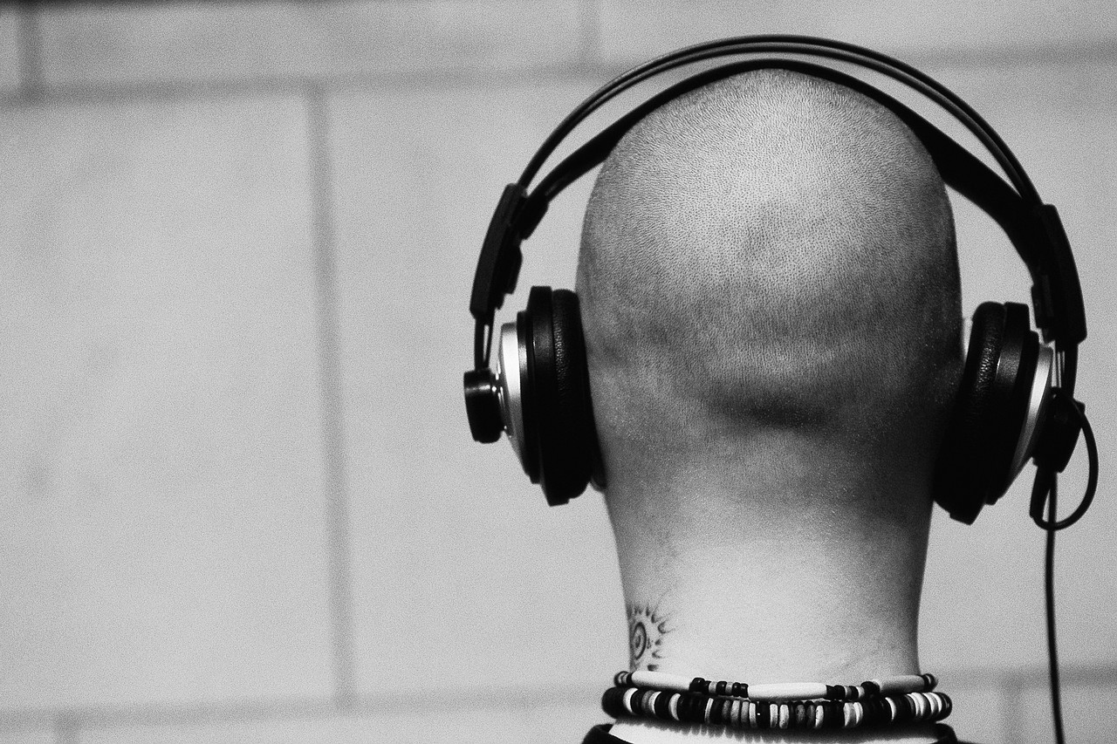escuchar - \_\_\_\_\_\_\_\_\_\_\_\_\_\_\_\_\_ 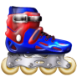patinar - \_\_\_\_\_\_\_\_\_\_\_\_\_\_\_\_\_\_\_\_\_ estudiar - \_\_\_\_\_\_\_\_\_\_\_\_\_\_\_\_\_\_ MC900433702[1]bailar - \_\_\_\_\_\_\_\_\_\_\_\_\_\_\_\_\_\_\_\_\_\_ MC900017099[1]hablar - \_\_\_\_\_\_\_\_\_ /\_\_\_\_\_\_\_\_\_\_\_  sacar (fotos) - \_\_\_\_\_\_\_\_\_(\_\_\_\_\_\_\_)

MC900295678[1]nadar - \_\_\_\_\_\_\_\_\_\_\_\_\_\_\_\_\_\_\_

MC900364158[1]caminar - \_\_\_\_\_\_\_\_\_\_\_\_\_\_\_\_\_\_\_\_ MC900232151[1]mirar - \_\_\_\_\_\_\_\_\_ /\_\_\_\_\_\_\_\_\_\_\_ MC900071322[1]visitar - \_\_\_\_\_\_\_\_\_\_\_\_\_\_\_\_\_\_\_\_ MC900229659[1]viajar - \_\_\_\_\_\_\_\_\_\_\_\_\_\_\_\_\_\_\_\_\_\_

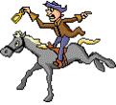montar (a caballo /en bicicleta)

\_\_\_\_\_\_\_\_\_\_\_\_\_\_\_\_\_\_( / )

**MC900079257[1]**esquiar - **\_\_\_\_\_\_\_\_\_\_\_\_\_\_\_\_\_\_\_\_\_\_**

MC900290163[1]dibujar - \_\_\_\_\_\_\_\_\_\_\_\_\_\_\_\_\_\_\_\_

MC900240181[1]cantar - \_\_\_\_\_\_\_\_\_\_\_\_\_\_\_\_\_\_\_ MC900195246[1]trabajar - \_\_\_\_\_\_\_\_\_\_\_\_\_\_\_\_ buscar - \_\_\_\_\_\_\_\_\_\_\_\_\_\_\_\_\_

odiar- \_\_\_\_\_\_\_\_\_\_\_\_\_\_\_\_\_\_\_\_

MC900383368[1] pescar - \_\_\_\_\_\_\_\_\_\_\_\_\_\_\_\_\_

C:\Users\JHrcak\AppData\Local\Microsoft\Windows\Temporary Internet Files\Content.IE5\BYLYMQKZ\MC900440458[1].wmf tomar - \_\_\_\_\_\_\_\_\_\_\_\_\_\_\_\_\_\_

C:\Users\JHrcak\AppData\Local\Microsoft\Windows\Temporary Internet Files\Content.IE5\BYLYMQKZ\MC900078746[1].wmf levantar (pesas) - \_\_\_\_\_\_\_\_\_\_\_\_\_\_\_\_\_

usar - \_\_\_\_\_\_\_\_\_\_\_\_\_\_\_\_\_\_\_\_

practicar - \_\_\_\_\_\_\_\_\_\_\_\_\_\_\_\_

pasar (tiempo con amigos) - \_\_\_\_\_\_\_\_\_\_\_\_\_\_\_(\_\_\_\_\_\_\_\_\_\_\_\_\_\_\_\_\_\_)

**Nuevo Vocabulario:**

MC900155440[1]celebrar- \_\_\_\_\_\_\_\_\_\_\_\_\_\_\_\_\_

MC900347489[1]decorar - \_\_\_\_\_\_\_\_\_\_\_\_\_\_\_\_\_

cocinar- \_\_\_\_\_\_\_\_\_\_\_\_\_\_\_\_

MC900078794[1]ayudar - \_\_\_\_\_\_\_\_\_\_\_\_\_\_\_\_\_\_\_

necesitar - \_\_\_\_\_\_\_\_\_\_\_\_\_\_\_\_\_

invitar - \_\_\_\_\_\_\_\_\_\_\_\_\_\_\_\_\_\_

organizar - \_\_\_\_\_\_\_\_\_\_\_\_\_\_\_\_

planear (la música) - \_\_\_\_\_\_\_\_\_\_\_(\_\_\_\_\_\_)

3

C:\Users\jhrcak\AppData\Local\Microsoft\Windows\Temporary Internet Files\Content.IE5\85QW62FA\MC900104838[1].wmf

**THE CORRECT VERB ENDINGS ARE:**

yo celebr*o* - I celebrate nosotros celebr*amos* - we celebrate

nosotras

tú celebr*as* - you celebrate vosotros celebr*áis* - you celebrate

vosotras

usted celebr*a* - you celebrate ustedes celebr*an* - you celebrate

él celebr*a* - he celebrates ellos celebr*an* - they celebrate

ella celebr*a* - she celebrates ellas celebr*an* - they celebrate

**NOW YOU TRY!**

yo invit\_\_\_\_- \_\_\_\_\_\_\_\_\_\_\_\_\_\_ nosotros(as) invit\_\_\_\_\_\_- \_\_\_\_\_\_\_\_\_\_\_\_\_\_

tú invit\_\_\_\_- \_\_\_\_\_\_\_\_\_\_\_\_\_\_ vosotros(as) invit\_\_\_\_\_\_- \_\_\_\_\_\_\_\_\_\_\_\_\_\_

usted invit\_\_\_\_- \_\_\_\_\_\_\_\_\_\_\_ ustedes invit\_\_\_\_\_- \_\_\_\_\_\_\_\_\_\_\_\_\_\_\_\_\_\_\_

él invit\_\_\_\_- \_\_\_\_\_\_\_\_\_\_\_\_\_\_ ellos invit\_\_\_\_\_\_ - \_\_\_\_\_\_\_\_\_\_\_\_\_\_\_\_\_\_\_\_

ella invit\_\_\_\_- \_\_\_\_\_\_\_\_\_\_\_\_\_ ellas invit\_\_\_\_\_\_- \_\_\_\_\_\_\_\_\_\_\_\_\_\_\_\_\_\_\_\_\_

4

**Invitaciones -**

***To ask someone if he/she would like to go somewhere, say...***

¿Te gustaría ir a /al.....? \_\_\_\_\_\_\_\_\_\_\_\_\_\_\_\_\_\_\_\_\_\_\_\_\_\_\_\_\_\_\_\_\_\_\_\_\_\_\_\_

¿Adónde te gustaría ir? \_\_\_\_\_\_\_\_\_\_\_\_\_\_\_\_\_\_\_\_\_\_\_\_\_\_\_\_\_\_\_\_\_\_\_\_\_\_\_\_

¿Quieres? \_\_\_\_\_\_\_\_\_\_\_\_\_\_\_\_\_\_\_\_\_\_\_\_\_\_\_\_\_\_\_\_\_\_\_\_\_\_\_\_

¿Puedes? \_\_\_\_\_\_\_\_\_\_\_\_\_\_\_\_\_\_\_\_\_\_\_\_\_\_\_\_\_\_\_\_\_\_\_\_\_\_\_\_

***To say you would like to go to a place, say....***

Me gustaría ir a /al..... \_\_\_\_\_\_\_\_\_\_\_\_\_\_\_\_\_\_\_\_\_\_\_\_\_\_\_\_\_\_\_\_\_\_\_\_\_\_\_\_\_\_

***Instead of “me gustaría” you could use…***

Quiero… - \_\_\_\_\_\_\_\_\_\_\_\_\_\_\_\_\_\_\_\_\_\_\_

Puedo… - \_\_\_\_\_\_\_\_\_\_\_\_\_\_\_\_\_\_\_\_\_\_\_

No puedo… - \_\_\_\_\_\_\_\_\_\_\_\_\_\_\_\_\_\_\_\_\_\_\_

***In conjunction with these sentences, you could use:***

conmigo - \_\_\_\_\_\_\_\_\_\_\_\_\_\_\_\_\_\_\_\_\_\_\_

contigo - \_\_\_\_\_\_\_\_\_\_\_\_\_\_\_\_\_\_\_\_\_\_\_

***¿Hay problema?:***

¿Está abierto? - \_\_\_\_\_\_\_\_\_\_\_\_\_\_\_\_\_\_\_\_\_\_\_\_\_\_\_\_\_\_\_\_\_\_\_\_\_\_\_\_\_\_\_\_\_\_

¿Está cerrado? - \_\_\_\_\_\_\_\_\_\_\_\_\_\_\_\_\_\_\_\_\_\_\_\_\_\_\_\_\_\_\_\_\_\_\_\_\_\_\_\_\_\_\_\_\_\_

**Unas razones (Some reasons** see textbook p. 198, 199**)**

Repaso: *FYI:*

I’m sick. -\_\_\_\_\_\_\_\_\_\_\_\_\_\_\_\_\_\_\_\_\_\_ *Estoy ocupado. -\_\_\_\_\_\_\_\_\_\_\_\_\_\_\_\_\_\_\_\_\_\_*

I’m tired. - \_\_\_\_\_\_\_\_\_\_\_\_\_\_\_\_\_\_\_\_\_ *demasiado - \_\_\_\_\_\_\_\_\_\_\_*

I’m sad. - \_\_\_\_\_\_\_\_\_\_\_\_\_\_\_\_\_\_\_\_\_\_ *un poco - \_\_\_\_\_\_\_\_\_\_\_\_\_*

very - \_\_\_\_\_\_\_\_\_\_\_

5

**IR**

**Fill in the correct form of the verb “ir”.**

ir - \_\_\_\_\_\_\_\_\_\_\_\_\_\_\_\_\_\_\_\_

yo \_\_\_\_\_\_\_\_\_\_\_\_\_\_\_\_\_\_\_\_\_ nosotros \_\_\_\_\_\_\_\_\_\_\_\_\_\_\_\_\_\_\_

tú \_\_\_\_\_\_\_\_\_\_\_\_\_\_\_\_\_\_\_\_\_ vosotros \_\_\_\_\_\_\_\_\_\_\_\_\_\_\_\_\_\_\_

él \_\_\_\_\_\_\_\_\_\_\_\_\_\_\_\_\_\_\_\_\_\_ ellos \_\_\_\_\_\_\_\_\_\_\_\_\_\_\_\_\_\_\_\_\_\_

ella \_\_\_\_\_\_\_\_\_\_\_\_\_\_\_\_\_\_\_\_\_ ellas \_\_\_\_\_\_\_\_\_\_\_\_\_\_\_\_\_\_\_\_\_\_

usted\_\_\_\_\_\_\_\_\_\_\_\_\_\_\_\_\_\_\_\_ ustedes \_\_\_\_\_\_\_\_\_\_\_\_\_\_\_\_\_\_\_\_

j0078711

There are 2 uses for the verb “ir”:

1. **to state someone “is going to” a place.**

Yo voy al colegio.  *I am going to the school.*

Tú vas al gimnasio. *You go to the gymnasium.*

### Él va a la playa. \_\_\_\_\_\_\_\_\_\_\_\_\_\_\_\_\_\_\_\_\_\_\_\_\_\_\_\_\_\_\_\_\_\_\_\_\_\_\_\_\_\_\_

## Usted va a la piscina. \_\_\_\_\_\_\_\_\_\_\_\_\_\_\_\_\_\_\_\_\_\_\_\_\_\_\_\_\_\_\_\_\_\_\_\_\_\_\_\_\_\_\_

Nosotros vamos a la biblioteca. *\_\_\_\_\_\_\_\_\_\_\_\_\_\_\_\_\_\_\_\_\_\_\_\_\_\_\_\_\_\_\_\_\_\_\_\_\_\_\_\_\_\_*

Vosotros vais a la ciudad. *\_\_\_\_\_\_\_\_\_\_\_\_\_\_\_\_\_\_\_\_\_\_\_\_\_\_\_\_\_\_\_\_\_\_\_\_\_\_\_\_\_\_\_*

# Ellos van al museo. \_\_\_\_\_\_\_\_\_\_\_\_\_\_\_\_\_\_\_\_\_\_\_\_\_\_\_\_\_\_\_\_\_\_\_\_\_\_\_\_\_\_\_

Ellos van al centro comercial. *\_\_\_\_\_\_\_\_\_\_\_\_\_\_\_\_\_\_\_\_\_\_\_\_\_\_\_\_\_\_\_\_\_\_\_\_\_\_\_\_\_\_\_*

Ustedes van al teatro. *\_\_\_\_\_\_\_\_\_\_\_\_\_\_\_\_\_\_\_\_\_\_\_\_\_\_\_\_\_\_\_\_\_\_\_\_\_\_\_\_\_\_\_*

**Notice how you say “to” in Spanish:**

“a” means \_\_\_\_\_\_\_\_\_\_\_\_\_\_\_\_\_\_\_\_\_\_\_\_\_\_\_\_

“al” = \_\_\_\_\_\_\_\_\_\_\_\_\_\_\_\_\_\_\_\_\_\_\_\_\_\_\_\_\_\_\_\_

“a la” = \_\_\_\_\_\_\_\_\_\_\_\_\_\_\_\_\_\_\_\_\_\_\_\_\_\_\_\_\_\_

6

**Actividad: Write the following sentences in Spanish.**

1. I go to the airport. \_\_\_\_\_\_\_\_\_\_\_\_\_\_\_\_\_\_\_\_\_\_\_\_\_\_\_\_\_\_\_\_\_\_\_\_\_\_\_\_\_\_\_\_\_\_\_\_\_\_\_\_\_
2. They (masc.) go to the department store. \_\_\_\_\_\_\_\_\_\_\_\_\_\_\_\_\_\_\_\_\_\_\_\_\_\_\_\_\_\_\_\_\_\_
3. You (formal, plural) go to the church. \_\_\_\_\_\_\_\_\_\_\_\_\_\_\_\_\_\_\_\_\_\_\_\_\_\_\_\_\_\_\_\_\_\_\_\_\_\_
4. You (informal, singular) go to the shoe store. \_\_\_\_\_\_\_\_\_\_\_\_\_\_\_\_\_\_\_\_\_\_\_\_\_\_\_\_\_\_\_\_
5. He goes to the post office. \_\_\_\_\_\_\_\_\_\_\_\_\_\_\_\_\_\_\_\_\_\_\_\_\_\_\_\_\_\_\_\_\_\_\_\_\_\_\_\_\_\_\_\_\_\_\_
6. Let’s go! \_\_\_\_\_\_\_\_\_\_\_\_\_\_\_\_\_\_\_\_\_\_\_\_\_\_\_\_\_\_\_\_\_\_\_\_\_\_\_\_\_\_\_\_\_\_\_\_\_\_\_\_\_\_\_\_\_\_\_\_\_
7. **To express something that you will do in the future.**

If you would like to say you are going to do something in the future use the following:

“form of ir” + “a” + “verb infinitive”

Yo voy a estudiar el francés. *I am going to study French.*

Tú vas a caminar a la escuela*. You are going to walk to school.*

Él va a hablar con su amigo. *He is going to talk with his friend.*

Ella va a leer un buen libro. *\_\_\_\_\_\_\_\_\_\_\_\_\_\_\_\_\_\_\_\_\_\_\_\_\_\_\_\_\_\_\_\_\_\_\_*

Usted va a ir a un concierto. *\_\_\_\_\_\_\_\_\_\_\_\_\_\_\_\_\_\_\_\_\_\_\_\_\_\_\_\_\_\_\_\_\_\_\_*

Nosotros vamos a visitar el museo. *\_\_\_\_\_\_\_\_\_\_\_\_\_\_\_\_\_\_\_\_\_\_\_\_\_\_\_\_\_\_\_\_\_\_\_*

Vosotras vais a ir de compras. *\_\_\_\_\_\_\_\_\_\_\_\_\_\_\_\_\_\_\_\_\_\_\_\_\_\_\_\_\_\_\_\_\_\_\_*

Ellos van a nadar mañana. *\_\_\_\_\_\_\_\_\_\_\_\_\_\_\_\_\_\_\_\_\_\_\_\_\_\_\_\_\_\_\_\_\_\_\_*

Ellas van a viajar.  *\_\_\_\_\_\_\_\_\_\_\_\_\_\_\_\_\_\_\_\_\_\_\_\_\_\_\_\_\_\_\_\_\_\_\_*

Ustedes van a jugar al tenis hoy. *\_\_\_\_\_\_\_\_\_\_\_\_\_\_\_\_\_\_\_\_\_\_\_\_\_\_\_\_\_\_\_\_\_\_\_*

j0078625

**Actividad: Write the following sentences in Spanish.**

1. I am going to ski. \_\_\_\_\_\_\_\_\_\_\_\_\_\_\_\_\_\_\_\_\_\_\_\_\_\_\_\_\_\_\_\_\_\_\_\_\_\_\_\_\_\_\_\_\_\_
2. She is going to play golf. \_\_\_\_\_\_\_\_\_\_\_\_\_\_\_\_\_\_\_\_\_\_\_\_\_\_\_\_\_\_\_\_\_\_\_\_\_\_\_\_
3. You (formal, singular) are going to work. \_\_\_\_\_\_\_\_\_\_\_\_\_\_\_\_\_\_\_\_\_\_\_\_\_\_\_\_
4. They (feminine) are going to sing. \_\_\_\_\_\_\_\_\_\_\_\_\_\_\_\_\_\_\_\_\_\_\_\_\_\_\_\_\_\_\_\_\_

7

***EL TRANSPORTE -\_\_\_\_\_\_\_\_\_\_\_\_\_\_\_\_\_\_\_***

el pie - \_\_\_\_\_\_\_\_\_\_\_\_\_\_\_\_\_\_ la motocicleta - \_\_\_\_\_\_\_\_\_\_\_\_\_\_\_\_\_\_

el taxi - \_\_\_\_\_\_\_\_\_\_\_\_\_\_\_\_\_ el metro - \_\_\_\_\_\_\_\_\_\_\_\_\_\_\_\_\_\_\_

el autobús - \_\_\_\_\_\_\_\_\_\_\_\_\_\_ el tren - \_\_\_\_\_\_\_\_\_\_\_\_\_\_\_\_\_\_\_\_\_

el avión - \_\_\_\_\_\_\_\_\_\_\_\_\_\_\_\_ el camión - \_\_\_\_\_\_\_\_\_\_\_\_\_\_\_\_\_\_

el bote - \_\_\_\_\_\_\_\_\_\_\_\_\_\_\_\_\_ el coche - \_\_\_\_\_\_\_\_\_\_\_\_\_\_\_\_\_\_

(el carro)

el barco - \_\_\_\_\_\_\_\_\_\_\_\_\_\_\_\_\_

***Repaso:***

la bicicleta el caballo

***FYI:***

el monopatín- \_\_\_\_\_\_\_\_\_\_\_\_\_\_\_\_ el automóvil - \_\_\_\_\_\_\_\_\_\_\_\_\_\_\_

**en + transporte - \_\_\_\_\_\_\_\_\_\_\_ \*a pie - \_\_\_\_\_\_\_\_\_\_\_\_\_\_\_**

**¿Cómo prefieres viajar? - \_\_\_\_\_\_\_\_\_\_\_\_\_\_\_\_\_\_\_\_\_\_\_\_\_\_\_\_\_\_\_\_\_\_\_\_\_\_**

**(Yo) Prefiero viajar en coche . - \_\_\_\_\_\_\_\_\_\_\_\_\_\_\_\_\_\_\_\_\_\_\_\_\_\_\_\_\_\_\_\_\_**

**¿Cómo vas a la escuela? - \_\_\_\_\_\_\_\_\_\_\_\_\_\_\_\_\_\_\_\_\_\_\_\_\_\_\_\_\_\_\_\_\_\_\_\_\_**

**Generalmente, (yo) voy a pie - \_\_\_\_\_\_\_\_\_\_\_\_\_\_\_\_\_\_\_\_\_\_\_\_\_\_\_\_\_\_\_\_\_\_**

C:\Program Files\Microsoft Office\Clipart\Pub60Cor\tn00234_.wmf C:\Program Files\Microsoft Office\Clipart\Pub60Cor\tn00253_.wmf C:\Program Files\Microsoft Office\Clipart\Pub60Cor\tn00218_.wmf C:\Program Files\Microsoft Office\Clipart\Pub60Cor\tn00255_.wmf

Español 8 Nombre: \_\_\_\_\_\_\_\_\_\_\_\_\_\_\_\_\_\_\_\_\_\_\_\_\_\_\_\_

Unidad 7 Fecha: \_\_\_\_\_\_\_\_\_\_\_\_\_\_\_\_\_\_\_\_\_\_\_\_\_\_\_\_\_

8

**¿Dónde está….?**

**You can use prepositions to describe the location of things. Do you remember these?** a la derecha de - \_\_\_\_\_\_\_\_\_\_\_\_\_\_\_\_\_\_\_\_\_\_\_

a la izquierda de - \_\_\_\_\_\_\_\_\_\_\_\_\_\_\_\_\_\_\_\_\_\_\_

aquí - \_\_\_\_\_\_\_\_\_\_\_\_\_\_\_\_\_\_\_\_\_

allí - \_\_\_\_\_\_\_\_\_\_\_\_\_\_\_\_\_\_\_\_\_\_

**Here are two more prepositions you could use with places;**

cerca de - \_\_\_\_\_\_\_\_\_\_\_\_\_\_\_\_\_\_\_\_\_\_\_

lejos de - \_\_\_\_\_\_\_\_\_\_\_\_\_\_\_\_\_\_\_\_\_\_\_

***Describing Location- Always* use the verb *estar* with location! (The word “is” would be *está*, not *es*!!!! For example:**

Mi casa está cerca del parque. - \_\_\_\_\_\_\_\_\_\_\_\_\_\_\_\_\_\_\_\_\_\_\_\_\_\_\_\_\_\_\_\_\_\_

La escuela está lejos del estadio. - \_\_\_\_\_\_\_\_\_\_\_\_\_\_\_\_\_\_\_\_\_\_\_\_\_\_\_\_\_\_\_\_

Wait!!! What’s going on here?

\_\_\_\_\_\_\_\_\_\_\_\_\_\_\_\_\_\_\_\_\_\_\_\_\_\_\_\_\_\_\_\_\_\_\_\_\_\_\_\_\_\_\_\_\_\_

**☞When using the name of a place in Spanish along with its proper name, place the proper name *after* the place.**

Ej.: Supermercado Tops, Restaurante Mangia, Farmacia Rite Aid

9

Vocabulario – Las Direcciones

Norte

Oeste Este

Sur

MC900352904[1]

# Necesito ayuda. \_\_\_\_\_\_\_\_\_\_\_\_\_\_\_\_\_\_

Estoy perdido(a). \_\_\_\_\_\_\_\_\_\_\_\_\_\_\_\_\_

\*¿Dónde está ......? \_\_\_\_\_\_\_\_\_\_\_\_\_\_\_\_

\*Repita, por favor. \_\_\_\_\_\_\_\_\_\_\_\_\_\_\_\_

\*Más despacio, por favor.

\_\_\_\_\_\_\_\_\_\_\_\_\_\_\_\_\_\_\_\_\_\_\_\_\_\_\_\_\_\_\_

# *Sal de…. \_\_\_\_\_\_\_\_\_\_\_\_\_\_\_\_\_\_\_\_\_\_\_*

Dobla \_\_\_\_\_\_\_\_\_\_\_\_\_ Continua \_\_\_\_\_\_\_\_\_\_\_\_\_

\*a la derecha en \_\_\_\_\_\_\_\_\_\_\_\_\_\_\_\_\_\_ Calle (c/)…….\_\_\_\_\_\_\_\_\_\_\_\_\_\_\_\_\_\_

\*a la izquierda en \_\_\_\_\_\_\_\_\_\_\_\_\_\_\_\_\_ Avenida (Avda.)…..\_\_\_\_\_\_\_\_\_\_\_\_\_\_\_\_\_

Sigue….. \_\_\_\_\_\_\_\_\_\_\_\_\_\_ todo derecho \_\_\_\_\_\_\_\_\_\_\_\_ Vaya \_\_\_\_\_\_\_

Está cerca de……….. \_\_\_\_\_\_\_\_\_\_\_\_\_\_\_\_\_\_\_\_\_\_\_\_\_\_\_\_

¿Está cerca de………..?

Está lejos de……….. \_\_\_\_\_\_\_\_\_\_\_\_\_\_\_\_\_\_\_\_\_\_\_\_\_\_\_\_\_

¿Está lejos de………..?

*FYI:*

*Pasa \_\_\_\_\_\_\_\_\_\_\_\_\_\_\_\_\_\_\_\_\_ Cruza…. \_\_\_\_\_\_\_\_\_\_\_\_\_\_\_\_\_\_\_*

*No pases \_\_\_\_\_\_\_\_\_\_\_\_\_\_\_\_\_\_ primer(a) \_\_\_\_\_\_\_\_\_\_\_*

*la esquina \_\_\_\_\_\_\_\_\_\_\_\_\_\_\_\_\_ segundo(a) \_\_\_\_\_\_\_\_\_\_\_*

*tercer(a) \_\_\_\_\_\_\_\_\_\_\_\_*

*la sala - \_\_\_\_\_\_\_\_\_\_\_\_\_\_\_\_\_\_\_\_\_ el corredor - \_\_\_\_\_\_\_\_\_\_\_\_\_\_\_\_\_\_\_\_\_\_\_\_*

*la escalera - \_\_\_\_\_\_\_\_\_\_\_\_\_\_\_\_\_\_ el piso - \_\_\_\_\_\_\_\_\_\_\_\_\_\_\_\_\_\_\_\_\_\_\_\_\_\_\_*

*sube - \_\_\_\_\_\_\_\_\_\_\_\_\_\_\_\_\_\_*

*baja - \_\_\_\_\_\_\_\_\_\_\_\_\_\_\_\_\_\_*

10

Las Plazas

Most cities designed by the Spanish are built around a central or main square known as *la plaza mayor.*  Some of these are actual structures and are very famous because of their beautiful architecture. Others are simply a central square closed off to street traffic and surrounded by administrative, government buildings and possibly the city’s cathedral.

Very often the *plaza mayor* serves as a gathering spot for a variety of social occasions. Since it is located in the city center, it is a convenient place to meet. Many years ago, bullfights, soccer games and even public executions were held there. Nowadays, friends might meet at the *plaza mayor* to enjoy some of the cafés, restaurants or shops located in and around *la plaza*. The *plaza mayor* is the sight of many public events: markets, a gathering place for fiestas and also various demonstrations. It is of course also a major tourist attraction.

Go online to discover interesting facts about Madrid’s most famous plaza: *la Plaza Mayor*. Write a few facts about its history. Then describe five things you might find there, as well as five activities that traditionally go on in *la Plaza Mayor*.

**History** 1**.**\_\_\_\_\_\_\_\_\_\_\_\_\_\_\_\_\_\_\_\_\_\_\_\_\_\_\_\_\_\_\_\_\_\_\_\_\_\_\_\_\_\_\_\_\_\_\_\_\_\_

2. \_\_\_\_\_\_\_\_\_\_\_\_\_\_\_\_\_\_\_\_\_\_\_\_\_\_\_\_\_\_\_\_\_\_\_\_\_\_\_\_\_\_\_\_\_\_\_\_\_

3. \_\_\_\_\_\_\_\_\_\_\_\_\_\_\_\_\_\_\_\_\_\_\_\_\_\_\_\_\_\_\_\_\_\_\_\_\_\_\_\_\_\_\_\_\_\_\_\_\_

**Things there:** 1. \_\_\_\_\_\_\_\_\_\_\_\_\_\_\_\_\_\_\_\_\_\_\_\_\_\_\_\_\_\_\_\_\_\_\_\_\_\_\_\_\_\_\_\_

2. \_\_\_\_\_\_\_\_\_\_\_\_\_\_\_\_\_\_\_\_\_\_\_\_\_\_\_\_\_\_\_\_\_\_\_\_\_\_\_\_\_\_\_\_

3. \_\_\_\_\_\_\_\_\_\_\_\_\_\_\_\_\_\_\_\_\_\_\_\_\_\_\_\_\_\_\_\_\_\_\_\_\_\_\_\_\_\_\_\_

4. \_\_\_\_\_\_\_\_\_\_\_\_\_\_\_\_\_\_\_\_\_\_\_\_\_\_\_\_\_\_\_\_\_\_\_\_\_\_\_\_\_\_\_\_

5. \_\_\_\_\_\_\_\_\_\_\_\_\_\_\_\_\_\_\_\_\_\_\_\_\_\_\_\_\_\_\_\_\_\_\_\_\_\_\_\_\_\_\_\_

**Activities:** 1. \_\_\_\_\_\_\_\_\_\_\_\_\_\_\_\_\_\_\_\_\_\_\_\_\_\_\_\_\_\_\_\_\_\_\_\_\_\_\_\_\_\_\_\_

2. \_\_\_\_\_\_\_\_\_\_\_\_\_\_\_\_\_\_\_\_\_\_\_\_\_\_\_\_\_\_\_\_\_\_\_\_\_\_\_\_\_\_\_\_

3. \_\_\_\_\_\_\_\_\_\_\_\_\_\_\_\_\_\_\_\_\_\_\_\_\_\_\_\_\_\_\_\_\_\_\_\_\_\_\_\_\_\_\_\_

4. \_\_\_\_\_\_\_\_\_\_\_\_\_\_\_\_\_\_\_\_\_\_\_\_\_\_\_\_\_\_\_\_\_\_\_\_\_\_\_\_\_\_\_\_

5. \_\_\_\_\_\_\_\_\_\_\_\_\_\_\_\_\_\_\_\_\_\_\_\_\_\_\_\_\_\_\_\_\_\_\_\_\_\_\_\_\_\_\_\_

11

Pictures of some famous *Plazas* in the Hispanic world:

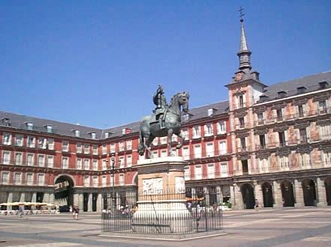 [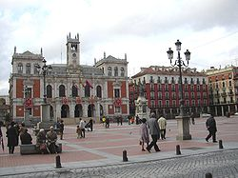](http://en.wikipedia.org/wiki/File:ValladolidAyto_20-4-03.JPG) La Plaza Mayor, Madrid, España La Plaza Mayor, Valladolid, España

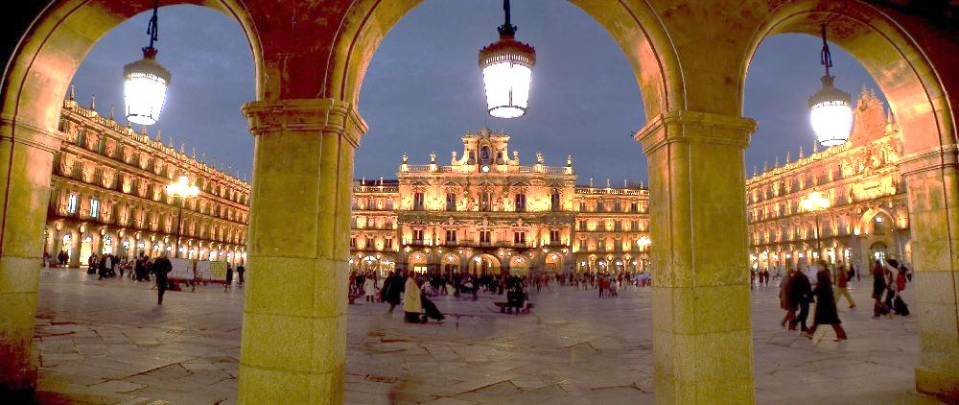 La Plaza Mayor, Salamanca, España

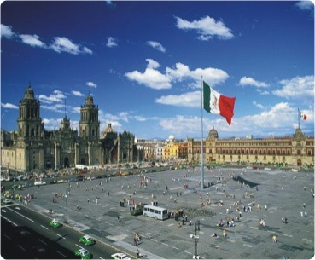 [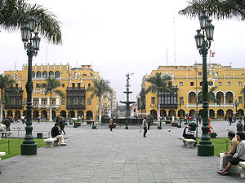](http://en.wikipedia.org/wiki/File:Square_in_Lima_Peru_01.jpg) El Zócalo, México D.F. La Plaza Mayor, Lima, Perú

[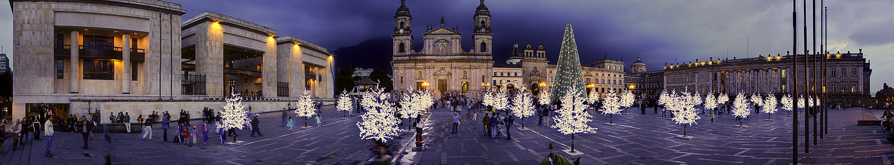](http://en.wikipedia.org/wiki/File:56_-_Bogota_-_D%C3%A9cembre_2008.jpg)Plaza de Bolívar, Bogotá, Colombia

12