## j0149435

The Great War

## Historians called World War I “The Great War” because it was supposed to be “the war to end all other wars.” Unfortunately, this was not to be the case as World War II erupted in 1938.

## Initial Declarations of War: <http://www.firstworldwar.com/features/declarationsofwar.htm>

1. How many countries were involved in “The Great War?” and where were most of them located?
2. Who was the last to join?

### President Wilson <http://www.firstworldwar.com/bio/wilson.htm>

1. In 1917 Wilson proclaimed American entrance into World War I as a crusade to make the world

_________________________________________________________________________________.

1. How is possible that Wilson could only receive 42 percent of the popular vote and still win the election of 1912?
2. After winning his second election, what did Wilson ask Congress to do in April 1917 and why?
3. What is conscription and why did President Wilson make a “Proclamation about it?”

#### Selective Services <http://spartacus-educational.com/FWWselective.htm>

#### Explain what Selective Service is and who it affects.

# Submarine Warfare <http://www.firstworldwar.com/source/uboat_wilson.htm>

1. Explain what “unrestricted submarine warfare” is and what was Germany’s purpose in using it.
2. How did Wilson and the United States react Germany’s submarine policy?

### Sinking of the Lusitania <http://www.firstworldwar.com/source/lusitania3rdprotest.htm>

1. Why did the sinking of the Lusitania concern the United States?
2. How did President Wilson respond?
3. How did Germany respond to Wilson?

# Zimmerman Telegram <http://www.firstworldwar.com/source/zimmermann.htm>

1. In 1916 Woodrow Wilson was elected President for a second term, largely because of the slogan:

_______________________________________________________.

1. The Zimmerman Telegraph (which was intercepted from U.S. ally, Great Britain) was sent from __________________ to _____________________ and finally drew the U.S. into The Great War. What did the Telegram say?

### Domestic Problems in the U.S. during the War…Espionage and Sedition Acts <https://historyengine.richmond.edu/episodes/view/5552>

1. Explain the Espionage Act of 1917
2. What were the immediate results?

### Sedition Act <http://www.u-s-history.com/pages/h1345.html>

1. Explain what the Sedition Act of 1918 did.
2. What happened to Eugene Debs as a result of this act? Review your previous notes on labor unions and write down why Mr. Debs advocated for the U.S. Government to adopt SOCIALISM .



### Schenck v. United States <http://legal-dictionary.thefreedictionary.com/Schenck+v.+United+States>

1. Explain the background of the SCOTUS case **“Schenck v. United States”**

<http://www.sourcewatch.org/wiki.phtml?title=Schenck_v._United_States>

1. Explain Supreme Court Justice Oliver Wendell Holmes’ opinion on the case and the effects of his decision.
2. Explain what a “Clear and Present Danger” meant.

#### Women in WORLD WAR I <http://en.wikipedia.org/wiki/Suffragette>

1. What did women do to help with the war effort?
2. What differences did women see from previous wars?

Now, using the above websites and/or your textbook, answer these last questions on U.S. involvement in THE GREAT WAR……

1. In what way did President Wilson change President Washington’s foreign policy that had existed from 1789-1917?
2. What were the names of the two groups fighting this war? Which group did the U.S. ally with?



1. How did the Espionage and Sedition Acts restrict civil liberties?
2. Define the following actions taken by the U.S. government to help raise money and support for the war.

**Federal Revenue Act (war bonds)-**

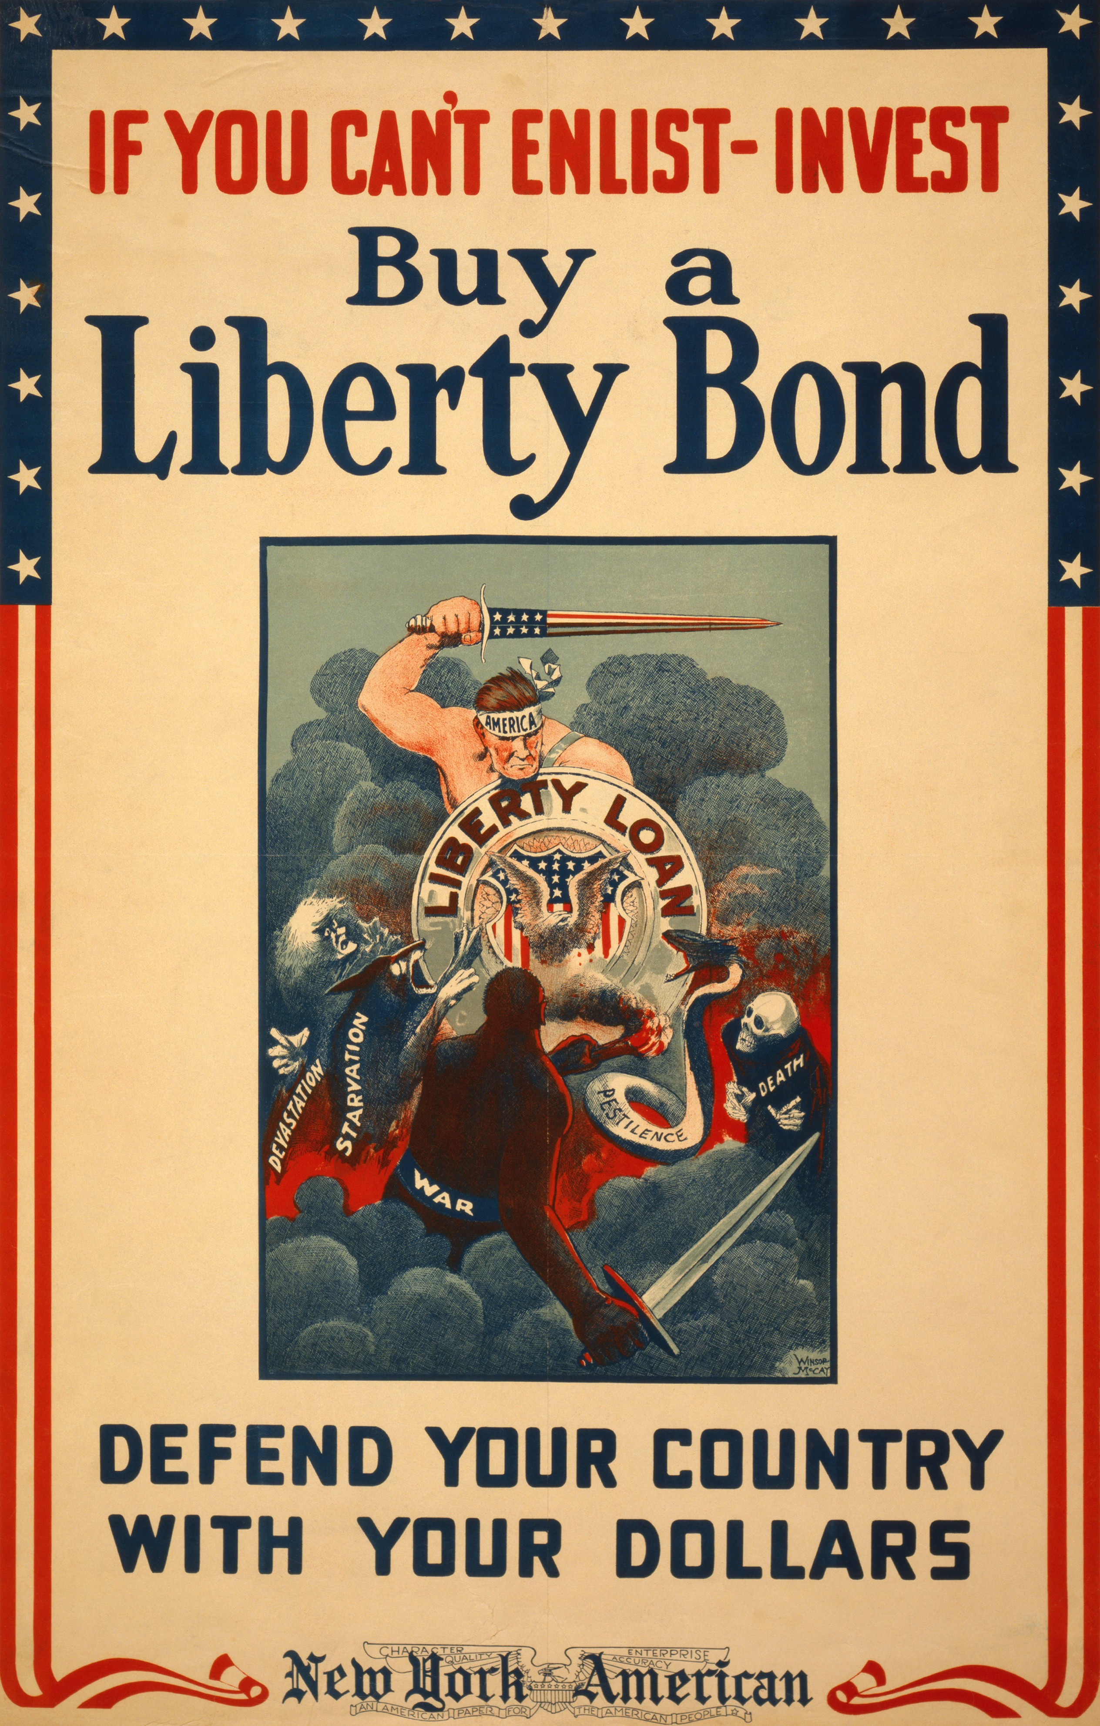

**Progaganda**

**Rationing-**

**Rosie the Riveter-**

[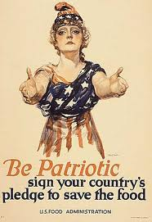](http://www.google.com/imgres?q=war+industries+board+propaganda&hl=en&safe=active&gbv=2&biw=843&bih=434&tbm=isch&tbnid=KPX_pfq4F_47FM:&imgrefurl=http://staff.imsa.edu/socsci/jvictory/help_05_06/exemplary_papers05/chen_1_6/progressive.htm&docid=iDIXMTMaY8LO2M&imgurl=http://staff.imsa.edu/socsci/jvictory/help_05_06/exemplary_papers05/chen_1_6/images/pp_us_15.jpg&w=400&h=584&ei=dstoT9OhIabY0QHX1MiRCQ&zoom=1)

**Victory Gardens -**

**War Industries Board-** responsible for the above- What was it?