Name: ________________________________ Date: ___________

Geometry B - Chapter 12 – HW #8 Solving for Angles Period: __________

Use the diagram below to answer questions 1 – 5. DRAW THE DIAGRAM FOR EACH and SHOW ALL FORMULAS!



1. If and , find . ______________

2. If and , find . ______________

3. If  and , find . ______________

4. If  and , find . ______________

5. If  is 3 : 6 : 9 : 6, find . ______________

Use the diagram to answer questions 6 – 10.

Tangents  and  intersect at P.

Show all formulas!

6. If , find . ______________

7. If , find . ________________

8. If  and , find = ________________

= ________________

9. If , find . ________________

10. If , find . ________________

Use the diagram to answer questions 11 – 15.

Chords  and  intersect at E.

11. If  and , find . ______________

12. If  and , find = ______________

= ______________

= ______________

13. If  and , find . ______________

14. Solve for x: ______________ 15. If  , find m<BAE.

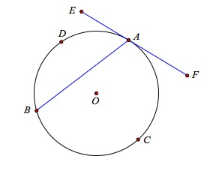[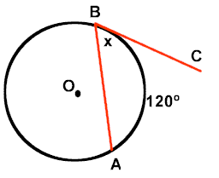](http://www.regentsprep.org/regents/math/geometry/gp15/circleangles.htm)

16. If , find the measure of each of the following:

<BAF _____________

<BAE _____________