Mr. Janas

US History

Immigration Project

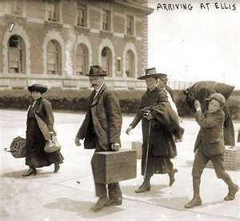 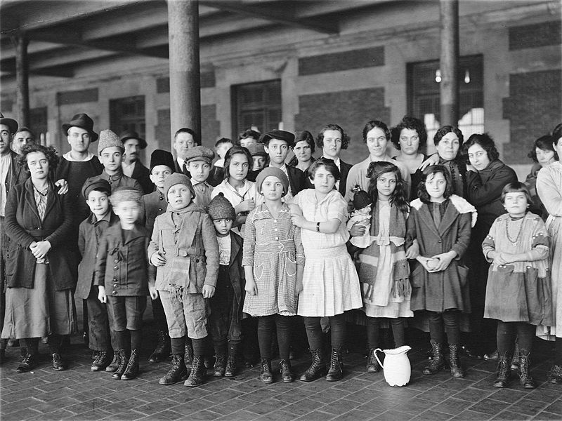

Immigration Project

This project has two parts:

Part A- Complete the attached webquest on immigration

Part B- Immigration Paper (3-4 pages)

Immigration Webquest

Topic #1- The Voyage and the Arrival

“It was a charming morning on which I left dear old Ireland. The balmy newborn day in all the freshness of early summer was gladdened by the beams of the sun which rose above the towers of the city, sunk in undisturbed repose. Too soon I arrived at the quay and left my last footprint on my native land. The boat pushed off and in a few minutes I was on board the brig that was to waft me across the wide Atlantic…”

-Robert Whyte, Journey of an Irish Coffin Ship, 1847

Introduction-

Like Robert Whyte, roughly 34 million immigrants came through Ellis Island between 1820 and 1920. Their experiences were varied, yet each held expectations for a new life in the United States. The first wave of immigrants was primarily Irish, English, German and Scandinavian. The second wave of immigrants in the latter half of the century was Polish, Romanian, Russian, Italian, Austrian, and Hungarian. In addition, thousands of Chinese and Japanese migrated to California and other areas on the Pacific coast during the 19th Century. When immigrants arrived in the United States at Ellis Island, they were physically examined and interrogated. Immigrants with complications (related to paperwork or other factors) were often held in cells anywhere from three to six months.

Directions:

Go to <http://www.socialstudies.com/article.html?article@immigrants_enroute>

Examine the photograph and answer the following questions:

1. What do you see literally depicted in the photograph? How would you describe the setting?
2. What do you imagine the weather to be like? How can you tell?
3. Describe how the people are dressed?
4. Describe the action in the picture. What do you think the people are doing?
5. Describe the facial expressions on these people’s faces. How do you think they were feeling?

Go to the following website: <http://library.thinkquest.org/20619/Past.html>

1. Briefly paraphrase the scene described in the passage.
2. Why did the Ellis Island official require that the children of the two old Hungarians put up a bond (cash)? Do you feel that this was a fair request?
3. What were the occupations of the Russian father and son trying to emigrate?
4. Why do you think the father was willing to be separated from his son? Why do you think the official only admitted the son into America?

Go to the Following Website: http://www.ellisisland.se/english/ellisisland_immigration3.asp

1. Why didn’t the doctors at Ellis Island examine all the immigrants who arrived there? How did they choose who they would examine?
2. What did some who failed the medical exams and were to be sent back to their native countries do? Why do you think they were so desperate?
3. Do you feel that immigrants were treated fairly during their Ellis Island inspections? Explain

Topic#2- Urban Immigrant Life

Introduction:

Written in 1906, Upton Sinclair’s The Jungle “provided a voice to the great masses of immigrants who came to America yearning to be free and comfortable and who found instead the wage slavery and misery of mill, factory, sweatshop, and slum. Sinclair highlighted the factory workers’ conditions- “physical danger, insecurity, fear, exploitation, corruption and faith.” The Jungle gives us a glimpse into immigrant life in US cities between 1880 and 1920.

Directions:

The Jungle by Upton Sinclair

Go to the following website: <http://www.online-literature.com/upton_sinclair/jungle/1/>

Read the first chapter and answer the following

1. What country are the main characters in “The Jungle” from?
2. Where do the immigrants live? How many others live in the neighborhood?
3. How big is the room the family is crowded into?
4. Describe Tamoszius Kuszleika’s clothing. What is he wearing? Why?
5. Describe the difference between the older immigrants and the younger immigrants
6. Describe Mikolas’s job. Where does he work? What does he do? Why did he miss work?
7. What is Jokubas’s and/or Aniele’s economic situation?
8. What can we learn about factory life?
9. Why do the immigrants hold this celebration even though they really can’t afford it? What does this tell us about how “assimilated” these urban immigrants felt?

Topic #3- The Question of Assimilation

Introduction:

The following article was written while World War I raged in Europe. The US was still officially neutral, but Americans of different heritages held spirited arguments about which side the US should eventually support. Many people were dismayed by German Americans fervent support for the Kaiser (king of Germany) and felt such behavior was “un-American” The author of this article takes issue with these criticisms of German Americans (and others) and proceeds to offer some thoughts on the process of “Americanization”

Directions:

Go to the following website: <http://www.swarthmore.edu/SocSci/rbannis1/AIH19th/Bourne.html>

This is a long article but you only need to look at the first few pages in order to answer the following questions:

1. How would you define the term “melting pot”? What does the “melting pot” ideal claim will eventually happen to immigrants to America?
2. In your own words, explain the meaning of this sentence from the article: “The discovery of diverse nationalistic feelings among our great alien population has come to most people as an intense shock.”
3. Why does the author claim that “assimilation in this country was proceeding along lines very different from thoses we had marked out for it”? Whom does the author claim have been most upset by this fact?
4. Why does the author claim that it is a mistake “to think of earlier nationalities as culturally assimilated to America, while we picture the later as a sodden and resistive mass”?
5. What do you think of the “melting pot” ideal? Should America expect all its immigrants to assimilate? Explain your position.

Immigration Paper

**Old Immigrants (Pre Civil War/ Western Europe) - Choose 1 Group**

1. Britain(English speaking)
2. France
3. Germany
4. Holland
5. Sweden
6. Irish

**New Immigrants (Post Civil War/ Eastern Europe) - Choose 1 Group**

1. Italy
2. Austria-Hungary
3. Greece
4. Russia
5. Poland
6. Jews
7. Other Eastern European Countries

## Asian Immigrants- Choose 1 Group

1. China
2. Japan

## Government Restrictions- Choose 3 Restrictions

1. Chinese Exclusion Act (1882)
2. Gentlemen’s Agreement (1907)
3. Literacy Test (1917)
4. Immigration Act of 1921
5. Immigration Act of 1924
6. Immigration Act of 1927
7. National Origins System of 1929
8. McCarran-Walter Act of 1952
9. Immigration Act of 1965

## Nativist Reactions to Immigration (American Groups) - Choose 2 Nativist Groups

1. Know Nothing Party
2. American Protection Association (1887)
3. Ku Klux Klan (20th century)
4. Workingmen’s Party(1877)
5. Immigration Restriction League (1894)

Discuss 1 immigrant group from each section(old, new, Asian) how they were different, why they came, difficulties each group faced, how they contributed to the shaping of American Society. Choose 3 Government Restrictions; explain how each restriction lead to discrimination & segregation in the US & how these policies had an effect on each group of immigrants discussed. Discuss 2 Nativist Groups and discuss their beliefs and actions. Why did they feel this way? Your answers will be put into a paper of 3-4 pages in length.

**Need a Bibliography (MLA Style)