The “Golden Age” of Islamic Culture
750 – 1050
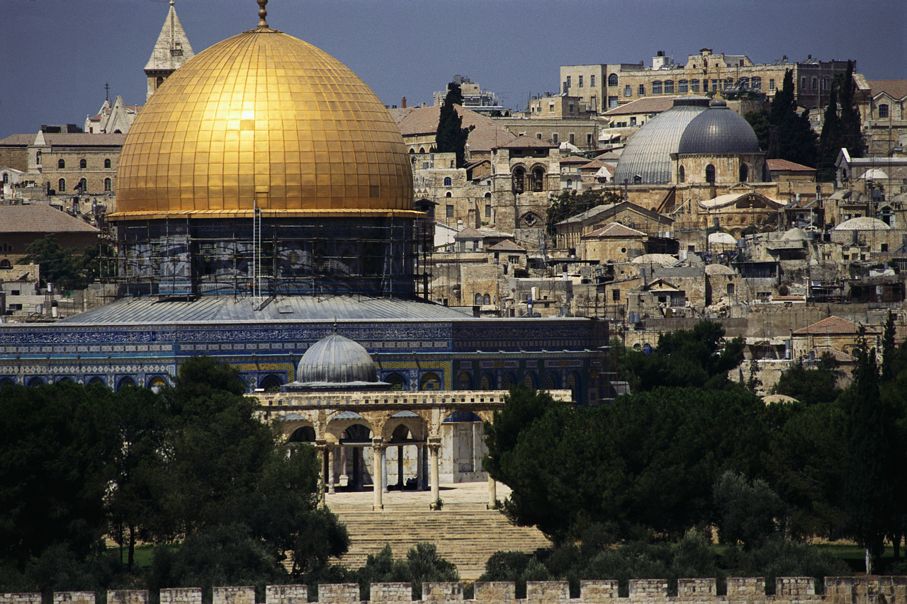
Shortly after Islam spread throughout the Middle East, North Africa, and parts of Europe, Islamic civilization entered a “golden age” from 750 – 1050 AD. In this period, Islamic civilization made some of the greatest achievements in history. Many of these achievements spread to Europe and the Western world, laying the foundation for the Renaissance.

Directions: As you browse through this web site, you are required to do TWO things: 1.) LEARN SOMETHING 2.) Answer the questions below as completely as possible.

Go to http://www.islamawareness.net/Maths/science_and_math.html

From the Main Page of the site scroll down to the bottom and find the link “Science and Mathematics” and click on it.
1.) What was the “Golden Age” of Islam?

2.) What were the SIX factors that fostered the “Golden Age” and briefly describe each?
a.

b.

c.

d.

e.

f.

3.) Click on “Advances in Science Page Two: Chemistry, Geometry, and Geography” at the bottom of the page and complete the following task: Describe one example of Muslim advances in Astronomy and describe one example of Muslim advances in Geography.

4.) Click on “Islamic Mathematics” at the bottom of the page and complete the following task: Describe TWO examples of Muslim advances in mathematics.

5.) Click on “Part Four; Islamic Sciences: Why did the Golden Age end?” and complete the following task: Describe how “Internal Pressures,” and “External Pressures,” ended the “Golden Age” of Islam.

Click on “Main Page” at the very bottom of the page and then find the link for “Architecture.” Click the link for “architecture” and complete the following tasks:

6.) Before Islam, the Kaaba housed about 360 idols. What did Muhammad do when he returned victoriously to Mecca?

7.) What is the significance of the Kaaba to Muslims? Why is it considered the “center” of Islam?

8.) What is the significance of the Dome of the Rock in Jerusalem?

Click on “Main Page” at the very bottom of the page and then find the link for “Education.” Click the link for “Education” and complete the following tasks:

9.) From which areas/cultures of the world did Islamic civilization benefit from in this period? How did the location of the Middle East in the world help to foster all of this cultural borrowing (the map below could help you answer this question)?

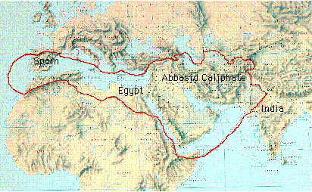
10.) How did Islam encourage education?

11.) How did education differ for boys and girls?

12.) How did education differ for rich and poor?

13.) Compare European and Islamic ideas about the Importance of Literacy during the early Middle Ages.

14.) How did Muslims get paper from the Chinese?

15.) Why was Timbuktu so respected in Islamic history (you need to click on “Page Two: Higher Education on the bottom of the page)?

Click on “Main Page” at the very bottom of the page and then find the link for “Medicine, Health and Hygiene.” Click the link for “Medicine, Health and Hygiene” and complete the following tasks:

16.) How did the religion of Islam encourage achievements in medicine and health?

17.) From which ancient civilization(s) did the Muslims get much medical knowledge?

18.) What were the accomplishments of the Muslim doctor Al-Zahravi?

19.) How did Muslim hospitals compare with European hospitals at that time?

20.) What was the job of the public health inspectors, and why were they important?

THE END

