Serial Killer Project

Assignment: For this project, you are going to delve into the world of a specific serial killer. You will research the historical attributes of 1 specific serial killer, create a Most Wanted poster and present it to the class.

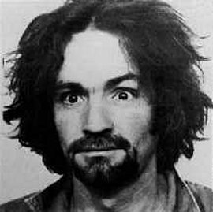
Background Information: Serial killers tend to be white, heterosexual males in their twenties or thirties who are sexually dysfunctional and have low self-esteem. Their killing rampages are almost always sexual in nature. Serial killers generally murder strangers with cooling off periods between each crime. Many keep trophy-like body parts as mementos of their work. Serial killers are sadistic in nature. Some return to crime scenes or gravesites of their victims to fantasize about their deeds. Many like to insert themselves in the investigation of their crimes and some enjoy taunting authorities with letters or carefully placed pieces of evidence.
Female serial killers tend to be "black widows" that kill a succession of husbands, lovers, or other family members. They can also be nurses or other medical professionals who become self-appointed "angels of death" who murder babies, the elderly, or desperately ill in a misguided effort to relieve their suffering. Most serial killers grew up in violent households. As youngsters they enjoyed torturing animals, setting fires and all-around bad behavior. As adults, many serial killers have some type of brain damage and are addicted to alcohol and/or drugs.

1. The Research:
You will select 1 serial killer from the following list or other with teacher approval (note each individual may only be selected once to enable each student appropriate use of resources and to keep it interesting!):

-Herman Mudgett -Nannie Doss -Edward Gein
-Albert DeSalvo -Charles Manson -Edmund Kemper III
-David Berkowitz -Ted Bundy -John Wayne Gacy
-Margie Velma Barfield -Genene Jones -Jeffrey Dahmer
-Ted Kaczynski -Richard Ramirez -Dorothea Puente
-Aileen Wuornos -Arthur Shawcross -Altemio Sanchez
-The Zodiac Killer

Research the following specific questions about your serial killer (note that these questions should serve merely as a guideline and suggestion to research – not everyone will be able to answer every question. You should consider your own questions to pose and answer as you do your research):
- What was their childhood like? Did childhood behavior reflect problems? Were they loners?
- What was their adult life like? Did they finish high school/college? Did they marry? Have children?
- Were they ever diagnosed with a mental disorder? Did they ever receive treatment?
- What was the nature of their crimes? What was the time span for their crimes? How many victims?
(THIS SHOULD BE THE BULK OF THE WRITEUP!)
- What was their behavior like when they were caught? Were they found capable to withstand trial?
- What were they charged with and sentenced to?
- Are they still alive? Were they executed? Did they die differently than what they were sentenced to?

*You must use a minimum of 2 sources!
These sources must be more than merely a search on Wikipedia or Google. You may use resources you find helpful and interesting however your minimum resource count must come from scholarly articles, books, etc. If you are not sure if a source can count as one of your required 3, just ask. Please also check the sources on the Library page: Projects-Social Studies-Feeley-COPS-Serial Killers

Your name __________________Killer name _________________Due Date: ____________Grade /50

2. Most Wanted Poster needs to contain the following:

-Front side: What the killer is wanted for with a picture of the killer and a reward amount/ phone number

-Back side: -Answers to the questions above
-A minimum of 2 photos related to the killer or his/her killing spree
-One video clip (3 min max) about your serial killer or the investigation
-A list of references in proper MLA format
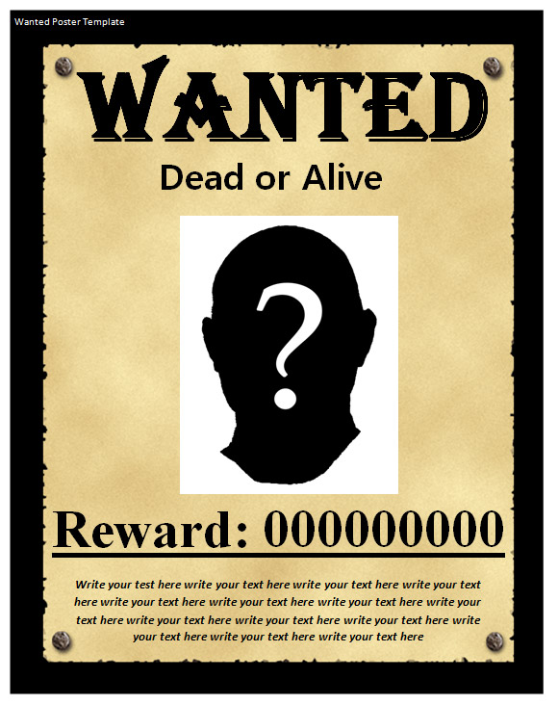
Back side: put answers, photos & video clip here:

FOUND

3. The Grading Rubric
Category | Max. Points | Points Earned | Comments
3 pictures of Serial Killer etc | 3
Works Cited | 2
Complete answers to above questions (ex. DETAILED description of method or procedures used by killer, court cases, etc) | 20
Relevant video clip included | 5
Creativity and Effort are apparent. | 5
Presentation is conversational, rather than “read” out loud and presenter can answer questions about his/her serial killer | 5
Productive use of class time | 10
TOTAL | /50

