Regents Biology Name_______________________________
Notes Period __________ Test Date ________

Chapter 8/19/20 The Working Cell: Energy from Sunlight

Autotroph –

The importance of plants:
Why are heterotrophs dependent on autotrophs?

Comparing plants and animals:

PLANTS ANIMALS

Plant cell Animal cell
A. Cells
Which organelles would you find only in plant or animal cells?

B. Tissues | Examples of plant tissues  1.  2.  3. | Examples of animal tissues  1.  2.
C. Organs | Plants have 4 organs  1.  -  2.  -  3.  -  4.  - | Animals have many organs?  List some you know  1. 4.  2. 5.  3 6.
D. Organ  systems | None | Animals have many organ systems  Examples  1.  2.  3.

Cross-section of a leaf
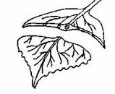

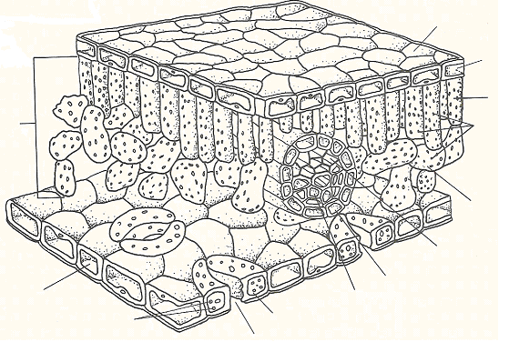
A
B
C
C
D
E
F
G

8.1 Photosynthesis uses light energy to make food. (A metabolic process unique to autotrophs)

Photo = Synthesis =

A. Chloroplasts

1. chlorophyll

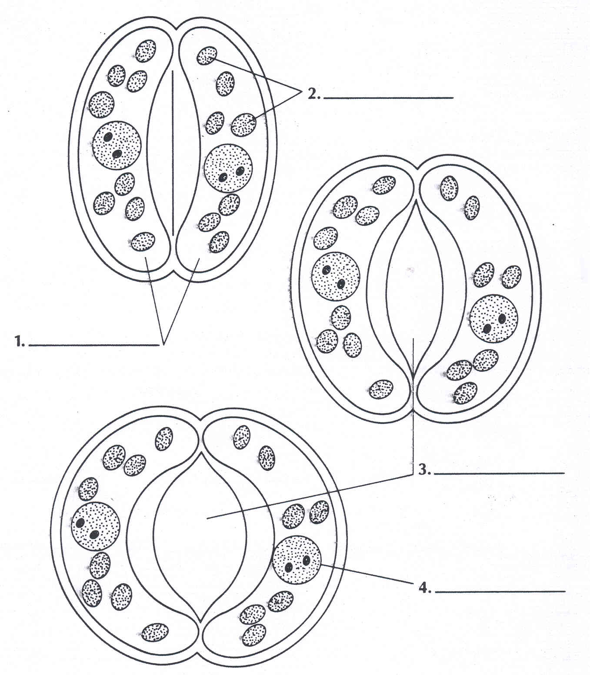
B. Guard cells

C. Stomata

D. Overview of Photosynthesis

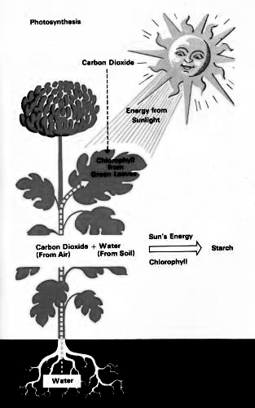
Photosynthesis is a chemical reaction. List the reactants on the left, and the products on the right of the diagram below:

Light Energy

Reactants
Products

Overall chemical equation for photosynthesis:
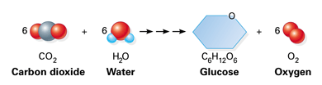

8.2 Light Energy

A. Light Energy and Pigments

1. Electromagnetic Spectrum

2. What is light?

3. What is the main source of light energy?

4. Visible Light:

THE LIGHT SPECTRUM _____ _____ _____ _____ _____ _____ _____

White light is actually a combination of __________________________________

For us to see an object, light energy must enter our _________________________

Objects appear as different colors because. . . .

5. Pigments and Color

What 3 things happen to light when it strikes an object:

1. 2. 3.

6. Identifying Chloroplast Pigments

a. Paper chromatography

Plants absorb only some of the light that strikes them. The rest is reflected away, and the energy associated with that part of the light spectrum is not available for photosynthesis.

Use the data table to make a bar graph of the absorption of light by plants.

R O Y G B

Data Table of Light Absorbance
Color | Absorbed (%)
Red | 80
Orange | 15
Yellow | 10
Green | 5
blue | 90
Based on the graph and your notes…

a. What colors do plants use most for photosynthesis?

b. What colors do plants use least for photosynthesis?

Questions to Consider:

- Why is light is not considered a reactant?

- Where, in the products of photosynthesis, is the energy from the light stored?

- In which organ of a plant does most photosynthesis occur?

- In which layer of the leaf does photosynthesis occur?

- Photosynthesis occurs in which organelle of plant cells?

- What chemical is in the organelle that absorbs light?

- The products of photosynthesis are the reactants for __________________________.
8. What happens to the light absorbed by plants?

- Write the balanced equation for photosynthesis:

Name____________________________________ Per _______ Date ___________________

Observing Stomata and Guard Cells in Leaves

Introduction:
Some of the raw materials and products of photosynthesis enter and exit through stomata in leaves. Guard cells will open or close depending on the environmental conditions.
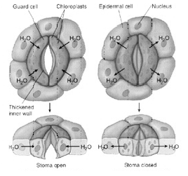

You will be looking at how guard cells and stomata work using a microscope and microviewers.

Station #1: A small part of the underside of a leaf (Wet Mount/Low Water Content):

1. Examine the underside of the leaf with the microscope on high power.

2. Identify and sketch a stoma and its guard cells.

High Power 430 X

3. Name 3 factors that affect photosynthesis:

a.

b.

c.

Station #2: A small part of the underside of a leaf (Wet Mount/High Water Content):

We will now change the environmental condition by placing a few drops of water on a leaf sample.

1. Examine the underside of the leaf with the microscope on high power.

2. Identify and sketch a stoma and its guard cells.

High Power 430 X

3. What happens to the guard cells when placed in water under ideal environmental conditions?

4. Why do you think it was important to observe the underside of leaf as opposed to the top part of the leaf?

Station #3: Microscope (Prepared Slides):
View the slide of the stomates found in the epidermis of a leaf using the high power magnification.

- The cells that regulate the opening and closing of the stomates are called ___________ cells.

- Is the stomate you are looking at on the slide opened or closed? ___________

- What must be plentiful in order for the guard cells to allow the stomates to open? ___________

- The opening and closing of the stomates help to maintain a stable internal environment or ______________________ in the plant.

- When stomates are open gas exchange from the environment to the leaf can occur.
  - What is oxygen used for in the plant? __________________________

  - What is carbon dioxide used for in the plant? _____________________________

Station #4: Microviewer:
Observe images 6 & 7 using the microviewer and answer the questions below. Use your knowledge of biology and the information on the microviewer card to help you.

Image #6
- Can you explain how this mechanism might:
  - Control the rate of photosynthesis?

  - Regulate water loss (transpiration)?

Image #7
- How does this arrangement assure the working cells of a constant supply of CO₂ for photosynthesis?

- How does it provide a way for eliminating the excess O₂ produced by the cells during photosynthesis? For eliminating the excess water in the cells?

What is Transpiration? Name ____________________

Transpiration is the evaporation of water from plants. It occurs chiefly at the leaves while their stomata are open for the passage of CO₂ and O₂ during photosynthesis.
In vascular plants, water is absorbed through the roots and carried upward through the stem to the leaves. The force behind this upward movement is called capillary action, a force of attraction between molecules (recall cohesion & adhesion) that causes liquids to move up narrow tubes, such as those inside a plant's stem.

Some of the water absorbed by a plant's roots is used for photosynthesis, but much is lost to the environment through a process called transpiration. During photosynthesis, tiny pores, on the under-surface of the leaves, called stomata, open to permit the intake of CO₂ and the release of O₂. Because the stomata must remain open for the exchange of gases, large amounts of water are lost to the environment through evaporation. Plants can control the rate of water loss by opening and closing the stomata. Water loss is at its fastest in warm, dry and windy conditions.

Water that evaporates from the leaves is continually replaced with water that is absorbed through the roots. Therefore a plant's rate of transpiration can be measured by observing the amount of water taken up through a plant's roots over a period of time.

Questions:

1. What plant organ looses water by transpiration?

2. Which plant organ takes up water to replace that lost by transpiration?

3. What is the name of the cells on either side of the stomate opening?

4. Describe the conditions in which transpiration will increase.

5. How do stomate openings reduce water loss?

6. Under what conditions is transpiration the slowest?

7. Suppose you coated the leaves of a plant with petroleum jelly. How would the plant's
rate of transpiration be affected?

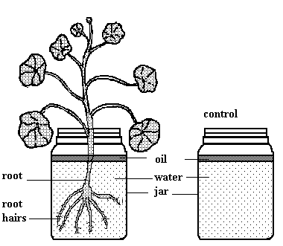

Experimental Set Up:

- Geranium plant in jar of water.
- Layer of oil put on top.
- Control set up (without plant present).
- Let sit for 24 hours.

Observe the diagram and information above.

8. What type of plant was used in this experiment?

9. Why was a layer of oil put on top of the water?

10. What would you expect to observe after 24 hours?

11. What happened to cause the change?

12. What is the dependant variable in this experiment (what would you measure)?

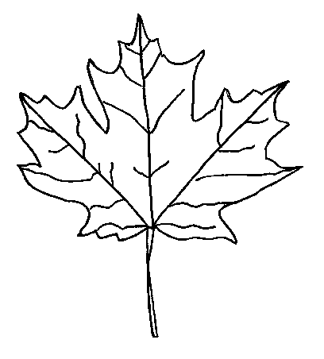
Name___________________________________ Per______ Date_____________

Leaf Chromatography Activity
Background:
Leaves use the green pigment, chlorophyll, to capture the sun’s energy. Using this energy, plants turn water and carbon dioxide into sugar (glucose) and oxygen. This process is called “photosynthesis.” Chlorophyll gives leaves their green color. During the fall, trees prepare for winter by shutting down photosynthesis. As this happens, the green chlorophyll disappears from the leaves. As the green fades, we begin to see yellow and orange. These colors have been there all along, but we couldn’t see them because they were covered by the green. Sugars trapped inside the leaves also react with light and other chemicals to make new colors.

Materials:
- Quarter
- Ruler
- Test tube
- Scissors

- Small section of spinach leaf
- Small cup or beaker
- Chromatography strip
- Solvent

Procedure:
  - Using a ruler measure 3cm from the edge of the chromatography strip.
  - Cut strip into a point.
  - Place a small pencil dot at the 3cm mark.
  - Place the spinach leaf over the pencil mark and use the quarter to “roll” the pigment from the leaf onto the filter paper.
  - Pour solvent into the test tube up to the line.
    - Caution…Do not inhale the fumes; they are toxic!
  - Place the chromatography strip into the test tube so that the bottom is in the solvent.
    - **Make sure the pigment is not in the solvent**
  - Put a stopper on the test tube.
  - Let it sit for about 10 minutes.

Answer the following questions while you are waiting:
- What colors did you observe from the marker demonstration?

- Why was there a difference observed between the 2 black markers?

- What is the main organelle in which green leaf pigments can be found?

- On the microscopic level, what happens when you rolled the coin over the spinach? In your answer include at least five cell components that would be in the mixture.

- What is the role of chlorophyll in plants?

- What colors of light are most effective for photosynthesis?
Remove the chromatography strip and let it dry.
Results:

- What colors can you observe on the chromatogram?

Plant pigments play an important role in capturing light for photosynthesis. These pigments give leaves their colors. For example, chlorophyll pigment makes leaves green. Anthocyanins make leaves red and carotenoids make leaves yellow.
Pigment Color
Carotene yellow/orange
Xanthophyll light yellow
Chlorophyll a green/blue green
Chlorophyll b dull green/olive
Anthocyanin red
- Using the chart to the right, list the pigments that
must be present in spinach leaves?

- Based on your chromatogram, which pigment do you think occurs in the greatest concentration?

- What is the value of chromatography?

- Why do the leaves of different plants appear to be different shades of green?

Consider the picture below for questions 12 through 15.
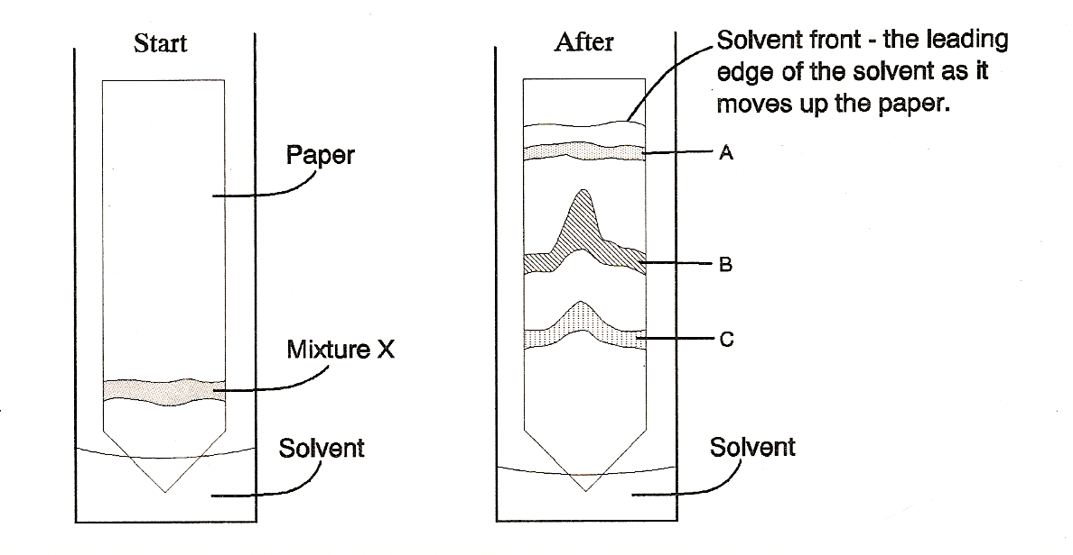

- How many different substances make up mixture X? _____________

- Which substance adheres most loosely to the paper? A B C D

- Which substance adheres most tightly to the paper? A B C D

- What is your reasoning for your answer to question 13 & 14?

Plant Game Activity
Analysis Sheet

Name __________________________ Period ___

Use the Balance Sheet for Plant Growth Activity to record your plant’s results:

At the end of ___ days of growth, my plant had ____ leaves, ____ roots, and ____ flowers.

Calculation the Leaf/Root ratio: Divide the number of leaves by the number of roots. Express the results as decimal value to 2 decimal places.

The Leaf/Root ratio is ________.

Add your results to the class results.

Class Results
Leaf/Root ratio | Total Number of flowers
<0.40
0.40 – 0.50
0.51 – 0.66
0.67 – 0.99
1.00 – 1.49
1.50 – 1.99
2.00 – 2.50
>2.50

Which Leaf / Ratio produced the greatest number of flowers? _______________

Why do you think that this ratio is better than the others? _______________________________

______________________________________________________________________________

Summary

The plant in this game was an annual, which means that it sprouts from a seed, grows roots, leaves, and flowers and then dies, all in one growing season. Why is the winner of the game the plant with the most flowers?

The major factors that influence plant growth and flower production are, the number of leaves, number of roots, and the weather (amount of sun and rainfall). Indicate how each of these factors has an effect on the ability to produce flowers.

# of leaves:
# of roots:
Weather:

If you were to play the game again, what strategy would you implement to attain the most flowers?

Balance Sheet for Plant Growth Activity
Day | Die Value | Water (+,-) | P (y,n) | Number of leaves |  | Photosyn Factor | Sugar produced | Total Sugars | Buy L, R, F | Spend from storage | Sugar stored
1 |  |  |  |  | x
2 |  |  |  |  | x
3 |  |  |  |  | x
4 |  |  |  |  | x
5 |  |  |  |  | x
6 |  |  |  |  | x
7 |  |  |  |  | x
8 |  |  |  |  | x
9 |  |  |  |  | x
10 |  |  |  |  | x
11 |  |  |  |  | x
12 |  |  |  |  | x
13 |  |  |  |  | x
14 |  |  |  |  | x
15 |  |  |  |  | x
16 |  |  |  |  | x
17 |  |  |  |  | x
18 |  |  |  |  | x
19 |  |  |  |  | x
20 |  |  |  |  | x
21 |  |  |  |  | x
22 |  |  |  |  | x
23 |  |  |  |  | x
24 |  |  |  |  | x
25 |  |  |  |  | x
26 |  |  |  |  | x
27 |  |  |  |  | x
28 |  |  |  |  | x
29 |  |  |  |  | x
30 |  |  |  |  | x

