Part II – The “Golden Age” of Islam
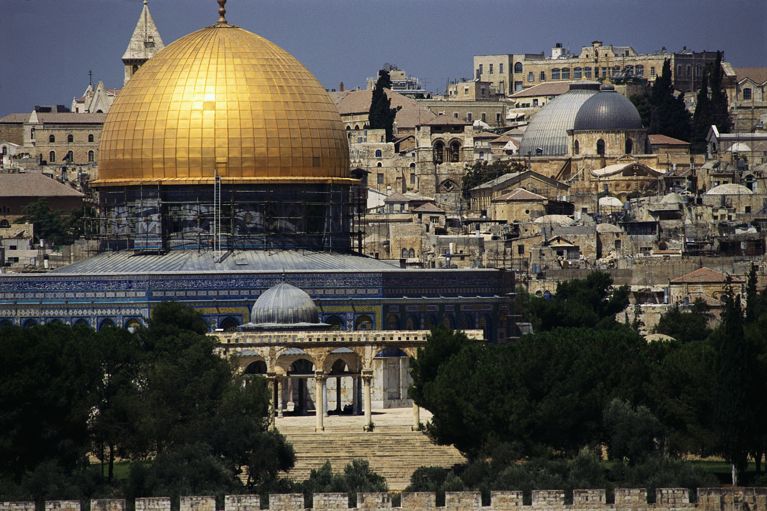

Answer the following question in paragraph form using the web quest you have just completed as support.

The “golden age” of Islamic civilization in the period 750 – 1050 contributed significantly to modern advances in science, mathematics, and medicine. Agree, or disagree with this statement supporting your answer with information from the web quest. Be specific, and the response should be well thought out.

