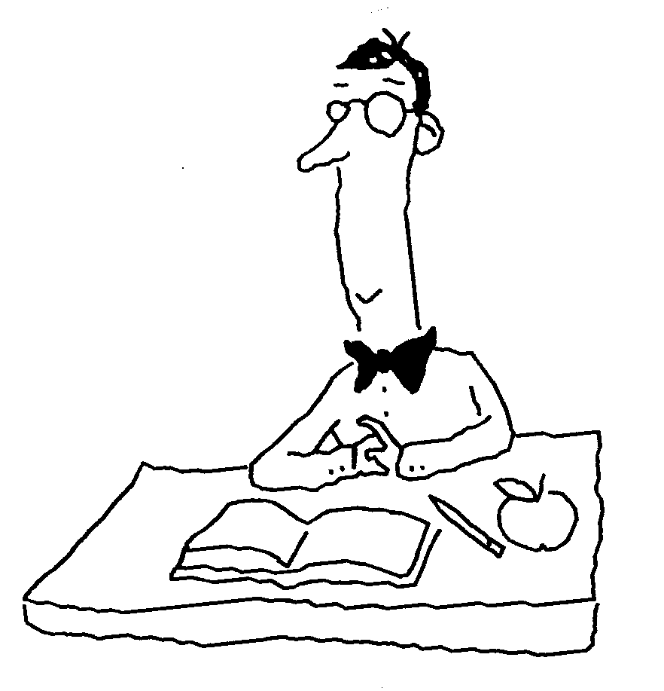
Regents Biology: The Living Environment Name____________________________
Chapter 6: A Tour of the Cell Period_____ Test Date_________

6.1 All organisms are made of cells

I. The Cell Theory

Three important components of the cell theory:

A.

B.

C.

But what about…

A.

B.

C.

II. The 3 Domains:

- Bacteria

- Archaea

- Eukarya

II. General Characteristics of all Cells

- Plasma membrane

\

- Nuclear material

- Cytoplasm

IV. Two Major Classes of Cells

- Prokaryotic cells –

Histone proteins -

2 divisions

Bacteria -

Archaea -

- Eukaryotic cells -

Development of Eukarya
      - Cell membranes can change shape

      - Endocytosis of prokaryotic cells

        - mitochondria

        - chloroplasts

3. Glycogen storage

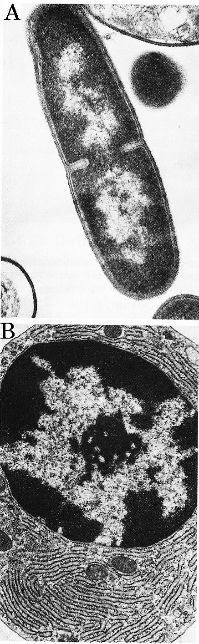
Comparison of Prokaryotic and Eukaryotic cells.
X

Y

The cells in the domain of Bacteria and Archaea differ from cells in the domain of Eukarya. Both Bacteria and Archaea have prokaryotic cells. The Eukarya (Plants, Animals, Fungi, Protists and Algae) have eukaryotic cells. Read the caption below the picture.
nuclear
material
Examine the picture.

1. Summarize the differences between the two basic types of cells.
New cell wall
developing
2. Which picture shows a eukaryotic cell? A B circle one

3. Draw a line from the end of this sentence to the nuclear membrane.

4. The dashed and dotted lines represent cell parts that extend outside of the field of view. What is the name and function of this structure at the end of the arrow?

Name __________________________________

Function: ________________________________

5. In picture A there is a structure marked x that is a
small part of a cell that prokaryotic cell (y) is touching.
Is cell x a prokaryotic or eukaryotic cell?

Prokaryotic Eukaryotic circle one

What evidence do you see in the picture to support your answer?

Prokaryotic and Eukaryotic Cells A prokaryotic cell (A) lacks a nuclear membrane or any other membrane-bound organelles. In contrast, the eukaryotic cell (B) contains many membrane bound organelles, including the nucleus.

Prokaryotic and Eukaryotic Cells.
A prokaryotic cell (A) lacks a nuclear membrane or any membrane-bound organelles. In contrast, the eukaryotic cell (B) contains many membrane bound organelles, including the nucleus.

Compare and Contrast the Domains

Comparison | Similarities | Differences
Bacteria vs Eukarya
Bacteria vs Archaea
Archaea vs Eukarya

Go to History of Life Activity on page 17

6.2 Membranes organize a cell’s activities

I. Membrane structure (Cell Membrane/Plasma Membrane)

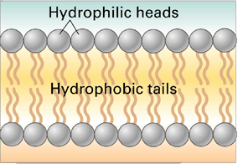
A. Phospholipid bilayer –

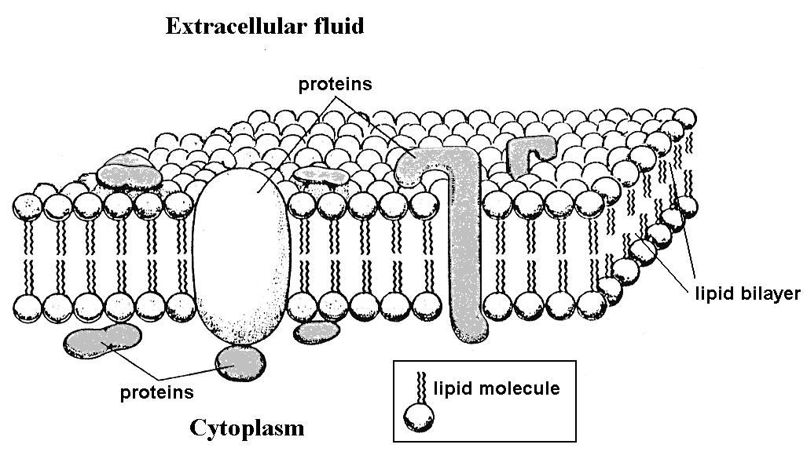

-cell membrane function

-homeostasis

-selectively permeable

- Many functions of Membrane Proteins

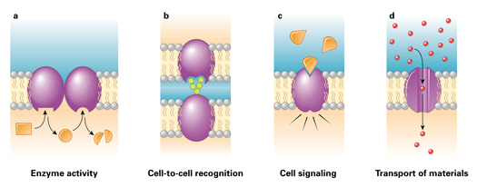

  - Membranes regulate the traffic of molecules.

Types of particles that might cross membranes:

Tiny molecules Small molecules Large molecules

Lipid Soluble Electrically charged Large particles
molecules particles

I. Diffusion

A. Concentration gradient

B. Equilibrium

TRANSPORT:

II. Passive Transport

- Selectively permeable membrane

- Facilitated diffusion

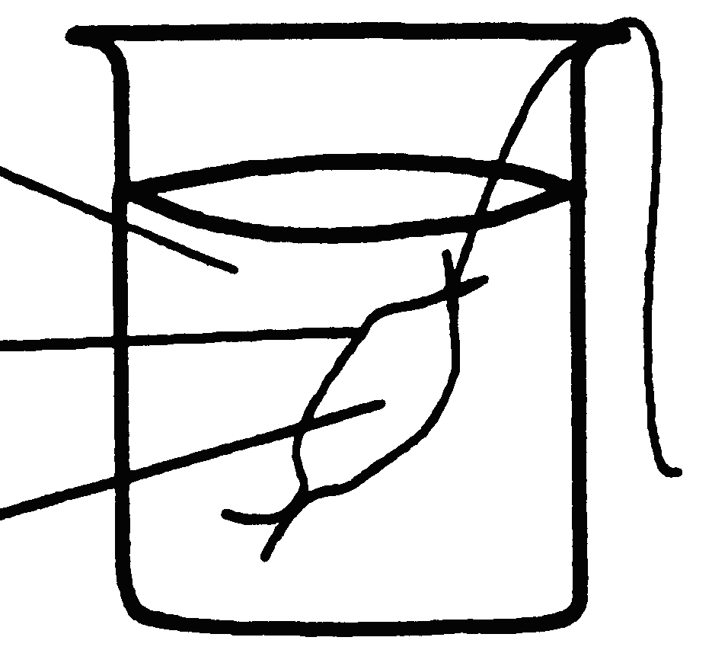
- Dialysis bag demo: (recall lab)

III. Osmosis (recall egg activity)

A. Hypertonic

B. Hypotonic

- Isotonic

thistle tube demo:

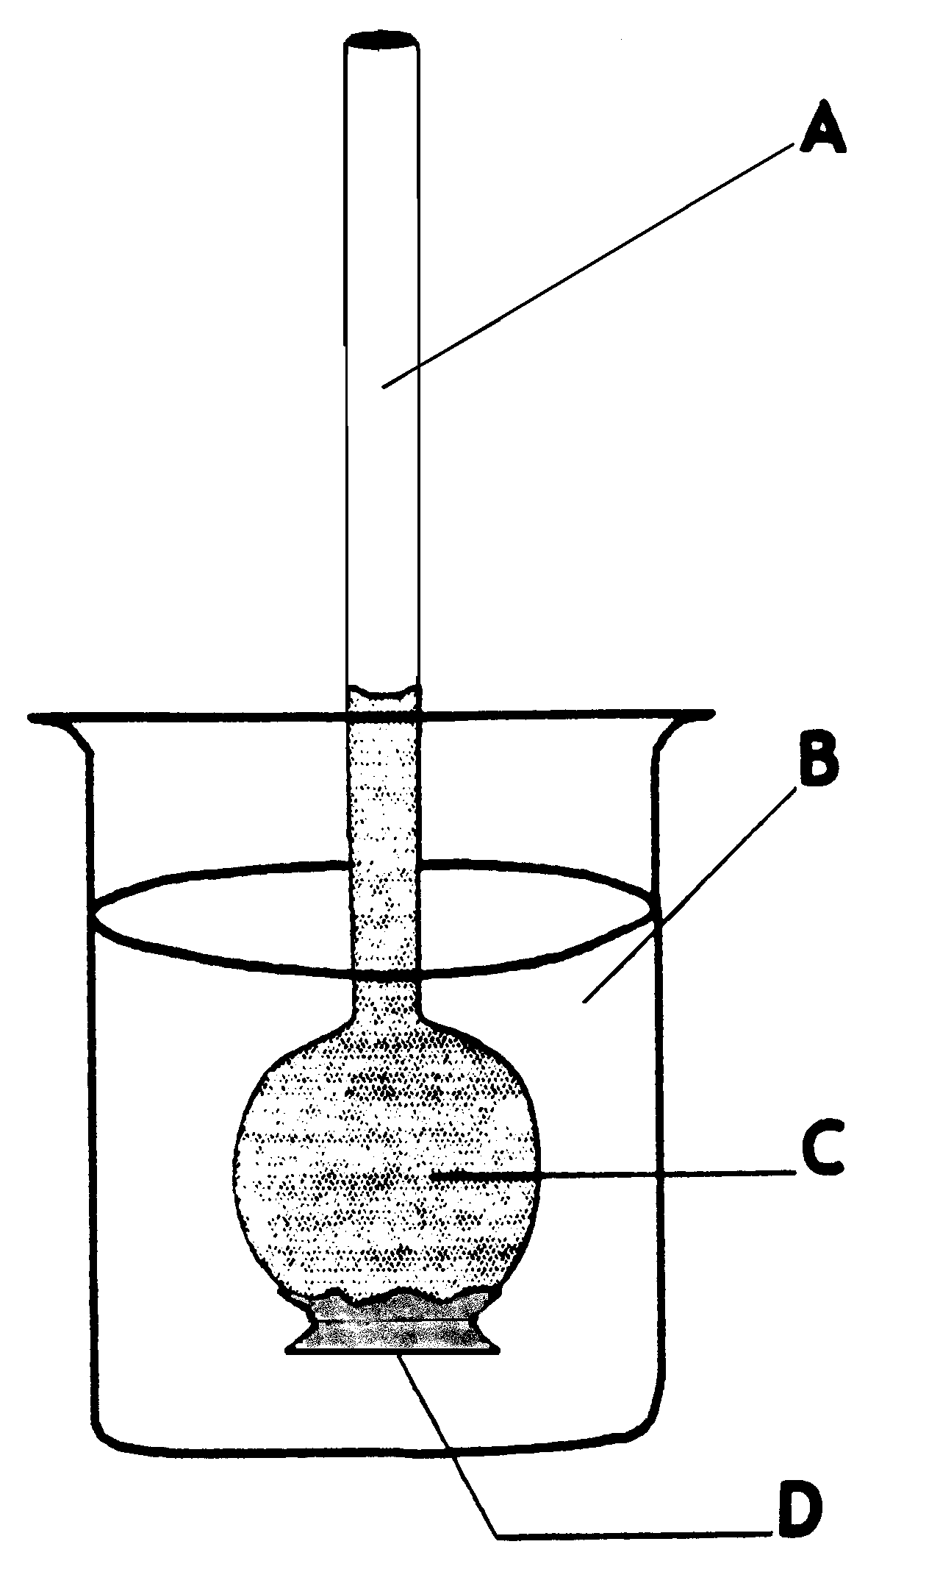

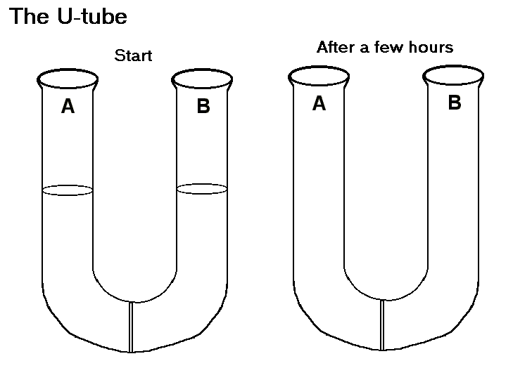

Write a brief description of what will happen in each situation described below.
Be sure to include the following terms: hypertonic, hypotonic, H₂O, osmosis, concentration

- Water Balance in Animal Cells
Describe what happens to red blood cells when placed in distilled water:

Describe what happens to red blood cells when placed in salt water:

- Water Balance in Plant Cells
Describe what happens to plant cells when placed in distilled water:

Describe what happens to plant cells when placed in salt water:

IV. Active transport

- Particles move

-

-

-

Active transport allows:

- Transport of Large Molecules

Vesicles –

  - Endocytosis

    - Phagocytosis

    - Pinocytosis

  - Exocytosis

  - Maintaining water balance in protists:

Summary Chart of the different methods of transport
Method  of  Transport | Uses  Cellular  Energy | Uses  protein  carriers in  the membrane | Follows the  laws of  diffusion | Examples of materials that  use this method of crossing membranes.
Passive
transport
Osmosis
Facilitated
diffusion
(facilitated
transport)
Active
transport
Pinocytosis
Phagocytosis

6.4 The cell builds a diversity of products.

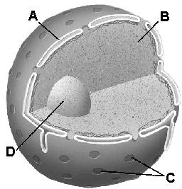
Organelle:

I. Nucleus

- nuclear envelope

- nucleolus

- nuclear pores

II. Ribosomes

III. Endoplasmic Reticulum

- rough vs. smooth

- vesicles

IV. Golgi Apparatus

- vesicles

V. Vacuoles

VI. Lysosomes

VII. Membrane Pathways in a Cell (The Endomembrane System) See Activity

6.5 Chloroplasts and mitochondria energize cells.

I. Chloroplasts

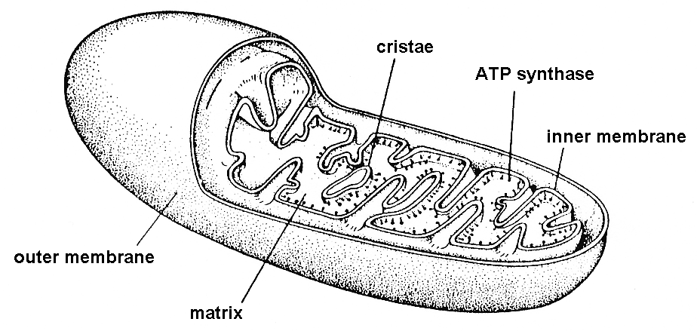

II. Mitochondria

- cristae

- matrix

- ATP

6.6 An internal skeleton supports the cells and enables movement

I. Cytoskeleton

  - Cytoplasm

  - Microtubules

  - Microfilaments

II. Flagella & Cilia

-microtubles

External Support

Cell Wall

Made of: in plants-

in fungi-

Function:

Animal Cell
Found in animal but not plant cells:
1.

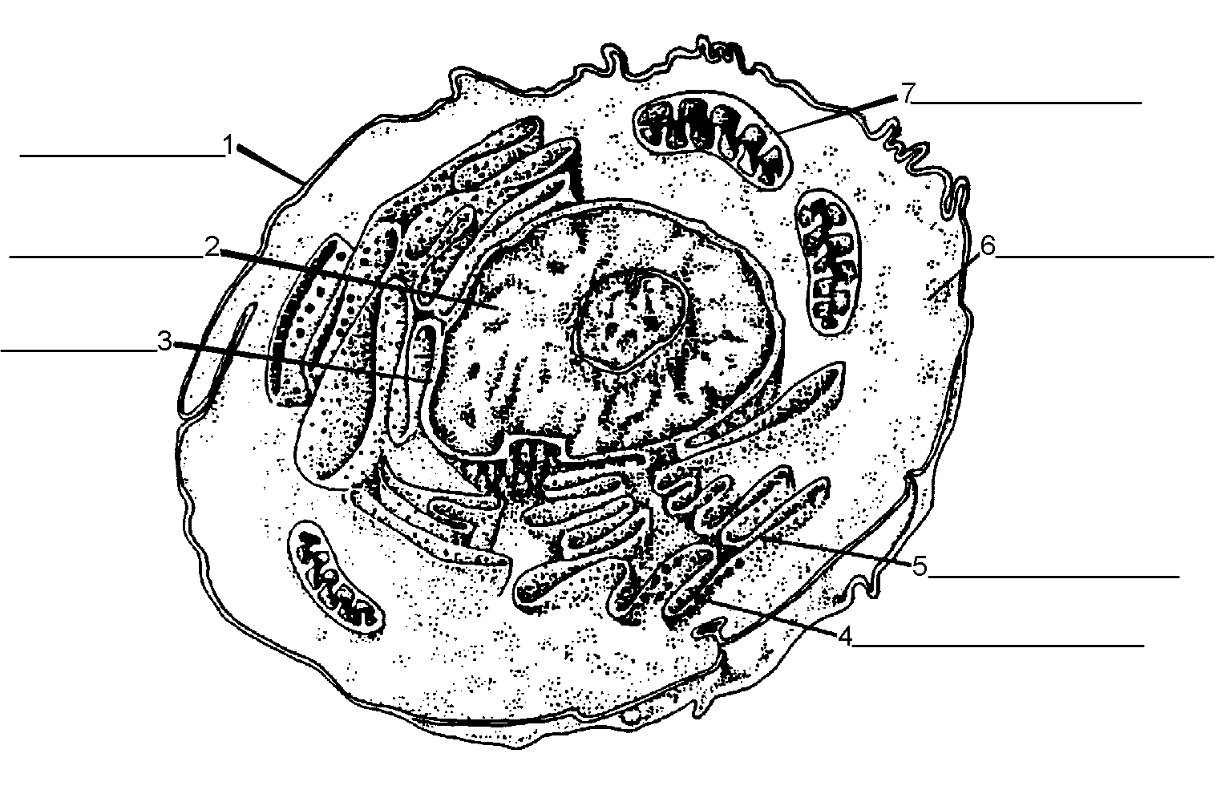
Centrioles:

Found in plant but not in animal cells:
1.
2.
3.

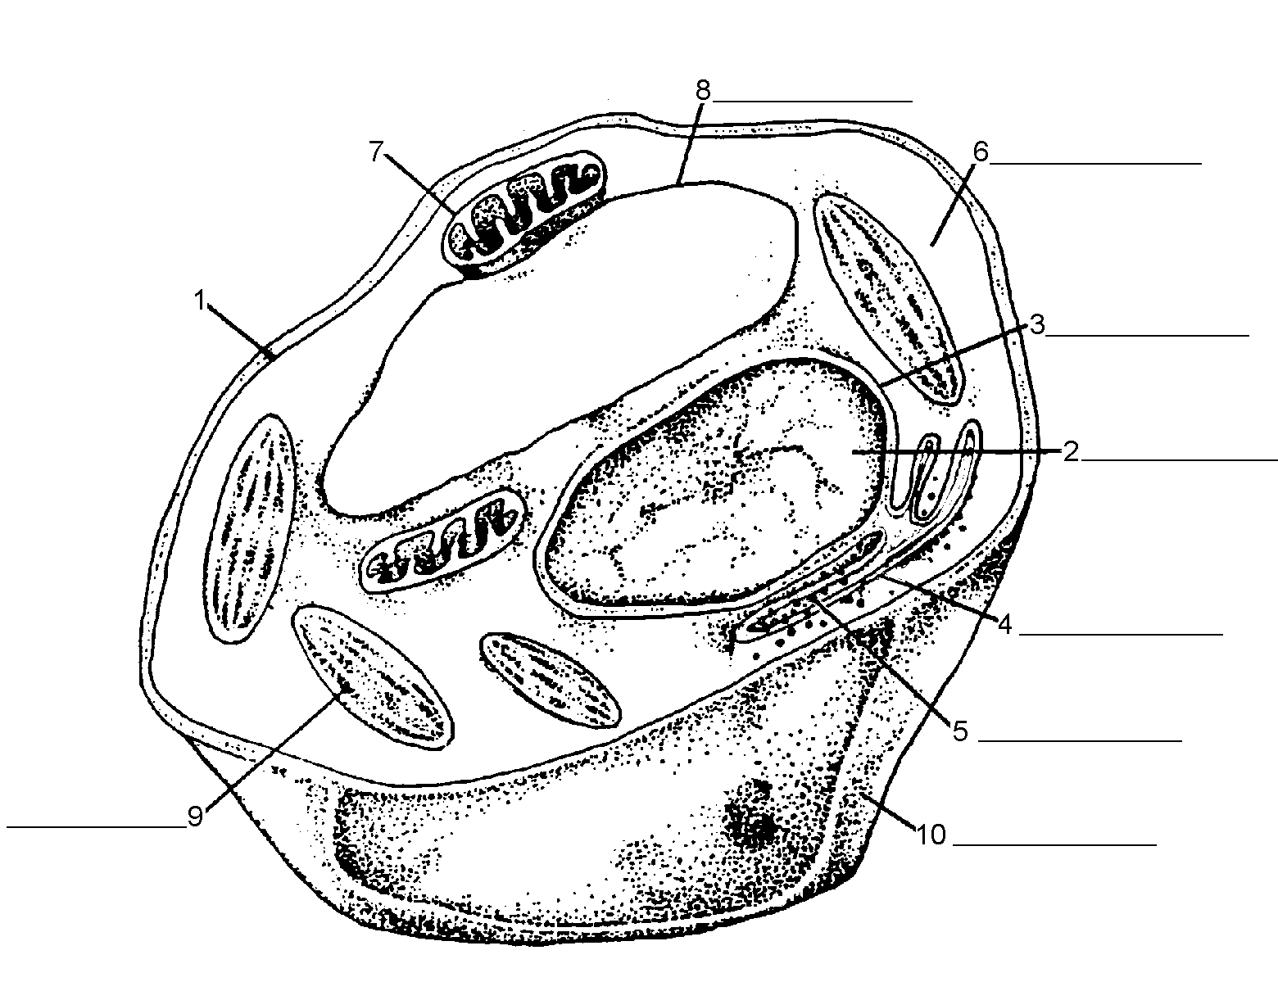
PlantCell

Present? Y or N | Plant Cells | Animal Cells
Cell Wall
Centrioles
Chloroplasts
Large Water Vacuole

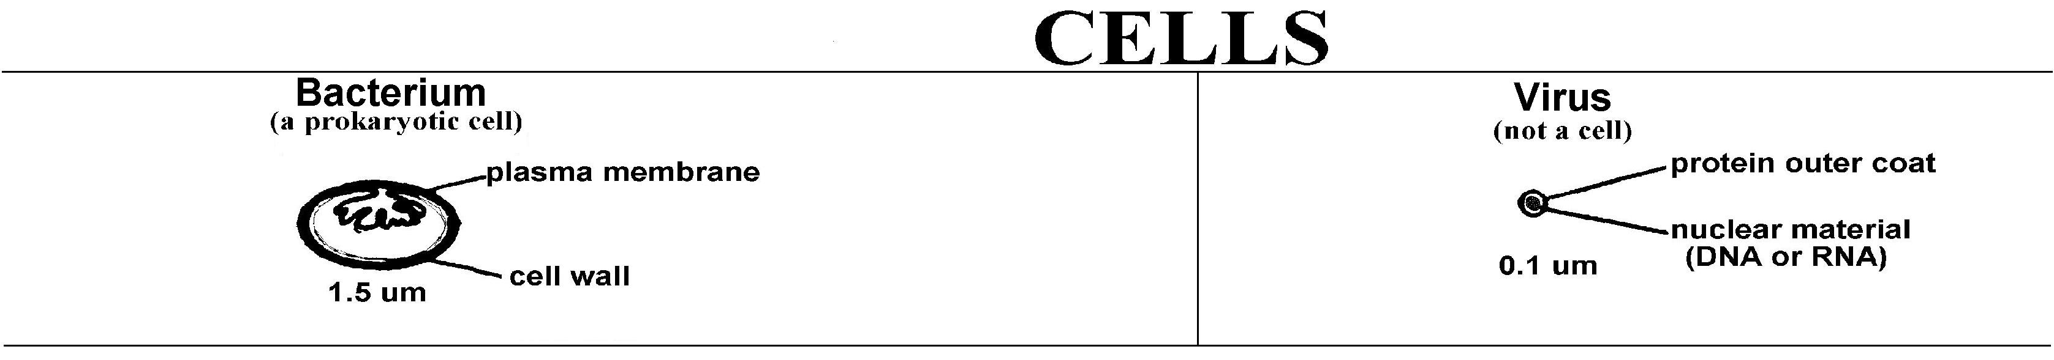
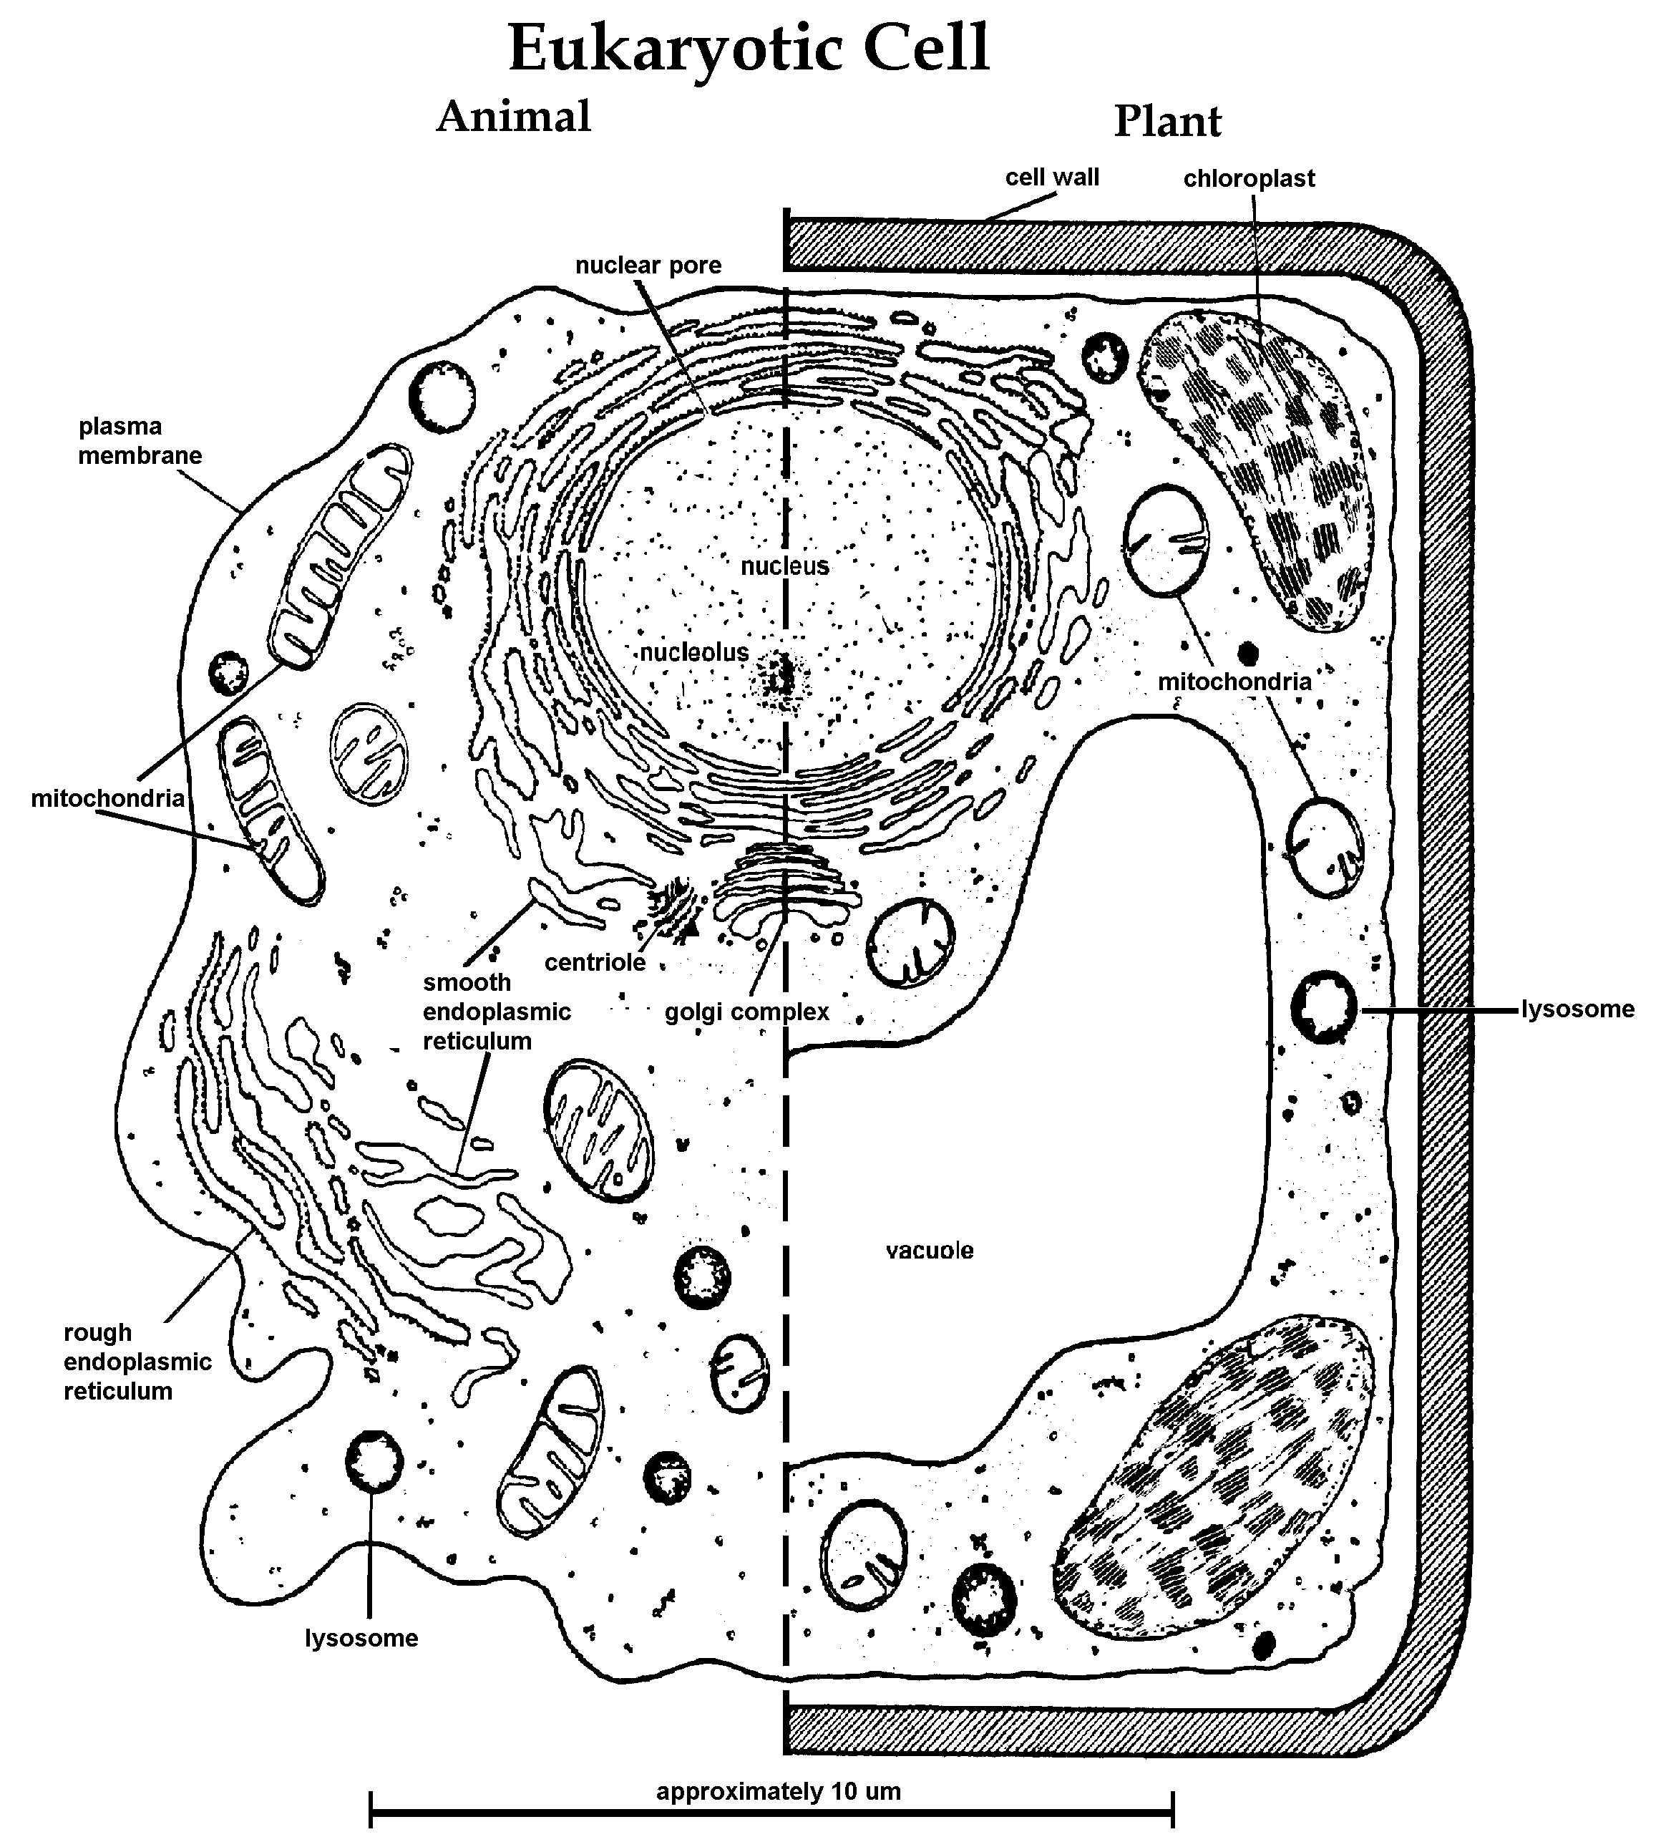

The History of Life Name_________________________

♦Refer to Figure 1, “A simplified chart of the history of life on earth.” Currently all of the living organisms are divided into 3 domains: bacteria, archaea, and eukarya. These 3 groups make up the great diversity on our planet.

- Go back in time 3.5 billion years. How many major types of organisms existed? _______

What do we call these organisms? _________________________________

What structures do you think that these cells had? Circle all that apply:
Cell membrane Nuclear membrane
Cytoplasm Mitochondria
Stored glycogen Chloroplasts
Histones Nuclear Material

- Just prior to 3 billion years ago, how many different types of organisms existed? _______

What structure distinguishes between these organisms?

Which of the following structures were present in cells at this time? Circle all that apply:
Cell membrane Nuclear membrane
Cytoplasm Mitochondria
Stored glycogen Chloroplasts
Histones Nuclear Material

What event happened about 2.7 bya?

Describe how this organelle came to be a part of eukaryotic cells:
3. Around 1 billion years ago, how many different types of organisms existed? _______

Name the types:

Which of the following structures were present in cells at this time? Circle all that apply:

Cell membrane Nuclear membrane
Cytoplasm Mitochondria
Stored glycogen Chloroplasts
Histones Nuclear Material

What event occurred about 1 bya?

Describe how this organelle came to be a part of some cells:

- Presently, how many different types of organisms exist? _______

Name the types:

Which of the following structures were present in cells at this time? Circle all that apply:

Cell membrane Nuclear membrane
Cytoplasm Mitochondria
Stored glycogen Chloroplasts
Histones Nuclear Material

On the list of structures below, put an “A” on the line if the structure is found in the cells of all organisms that currently exist on earth, put an “S” if the structure occurs in some, but not all, organisms.
_____Cell membrane _____Nuclear membrane
_____Cytoplasm _____Mitochondria
_____Stored glycogen _____Chloroplasts
_____Histones _____Nuclear Material

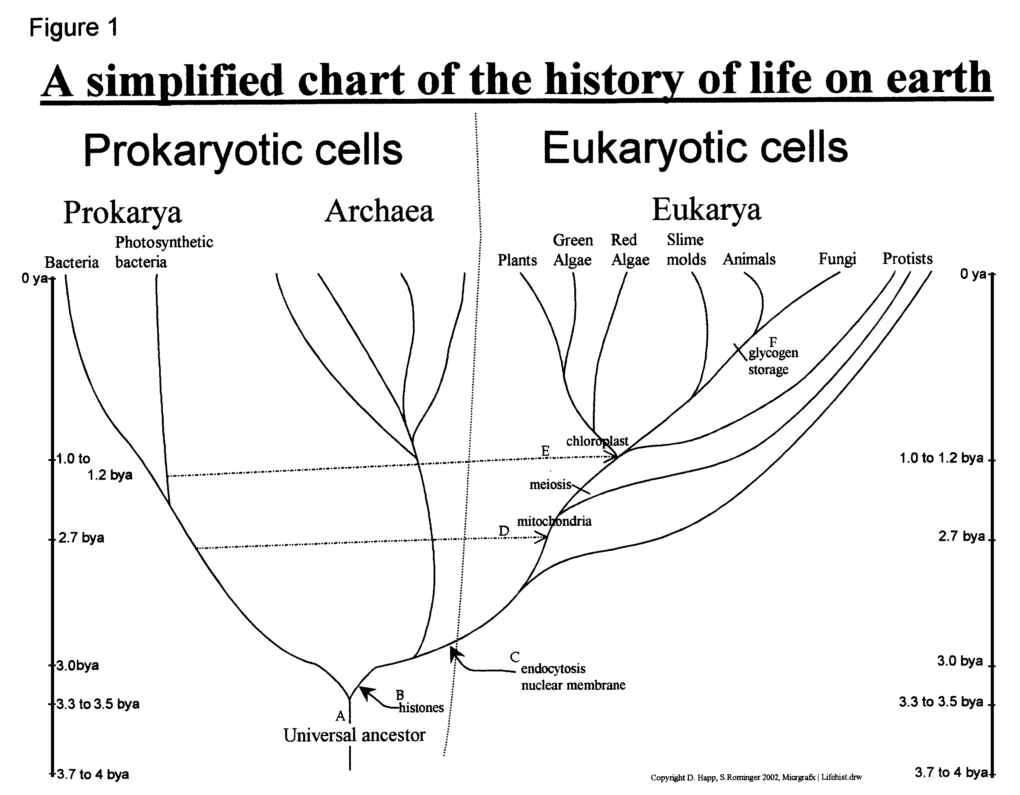
Bacteria

