UNIDAD 2
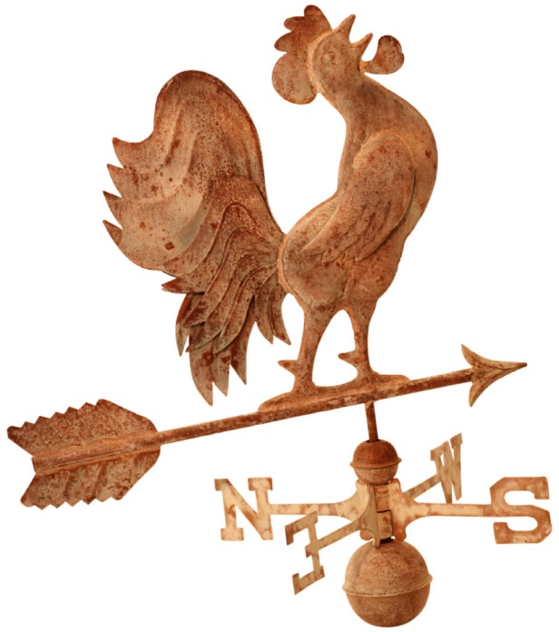
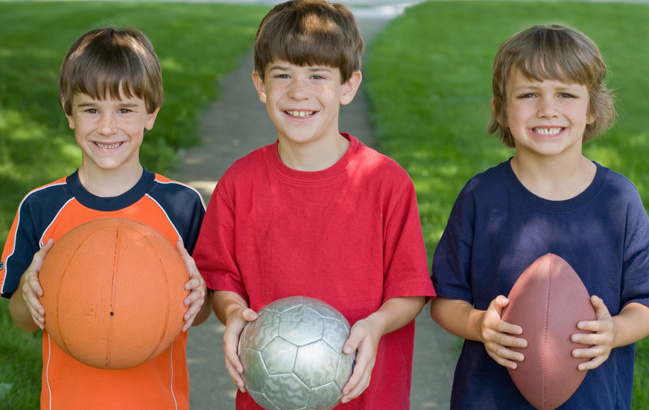
¿Qué te gusta hacer?
El paquete de apuntes

Nombre: _________________________
Base: _____________________
Clase: ____________

Unidad 2: ¿Qué te gusta hacer?
Objectives: In this unit you will learn:

- Weather expressions (18 – 21, 23)
- Seasons (p. 18, 23)

- Sports (p. 198, 212, 213, 218)
- Sports equipment and related vocabulary (p. 198)
- Bullfighting, Jai alai and the Running of the Bulls in Pamplona, Spain (p. 16, 37, 40, 41, )

- Expressing favorites
- Expressing likes and dislikes (p. 26, 27, 30, 37, 38, 46)

- Recreational activities (p. 26, 27, 37, 40, 41, 46)
- Recreational places (p. 172, 194)

¿Qué tiempo hace?
(libro páginas 18, 23)
__________________ __________________
El tiempo_ _____________
Hace viento.
Llueve.
Hace calor.
Nieva.
Hace frío.
Está nublado.
Hace sol.

Hace mal tiempo.

Hace buen tiempo.

Hace fresco.

__________________ __________________

_______________________ _______________________ _______________________

_______________________ _______________________ _____________________

afuera / al aire libre - _______________
1

FYI:
Cellisquea. Está despejado.
It’s sleeting. It’s clear.
Truena. Relampaguea.
It’s thundering. It’s lightening.
Cae granizo. Está húmedo.
It’s hailing. It’s humid.
Hay niebla. Hay tormenta.
It’s foggy. There’s a storm.

Las estaciones -___________________________
(libro página 18, 23)
la primavera
___________________________
el verano
____________________________

el invierno
____________________________
el otoño

____________________________

¿Qué estación es?–
2

LOS DEPORTES - _____________
(libro págs. 198, 212, 213, 218)

¿Cuál es tu deporte favorito? _____________________________
Mi deporte favorito es…. ________________________________

el fútbol ___________________________

el fútbol americano __________________

el baloncesto _______________________

el volibol ___________________________ el vóleibol

el béisbol ___________________________

el hockey ___________________________

el golf ______________________________

el tenis _____________________________

la corrida de toros _____________________

el jai alai ____________________________

el lacrosse ___________________________

la natación ____________________________

el boxeo ______________________________

la lucha libre ___________________________

FYI:
el boliche _____________________________
el monopatín _________________________
la gimnasia ___________________________
el surf de nieve ________________________
la equitación __________________________
el esquí ______________________________
3
la pesca _____________________________
VOCABULARIO DE LOS DEPORTES

el partido _______________________
( un partido de béisbol – a baseball game)

el equipo _______________________
(equipo de hockey – hockey team)

¡Buena suerte! ________________

FYI: ¡Olé! ___________________

ARTÍCULOS DEPORTIVOS ____ (libro página 198)

¿Qué necesitas para….? _________________________
(Yo) Necesito……. ______________________________

la pelota ___________________
(la pelota de béisbol)

el balón ___________________
(el balón de fútbol)

el bate ____________________

el guante __________________

la raqueta _________________

el casco ___________________

la red _____________________

FYI ... los esquís _____________
los patines _______________________
la caña de pescar ___________________
los palos (de golf, de hockey) ________________
la pista _______________________
el campo de fútbol __________________
4
la corrida de toros
La corrida de toros (bullfighting) originated in Spain and dates back to the year 415. In Spain it is technically considered an art and not a sport. The conquistadores brought bullfighting to the Americas in 1500. It is now popular in Spain and parts of Latin America (mainly Mexico, Colombia, Peru and Venezuela). In Spain the bullfight is a major part of practically every major fiesta (festival).
In Mexico the bullfighting season lasts from November to March (Spain from March to October). The bullring is called la plaza de toros and the largest of all is the Plaza de México in Mexico City seating 55,000. Seating for a bullfight is priced according to whether you sit in the sol (sun) or sombra (shade). Sombra is the most expensive, sol is the cheapest and sol y sombra is in the middle.
La corrida de toros has three parts. First is el paseo (parade) when those who will be participating in the bullfight enter and then observe and test the bull's behavior. During the second part the picadores (lancers on horseback) jab the nape of the bull's neck (to weaken the muscles that enable it to toss its head) and the banderilleros place banderillas (darts covered with colorful paper) in the neck. During the third part the matador (killer of the bull) capes the animal in a colorful display of bravery and grace. Finally el momento de la verdad (the moment of truth), the matador kills the bull with a sword through the heart.
In each corrida de toros, six bulls are fought, two by each matador. The spectators show their approval by applauding and shouting ¡Olé! and sometimes by waving handkerchiefs. There are several possible awards depending on the performance of the matador. He may be given one or more of the following; oreja(s), rabo (tail), or pata(s) (hoof) of the bull.
Many people enjoy the bullfight and find it exciting involving great courage and skill. Others oppose bullfighting feeling that it is cruel and barbaric. In 2010, lawmakers voted to outlaw bullfighting in Catalonia, a northeastern region of Spain. Some argue that without la corrida de toros these animals would have no existence at all since the toros de lidia are raised solely for bullfighting. How do you feel?

(Source: The Hispanic Way Noble and Lacasa ©1991)

el toro
el traje de luces
el matador
la montera
la capa

5
Jai alai
The game is jai alai (pronounced HIGH-lie), also called pelota vasca. The sport started in the Basque region of Spain in the 1600's. It reached Cuba around 1900 and arrived in Miami in 1924. Jai alai is a popular spectator sport in Mexico, Cuba, Spain and in Florida in the U.S. The season runs from October to June.
Jai alai is similar to handball and is one of the fastest and most demanding sports ever devised. It is played on a long (about 176 ft. long, nearly two-thirds the length of a football field) three-walled court called a frontón. The fourth side, one of the long ones, is made of wire mesh to protect the spectators from the ball. The largest frontón in the world is in Miami Florida and seats 5,100. Each player is equipped with a cesta, a long scooplike wicker basket that is strapped to one hand, to catch the ball. The pelota (ball) is constructed of hard wound rubber covered with linen thread and then two layers of goatskin.
As in handball, jai alai can be played in singles (one-on-one) or doubles (two-on-two). The ball must hit the front wall on the fly. The opponents must catch it on the fly or on one bounce and return it to the frontis (front wall) without the ball hitting the ground. The ball can travel up to 150 miles per hour! With a good hit, the ball smashes against the front wall and soars all the way to the back wall. When this happens the crowd lets out a thundering cry: "Rebote!”
Eight teams play in a round-robin game with seven points needed to win. When a team wins a point, it stays on the court to meet the next team while its opponents sit down and wait for another chance. Players wear white uniforms with a colored arm band to identify teams. Players are all professionals and receive salaries comparable to U.S. professional athletes. Many fans go to jai alai matches to bet on the outcome, but try watching this beautiful and dangerous sport just for the thrill.

(Souces: The Hispanic Way © 1991 and Sports Gear)

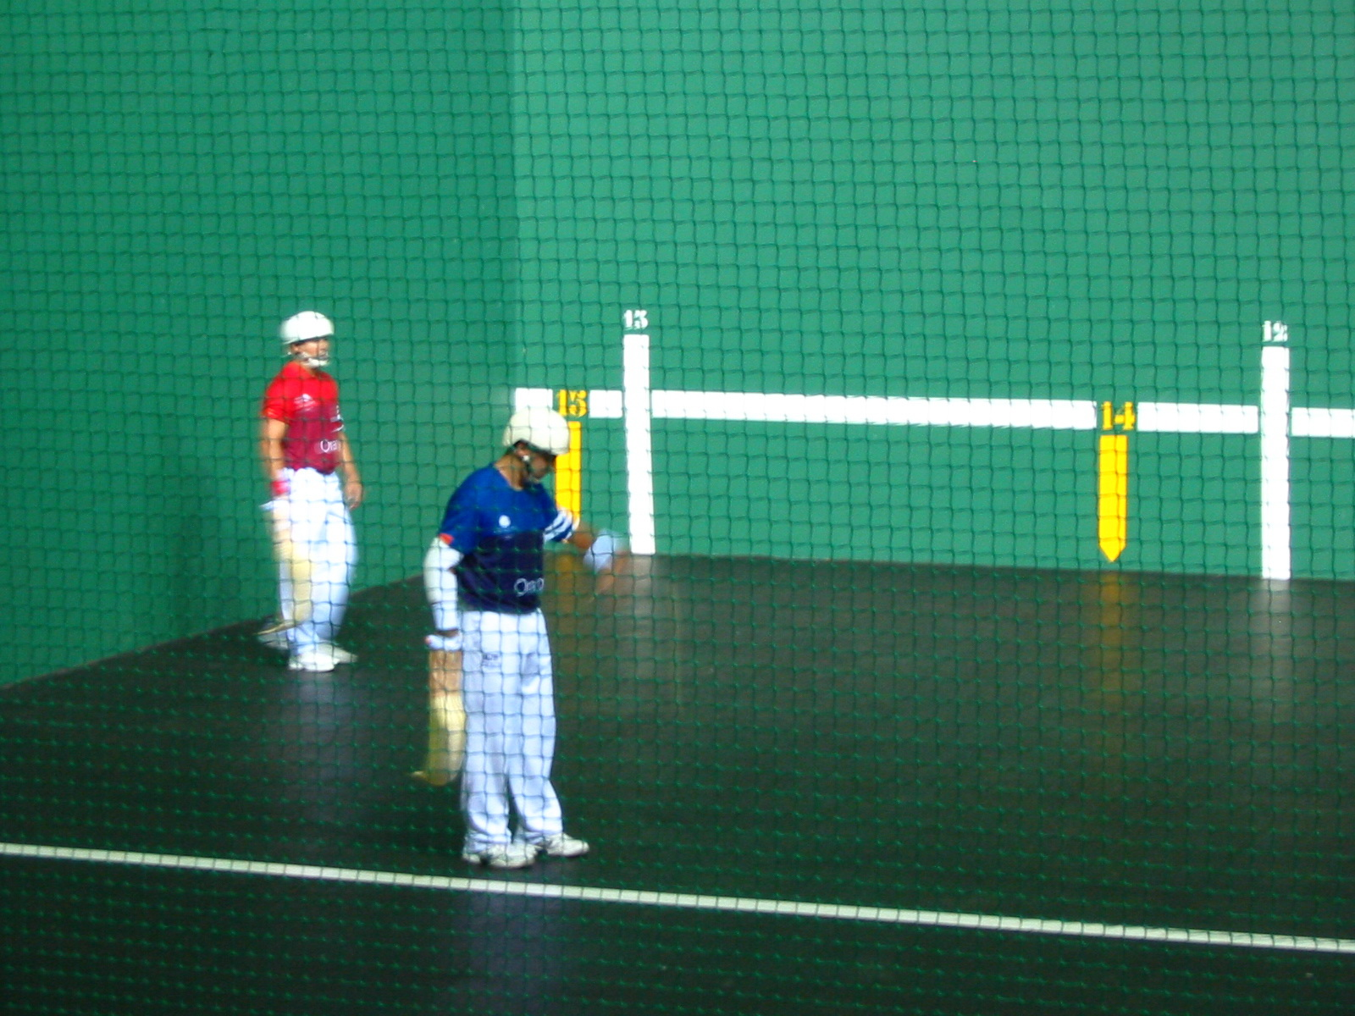

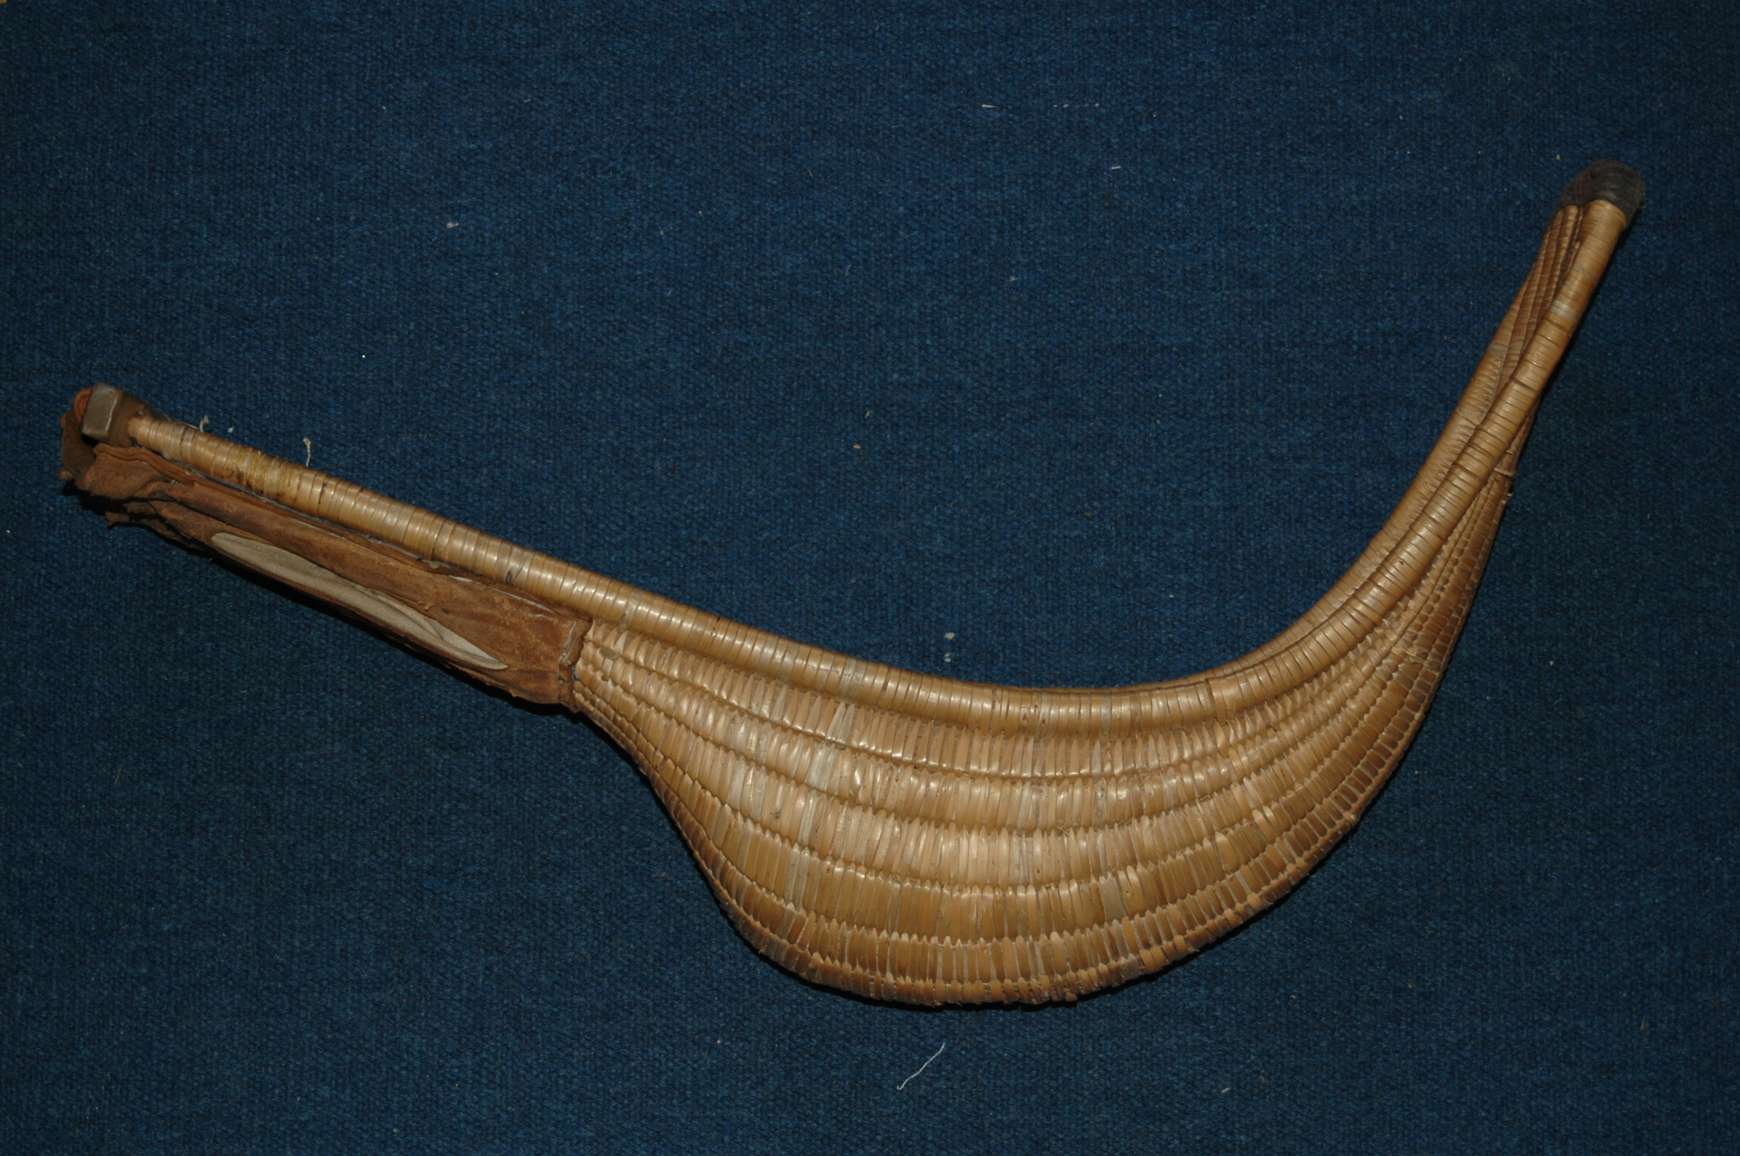

6
LAS PREFERENCIAS- _______________
(libro págs. 26, 27, 30, 37, 38, 46)

To express degrees of liking or disliking:

(Yo) Odio No me gusta(n) Me gusta(n) Me encanta(n)
____________ _______________ _____________ _____________

~~~~~~~~~~~~~~~~~~~~~~~~~~~~~~~~~~~~~~~~~~~~~~~~~~~~~~~~~
¿Qué te gusta? - ____________________________

¿Te gusta(n).....? - ____________________________

Sí, me gusta(n) ....... - ___________________________
Sí, me encanta(n) ....... - _________________________
No, no me gusta.... - ____________________________
No, (yo) odio.... - _______________________________
*(Yo) No sé. - __________________________________

A mí también. - ___________________
A mí tampoco. - ___________________

Ejemplos:
Me gustan los deportes mucho. __________________________________
Me encanta el volibol también. ___________________________________

~~~~~~~~~~~~~~~~~~~~~~~~~~~~~~~~~~~~~~~~~~~~~~~~~~~~~~~~~
FYI:
A mí me gusta ……. __________________________________________________
No me gusta nada. ____________________________________________________
No me gusta ni ……. ni ……. ___________________________________________

Ejemplos:
No me gusta nada el esquí. _____________________________________
No me gusta ni la natación ni el fútbol. _____________________________
No me gusta nada. ____________________________________________
7
LAS ACTIVIDADES - _______________
(libro páginas 26, 27, 46)

¿Cuál es tu actividad favorita? ________________________
Mi actividad favorita es…. _____________________________
¿Qué te gusta hacer? ________________________________
¿Te gusta…? _______________________________________

hablar por teléfono (celular) _____________________________

escuchar música _____________________________________

ver la tele ___________________________________________
ver una película ______________________________________

jugar videojuegos ____________________________________

usar la computadora __________________________________

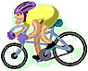
practicar deportes __________________

correr __________________ pescar ____________________

patinar _____________________ esquiar ____________________

nadar ______________________ jugar al….. _________________

montar en bicicleta - ________________________
(montar a caballo - ________________________)

dibujar - _________________ bailar - _____________________
leer - _______________________ cantar - _____________________
pasar tiempo con amigos - __________________

ir de compras - _______________

ir a... - ______________

FYI: cocinar - ____________________________
comer - _____________________________
8

LOS LUGARES - ________________________
(libro páginas 172, 194)
Me gusta ir a….. - ___________________

las montañas - ________________
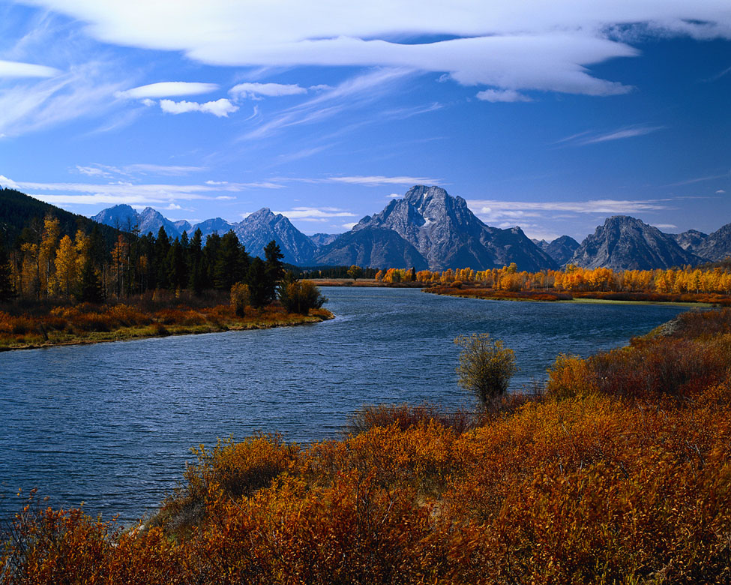

el lago - ___________________

el parque - ___________________
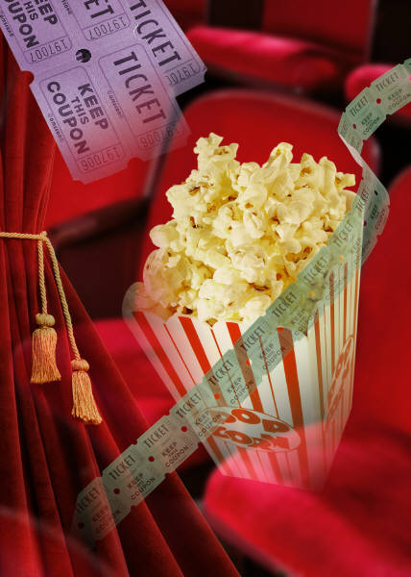



el cine - __________________

el centro comercial - ____________

la biblioteca - __________________

el estadio - ________________
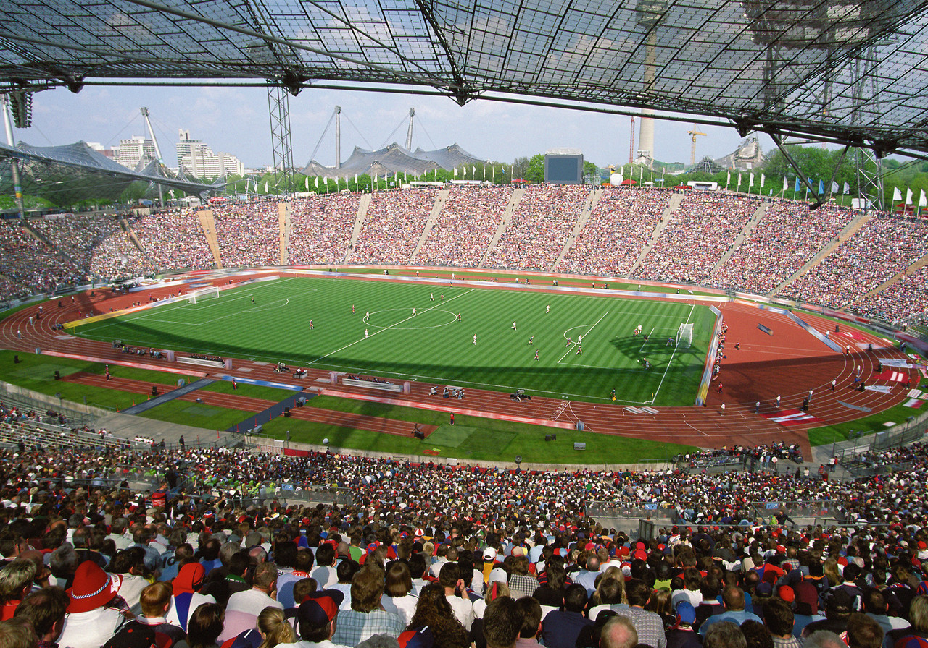

la plaza de toros - ________________________

el gimnasio - _______________
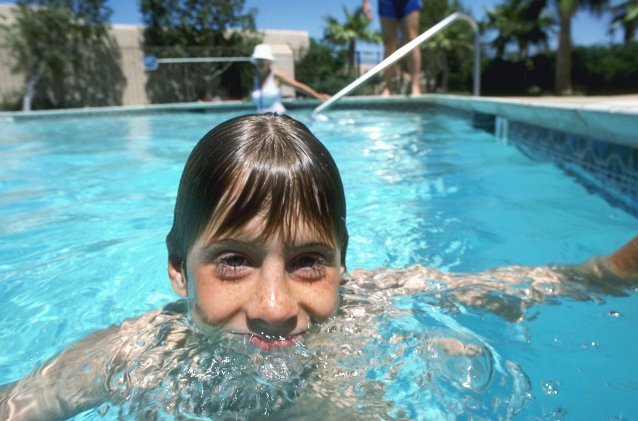
la playa - _____________________

la piscina - _________________

Ejemplos:
Me gusta ir al parque. _____________________________________
No me gusta ir a la playa. __________________________________
Me gusta ir a las montañas. ________________________________

¿Adónde vas? - ____________________
Voy a…. - _________________________

Ejemplos:
Voy al parque. ______________________________________
Voy a la playa. ______________________________________
Voy a las montañas. _________________________________
9

