UNIDAD 2
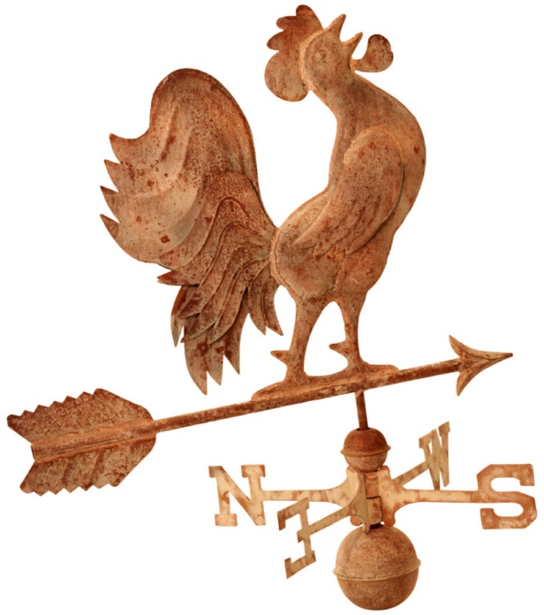
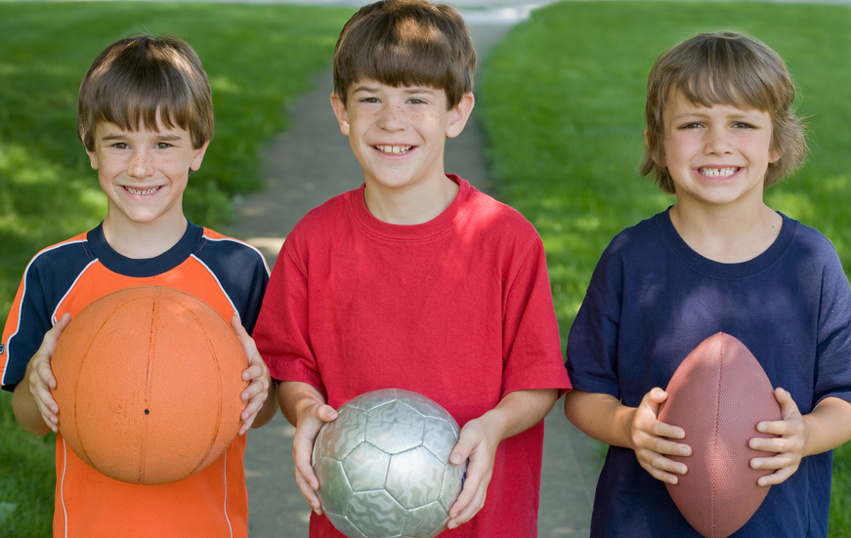
¿Qué te gusta hacer?
El paquete de apuntes

Nombre: _________________________
Base: _____________________
Clase: ____________

Unidad 2: ¿Qué te gusta hacer?
Objectives: In this unit you will learn:

- Weather expressions (18 – 21, 23)
- Seasons (p. 18, 23)

- Sports (p. 198, 212, 213, 218)
- Sports equipment and related vocabulary (p. 198)
- Bullfighting, Jai alai and the Running of the Bulls in Pamplona, Spain (p. 16, 37, 40, 41, )

- Expressing favorites
- Expressing likes and dislikes (p. 26, 27, 30, 37, 38, 46)

- Recreational activities (p. 26, 27, 37, 40, 41, 46)
- Recreational places (p. 172, 194)

Español 7 Unidad 2 Fecha _______________________________

¿Qué tiempo hace? What’s the weather like?
(libro páginas 18, 23)
__________________ __________________
El tiempo_the weather
Hace viento. It’s windy.
Llueve.It’s raining.
Hace calor.It’s warm.
Nieva.It’s snowing.
Hace frío.It’s cold.
Está nublado.
Hace sol. It’s sunny. It’s cloudy.

Hace mal tiempo. It’s bad weather.

Hace buen tiempo. It’s good weather.

Hace fresco. It’s chilly.

__________________ __________________

_______________________ _______________________ _______________________

_______________________ _______________________ _____________________

afuera / al aire libre - _______________
1

FYI:
Cellisquea. Está despejado.
It’s sleeting. It’s clear.
Truena. Relampaguea.
It’s thundering. It’s lightening.
Cae granizo. Está húmedo.
It’s hailing. It’s humid.
Hay niebla. Hay tormenta.
It’s foggy. There’s a storm.

Las estaciones -__the seasons____________
(libro página 18, 23)
la primavera
____the spring______________
el verano
_____the summer_________

el invierno
_______the winter____
el otoño

____the fall_______

¿Qué estación es?– What season is it?
2

LOS DEPORTES - _the sports___
(libro págs. 198, 212, 213, 218)

¿Cuál es tu deporte favorito? _What is your favorite sport?____
Mi deporte favorito es…. _My favorite sport it ….._

el fútbol _soccer__________________

el fútbol americano __football______

el baloncesto __basketball________

el volibol _volleyball_____________ el vóleibol

el béisbol _baseball__________________

el hockey _hockey__________________

el golf ___golf______________________

el tenis _tennis______________________

la corrida de toros _bullfighting__________

el jai alai __jai alai__________________

el lacrosse __lacrosse____________

la natación __swimming_________________

el boxeo __boxing___________________

la lucha libre __wrestling_______________

FYI:
el boliche __bowling____________________
el monopatín __skateboarding____________
la gimnasia _gymnastics________________
el surf de nieve ___snowboarding__________
la equitación __horseback riding___________
el esquí _skiing______________________
3
la pesca ___fishing__________________
VOCABULARIO DE LOS DEPORTES

el partido __the game___________
( un partido de béisbol – a baseball game)

el equipo __the team/the equipment____
(equipo de hockey – hockey team)

¡Buena suerte! _Good luck!_____

FYI: ¡Olé! ___________________

ARTÍCULOS DEPORTIVOS Sport supplies (libro página 198)

¿Qué necesitas para….? What do you need for….?
(Yo) Necesito……. I need ……….

la pelota __the ball (smaller)___
(la pelota de béisbol)

el balón __the ball (larger)__
(el balón de fútbol)

el bate _the bat___________

el guante __the glove_______

la raqueta __the racket_____

el casco __the helmet_______

la red _the net___________

FYI ... los esquís =the skis
los patines = the skates
la caña de pescar = the fishing pole
los palos (de golf, de hockey) = the golf club/the hockey stick
la pista = the ski slope
el campo de fútbol = the soccer field
4
la corrida de toros
La corrida de toros (bullfighting) originated in Spain and dates back to the year 415. In Spain it is technically considered an art and not a sport. The conquistadores brought bullfighting to the Americas in 1500. It is now popular in Spain and parts of Latin America (mainly Mexico, Colombia, Peru and Venezuela). In Spain the bullfight is a major part of practically every major fiesta (festival).
In Mexico the bullfighting season lasts from November to March (Spain from March to October). The bullring is called la plaza de toros and the largest of all is the Plaza de México in Mexico City seating 55,000. Seating for a bullfight is priced according to whether you sit in the sol (sun) or sombra (shade). Sombra is the most expensive, sol is the cheapest and sol y sombra is in the middle.
La corrida de toros has three parts. First is el paseo (parade) when those who will be participating in the bullfight enter and then observe and test the bull's behavior. During the second part the picadores (lancers on horseback) jab the nape of the bull's neck (to weaken the muscles that enable it to toss its head) and the banderilleros place banderillas (darts covered with colorful paper) in the neck. During the third part the matador (killer of the bull) capes the animal in a colorful display of bravery and grace. Finally el momento de la verdad (the moment of truth), the matador kills the bull with a sword through the heart.
In each corrida de toros, six bulls are fought, two by each matador. The spectators show their approval by applauding and shouting ¡Olé! and sometimes by waving handkerchiefs. There are several possible awards depending on the performance of the matador. He may be given one or more of the following; oreja(s), rabo (tail), or pata(s) (hoof) of the bull.
Many people enjoy the bullfight and find it exciting involving great courage and skill. Others oppose bullfighting feeling that it is cruel and barbaric. In 2010, lawmakers voted to outlaw bullfighting in Catalonia, a northeastern region of Spain. Some argue that without la corrida de toros these animals would have no existence at all since the toros de lidia are raised solely for bullfighting. How do you feel?

(Source: The Hispanic Way Noble and Lacasa ©1991)

el toro
el traje de luces
el matador
la montera
la capa

5
Jai alai
The game is jai alai (pronounced HIGH-lie), also called pelota vasca. The sport started in the Basque region of Spain in the 1600's. It reached Cuba around 1900 and arrived in Miami in 1924. Jai alai is a popular spectator sport in Mexico, Cuba, Spain and in Florida in the U.S. The season runs from October to June.
Jai alai is similar to handball and is one of the fastest and most demanding sports ever devised. It is played on a long (about 176 ft. long, nearly two-thirds the length of a football field) three-walled court called a frontón. The fourth side, one of the long ones, is made of wire mesh to protect the spectators from the ball. The largest frontón in the world is in Miami Florida and seats 5,100. Each player is equipped with a cesta, a long scooplike wicker basket that is strapped to one hand, to catch the ball. The pelota (ball) is constructed of hard wound rubber covered with linen thread and then two layers of goatskin.
As in handball, jai alai can be played in singles (one-on-one) or doubles (two-on-two). The ball must hit the front wall on the fly. The opponents must catch it on the fly or on one bounce and return it to the frontis (front wall) without the ball hitting the ground. The ball can travel up to 150 miles per hour! With a good hit, the ball smashes against the front wall and soars all the way to the back wall. When this happens the crowd lets out a thundering cry: "Rebote!”
Eight teams play in a round-robin game with seven points needed to win. When a team wins a point, it stays on the court to meet the next team while its opponents sit down and wait for another chance. Players wear white uniforms with a colored arm band to identify teams. Players are all professionals and receive salaries comparable to U.S. professional athletes. Many fans go to jai alai matches to bet on the outcome, but try watching this beautiful and dangerous sport just for the thrill.

(Souces: The Hispanic Way © 1991 and Sports Gear)

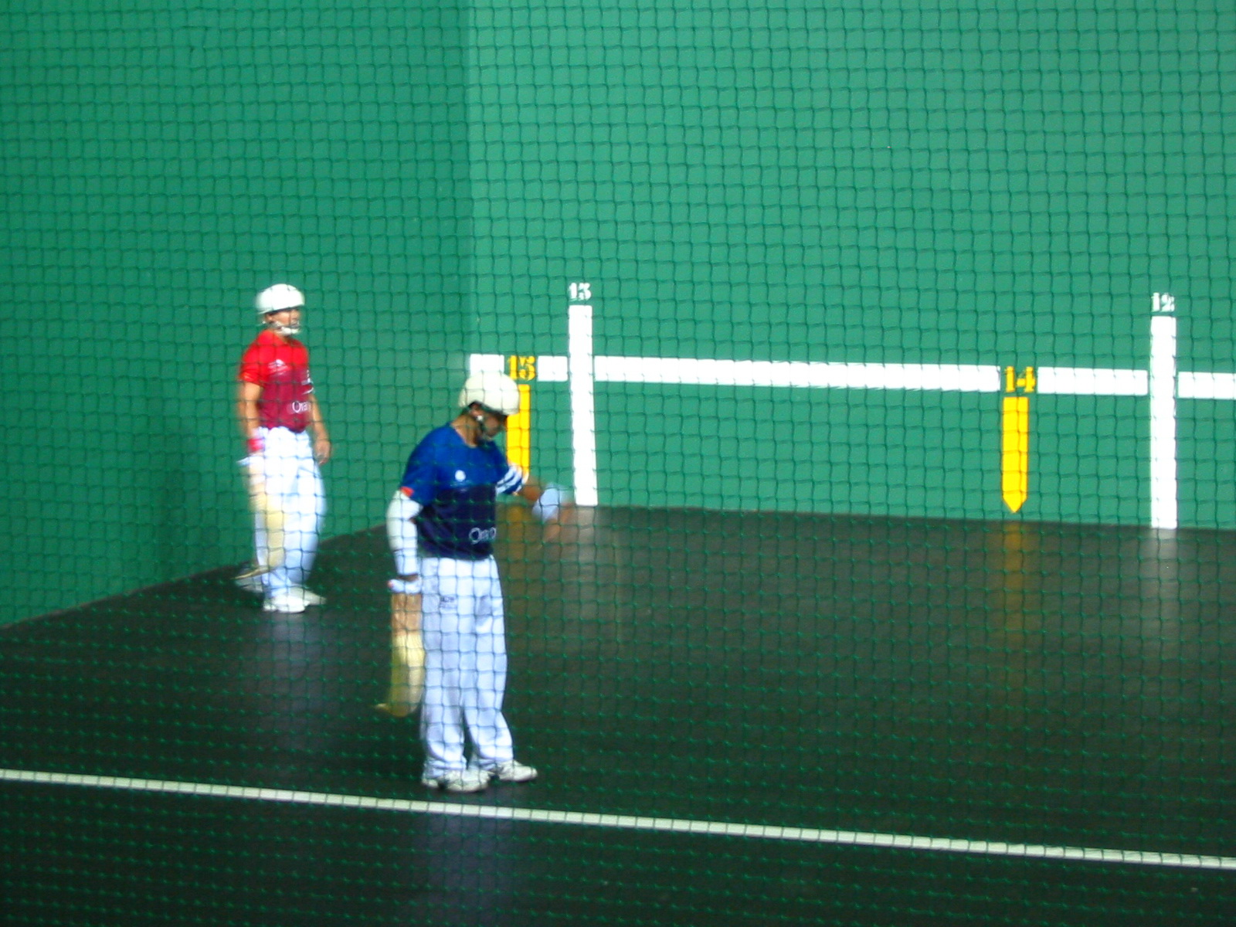

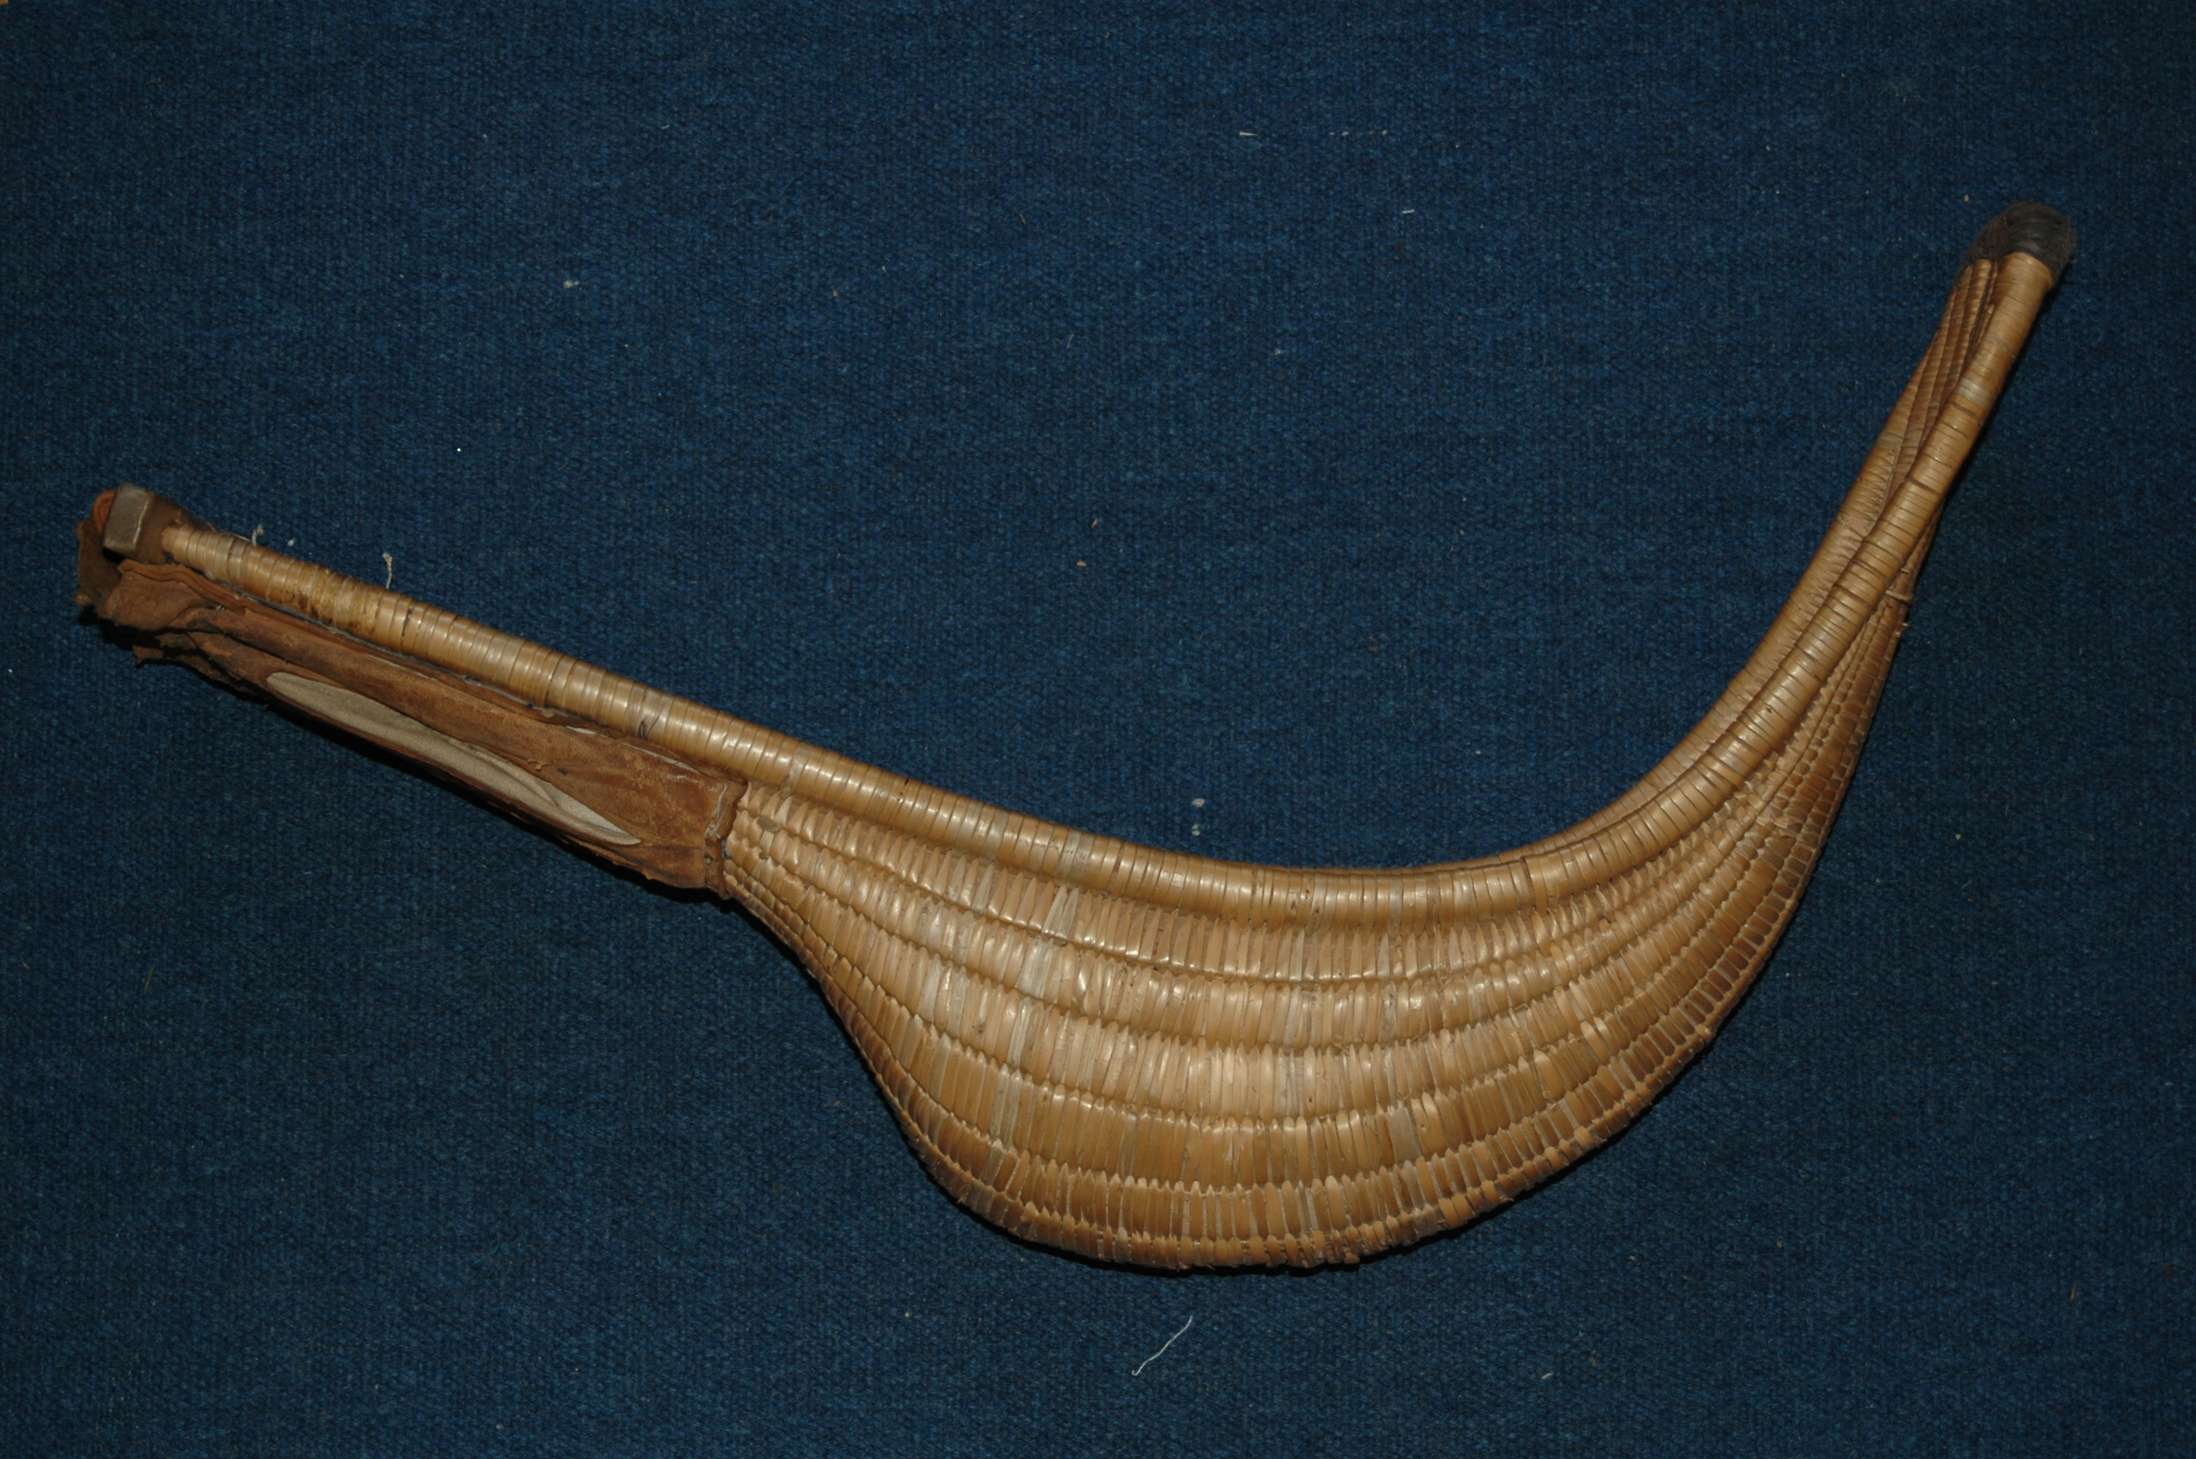

6
LAS PREFERENCIAS- the preferences
(libro págs. 26, 27, 30, 37, 38, 46)

To express degrees of liking or disliking:

(Yo) Odio No me gusta(n) Me gusta(n) Me encanta(n)
I hate I don’t like I like I love

~~~~~~~~~~~~~~~~~~~~~~~~~~~~~~~~~~~~~~~~~~~~~~~~~~~~~~~~~
¿Qué te gusta? - What do you like?
¿Te gusta(n).....? - Do you like….?

Sí, me gusta(n) ....... Yes, I like …………
Sí, me encanta(n) ....... Yes, I love ……
No, no me gusta.... No, I don’t like ……
No, (yo) odio.... No, I hate …..
*(Yo) No sé. I don’t know.

A mí también. Me too.
A mí tampoco. Me neither.

Ejemplos:
Me gustan los deportes mucho. I like sports a lot.
Me encanta el volibol también. I love volleyball too.

~~~~~~~~~~~~~~~~~~~~~~~~~~~~~~~~~~~~~~~~~~~~~~~~~~~~~~~~~
FYI:
A mí me gusta ……. __________________________________________________
No me gusta nada. ____________________________________________________
No me gusta ni ……. ni ……. ___________________________________________

Ejemplos:
No me gusta nada el esquí. _____________________________________
No me gusta ni la natación ni el fútbol. _____________________________
No me gusta nada. ____________________________________________
7
LAS ACTIVIDADES – the activities
(libro páginas 26, 27, 46)

¿Cuál es tu actividad favorita? What is your favorite activity:
Mi actividad favorita es…. My favorite activity is …..
¿Qué te gusta hacer? What do you like to do?
¿Te gusta…? Do you like ……?

hablar por teléfono (celular) to talk on the telephone

escuchar música to listen to music

ver la tele to watch TV
ver una película to see/watch a movie

jugar videojuegos top lay videogames

usar la computadora to use the computer

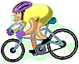
practicar deportes to practice sports

correr to run pescar to fish

patinar to skate esquiar to ski

nadar to swim jugar al….. top lay

montar en bicicleta to ride a bike
(montar a caballo to ride a horse )

dibujar to draw bailar to dance
leer to read cantar to sing
pasar tiempo con amigos to spend time with friends

ir de compras to go shopping

ir a... to go to …..

FYI: cocinar to cook
comer to eat
8

LOS LUGARES – the places
(libro páginas 172, 194)
Me gusta ir a….. I like to go to …….

las montañas the mountains
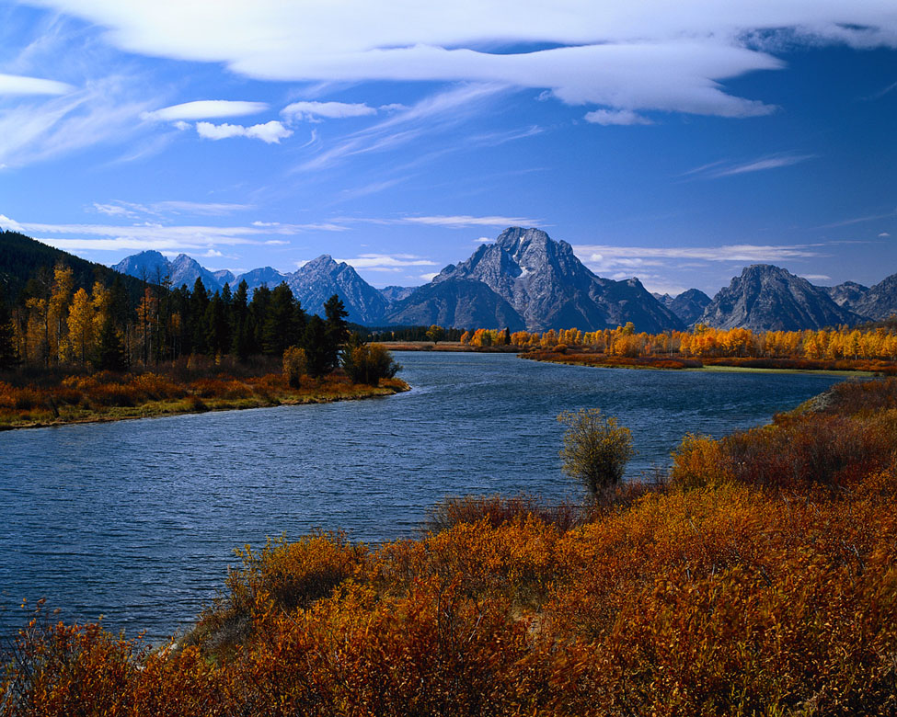

el lago the lake

el parque the park
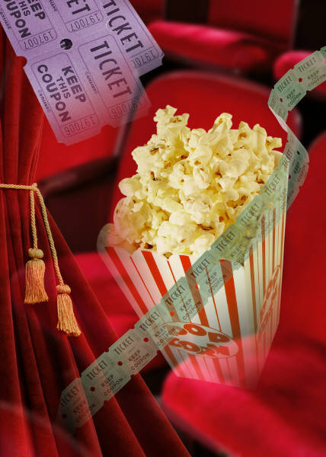



el cine the cinema

el centro comercial the mall

la biblioteca the library

el estadio the stadium
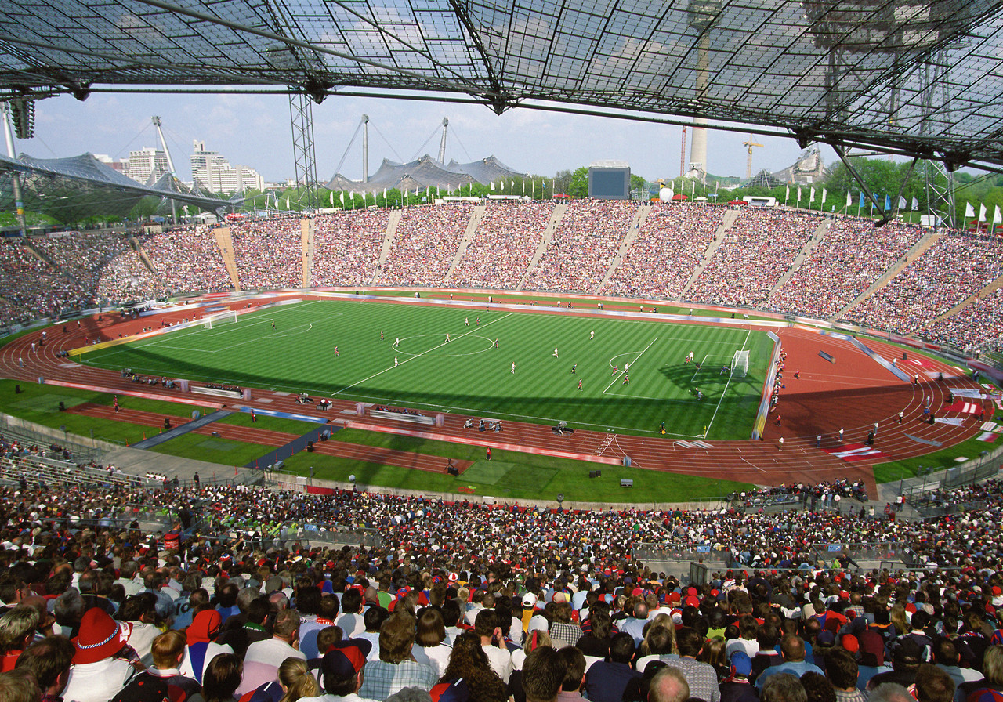

la plaza de toros the bullring

el gimnasio the gymnasium
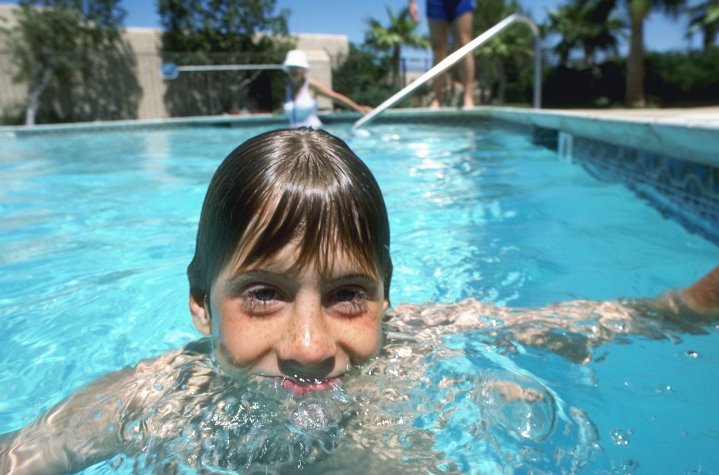
la playa the beach

la piscina the swimming pool

Ejemplos:
Me gusta ir al parque. _I like to go to the park.__________________
No me gusta ir a la playa. _I don’t like to go to the beach.________
Me gusta ir a las montañas. _I like to go to the mountains.______

¿Adónde vas? Where are you going?
Voy a…. I am going to …..

Ejemplos:
Voy al parque. __I am going to the park._________
Voy a la playa. __I am going to the beach________
Voy a las montañas. _I am going to the mountains._
9

