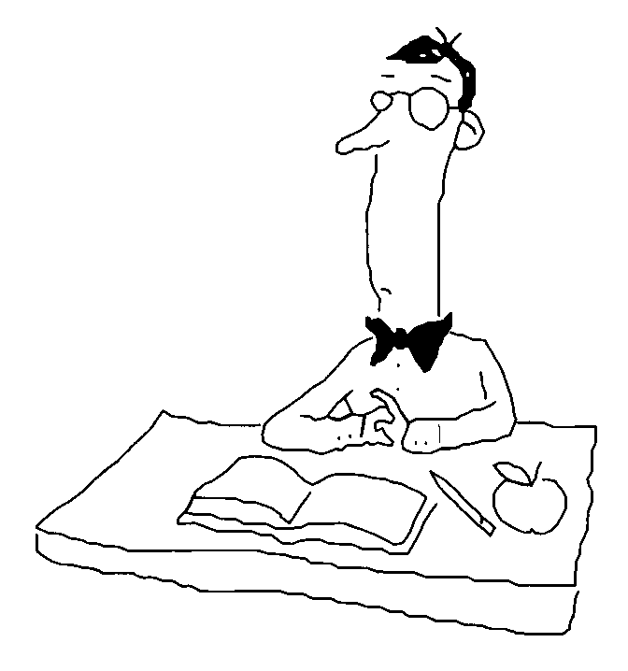
Chapter 28: The Nervous System Name______________________________ Test Date_________

28.1 The nervous system links sensation to response.

Activity to learn some key terms of nervous regulation
Study the flow chart at the left and then read each situation.
Fill in the chart at the bottom of the page by identifying each part of the situation.

Situations:
Receptor: a specialized body part that is sensitive to certain type of stimulus. Receptors send messages to the CNS.
Stimulus: a factor that triggers a receptor to send a message. The most common stimuli are
Light energy.
Sound energy.
Mechanical energy.
Heat energy.
Electrical energy.
Molecules in the environment.
CNS: the Central Nervous System. It consists of the brain and spinal cord. Messages from receptors are processed and sent to effectors.
Effector: a muscle, gland, or brain part that responds to an impulse from the CNS.
Response: the activity that occurs because of the action of the effector.

- A doctor shines a light into your eye and notices that your pupil constricts (gets smaller).
- The fragrance of freshly cooked chocolate chip cookies wafts into the room and you salivate.
- A person touches a hot iron and pulls his hand away.
- A crack of thunder startles you and your heart beats faster.
- The doctor hits the front of your knee with a hammer; your foot and lower leg jerk forward.
- You hear a song and remember where you were last summer.

 | STIMULUS | RECEPTOR | EFFECTOR | RESPONSE
1
2
3
4
5
6
28.2 Neurons conduct nerve impulses.
1. Structure of a Neuron (nerve cell)

____a. Cell body (cyton, soma)

____b. Dendrites
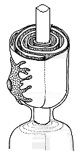

____c. Axon

____d. Myelin sheath

____e. Terminal branches

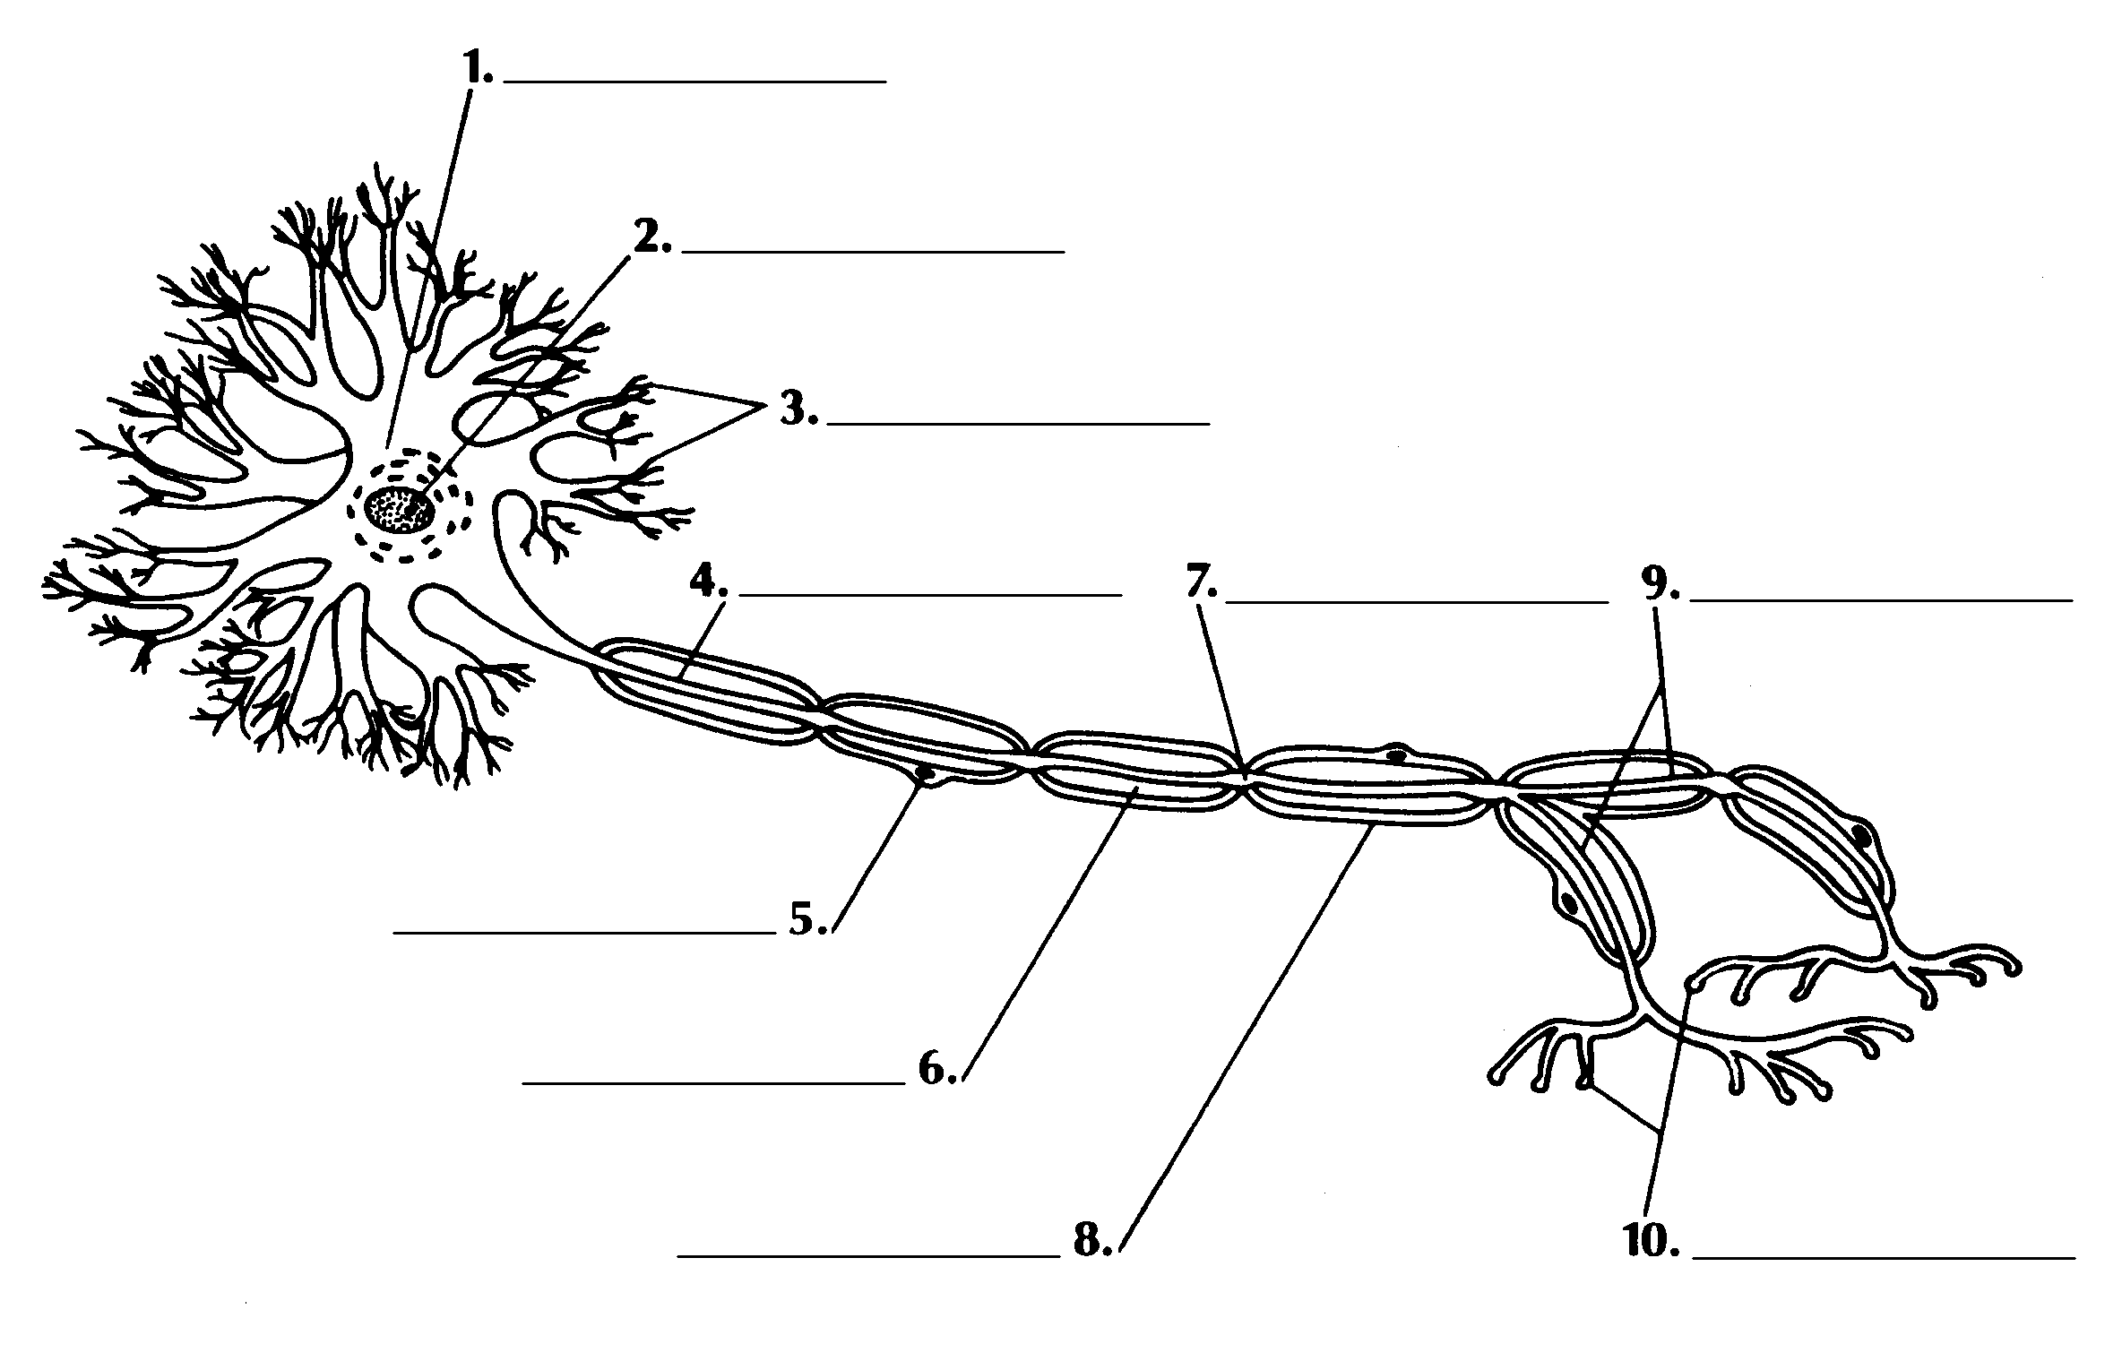
2. Three types of neurons

a. sensory

b. interneuron (associative neurons)

c. motor

What type of neuron is each of the following?

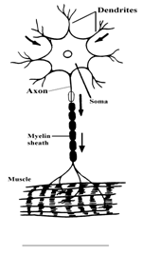
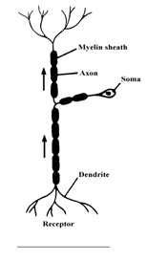
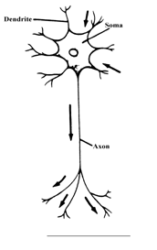

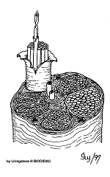

3. Nerves

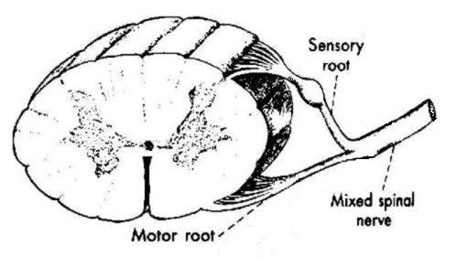

The Membrane of a Restiong Neuron Is Polarized:
4. Transport Channels (proteins in the lipid bilayer of the membrane of the neuron)
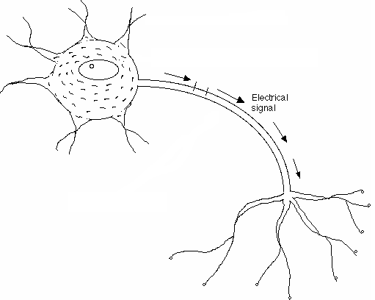
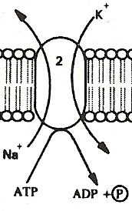
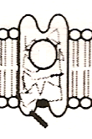
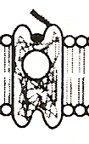
3
3
1
3
3
1

5. How a Nerve Signal Travels
The Impulse
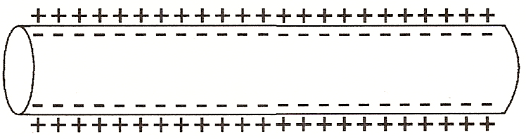
Resting Neuron
A

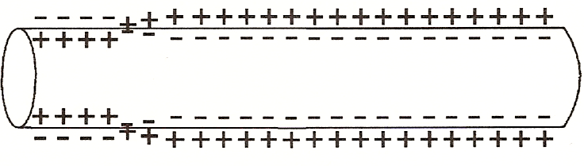
B

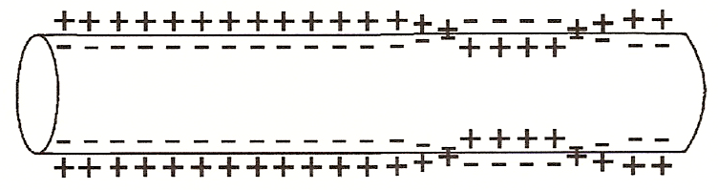
C

All-or-none impulse:

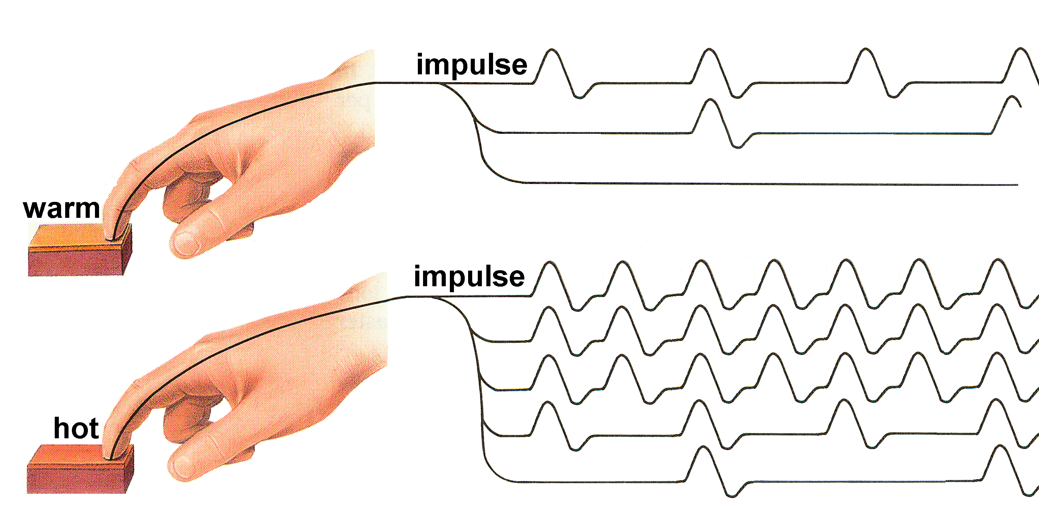

Threshold:

6. Synapse:

(Use the lines in front of each letter to place the number that corresponds to the diagram below).
____a. synaptic vesicles

____b. neurotransmitter

____c. presynaptic membrane

____d. postsynaptic membrane

____e. synaptic cleft

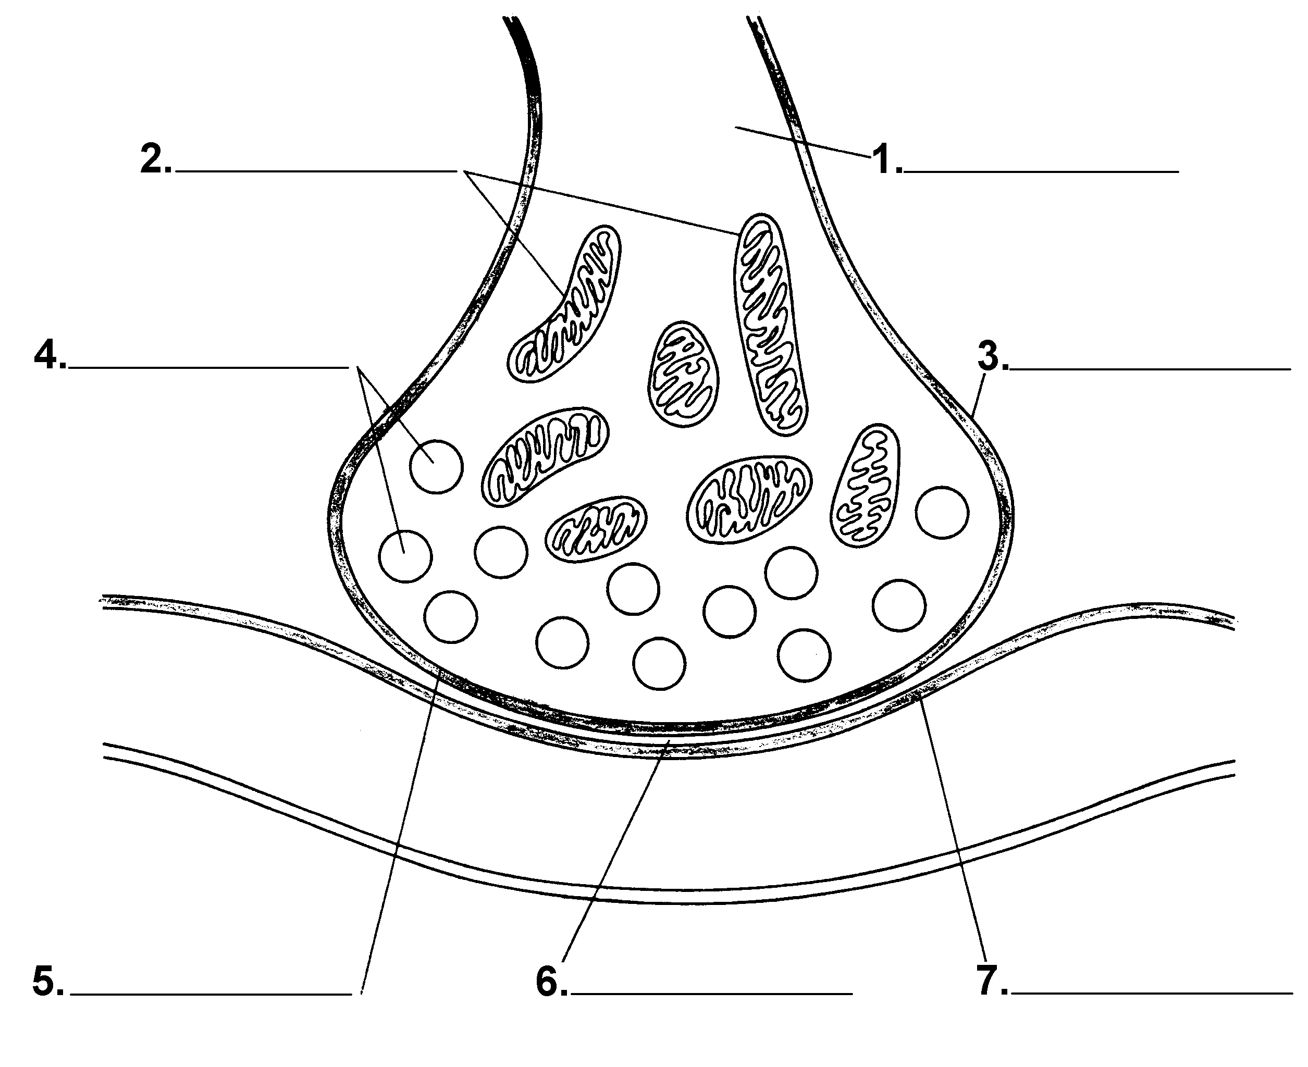

Activity: What happens at a Synapse?

Look closely at the diagram below. Label as many parts as you can without looking back in your note packet. Check your answers and then complete the questions that follow.

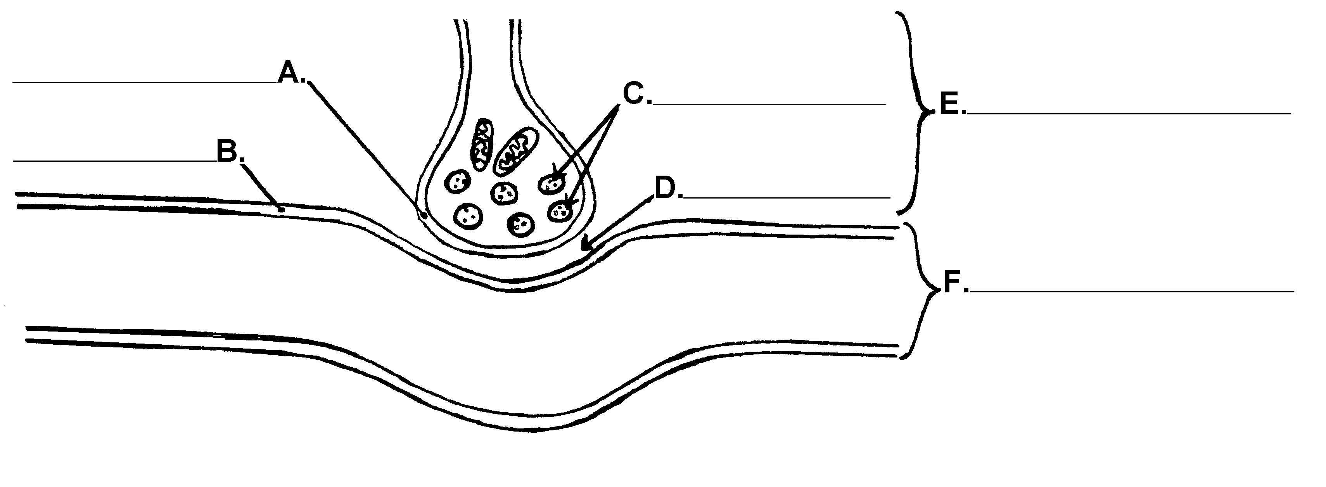

- What occurs at the pre-synaptic membrane?

- What happens across the synaptic cleft? What process is involved?

- From which structure are the neurotransmitters released?

- The neurotransmitters are released into the:

- What causes the neurotransmitters to be released?

- What do postsynaptic membranes have that pre-synaptic membranes do not have?

- How is the neurotransmitter removed from the synapse?

Review: The Neuron and The Synapse

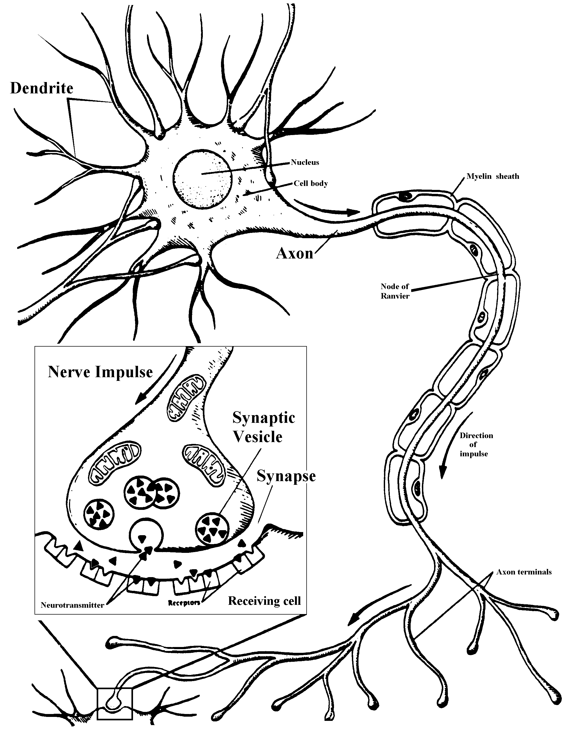

28.3 The PNS carries information to and from the CNS.
A. Two Main Divisions of the Human Nervous System:
1. CNS:

2. PNS:

Two divisions of the PNS:
a. Sensory

b. Motor

i. autonomic
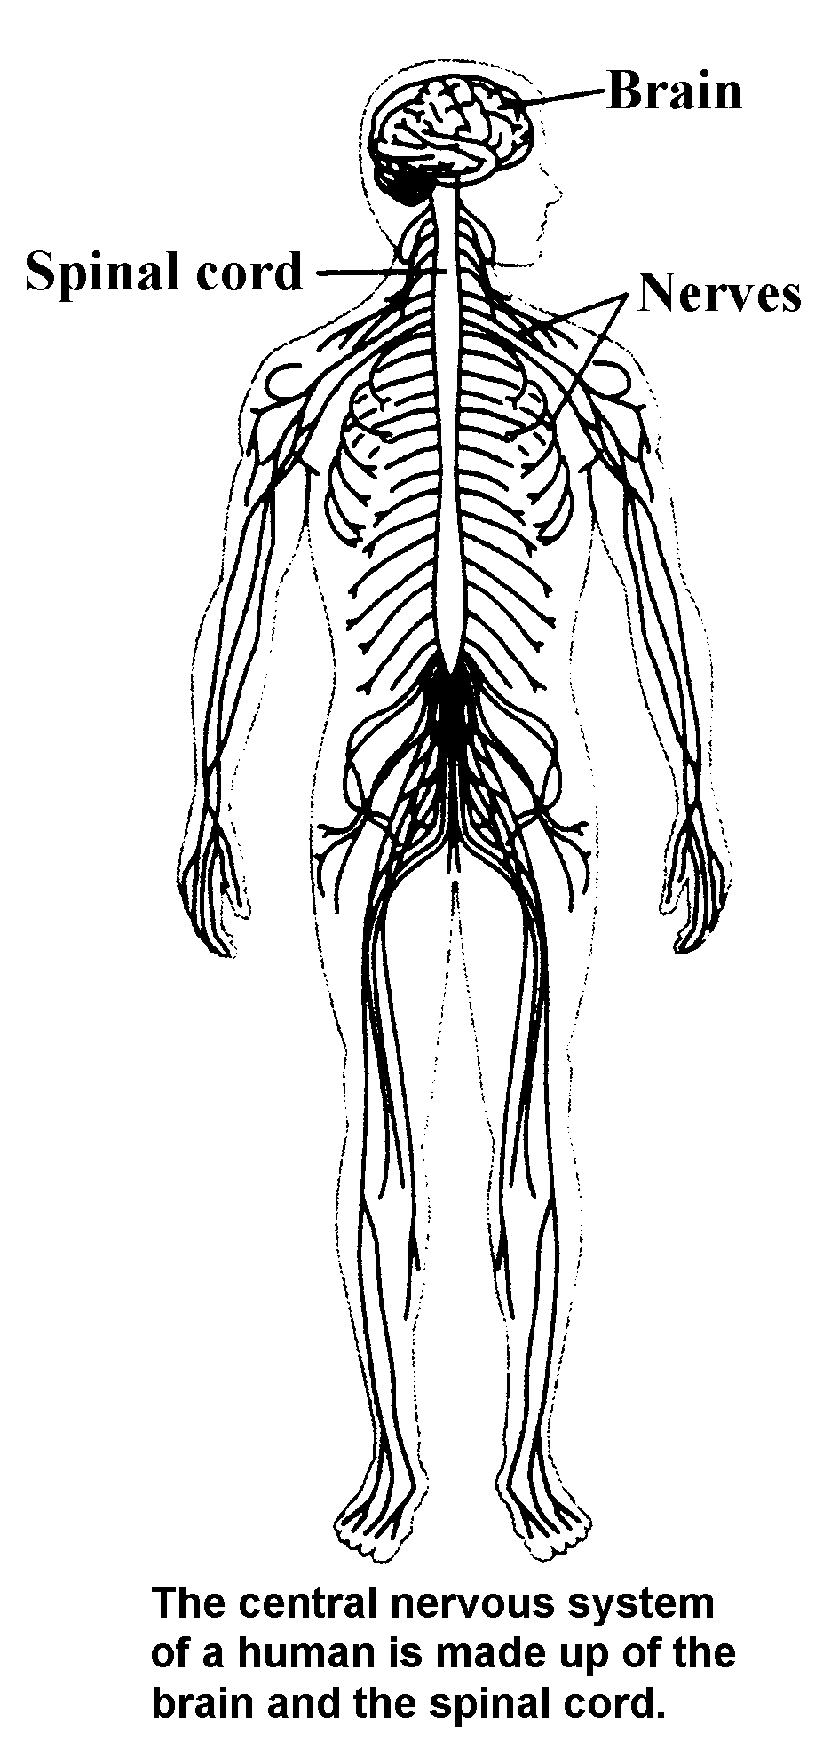

ii. somatic

28.4 The CNS integrates nervous information.
A. Central Nervous system protection
1. cranium( )

- spinal column ( )

- meninges

- cerebrospinal fluid
B. The Brain
1. Three major parts
a.

b.

c.

2. Other important parts of the brain
a.

b.

c.
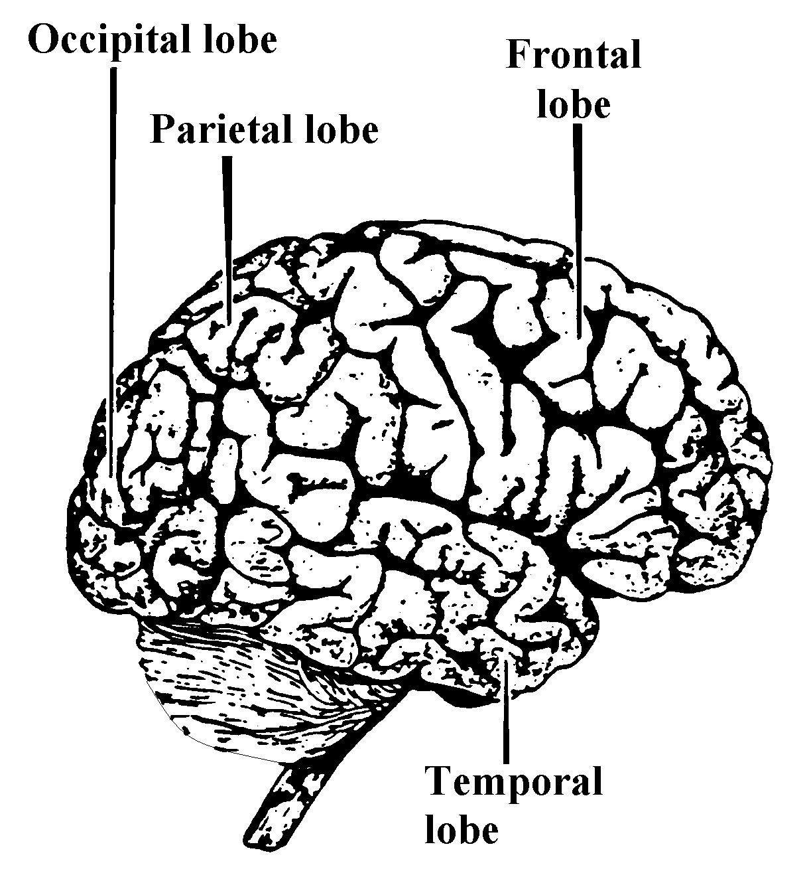

3. Human Brain Diagrams:

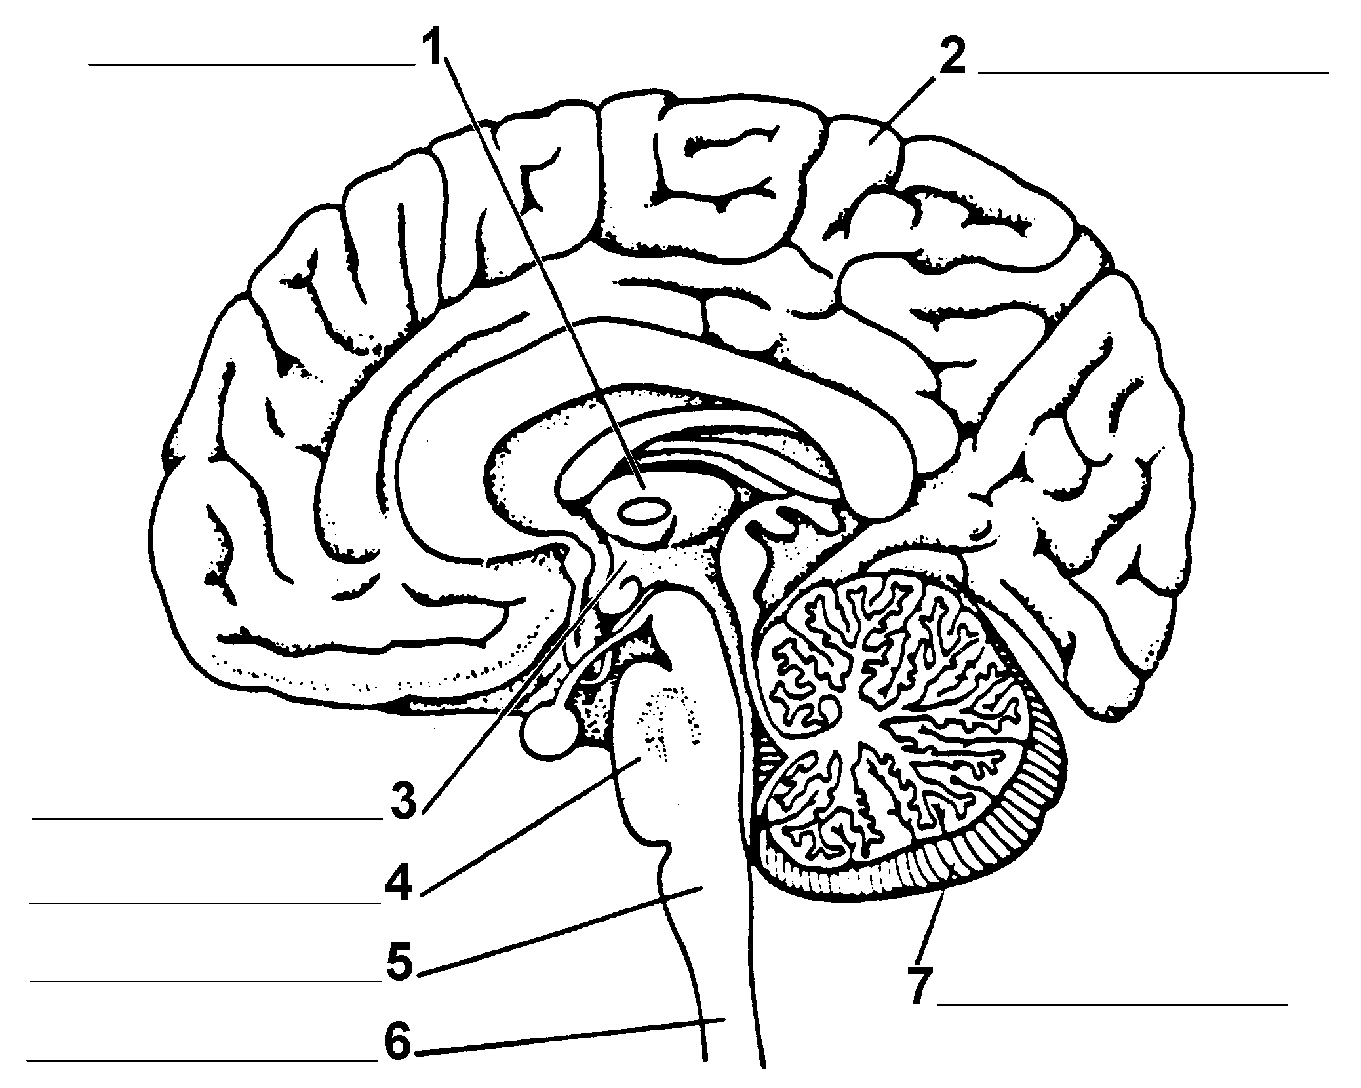

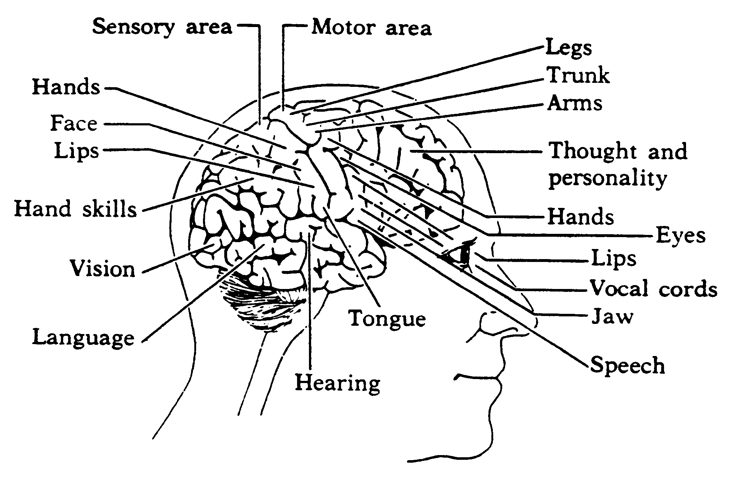

C. The Spinal Cord
1. Description:

2. Functions
a.

b.

D. Reflexes (see diagram)
1. Definition:

2. Impulses follow a set pathway called a ___________ _______

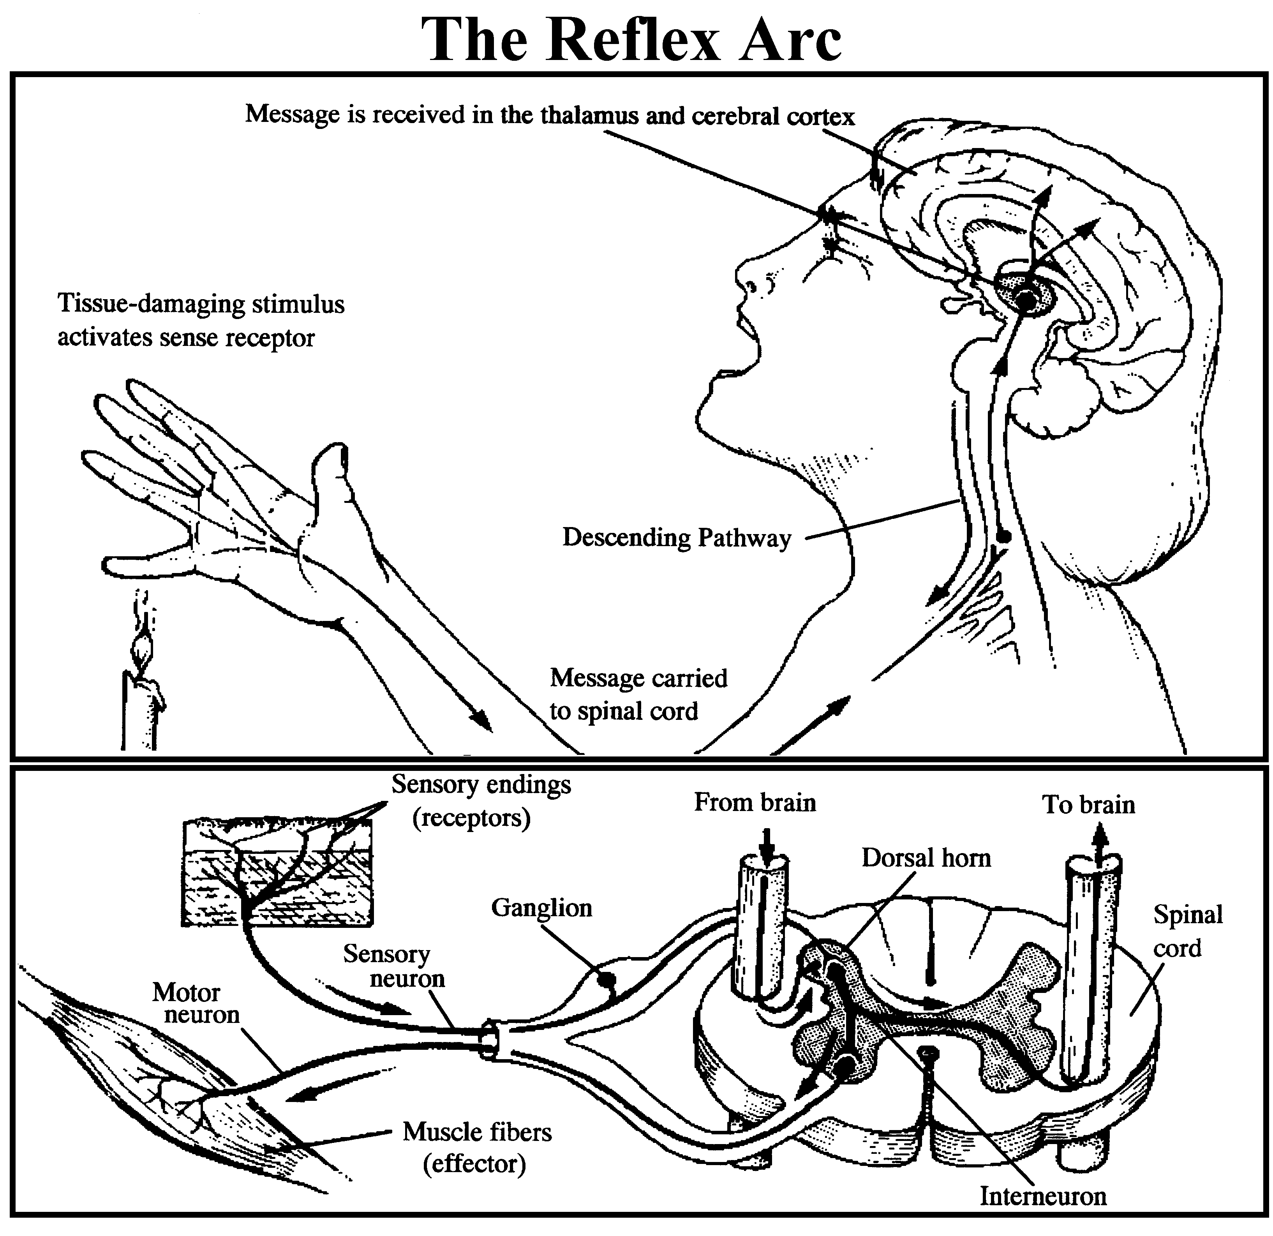

E. Habits

F. Memory

G. Disorders of the Nervous System
1. Cerebral Palsy

2. Meningitis

3. Stroke

- Polio

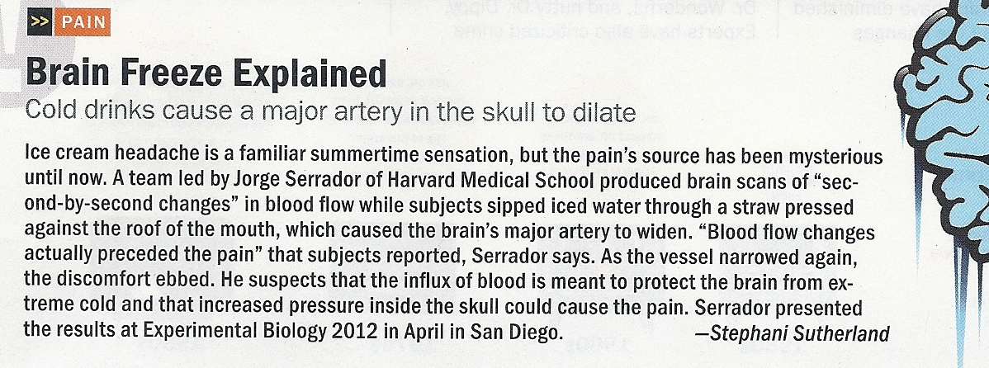

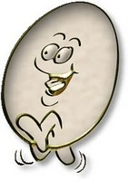
In-Class Demonstration:

Mr. Egghead - The Cerebrospinal Fluid
The cerebrospinal fluid (CSF) has several functions.
- Protection: the CSF protects the brain from damage by "buffering" the brain. In other words, the CSF acts to cushion a blow to the head and lessen the impact.
- Buoyancy: because the brain is immersed in fluid, the net weight of the brain is reduced from about 1,400 gm to about 50 gm. Therefore, pressure at the base of the brain is reduced.
- Excretion of waste products: the one-way flow from the CSF to the blood takes potentially harmful metabolites, drugs and other substances away from the brain.
- Endocrine medium for the brain: the CSF serves to transport hormones to other areas of the brain. Hormones released into the CSF can be carried to remote sites of the brain where they may act.
We are going to examine how CSF functions to protect the brain from sudden impacts. To demonstrate how this works, we need to bring in "Mr. Egghead." Mr. Egghead is a raw egg. The inside of the egg represents the brain and the egg shell represents the pia mater (the inner most layer of the meninges or membranes covering of the brain).
1. We will put Mr. Egghead in a container that is a bit larger than the egg. The container represents the skull. Now we will put a tight top on the container and shake it.
What happened to Mr. Egghead? _________________________________________
Why? _____________________________________________________________

2. Now we will repeat this experiment with a new Mr. Egghead, except this time, we will fill the container with water.
What does the water represent?_________________________________________
What happened to Mr. Egghead?__________________________________________
Why?____________________________________________________________

Organization of the Human Nervous System Name__________________________

Word Bank: Somatic Brain Nervous System CNS Motor
Endocrine System Spinal Cord Sensory Autonomic PNS

Regulation
2 Systems that work to maintain Homeostasis

Name _____________________________________ Per _____ Test Date _________
Nervous System Review

WordBank:
axon | synaptic cleft | vesicle | receptor | effector
sensory neuron | interneuron | stimulus | neuron | cell body
myelin sheath | neurotransmitter | response | synaptic knob | impulse
brain | nerve | motor neuron | dendrites | terminal branch

Vocabulary:

1. ______________________ A specialized body part that is sensitive to a certain type of stimulus

2. ______________________The activity that occurs because of the action of the effector

3. ______________________A muscle, gland, or brain part that responds to an impulse from the CNS

4. ______________________An electrical charge that is initiated by a stimulus and moves along the membrane

5. ______________________The neurons that carry impulses from receptors to the spinal cord

6. ______________________The neurons that carry impulses from the brain and spinal cord toward effectors

7. ______________________The neurons that send impulses from one neuron to another within the brain and spinal cord

8. ______________________controls and coordinates the activities of the nervous system

9. ______________________Any factor that causes an impulse in a nerve pathway; a change in the environment

10. ______________________a bundle of axons or fibers bound together

11. ______________________a nerve cell

12. ______________________receives impulses and send them to the cell body

13. ______________________part of the neuron that contains the nucleus

14. ______________________branch at the end of an axon

15. ______________________carries impulses away from the cell body of a neuron

16. ______________________insulates the axon to speed up the electrical impulse

17. ______________________a gap or space between nerve cells

18. ______________________a chemical substance that maintains communication between neurons

19. ______________________structure that contains and releases neurotransmitters

20. ______________________the end of a terminal branch that is part of the presynaptic membrane

Diagrams WordBank:

ion channel | motor neuron | interneuron | dendrites | reflex arc
cerebellum | cell body | terminal branches | Schwann cell | medulla oblongata
axon | cerebrum | sensory neuron | synapse

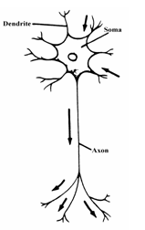
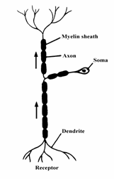
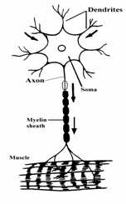

21. _________________ 22. ____________________ 23. __________________

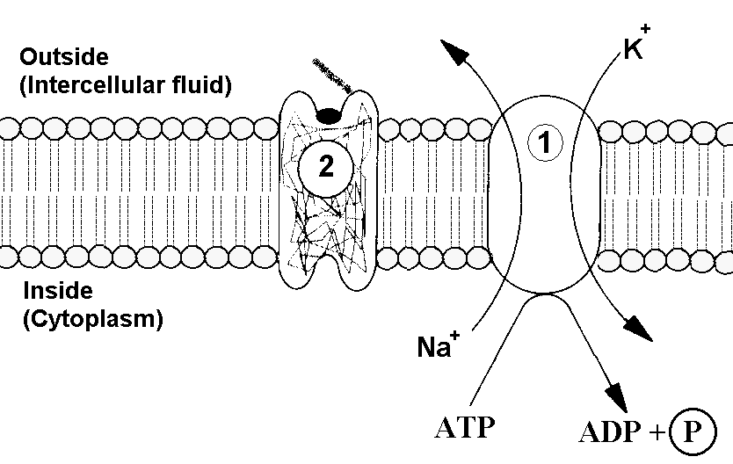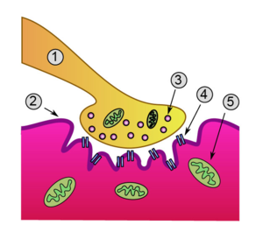

24. _____________________________ 25. _________________________

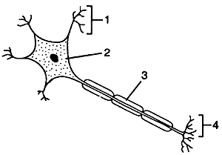

26. _____________________________ 27. _________________________

28. ______________________________ 29. _________________________

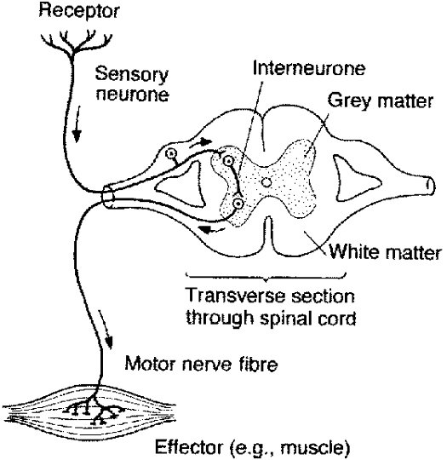

30. _______________________________ 31. _________________________

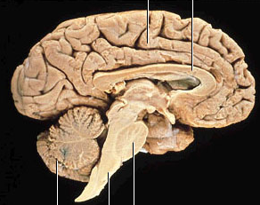

32. __________________ 33. ____________________ 34. ___________________

Cerebrum | Problem solving  Interpretation of stimuli  Initiation of voluntary acts  Hand skills, vision, language, hearing, thought and personality, hands, eyes, etc (diagram on page 11)
Cerebellum | Coordinate body movement and balance (equilibrium)  Voluntary and involuntary
Medulla Oblongata | In the brainstem  Involuntary  Controls vital activities – breathing, heartbeat, blood pressure, peristalsis
Pons | Relays info between cerebrum & cerebellum (linking center)  Assists in autonomic functions  Arousal, sleep
Thalamus | Directs sensory & motor pathways to and from the 3 major brain parts; can enhance or block signals
Hypothalamus | Essential life functions – body temp, blood pressure, hunger, thirst  Emotional center, sleep  Biological clock

