Name:______________________________________ Per._____ Due_________ Assign #1
Unit 9 – The Nervous System (Chapter 28)

Read pages 610-612 in your text and use your notes to complete this assignment.

1. What is a stimulus?

2. Give two examples of environmental stimuli.
a. b.

3. Give two examples of receptors.
a. b.

4. Give two examples of effectors.
a. b.

5. Read the example below and identify the stimulus, receptor, effector and response.
You hear a person yell for help and run into the hall to find the person.
Stimulus –
Receptor –
Effector –
Response –

6. What part of the CNS interprets a stimulus from a receptor and make a decision about what the response should be?

Name:______________________________________ Per._____ Due_________ Assign #2
Unit 9 – The Nervous System (Chapter 28)

Read pages 612-616 in your text and use your notes to complete this assignment.

1. What is another name for a nerve cell?
2. Fill in the following table using your notes and the textbook:
Type of Neuron | Transmits information from: | Transmits information to:

3. Label the diagram of a neuron below using the following words: terminal branches, nucleus, dendrites, axon, synaptic knob, myelin sheath, node of Ranvier, cell body

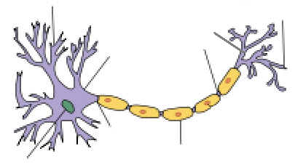

4. What direction does an impulse travel through a neuron?

5. What is the insulation on neurons called? What is the benefit of a neuron having this insulation?

Name:______________________________________ Per._____ Due_________ Assign #3
Unit 9 – The Nervous System (Chapter 28)

Read pages 614-617 in your text and use your notes to complete this assignment.

1. A resting neuron is polarized. What does that mean?

2. Describe what happens to a Na+ gate (channel) when a stimulus begins an impulse?

3. Why does the neuron become depolarized as the impulse travels?

4. What type of organic compound is an ion channel made of?

5. What is a synapse?

6. What are the chemicals that carry a message across the synapse called?

Name:______________________________________ Per._____ Due_________ Assign #4
Unit 9 – The Nervous System (Chapter 28)

Read pages 618-621 in your text and use your notes to complete this assignment.

1. What are the two functions of sensory neurons in the sensory division of the PNS?
a. b.

2. What is the somatic nervous system?

3. What is the autonomic nervous system?

4. Describe the role of the spinal cord in the CNS:

5. DEFINE the following terms:
a. central nervous system

b. Peripheral nervous system

c. Corpus callosum

d. Cerebral cortex

e. Brain stem

(list 3 parts) ___________________ ___________________ __________________

Name:______________________________________ Per._____ Due_________ Assign #5
Unit 9 – The Nervous System (Chapter 28)

Read pages 620-622 in your text and use your notes to complete this assignment.

Describe each of the following human brain parts. (The first one is done for you).

A. Optic Lobe (tectum):
location: It lies at the rear of the brain above the cerebellum.

structural description: convoluted tissue of the cerebrum

functions: Part of the brain that processes sensory impulses from the eyes. In higher organisms it is incorporated as part of the cerebrum.

B. Cerebrum:
location:

structural description:

functions:

C. Cerebellum:
location:

structural description:

functions:

D. Brainstem:
location:

structural description:

functions:

E. Thalmus:
location:

structural description:

functions:

F. Hypothalmus
location:

structural description:

functions:

Label the diagram of the human brain on the back of this page!! →

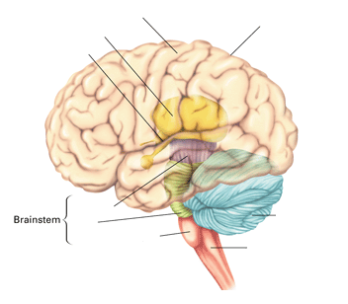
A
B
C
D
G
F
E
H
I

Cerebral Cortex convolutions
A ________________________________ B ________________________________
C ________________________________ D ________________________________
Midbrain
Pons
E ________________________________ F ________________________________
Spinal Cord
G ________________________________ H ________________________________
I ________________________________

Name:______________________________________ Per._____ Due_________ Assign #6
Unit 9 – The Nervous System (Chapter 28)

Read pages 620-622 in your text and use your notes to complete this assignment.

1. Describe how your cerebellum and cerebrum work together in body movements.

2. Explain why a skill is harder to learn than a simple fact.

3. How does your hypothalamus act as your "biological clock"?

4. Describe the difference between how your brain creates a skill memory, such as using a yo-yo, and how it creates the memory of a fact, such as an address.

5. Walking home from a friend's house, Ralpie is confronted by a large puddle. He decides to leap across it. Which regions of his brain will be involved in this action? How will they work together?

6. Use the diagram on page 621 to fill in the following:

a. What part of the brain is convoluted? ____________________________

b. What part of the brain is responsible for problem solving? ____________________________

c. What part of the brain is responsible for speech? ____________________________

d. What part of the brain is responsible for breathing and heartbeat? _______________________

e. What part of the brain is responsible for sensory interpretation? ________________________

f. What part of the brain is responsible for muscle coordination? _________________________

g. What part of the brain is involved with the endocrine system, emotion and sleep? ______________

h. What part of the brain controls voluntary movement? ____________________________

Name:______________________________________ Per._____ Due_________ Assign #7
Unit 9 – The Nervous System (Chapter 28) Test Review Assignment

Read the following and answer the questions on the other side of this page.

Nerve Cells!
The human body is made up of trillions of cells. Cells of the nervous system, called nerve cells or neurons, are specialized to carry “messages” through an electrochemical process. The human brain has about 100 billion neurons. Neurons carry messages called impulses.
Neurons come in many different shapes and sizes. Some of the smallest neurons have cell bodies that are only 4 microns wide. Some of the biggest neurons have cell bodies that are 100 microns wide. (Remember that 1 micron is equal to one thousandth of a millimeter!).
Neurons are similar to other cells in the body because:
1. Neurons are surrounded by a cell membrane.
2. Neurons have a nucleus that contains genes (DNA).
3. Neurons contain cytoplasm, mitochondria and other organelles
4. Neurons carry out basic cellular processes such as protein synthesis and energy production.
However, neurons differ from other cells in the body because:
1. Neurons have specialized extensions called dendrites and axons. Dendrites bring information to the cell body and axons take information away from the cell body.
2. Neurons communicate with each other through an electrochemical process.
3. Neurons contain some specialized structures (for example, synapses) and chemicals (for example, neurotransmitters).
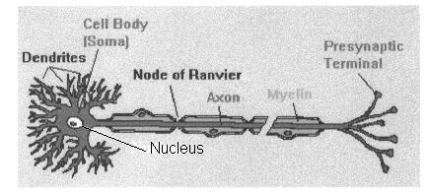

There are several differences between axons and dendrites:
Axons | Dendrites
Take information away from the cell body | Bring information to the cell body
Smooth Surface | Rough Surface (dendritic spines)
Generally only 1 axon per cell | Usually many dendrites per cell
No ribosomes | Have ribosomes
Can have myelin | No myelin insulation
Name:__________________________________ Per. ______ Assign #7

Read “Nerve Cells!”, and use pg 612 in the book to answer the questions below.

1. Cells of the nervous system are called _________________.

2. Neurons are specialized to __________ ______________, and there are about _________________ neurons in humans.

3. Neurons carry messages called __________________.

- Like all cells, neurons are surrounded by a _____________, have a ______________ that contains DNA, and they contain _____________ and other organelles.

5. Unlike other body cells, neurons have specialized extensions called ________________ and _______________.

6. Neurons communicate with each other through an ____________________ process.

7. What do axons do?

8. What do dendrites do?

9. Myelin is sometimes found around what part of a neuron?

10.Below is a diagram of a nerve cell –also called a(n) ________________________. Label the cyton, dendrites, axon, myelin sheath, and synaptic knobs. *Draw an arrow to show the direction an impulse would travel through the cell.
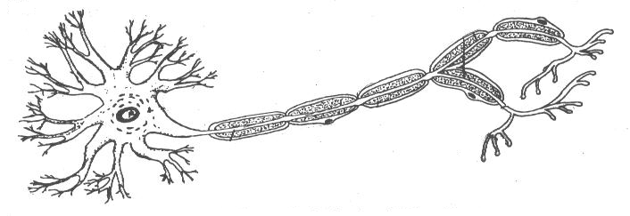

11. What is the difference between a neuron that has a myelin sheath and one that does not have a myelin sheath?

12. What does CNS stand for?
What makes up the CNS of a human?
What type of neurons would be found in the CNS of a human?

13. What does PNS stand for?

What makes up the PNS of a human?
What types of neurons would be found in the PNS of a human?

14. You reach into a drawer and stab your finger with a tack. This causes you to pull your hand quickly out of the drawer.

What was the stimulus in the above scenario? _______________________
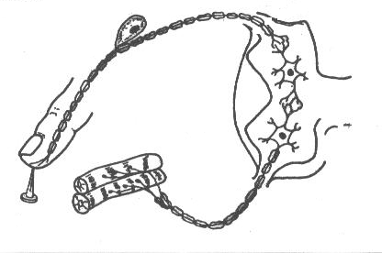
The receptor? ____________________
The effector? _____________________
The response? ____________________

15. At the right is a diagram of the path of the impulse from the receptor to the effector.

Label the following in the diagram:
interneuron, effector, stimulus, receptor, motor neuron, synapse, neuromuscular junction.

*Draw an arrow to show the direction the impulse will travel.

16. The impulse above does not travel to the brain. This pathway is referred to as a _____________ _________.

17. Along what cell structure does a nerve impulse travel? ____________ ____________________

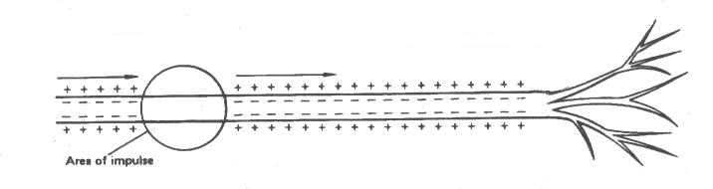
18. On the following diagram, use “+” and “-” signs to show the electrical charge across the nerve cell membrane in the area of the nerve impulse.

19. Explain below what occurs to cause the reverse polarization at the area of the nerve impulse in the diagram above:

20. A neuron is polarized because of a higher concentration of _______ ions on the outside of the axon.

21. One of the proteins in the cell membrane that is involved in moving ions across the cell membrane is called the ___________________ - ___________________ pump.

22. Describe the refractory period:

23. The space between two neurons is called a _______________.

24. The chemical that diffuses across the space between two neurons is a ______________________.

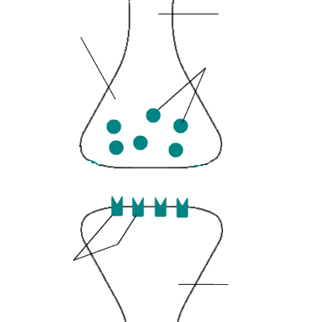
A
C
D
B
E
F
G

A. _________________________
B. _________________________
C. _________________________
D. _________________________
E. _________________________
F. _________________________
G. _________________________

25. Above is a diagram of a synapse. The arrow indicated the direction of the impulse. Label the following parts; receptor molecules, axon, veisicle, synaptic cleft, synaptic knob, receiving neuron.

26. Fill in the following table describing the function of each of the following brain structures:

Structure | Function
Cerebrum
Cerebellum
Thalamus
Hypothalamus
Pons
Medulla
Meninges

Assign #8 Complete the Castle Learning 9 Nervous System Assignment

