Name:______________________________________ Per._____ Due_________ Assign #1
Unit 8 – The Human Organism (Chapter 27)

Read pages 586-592 in your text to complete this assignment.

1. Explain how anatomy and physiology are related.

2. List in order from smallest to largest the five levels of structure in the human body.

3. Fill in the table below:

Tissue Type | Major Function
1.

2.

3.

4.

4. Give an example of how structure and function are related in a type of tissue.

5. Describe the differences between skeletal, cardiac, and smooth muscle.

Name:______________________________________ Per._____ Due_________ Assign #2
Unit 8 – The Human Organism (Chapter 27)

Use your notes from the Introductory notes on Diseases & Homeostasis.

1. What is homeostasis?

1. What could occur if there is a disruption in homeostasis?

2. What is an endogenous cause of a disease? Give 2 examples of an endogenous cause.

3. What is an exogenous cause of a disease? Give 2 examples of an exogenous cause.

4. What is a pathogen?

5. What is a toxin?

Name:______________________________________ Per._____ Due_________ Assign #3
Unit 8 – The Human Organism (Chapter 27)

Read pages 593-604 in your text to complete this assignment.

1. The nervous system and endocrine system help to regulate homeostasis. Describe how these systems would work together to help a person escape from a chance meeting with a bear in the woods.

2. Lungs are involved in maintaining homeostasis. What gases are exchanged at the lungs to help maintain homeostasis?

3. Why does gas exchange have to happen in your body?

4. Give three examples of ways your skin helps maintain homeostasis in your body.

5. In what layer of skin would you find nerves, blood vessels and sweat glands?

6. What tough structural protein is found in the outer layer of skin, in hair, and in nails?

Name:______________________________________ Per._____ Due_________ Assign #4
Unit 8 – The Human Organism (Chapter 27)

Read pages 597-605 in your text to complete this assignment.

1. Describe the functions of the following structures found within the musculoskeletal system.

Cartilage –

Tendons –

Ligaments –

Bone Marrow –

2. Explain how muscles work in pairs to move limbs.

3. What two proteins are responsible for muscle contraction?

4. Identify at least 3 organ systems involved in a handshake. Describe what each system contributes to the handshake.

Organ System Contribution

1.)

2.)

3.)

Name:______________________________________ Per._____ Due_________ Assign #5
Unit 8 – Nutrition and Digestion (Chapter 29)

Bring in a food label off of a box or can to be used in class tomorrow. Be sure it includes the Nutrition Facts about that food.

Item name: __________________________________________________

Look at the label carefully:

- Indicate below the number of grams of each nutrient your item has per serving:

  - Fat ________
  - Protein ________
  - Carbohydrates _________
  - Fiber ________

- List some vitamins found in your item:

- List some minerals found in your item:

Trans Fats Pose Many Dangers to Health

Buffalo News, 11/4/03, by Dr. Rallie McAllister
Assignment #6: Read the following article and answer the Questions that follow.

If you’re trying to lower your risk of heart disease by cutting back on cholesterol and saturated fats, you still could be consuming too much of the most dangerous fat of all — trans fat. Trans fat, also known as trans fatty acid, is a solid type of fat that is produced artificially by heating liquid vegetable oils in the presence of hydrogen. This process, called partial hydrogenation, causes the resulting product to remain in a solid state at room temperature. Manufacturers use trans fat in their food products to make them taste less greasy and to prolong their shelf life by retarding spoilage. Trans fat is widely used by food processors and the restaurant industry as an ingredient in baked and fried goods. Margarine, shortening, crackers, cookies, candies and salad dressings are typically loaded with the unhealthy fat. Most fast-food restaurants use trans fat in the preparation of french fries and other fried foods.
Over the past decade, numerous studies have found that the consumption of trans fat not only elevates blood levels of low-density lipoprotein (LDL), the “bad” type of cholesterol, but it also lowers levels of heart-healthy high-density lipoproteins (HDL) in the-bloodstream. No other known dietary component has both of these adverse effects, each of which contributes to the development of heart disease. Some experts speculate that the widespread consumption of trans fat played a role in the 20th century epidemic of heart disease.
Dr. Frank Hu, Harvard professor of nutrition, calls trans fat “one of the most dangerous players in the human diet for cardiovascular disease risk.” Harvard researchers estimate that approximately 30,000 premature coronary heart disease deaths annually could be attributable to the consumption of this dangerous dietary ingredient. In addition to contributing to heart disease, trans fat seems to pose other health dangers as well. Recent studies suggest that the fat interferes with normal metabolism of essential fatty acids, leading to disruption in the production of various hormones and blood clotting factors. Trans fat consumption can trigger insulin resistance and increase the risk of developing Type 2 diabetes. Based on findings like these, the U.S. food and Drug Administration published a rule requiring food manufacturers to list trans fat on the Nutrition Facts panels of conventional foods and some dietary supplements. The rule was finalized in July of this year, but food manufacturers have until Jan. 1, 2006, to comply.
For years, the American Heart Association has advised Americans to limit their consumption of trans fat, but without the appropriate food labeling, this is no easy task. The additional label information mandated by the FDA should help consumers make wiser food choices that can lower their risk of developing cardiovascular disease. Although they’ll undoubtedly comply, food manufacturers aren’t exactly thrilled about the new FDA rule. In a recent press release, the Grocery Manufacturers of America opposed the mandatory listing of trans fat, saying that “this type of nutritional counseling is best done elsewhere and not within the Nutritional Facts box.”
If you’re in search of dietary fats that are better for your health, your best bet is to stick to the polyunsaturated and monounsaturated varieties. Polyunsaturated fats are liquids at room temperature, and they’re found in plant oils, including sunflower, safflower, soybean, sesame seed and corn oil. Cold-water fish, including tuna and salmon, are also good sources. Polyunsaturated fats have been shown to help lower blood cholesterol levels. Monounsaturated fats are found in fish oil, olive oil, peanut oil and canola oil. These types of fats are an important part of the Mediterranean diet, an eating plan that is known to reduce the risk of heart disease.
Although the revised Nutrition Facts panels won’t hit the supermarket shelves for a few
years, reading the labels on packaged foods still yields useful information. Foods that contain trans fat currently list “partially hydrogenated” vegetable oil as an ingredient. While it’s a good idea to try to limit the amount of trans fat in your diet, it probably isn’t practical — or even possible — to eliminate it altogether. Even “natural” foods, like beef and dairy products contain small amounts of the fat. You can significantly lower your- intake of trans fat by curbing your consumption of fast foods and junk foods. While you’re reducing your intake of trans fat, don’t forget to increase your level of physical activity. A little effort in the diet and exercise department goes a long way toward protecting you from heart disease.

Name:_____________________________________ Per._____ Due_________ Assign #6
Unit 8 – Nutrition and Digestion (Chapter 29)

Read the article “Trans Fats Pose Many Dangers to Health” and answer the following questions.
- Trans fat is also known as:
- Describe how trans fat (a solid type of fat) is produced :

- Trans fat is the most dangerous of all dietary fats because it contributes to the development of what disease?
- Why do manufacturers use trans fat?

- Numerous studies have shown that trans fat elevates (raises) blood levels of _____________________________________________ and also LOWERS blood levels of ______________________________________________.
- Which lipoprotein is considered the “bad” type of cholesterol?

- In addition to contributing to hear disease, trans fat also seems to pose some other health dangers.
List some:

- Are you able to find the amount of trans fat listed on nutrition labels on food products now?
- What are 2 dietary fats that are better for your health than trans fats?

- Describe polyunsaturated fats and list some food sources of them.

- Describe monounsaturated fats and list some food sources of them.

- Why is it nearly impossible to eliminate all trans fats from your diet?

- What is a way to significantly lower your intake of trans fat?

In addition to reducing your intake of trans fat, to help protect yourself from heart disease you should also increase what?
Name:______________________________________ Per._____ Due_________ Assign #7
Unit 8 – Nutrition and Digestion (Chapter 29)

Read pages 636-637 in your text to complete this assignment.

- Fill in the chart below with the names of the SIX major nutrients and provide a BRIEF description of the function of each.

Nutrient Type | Some functions | Building blocks
 |  | monosaccharides
 |  | Glycerol and fatty acids
 |  | Amino acids
 |  | ------
 |  | -----
 |  | -----

2. Fill in the boxes below naming the four stages of food processing. Also provide a brief description of what happens during each stage.

Read the following text and answer the questions that follow.

Digestion is the process by which large, complex molecules of food are converted into smaller, simple ones. First, food is mechanically broken down (called mechanical digestion) into smaller pieces to increase surface area. Then digestive enzymes chemically convert nutrients to end products that are absorbed and used by body cells; this chemical digestion occurs by the process of hydrolysis that we studied in an earlier chapter.
Some digestion occurs inside of cells when organelles called lysosomes fuse with food vacuoles; this is called intracellular digestion. Protists such as amebas, parameciums, and euglenas carry out intracellular digestion. Some digestion occurs outside of cells, in cavities or sacs (such as a stomach or a gizzard); this is called extracellular digestion.

3. Identify and describe two types of digestion:
a.

b.

4. Describe each of the following:
intracellular digestion

extracellular digestion
Name:______________________________________ Per._____ Due_________ Assign #8
Unit 8 – Nutrition and Digestion (Chapter 29)

Read pages 638-642 in your text to complete this assignment.

Label the organs of the digestive system that correspond to the numbers on the diagram.
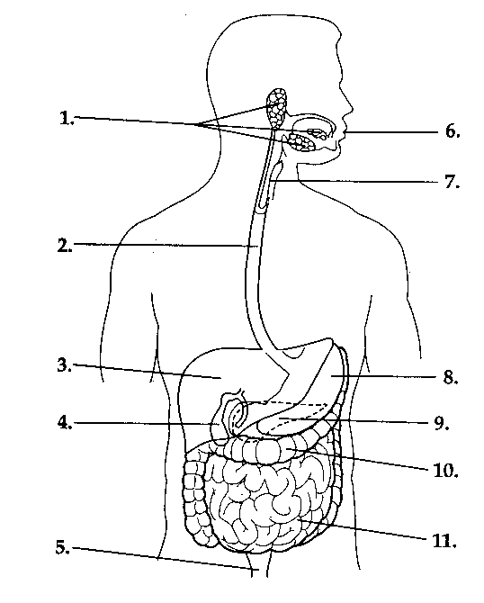
Use the following terms: pancreas, gallbladder, large intestine, rectum, salivary glands, small intestine, stomach, mouth, esophagus, liver, and pharynx.

- ________________________________
- ________________________________
- ________________________________
- ________________________________
- ________________________________
- ________________________________
- ________________________________
- ________________________________
- ________________________________
- ________________________________
- ________________________________
1. Describe the mechanical changes in the food that take place in the mouth:

2. Describe the chemical changes in the food that takes place in the mouth:

3. During the act of swallowing, how is food prevented from entering the trachea? (see text p.639)

4. Describe peristalsis:

5. What is chyme?
Name:_____________________________________ Per._____ Due_________ Assign #9
Unit 8 – Nutrition and Digestion (Chapter 29)

Read pages 636-642 in your text to complete this assignment.

1. Hydrochloric acid and pepsin break down proteins in the stomach. The tissues of the stomach are made of proteins. What question might these facts make you ask?

2. Which organ is most responsible for absorption of nutrients? _________________________________

What structures are found in this organ that increase surface area? ___________________

3. What happens to proteins in the small intestine, and what enzymes are necessary?

5. What happens to fats in the small intestine, and what enzyme is necessary?

6. What happens to starches in the small intestine, and what enzymes are necessary?

7. Is digestion in humans intracellular or extracellular?

7. What is the main function of the large intestine?

1. List IN ORDER the organs of the alimentary canal that food passes through in humans:
1. ___________________________-where food enters (called ingestion)
2. ___________________________ -also called the throat
3. ___________________________ -also called the food tube
4. ___________________________ -where chemical digestion of proteins begins
5. ___________________________ -where most chemical digestion and absorption occur
6. ___________________________ -where water & vitamins are absorbed
7. ___________________________ -last part of the large intestine
8 ____________________________-where feces leave the body

Name:_____________________________________ Per._____ Due_________ Assign #10
Unit 8 – The Human Organism (Chapter 27) & Nutrition and Digestion (Chapter 29)
1. Explain the relationship between anatomy and physiology.

2. Name two general functions of connective tissue.

3. Describe one function of smooth muscles.

4. What function does the cartilage between your vertebrae have?

5. Describe the difference between ligaments and tendons.

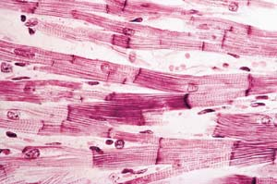
6. The photo at the right is of cardiac muscle tissue.
a. Where in the body is this tissue found?
b. Is the contraction of the muscles containing this tissue voluntary or involuntary?

c. What type of muscle tissue would you find in blood vessels and in the digestive tube organs?
d. What type of muscle tissue is responsible for movement?
7. How might a burn injury to the skin affect your body's ability to maintain homeostasis? Explain.

8. Name an object in your home or classroom that is similar in structure to a hinge joint found in your body.

Describe how their functions are similar.

9. Explain what roles the stomach plays in mechanical and chemical digestion.

10. How does heartburn occur?

11. How does the structure of the small intestine match its function?
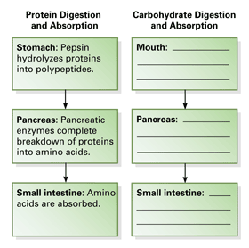
12. Follow the example in the completed protein flowchart to finish the similar flowchart for carbohydrates.
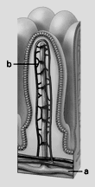
13. Analyzing Diagrams Use the diagram of a villus to answer the questions.
a. Which digestive system organ contains villi?
b. The structure labeled b is a capillary. What is it’s function in the villi?
c. The villi increase the _____________________ for absorption to occur.
14. Briefly explain why each statement below is inaccurate.
a. Digestion is completed in the large intestine.

b. You cannot drink water while standing on your head.

c. Polysaccharide digestion occurs in the liver.
Assign #11 Due _________
Review Assignment:
Castle Learning
Go to Castle Learning and complete the Unit 8 Human Organism and Nutrition/Digestion (Ch 27 & 29) assignment.

d. Your cells can manufacture vitamin K.

