Name:______________________________________ Per._____ Due________ Assign #1
Unit 7 –Frontiers of Genetics (Chapter 13.3)

Read pages 274-277 in your text to complete this assignment.

1. What is a GMO?

2. How is producing a GM plant different from producing a GM animal?

3. What is meant by the term transgenic?

4. What is one potential advantage to cloning animals?

5. Give an example of one potential risk posed by GMOs.

Name:______________________________________ Per._____ Due________ Assign #2
Unit 7 –Frontiers of Genetics (Chapter 13.2)

Read pages 266-272 in your text to complete this assignment.

1. Homer Simpson is working to insert a gene for calcium production in wheat plants in order to make a more nutritious doughnut. Which type of technology does this technique fall under?

2. Why would it be useful to insert certain human genes in to the genome of bacteria?

3. What is a plasmid?

4. Describe the procedure called gene cloning:

5. What is a restriction enzyme?

6. What are “sticky ends” and why are they “sticky”?

Name:______________________________________ Per._____ Due________ Assign #3
Unit 7 –Frontiers of Genetics (Chapter 13.2)

Read pages 278-280 in your text to complete this assignment.

1. One hair follicle was found at a crime scene and a small sample of DNA was obtained from it. How can scientists make copies of this DNA in order to acquire enough samples to fully analyze it?

Describe the process:

2. Name one other application of the mass-production of DNA using PCR.

3. What technique is used to sort fragments of DNA and by what characteristic are they sorted?

4. Explain how gel electrophoresis compares DNA samples.

5. What is a DNA fingerprint?

Name:______________________________________ Per._____ Due________ Assign #4
Unit 7 –Frontiers of Genetics (Chapter 13.5)

Read pages 283-284 in your text to complete this assignment.

1. Define cellular differentiation.

2. Considering that cells differentiate as organism develops and fill in the following table with the words ON or OFF.

 | Red Blood Cell | Zygote | Nerve Cell
Hemoglobin Gene
Kreb’s Cycle Enzyme gene

2. Even though stem cell research continues to be debated, there is hope that what will be able to happen in the future?

3. Where do embryonic stem cells come from?

Name:______________________________________ Per._____ Due_________ Assign #5
Unit 7 – Exploring the History of Life (Chapter 14.1)

Read pages 292-298 in your text to complete this assignment.

1. Define evolution:

2. How did the work of Lyell and Malthus influence Darwin as he developed his theory of evolution?

3. What characteristics of the Galapagos Islands were particularly important to Darwin?

4. What is natural selection?

5. Which of the following is an adaptation?

the sharp teeth of a house cat or a scar on the cat’s ear Explain:

6. Define adaptation:

Name:_____________________________________ Per._____ Due_________ Assign #6
Unit 7 – Exploring the History of Life (Chapter 15)

Read the following situation below and identify the key concepts of Darwin’s natural selection.

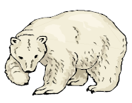
There are 3 types of polar bears: ones with thick coats, ones with thin coats and ones with medium coats. It is fall, soon to be winter. The temperatures are dropping rapidly and the bears must be kept warm, or they will freeze to death. Many of the bears have had ~2 cubs each but due to the extreme temperatures, many mothers only have one cub left.

1. Which polar bear will not benefit from natural selection?

2. Identify the type of variation in the polar population.

3. Who is the most fit in her environment?

4. Predict how the gene pool will change over time.

Assign #6 Continued…

Below is a series of pictures representing changes in a population or cacti over many generations.

1. Why would a deer be more likely to eat the left cactus than the right cactus?

2. In figure 3, the right cactus has flowers, but the cactus that has been eaten by the deer is too damaged to make flowers. Figure 4 shows the situation several months later. What has happened?

3. Do you think that evolution by natural selection is occurring in this cactus population? Explain why or why not.

4. What adaptation seems to increase the fitness of the cacti on the right? How do you think this adaptation increases the ability of cacti on the right to survive and reproduce?

Name:______________________________________ Per._____ Due_________ Assign #7
Unit 7 – Exploring the History of Life (Chapter 14.5)

Read pages 317-319 in your text to complete this assignment.

1. Define antibiotic:

2. Identify a possible risk of overuse of antibiotics.

3. Explain how the effectiveness of an antibiotic decreases with time.

4. Why does a specific pesticide become less effective over time?

5. What is the goal of artificial selection?

Name:_____________________________________ Per._____ Due_________ Assign #8
Unit 7 – Exploring the History of Life (Chapter 15.1)

Read pages 324-330 in your text to complete this assignment.

1. What is a species?

2. What is speciation?

3. Name 3 reproductive barriers that may separate two similar species:

4. What is geographic isolation?

5. Describe conditions that could make a new island a likely place for adaptive radiation.

6. How does punctuated equilibrium relate to Darwin’s theory of natural selection?

Assign #8 Continued…
Unit 7 – Exploring the History of Life (Chapter 15.3)

Read pages 335-340 in your text to complete this assignment.

1. Use the diagram of sedimentary rock layers below to answer the questions.
a. What major change in the environment occurred after layers D and E? Explain.

b. What inferences can you make about life forms at the time layer A was formed?

c. If radiometric dating identifies the rock in layer C as 425 million years old, what can you infer about the age of the fossils in layer C? In layers B and D? Explain.

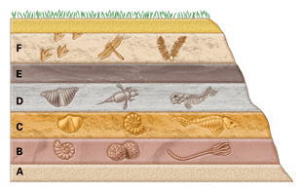
2. What parts of organisms are most commonly found as fossils?

3. What main characteristic distinguishes the fossil record of the Paleozoic Era from that of the Precambrian Era?

4. How does a mass extinction change conditions for species that survive?

Name:______________________________________ Per._____ Due_________ Assign #9
Unit 7 – Exploring the History of Life (Chapter 14.2)

Read pages 299-304 in your text to complete this assignment.

1. List 5 major evidences of evolution:

2. How can evolutionary theory explain why Australia is home to relatively few native placental mammals?

3. What are homologous structures? Provide an example.

4. What are vestigial structures? Provide an example.

5. What can you infer about species that differ significantly in their DNA sequences?

Assign #9 Continued…
Unit 7 – Exploring the History of Life (Chapters 14 & 15)

Read pages 303-304 & 345 in your text to complete this assignment.

6. The amino acid sequences of three species shown below were determined in an
investigation of evolutionary relationships.

Based on these data, which two species are most closely related? Support your answer.

_______________________________________________________________________

_______________________________________________________________________

Place species the phylogenetic tree below to reflect the results of analyzing the amino acid sequences above.

Possible Evolutionary Relationships
Between Species A, B, and C

Name:_____________________________________ Per._____ Due_________ Assign #10
Frontiers of Genetics (Chapter 13) Review Assignment

1. What organism is most commonly used as the host cell in the production of protein via recombinant DNA technology?

2. Describe the function of restriction enzymes:

3. What is a GMO? Give an example.

4. A blood sample was obtained from a crime seen. Explain how PCR and gel electrophoresis can be used to determine if this blood is from the murder suspect.

5. Describe the difference between a human zygote and a human brain cell using the term differentiation.

6. What does the term pluripotent mean? What cells are pluripotent?

Exploring the History of Life (Chapter 14 &15)

1. The graph below shows the mating seasons for seven species of frogs in eastern North America. Different breeding sites are used when mating seasons overlap.
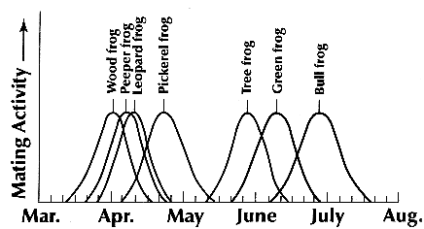
a. Which two species of frogs have almost identical mating seasons?

b. In Evolutionary terms, explain why all of the species listed in the graph that exist today most likely evolved from a common ancestor?

2. Refer to the diagram below to answer the following 3 questions: 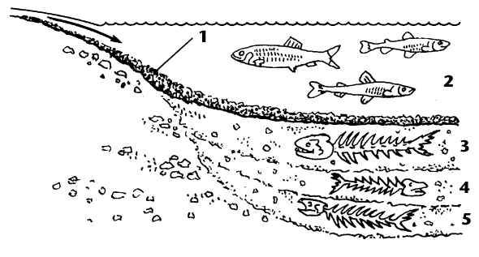
a. Fossils are located in which layer(s)?

b. The oldest fossil is located in layer:

c. The newest fossil is located in layer:

3. Whales have been found to contain leg bones in their body wall. These are an example of what kind of structures?

4. The best definition of natural selection is
a. the constancy of species populations in spite of the production of far more offspring than needed to maintain them.
b. the appearance in the fossil record of a new species relatively suddenly, over a short period of time.
c. the greater survival and reproduction of organisms with favorable variations than of organisms with unfavorable variations.
d. the strengthening and development of a body part by constant use.
e. the inheritance of traits that are acquired during an organism’s lifetime.

5. Define Speciation:

6. How does artificial selection differ from natural selection?

7. What is a phylogenetic tree?

8. Explain how the formation of fossils provides a chronological record of past life forms.

9. How is evidence from DNA useful in understanding the evolution of species?

10. How are pesticide-resistant insects an example of natural selection?

11. A population containing striped and unstriped snails has recently moved into a new region. Birds break the snails open by dropping them onto rocks. The birds eat the bodies of the snails and leave the shells. In one area, researchers counted both live snails and broken shells. The data are summarized below.
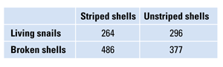
a. Based on the data, tell which form of snail (striped or unstriped) is more likely to be caught by the birds for food. Explain.

b. Suggest a hypothesis to explain what is happening to the snails.

c. Predict how the frequencies of striped and unstriped individuals in the population might change over the generations.

*****************************************************************************

Due __________ Review Assignment: Castle Learning Assign #11

Go to Castle Learning and complete the Biotech/Evolution; Chapters 12, 13, 14 &15 assignment.

Name:_____________________________________ Per._____

Writing a Dichotomous Key
Read your note packet pages 12 & 13 and complete the following:

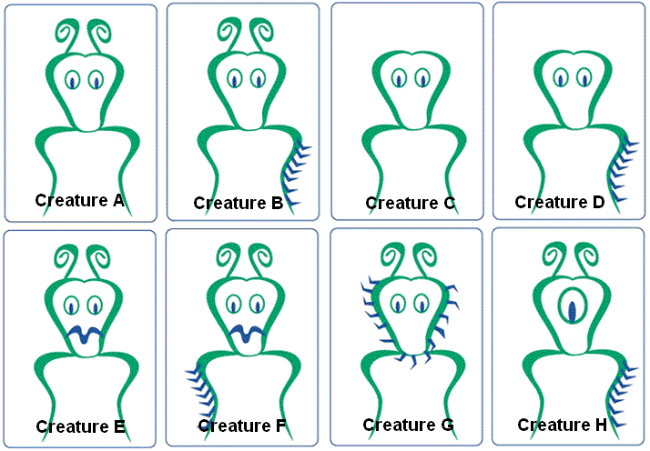

- A dichotomous key to identify 8 organisms should have 7 pairs of statements.

Finish the dichotomous key below by using characteristics to identify the eight creatures in the pictures above.

1. Has one eye _____________________ Creature H
Has two eyes_____________________ Go to 2___

2. ______________________________ ___________
______________________________ ___________

3. ______________________________ ___________
______________________________ ___________

4. ______________________________ ___________
______________________________ ___________

5. ______________________________ ___________
______________________________ ___________

6. ______________________________ ___________
______________________________ ___________

7. ______________________________ ___________
______________________________ ___________

