Name:______________________________________ Per._____ Due_________ Assign #1
Unit 6 – DNA and the Language of Life (Chapter 11)

Read pages 229-234 in your text to complete this assignment.

- Label the three parts that make up a nucleotide

B
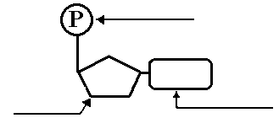

C
A

2. Which two parts make up the backbone of DNA?

i. ____________________________ ii. ___________________________

3. Describe the shape of a DNA molecule:

4. What kind of bond holds the bases of a base pair together?

5. What is the base-pairing rule? A (adenine) always bonds with _________________

G (guanine) always bonds with ________________

6. If six bases on one strand of a DNA double helix are AGTCGG, what are the six bases on the complementary section of the other strand of DNA?

____ ____ ____ ____ ____ ____

Name:______________________________________ Per._____ Due_________ Assign #2
Unit 6 – DNA and the Language of Life (Chapter 11)

Read pages 233-234 in your text to complete this assignment.

1. What process is involved in changing a single-stranded chromosome into a double stranded chromosome?

2. Under what circumstances is DNA replicated?

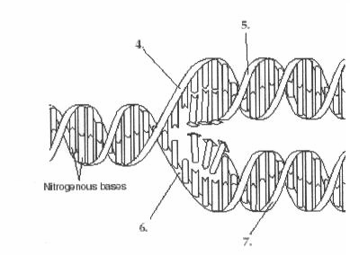
3. On the lines corresponding to the numbers on the diagram, write whether the DNA pointed to is an original strand or a new strand.
2
1

1. ________________________

2. ________________________

3. ________________________

4. ________________________

3
4

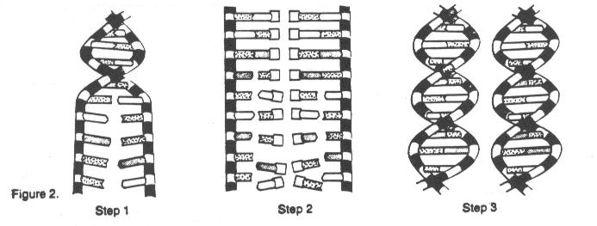4. Figure 2 below shows how DNA replicates.

- Describe what is happening in Step 1:

- Describe what is happening in Step 2:

- Describe what is happening in Step 3:
Name:______________________________________ Per._____ Due_________ Assign #3
Unit 6 – DNA and the Language of Life (Chapter 11)

Read pages 235-239 in your text to complete this assignment.

1. Which molecule completes the flow of information from DNA to protein?

2. In which cell organelle does Transcription take place?

3. What is the name of the new molecule formed as a result of Transcription?

4. When Transcription is complete, what happens to the strand of DNA used?

5. When Transcription is complete, what happens to the strand of mRNA?

6. List 3 ways does DNA differs from RNA.

a.

b.

c.

Name:______________________________________ Per._____ Due_________ Assign #4
Unit 6 – DNA and the Language of Life (Chapter 11)

Read pages 235-239 in your text to complete this assignment.

1. Name the three types of RNA found in the cell and describe each.

Type of RNA | Function

2. What are the building blocks of RNA?

3. What must happen to the DNA before it can be transcribed?

4. What is the side of DNA that is used in transcription called?

5. Transcribe the following DNA to determine the mRNA produced:
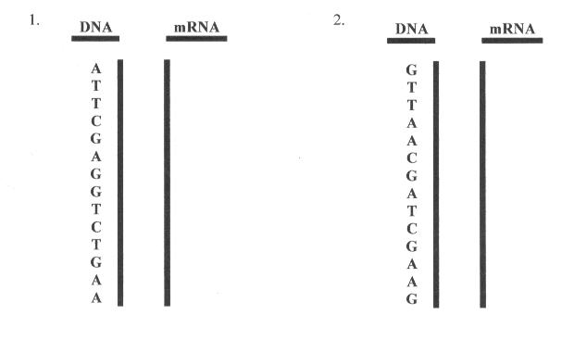

Name:______________________________________ Per._____ Due_________ Assign #5
Unit 6 – DNA and the Language of Life (Chapter 11)

Read pages 239-241 in your text to complete this assignment.

1. What process uses RNA as a template to construct proteins?

2. What is a codon?

3. Where does Translation take place?

4. What is the name of the new molecule formed as a result of Translation?

5. What is the function of mRNA in Translation?

6. What is the function of tRNA in Translation?

7. What is the function of the ribosome in Translation?

8. How many nucleotides long would an mRNA molecule have to be in order to make a polypeptide which has 27 amino acids? Show your math!

Name:______________________________________ Per._____ Due_________ Assign #6
Unit 6 – DNA and the Language of Life (Chapter 11)

Read pages 242-243 and use the Codon table on page 237 in your text to complete this assignment.

1. Use the following “sense strand” of DNA to make mRNA.
A T G T C C A G C C A T T T G G A G
mRNA:

2. Now use the codon table on page 237 in your textbook to covert the mRNA in question 1 to a polypeptide sequence:

3. Repeat the above process and transcribe and translate the following “sense strand” of DNA:
T T C G A A A C C G T C A T A C C C
mRNA:

poypeptide:

From page 243:
4. Explain why a base substitution is often less harmful than a base deletion or insertion.

5. Describe how a mutation could be helpful rather than harmful.

6. Give 2 examples of mutagens.

7. What molecule is described by the following?
Molecule A is a single stranded molecule with uracil ______________
Molecule B contains deoxyribose ________________
Carries amino acids to the ribosome _______________
Made into ribosomes ___________________
Name:______________________________________ Per._____ Due________ Assign #7
Unit 6 – DNA and the Language of Life (Chapter 11)

Review Assignment (Part 1)

1. What is the function of DNA?

2. What are the building blocks of DNA?

3. Label the parts of a DNA nucleotide on the diagram below.
- Circle one nucleotide and
- Indicate a hydrogen bond with an X
-~

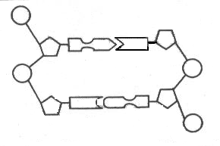

4. The following is a section of a side of DNA. What would the complementary DNA side be?
ATCGCAATGCTGCA

5. Describe the shape of DNA.

6. The process of DNA making an exact copy is called:

Name:______________________________________ Per._____ Due________ Assign #8
Unit 6 – DNA and the Language of Life (Chapter 11)

Review Assignment (Part 2)

7. When does DNA replication take place?

8. A section of a chromosomal material that codes for one polypeptide is called a ________________________

9. Protein synthesis can be broken down into two processes. Name each process (in order), describe each process, and describe where each process takes place in the cell.

Process Name |  | Location in Cell | What takes place?
1
2

10. List the three types of RNA and describe the function of each in protein synthesis.
a.

b.

C.

11. Compare and contrast the structure of DNA and RNA.

DNA RNA

Made of

# strands

Bases

located?

12. The following is a section of a strand of DNA. What would the mRNA strand that would be transcribed from this strand?

G A T C G G A A T G C T G C A

13. Given the above DNA nucleotide sequence. What would the amino acid sequence be if the DNA sequence was transcribed and then translated? (use chart on page 237)

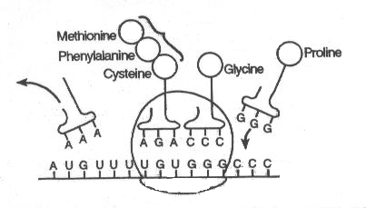

14. Above is a diagram representing the process of _______________________

LABEL: mRNA, tRNA, amino acid, a codon, an anticodon, a ribosome, a polypeptide

*****************************************************************************

Due __________ Castle Learning Assign #9

Go to Castle Learning and complete the Chapter 11 assignment.

Name:______________________________________ Per._____ Due_________ Assign #
Unit 3b – DNA and the Language of Life (Chapter 11)

Color and cut out the following shapes and put them in an envelope to be used in class tomorrow.

DNA Nucleotides
Color the tabs only (nitrogen bases)
A (Adenine) – red
G (Guanine) – green
T (Thymine) – yellow
C (Cystine) – Blue

Cut out all 8 nucleotides.
Bring to class in an envelope.

