
Regents Biology Name ______________________________
Chapter 33 Reproduction & Development Period _________ Test Date ___________

33.1 Reproductive organs produce and transport gametes.
A. The Female Reproductive System
- ovaries (gonads)

a. estrogen

b. follicles

- ovulation

d. oviduct

2. uterus

3. cervix

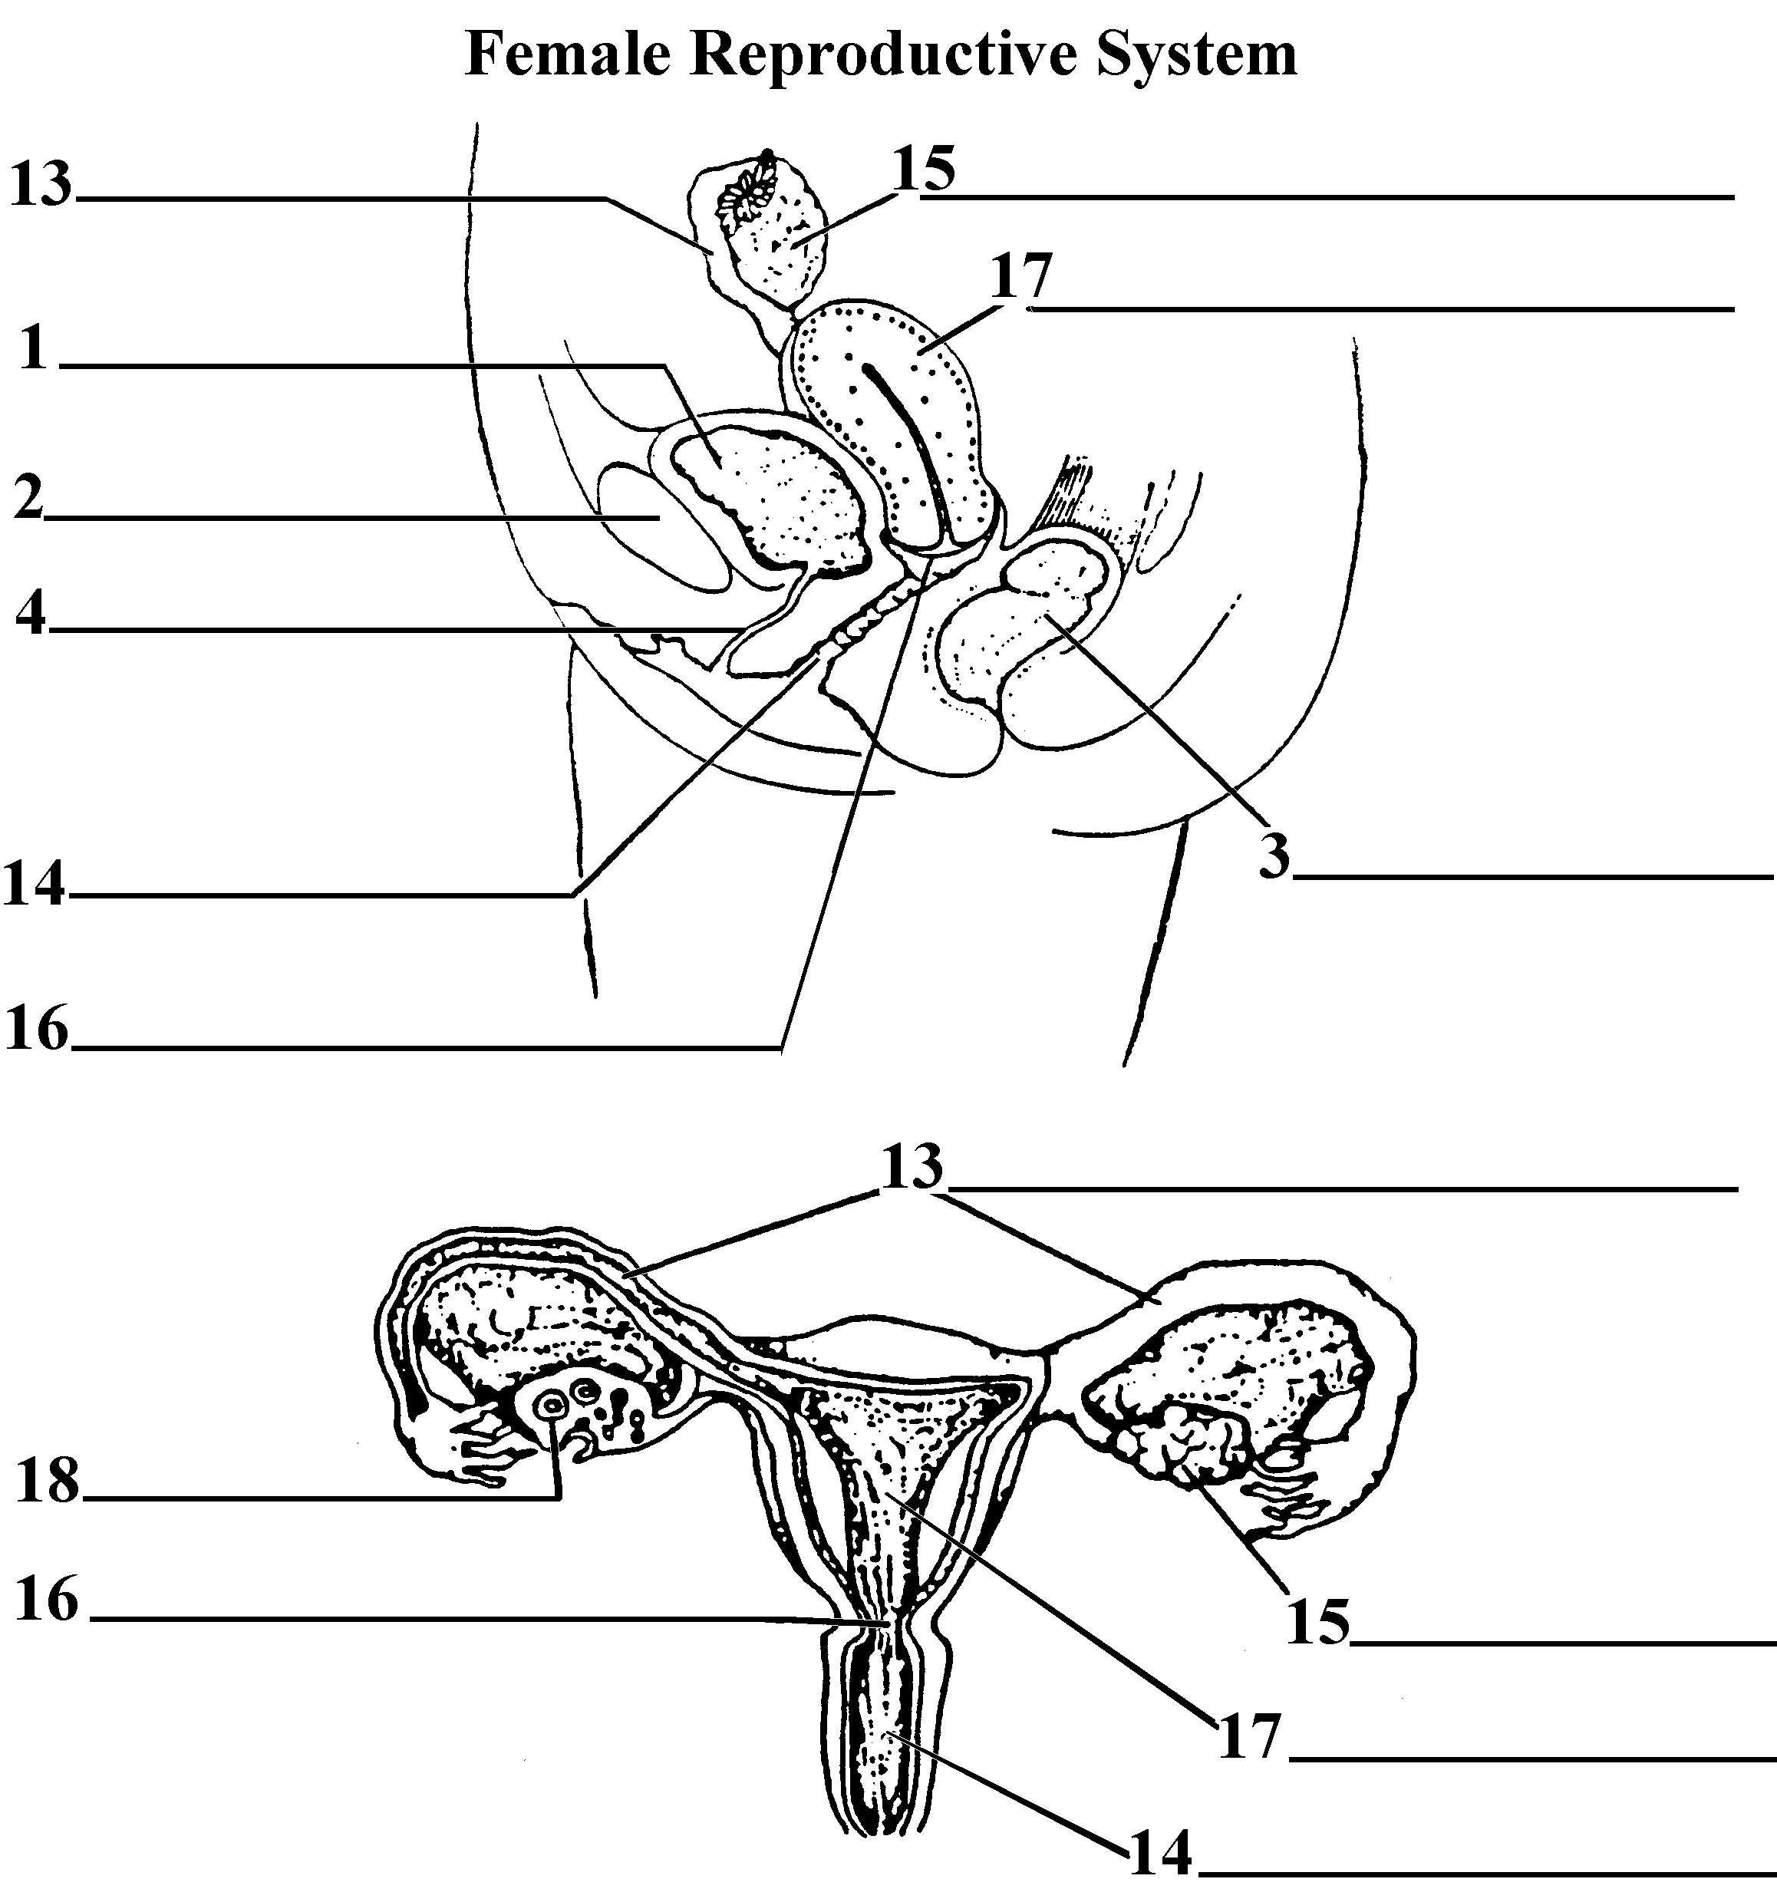
4. vagina

B. The Male Reproductive System
1. testes (gonads)

- testosterone

b. scrotum

c. epididymis

d. semen

e. vas deferens

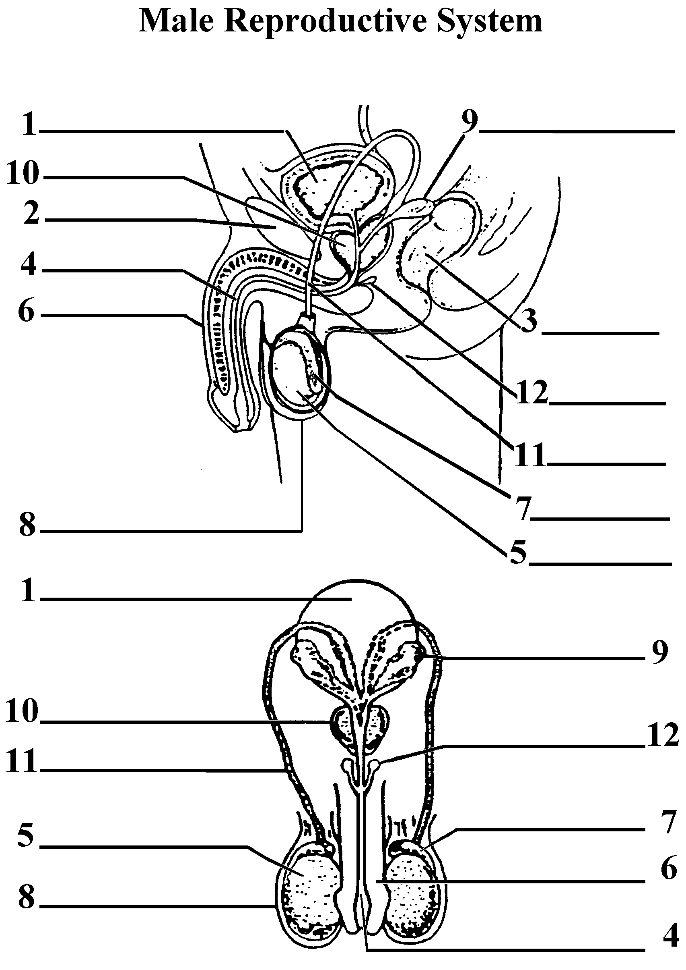

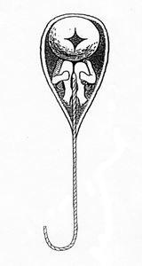
Some early biologists thought they could see a miniature man within each sperm head. Hartsoeker, 1694

C. Development of Eggs and Sperm
1. Gametogenesis

a. Egg Cells (oogenesis)

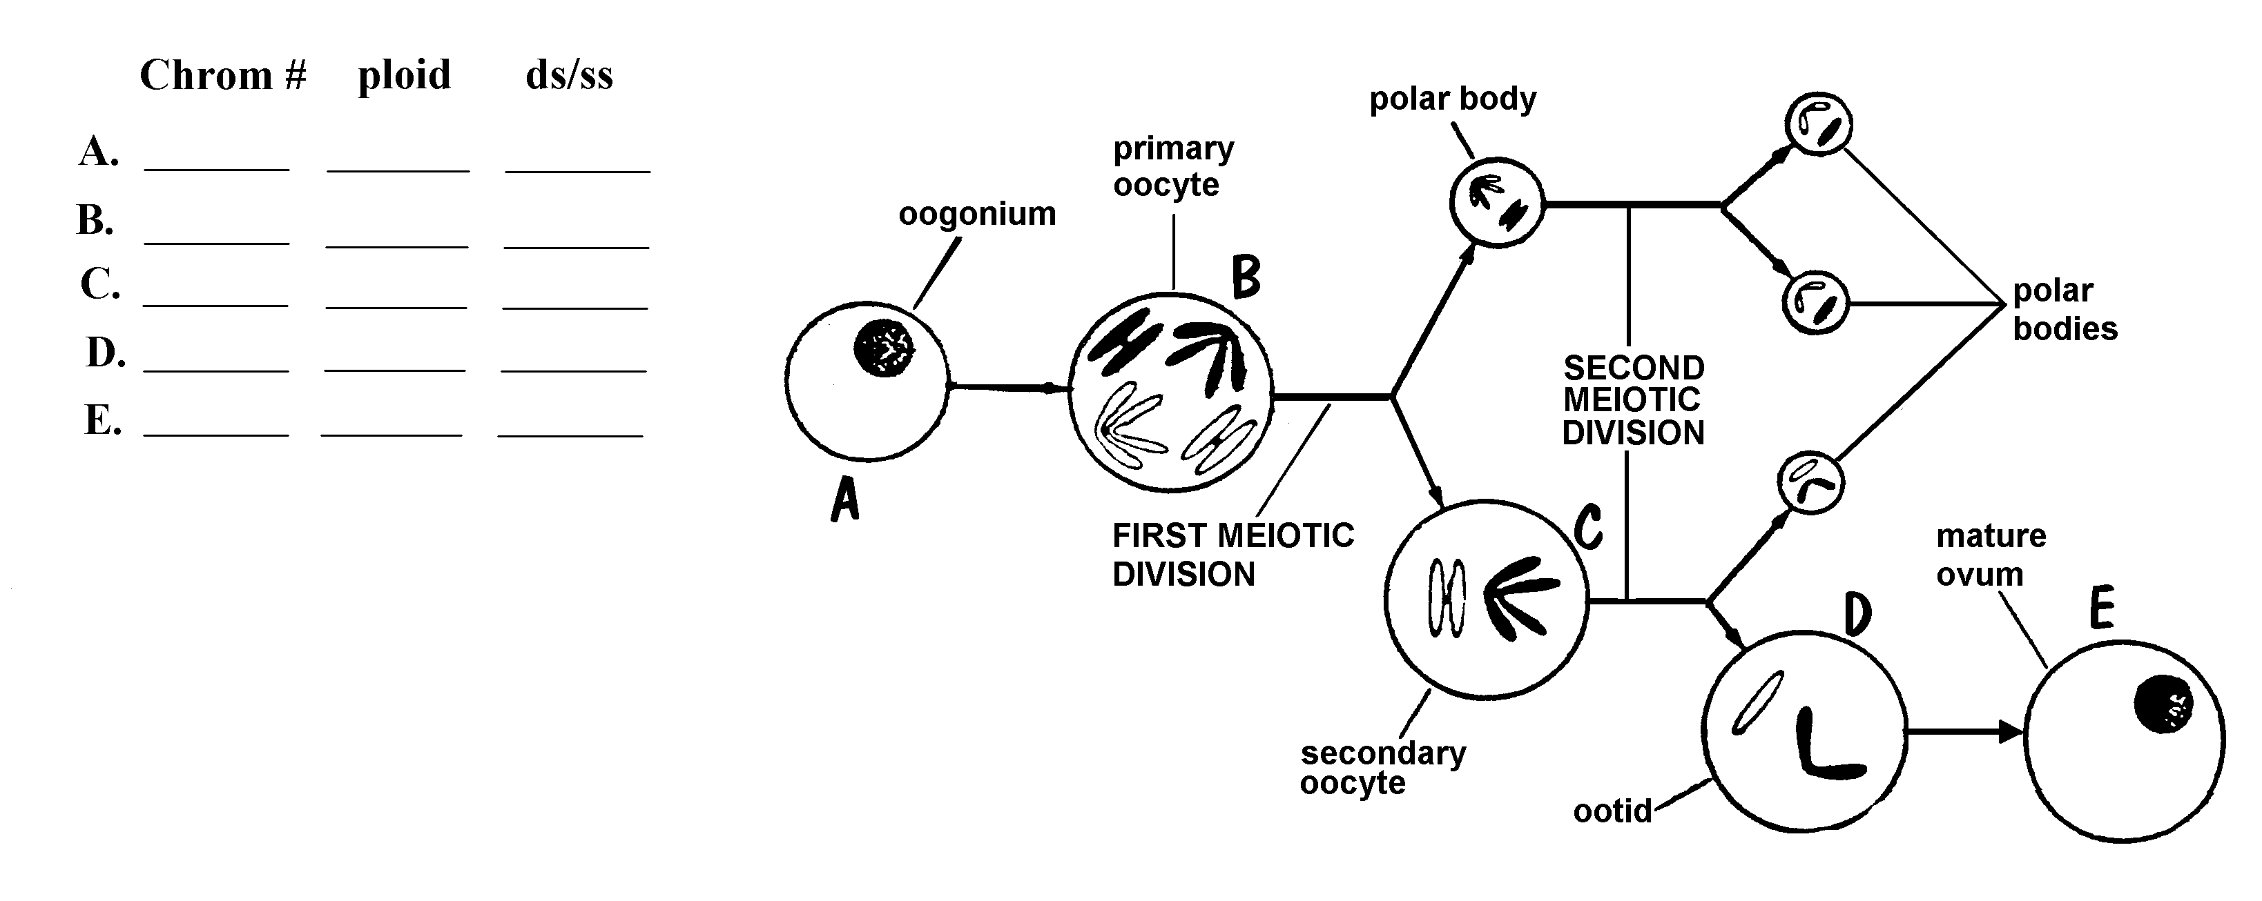

b. Sperm Cells (spermatogenesis)

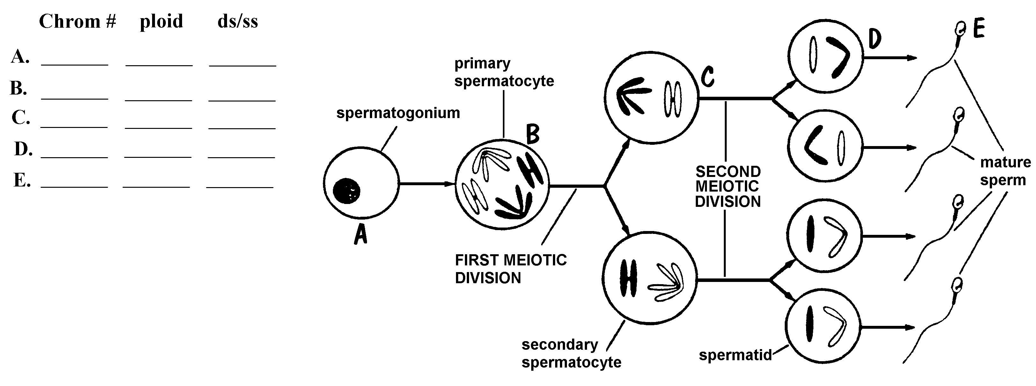

33.2 Hormones regulate the reproductive system.

A. Hormonal Control of the Female Reproductive System
1. The Ovarian & Menstrual Cycles:
- Description

- 4 stages
Stage | Hormones | Description | Duration
Follicle | FSH  Estrogen
Ovulation | LH
Corpus  Luteum | Progesterone
Menstruation

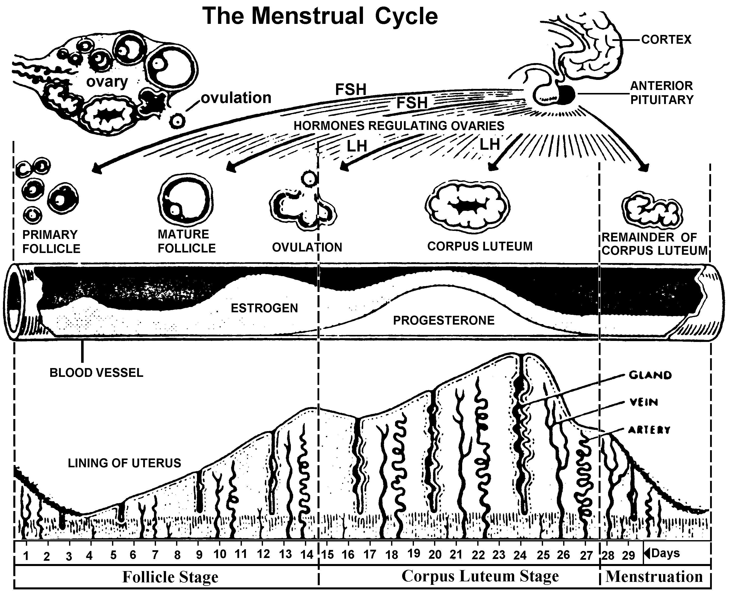

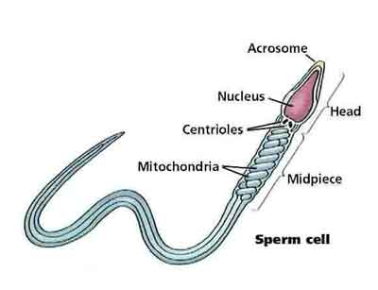
B. Hormonal Regulation of the Testes

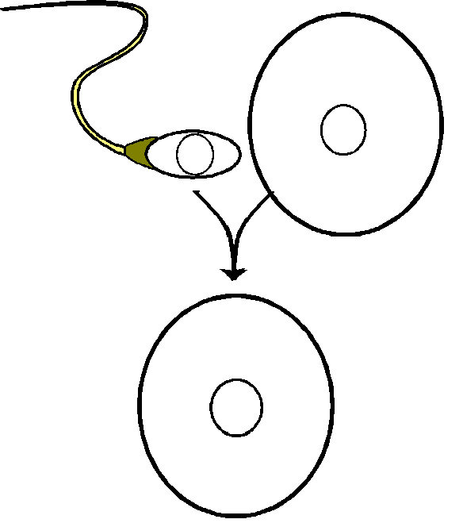33.3 Fertilization occurs in the oviduct.
A. Fertiliztion Involves:

*

*

*

*
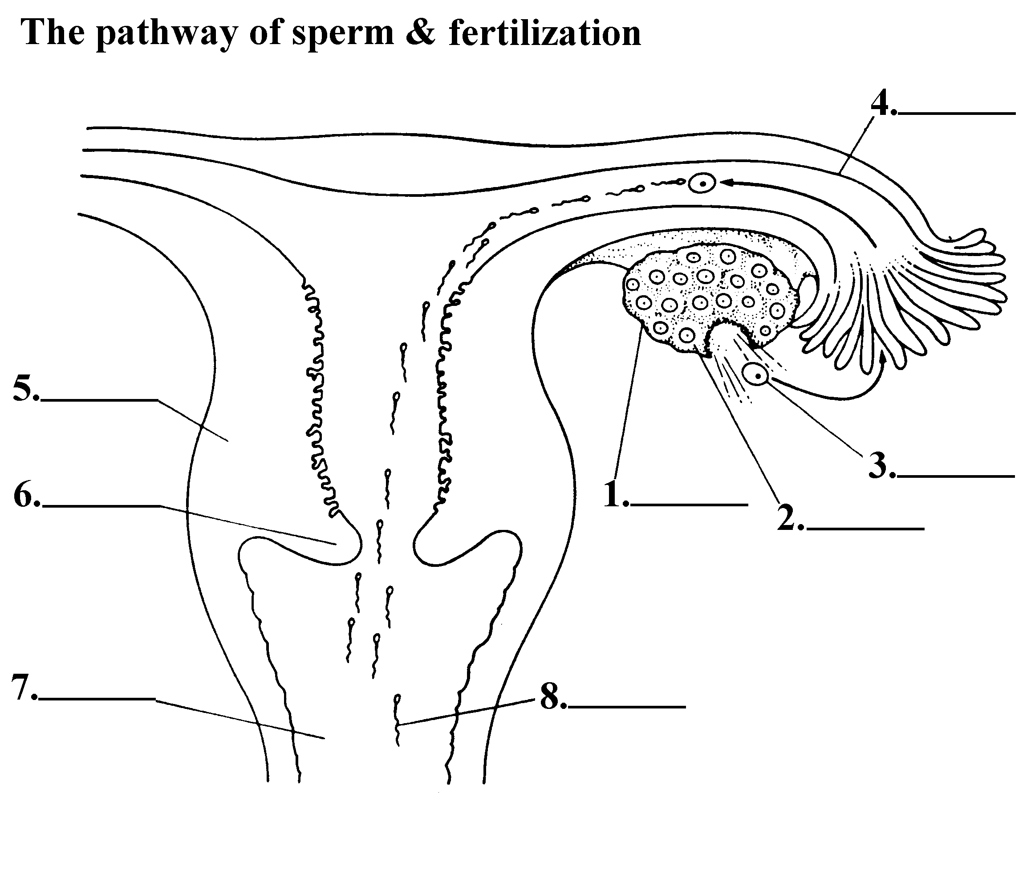

B. Human Development: The First Week

Fertilization

Day 1 Zygote

Embryo Formation:
Day 2
cleavage:

Day 3

Day 4

Day 5 Blastocyst trophoblast

inner cell mass
:

gastrulation: Implantation

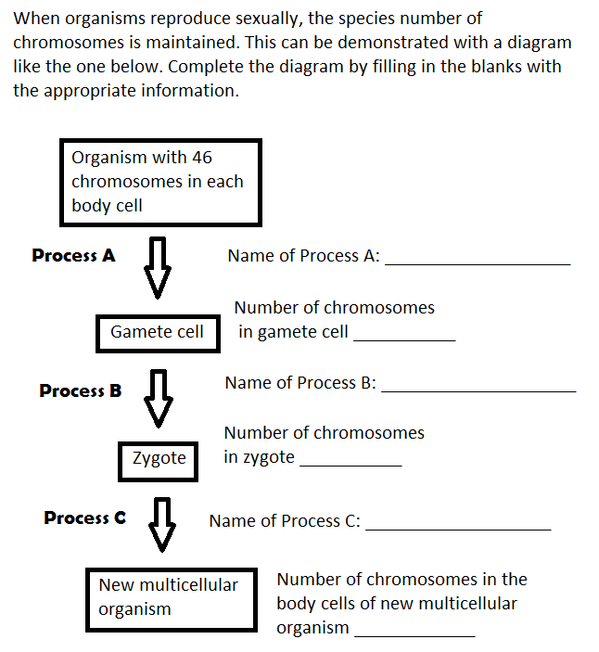

C. Multiple Births (Twins & “Supertwins”)

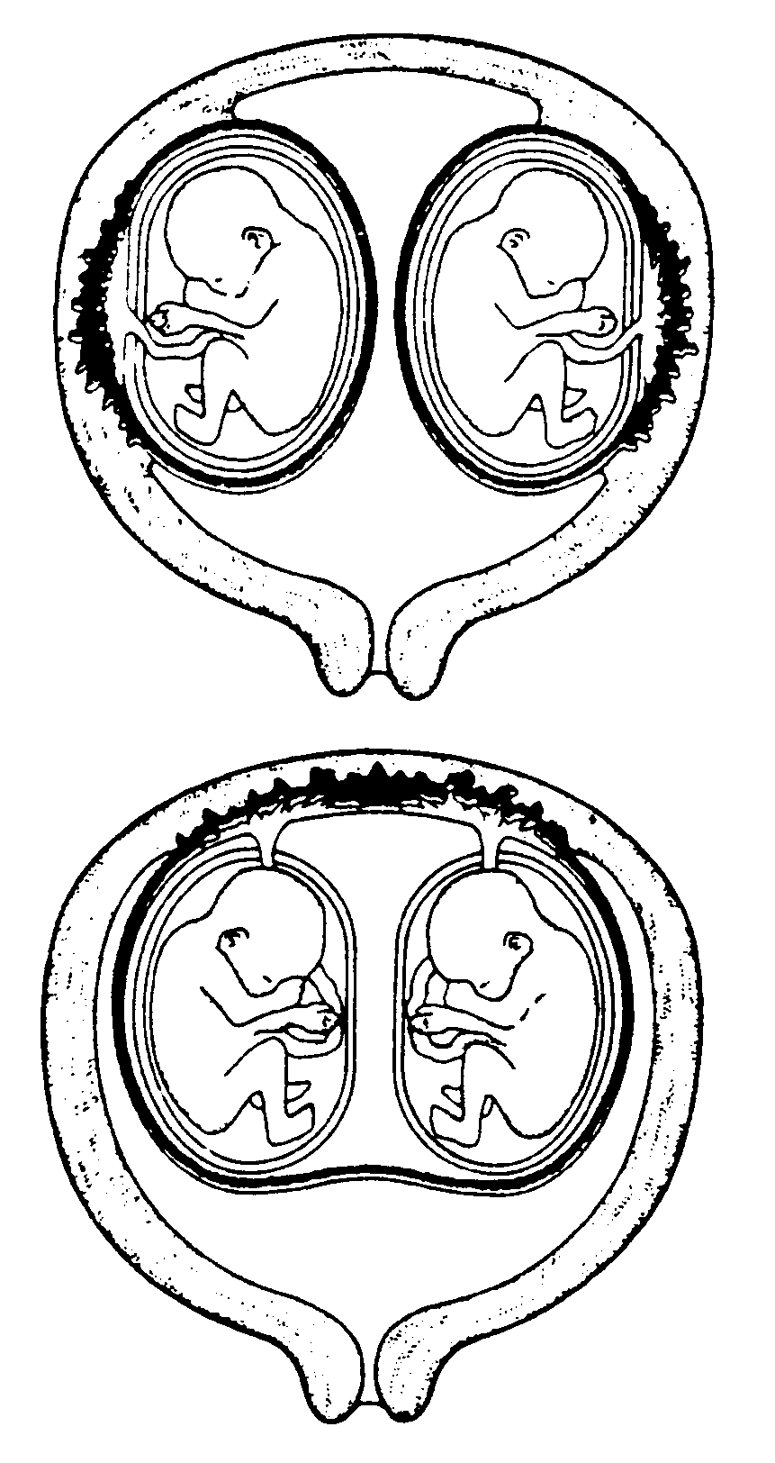

-Fraternal Twins

-Identical Twins

33.4 Embryonic and fetal development occurs in the uterus.
A. The First Trimester

1. gastrulation

Formation of 3 Germ Layers:
a. inner

b. outer

c. middle

2. differentiation:

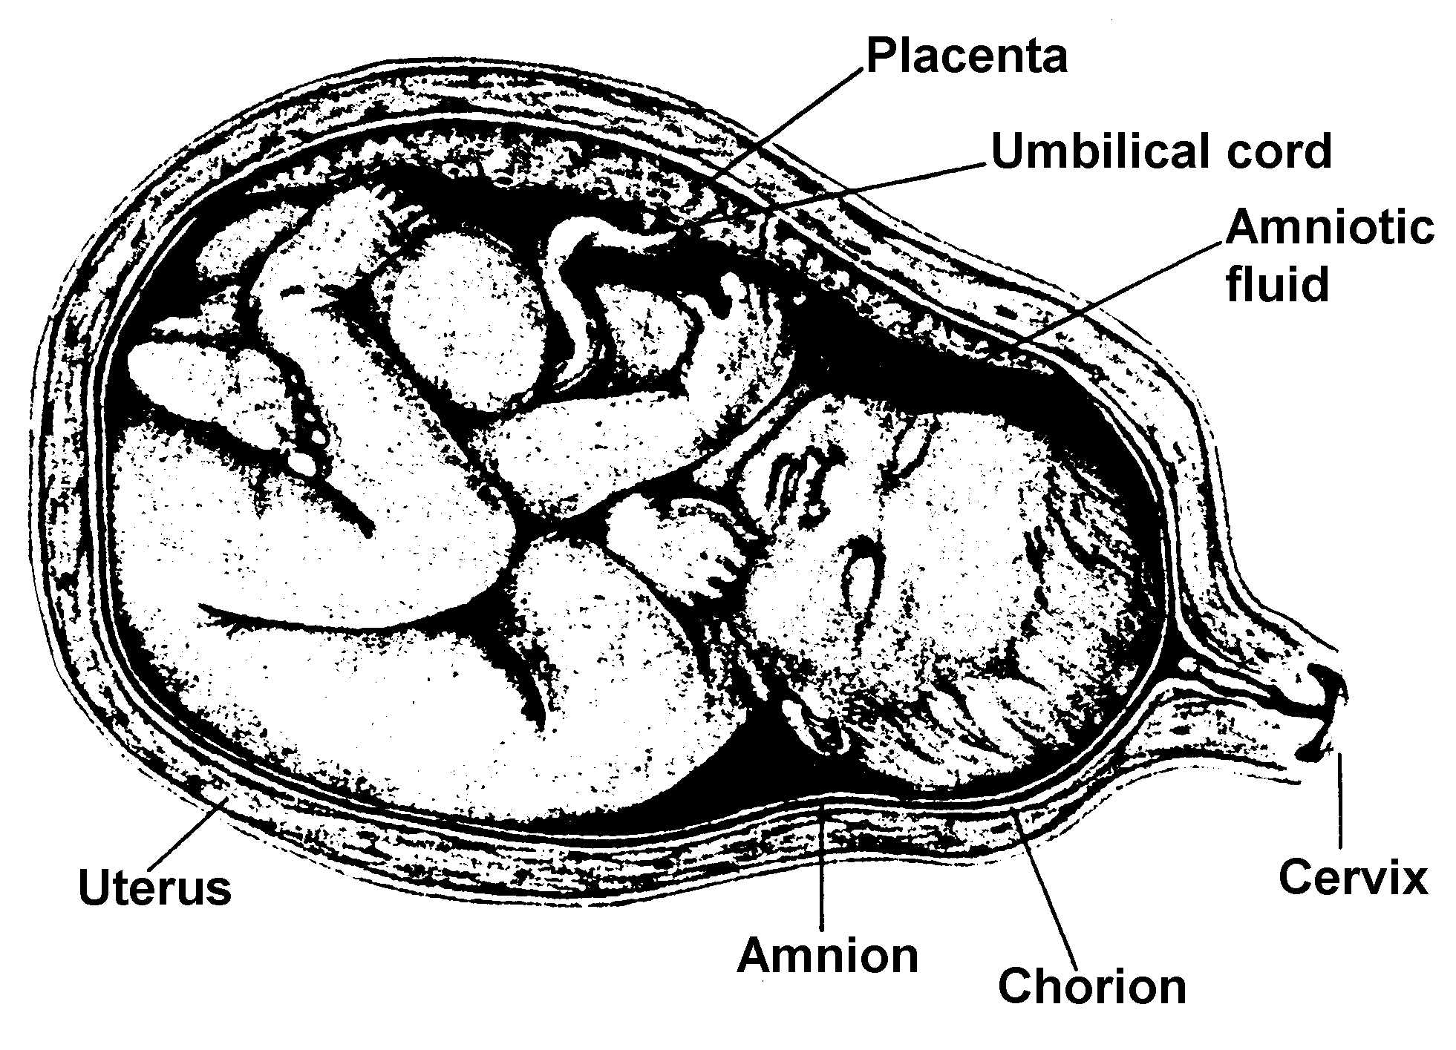
3. membranes

a. chorion

b. amnion

-Nourishment of the Embryo

- placenta

A chicken embryo… how does it compare?
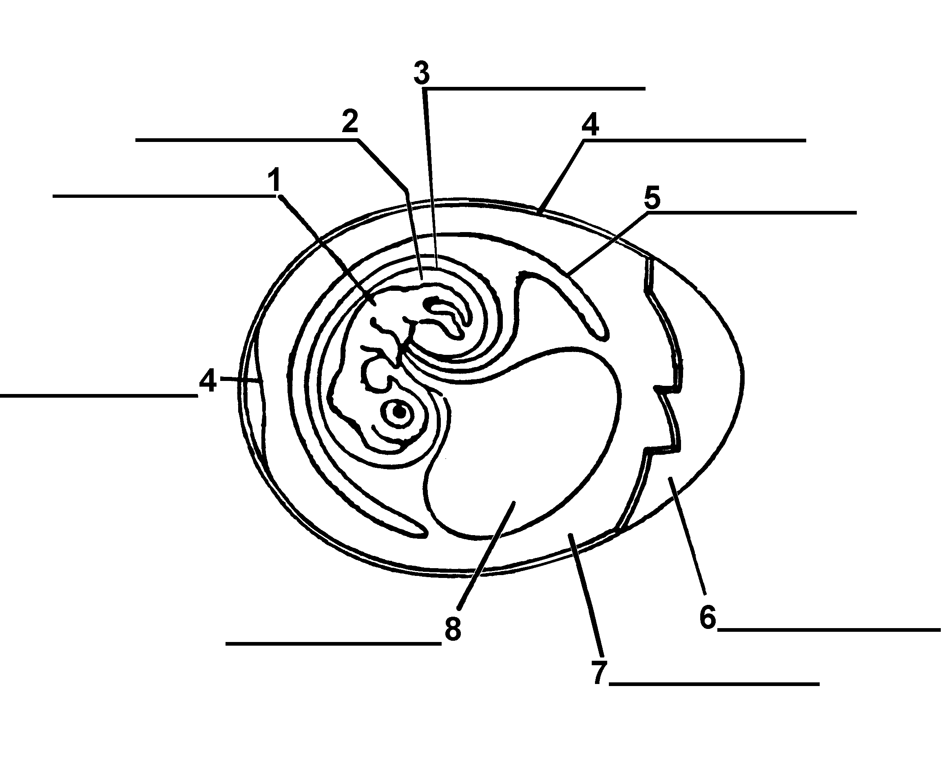

Overview of Reproduction in Vertebrates:
Vertebrate | Fertilization | Development | # of Eggs | Parental Care

Fish
Amphibians
Reptiles
Birds
Mammals

B. The Second Trimester

C. The Third Trimester

Importance of Nutrition during Pregnancy:

D. Childbirth

1. gestation

2. labor

Labor is an example of positive feedback:
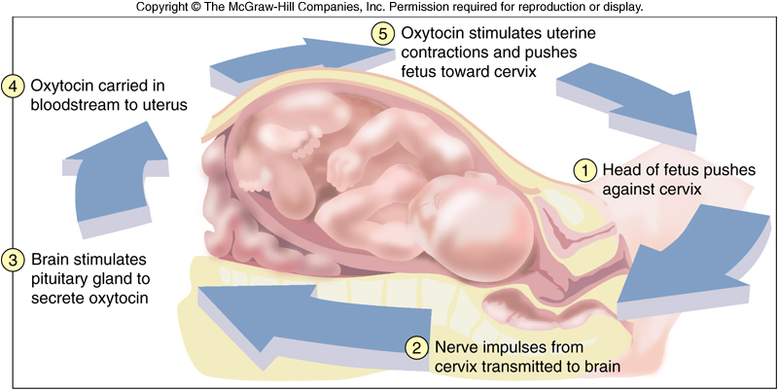

3. afterbirth

4. hormones

33.5 Development is a lifelong process.

A. Infancy Through Adolescence

1. Infancy

2. Childhood

3. Adolescence

B. Adulthood and Aging

33.6 Maintaining a healthy reproductive system requires knowledge.

A. Gynecology

B. Urology

C. Sexually Transmitted Diseases (STDs)

Sex Determination
Control Genes (Video)

SRY Gene

