Name:___________________________________ Per._____ Due______ Assign #1
Unit 3 – A Tour of the Cell (Chapter 6)

Read pages 110-113 in your text. Use your textbook and notes to answer the questions below.

1. What laboratory instrument led to the discovery of cells?

2. Summarize the three components of the cell theory.
a.

b.

c.

3. Living organisms are unicellular or multicellular. Explain what that means and give examples of unicellular organisms and multicellular organisms.

4. Name the three domains.

1.

2.

3.

5. What characteristics do all cells have in common?

a.

b.

c.

Name:________________________________ Per._____ Due_________ Assign #2
Unit 3 – A Tour of the Cell (Chapter 6)

Read pages 114 in your text. Use your textbook and notes to answer the questions below.

1. Cells are classified as either prokaryotic or eukaryotic. How is a prokaryotic cell different from a eukaryotic cell?

2. What types of organisms have prokaryotic cells?

3. What types of organisms have eukaryotic cells?

4. Most prokaryotic cells are 1-10 micrometers (µm) in size while eukaryotic cells are typically 10-100 µm. How many micrometers are in one millimeter?

5. A cell is 50 µm in diameter. Convert the measurement to millimeters.

Read about the anatomy of a chicken egg below and answer the questions that follow.

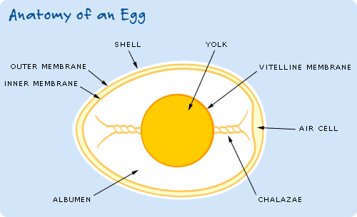

SHELL | Bumpy and grainy in texture, an eggshell is covered with as many as 17,000 tiny pores. Eggshell is made almost entirely of calcium carbonate (CaCO₃) crystals. It is a semipermeable membrane, which means that air and moisture can pass through its pores. The shell also has a thin outermost coating called the bloom or cuticle that helps keep out bacteria and dust.
INNER AND OUTER MEMBRANES | Lying between the eggshell and egg white, these two transparent protein membranes provide efficient defense against bacterial invasion. If you give these layers a tug, you’ll find they’re surprisingly strong. They’re made partly of keratin, a protein that’s also in human hair.
AIR CELL | An air space forms when the contents of the egg cool and contract after the egg is laid. The air cell usually rests between the outer and inner membranes at the egg’s larger end, and it accounts for the crater you often see at the end of a hard-cooked egg. The air cell grows larger as an egg ages.
ALBUMEN | The egg white is known as the albumen, which comes from albus, the Latin word for “white.” Four alternating layers of thick and thin albumen contain approximately 40 different proteins, the main components of the egg white in addition to water.
CHALAZAE | Opaque ropes of egg white, the chalazae hold the yolk in the center of the egg. Like little anchors, they attach the yolk’s casing to the membrane lining the eggshell. The more prominent they are, the fresher the egg.
VITELLINE  MEMBRANE | The clear casing that encloses the yolk.
YOLK | The yolk contains less water and more protein than the white, some fat, and most of the vitamins and minerals of the egg. These include iron, vitamin A, vitamin D, phosphorus, calcium, thiamine, and riboflavin. The yolk is also a source of lecithin, an effective emulsifier. Yolk color ranges from just a hint of yellow to a magnificent deep orange, according to the feed and breed of the hen.

6. Placing a chicken egg in vinegar will remove the shell. If the shell is removed from the egg what will the outermost layer be?

7. The egg white is known as albumen. What is albumen made out of?

- What is found in the yolk of the egg?

9. Why is there yolk in a chicken egg?

Name:________________________________ Per._____ Due_________ Assign #3
Unit 3 – A Tour of the Cell (Chapter 6)

Refer to your notes packet to answer the following questions.

1. What are the two major classes of cells?

2. Some prokaryotic and all eukaryotic cells have histone proteins. What is their function?

3. What two domains have organisms that have prokaryotic cells?

4. Eukaryotic cells developed the ability to engulf prokaryotic cells (endocytosis). What two organelles developed in eukaryotic cells by the endocytosis of prokaryotic cells?

- Name one difference between organisms in the domain archaea and the domain eukarya.

6. Name one similarity between organisms in the domain bacteria and the domain eukarya.

Refer to Figure 1 (A simplified chart of the history of life on earth) in your notes packet to answer the following questions.

7. Was the universal ancestor prokaryotic or eukaryotic?

8. What is the function of glycogen (remember chapter 5)?

9. What two groups of organisms that are alive today have the ability to store glycogen?

Name:________________________________ Per._____ Due_________ Assign #4
Unit 3 – A Tour of the Cell (Chapter 6)

Read pages 115 - 117 in your text. Use your textbook and notes to answer the questions below.

- A plasma membrane is made out of a phospholipid bilayer. Draw a diagram below of what that looks like.

- Membrane proteins are embedded in the plasma membrane of a cell. List four functions of proteins that are found in the plasma membrane

a.

b.

c.

d.

- How does the plasma membrane help a cell to maintain homeostasis?

- Define the following words. Refer to the Teacup Activity completed in class.

Concentration –

Volume -

Solute –

Solvent –

5. Consider a salt water solution, what is the solute and what is the solvent?

Solute –

Solvent -

6. In a 5% glucose solution. List below the percentage of water and the percentage of glucose that you would find in a specific volume.
Name:________________________________ Per._____ Due_________ Assign #5
Unit 3 – A Tour of the Cell (Chapter 6)

Read pages 118-121 in your textbook, and then answer the questions below

- Plasma membranes are selectively permeable. What does that mean?

- Explain the difference between a large molecule and a large particle.

- Define Diffusion.

- Figure 6-11 on p.119 shows an example of diffusion. Sketch and label the water and dye molecules on the diagram below using Figure 6-11.

- Diffusion across a plasma membrane is called __________________ _______________.

- What are some molecules that typically diffuse freely through the plasma membrane by passive transport?

7. What does the process of facilitated diffusion require in order for the molecules to be able to move through the plasma membrane?

8. List substances that moves through the plasma membrane by facilitated diffusion.

9. The passive transport of water across a plasma membrane is called _________________

10. Do cells have to use energy to make diffusion, passive transport, facilitated transport or osmosis take place?
Name:________________________________ Per._____ Due_________ Assign #6
Unit 3 – A Tour of the Cell (Chapter 6)

Refer to pages 118-121 in your textbook and the Egg Activity completed in class to answer the questions below.

1. Solutions are named according to whether or not they have more or less solute (dissolved “stuff”) than a cell.
  - Solutions with a HIGHER concentration of solute are said to be ________________
  - Solutions with a LOWER concentration of solute are said to be _________________
  - Solutions with equal concentrations of solute are said to be ____________________

2. In the beakers below draw what would happen to an animal cell that was placed in the following solutions. Draw the cell in the beaker and draw arrows in the direction of water flow because of osmosis taking place.

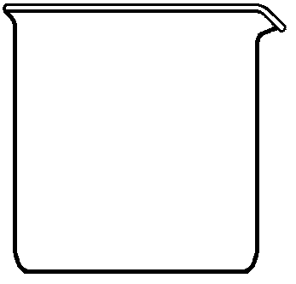
Hypertonic solution Isotonic solution Hypotonic solution

3. The diagram below represents a laboratory setup used by a student during an investigation
of diffusion. Write a statement that best explains why the liquid in tube A will rise over a period of time?
You must include the word concentration, diffuse, and osmosis in your answer.

4. A red onion cell has undergone a change, as represented in the diagram below. Label the cell wall, the plasma membrane, and the cytoplasm in the diagram below.

This change is most likely due to the cell being placed in what type of solution?
(a) distilled water (c) light
(b) salt water (d) darkness
Name:________________________________ Per._____ Due_________ Assign #7
Unit 3 – A Tour of the Cell (Chapter 6)

Read pages 121-122 in your textbook to answer the questions below.

1. What role does active transport play in a cell?

2. Compare and contrast active transport and passive transport.

3. What do plasma membranes form to transport large particle into cells?

4. How are active transport and facilitated diffusion different? How are they similar?

5. How do protests that live in fresh water maintain water balance?

Type of Transport | Does it use energy? Yes or No
Osmosis
Active Transport
Endocytosis
Passive Transport
Facilitated Diffusion
Pinocytosis
Exocytosis
Phagocytosis

Name:________________________________ Per._____ Due_________ Assign #8
Unit 3 – A Tour of the Cell (Chapter 6)

Read pages 124-131 in your textbook and the following information to answer the questions below.

The Generalized Cell

Cells vary greatly in the details of their form and in the special functions they perform. However, most cells have certain features in common. The reading below has descriptions and functions of various cell structures and organelles.

Cell Walls

The cell wall is a structure found just outside the cell membrane in plant cells. It is considered to be a “nonliving” part of the cell, since it does not take part in any of the life processes of the cell. The cell wall is made up chiefly of cellulose (a carbohydrate humans are unable to digest), is relatively rigid, and provides support for the cell.
- What is the function of the cell wall in plant cells? _________________________________________________________________________________

Plasma Membrane

The plasma membrane or cell membrane surrounds the cell. It plays an active role in determining which substances enter and which substances leave the cell. Because some substances can pass freely through the cell membrane and others cannot, the membrane is said to be selectively permeable, or semipermeable. The permeability of the cell membrane varies from one cell type to another and from time to time in the same type of cell, depending on the state of metabolic activity. The cell membrane is composed of lipids and proteins.

- Describe the functions of the cell membrane.
___________________________________________________________________________

- Why is the cell membrane described as “selectively permeable”?
__________________________________________________________________________________

Nucleus

The nucleus is the control center for cell functions. It is surrounded by a selectively permeable membrane Within the nucleus are the chromatin threads that are made up of deoxyribonucleic acid (DNA). Inside of the nucleus is found at least one nucleoli. Nucleoli are involved in the production of ribosomes.

- The control center of the cell is the _______________________

- DNA stands for _____________________________________________________ , which hold the instructions for what proteins the cell will produce.

- The_____________________ is involved in the production of ribosomes.
Ribosome

The DNA in the nucleus contains instructions for making proteins. Proteins are constructed in a cell by the ribosomes. These organelles work as protein “assembly lines”. Proteins do many jobs in organisms. Antibodies, enzymes, pigments and some hormones are all made out of proteins.

- What is the function of ribosomes? ______________________________________________

__________________________________________________________________________

- What are examples of proteins in a living thing? ____________________________________

___________________________________________________________________________

Cytoplasm

The material in the cell outside the nucleus is called the cytoplasm. Although it contains thousands of substances, it consists mainly of water. Within the cytoplasm are the various organelles of the cell. The cytoplasm provides the environment in which the organelles carry on the life processes of the cell.

9. What is the main function of the cytoplasm? _________________________________________

_____________________________________________________________________________

10. The cytoplasm consists mainly of ______________________

Endoplasmic Reticulum

The endoplasmic reticulum is a membrane-bounded system of fluid-filled channels or tubes through which materials are transported within the cell. The membranes of the endoplasmic reticulum may also serve as sites of biochemical reactions. There are two types of endoplasmic reticulum—smooth and rough. The rough, or granular, appearance of some endoplasmic reticulum is due to the presence of ribosomes on the endoplasmic reticulum membranes. Rough endoplasmic reticulum is found mainly in cells involved in protein synthesis. Smooth endoplasmic reticulum, which has no ribosomes on its membranes, is found mainly in cells involved in synthesis of nonprotein substances.

11. What are the functions of the endoplasmic reticulum? ________________________________
___________________________________________________________________________

12. What is found on the surface of rough endoplasmic reticulum? ________________________

Name:________________________________ Per._____ Due_________ Assign #9
Unit 3 – A Tour of the Cell (Chapter 6)

Read pages 124-131 in your textbook and the following information to answer the questions below.

Golgi Apparatus

The golgi apparatus is made up of a series of membrane-enclosed sacs. It is usually found near the nucleus. This organelle is associated with the packaging and processing of cell products to be secreted by the cell. As portions of endoplasmic reticulum become filled with products, small sections break off, forming small spherical sacs called vesicles. The vesicles become a part of the golgi apparatus’ complex of membranes. The vesicles eventually move toward the cell membrane and release their products outside the cell.

- What are the functions of the Golgi apparatus? _______________________________________
___________________________________________________________________________

- Vesicles carry products of cells. How are they formed? ______________________________
___________________________________________________________________________

Lysosomes

Lysosomes are “packages,” or sacs, of digestive enzymes. They keep the enzymes separated from the rest of the cell contents until they are needed. Lysosomes, which are found mainly in animal cells, are egg-shaped structures enclosed by a membrane. They are thought to be produced by the Golgi apparatus.

- What is the function of lysosomes? ______________________________________________
___________________________________________________________________________

- What does digestion mean? ____________________________________________________
___________________________________________________________________________

Mitochondria

Mitochondria are slipper-shaped organelles found in the cytoplasm. Cellular respiration, which is how an organism makes energy for life processes, take place here.

- What is the function of mitochondria? ____________________________________________
___________________________________________________________________________

Centrioles

The centrioles are a pair of small cylindrical organelles found near the nucleus in animal cells. They are involved in cell division.

- Centrioles are only found in _______________________ cells.

- What are the functions of centrioles? _____________________________________________
___________________________________________________________________________

Cilia and Flagella

Cilia and flagella are threadlike organelles that can move. Their whiplike movements can cause locomotion in one-celled organisms or can push substances over the cell surface in multicellular organisms. Cilia usually occur in large numbers on a cell surface. Only a few flagella are found on a cell.

- In one-celled organisms cilia or flagella can cause __________________________.

Vacuoles

Vacuoles are membrane-enclosed structures that are generally filled with water containing various dissolved substances. Vacuoles in animal cells are usually small. Large vacuoles are often present in plant cells. In simple organisms, such as the ameba, there are food vacuoles in which food is digested so that it can be used by the cell. In some fresh-water organisms, such as the paramecium, there are contractile vacuoles that remove excess water from the cell and discharge it back into the environment. Much of the inside of a typical green plant cell is filled with a large vacuole. The pressure created by the vacuole helps to maintain the rigid structure of the cell and of the plant.

- What is the function of vacuoles? _____________________________________________
______________________________________________________________________

- Vacuoles in animal cells are usually _________________.

- What is the function of the large vacuole present in the cells of green plants? ________
____________________________________________________________________

Chloroplasts

Chloroplasts contain the green pigment chlorophyll, which carries on the process of photosynthesis. In photosynthesis, light energy is used for the manufacture of food.

- Plant cells contain chloroplasts, which is the site of __________________________.

- The source of energy for photosynthesis is the ________________________.

14. The most important pigment in chloroplasts is ___________________________.
Name:________________________________ Per._____ Due_________ Assign #10
Unit 3 – A Tour of the Cell (Chapter 6)

Read pages 124-131 in your textbook to answer the questions below.

1. In what way does the nucleus direct activities of the cell?

2. Trace the path of a protein from the time it is produced by a ribosome on the endoplasmic reticulum until it reaches its destination.

3. How are undigested nutrients in a vacuole made available to a cell?

4. How are the functions of chloroplasts and mitochondria similar?

5. How does a cell use the energy produced by mitochondria?

6. In what way is energy changed by reactions in a chloroplast?

7. How is membrane structure important to the functions of mitochondria and chloroplasts?

8. How do microfilaments function in the cytoplasm of a cell?

9. How do flagella differ in structure and function from cilia?

10. Give an example of coordination within a cell.

Name:________________________________ Per._____ Due_________ Assign #11
Unit 3 – A Tour of the Cell (Chapter 6)

Review Assignment

Label the cell parts in the diagrams of the cells below and list functions next to the labels

Nucleolus ribosomes rough endoplasmic reticulum
Plasma membrane lysosome smooth endoplasmic reticulum
Vacuole golgi apparatus cytoplasm
Mitochondria cell wall nuclear membrane
Nucleus chloroplast

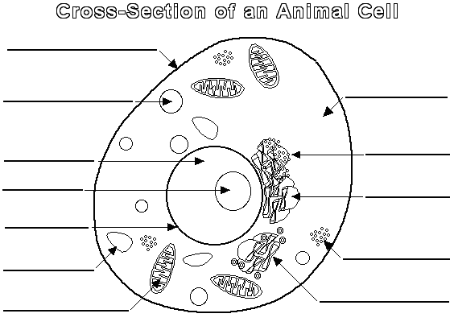
C)

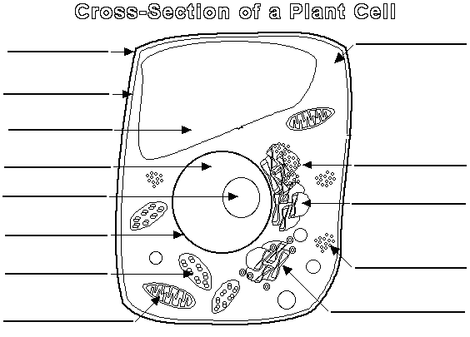

- Are the cells in the above diagrams prokaryotic or eukaryotic? How do you know?

- List the three parts of the cell theory:
a.

b.

c.

- Fill in the table below with an X in the box if the statement in the left column applies to the Domain.

 | Domain Bacteria | Domain Archaea | Domain Eukarya
Have Histone Proteins
Have Organelles
Have Internal Membranes
The Universal Ancestor
Plants and Animals
Glycogen Storage

- Below is a diagram of a cell membrane. Label the organic compounds that make up the membrane. What is the job of the proteins? ________________________________

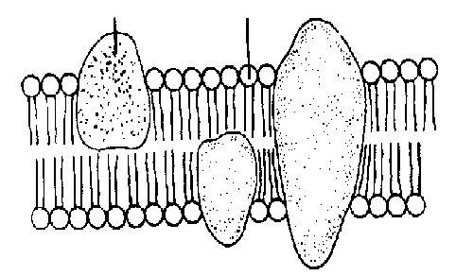
- Describe what is meant by selective permeability.

- Define the following:

concentration gradient

equilibrium

diffusion

hypertonic

hypotonic

isotonic

passive transport

active transport

osmosis

facilitated diffusion

endocytosis

exocytosis

pinocytosis

phagocytosis

- Diffusion, facilitated diffusion, osmosis, endocytosis, pinocytosis, phagocytosis, and exocytosis are all methods of membrane transport. List each type as examples of either active transport or passive transport.

a. active transport -

b. passive transport –

- The following substances may pass into or out of a cell. What process moves each of them?

Water - Glucose -
Oxygen - Amino acids -
Carbon dioxide - Small particles -
Proteins - Small organisms –

- What is the major difference in the types of materials that are passively transported and the materials that must be actively transported?

- Below is the cell wall of plant cells in distilled water. Add the cell membrane to the diagram and color in the cytoplasm. Describe the movement of water due to osmosis.

Below is the cell wall of the plant cell above that is now placed in 15% salt solution. Add the cell membrane to the diagram and color in the cytoplasm. Describe the movement of water due to osmosis.

- Describe what would happen to the following cells if they were placed in distilled water.
Paramecium –

Human liver cell –

Plant cell –

Review Assignment: Castle Learning Assign #12
Unit 3 Due __________

Go to Castle Learning and complete “Unit 3, A Tour of the Cell.”

To help you prepare for your upcoming test, you will complete a Castle Learning assignment Do not wait until the last minute to complete the assignment.

CASTLE LEARNING: www.castlelearning.com
Login = op-9 digit student number

