Name:______________________________________ Per._____ Due_________ Assign #1
Unit 2 – The Chemical Basis of Life (Chapter 4)

Read pages 72-77 in your text. Use your textbook and notes to answer the questions below.

1. List the four most abundant elements in your body.

2. How are elements and compounds different?

3. What is the difference between a symbol and a formula? Give an example.

4. Give an example showing the importance of trace elements to the human body.

5. Describe the LOCATION (inside or outside the nucleus) and the CHARGE (+, -, 0 )of each of the subatomic particles

PARTICLE | LOCATION | CHARGE
Proton
Neutron
Electron

6. SKETCH an atom. Label: electrons, nucleus, protons, and neutrons

Name:______________________________________ Per._____ Due_________ Assign #2
Unit 2 – The Chemical Basis of Life (Chapter 4)

Read pages 78-80 in your text. Use your textbook and notes to answer the questions below.

1. Describe how an ionic bond forms. How is this different from the formation of a covalent bond?

2. What is the difference between the chemical formula and the structural formula for a compound?

3. In a molecule represented by the chemical formula C₆H₁₂O₆, how many atoms of each element are present?

4. What is a chemical reaction?

5. On which side of a chemical equation do reactants appear? _________________ Products? _____________

6. Label the reactants and the products on the equation below:

6 H₂O + 6 CO₂ → 6 O₂ + C₆H₁₂O₆

7. Is the equation above balanced? Why or why not?

Name:______________________________________ Per._____ Due_________ Assign #3
Unit 2 – The Chemical Basis of Life (Chapter 4)

Read pages 81-86 in your text. Use your textbook and notes to answer the questions below.

1. Explain how the structure of water molecules (polar molecules) results in attractions among them?

2. What is the difference between cohesion and adhesion of water molecules? How are these forces important to living things?

3. When salt is dissolved in water, an aqueous solution is formed. Which is the solvent and which is the solute?

4. What is the pH scale a measure of?

5. Number the following line to represent the pH scale, and label bases, acids, and neutral substances:

________________________________________________________________________________

6. What is a buffer?

7. Explain why buffers are found in many biological fluids.

Name:______________________________________ Per._____ Due_________ Assign #4
Unit 2 – The Chemical Basis of Life (Chapter 4)

Read the information on the back of this page and/or use chapter 4 in your textbook to answer the following questions.

- Define ion: _________________________________________________________________________

- Define pH: __________________________________________________________________________

- The pH scale ranges from _______ to ________ .

- What type of ions do acids form in a water solution? ___________________________

- What type of ions do bases form in a water solution? ___________________________

- In which type of solution are OH- ions and H+ ions in equal concentrations? ______________________

- What pH represents the strongest base? ________________________________________

- What pH represents the strongest acid? ________________________________________

- What is another name for a basic solution? ____________________________________________

- A substance that changes color when the pH of a solution changes is called a(n) ____________________________________________________

- What is bromthymol blue, and what is it used for?

- What is phenolphthalein, and what is it used for?
Regents Biology - pH Information

pH is a measure of the concentration of hydrogen ions in a solution. Remember, ions are charged atoms (atoms that have gained or lost electrons). There are two common ions that are important to living things: hydrogen ions (H⁺) and hydroxide ions (OH⁻). The concentration of hydrogen ions in a solution is expressed as a pH value which ranges from 0 to 14.

In the pH scale, a pH value of 7 represents a neutral solution. A pH lower than 7 indicates an acidic solution. A pH above 7 indicates a basic (alkaline) solution.

In an acidic solution, the H⁺ concentration is greater than the OH⁻ concentration.

In a basic solution (also called an alkaline solution), the OH⁻ concentration is greater than the H⁺ concentration.

In an neutral solution, such as pure water, the H⁺ concentration is equal to the OH⁻ concentration.

0 1 2 3 4 5 6 7 8 9 10 11 12 13 14

Strong Weak NEUTRAL Weak Strong
Acids Acids Bases Bases

Biochemical reactions are affected by how acidic or basic the environment is. For example, the digestion of proteins can only occur in an acidic environment such as the stomach. The pH of gastric juices in the stomach is about 2 (very acidic). On the other hand, the chemical reactions in the blood involving the transport of oxygen and carbon dioxide occur in a slightly basic environment. The pH of blood is about 7.4 (slightly basic).

Certain dyes, called indicators, change color when exposed to an acid or base, The color change indicates a certain pH value or range. You may have use pH paper to determine pH value. pH paper (also called pHydrion paper) is paper that has been treated with many indicators; the indicators in this paper turn a different color at each pH value. To use the paper to determine the pH of a substance you simply tear off a small piece of the paper and dip it into the solution being tested. You then compare the color of the paper with a color chart to determine the pH value indicated.

Phenolphthalein is an indicator that turns pink in a basic solution and remains colorless in an acidic solution. Although phenolphthalein tells us whether a solution is acidic or basic, but it does not tell us how acidic or basic the solution is (it doesn’t tell us the exact pH). Bromthymol blue is an indicator that turns yellow in acidic pH values and stays blue in basic pH values. Bromthymol blue is useful in biology because it can be used to detect the presence of carbon dioxide in a solution. Carbon dioxide (CO₂) is produced by the life process called cellular respiration. When carbon dioxide mixes with the bromthymol blue an acid (carbonic acid) is formed, and the bromthymol blue turns yellow.

Name:______________________________________ Per._____ Due_________ Assign #5
Unit 2 – The Molecules of Life (Chapter 5)

Read the article and answer the questions on the back.
Sources: University of Toronto and ScienceDaily 6/22/00

Scientists at the Toronto General Hospital announced a new treatment for carbon monoxide poisoning that may save thousands of lives around the world. This treatment helps victims of carbon monoxide (CO) exposure eliminate the poison from their bodies faster than the current treatment. In a paper published in the American Journal of Respiratory and Critical Care Medicine, Toronto General Hospital researchers describe a simple new way of speeding up the elimination of carbon monoxide, which can be applied by paramedics even while en route to a hospital.
Carbon monoxide is the leading cause of fatal poisoning in the industrialized world, as well as being endemic in many parts of the developing world," says Dr. Joseph Fisher, an anesthesiologist at Toronto General Hospital, University Health Network. "In North America, it results in as many as 70,000 emergency room visits a year and in thousands of deaths. Up to 30 per cent of survivors of severe poisoning are left with disabling psychological and neurological symptoms, which sometimes last for years."
You can’t see or smell carbon monoxide, but at high levels it can kill a person in minutes. Carbon monoxide is an odorless colorless gas formed during combustion (burning). Carbon monoxide (CO) is produced whenever any fuel such as gas, oil, kerosene, wood, or charcoal is burned. If appliances that burn fuel are maintained and used properly, the amount of CO produced is usually not hazardous. However, if appliances are not working properly or are used incorrectly, dangerous levels of CO can result. Hundreds of people die accidentally every year from CO poisoning caused by malfunctioning or improperly used fuel-burning appliances. Even more die from CO produced by idling cars. Fetuses, infants, elderly people, and people with anemia or with a history of heart or respiratory disease can be especially susceptible.
When carbon monoxide is inhaled--even in tiny concentrations--it combines with the hemoglobin in the red blood cells to prevent the delivery of oxygen to the body. This results in few symptoms until the poisoning is advanced. Those suffering from carbon monoxide poisoning may initially complain of headache, nausea, mental confusion and fatigue. Since many of these symptoms are similar to those of the flu, food poisoning, or other illnesses, you may not think that CO poisoning could be the cause. The symptoms can rapidly progress to coma and even death. It is therefore critical that carbon monoxide be eliminated from the body as soon and as quickly as possible.
The only currently available emergency treatment for carbon monoxide poisoning is giving the patient 100 per cent oxygen. "We developed a device that greatly increases the rate of carbon monoxide elimination compared to the current treatment, yet is very easy to apply to patients no matter where they are," says Dr. Fisher. The device is easily portable, and consists of a few simple additions to the oxygen mask and oxygen tank found in every ambulance. When treating CO poisoning, oxygen is administered via a standard facemask placed on a patient. However, Dr. Fisher and his team found that adding a simple mechanical device that provides a mixture of oxygen and carbon dioxide in a specific way to the mask markedly increases the rate of carbon monoxide elimination. "The device is so simple that it can be assembled from a few components available in any SCUBA diving store" says Dr. Fisher.
The novel treatment has been compared to conventional treatment with 100 per cent oxygen in seven men who volunteered for the study. The volunteers were first exposed briefly to carbon monoxide and then received either the conventional treatment or the new treatment. They then returned for a second session and were treated with the other treatment and the rates of carbon monoxide elimination were then compared. The new treatment increased the rate of carbon monoxide elimination by up to three times. Dr. Fisher's team has since confirmed these results with additional tests. A study from the University of Washington in Seattle presented last month at the American Thoracic Society conference in Toronto also confirmed the efficacy of the method. (More information is available at isocapnia.com).

1. What is carbon monoxide?

- What does carbon monoxide do in the body?

- What are some early symptoms of carbon monoxide poisoning?

- What are some later symptoms of carbon monoxide poisoning?

- How many cases of carbon monoxide poisoning are there in North America each year?

- What is the only current treatment for carbon monoxide poisoning?

- What is the new treatment?

- What is the major cause of carbon monoxide in a home?

- How can you protect your family from carbon monoxide poisoning?

Name:______________________________________ Per._____ Due_________ Assign #6
Unit 2 – The Molecules of Life (Chapter 5)

Read pages 92-94 in your text. Use your textbook and notes to answer the questions below.

1. What is the main difference between organic and inorganic molecules?

2. Carbon is represented by the letter ‘C’. Is this a symbol or a formula?

3. What are the different types of bonds that carbon can make with itself?

4. When carbon bonds, it can form different structures. What are the 2 structures that carbon bonding can form?

5. Explain the connection between monomers and polymers.

Name:______________________________________ Per._____ Due_________ Assign #7
Unit 2– The Molecules of Life (Chapter 5)

Read pages 95-97 in your text. Use your textbook and notes to answer the questions below.

1. What elements are found in all carbohydrates?

2. Give the common names of simple carbohydrates (monomers and dimers) and complex carbohydrates (polymers).

3. What is the biological importance of carbohydrates?

4. What are the building blocks of carbohydrates?

5. Explain the difference between a monosaccharide and a disaccharide. Give an example of each.

6. Compare and contrast starch, glycogen, and cellulose.

7. How do animals store excess glucose molecules?

8. What molecule is released during construction of a polymer? What is this reaction called?

9. Hydrolysis gets its name because ___________________(hydro) is used to _______________ (lysis) the polymer.
Name:______________________________________ Per._____ Due_________ Assign #8
Unit 2 – The Molecules of Life (Chapter 5)

Read pages 98-99 in your text. Use your textbook and notes to answer the questions below.

1. What elements are found in all lipids?

2. What is the biological importance of fats?

3. What is the biological importance of steroids?

4. Name the building blocks of lipids.

5. What property do lipids share?

6. What does the term saturated fat on a food label mean? List some examples of foods that contain saturated fat.

7. What does the term unsaturated fat on a food label mean? List some examples of foods that contain unsaturated fat.

Name:______________________________________ Per._____ Due_________ Assign #9
Unit 2 – The Molecules of Life (Chapter 5)

Read pages 100-102 in your text. Use your textbook and notes to answer the questions below.

1. What elements are found in all proteins?

2. List some of the biological importance of proteins.

3. Name the building blocks of proteins.

4. How do amino acids, polypeptides, and proteins relate to each other?

5. Draw the basic structure of an amino acid below:

6. Which parts of an amino acid’s structure are the same in all amino acids?

7. Which part of an amino acid is unique?

8. The shape of a protein molecule determines its __________________________________ .

Name:_____________________________________ Per._____ Due_________ Assign #10
Unit 2 – The Molecules of Life (Chapter 5)

Use your textbook and notes to answer the questions below.

1. What are 3 organic compounds that are essential to our lives?

2. How are you know they are organic?

3. Describe the differences between:

a. glucose

b. glycerol

c. glycogen

4. What does a protein molecule contain that carbohydrates and lipids do not?

5. What is the difference between dehydration synthesis and hydrolysis?

Name:_____________________________________ Per._____ Due_________ Assign #11
Unit 2 – The Molecules of Life (Chapter 5)

Read the article, highlight the key information and answer the questions following the article.

Alcohol Dehydrogenase

Here's a toast to alcohol dehydrogenase. Alcohol dehydrogenase is our primary defense against alcohol, a toxic molecule that compromises the function of our nervous system. The high levels of alcohol dehydrogenase in our liver and stomach detoxify about one drink each hour. The alcohol is converted to acetaldehyde, an even more toxic molecule, which is then quickly converted, by another enzyme, into acetate and other molecules that are easily utilized by our cells. Thus, a potentially dangerous molecule is converted into a mere foodstuff, by alcohol dehydrogenase.

Our bodies create at least nine different forms of alcohol dehydrogenase, each with slightly different properties. Most of these are found primarily in the liver, including the beta3 form pictured here. The sigma form is found in the lining of the stomach. Each enzyme is composed of two polypeptide chains, and quite remarkably, you can mix and match polypeptides between the different forms, creating mixed dimers that are still active. Ethanol is not the only target of these enzymes; they also make modifications to retinol, steroids, and fatty acids. The range of different types of alcohol dehydrogenase ensures that there will always be one that is perfect for the current task.

Alcohol dehydrogenase provides a line of defense against a common toxin in our environment. But this protection carries with it some dangers. Alcohol dehydrogenase also modifies other alcohols, often producing dangerous products. For instance, methanol, which is commonly used to "denature" ethanol rendering it undrinkable, is converted into formaldehyde by alcohol dehydrogenase. The formaldehyde then does the damage, attacking proteins making them inactive. Small amounts of methanol causes blindness, as the sensitive proteins in the retina are attacked, and larger amounts, perhaps a glassful, lead to widespread damage and death.

The questions are on the back!

- Alcohol dehydrogenase is an enzyme. What is its function?

2. Alcohol is a toxin that affects the nervous system. How much can a person expect to drink per hour if s/he does not want to be affected by alcohol?

3. What happens to the alcohol after it is combined with alcohol dehydrogenase?

4. Our bodies create at least nine different forms of alcohol dehydrogenase. Where in the body would these enzymes be found?

5. Why would it be a benefit to have many varieties of this enzyme?

6. Why might a person become blind or die after the consumption of the alcohol methanol?

7. Scientific studies have shown that females have less gastric alcohol dehydrogenase activity than males. Knowing this information, how might gender affect a person’s ability to tolerate alcohol?

Name:_____________________________________ Per._____ Due_________ Assign #12
Unit 2 – The Molecules of Life (Chapter 5)

Read pages 103-104 in your text. Use your textbook and notes to answer the questions below.

1. Which organic molecule is an enzyme? ________________________________________

2. Describe the terms catalyst and substrate in terms of a particular chemical reaction.

3. Explain the role of activation energy in a reaction.

4. What are the building blocks of enzymes called?

5. Explain the lock and key model of enzyme activity. (See your class notes)

6. Where on the enzyme does the substrate attach itself? ________________________

7. The suffix (ending) that identifies most substances that are enzymes. ______________

8. Can enzymes be used again after they have been involved in a chemical reaction?

Name:_____________________________________ Per._____ Due_________ Assign #13
Unit 2 – The Molecules of Life (Chapter 5)

Read pages 103-104 in your text. Use your textbook and notes to answer the questions below.

- List 4 factors that can affect the rate at which an enzyme will catalyze (speed up) a biological reaction.
a.

b.

c.

d.

- Amylase is an enzyme that converts starch, by hydrolysis, into sugars. An experiment was performed to determine how rapidly amylase works at different temperatures. The data from this experiment are listed in the table below.

Temperature (ºC) | Rate of Starch Conversion (grams/minute)
0 | 0.0
10 | 0.4
20 | 0.6
30 | 0.8
40 | 1.0
50 | 0.4
60 | 0.2
70 | 0.0

- What is the independent variable in this experiment? ________________________

- What is the dependent variable in this experiment? __________________________

- Graph the data in the table on the graph paper on the back of this sheet.
Answer questions d and e AFTER you finish the graph.

- Draw a conclusion about the effect of temperature on the rate of activity of amylase.

e. According to the data, at which temperature does amylase function most efficiently (optimum temperature of the enzyme)?

Name:_____________________________________ Per._____ Due_________ Assign #14
Unit 2 – The Chemical Basis and Molecules of Life (Chapters 4 & 5) Review Assignment

Use your textbook and notes to complete this homework assignment.
- What part do enzymes play in the chemical reactions taking place in all living organisms?

- Enzymes are specific. What does that statement mean?

- Below is a diagram of an enzyme controlled process. Label the lettered parts of diagram.
(Choices: products, enzyme-substrate complex, enzyme, reactant )
A __________________ C________________________
B__________________ D________________________
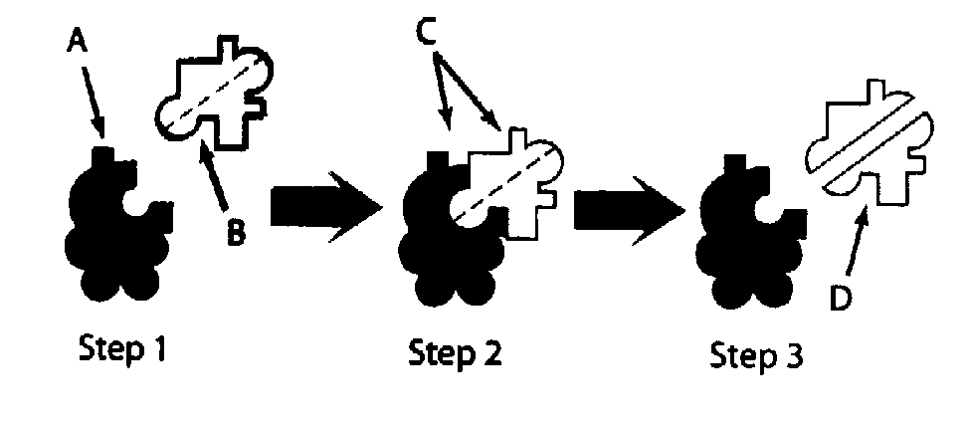
What chemical process is taking place in the diagram (hydrolysis or dehydration reaction)?

- Where would you find enzymes in the human body? _____________________

- What type of organic compound is an enzyme? _________________________

- Name an enzyme used to hydrolyze (digest) lipids. ______________________

- Are enzymes used up by a chemical reaction? ___________________

- If a specific enzyme has an optimum temperature of 37ºC, why might the enzyme lose reactivity if heated more?

- Define: acid –

base –

denaturation –

active site –

catalyst –
- Carbohydrates contain what elements? ________________________________
- Lipids contain what elements? _______________________________________
- Proteins contain what elements? ______________________________________
- The building blocks of proteins _______________________________________
- The building blocks of carbohydrates ___________________________________
- The building blocks of lipids ______________________ & _________________________
- Glucose is an example of what kind of carbohydrate? ______________________
- What does the “R” in an amino acid stand for? ______________________
- What is a disaccharide? ______________________________
- Glycerol is a building block of which kind of organic compound? ______________________
- What is hydrolysis? ______________
- Proteins are long chains of what monomers? ______________
- Fats, oils, steroids, and waxes are what kind of organic compound? ______________
- Which polysaccharide is found in the cell walls of plants? ______________
- Excess sugars are stored in the form of __________________ in plants and _____________ in animals.
- Which type of organic compounds contain nitrogen? _____________________
- A long chain of repeating units is called ? ___________________________
- Names of sugars end in what 3 letters? ______________
- Glycogen is a polymer (long chain) of what sugar? _______________________
- Organic compounds always contain ______________and _____________.
- Is water organic or inorganic? _____________
- Compounds that do NOT contain both carbon and hydrogen are called _________
- What is a polymer? _________________________________________________
- Chemicals that turn different colors in different pH values are called ___________
- Explain function of each of the following indicators (use words acid or base or a color)
bromthymol blue: blue in_____________, turns what color when acids are added _____________

phenolphthalein: clear in _____________; turns what color in bases? ______________________
- Define:
  - Dehydration reaction:

  - Hydrolysis reaction:

Identify the following structural formulas

A. Entire molecule = __________

Circled region = ___________

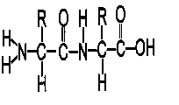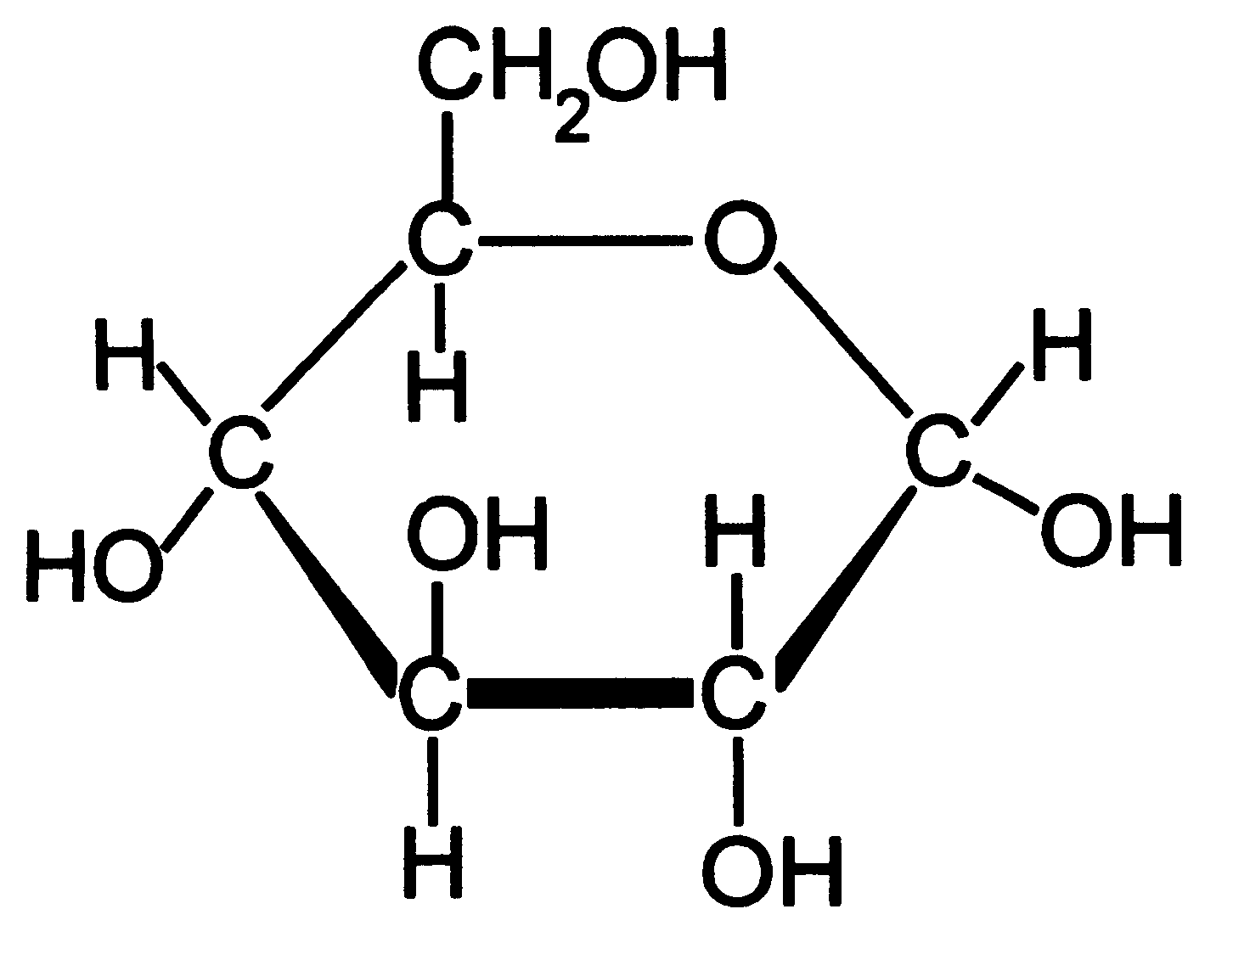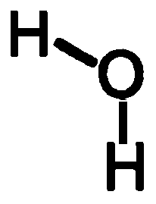
B. ____________________ C. ______________ D. _________
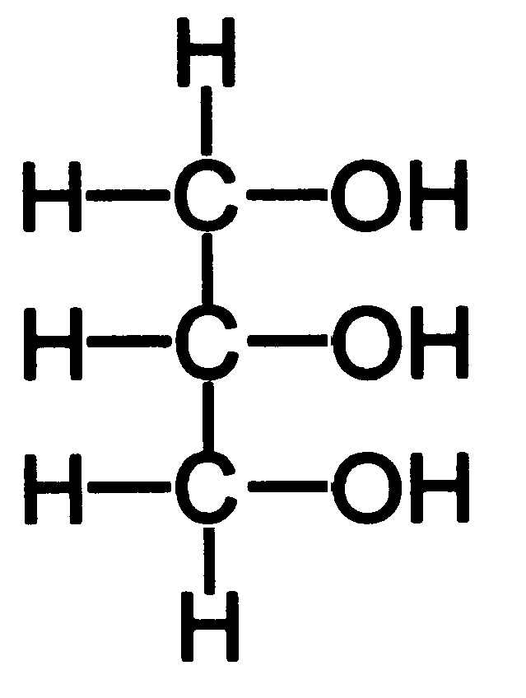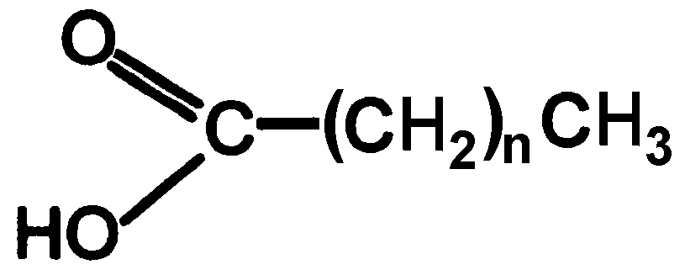

E. _________________________________ F. ______________________

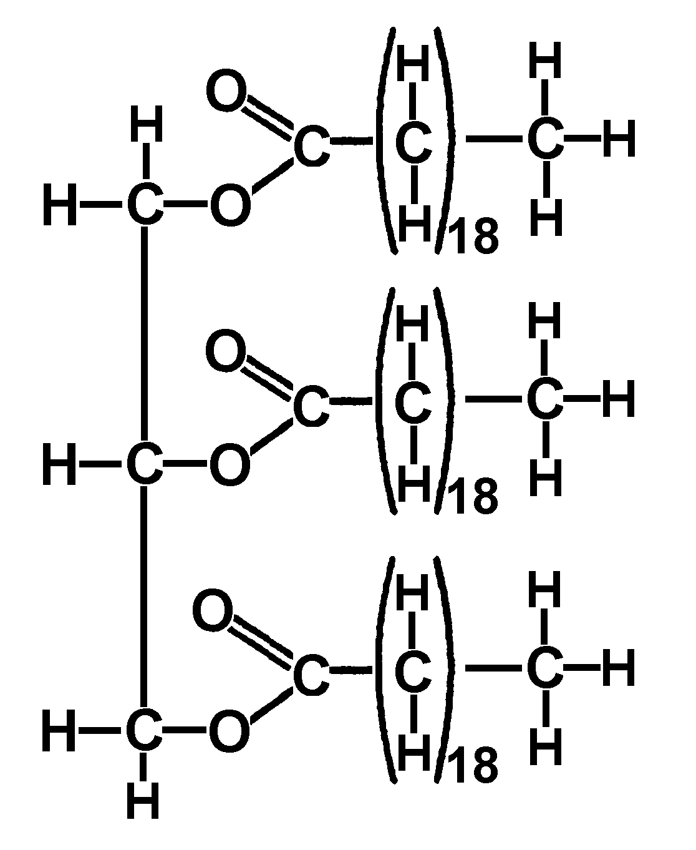

G. ______________________

Review Assignment: Castle Learning Assign #15

Due __________

Go to Castle Learning and complete “Unit 2 Chemical Basis & Molecules of Life.”

To help you prepare for your upcoming test, you will complete a Castle Learning assignment Do not wait until the last minute to complete the assignment.
CASTLE LEARNING: www.castlelearning.com
Login = op-9 digit student number
Example: op-123456789
Password - make it something you will remember and write in down in your agenda or bio notebook!

