ORCHARD PARK HIGH SCHOOL

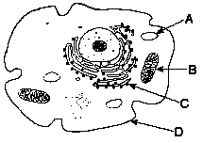
REGENTS BIOLOGY HANDBOOK
Table of Contents

I. INTRODUCTION 1
II. NOTEBOOK 1
III. TEXTBOOKS 1
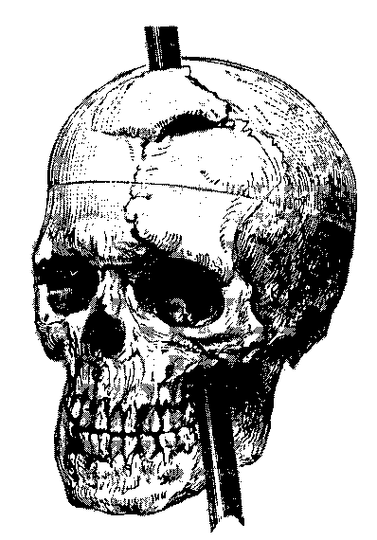
IV. HOMEWORK 1
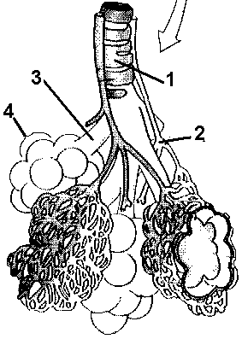
Assignment sheets 1
Heading for homework assignments 1
Homework format 1
Late homework 1
Bonus points on exams 1
Absences 2
Exemption from written assignments 2
V. CLASS ABSENCES 2
VI. STUDY HABITS 2
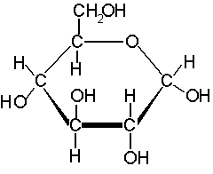
VII. QUIZZES 2
Procedure 2
Absences 2

VIII. EXAMS 3
Start time 3
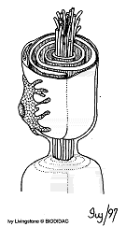
Materials 3
Absences 3
Erasures 3
Bonus Club 3
IX. MARKING PERIOD GRADES 3
X. LAB REQUIREMENT 4
XI. EXTRA CREDIT 4
XII. Grade weighting 4

I. INTRODUCTION
Welcome. Our task this year is to prepare for the New York State Regents Living Environment Exam. As well as being assigned to this class, you have also been assigned to a lab class; your grade in lab class will be counted as 20% of your report card grade.

II. NOTEBOOK
It is important that you develop good note taking skills; much of the material covered in class is what you will be tested on in exams and quizzes. I distribute handouts frequently and suggest that you use a loose-leaf binder for taking your notes. Some teachers may collect or grade notebooks.

III. TEXTBOOKS
Keep your textbook at home, in a safe place. Use it to read, study and do your homework. Please cover your textbook.
Read your textbook - you are expected to read every section three times: 1) each night that you are given a textbook homework assignment, 2) when you prepare for a quiz and 3) when you prepare for the unit test.

IV. HOMEWORK

Assignment packets
These packets have an assignment that you are to do each night. A list of the assignments with their due dates will be posted in the classroom.

Heading for homework assignments
Each homework assignment should have your name, the assignment number, and your class period indicated on it. Homework which does not have the proper heading will not be counted.

Homework format
The questions in the homework should be answered completely. Each answer should be worded so that the reader can tell what the question is without having to refer to the book.

Late homework
Homework is due at the beginning of each class. If you hand in an assignment after the day that it is due it will count for 1/2 of a homework.

Homework Grade
If you submit all of the homework assignments (and they are well done) in preparation for an exam then you will reieve a 100% homework grade for the next unit. You will be permitted to miss 1 assignment per unit without penalty. Any participation in fraud (cheating) related to homework will exclude all students involved from the bonus club (see below) for the current unit.

Exemption from written assignments
If you achieve a raw grade of 90% or higher on an exam then you will not be required to hand in the written part of the homework assignments until the next exam. You are still expected to do the reading and to review the questions so that you are prepared for class. You will be a member of the Bonus Club (see VIII) for the next exam. If your grade is below 90 then you will have to do the homework until the following exam in order to earn membership in the Bonus Club.

Absences
You are responsible for the homework that is assigned when you are absent. You should call a friend or the school to find out about assignments. When you return to school you should have the assignments that you have missed as well as the assignment that is due that day. If you know that you will be missing classes for an extended absence see me to find out what assignments will be due upon your return.

V. CLASS ABSENCES
You are responsible for the material covered during any class absences. Call a friend to find out what was covered and if an exam or quiz was announced.
DO NOT USE CLASS TIME TO COPY NOTES THAT YOU MISSED. Copy the notes at home or in a study hall.

VI. STUDY HABITS
- read the text--don't just hunt for the answers.
- vocabulary - use file cards [word on one side - definition on the other]
- read over your notes frequently not just for quizzes.
If you want to improve your grade you should consider buying a good quality review book which has practice questions in it. You can also build your own “quizzes” in Castle Learning to test yourself.
Free tutoring - Students in the National Honor Society provide free tutoring in biology during study halls and after school. To arrange for a tutor see your biology teacher.

VII. QUIZZES

Procedure
Quiz answer sheets will be given out at the beginning of each marking period and all quizzes for each marking period will be taken on those sheets. A quiz may have up to 15 questions on it. Get in the habit of looking on the back of the question paper for more questions. You may write on the quiz to help you get the correct answer. Put your answers on the quiz answer sheet. I will go over the questions after the answer sheets are collected; then the question sheets will be collected.

Quiz Absences
You are responsible to know when a quiz is going to be given. I will announce an up coming quiz at least two days ahead of time, and posted on the chalkboard.
If you are absent either when a quiz is announced, or the day before the quiz, you will still have to take the quiz. If you are absent on the day of a quiz a zero (0) will be assigned as the grade for that quiz until it is made-up. You must make up any missed quizzes before the unit test on that material has been given. Make arrangements with me to make up the quiz in the allotted time.

VIII. EXAMS

Start time
You must be quiet from the time that you enter the room until the end of the period.

Materials
All exams are to be taken in #2 pencil. Be sure that you have at least two pencils. The teacher does not have any pencils to lend you.

Absences
You are responsible to know when an exam is scheduled. Each exam will be announced at least 3 days before it will be given.
If you are absent on the days before an exam is given then you will have to take the exam when everyone else does.
If you are absent on the day that an exam is given then you will take the exam on the day that you return.
If you know ahead of time that you are going to be absent on the day of an exam, please see me to arrange when you will take the exam. Expect to take the exam before your absence.
If it is determined that your absence on the day of an exam is an illegal absence then you will not be given the opportunity to make it up -- a zero (0) will be assigned for the exam grade.

Erasures
The machine that marks your papers is sensitive to any pencil mark that has not been thoroughly erased. You should mark your answers lightly at first then if you need to erase you will not have trouble. After you are done with the exam go back and darken each mark. Buy yourself a good eraser.

Bonus Club
To become a member of the "Club" you must have scored an 90% or above (raw score) on the previous exam. Members of this "Club" are not required to submit most written homework assignments and will earn an automatic 100% homework grade for the next unit (as long as all required assignments are completed).

IX. MARKING PERIOD GRADES
Grades will be posted on the OPCSD Student Portal. Please make arrangements to gain access to this site so that you can track your progress.

X. LAB REQUIREMENT
The successful completion of the laboratory program, which is prerequisite for admission to the regents examination in biology, requires that the student must:

1. Complete at least 30 full-time laboratory experiences.
2. Complete a satisfactory written report for each laboratory experience.

XI. EXTRA CREDIT
Each quarter there will be an opportunity for all students to complete a project that will count as an extra test grade.

Occasionally extra out of class activities/worksheets are offered that are usually awarded extra credit in the form of an extra quiz grade.

Occasionally the class may be offered an optional project for extra exam points. The maximum points offered will be +3 on the next exam.

If your grades are lower than you want, consider these questions:

- are you doing your homework regularly?
- do you study your notes every night to review what was done in class?
- do you use file cards to keep up with the vocabulary?
- do you come into class on the day before an exam to review the quizzes and to ask questions?

If you feel that your homework and study habits are good then you might want to buy a biology review book at a local bookstore. Be sure to get a book that will have the explanations that you need.

Another option is to do extra questions on the Castle Learning Website. See your teacher if you have any questions about Castle Learning.

XII. Grade Weighting

 | Percentage of Final Grade
Tests | 60%
Quizzes | 10%
Homework | 10%
Lab | 20%

