Evolution Name _____________________________ Period ______ Test date _________

Chapters 14 & 15
Evolution: A History and a Process

- Evolution

- The Voyage of the Beagle

The importance of the Finches that Darwin studied:

- Darwin Publishes His Theory
  - Origin of Species (published in 1859)
  - Three Main Points:
    - Species living today descended from ancestral species
    - Individuals best adapted to their environment will survive and produce more offspring
    - Evolutionary change occurs because environment leads to a struggle for existence.
14.3 Darwin Proposed natural selection as the mechanism of evolution.

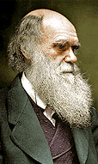
A. Charles Darwin: Natural Selection
1. population

2. overproduction

- variation

  - sources
i. mutations

ii. genetic shuffling

  - adaptive value

4. competition

5. differential survival and reproduction

Result of natural selection over millions of years results in the evolution of new species.
Examples of Natural Selection

1. Peppered Moth

2. Pesticides

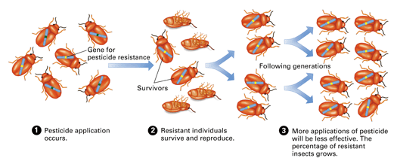

- Antibiotic Resistance (Antibiotic: medicine that kills bacteria)

Artificial Selection

Artificial Selection vs. Natural Selection

15.1 The diversity of life is based on the origin of new species.

A. What is a Species?

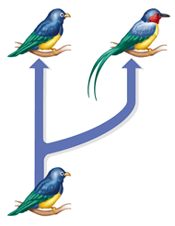
B. Speciation

C. How does Speciation Occur?

1. Geographic Isolation

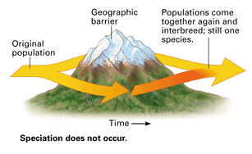
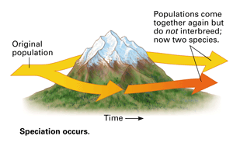

- The Tempo of Speciation

1. Gradualism -
Gradually Changing Environment
Evolution

Time

2. Punctuated equilibrium -
Stable Environment
Evolution

Rapidly Changing Environment

Time

- Extinction

Evolution has left much evidence.
- The fossil record provides evidence of life’s history (15.3)

- fossils

The Geologic Time Scale

Geologic time categories
Era | Geologic time span | Typical organisms
Cenozoic | 65 million years ago to the now | Birds and mammals
Mesozoic | 250 to 65 million years ago | Reptiles, conifers, dinosaurs
Paleozoic | 540 to 250 million years ago | Ferns, moss, fish, amphibians
Precambrian | > 540 million years ago | Bacteria, small fungi

A Geological Timeline for Planet Earth
Below is a line we will use to represent the life of the planet earth.
4  Time (Billion Years Ago) |  | 3 |  | 2 |  | 1 |  |  |  |  |  |  |  |  |  |  |  |  |  |  |  |  |  |  |  | 0

Symbol  Enter the symbols on the timeline. | Event | When (Years ago)  There are 1000 million in a billion.
N | Now | 0
F | First life | 3.5 billion
P | Modern Plants | 500 million
D1 | Dinosaurs appeared | 250 million
D2 | Dinosaurs die out. | 65 million
H | First Homo sapien | 250,000
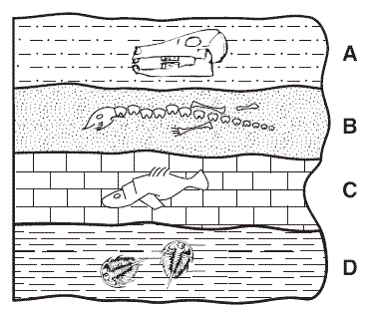
Dating Fossils

1. Relative dating

2. Absolute dating

Radiometric dating

- Evidence of Evolution: Continental Drift

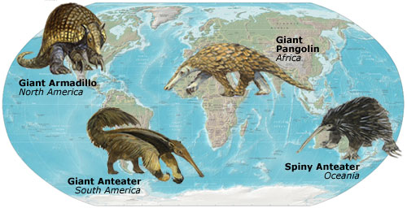

3. Evidence of Evolution: Similarities in Structure (Comparative anatomy)

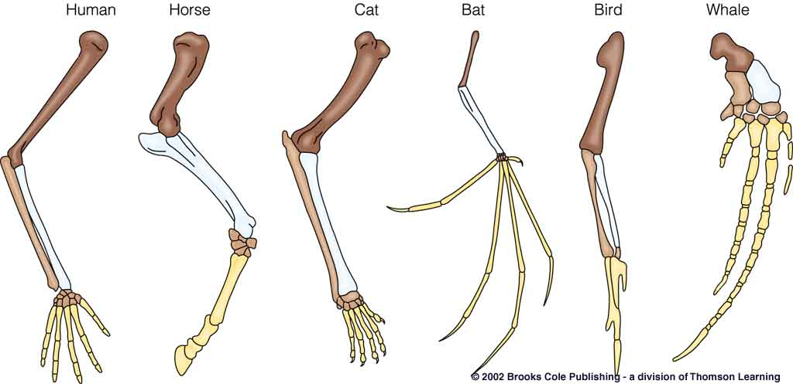

a. homologous structures

b. vestigial structures

4. Evidence of Evolution: Similarities in Development (Comparative embryology)

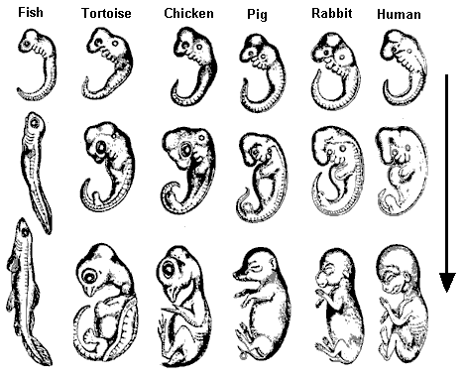

- Evidence of Evolution: Molecular Biology (Comparative Biochemistry)
Examine Data Table 1, which lists the sequence of amino acid molecules in the blood protein hemoglobin for humans and other primates.

Note the position of each amino acid in Data Table 1. Compare each primate’s amino acid sequence. Count the number of differences in the positions of each amino acid sequence and fill in Data Table 2.

Data Table 1 - Amino Acid Sequences in Hemoglobin
Position | Human | Chimpanzee | Baboon | Lemur
1 | SER | SER | ASN | ALA
2 | THR | THR | THR | THR
3 | ALA | ALA | THR | SER
4 | GLY | GLY | GLY | GLY
5 | ASP | ASP | ASP | GLU
6 | GLU | GLU | GLU | LYS
7 | VAL | VAL | VAL | VAL
8 | GLU | GLU | ASP | GLU
9 | ASP | ASP | ASP | ASP
10 | THR | THR | SER | SER
11 | PRO | PRO | PRO | PRO
12 | GLY | GLY | GLY | GLY
13 | GLY | GLY | GLY | SER
14 | ALA | ALA | ASN | HIS
15 | ASN | ASN | ASN | ASN
16 | ALA | ALA | ALA | ALA
17 | THR | THR | GLN | GLN
18 | ARG | ARG | LYS | LYS
19 | HIS | HIS | HIS | LEU

Data Table 2 - No. of Differences in the Amino Acid Sequences of Hemoglobin
 | Human | Chimpanzee | Baboon | Lemur
Human | 0
Chimpanzee |  | 0
Baboon |  |  | 0
Lemur |  |  |  | 0

Using the data in Data Table 2, fill in the names of the primates on the phylogenetic tree below.

Phylogenetic Tree of Primates
Now

15.4 Modern Taxonomy reflects evolutionary history.
A. Classification and Evolution
1. phylogenetic tree
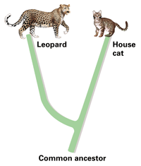
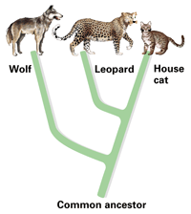

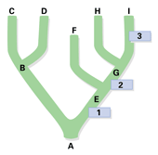
Use the diagram to answer the questions that follow.

- Which species is the common ancestor of all those shown?

- Which organism is extinct?

- To which living species is species H most closely related?
- What type of “tree” is the diagram?

- What do 1, 2, and 3 represent?

- Which organisms have “E” as a common ancestor?

DICHOTOMOUS KEYS

There are a great variety of living things on our planet and biologists have tried to group them into various categories based on the similarities and differences in structure.

To distinguish between different organisms which show a great deal of similarity a person must make careful observations of the creatures involved. Biologists use a method of dividing similar organisms into two groups based on a single difference. This is referred to as dichotomizing. Each of those groups are then divided into sub-groups; this method of splitting continues until each organism is in its own group.

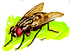
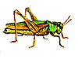

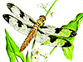

Suppose you have four insects a ladybug, a housefly, a dragonfly and a grasshopper. After studying the insects, you might use wing covering, body shape, and where the wings point towards. To begin the key, you could start separating the four insects based on wing covering - "wings covered by exoskeleton" vs. "wings not covered by exoskeleton."
The first step in the key will be organized the following way:
1. a. wings covered by an exoskeleton
b. wings not covered by an exoskeleton
Next, the statements need to lead the observer to the next step to narrow the identification further:
1. a. wings covered by an exoskeleton ………go to step 2
b. wings not covered by an exoskeleton ……….go to step 3
Step 2 needs to consist of a pair of statements that will allow for the identification of the ladybug and the grasshopper:
2. a. body has a round shape ……….ladybug
b. body has an elongated shape ……….grasshopper
Step 3 needs to consist of a pair of statements that will allow for the identification of the housefly and dragonfly:
3. a. wings point out from the side of the body ……….dragonfly
b. wings point to the posterior of the body ……….housefly

Notice that there were four organisms to be identified and it only took three steps. There should be one less step than the total number of organisms to be identified in your dichotomous key.

When using a key, keep the following in mind:
- Always read both choices, even if the first seems to be the logical one at first.
- Be sure you understand the meaning of the terms involved. Do Not Guess.
- When measurements are given, use a calibrated scale. Do Not Guess.
- Since living things are always somewhat variable, do not base your conclusion on a single observation. Study several specimens to be sure your specimen is typical.
- If the choice is not clear, for whatever reason, try both divisions. If you end up with two possible answers, read descriptions of the two choices to help you decide.
- Having arrived at an answer in a key, do not accept this as absolutely reliable. Check a description of the organism to see if it agrees with the unknown specimen. If not, an error has been made somewhere, either in the key or in its use. The ultimate check of identifications is a comparison of the unknown with an authentically named "Type Specimen".

