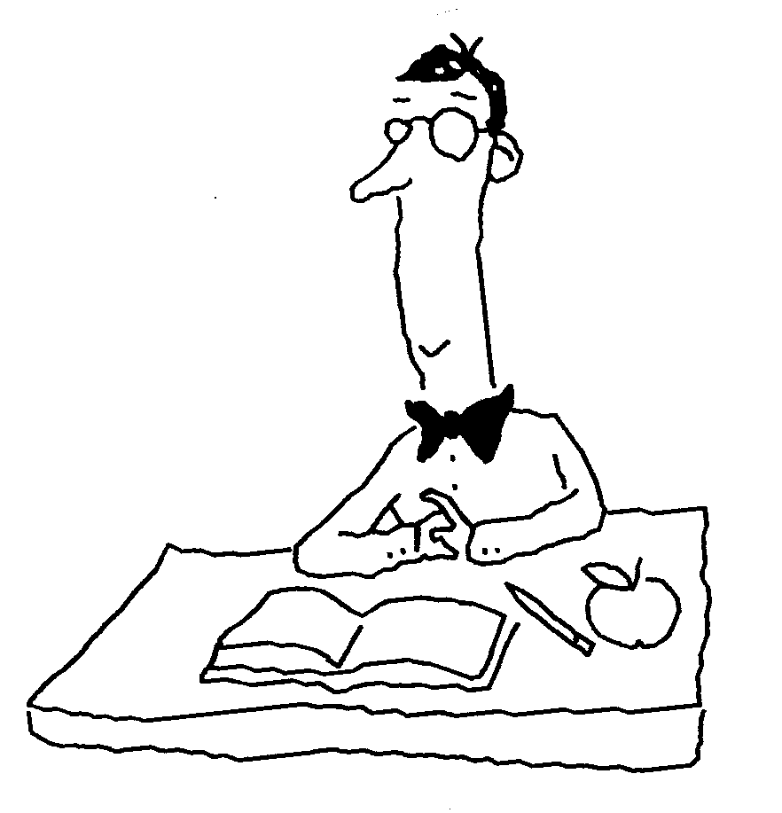
Regents Biology Notes Name___________________________
Chapter 32/Regulation of the Internal Environment Period______ Test Date_______

The Excretory System:
Introduction: Excretion vs. Elimination

Excretion:

Elimination:

A. Recall: What is metabolism?

Metabolic waste:

What are two metabolic wastes we have already learned about?

1.

2.

Metabolic wastes continued
3. inorganic salts (minerals)

4. nitrogenous wastes

-deamination of amino acids

(Draw the structure of an amino acid below)

Nitrogenous Waste | ATP to produce | TOXICITY | SOLUBILITY | water needed to remove
Ammonia NH₃
Urea
Uric Acid
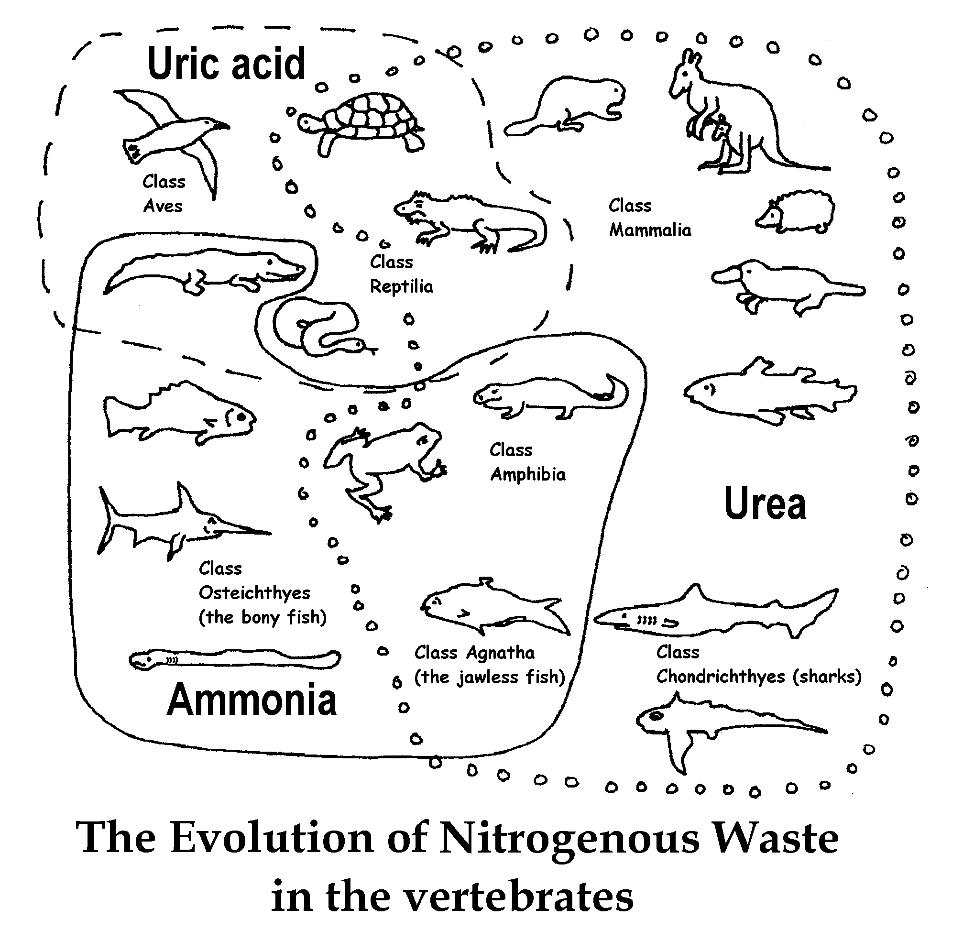
The Evolution of Nitrogenous Wastes

Human Excretory System Includes the Urinary System, Liver, Lungs & Skin

The Human Excretory System:
function:

A. Organs of the Urinary System: (see diagrams)

kidneys

ureters

urinary bladder

urethra

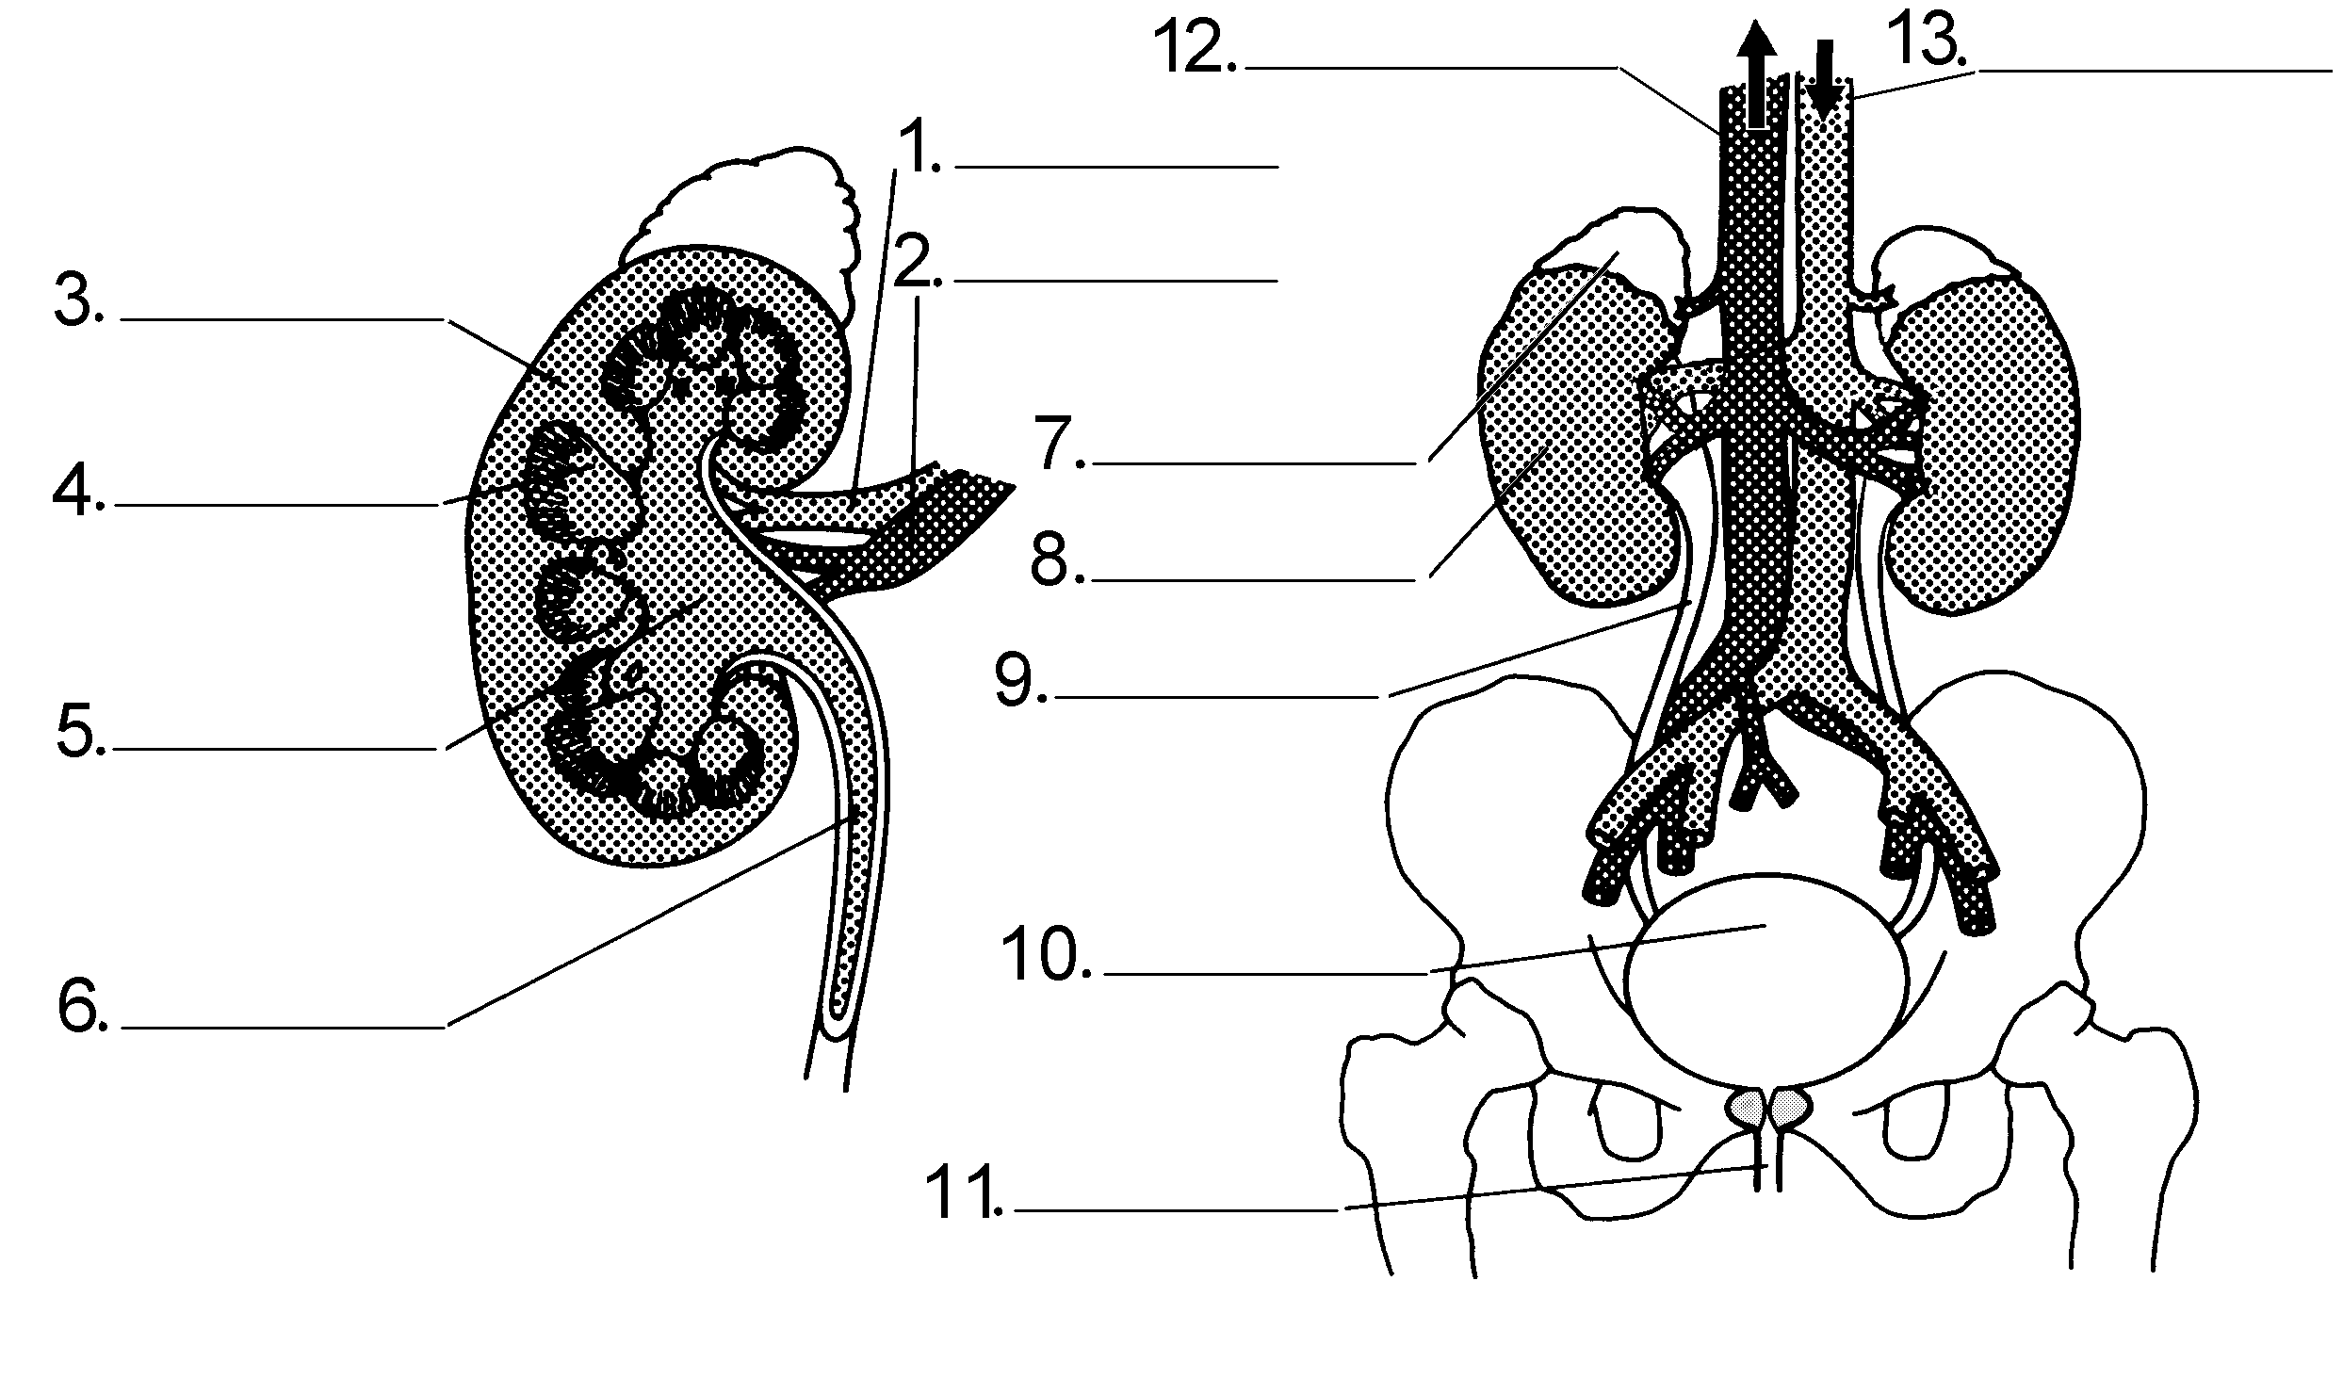

B. Kidney Structure and Function:

The Nephron How many per kidney? __________________
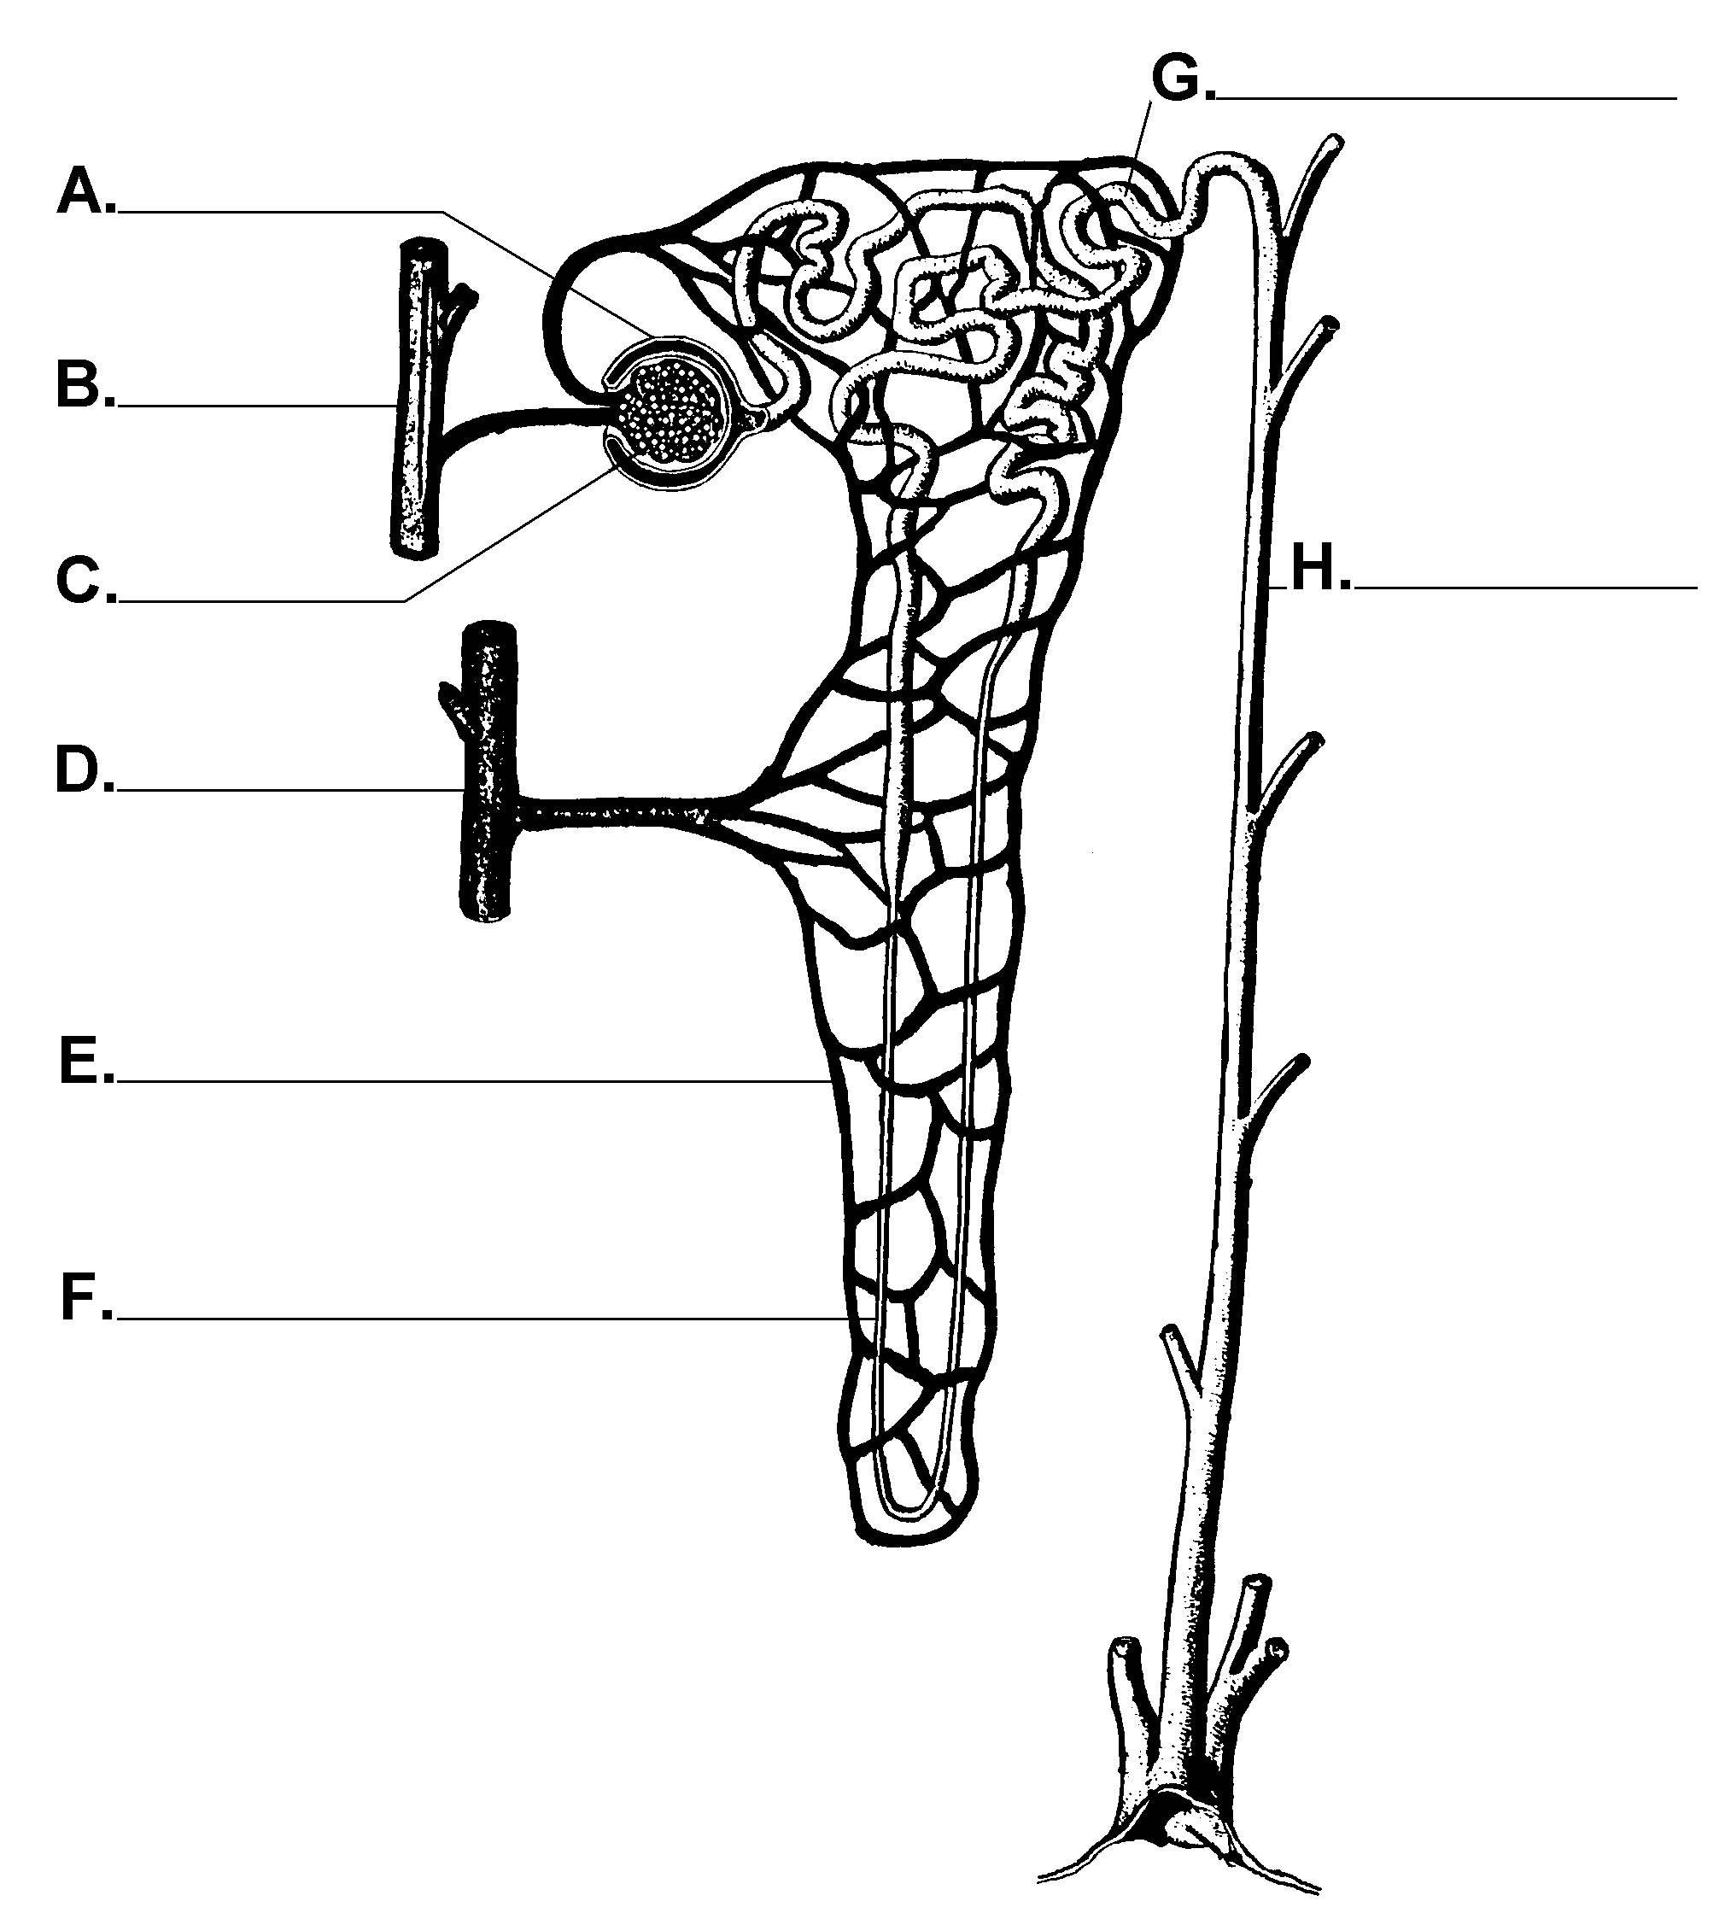

1. Filtration

a. Remains in the blood:

b. Filters into Bowman’s capsule:

2. Reabsorption

a. absorbed back into the blood:
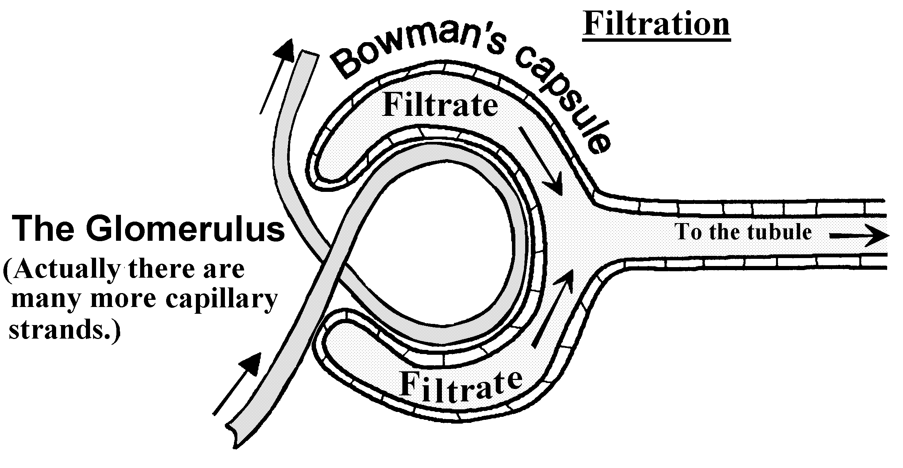

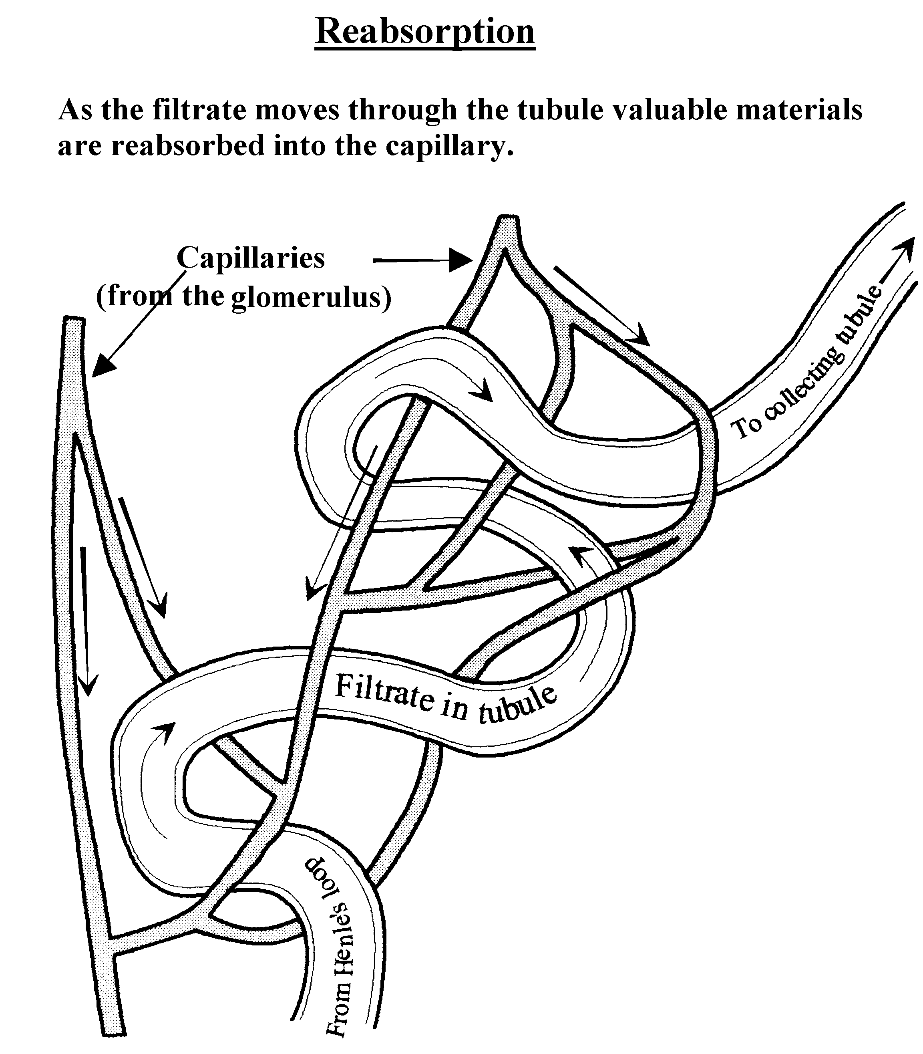
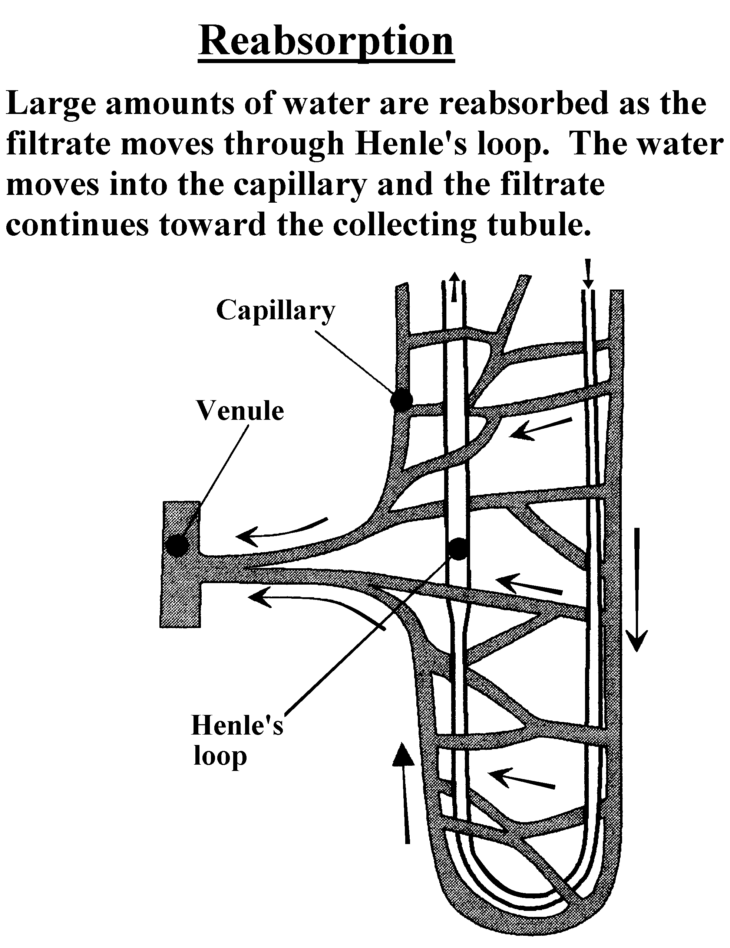

The Formation of Urine:

- For each material in the blood, determine if it moves into the tubule, then determine if it ends up in the collecting tube and will be eliminated in the urine.

- Use the symbol to indicate a material that is not reabsorbed, so it goes into the collecting tube and becomes part of the urine.

- Use the symbol to indicate that some of the material is reabsorbed into the blood and some goes into the collecting tube and becomes part of the urine.

Capillary |  | Tubule |  | Collecting tube
Blood | Symbol | Filtrate | Symbol | Urine
Water |  | Water |  | Water

Urea

Glucose
Hormones
Red blood cells
Amino acids
Degraded toxins
White blood cells
Plasma proteins
Platelets
Mineral salts

You produce approximately 180 liters of filtrate per day. How many gallons is that? ______
(Hint: there are 4 qts in one gallon and a liter is approximately one quart.)

How can you produce so much filtrate and not dehydrate?

You produce about 1 to 1.5 liters of urine each day if your water intake is appropriate.

Look at the final column and list the 4 MAIN components of urine:
a.

b.

c.

d.

C. Treating Kidney Disease

Causes:

Dialysis:

Transplant:

Gout:

The liver is and excretory organ and helps maintain homeostasis.
- The Liver (So many functions!)

1. Role in Carbohydrate storage

2. Role in digestion

3. Nutrients are received via the Hepatic Portal Vein from the intestines

4. Role in clotting:

5. Roles in excretion
a. detoxification

b. urea formation (see page 4)

B. Liver Diseases
1. hepatitis

2. cirrhosis

Other Excretory Organs

A. The Lungs

B. The Skin

Glands Secrete Many Substances
What is an Excretion? (Review)

What is a secretion?

What are glands?

There are two types of glands:
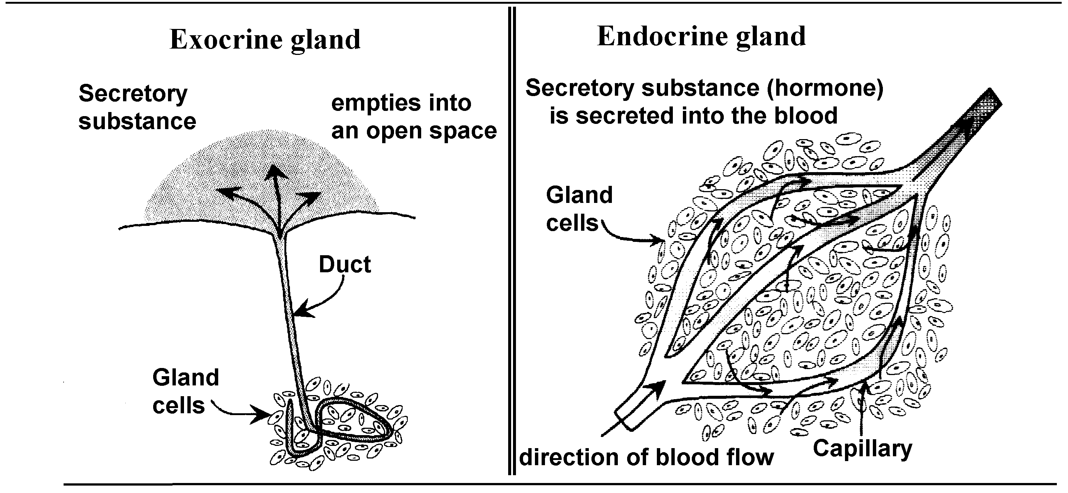

A list of some Exocrine Glands and their secretions: (fill in the missing information).

Gland | Secretion | Duct | Destination | Function of secretion
Liver |  | Bile duct | Small intestine
 | Saliva |  | Mouth
Sweat glands | Sweat | Sweat ducts | Skin surface | Removes heat
Tear glands | Tears | Tear ducts |  | Lubricate and clean eye
Sebaceous glands | Skin oil | Sebaceous ducts | Skin surface | Lubricate and water proof skin
Mammary glands | Milk | Milk duct | Child | Nourish child
Prostate glands | Prostatic fluid | Prostate duct | Urethra | Activate sperm cells
Wax glands | Wax | Wax ducts | Ear canal | Insect repellent
Gastric glands |  | Gastric ducts | Stomach | Enzymes & HCl for digestion
 | Pancreatic juice | Pancreatic duct |  | Enzymes for digestion

Exocrine glands do not secrete _________________.
Two body systems involved in regulation of homeostasis are:

1.

2.

The Endocrine System – a system of glands found throughout the body that secrete hormones.

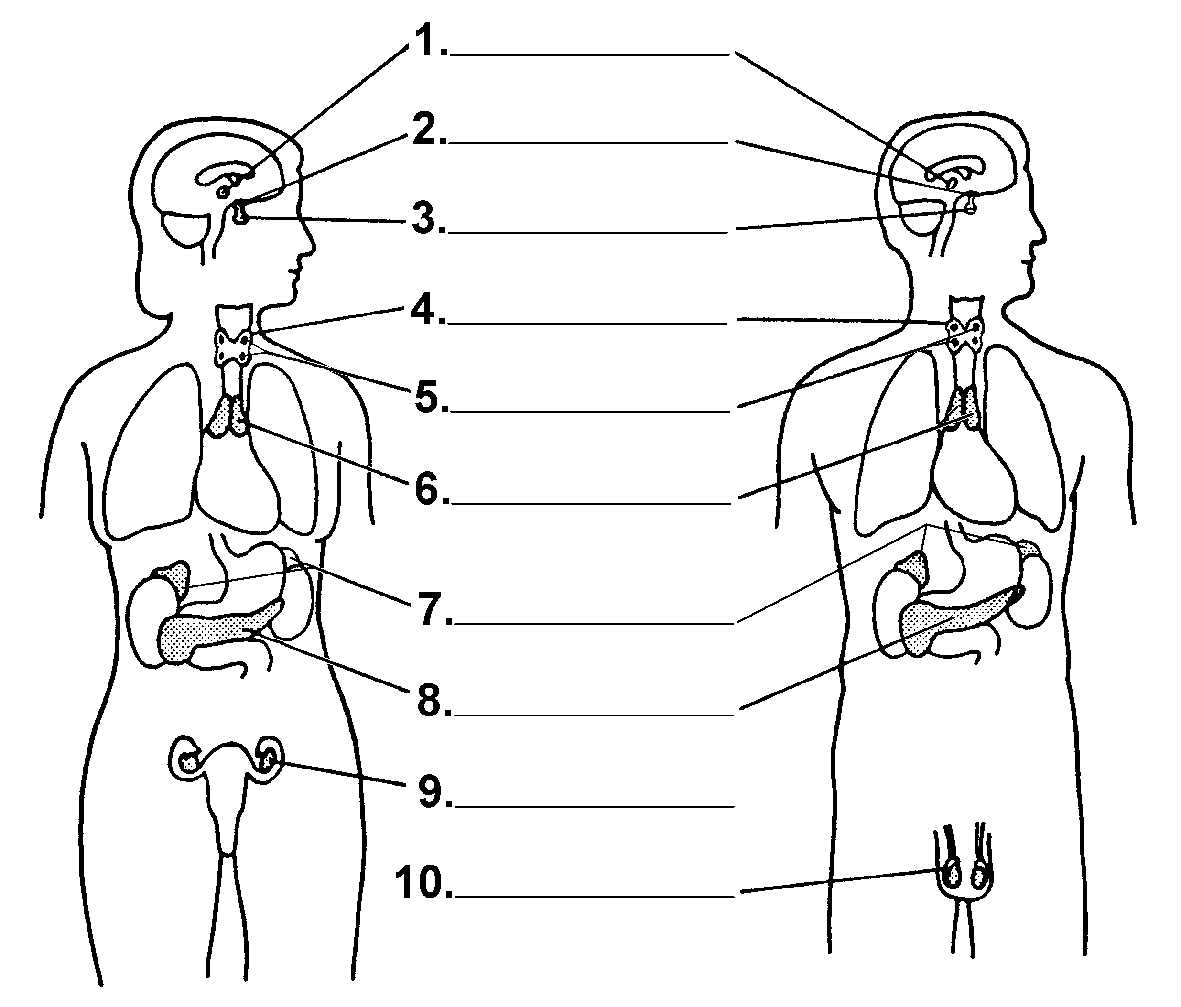

A. How Hormones Affect Target Cells:

Hormones regulate metabolism by:
Starting a process
Stopping a process
Accelerating a process
Slowing down a process

Hormones are chemical messengers
- Produced:

- Transported:

- Regulate metabolism in target cells
  - Target cell:

- Two types of Hormones: (Work by either a one-messenger or two-messenger system). (See activity)
  - Steroid

  - Protein

- Excreted in the urine.
- Effected by negative feedback.

Regulation of hormones:

Hyper-secretion

Hypo-secretion

Homeostasis depends on mechanisms of regulation.

A. Feedback

-Positive feedback
A rare system of regulation, increases without limit, does not maintain homeostasis.

-Negative feedback
A system of regulation that reacts when limits are reached.

It adjusts by negating.

Negative feedback
- Turns on processes that are off.
- Turns off processes that are on.
- Increases materials that are low.
- Decreases materials that are high.

Negative feedback maintains levels of substances or activities.
Negative feedback is essential in maintaining homeostasis.

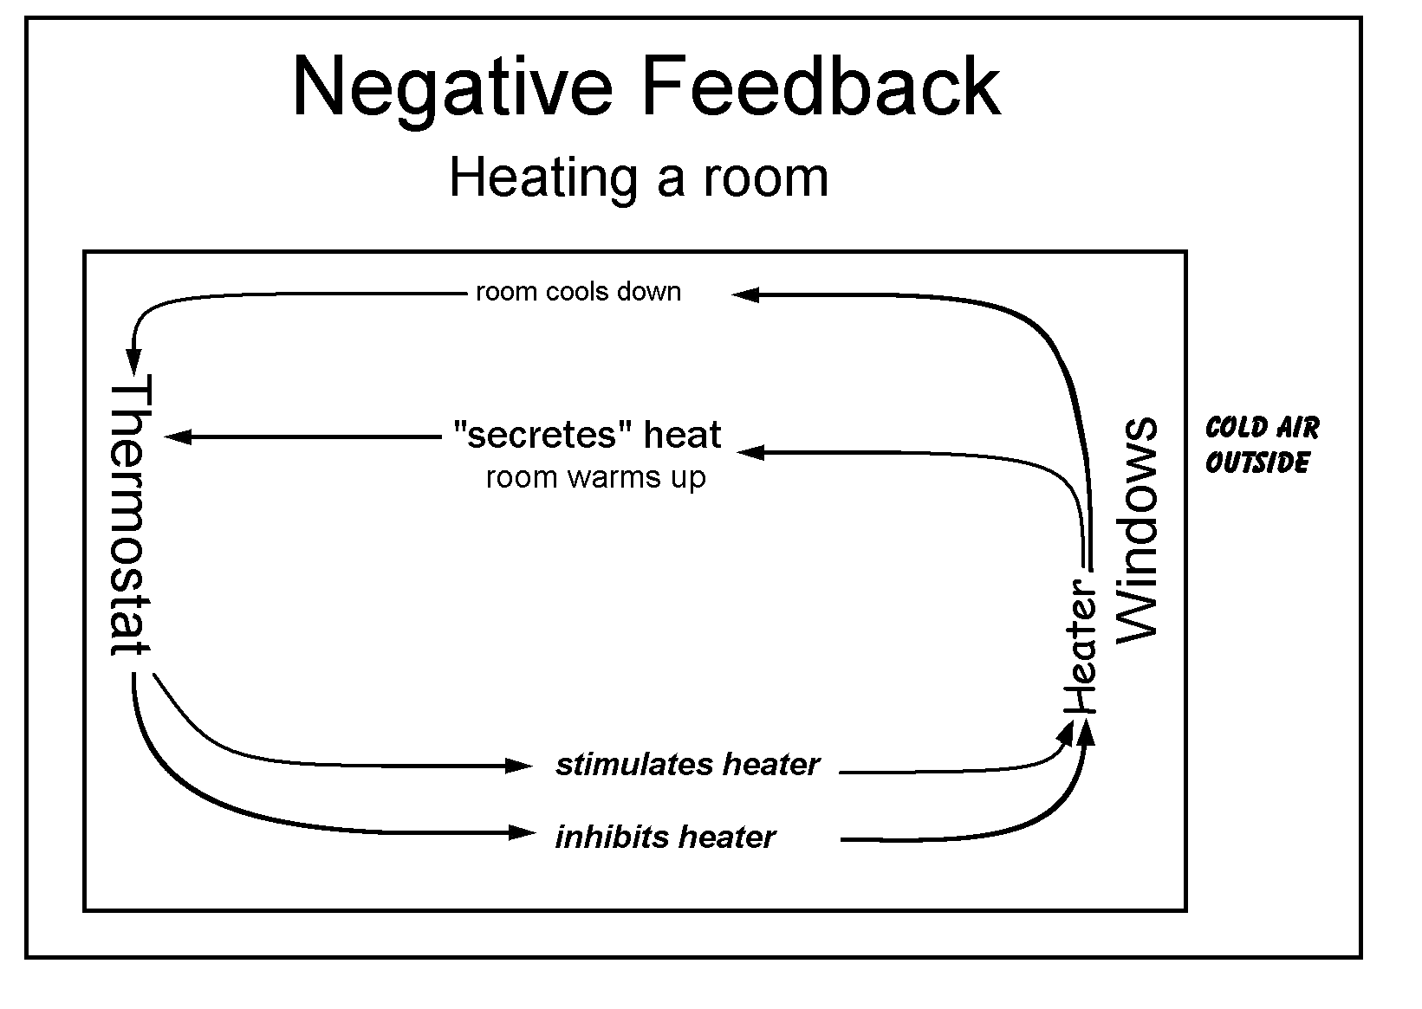
Example of negative feedback

B. Examples of Negative Feedback Mechanisms (See Diagrams)

Regulation of Body Temperature:

- Body Temp Increases Above Normal:

The thermoregulation center in the _________ is activated, which makes
blood vessels __________ to remove heat and __________ is released from skin

- Body Temp Decreases Below Normal:

The thermoregulation center in the _________ is activated, which makes
blood vessels __________ and skeletal muscles __________ to generate heat (shiver)

Regulation of Water:

- Water Level Below Normal Range

The ________________ detects higher concentration of solutes in the blood and creates feelings of __________. The posterior pituitary releases more ________________ hormone. ADH stimulates the _____________ to reabsorb more ___________.

- Water Level Above Normal Range

The ________________ detects low concentration of solutes in the blood. The posterior pituitary releases less _________________ hormone. ADH stimulates the ___________ to reabsorb less ____________.

Insulin & Glucagon Feedback Loop:

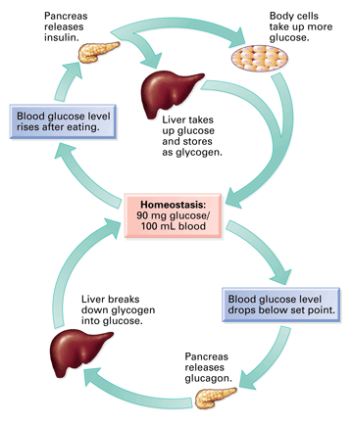

Blood Calcium Feedback Loop:

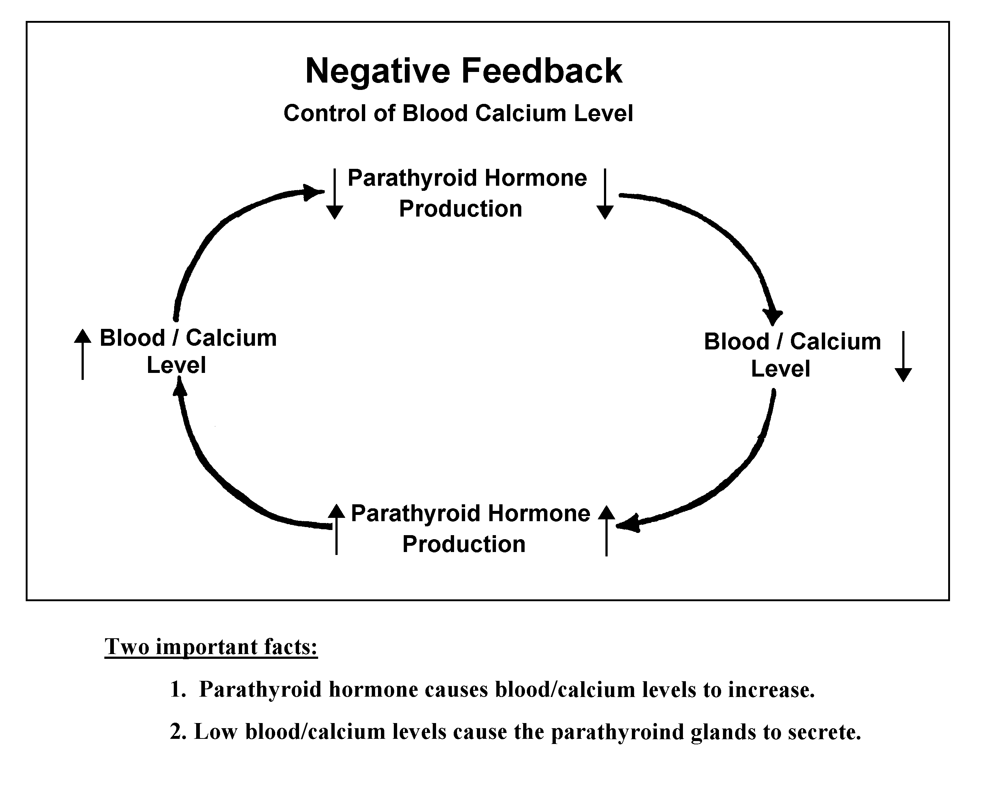

The Hormones You Should Know
GLAND | HORMONE | ACTION
Adrenal Glands
Adrenal cortex | Corticosteroids | - Conversion of fats and protein to glucose.  - Reabsorption of sodium at the kidney tubules
Adrenal medulla | Adrenaline | - Released at time of stress.  - Increases heartbeat rate.  - Increases breathing rate.  - Increases blood sugar.
Hypothalamus |  | Influences pituitary gland
Pituitary — secretes hormones that regulate the activities of other glands
Some pituitary hormones are | Growth-stimulating hormone (GSH) | - Stimulates long bone growth.
Some pituitary hormones are | Thyroid stimulating hormone (TSH) | - Stimulates the thyroid gland to secrete thyroxin.
Some pituitary hormones are | Follicle stimulating hormone (FSH) | - Females - stimulates the development of follicles in the ovaries.  - Males - influences sperm production.
Thyroid gland | Thyroxin | - Contains iodine.  - Regulates the rate of metabolism in the body cells.  - Essential for normal physical and mental development.
Parathyroid glands | Parathyroid hormone | Controls calcium metabolism.
Pancreas (also secretes digestive juices, which are NOT hormones.)
Islets of Langerhans  Beta cells | Insulin | - decreases blood glucose levels by promoting the absorption of glucose from the blood to the body cells  - stimulates the conversion of glucose to glycogen in the liver cells
Islets of Langerhans  Alpha cells | Glucagon | - increases blood glucose level by promoting conversion of glycogen to glucose in liver and muscle cells
Gonads (also the site of the production of the gametes, sperm and eggs.)
Testes | Testosterone | - secondary sexual characteristics in males.
Ovaries | Estrogen | - stimulates egg production  - secondary sexual characteristics in females.
Ovaries | Progesterone | - stimulates thickening of the uterine  lining in preparation for the implantation of an embryo
BE SURE THAT YOU KNOW THE LOCATION OF EACH GLAND.

Sequencing is putting events in proper order. Even though you may not have given it much thought, there are many things in your life that must be done in a certain sequence in order to accomplish them properly. For example, you don't put on your shoes before you put on your socks, and you don't get dressed before taking a shower. So it is with biological processes. Many of them must occur in a very exact sequence to yield the appropriate result.
Sequencing Activity
Name ________________________________

1. Read the passage below and list the sequence of events required for hormones to have an effect.
One-messenger model.
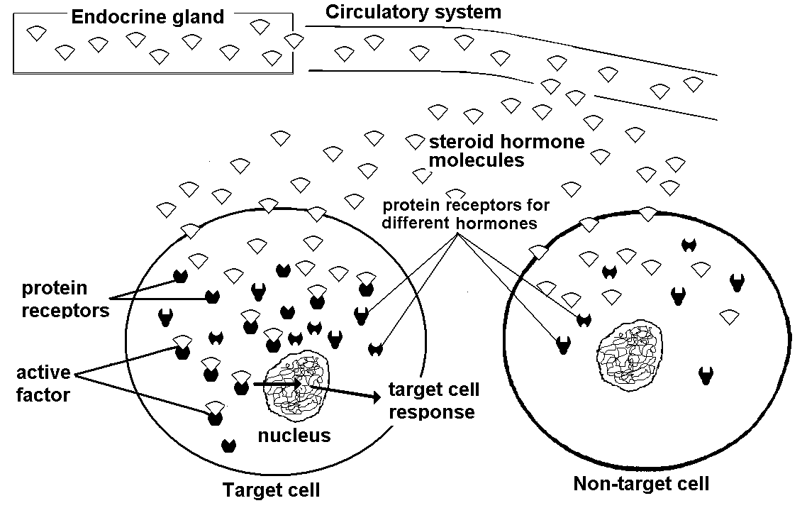
After hormones are secreted from glands and travel in the blood throughout the body they encounter all of the body cells. Steroid hormones are lipid molecules that are able to pass through cell membranes. These hormones therefore enter all cells of the body. However, it is only in the target cells that the hormones produce an effect. In these cells there are receptor proteins that recognize a particular steroid hormone and combine with it, forming an active factor. The active factors produce their effect by entering the cell nucleus and acting on the genetic material (DNA) that controls the cell's activities.

What distinguishes a target cell from a non-target cell?

2. Read the passage below and list the sequence of events required for protein hormones to have an effect.
Two-messenger model.
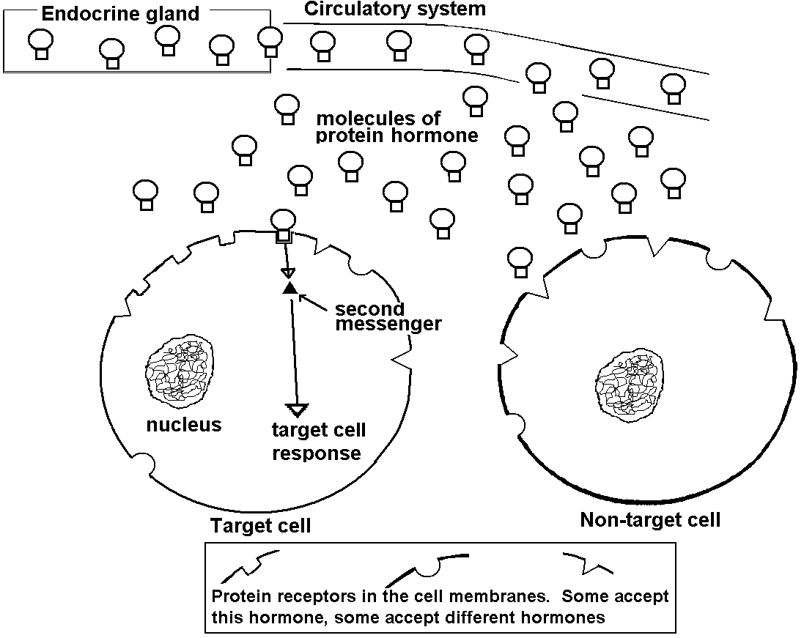
After hormones are secreted from glands and travel in the blood throughout the body they encounter all of the body cells. Protein hormones are large molecules and are not able to pass through cell membranes. They are however, recognized by specific receptors on the outer surface of target-cell membranes. When the hormone combines with the receptor on the membrane surface, the combination causes enzymes in the membrane to produce a compound that acts as the second messenger. The second messenger diffuses through the cytoplasm and produces the hormonal effect. The hormone does not enter the cell in this model. Instead, a second messenger does its work. Although the same second messenger may be produced in different types of target cells, it produces different effects in different cells. For example, it causes thyroid cells to produce thyroxine, adrenal cortex cells to produce corticosteroids, and kidney tubule cells to reabsorb more water.

What distinguishes a target cell from a non-target cell?
In the two messenger model, what is the first messenger?
What is the second messenger?

- Read the passage below and list the sequence of events for regulating thyroid gland function by negative feedback, starting with a lower-than-normal concentration of thyroxine in the blood.

Negative Feedback
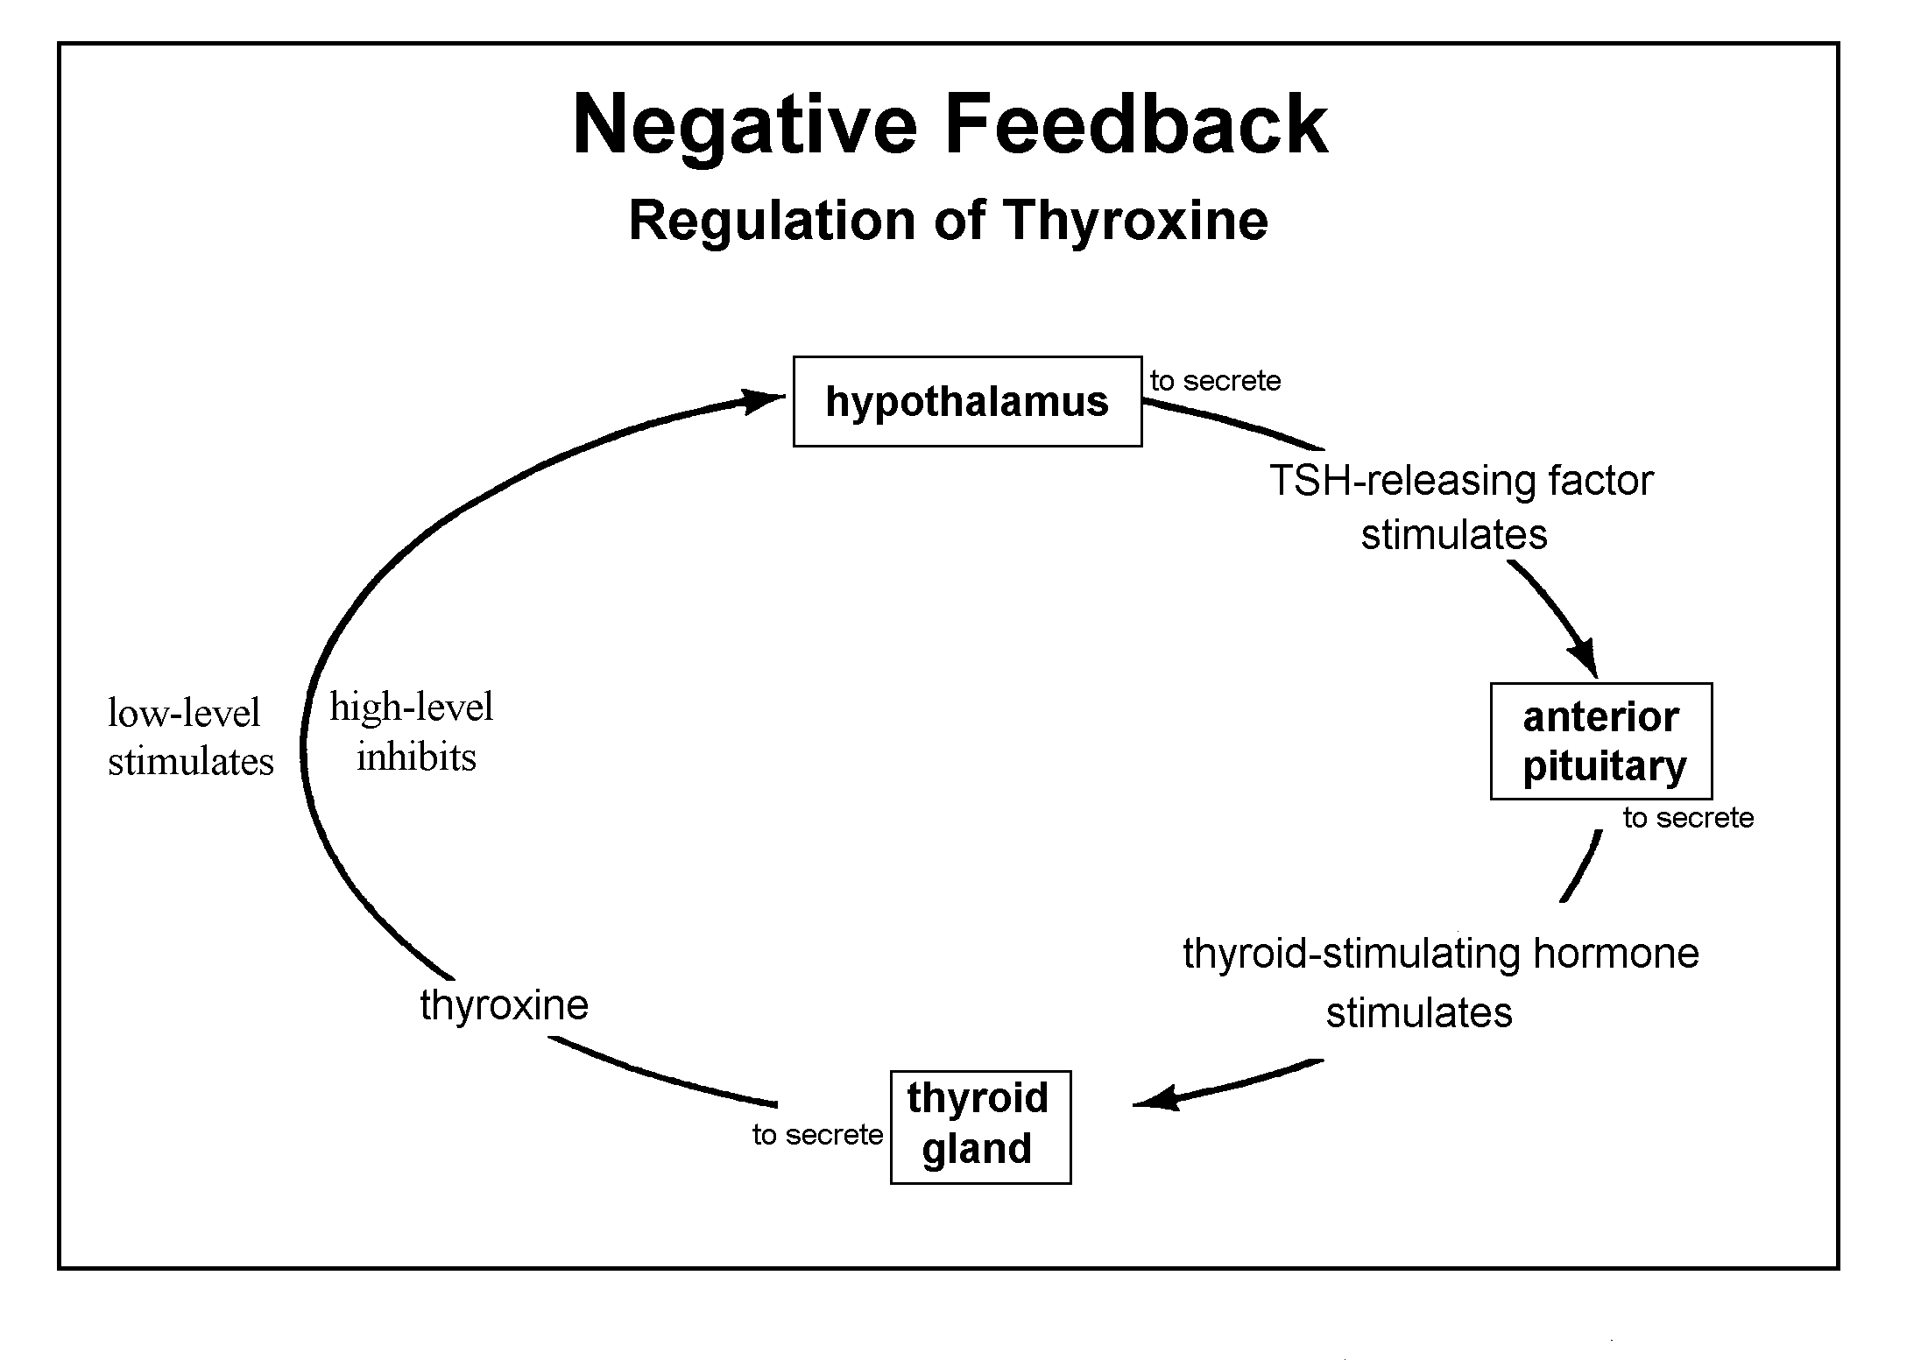
The secretion of thyroxine is regulated by the interaction of several hormones. If the concentration of thyroxine in the blood falls* below a certain level, the hypothalamus is stimulated to produce the hormone TSH-releasing factor. The releasing factor stimulates the pituitary to secrete thyroid-stimulating hormone (TSH). The TSH, in turn, stimulates the release of thyroxine by the thyroid. Increasing levels of thyroxine in the blood inhibit the production of releasing factor by the hypothalamus. This inhibits the production of TSH and thereby decreases the stimulation of the thyroid. Thus, by negative feedback the concentration of thyroxine in the blood controls the system by which it is produced.

THE TOILET TANK PROJECT
Due Date: _______
All students should hand in this assignment.
There are no homework exemptions for this assignment.

INTRODUCTION
The tank behind a toilet contains a certain amount of water ready to completely flush the toilet. If the amount of water in the tank is too low then the toilet will not be completely emptied. If the amount of water in the tank is too high then the tank will over flow or the toilet will run continuously. After each flush the tank must be refilled to the proper level.

In the 1870's a man named Thomas Crapper invented the mechanism used to allow the water to enter the tank at the right time and to fill the bowl to a certain level and then shut off. If too much water enters the tank the mechanism removes some water; if some water is removed from the tank the mechanism replaces just the right amount. The system that keeps the right amount of water in the tank is a nice model of negative feedback.

OBSERVATIONS
Go into your bathroom and remove the lid from the toilet tank (you may want to ask for an adult's assistance). Be very careful with the lid; it is heavy and fragile. Place it on the floor.

Inspect the contents of the tank. Take note of the water level. This water comes from the same source as the cold water that flows into the sink. Find the pipe coming out of the wall below the tank that supplies the water to the toilet. Notice where it connects under the tank.

Flush the toilet once to see what happens. How does the water get out of the tank? Where does it go? What happens when the bowl is emptied? When does fresh water start entering? What prevents the fresh water from escaping? When does the fresh water stop entering?

You may need to flush the bowl two or three times in order to understand all of the events involved.

What happens if you push down on the flotation device? What happens if you add water (about a gallon) slowly to the tank after it is full?

TO BE HANDED IN
Draw an illustration of the mechanism. Make your picture from a view through the wall of the tank. Don't make a top view. You may want to make two pictures, one when the tank is full and one when it is empty.
Write a separate paragraph for each of the following:
- Describe the sequence of events that occurs during the cycle of flushing and refilling.
- Describe what happens when you add water to the tank after it is full.
- Explain how this mechanism demonstrates negative feedback.
- If the tank or toilet were to malfunction and spill water on the bathroom floor, where could you go to turn off the water to the tank or to the whole house?

Some guidelines:
- Be sure that your name is on the assignment.
- Do not use oversized paper for this assignment.
- Use only one sheet of paper -- all parts (pictures, descriptions, and explanations) must fit on one sheets of paper. You may use both sides it you wish.
- Concentrate your efforts on the how the tank (not the bowl) empties and how it refills to its original volume.

Name: _______________________________________ Per. _______
Hormones

Fill in the blanks in the table below.

Endocrine Gland | Hormone | Function
 | Estrogen
 | Growth Stimulating Hormone (GSH)
Testes

 |  | Released at time of stress and causes “fight or flight” reaction
Hypothalamus | ------------------
 | Parathyroid Hormone
 |  | Regulates the rate of metabolism
Pancreas |  | Lowers blood glucose levels
Pancreas |  | Increases blood glucose levels

Name: ________________________________ Per. ______

Negative Feedback Activity

- Summarize how a thermostat regulates temperature in a house?

- The action of the thermostat is an example of a ______________ _____________ mechanism.

- Chemical messengers called ____________________ help to regulate homeostasis. These chemical messengers cause changes to occur in target tissues throughout the body.

- Insulin and glucagon are hormones that are secreted by the ___________________ and help to maintain blood _______________ levels.

Blood Glucose Regulation – an example of a Negative Feedback mechanism

1.
2.
6.
5.
4.
3.

Name: ____________________________ Per. _______

Match the organ name, from the word bank below, with its function. The organs may be used more than once or not at all.

Kidneys Small Intestine Heart

Liver Brain Pancreas

Bladder Stomach Ovaries

Ureter Gallbladder Lungs

Urethra Adrenal Glands Thyroid

Skin Arteries Esophagus

- ______________Location of the hypothalamus.

- ______________Releases adrenaline at times of stress.

- ______________Contains nephrons that filter the blood.

- ______________Produces bile.

- ______________Tube that leads from a kidney to the bladder.

- ______________Begins the digestion of proteins.

- ______________Makes insulin and glucagon to regulate blood sugar levels.

- ______________Involved in the excretion of carbon dioxide.

- ______________Carries urine out of the body.

- ______________A muscular sac that stores urine.

- ______________Make a hormone involved in secondary sex characteristics.

- ______________Makes a hormone involved in the rate of metabolism.

- ______________An accessory organ of the digestive system that makes digestive enzymes.

- ______________An excretory organ other than the kidneys that releases urea.

- ______________Makes proteins involved in blood clotting.

Name ____________________________________ Period _____

Due Date: _______

Kidney Function Activity Sheet

The function of the kidneys is the production of urine. Urine carries waste materials out of the body. If something prevents the kidneys from producing urine, poisons build up that will cause death unless some kind of medical treatment is provided.

Urine contains a number of different kinds of ions. The sodium ion (Na⁺) is one of them. The kidneys play a role in keeping the concentration of sodium ions within a safe range. When too much sodium is eliminated in the urine there is too little sodium available to the tissues. Among other things, this can make a person weak.

The kidneys also play an important role in regulating the amount of water in the body. If too much water is passed in the urine a person’s blood pressure will drop below its normal level. If not enough water is eliminated; the blood pressure will become abnormally high. Abnormal blood pressure is one example of what can happen when the body’s water balance is not maintained.

The amount of water and sodium needed for normal maintenance is related to the surface area of the body. The larger the surface area the greater the amount of water and sodium we need to take in each day.

In this activity you will use your body weight to find the surface area of your body. You will then calculate the amount of water and sodium you need each day to maintain homeostasis.

The heavier you are, the greater your surface area. The table below shows the approximate surface areas associated with certain body weights.

Weight | Surface Area
(lbs) | (m²)
60 | 0.97
70 | 1.10
80 | 1.21
90 | 1.33
100 | 1.40
125 | 1.60
150 | 1.75
175 | 2.00
200 | 2.20
250 | 2.70

Graph the data in the above chart.
Weight is the independent variable.

Continue on to the other side.

- Use the graph to determine the surface area of your body. Look up your weight then draw a line up to the plotted line. Look across to the surface area and read the value associated with your weight.

The approximate surface are of my body is ___________________ (don’t forget units!)

- When a person is not under stress he or she needs about 1,500 ml (1.5L) of water each day for each square meter of body surface area. From the surface area of your body calculate the amount of water that you need to drink each day under non-stress conditions.

Calculation:

Answer: _________________(don’t forget units!)

- When a person is not under stress, he or she needs about 1,380 milligrams of sodium each day for each square meter of body surface area. Calculate the amount of sodium that you should take in each day under non-stress conditions.

Calculations:

Answer: _________________(don’t forget units!)

- Under what conditions might you need to take in more water and sodium than you calculated?

