Name:______________________________________ Per._____ Due_________ Assign #1
Unit 5 – Mitosis & Meiosis (Chapter 9)

Read pages 180-181 in your text to complete this assignment.
(Concept Check 9.1)

1. Relate cell reproduction to the replacement of skin cells.

2. Describe two ways in which asexual and sexual reproduction differ.

a.)

b.)

3. How is cell division involved in growth?

Additional question…

4. Can an organism reproduce both sexually and asexually? Give an example. (Hint: figure 9-2)

Name:____________________________________ Per.______ Due__________ Assign #2
Unit 5 – Mitosis & Meiosis (Chapter 9)

Read pages 182-188 in your text to complete this assignment.

1. Describe how the appearance of chromosomes changes as a cell is about to divide (Use the terms chromatin and chromosome).

2. The following is a diagram of a double stranded chromosome. Label the following parts on the diagram; chromatid, centromere

3. In which cell organelle would you find chromosomes?

4. What structure is formed when DNA is wrapped around histone proteins?

5. Look at the Chromosome Number Chart on page 4 of your note packet. Name 2 organisms
that have 40 chromosomes:

Name:____________________________________ Per.______ Due__________ Assign #3
Unit 5 – Mitosis & Meiosis (Chapter 9)

- Define Genome:

- How might a complete map of the human genome be useful?

- How many chromosomes do humans have in all of their body cells?

- What are the 4 nitrogenous bases that make up DNA?

Name:____________________________________ Per.______ Due__________ Assign #4
Unit 5 – Mitosis & Meiosis (Chapter 9)

Read pages 190-191 in your text to complete this assignment.
(Concept Check 9.4)

1. List two differences between benign tumors and malignant tumors.
a.

b.

2. How might drugs that interfere with mitosis be effective in treating cancer?

Additional questions…

4. What are some possible side-effects that can happen to normal body cells as a result of radiation and/or chemotherapy?

5. What part of the cell cycle is decreased in cancer cells?

Name:____________________________________ Per.______ Due__________ Assign #5
Unit 5 – Mitosis & Meiosis (Chapter 9)

Read pages 192-197 in your text to complete this assignment.
(Concept Check 9.5)

1. Describe how homologous chromosomes are different from sister chromatids:

2. Compare the number of sets of chromosomes in human gametes with the number of sets in other cells in the body (somatic cells):

3. How does meiosis I reduce the number of chromosomes in the daughter cells?

4. What is the final result of meiosis?

Additional questions…
5. What does “2n” mean?

6. What would be the effect on the chromosome number of a species if fertilization occurred without meiosis?

7. What is fertilization?

8. What is synapsis?

Name:____________________________________ Per.______ Due__________ Assign #6
Unit 5 – Mitosis & Meiosis (Chapter 9)
Read pages 198-201 in your text to complete this assignment.

1. Describe how crossing over during meiosis in an individual organism recombines the genetic material of the organism’s 2 parents:

2. Compare mitosis and meiosis
Mitosis Meiosis

Function

Number of cells created

Parent cell (2n or n)

Daughter cells (2n or n)

Additional questions…
3. The diagrams below represent what process? ____________________

Label the following: a homologous pair of chromosomes, synapsis, tetrad, crossing over, gametes, daughter cell
4. What is the diploid number of the parent cell? ________

5. What is the haploid number of the daughter cells? ________

Assign #6
Unit 5 – Human Genetics (Chapter 12)
Read pages 248-251 in your text to complete this assignment.

1. What does trisomy 21 mean? What is another name for this disorder?

2. Use the diagram below to answer the questions (textbook p 251).
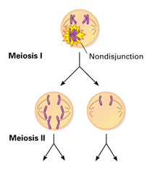
a. In the circles provided, draw the four gametes produced, including the number of chromosomes in each.

b. Explain how each gamete is abnormal:

c. Note that the process shown is simplified, showing only two pairs of chromosomes at meiosis I.
In a human, how many pairs of chromosomes would there actually be at meiosis I?

Name:____________________________________ Per.______ Due__________ Assign #7
Unit 5 – Patterns of Inheritance (Chapter 10)
Read pages 206, 209 & 211 in your text to complete this assignment.
Answer the following questions.

- What are the two possible gametes produced by a plant that has the genotype Aa? Give the probability of each type of gamete.

- What is a gene?

- What is an allele?

- What is a dominant gene?

- What is a recessive gene?

- A genotype of Tt would be called ________________________ (p. 209)

- A genotype of TT would be called _______________________ (p. 209)

- A genotype of tt would be called ________________________ (p. 209)

- Describe phenotype:

- Describe genotype:

Name:____________________________________ Per.______ Due_________ Assign #8
Unit 5 – Patterns of Inheritance (Chapter 10)
Read pages 216 & 217 in your text to complete this assignment.
Answer the following questions.

1. Two parents have type O blood.

What blood type would you expect from their first child? ____________

What blood type would you expect from their second child? _____________

Explain:

2. If a father’s blood type is B and a mother’s blood type is A, is it possible that their child could have blood type O?

Explain your response:

3. If a father’s blood type is A and a mother’s blood type is AB, what are the possible blood types of their offspring. (Hint: more than one genotype for type A blood!)

4. Give three examples of human physical characters affected by environment:

a.

b.

c.

5. Using your class notes describe how the environment affects the fur of the Himalayan hare:

Name:____________________________________ Per.______ Due_________ Assign #9
Unit 5 – Patterns of Inheritance (Chapter 10)
Read pages 218 - 221 in your text to complete this assignment.
Answer the 2 questions below from page 221 (Concept Check 10.5).

- Describe why one would expect to find more white-eyed male fruit flies than white-eyed females in natural populations:

- A man with hemophilia and a homo9zygous non-hemophiliac woman have a son. Is it possible that the son will inherit hemophilia? Why or why not?

Additional questions…

- A female carrier and a man with normal vision have children. Determine the characteristics of all their possible offspring:

- A man with normal vision and a colorblind woman have children. Determine the characteristics of all their possible offspring.

Name:____________________________________ Per.______ Due_________ Assign #10
Unit 5 – Mitosis & Meiosis (Chapter 9) & Patterns of Inheritance (Chapter 10)
Use your notepackets and your text to complete this assignment.
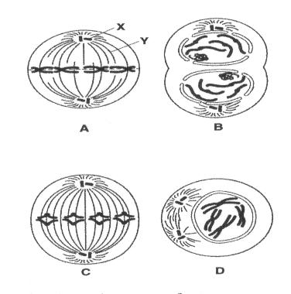

1. What process do the figures represent?

2. Do these figures represent plant cells or animal cells? (circle one)
How do you know that they are animal cells or plant cell? (See text page 188)

3. What is the chromosome number of the cell shown in the figure D?

4. Identify the structures labeled X and Y in figure A.

5. List the correct order of the diagrams:

6. Give three examples of organisms that reproduce asexually.
a. b. c.
7. What is the function of the spindle during mitosis?

8. Explain how cancer tumors spread.

9. Describe the most obvious way the karyotypes of a sister and brother look different.

10. Describe the structure of a tetrad. When do tetrads form?

11. Describe one similarity between mitosis and meiosis II.

Describe one difference.

12. Name two factors that introduce genetic variation during the process of meiosis.
a. b.

Explain how they introduce variation.

13. The diagram below represents metaphase I of meiosis in a cell that has two pairs of homologous chromosomes. Using colored pencils or pens, draw a similar diagram to show how the chromosomes would look if the cell were in metaphase of mitosis.

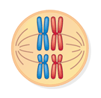
Metaphase I of Meiosis: Metaphase of Mitosis:

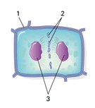
14. Use the diagram below of a cell undergoing cytokinesis to answer the following questions.
a. Does the diagram show a plant cell or an animal cell? ___________________

b. Identify each of the numbered structures in the diagram.
1 =
2 =
3 =

15. How are the growth of a malignant tumor and the repair of a cut on your finger similar?

How are they different?

16. Suppose you have two fully grown pea plants, one tall and one dwarf. Dwarf height is a recessive trait. Using T and t as the alleles, what is the the dwarf plant's genotype?

17. Explain how a white-eyed male fruit fly can have a red-eyed father.

18. The diagram shows three gene loci on a pair of homologous chromosomes.
a. Of the three genes found on this pair of homologous chromosomes, which two are most likely to be separated from each other by a crossover event? Explain.

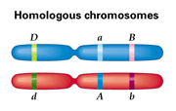
b. If no crossovers occurred between any of the genes, list the possible combinations of alleles in this individual's gametes.

19. Tim and Christine have freckles (a dominant trait that is not sex-linked), but their son Michael does not. Explain how this is possible.

Tim and Christine are expecting a baby. What is the probability of freckles in that child?

20. A man with hemophilia and a homozygous non-hemophiliac woman have a son. Is it possible that the son will inherit hemophilia? Why or why not?

21. A female carrier and a man with normal vision have children. Determine the characteristics of all their possible offspring.

**************************************************************************
Due __________ Assign #11
Unit 45– Mitosis & Meiosis (Chapter 9) & Patterns of Inheritance (Chapter 10)
Review Assignment: Castle Learning

Go to Castle Learning and complete the
Unit 5 – Mitosis/Meiosis/Patterns of Inheritance

Extra Homeworks:

Name:______________________________________ Per._____ Due_________ Assign #1
Unit 3b – Human Genetics (Chapter 12)

Read pages 248-251 in your text to complete this assignment.

1. How might a complete map of the human genome be useful?

2. What does trisomy 21 mean? What is another name for this disorder?

3. How is a mother’s age related to the probability or nondisjunction of chromosomes in her gametes?

4. Use the diagram below to answer the questions (textbook p 251).
a. In the circles provided, draw the four gametes produced, including the number of chromosomes in each.

b. Explain how each gamete is abnormal:

c. Note that the process shown is simplified, showing only two pairs of chromosomes at meiosis I.
In a human, how many pairs of chromosomes would there actually be at meiosis I?

Name:______________________________________ Per._____ Due_________ Assign #2
Unit 3b – Human Genetics (Chapter 12)

Read pages 250-251 in your text and complete the following questions.
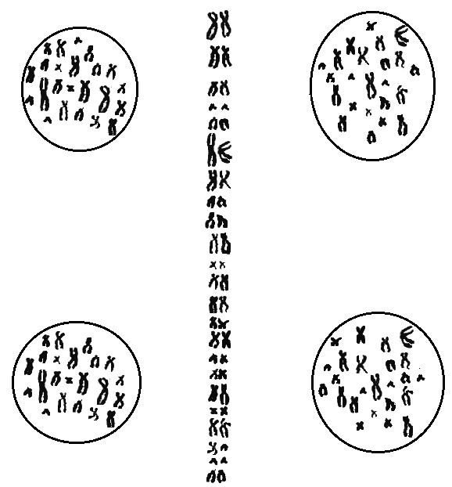
A
B
C
D
# of c’somes = _______
# of c’somes = _______
# of c’somes = _______
# of c’somes = _______
Meiosis I in a Human Male
Non-disjunction Review

The column of tetrads in the center of the illustration is the way that human chromosomes line up during meiosis I.
- The upper two cells (A & B) are the result of normal meiosis.
- The lower cells (C & D) result if a non-disjunction occurs.
1. Count and record the number of chromosomes in each cell in the illustration.

2. If cell C were to mature into a sperm cell and then fertilize a normal egg cell. How many chromosomes would the zygote contain? ____________

3.If cell D were to mature into a sperm cell and then fertilize a normal egg cell. How many chromosomes would the zygote contain? ____________

Read pages 266-267 in your text and complete the following questions.

4. Describe one use of DNA Technology.

5. Which major biological question will biotechnology help to answer?

6. List 3 ways that genetic recombination occurs in bacteria.
a.

b.

c.

