
Regents Biology Name_________________________________
Unit 5/Chapter 9 & 12 Exam Date____________

The Cellular Basis of Inheritance / Human Genetics

9.1 All cells come from cells
A. Repair and Growth

B. Reproduction

Two types of Reproduction

 | Asexual | Sexual

Parents
Variation
Mate Selection

Examples of Asexual Reproduction:
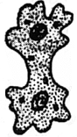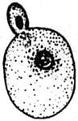 1. Binary Fission 2. Budding

Ameba Yeast

3. Clone

9.2 The cell cycle multiplies cells.
A. Chromosomes and Cell Division
1. Chromosome forms:
- chromatin

- Chromosome
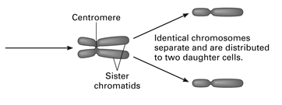
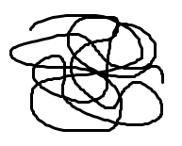
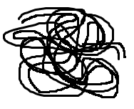

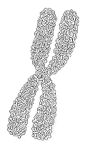

  - sister chromatid

  - centromere

Questions: (refer to the diagram of the chromosome above)
1. Is the chromosome illustrated double stranded or single stranded?
2. What process occurred that resulted in the two strands?
3. Circle and label one chromatid.
4. Circle and label the centromere

2. Histones (see chapter 12)

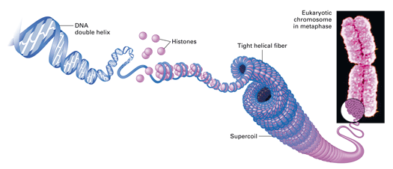

3. Chromosome Number
Each species has a particular chromosome number that is found in each body cell.

Fruit fly_____ pigeon_____ human_____ gorilla_____ corn _____

Gametes:

Chromosome numbers found in some different species of organisms*
Common Name | Species | Diploid No. |  | Common Name | Species |  | Diploid No.
animals |  |  |  | Plants
human | Homo sapiens | 46 |  | green algae | Acetabularia mediterranea |  | ca. 20
chimpanzee | Pan troglodytes | 48 |  | garden onion | Allium cepa |  | 16
gorilla | Gorilla gorilla | 48 |  | barley | Hordeum vulgare |  | 14
Rhesus monkey | Macaca mulata | 42 |  | rice | Oryza sativa |  | 24
cattle | Bos taurus | 60 |  | spiderwort | Tradescantia virginiana |  | 24
dog | Canis familiaris | 78 |  | wheat | Triticum aestivum |  | 42
cat | Felix domestic | 38 |  | corn (maize) | Zea mays |  | 20
horse | Equus calibus | 64 |  | snapdragon | Antirrhinum majus |  | 16
donkey | Equus asinus | 62 |  | squash | Cucurbitla pepo |  | 40
house mouse | Mus musculus | 40 |  | upland cotton | Gossypium hirsutum |  | 52
rat | Rattus norvegicus | 42 |  | tomato | Lycopersicon esculentum |  | 24
golden hamster | Mesocricetus auratus | 44 |  | tobacco | Nicotiana tabacum |  | 48
guinea pig | Cavia cobaya | 64 |  | evening primrose | Oenothera biennis |  | 14
Rabbit | Oryctolagus caniculus | 44 |  | kidney bean | Phaseolus vulgaris |  | 22
pigeon | Columbia livia | ca. 80 |  | white oak | Quercus alba |  | 24
chicken | Gallus domesticus | ca. 78 |  | white pine | Pinus albas |  | 24
alligator | Alligator mississipiensis | 32 |  | garden pea | Pisum sativum |  | 14
toad | Bufo americanus | 22 |  | potato | Solanum tubersum |  | 48
leopard frog | Rana pipiens | 26 |  | while clover | Trifolium repens |  | 32
carp | Cyprinus carpio | 104 |  | broad bean | Vicia faba |  | 12
starfish | Asterias forbesi | 36
silkworm | Bombyx mori | 56 |  | Fungi and Protist |  | Haploid No.
red ant | Frmica sanguinea | 48 |  | yeast | Saccharomyces cerevisiae |  | ca. 17
house fly | Musca domestica | 12 |  | slime mold | Dictyostelium discoideum |  | 7
fruit fly | Drosophila melanogaster | 8 |  | black bread mold | Aspergillus nidulans |  | 8
mosquito | Culex pipiens | 6 |  | pink bread mold | Neurospora crassa |  | 7
cockroach | Blatta germanica | 23♂, 24♀ |  | penicillin mold | Penicillium species |  | 4
grasshopper | Melanoplus differentialis | 24 |  | green algae | Chlamydomonas reinhardii |  | 16
honeybee | Apis mellifera | 32 |  | amoeba | Amoeba proteus |  | ca. 250
flatworm | Planaria torva | 16
freshwater hydra | Hydra vulgaris attentuata | 32
nematode | Caenorhabditis elegans | ll♂, 12♀
* In most diploid organisms both males and females possess the full diploid number of chromosomes. In a few organisms, such as bees the sexes differ in the number of sets of chromosomes, the females being diploid (2 sets) and the males haploid (one set).

12.1 The nucleus contains an information-rich genome.

1. Genome

2. The Human Genome Project

- The Cell Cycle

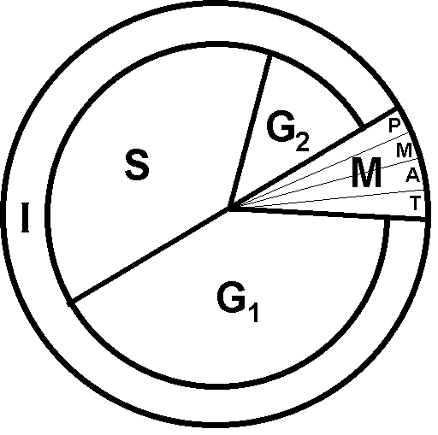

Stages of the cell cycle
    - Interphase

    - Mitotic Phase
      - chromosome condensation
      - nuclear membrane disintegrates
      - spindle fibers form
Mitosis
      - chromosomes line up
      - separation of double stranded chromosomes
      - nuclear membrane forms
      - cytokinesis

9.3. Cells divide during the mitotic phase.

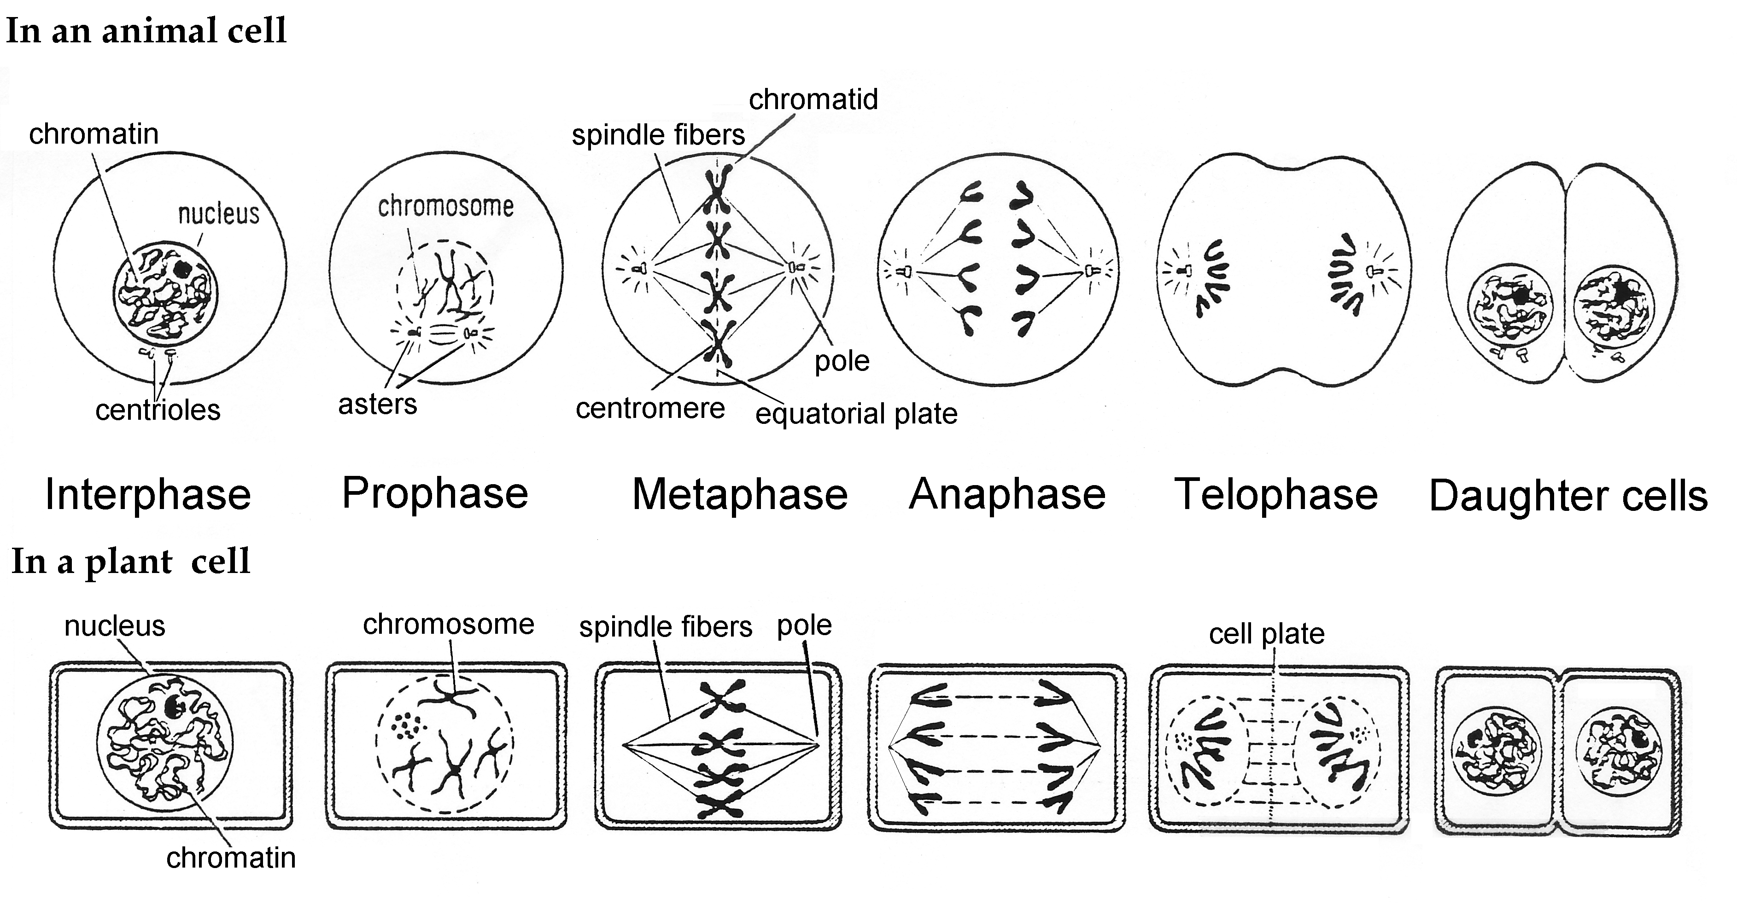

Differences between Cell division in plant cells and animal cells:
 | Plant | Animal

Centrioles
Cytokinesis

  - Cancer cells grow and divide out of control.
- Tumors and Cancer
  - Benign

  - Malignant

  - Metastasis

- Cancer Treatment
  - Radiation therapy

  - Chemotherapy

9.5 Meiosis functions in sexual reproduction.

- Homologous Chromosomes

1. Meiosis

2. Karyotype

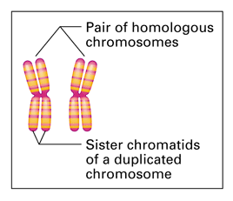
3. Homologous Chromosomes:

a. sex chromosomes

b. autosomes

Important definitions and terms:
Gonads

1. Male

2. Female

Gametes

1. Male

2. Female

4. Diploid and Haploid Cells

a. diploid number:

b. haploid (monoploid) number:

c. fertilization

1. internal

2. external

3. hermaphrodism

d. zygote

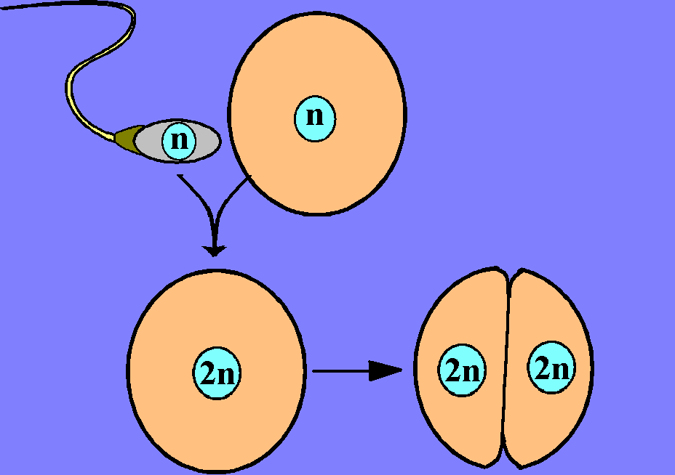

5. The Process of Meiosis (Gametogenesis)
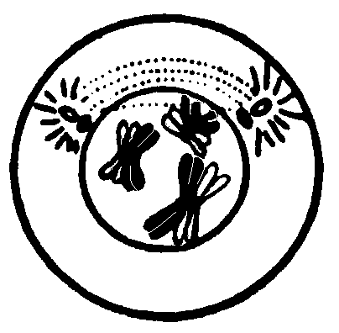
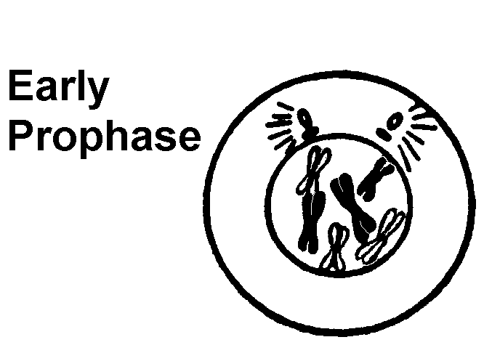
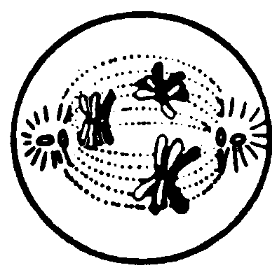
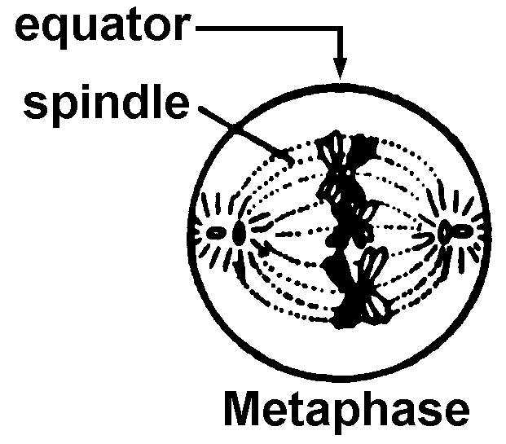
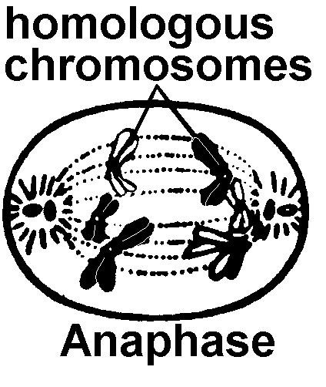
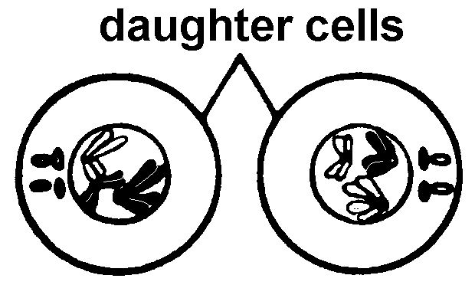
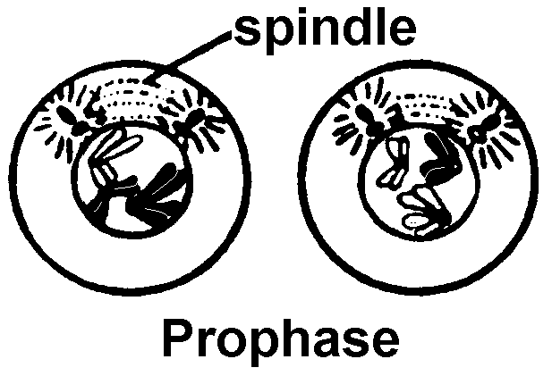
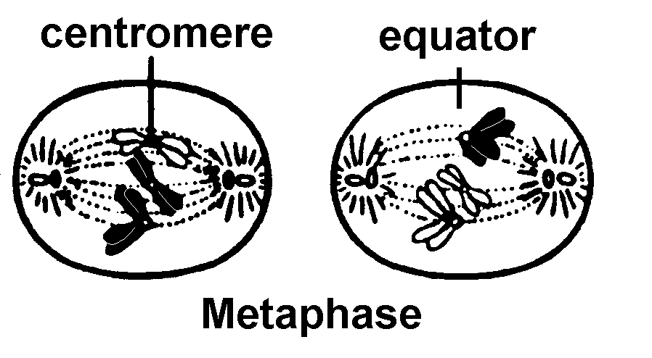
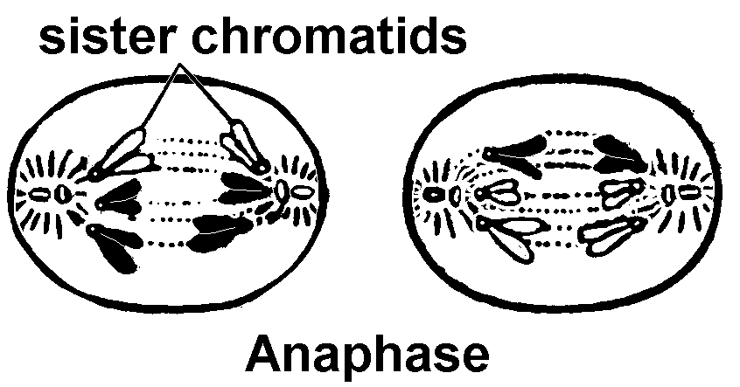
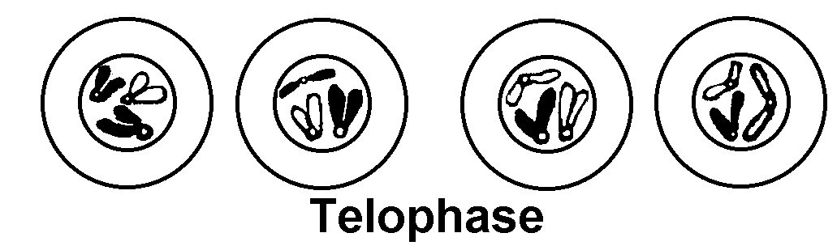

9.6 Meiosis increases genetic variation among offspring.
A. synapsis:
Tetrad:

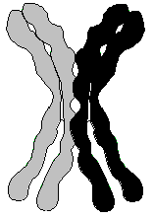

B. tetrad:

What are there four of? _____________________

What are there two of? _____________________

What is there one of? _____________________

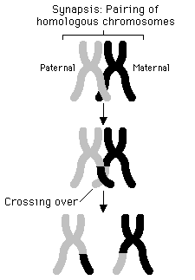

C. Crossing Over:

Genetic recombination

D. Disjunction

12.2 Accidents affecting chromosomes can cause disorders.

What happens if a mistake occurs during Meiosis?
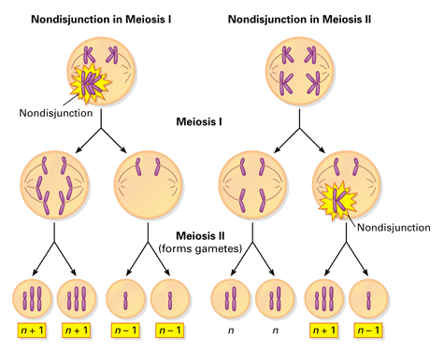
A. Nonseparation of Chromosomes: Non-disjunction

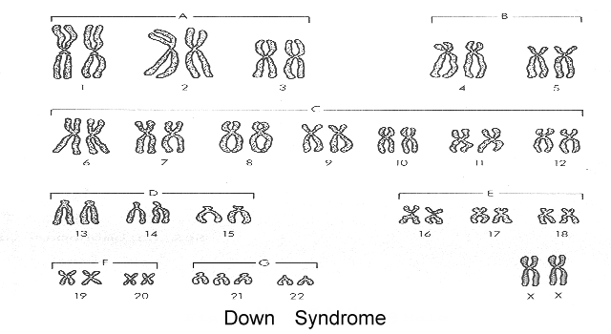
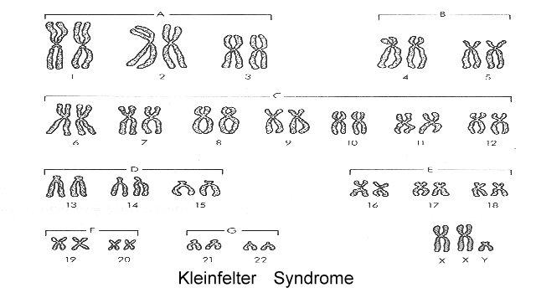
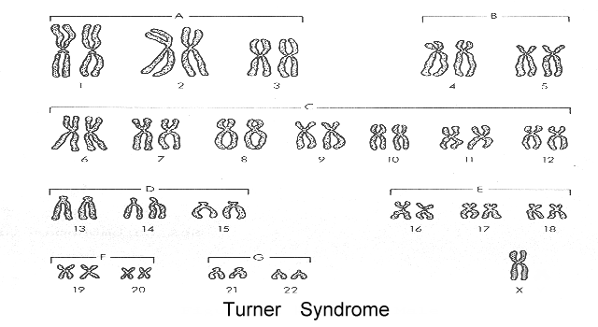
No. of Chromosomes: __________
Sex:_________
Karyotype Notation:____________
No. of Chromosomes: _______
Sex:_________
Karyotype Notation:____________
No. of Chromosomes: _______
Sex:_________
Karyotype Notation:____________

Refer to the diagram of the cell cycle below:
Name ___________________________________________

a. What letter(s) indicates when mitosis takes place?

b. What letter(s) indicates when DNA replication takes place?

c. What letter(s) indicates when growth and protein synthesis takes place?

d. What letter(s) indicates when you would find chromosomal material in the form of:

chromatin?

single stranded chromatin?

double stranded chromatin?

e. What letter(s) indicates when you would find chromosomal material in the form of:

chromosomes?

double stranded chromosomes?

single stranded chromosomes?
f. What letter(s) indicates when cytokinesis would take place?

g. What part of the cell cycle is decreased in cancer cells?

Comparison of Mitosis and Meiosis

 | Mitosis | Meiosis

Number of cells produced?

Where, in an organism, does the process occur?
For what purpose does the process occur?

Ploid of parent cell vs daughter cells
(n or 2n)
Number of divisions

Synapsis occurs?
(Y / N)

What lines up at metaphase?
Replication precedes the process? (Are the Chromosomes double stranded at the start?)
(Y / N)

Mitosis and Meiosis – A Comparison of the 2 Types of Cell Division
Mitosis is cell division for the purpose of ____________________________________________________
Meiosis is cell division for the purpose of ___________________________________________________

Mitosis | Meiosis I | Meiosis II
n or 2n  Interphase | n or 2n  Interphase | n or 2n  Prophase II
n or 2n  Prophase | n or 2n  Prophase I | n or 2n  Metaphase II
n or 2n  Metaphase | n or 2n  Metaphase I | n or 2n  Anaphase II
n or 2n  Anaphase | n or 2n  Anaphase I | n or 2n  Telaphase II
n or 2n  Telaphase  Interphase | n or 2n  Telaphase I  Interphase  Interphase | n or 2n  Telaphase II

