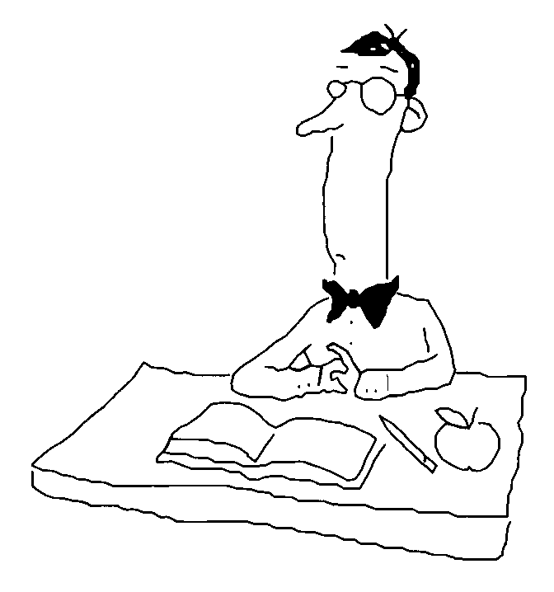
Name _____________________________
Regents Biology Unit 8 Chapter 27b Skeletal & Muscular Systems

Introduction:
Locomotion:

A. Among many Protists and animals, locomotion increases an organism’s chance of
survival by improving its chances of:
a.
b.
c.
d.

B. Motile:

C. Sessile (nonmotile):

Example:

27.4 The Skeleton functions in support and movement. (p. 597-600)

- Anatomy of the Skeleton

Functions:
1.

2.

a. skull protects:

b. backbone (vertebrae) protects:

c. ribs protect:

B. Bones as Living Organs
1. bone matrix

2. cartilage

3. marrow
a. yellow:

b. red:

C. How Joints Work

1. Joints:

a. Ligaments:

b. Several types of joints in the human body:

>

>

>

>

D. Skeletal Disorders
1. Arthritis

2. Osteoporosis

27.5 Muscles move the skeleton by contracting.
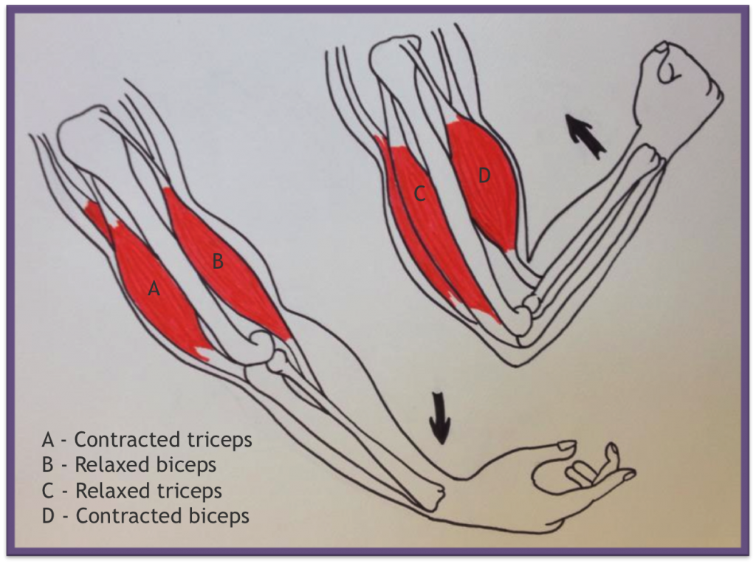
(pp. 601-604)
A. Muscles and Bones Work Together

1. Tendons:

2. Antagonistic pairs:

B. The Structure of a Muscle

1. Recall 27.2, 3 types of muscle tissue:

2. Skeletal muscle:

a. muscle fiber

b. actin & myosin

