
Name _____________________________
Regents Biology Unit 8a Chapter 27a The Human Organism: An Overview

27.1 Structure fits function in the human body.

A. Anatomy and Physiology
1. Anatomy

2. Physiology

B. Levels of Body Structure

Cell Tissue Organ Organ system Organism

- Cells

The human body is designed so that all cells can get what they need to survive and remove the waste that they create through metabolism.

Example: Gas Exchange (Chemical Exchange With the Surroundings and Cells)
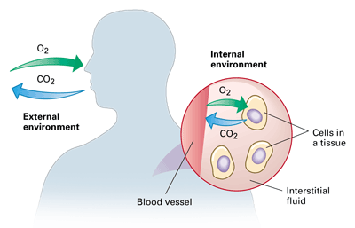

- Tissues (27.2) A tissue is a group of cells with the same structure and function.

A. Epithelial Tissue

B. Connective Tissue

C. Nervous Tissue

Neuron

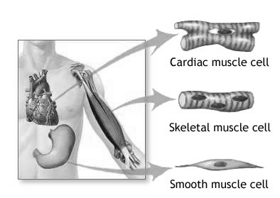
D. Muscle Tissue

- Skeletal:

- Cardiac:

iii. Smooth:

- Organ Systems (Humans have 12 Organ Systems)

Human Body Systems Matching - Below you will find a list of the organ systems found in the human body. Read the functions below and write the letter to correctly match the organ system with the correct function.

_________ Circulatory System _________ Nervous System
_________ Digestive System _________ Reproductive System
_________ Endocrine System _________ Respiratory System
_________ Integumentary System _________ Skeletal System
_________ Muscular System _________ Urinary System
_________ Lymphatic/Immune System

- A system that receives information from the environment, interprets the information and stimulates action all over the body. It helps to maintain homeostasis.

- A system that delivers important raw materials to the cells for metabolism and carries waste excreted from cells.

- A system responsible for creating haploid gametes.

- A system responsible for the gas exchange of oxygen and carbon dioxide.

- A system that filters the blood and creates and removes excreted waste from the body.

- A system that functions as structural support and protection for the body.

- A system that creates hormones and helps regulate homeostasis.

- A system that protects the inside of the body from disease causing pathogens.

- A system that houses and carries white blood cells for distribution throughout the body.

- A system that attaches to bones to create movement.

- A system that hydrolyzes large organic molecules into their building blocks.

27.3 The body regulates its internal environment.

- Homeostasis: goal of all living things

1. Two main body systems that work to maintain homeostasis:

a. Nervous System

b. Endocrine System

i. hormones

B. The Integumentary System … Important for Homeostasis

1. The Skin
Functions
a. b.

c. d.
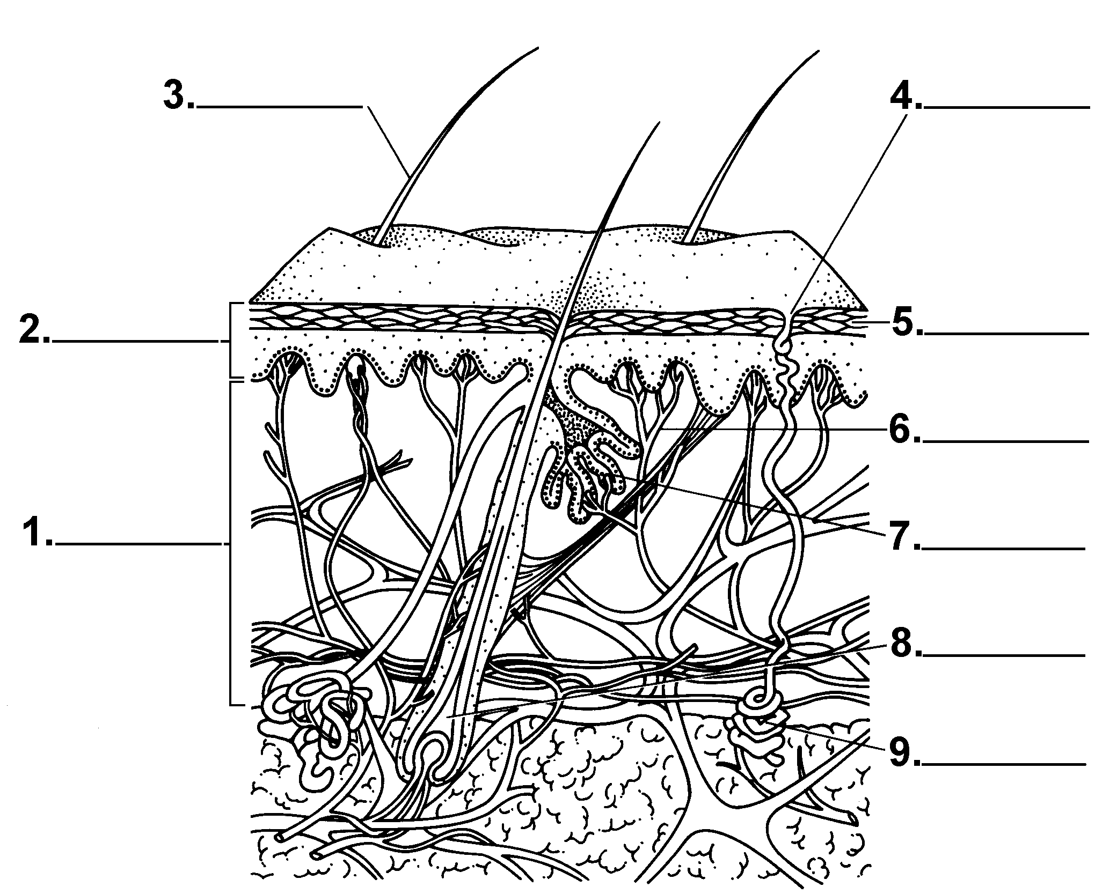

2. Hair & Nails

- Role in Homeostasis

The integumentary system works with other organs systems to help maintain homeostasis.

Read about the functions of skin below and fill in the blank with the correct organ system that the skin is working with to help maintain homeostasis.

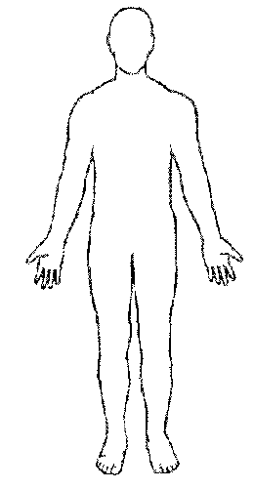
The skin makes vitamin D with sunshine, which helps prevent osteoporosis.

_____________________

Sensory receptors in the skin help you respond to external stimuli like hot and cold.

___________________
The skin acts as a barrier to prevent pathogens from entering.

_______________
Sweat helps to remove excess heat and metabolic wastes like urea.

____________________
Tiny blood vessels named capillaries are located very close to the skin surface to help in heat regulation. (Some medications can be delivered to the blood through skin patches).

_______________________

A. Introductory Notes on Disease and Homeostasis
Homeostasis: A stable internal environment.

Disruption of Homeostasis: Anything that prevents processes that are important to survival; called a disease or a disorder.

Causes of Disease

There are two broad categories of diseases (disorders), endogenous causes and exogenous causes.

1. Endogenous causes– Conditions that result from endogenous causes are also called inherited disorders or genetic diseases.

Endogenous causes are also called Inborn errors of metabolism
  - Introduced into the zygote by the chromosomes of the sperm and/or ovum.
  - May be an error in the number of chromosomes.
  - May be an error to the gene code that instructs the cell on how to produce a specific enzyme. The enzyme controls a biochemical reaction that is important to survival.
  - May be an error in the genes that control development, therefore a body part is malformed

Examples: Krabbes Disease, Diabetes, Dysfunctional Temporomandibular Joints (TMJ)

2. Exogenous causes of diseases and disorders - of external origin
  - Pathogens (organism invaders)
    - Consume body fluids and digest cells and tissues
    - The pathogens use the nutrients to do their own metabolism, and reproduce.
    - The more of the invading organism that are present, the greater the effect on the host.
    - May secrete waste products that are toxic and disrupt metabolism.
- Viruses
Examples: Common Cold, Viral Meningitis

- Bacteria
Examples: Gonorrhea, Salmonellosis

- Fungi
Examples: Athlete’s Foot, Candidiasis

d. Parasites
      - May be unicellular or multicellular
Examples: Amoebiasis, Giardiasis, Tapeworm

  - Toxins
    - Chemicals that come from the environment.
    - May be inhaled, ingested or cross the skin.
    - May be the waste products of a pathogen.
    - Alter the metabolism of the host, often preventing a vital process.
Examples: Lead Poisoning, Acquired Aplastic Anemia
  - Dietary
    - Nutrient intake is
      - too low.
      - too high
      - lacking in specific materials.
Examples: Cavities, Diabetes
  - Injury
    - Temporary or permanent damage to tissues and organs.

Disease and Homeostasis Name: ________________________________Per. ______

Activity

Causes of Disease Stations

Endogenous Causes:
- Inherited Disorders- Record the letter on the picture/object next to the appropriate disease.

Krabbe: _____________________. Down Syndrome: ______________________.

Exogenous Causes:
- Exposure to Toxins- Record the letter on the picture/object next to the appropriate disease.

Mesothelioma: _____________________. Lead poisoning: ____________________.

- Poor Nutrition- Record the letter on the picture/object next to the appropriate disease.

Scurvy: ______________________. Rickets: _________________________.

- Endogenous vs. Exogenous
- match the clues at the station their appropriate category.

Endogenous: __________________. Exogenous: _________________.

- Read about the 2 diseases. Record the letter on the picture/object next to the appropriate disease. Circle the appropriate cause(s) for each.

Skin cancer : _____________________. Lung cancer : __________________

Endogenous Pathogen Dietary Toxins Injury Endogenous Pathogen Dietary Toxins Injury

- Pathogens- Record the letter of the appropriate display material on the space below

a. Viruses: __________.

b. Bacteria: _________.

c. Fungi: ___________.

d. Parasites: ________.

- Read about Lyme Disease.
Which of the 6 causes of disease does Lyme disease fall under? (circle)

Endogenous Pathogen Dietary Toxins Injury

