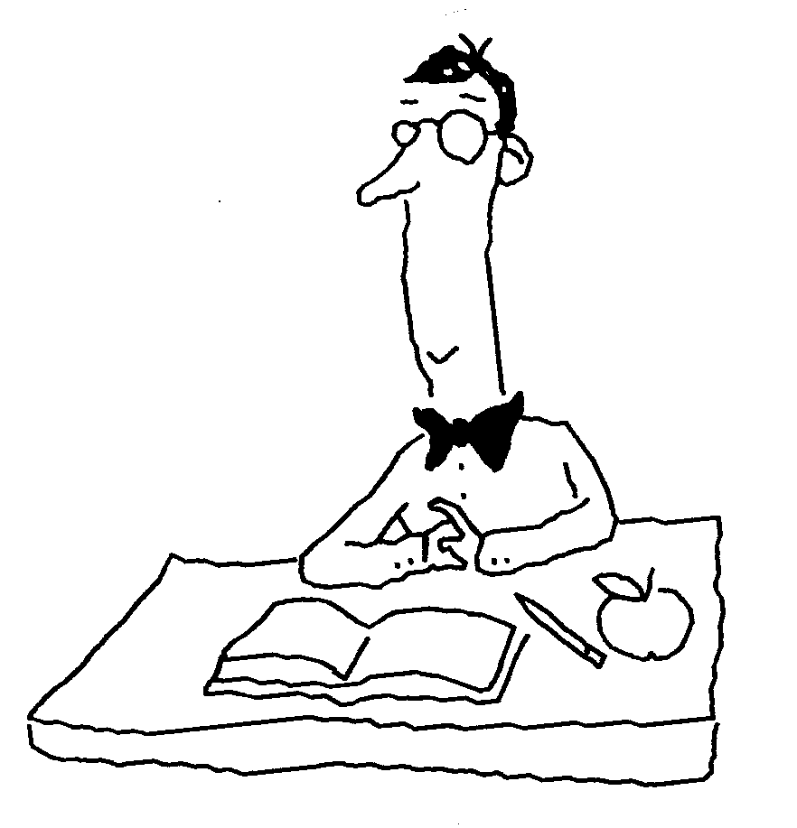
Regents Biology Name______________________________
Chapter 11 Notes Period______________

DNA and the Language of Life

11.2 Nucleic acids store information in their sequences of chemical units.

A. The Building Blocks of DNA
1. DNA

- Nucleotides

1. Three parts:

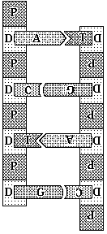

2. Four nitrogenous bases:

- DNA’s Structure

The Double Helix

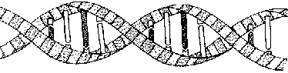
Complimentary Base Pairs

Hydrogen bonds

11.3 DNA replication is the molecular mechanism of inheritance.

A. Why does Replication Occur?
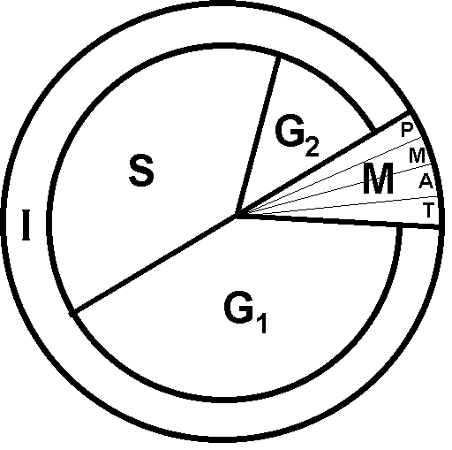

- In which part of the cell cycle does replication occur?

- Materials needed for Replication
1.

2.

3.

- The Steps of Replication: The Template Mechanism

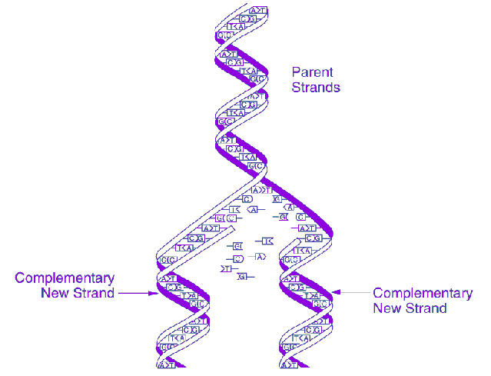

- The Results of Replication:

11.4 A gene provides the information for making a specific protein.
A. One Gene, One Polypeptide

B. Information Flow: DNA to RNA to Protein

Polypeptide
(amino acid sequence)
mRNA code
DNA code

Overview
1. DNA never leaves the __________________

2. Genes

Humans have _____ chromosomes and together they hold ____________genes.
- Polypeptide

- Protein

- 2 steps required in protein synthesis
Process | Where it occurs | What is produced
Transcription
Translation

RNA
- Stands for ___________________________________
- Three types:

c.

3. Comparing DNA & RNA:
 | DNA | RNA

Strandedness

Nitrogenous
bases

Sugar
Leaves the nucleus?

(Y or N)
Building Blocks?

11.5 There are two main steps from gene to protein.

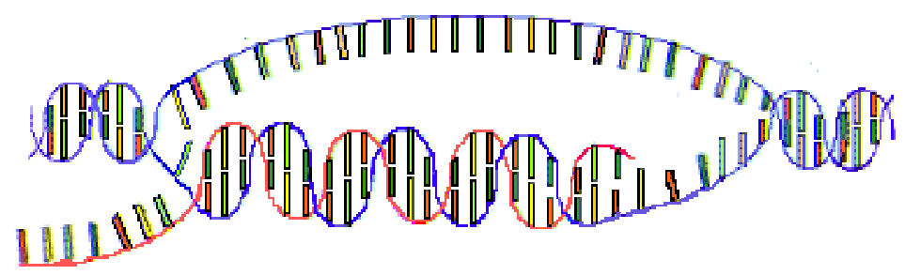
Transcription

Materials needed:

Step in the process of transcription:

Summary facts about transcription:
- Transcription occurs in the cell’s __________________.
- A molecule of _____________________ is made from the DNA.
- The DNA molecule acts as a __________ for organizing the RNA nucleotides.
- To make mRNA, the DNA first must un________, then un_____.
- Where do the nucleotides come from to build the mRNA?
- Where does the mRNA go after it is made?
- When the mRNA has been made, what happens to the DNA?

Translation

Materials needed:

Steps in the process:

Where does Translation occur?

codon (the triplet code)

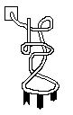
-tRNA

anti codon

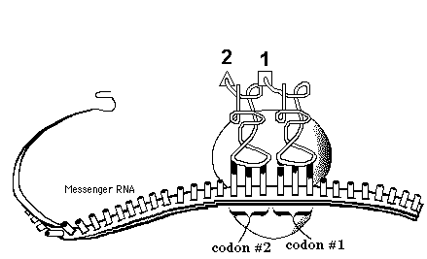

Review:

In which part(s) of the cell cycle is protein synthesis occurring?

  - Mutations can change the meaning of genes.
A. How Mutations Affect Genes
Mutation:

- Mutagens:

- Chromosomal mutations:

- Gene mutations:

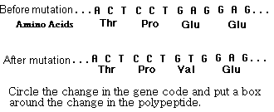
a. substitution

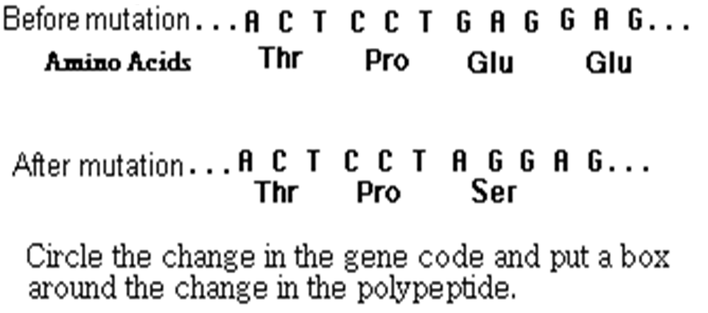
b. deletion

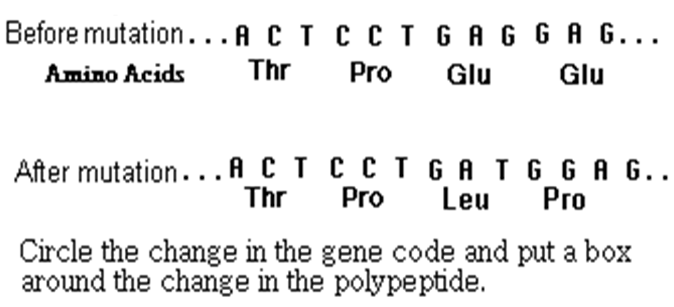
c. insertion

- Which type of gene mutations would have the most damaging effect on a gene?

- Where in the gene below would a mutation be most harmful?

1 2 3 4
ATT CGA TCA GGC ACT

B. When do Mutations Matter?

Codon BINGO

RNA  Codon  Table |  | 2nd B A S E
 |  | U | C | A | G
1st  B  A  S  E | U | UUU Phenylalanine  UUC Phenylalanine  UUA Leucine  UUG Leucine | UCU Serine  UCC Serine  UCA Serine  UCG Serine | UAU Tyrosine  UAC Tyrosine  UAA Stop  UAG Stop | UGU Cysteine  UGC Cysteine  UGA (Stop)  UGG Tryptophan
1st  B  A  S  E | C | CUU Leucine  CUC Leucine  CUA Leucine  CUG Leucine | CCU Proline  CCC Proline  CCA Proline  CCG Proline | CAU Histidine  CAC Histidine  CAA Glutamine  CAG Glutamine | CGU Arginine  CGC Arginine  CGA Arginine  CGG Arginine
1st  B  A  S  E | A | AUU Isoleucine  AUC Isoleucine  AUA Isoleucine  AUG Methionine, Start | ACU Threonine  ACC Threonine  ACA Threonine  ACG Threonine | AAU Asparagine  AAC Asparagine  AAA Lysine  AAG Lysine | AGU Serine  AGC Serine  AGA Arginine  AGG Arginine
1st  B  A  S  E | G | GUU Valine  GUC Valine  GUA Valine  GUG Valine | GCU Alanine  GCC Alanine  GCA Alanine  GCG Alanine | GAU Aspartic acid  GAC Aspartic acid  GAA Glutamic acid  GAG Glutamic acid | GGU Glycine  GGC Glycine  GGA Glycine  GGG Glycine

