Notes Name____________________________________
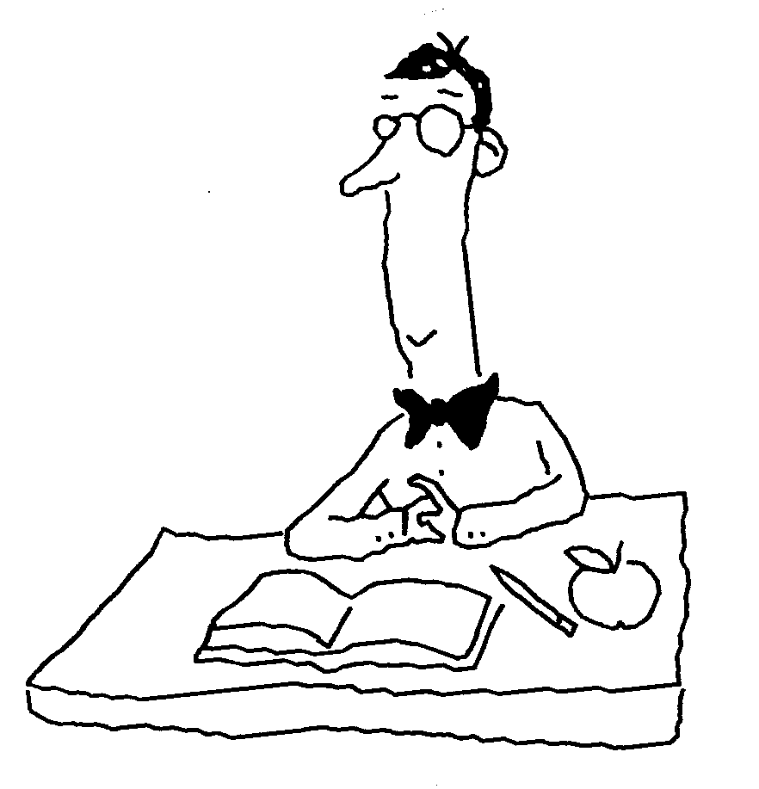
Unit 5/Chapter 10: Patterns of Inheritance Exam Date __________________

10.1 Genetics developed from curiosity about inheritance.

Genetics

Trait

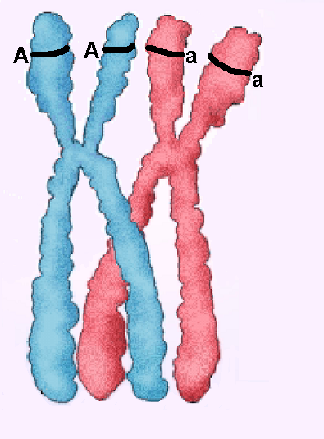
10.2 Mendel discovered that inheritance follows rules of chance.

Allele

●

●

●

a. dominant allele

b. recessive allele

Genotype

●

●

●

a. homozygous dominant

b. homozygous recessive

c. heterozygous

carrier

●

●

Phenotype

Amylase Production
Genotype vs. Phenotype

Key to some Human Traits

 | Description of the Alleles  for Each Gene | Locate each gene using the Human Chromosome Map and write the chromosome number in the space below. | Question about Each Gene
A | R - This gene codes to make a chemical on the surface of red blood cells. If you make this chemical then you are Rh+.  r - The code of the gene does not make the chemical so the person is Rh-. | The gene for the Rh protein.  __________ | If someone is heterozygous for this gene, what would their gene make-up be? _______  What blood type would they have?  Rh + or Rh-
B | A - This gene has the instructions for how to make the enzyme amylase. Amylase helps to digest starch in your mouth and small intestine.  a - The code is altered so that amylase is not produced. | The amylase gene  __________ | What does amylase do?  In what tissue would this gene be turned on?
C | C - This normal gene codes for how to make the protein CFTCR, which is necessary for normal movement of chloride ions into and out of cells.  c - The recessive version of the gene has the incorrect code for how to make CFTCR.  Improper balance of chloride ions results in a condition known as Cystic Fibrosis. | The gene for cystic fibrosis  __________ | If someone received a C from one parent and c from the other, would they suffer from the symptoms of cystic fibrosis?
D | P - this gene is the DNA code for how to make the enzyme phenylalanine hydroxylase.  p - This altered form of the gene fails to code for the proper structure of the enzyme.  Inability to produce phenylalanine hydroxylase result in a serious condition called PKU | The gene for PKU  __________ | If someone has PKU, what gene make-up (genotype) do they have?  ________
E | T - The gene code for how to synthesize trypsin, a digestive enzyme that hydrolyzes proteins.  t - The incorrect code for the synthesis of trypsin. | The Trypsin gene  __________ | Since you are able to make trypsin and digest proteins properly, what genotype(s) (gene make-up) might you have for this gene?  TT Tt tt

Modified 4/13/2006

The Importance of Environment

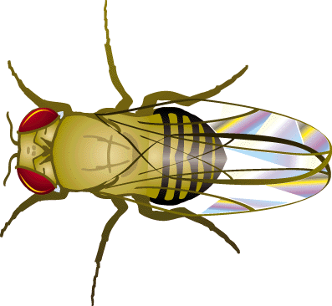
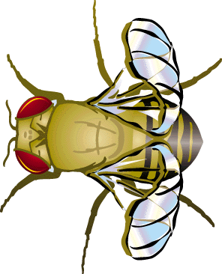
a. Wings of Fruit Flies:

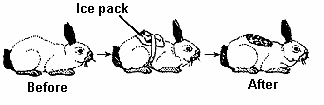
b. Himalayan hares

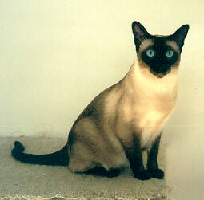
c. Siamese Cats

d. PKU

  - There are many variations of inheritance patterns

Multiple Alleles

The gene controlling the A, B, AB, O characteristic is located on chromosome 9 and the letter “I” is used to represent it. Gene I occurs in three alleles (versions): I^{A}, I^{B} and i. The protein produced by gene I attaches to a protein in the cell membrane of red blood cells (erythrocytes).

I^{A} – a DNA sequence that results in an A-type protein. The protein becomes fastened into the membrane of red blood cells.

I^{B} – a DNA sequence that results in a B-type protein in the membrane of rbcs.

i – a DNA sequence which results in neither A-type protein nor B-type protein in the membrane of rbcs.

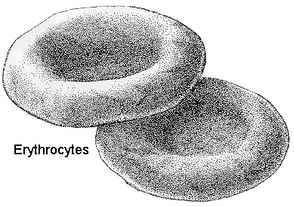
cytoplasm
The membrane has a variety of embedded proteins.

The Molecular Explanation of the Four ABO Blood Types
A
A
A
A
A
A
A membrane with the “A” type protein.
B
B
B
B

A membrane with the both “A” & “B” type proteins.
A membrane with neither the “A” nor “B” type proteins.
B
A membrane with the “B” type protein.
B
B
A
B
A
A
B

Since genes occur in pairs, the different blood types are the results of different combination of genes.

Genotypes that Result in Various Blood Types
Blood Type A | Blood Type B | Blood Type AB | Blood Type O
I^{A}I^{A} | I^{B}I^{B} | I^{A}I^{B} | ii
I^{A}  I^{A} | I^{B}  I^{B} | I^{A}  I^{B} | i  i
I^{A}i | I^{B}i
i  I^{A} | i  I^{B}

Problems:
1. If your blood type is type A and your mom’s blood type is O, what are the possible blood types of your dad?

2. Susan has blood type O and James has blood type AB. What are the possible blood types of their children?

3. John was adopted at an early age. When he was 8 years old, a man named Arthur claimed he was John’s biological father. Birth records show that John’s birth mother has type B blood and that John has type O. Arthur is type A. Comment on the likelihood that John is Arthur’s son.

10.5 Sex-linked traits have unique inheritance patterns.

A. Sex-linked Traits

- hemophilia

Example: Normal Father Normal Mother (carrier) = phenotype
X^{R}Y x X^{R}X^{r} ⁼ genotype

Example: Hemophiliac Father Normal Mother = phenotype
X^{r}Y x X^{R}X^{R} ⁼ genotype

- color blindness

Example: Normal Father Normal Mother (carrier) = phenotype
X^{N}Y x X^{N}X^{n} ⁼ genotype

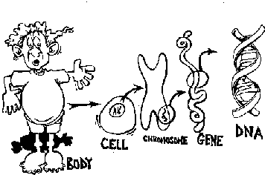
What does this picture mean?

PTC
Phenylthiocarbamide

The surface of your tongue has many taste buds embedded into it. Each taste bud has a variety of receptor molecules on its surface; each receptor molecule has a special shape which allows it to join with certain chemicals in your food. If a food molecule fits into a receptor it will trigger a neuron to carry a message to the brain where you will experience the sensation of taste.

Some people have receptor molecules for PTC; others don't. If you have the receptor molecule then you will be able to taste PTC.

The instructions for making the PTC taste receptors are found on one of the autosomes. You received one copy of that chromosome from your mother and another copy from your father. To determine if you have a copy of the instructions for making the PTC receptor taste the small piece of paper that your teacher gave you; put it in your mouth and get it wet with saliva.

I am a taster / non-taster of PTC. (circle one)
The gene for taster is represented by T and the gene for non taster is represented by t.

Since everyone has gotten two copies of each gene you might be TT, Tt or tt.
Label the homologous pair that represents a non-taster.

A person is a nontaster, does that mean their parents must be non-tasters? Explain.

A person is a nontaster, does that mean that their siblings must be non-tasters? Explain.

Food preferences: In the genes

If you dislike broccoli, don't be surprised if your child says yuck to it -- even if you keep your opinion to yourself. Recent research has found that genetic factors influence your preference for this vegetable, as well as for orange juice, cottage cheese, chicken, and hamburger. And there are probably many more such food preference links, says Grace A. Falciglia, Ph.D., professor of nutrition at the University of Cincinnati and director of the study. For broccoli, food scientists have fingered an inherited sensitivity to a bitter-tasting chemical found naturally in the vegetable. But even if you have a "sensitive" child, keep serving these foods, urges Dr. Falciglia. Just as many grown-ups develop a taste for the sourness of grapefruit or bitterness of arrugula, "the more kids at least try foods, the more likely they will grow to like them."

Pedigree charts show the phenotype of genetic traits and how they are expressed in a family from one generation to the next. The pedigree can help predict the genotype of each person for a certain trait.

Introductory Information:
- In a pedigree chart, generations are represented by Roman numerals. Each person in each generation is numbered with an Arabic numeral.
- Males are represented by a square and females by a circle.
- A horizontal line connecting a male and a female is called a mating line.
- Vertical lines represents children
- Children on the vertical line are always placed from left to right, with the child on the left being the oldest.
- Examine figure A below. Answer the questions that follow.

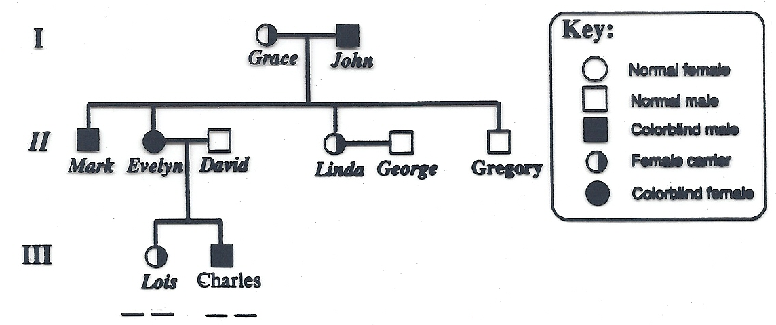
Figure A
1
2

3
2
1
5
6
4

2
1

- Which assumption about generation I is true?
  - John had one gene for colorblindness.
  - John had two genes for colorblindness.
  - Grace carried two genes for colorblindness.
  - Grace was colorblind.

- If Linda and George have a son, wht is the probability that it will be colorblind?

- What are the genotypes of Lois and Charles?

Pedigree Worksheet (Extra Credit) Name_________________________________
Period _____ Date_____________

Introduction to Pedigrees: Pedigrees are family charts that help us to determine how a specific trait affects those that are related.

To determine the genotype of an individual be sure to consider the person’s phenotype and whatever information you can deduce by looking at the phenotypes of the person’s parents and / or children.

Multiple Alleles: In class we learned about blood types. Blood types are controlled by three genes I^{A}, I^{B} and i. A combination of these genes is a genotype. Below is a pedigree of a family. List all the possible genotypes for each of the lettered members.

Genotypes:

a__________
b__________
c__________
d__________
e__________
f__________

a
O
b
c
d
e
f
O
O

A

A
B
B
AB

B

Sex Linked Traits refer to genes that are carried on the X chromosome. In this case if a male inherits one of the faulty genes he will have the condition or disease. Consider the pedigree chart below for colorblindness. Indicate the genotypes in the box to the right for the lettered individuals. Shaded symbols indicate individuals who are colorblind.

Genotypes:

a__________
b__________
c__________
d__________
e__________
f__________

a
b

c

d
e
f

Name: ____________________________________________ Per. ______
Ch. 10 - Genetics Problems

- In humans, brown eyes, B, are dominant to light eyes, b. The parents of a light-eyed man were both brown-eyed. He marries a brown-eyed woman whose father was brown-eyed and whose mother was light-eyed. They have one child who is light-eyed. What are the most probable genotypes of the individuals mentioned?

- Suppose that in outer space there exists creatures in which purple eyes, P, are dominant to yellow eyes, p. Two purple-eyed creatures mate and produce six offspring. Four of them have purple eyes and two have yellow eyes. What are the genotypes of the parents?

- A woman homozygous for type B blood marries a man who is heterozygous type A. What will be the possible genotypes and phenotypes of their children?

- A man with type O blood marries a woman with type AB blood. What will be the possible genotypes and phenotypes of their children?

- A couple has a child with type A blood. If one parent is type O, what are the possible genotypes of the other parent?

- A woman who is heterozygous for hemophilia marries a normal man. What will be the possible genotypes and phenotypes of their children?

- A woman who is a carrier for hemophilia marries a man with hemophilia. What will be their children’s possible phenotypes?

- A phenotypically normal woman has phenotypically normal parents. However, she has a hemophiliac brother. What are her chances of being a carrier for hemophilia? If she is a carrier and marries a normal male, what is the chance of their child having hemophilia?

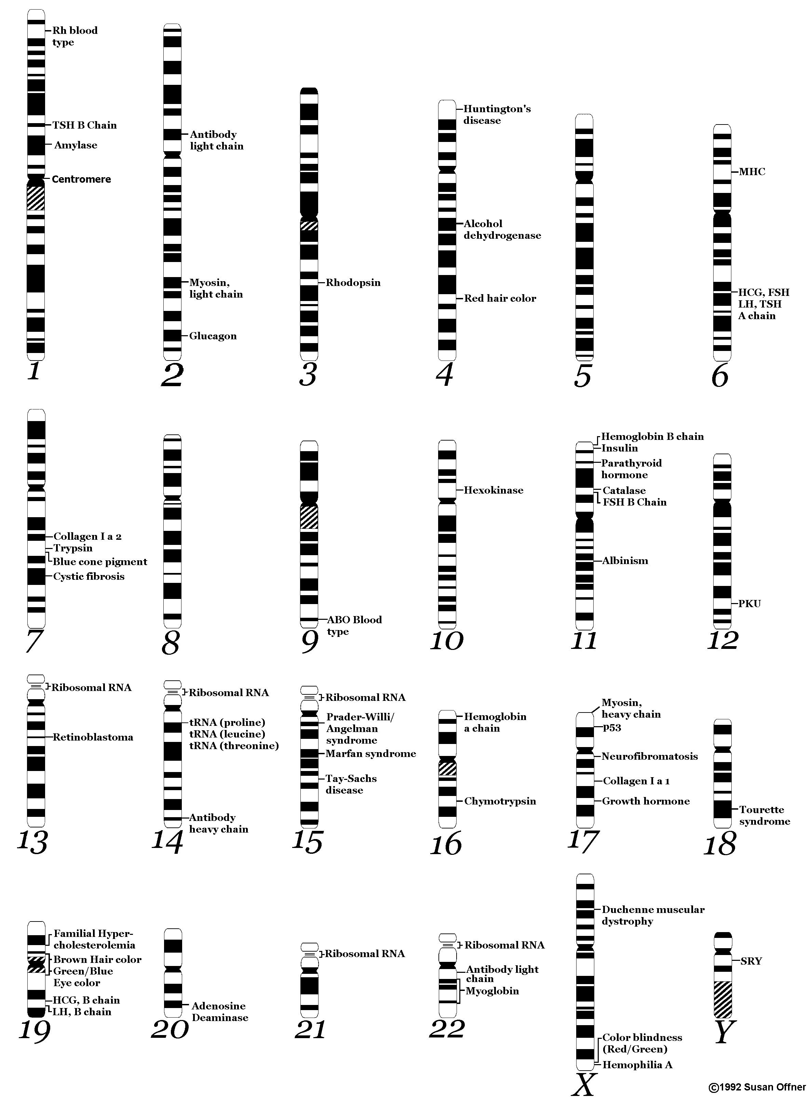
Human Chromosome Map

