
Regents Biology Name__________________________
Chapter 5 The Molecules of Life Date_______ Per_______

5.1 Carbon is the main ingredient of organic molecules.
- Organic vs. Inorganic

  - organic

  - inorganic

B. Carbon
1. Symbolic representation: C

2. Examples:

a. Carbon-Carbon single bonds:

b. Carbon-Carbon double bonds:

c. Carbon-Carbon triple bonds:

3. Carbon atoms bond to other carbon atoms to form
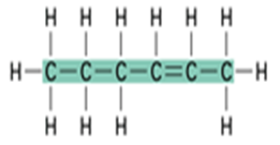
a. Chains

b. Rings
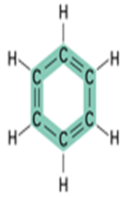

C. Monomers & Polymers

mono-

di-

poly-

mer-

monomer =

dimer =

polymer =

5.2 Carbohydrates provide fuel and building material.

-sugars (monomers and dimers)

-starches (polymers)

- Biological Importance:

- Composed of the following elements:

- monosaccharides (simple sugars)

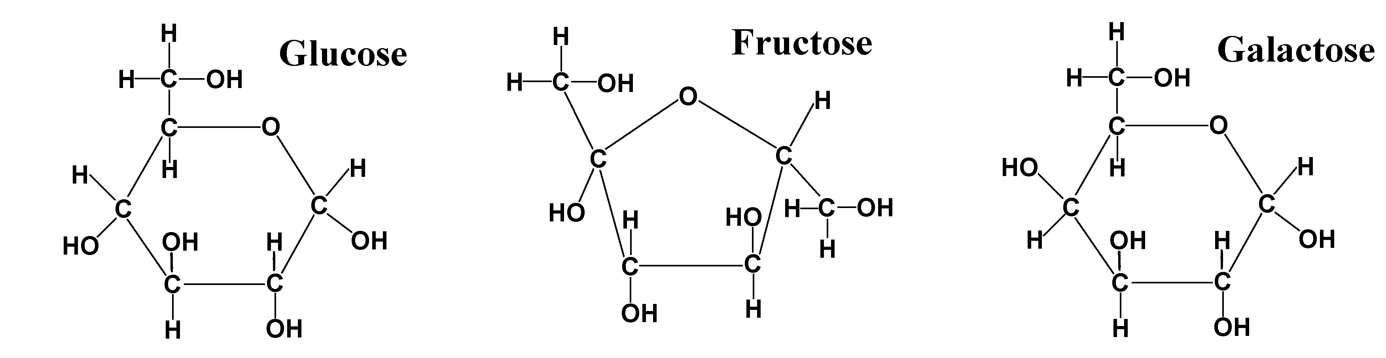

- disaccharides (double sugars)

maltose (glucose + glucose)
sucrose (glucose + fructose)
lactose (glucose + galactose)
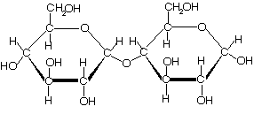

E. polysaccaharides (polymers of sugar molecules)

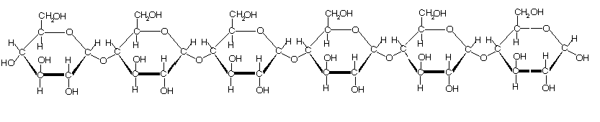

a. starch c. cellulose

b. glycogen d. chitin

F. Dehydration Synthesis:

Word equations:
monosaccharide + monosaccharide ---> disaccharide + H₂O
glucose + glucose ---> maltose + H₂O

Molecular formula equation:

C₆H₁₂O₆ + C₆H₁₂O₆ ---> C₁₂H₂₂O₁₁ + H₂O

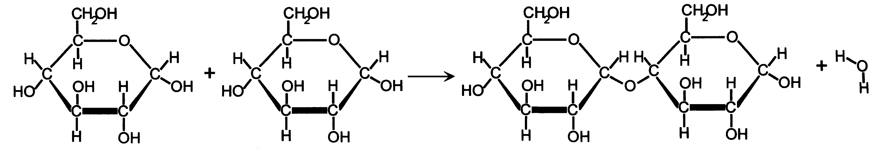

- Hydrolysis:

Word equations:

Disaccharide + H₂O ----> 2 monosaccharide
Maltose + H₂O ----> glucose + glucose

Molecular formula equation:

C₁₂H₂₂O₁₁ + H₂O ---> 2C₆H₁₂O₆

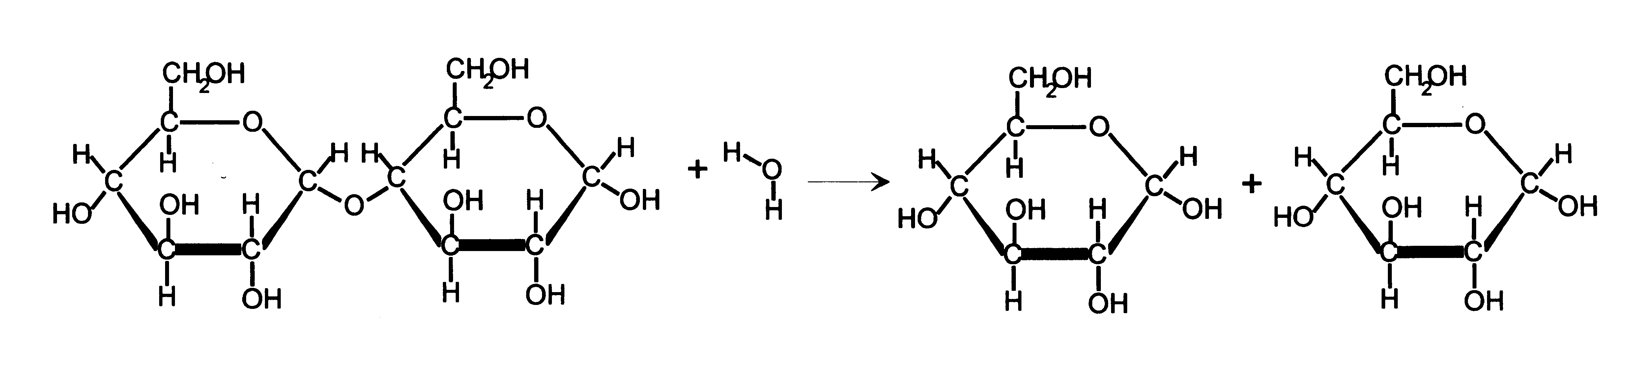

5.3 Lipids include fats and steroids.

- Biological importance:
  - Fats

  - Steroids

- Composed of the following elements:
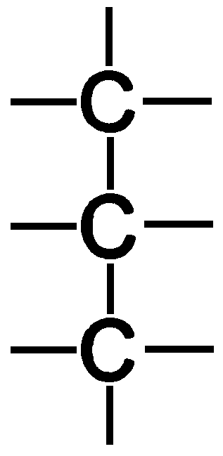
- Building blocks of Lipids:
a. Glycerol (Complete the molecule at right.)

b. Fatty Acids
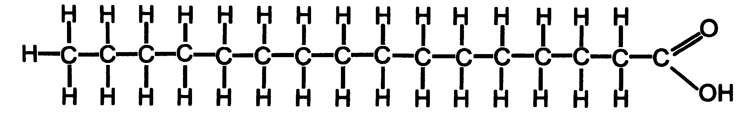

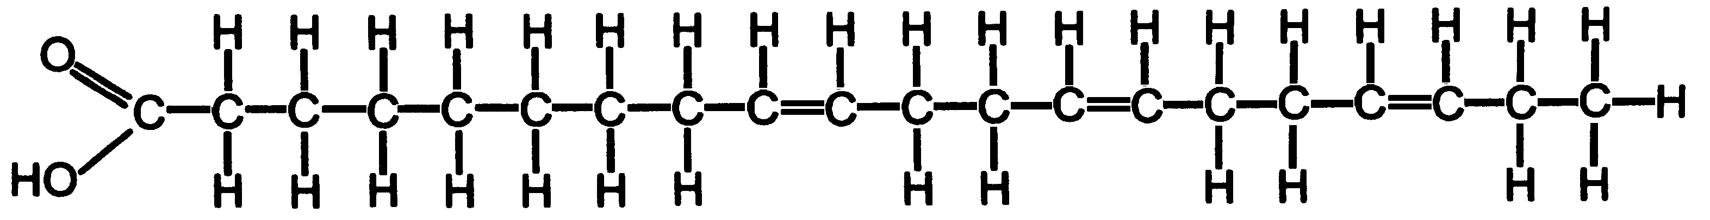

D. Lipid Synthesis
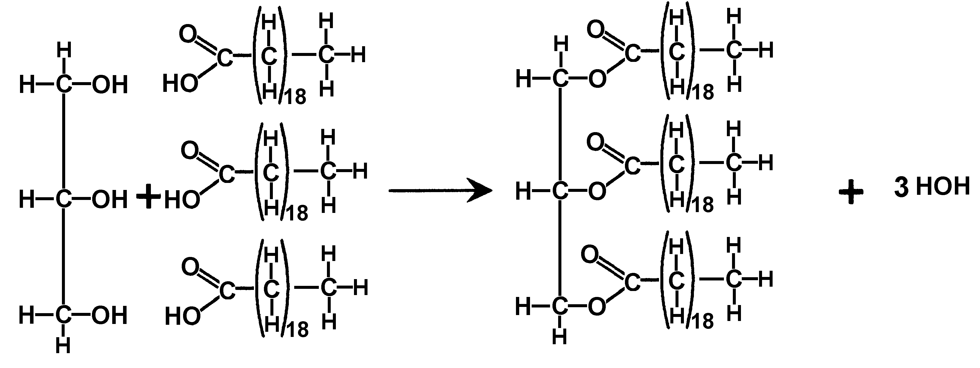

5.4 Proteins perform most functions in cells.

A. Biological Importance
-structural
-pigments
-hormones
-contraction
-antibodies
-enzymes
-cell surfaces

B. Composed of the following elements:

C. Amino Acids

Two amino acids bonded together make up a ____________________

Many amino acids bonded together make up a _____________________

1 or more polypeptide chains twisted together make up a _____________

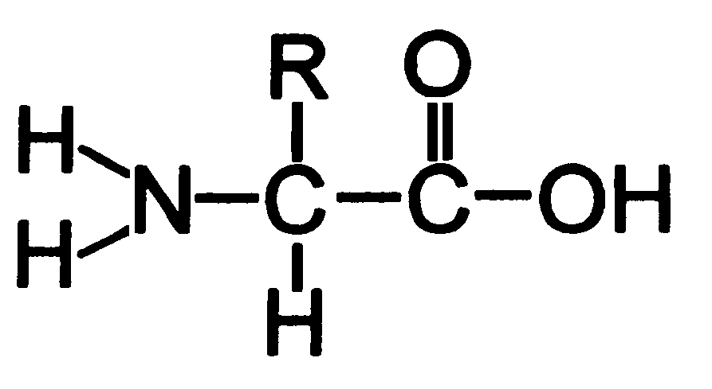

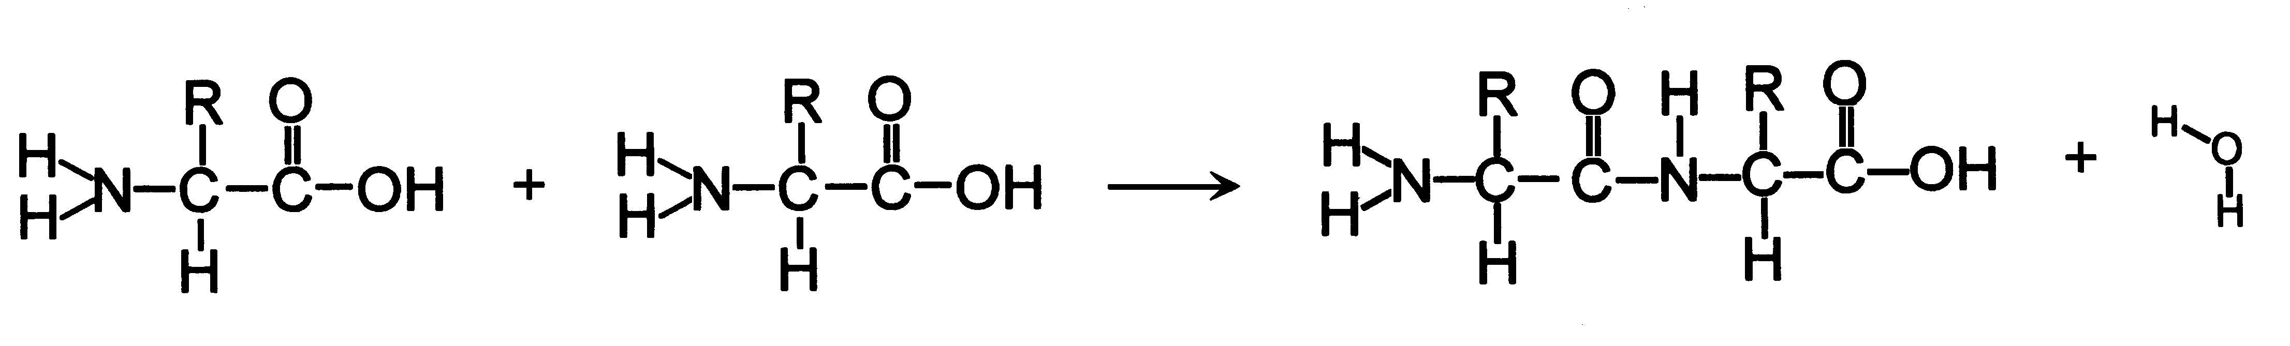

Name this process: ___________________________________

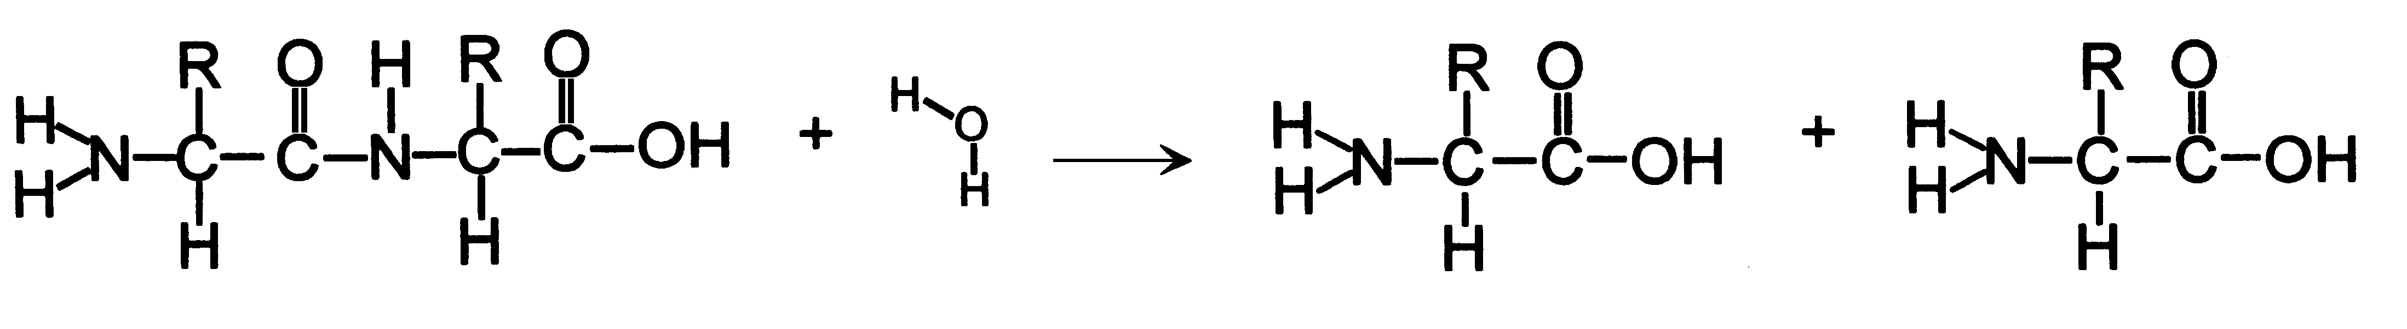

Name this process: ___________________________________

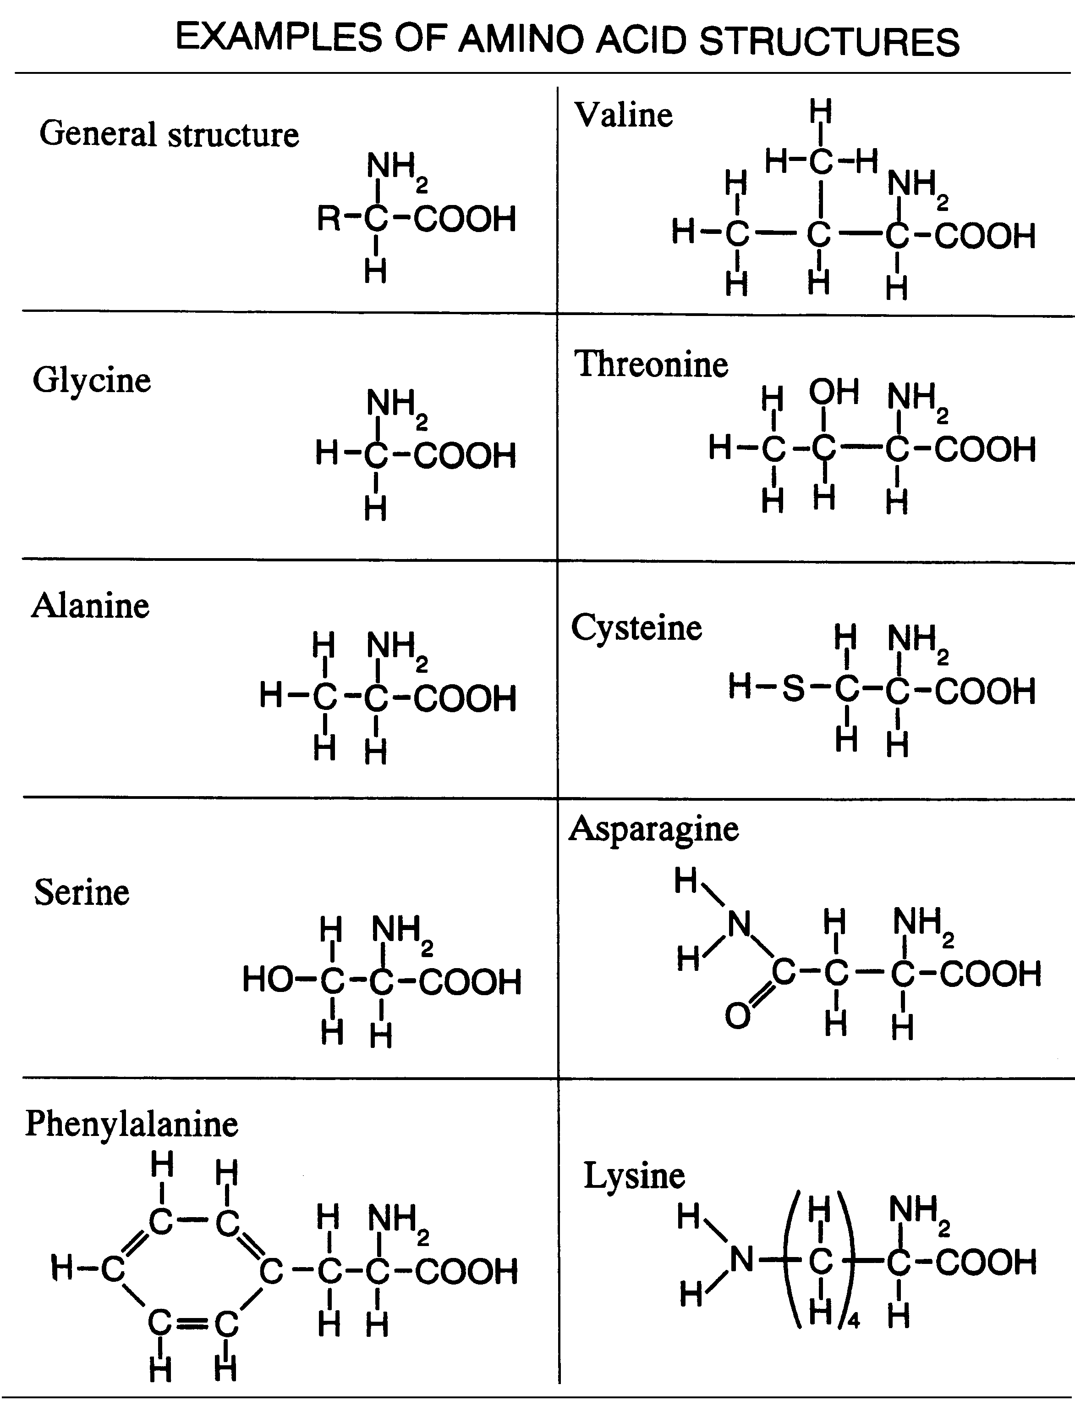

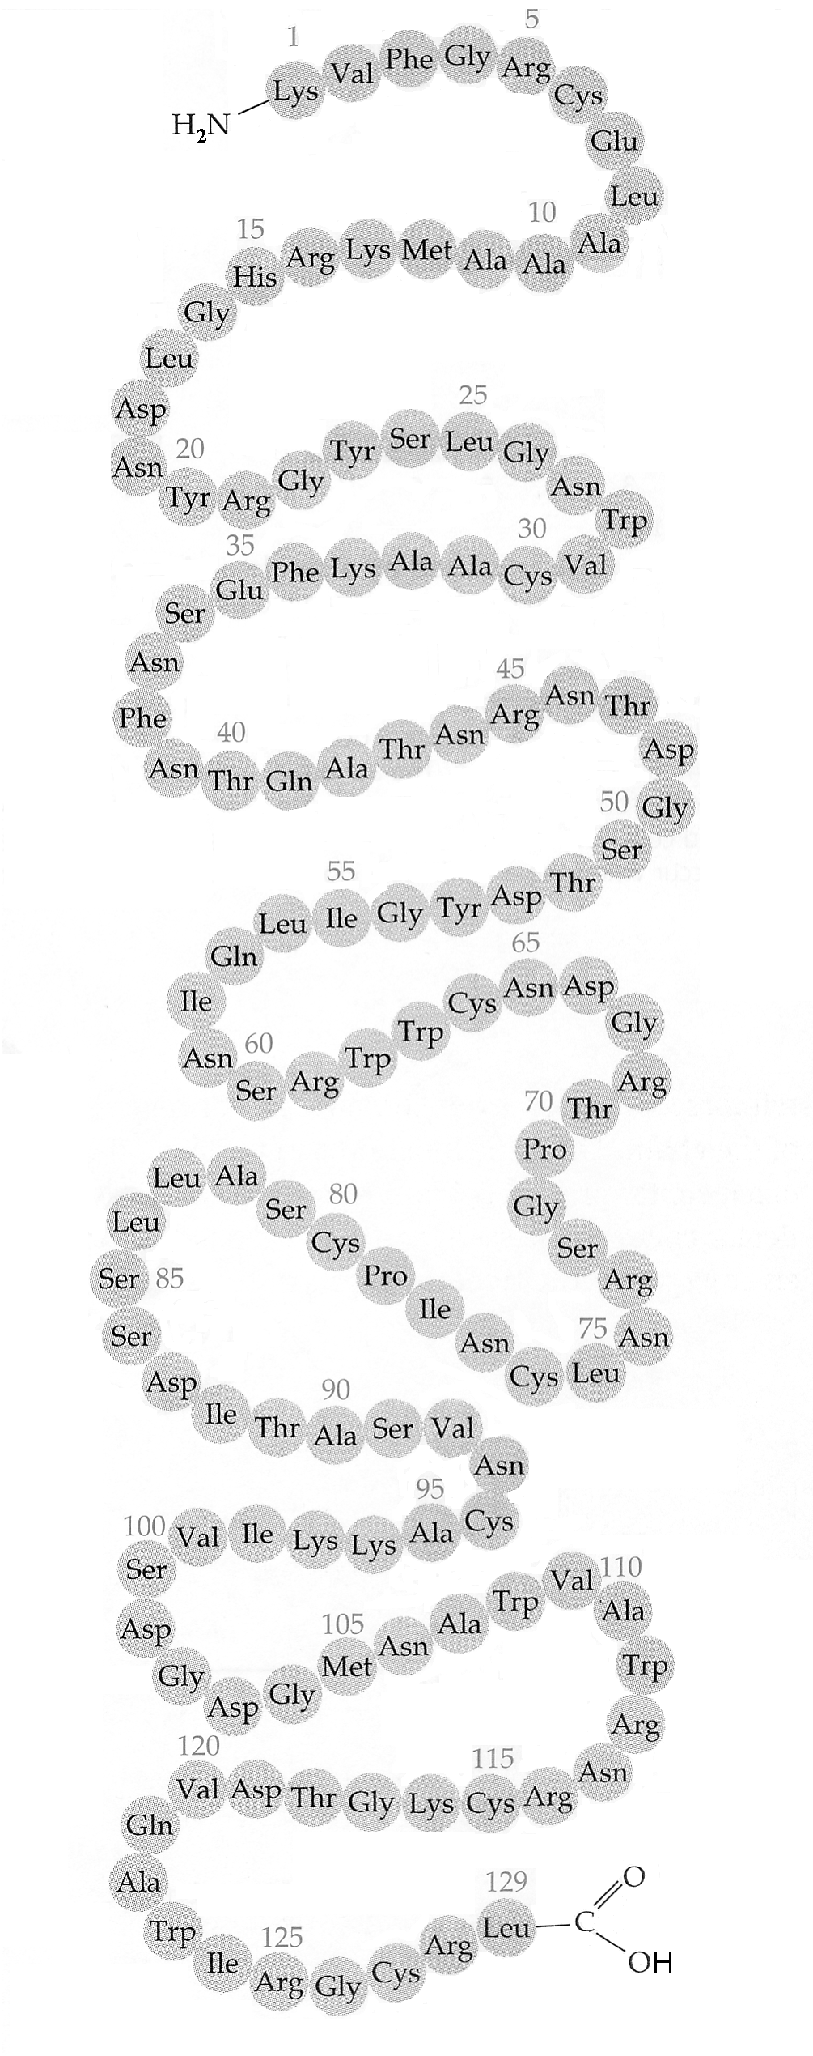
D. Building a Protein

Proteins are long chains of amino acids (POLYPEPTIDES).
They are coiled and folded into a specific shape.
(Shape determines function)
Amino Acid Table #1
Reference Table of Amino Acids
Name | Abbreviation
Alanine | Ala
Arginine | Arg
Asparagine | Asn
Aspartic acid | Asp
Cysteine | Cys
Glutamic acid | Glu
Glutamine | Gln
Glycine | Gly
Histidine | His
Isoleucine | Iso
Leucine | Leu
Lysine | Lys
Methionine | Met
Phenylalanine | Phe
Proline | Pro
Serine | Ser
Threonine | Thr
Tryptophan | Trp
Tyrosine | Tyr
Valine | Val

1. How do these amino acids differ from one another?

2. The protein at the right is an enzyme (called Lysozyme), found in tears; it consists of how many amino acids in one polypeptide chain. _________

3. What group is found to the left of the first amino acids?

4. What group is found to the right of the last amino acid?

5. What are the bonds between the amino acids called?

Lysozyme binds to bacteria and breaks down their walls, killing the bacteria.

The molecule at the right is insulin, an important hormone in all mammals.
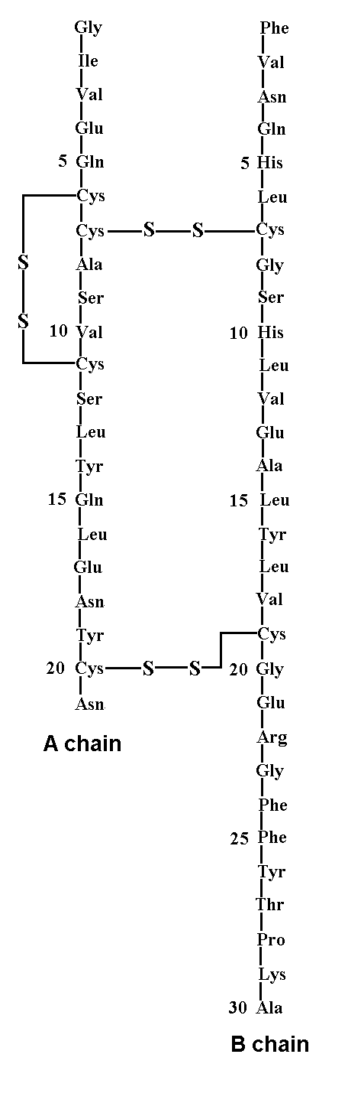

How many polypeptide chains make up one molecule of insulin? ___________

Amino Acid Table #2
Comparison of Insulin Molecules
Species | Amino Acid Position
Species | A-8 | A-10 | A-18 | B-30
porcine (pork), dog | Thr | Ile | Asn | Ala
human | Thr | Ile | Asn | Thr
cat | Ala | Val | His | Ala
bovine (beef) | Ala | Val | Asn | Ala

1. The insulin molecule at right is from which organism? (Use the table above.)

______________________

2. There are small vertical lines between each of the amino acids. What do these lines represent?

______________________

3. How many total amino acids in one molecule of insulin?

______________________

4. Compare the molecules on this and the previous page.

What are the three ways that proteins molecules can differ from one another.

Insulin is a hormone that regulates how much sugar is in

your blood.

The diagram at right shows how one molecule of hemoglobin is constructed.
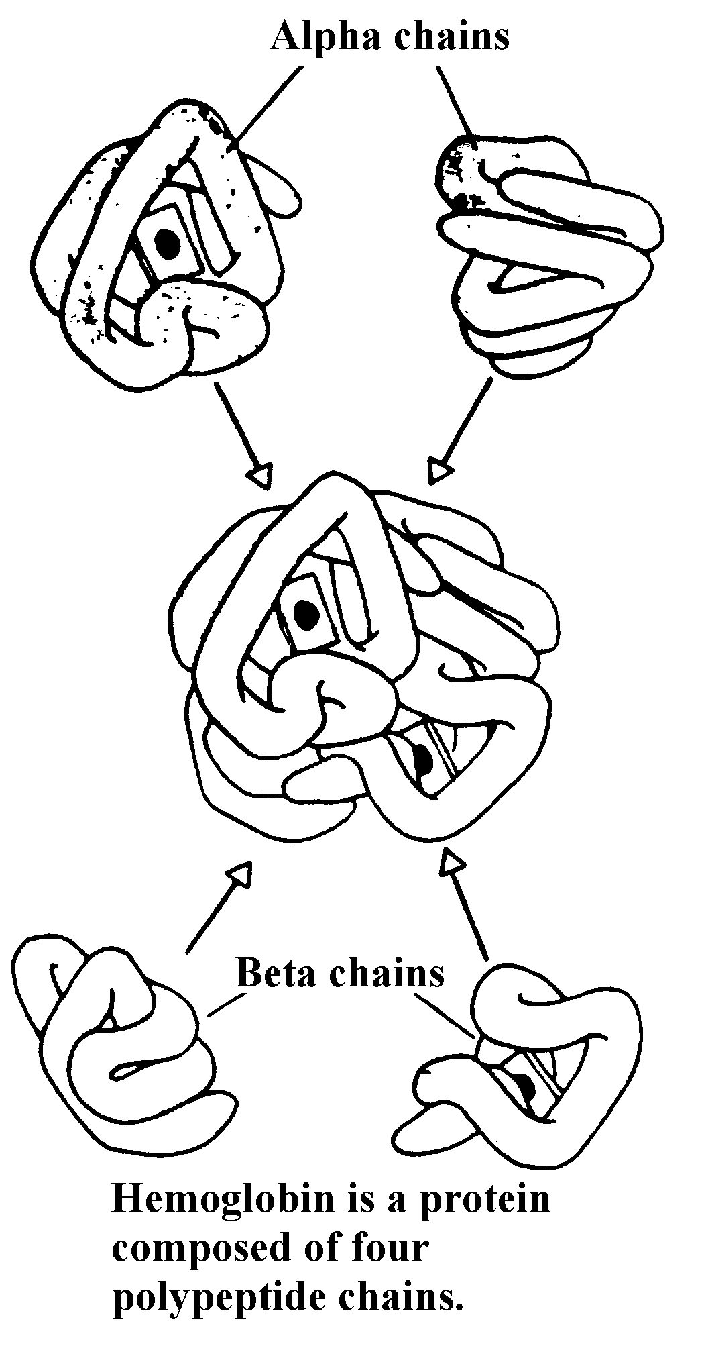

Each molecule of hemoglobin is composed of four polypeptide chains.

Each alpha chain consists of 140 amino acids

Each Beta chain consist of 146 amino acids.

How many amino acids in one molecule of hemoglobin?

Hemoglobin carries oxygen in your blood and is responsible for

the red color of blood.

Protein molecules have shape because they are coiled and folded.

Their shape determines their function.

5.5 Enzymes are proteins that speed up specific reactions in cells.

- Enzymes and Activation Energy

1. activation energy

2. catalysts

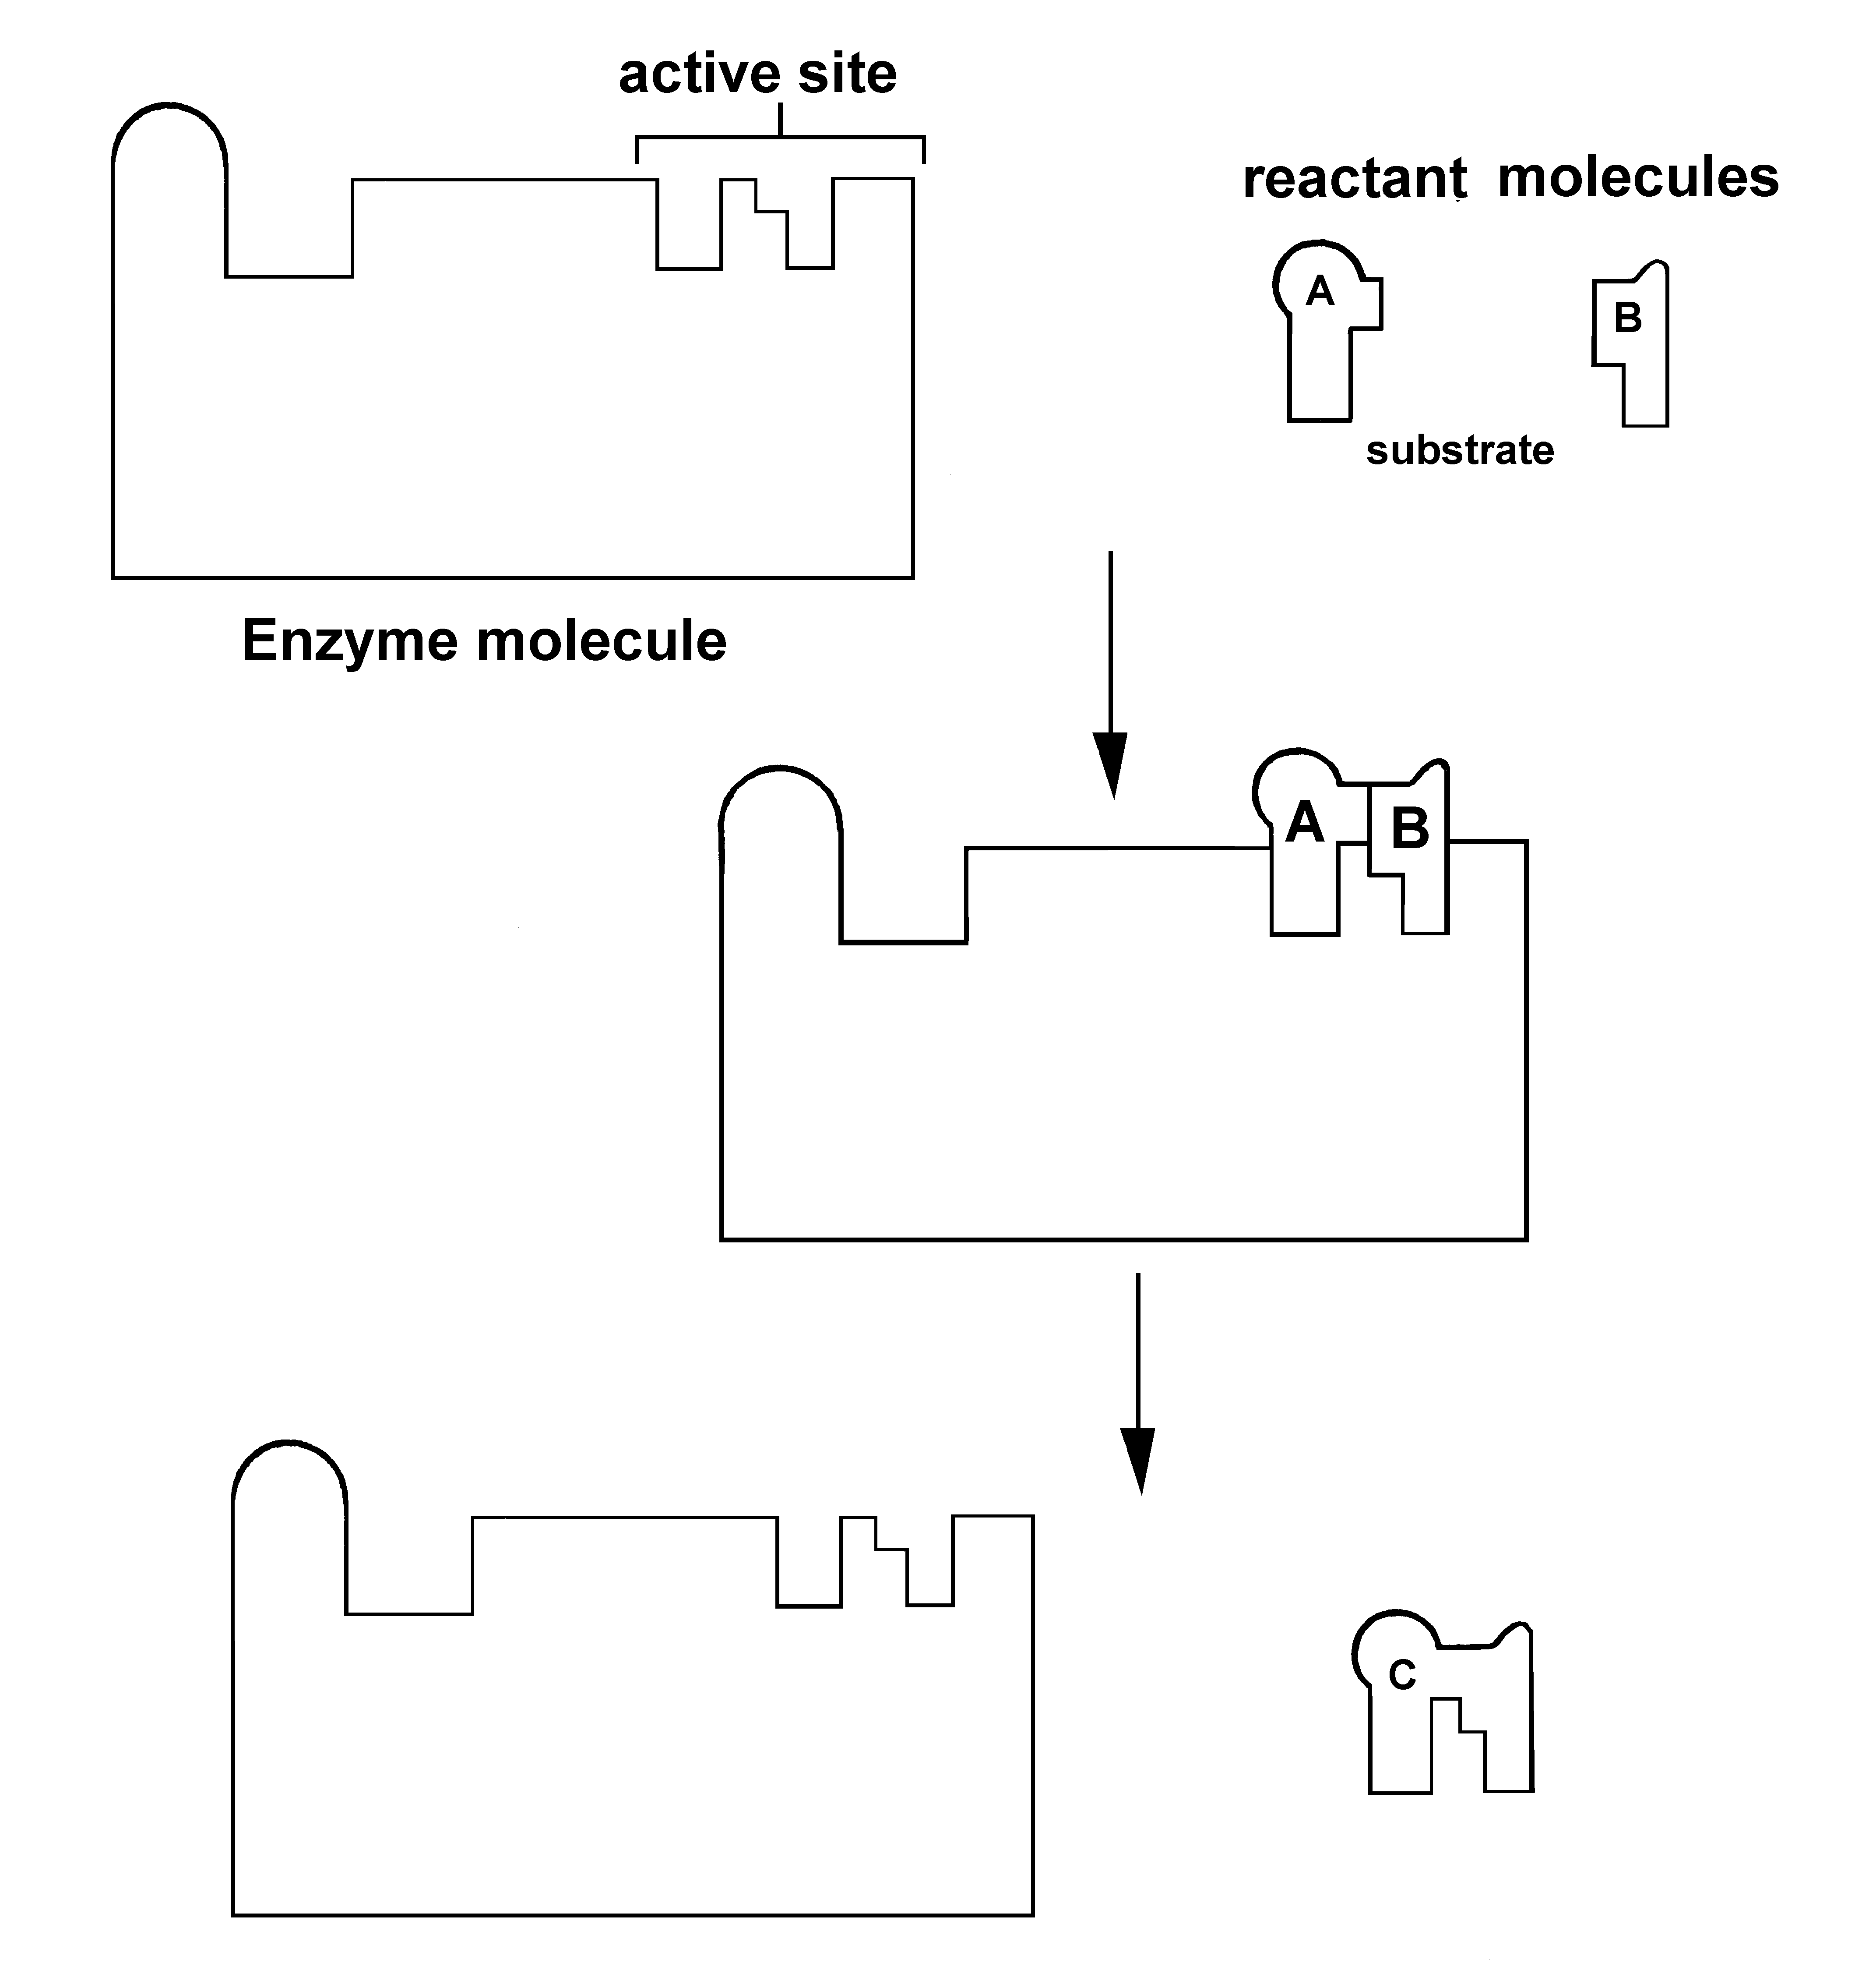
- How Enzymes Work

Name all of the Parts:

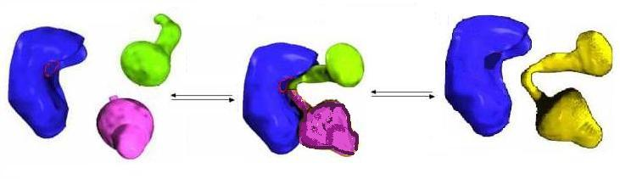

The Lock and Key Hypothesis:

The Naming of Enzymes:

- Factors that effect the rate of enzyme action:

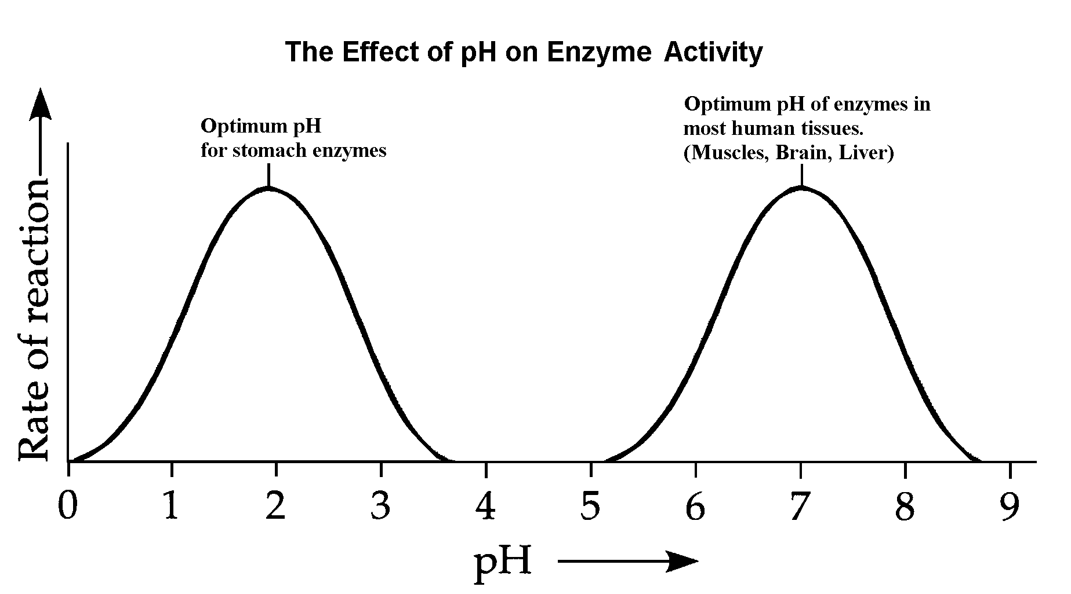
1. pH

Optimum pH:

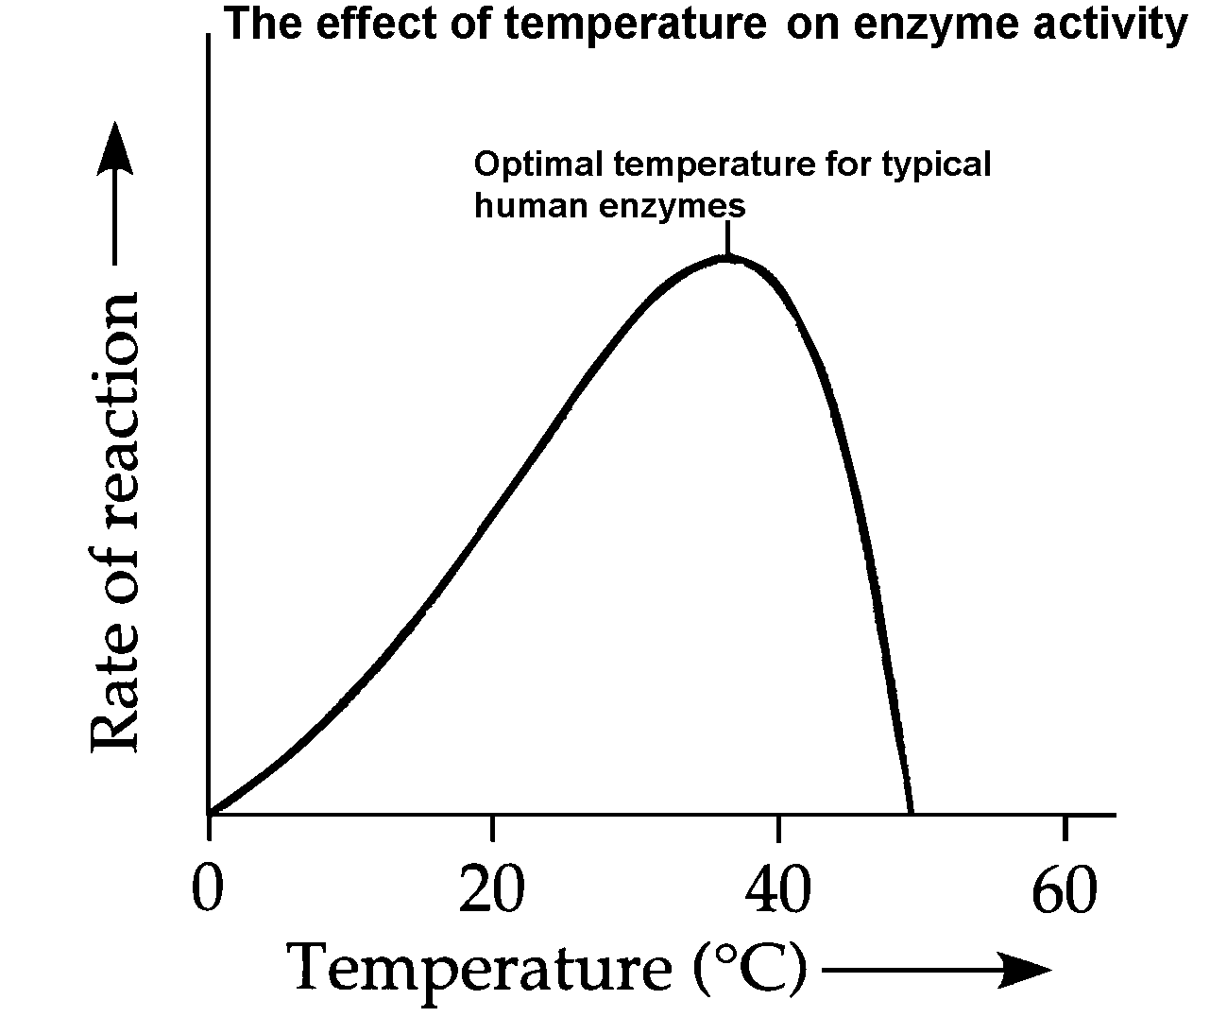
2. Temperature

Optimum temperature:

Denaturation

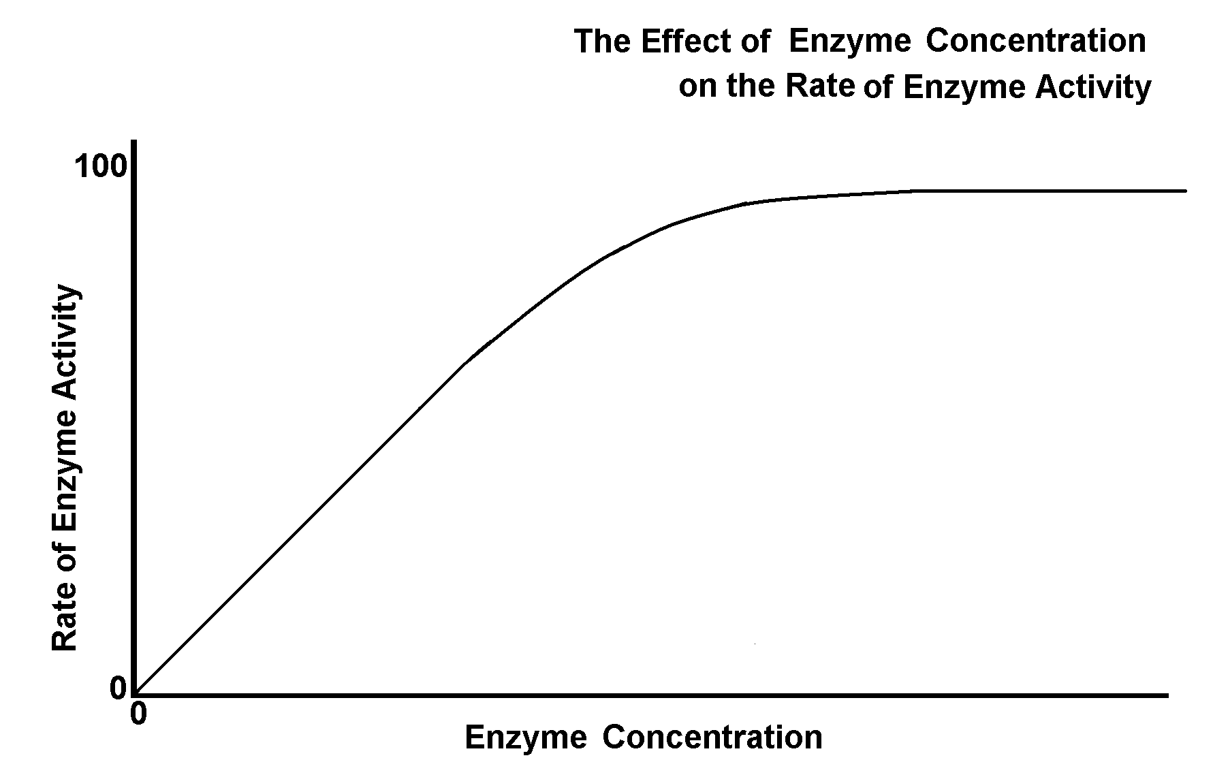
3. Enzyme concentration
Describe the graph

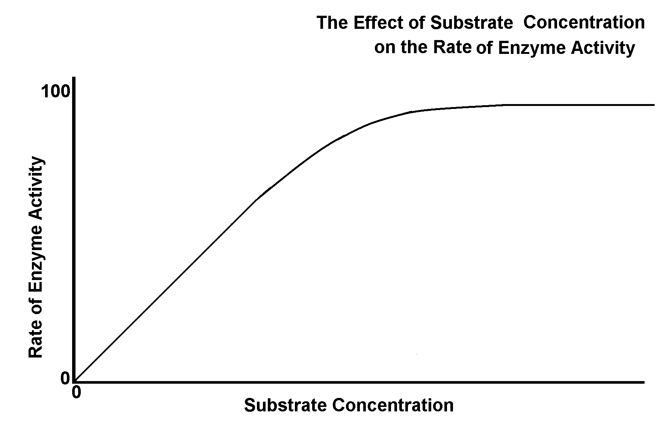
4. Substrate concentration
Describe the graph.

Chart of Organic Compounds Important in Biology
 | Carbohydrates | Lipids | Proteins
Made of
Elements
Examples of
S
T
R
U
C
T
U
R
E

Monomers
(Building Blocks)
Examples of
Polymers
Function
Misc.

Do you know the difference between glucose, glycerol and glycogen?
Labeling Exercise.
Label each molecule.
A.
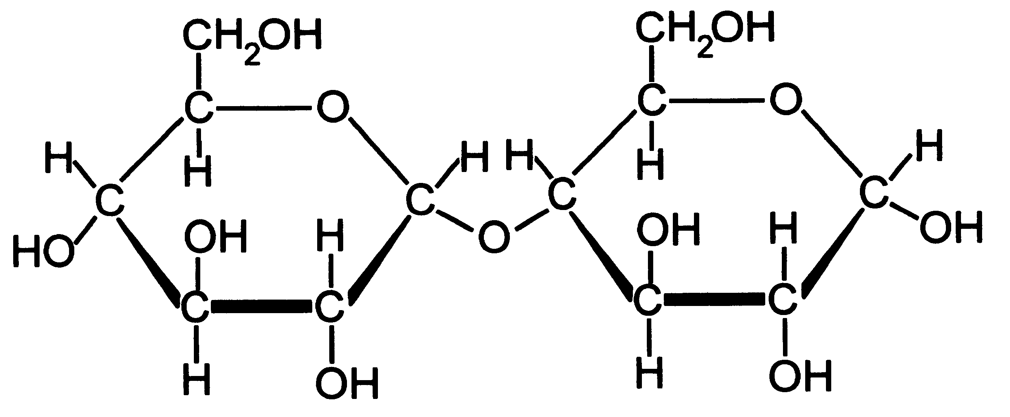
B.
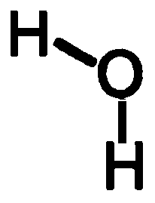

E.
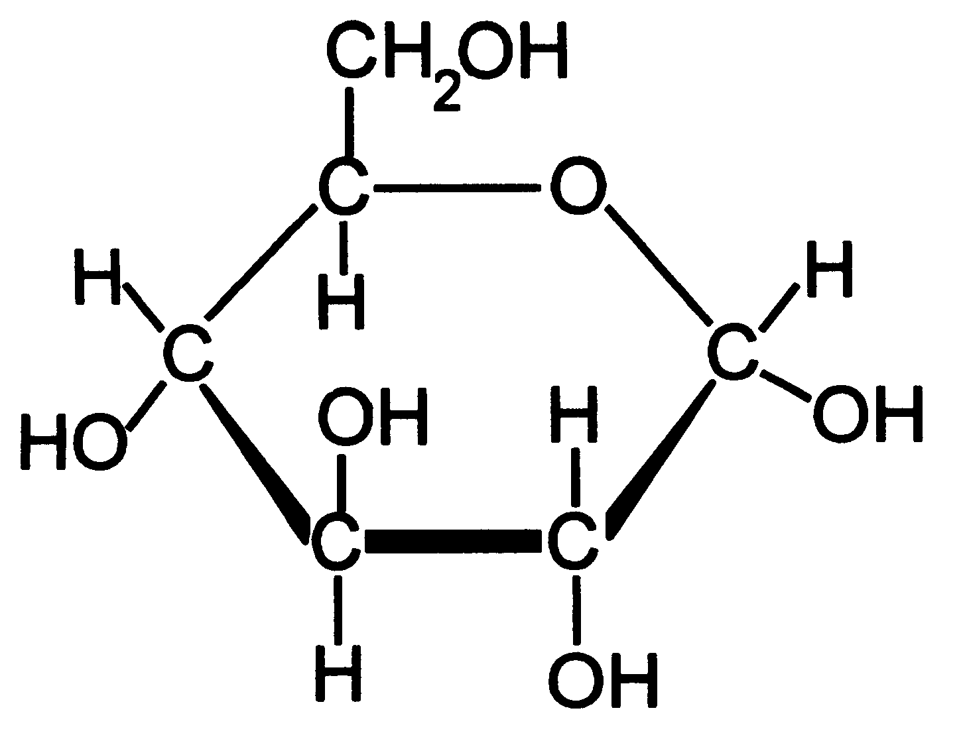
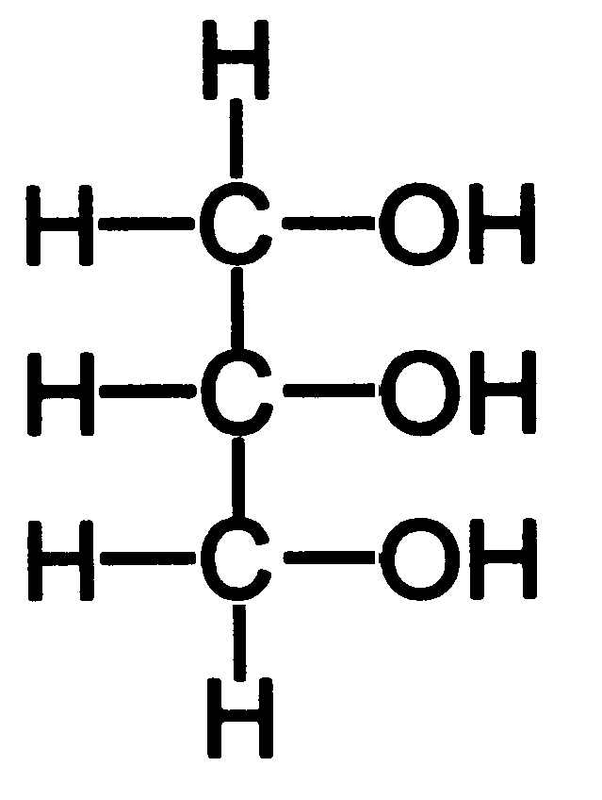
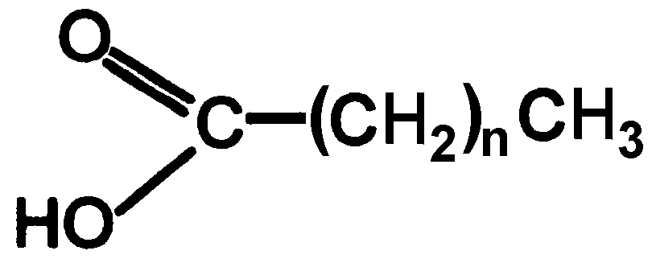
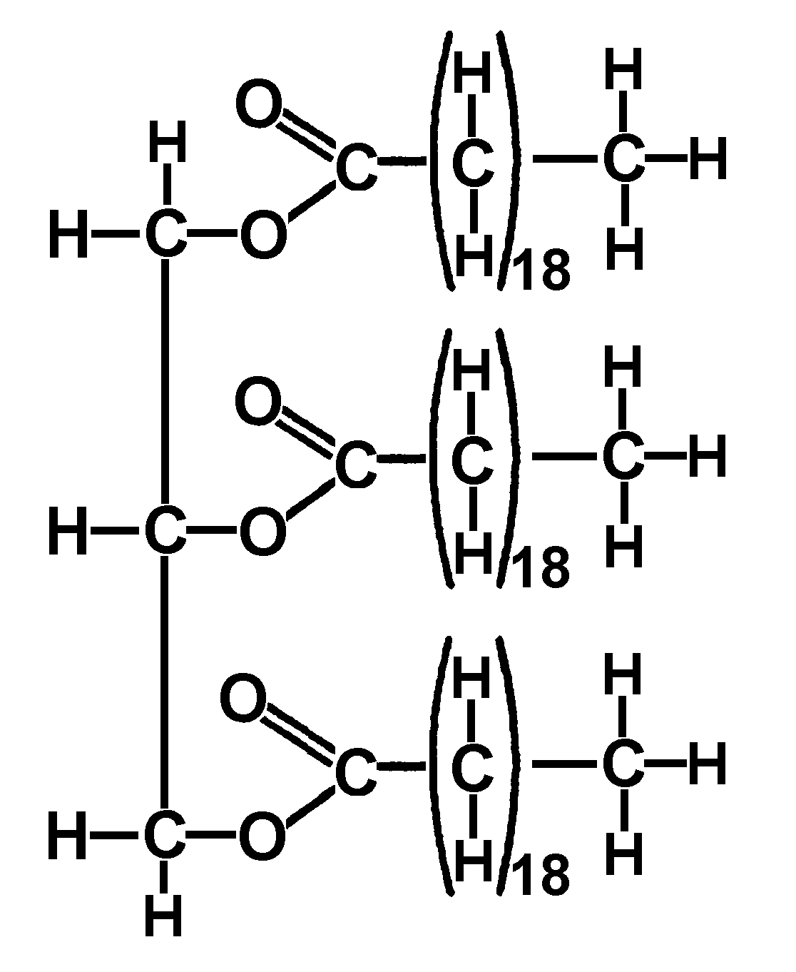
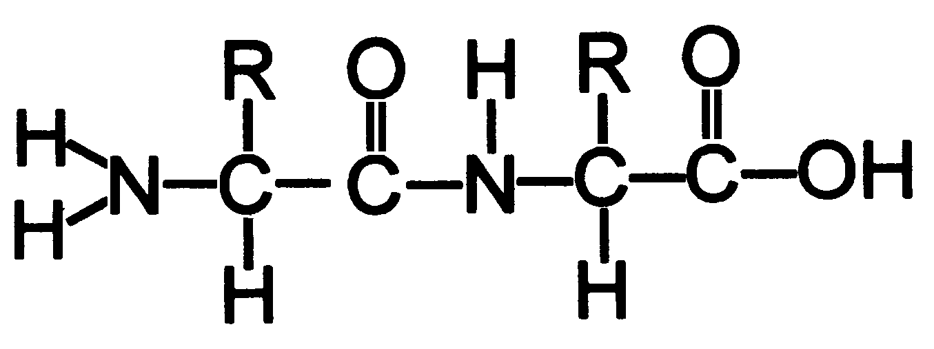
C.
D.
F.
G.
H.
A

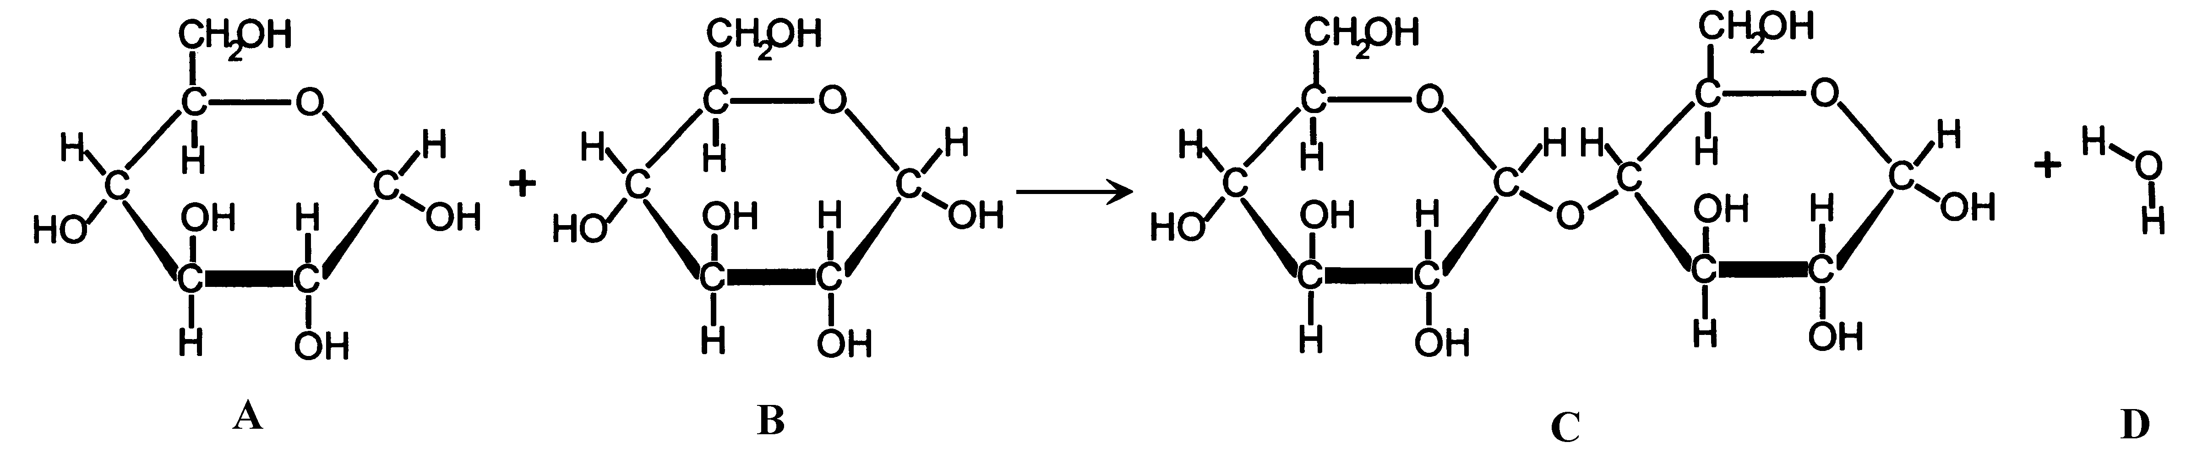

B

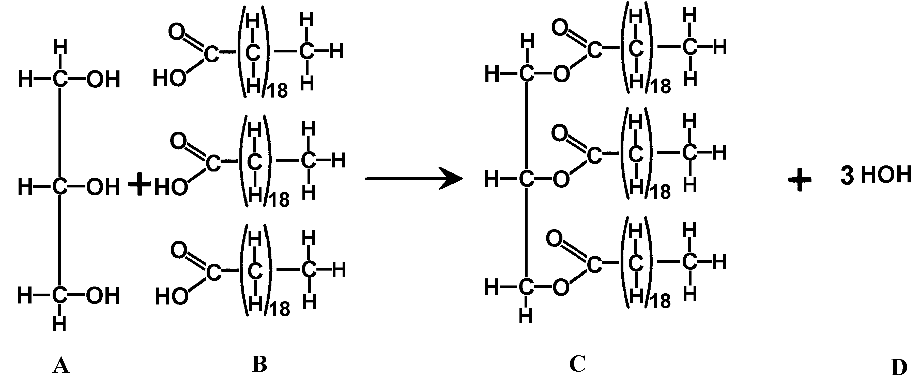
Equation A

Equation B
Equation C

C

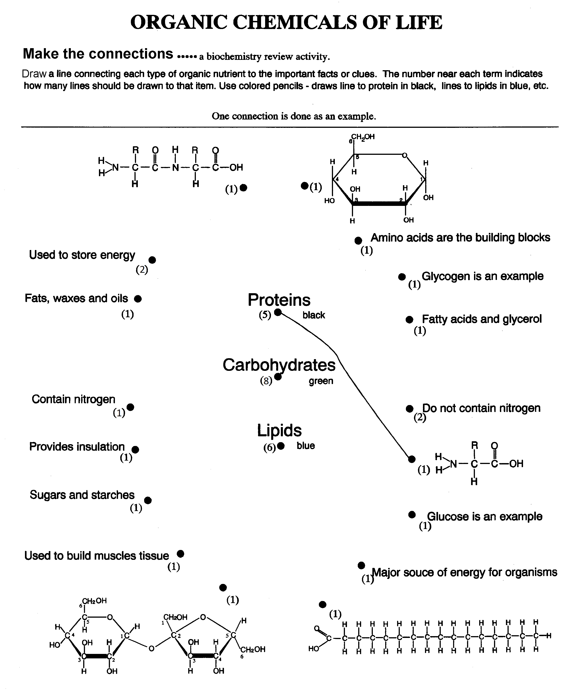

ENZYMES – Review Chart
Where are
they found?
How do they work?

What are they? | 1.  2.
Factors that change rate of reaction | 1.  2.  3.  4.
Function | 1.  2.
Misc. | 1.  2.  3.  4.

Chapter 5: The Molecules of Life

NAME_________________________________ Period __________

Directions: Follow the directions on the ½ sheet for logging into the textbook website. Do each activity and answer the following questions.

Activity 5.1 Carbon Based Molecules

1. What is the difference between organic and inorganic molecules?

2. How are polymers built and what is the role of water in this process?

3. How is starch broken down into usable glucose?

Activity 5.2 The Role of Glucose

1. What is the primary source of energy for plants and animals?

2. What happens when there is more glucose than is needed to do the life processes?

3. What kind of reaction takes place when a cell converts a glycogen molecule into
glucose molecules?

Activity 5.3 The properties of Lipids

1. How do water molecules stay together?

2. Give the three examples of foods that have saturated fats. Which of these three is
most saturated?

3. What is a major function of the steroid, cholesterol?

Activity 5.4 Proteins

1. What are proteins made from?

2. What do all amino acids have in common?

3. What makes one amino acid different from another?

Activity 5.5 Enzymes

1. What happens to enzymes as you change the temperature?

2. What is the maximum temperature at which the enzymes worked?

Cut out for flash cards

