
Regents Biology Name______________________________
Chapter 4 The Chemical Basis of Life Date______________

  - Life requires about 25 chemical elements
- Matter

  - Elements

  - Compounds

Elemental Composition
of the Human Body

Chemical Mass
Symbol (in a 70 Kg person)

O 43 Kg

C 16 Kg

H 7 Kg
N 1.8 Kg
Ca 1 Kg
P 780 g

K 140 g
Note: 1 Kg = 2.2046 lbs

B. Important Elements in Life:

  - Chemical properties are based on the structure of atoms
- Atoms

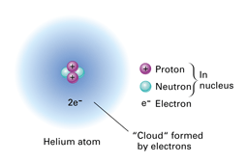
  - Structure

    - Electron orbitals (shells, cloud)

      - electron

    - nucleus

      - proton

      - neutron

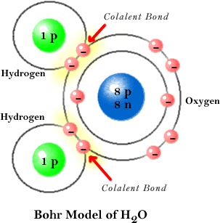
  - Chemical bonds join atoms to one another
- Chemical bonding

  - Covalent bond

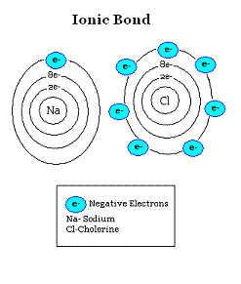

  - Ionic bond

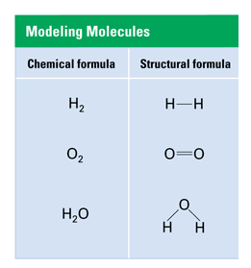
- Chemical Formulas

  - Chemical (molecular)

  - Structural

- Chemical Equations

Ex. 2 H₂ + O₂ à 2 H₂O

  - Reactants

  - Products

  - Balanced equations

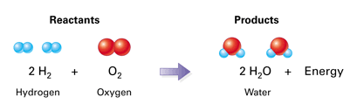

Example:

H₂ + O₂ à H₂O is unbalanced, why?

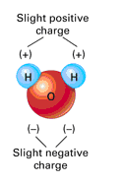
  - Life depends on the unique properties of water

- Structure of water

  - Cohesion

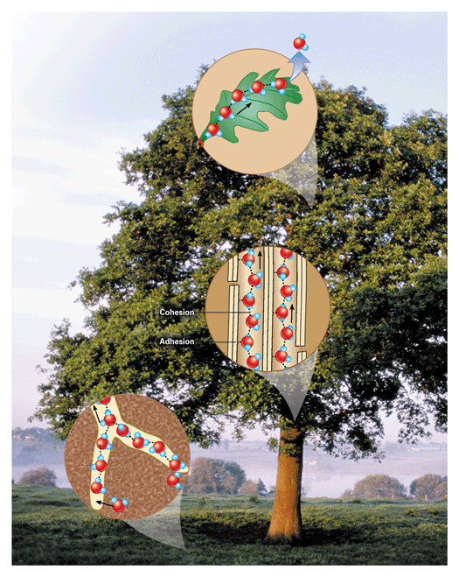

  - Adhesion

c. Why is this important to trees?

- Water’s ability to dissolve other substances

  - Solvent

  - Solute

  - Aqueous solution

- The pH Scale

0___________________________________________________________14

  - Ions

    - Hydrogen ions

    - Hydroxide ions

- Acids

  - pH range:

  - Examples:

- Bases

  - pH range:

  - Examples:

- Neutral Substances

  - pH:

  - Examples:

- Buffers

- Indicators (See activity)

Biology Activity Name______________________________
pH Period __________ Date_________

With your partner obtain pH paper and test the pH of the solutions provided by your instructor. You will test one solution at a time. Take the solution to your work area. Tear off a small strip (2 cm) from the dispenser, dip the paper into the solution, and compare the resulting color with the scale provided on the dispenser. Record the information in the data table that follows. Place used strips on a paper towel and dispose of them in the wastebasket when you are finished with all of your testing. Return the solution to the central location and take another.

Data Table pH values of Various Household Substances

Solution | phydrion color | pH  (0-14) | Type of solution  (acid/base/neutral)
Water
Ammonia
Vinegar
Juice ( )
Anti Acid
Soda (pop)
Drain opener
Saliva
Soapy Water

Conclusions and Related Questions:

- According to your data table, which solution is

  - most acidic ______________, pH = ________

This solution has a greater concentration of : OH⁻ ions or H⁺ ions?
(circle one)

  - most alkaline ______________, pH = ________

This solution has a greater concentration of : OH⁻ ions or H⁺ ions?
(circle one)

- Anti acid is used as a medication for an upset stomach. What chemical reaction takes place when a person takes this medication? (Refer to your text if needed)

__________________________________________________________________

__________________________________________________________________

__________________________________________________________________

The graph below shows the effect of pH on the rate of a biochemical reaction.

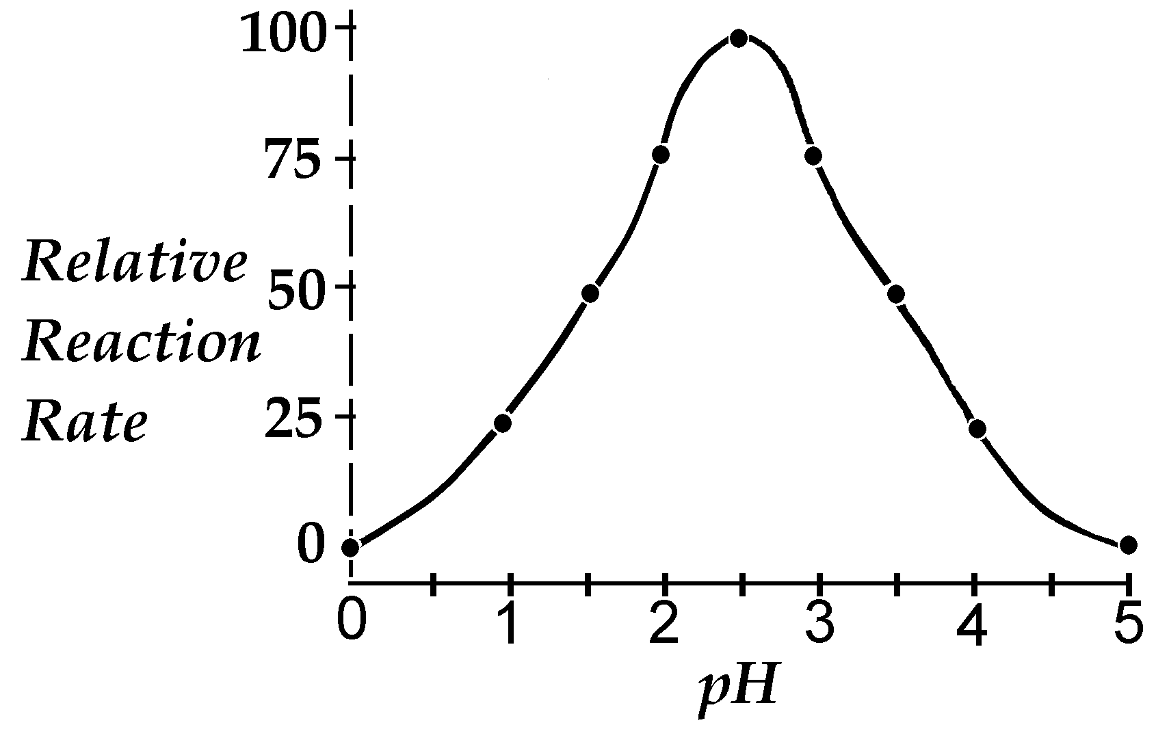

3. What is the relative rate of this reaction at a pH of 2? ____________

4. What is the relative rate of this reaction at a pH of 3.5? ____________

5. Compare the reaction rates at the pH values of 1 and 4 _____________________________________________________________________

6. What is the optimum (best) pH for this reaction to occur?____________

7. At what pH values are there no reactions? ____________

Part II (Demonstrations):
- Bromothymol Blue:
Observations:
(illustrations may be helpful)

Bromothymol Blue is an indicator that turns ____________ in the presence of _______________.

- Phenolphthalein:
Observations:
(illustrations may be helpful)

Phenolphthalein is an indicator that turns ____________ in the presence of _______________.

- pH paper:
Observations:

