Name:____________________________________ Per. ______ Due _________ Assign #1
Unit 11 - Homeostasis, Excretion, Endocrine (Chapter 32)

Read pages 698-701 in your text. Use your textbook, the internet, or a dictionary to complete this homework assignment.

THE EXCRETORY PROCESS
In the course of the biochemical activities of the cell, nutrients are oxidized, releasing energy for life processes and producing numerous new substances. Some of these materials are useful, but others, if allowed to accumulate, are poisonous and interfere with normal metabolic reactions. Homeostasis depends on regulating the chemical makeup of body fluids such as blood and interstitial fluid. This is accomplished by removing waste products and balancing the intake and loss of water.
Excretion is the removal of metabolic wastes from the body. These wastes include carbon dioxide, which is a product of cell respiration, and nitrogenous wastes, which result from the breakdown of amino acids. Excess salts and water must also be excreted.

1. What is excretion? ______________________________________________________
_____________________________________________________________________

2. What are the four types of metabolic wastes that must be removed from the body?

A |  |  | C
B |  |  | D

Excreting Nitrogenous Wastes

Fats and carbohydrates break down into water and CO₂, which are easily eliminated. Excess fats are stored; excess sugars are converted to glycogen (animal starch) and stored in the liver. But the building blocks of proteins (amino acids) are not stored. If there is an excess of amino acids they are removed.
The liver breaks down excess amino acids. The disassembly process is called deamination [de – removal; amin – amino group (–NH₂)]. Deamination results in the production of ammonia (NH₃), which is the simplest form of nitrogenous waste.
Ammonia is highly toxic and very soluble in water. It must be either quickly eliminated or converted into less toxic substance such as urea or uric acid. To change ammonia to the less toxic substance called urea requires a few ATP molecules. To change the ammonia to the not-very-toxic molecule called uric acid requires more ATP molecules.
There is a tradeoff between production cost (ATPs required) and water loss. For each molecule of ammonia converted to urea an organism must spend 1 ATP molecule. Most aquatic animals continuously excrete ammonia. It is very soluble in water and diffuses rapidly across cell membranes to the outside environment. In mammals, a very small amount of ammonia in the blood is lethal (deadly). Since mammals don’t live in an aquatic environment they don’t have enough water to flood out the ammonia.
Mammals and other land dwellers convert highly poisonous ammonia into less toxic urea or uric acid. Mammals and amphibians excrete this urea as their principal nitrogenous waste. They are referred to as Urea excretors. They require a moderate amount of water to be retained in their tissue and can live away from a water habitat for periods of time.
Mammals have kidneys that concentrate urea, which is water soluble. We mammals require water in all of our meals and throughout the day. We excrete over a liter of urine per day. The urine is yellow because of the urea that we excrete.

Some terrestrial animals that live in very dry environments or can fly excrete uric acid. Examples of such organisms are insects, reptiles, and birds. Uric acid is water-insoluble and is excreted as a semisolid (the whitish material in bird droppings). Since uric acid is insoluble it prevents water loss during removal of nitrogenous waste. Therefore the organisms don’t need to carry much water with them, making them light enough to fly or they can live in dry habitats.

1. Which of the following nutrients are stored in animals? (circle your answer or answers)
Fats, Proteins, Sugars
2. What does deamination mean?
3. In what organ does deamination occur?
4. What is the waste product created by deamination?
5. What are the three forms of nitrogenous waste produced by animals?
6. What type of organisms excrete ammonia?
7 What type of organisms excrete urea?
8. What type of organisms excrete uric acid?
9. Why is urine yellow?
10. What is the advantage to excreting ammonia?
11. What is the advantage to excreting urea?
12. What is the advantage to excreting uric acid?
Name:______________________________________ Per. ______ Due _______ Assign #2
Unit 11 - Homeostasis, Excretion, Endocrine (Chapter 32) due ______________

Read 702-703 in your text

HUMAN URINARY SYSTEM
The urinary system consists of the kidneys and associated structures—the ureters, bladder, and urethra. The renal arteries, which branch off the aorta, carry blood to the kidneys, which filter out urea, salts, and water. These substances form the urine which passes from the kidneys into the ureter, a tube leading to the urinary bladder. The urine is stored temporarily in the bladder. Urine then exits the body through a tube called the urethra. The urethra extends through an opening near the vagina in females; the urethra extends through the penis in males.

- Label the parts indicated on the drawing. Use the Word bank (and hints)

Abdominal aorta (carries blood away from the heart and toward the lower part of the body)
Adrenal glands (located on top of the kidney)
cortex (outer region of kidney)
inferior vena cava (carries blood toward heart)
kidney (an organ of excretion)
medulla (middle region of kidney)
pelvis ( inner region of kidney)
Renal artery (carries blood toward the kidneys)
Renal vein (carries blood away from kidneys)
Urethra (carries urine to outside of the body)
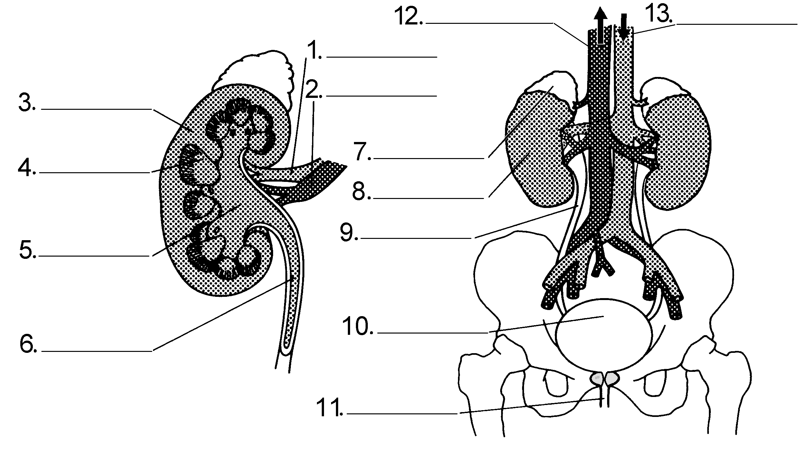
Ureter (carries urine away from kidneys; use this word twice!)
Urinary bladder (stores urine)

A. Study Figure 32-5 on page 703. What are the four processes that occur in the kidneys?

1. ___________________________ : blood pressure forces ________ and small
(ncluding ____________ ) into the Bowman’s capsule

2___________________________. _____________, ____________, and ___________________________, are returned to the blood.

3. _______________________: Excess salts and some toxins are transported from the blood into the nephron.

4. _______________________ : In this final step, remaining filtrate (called _____________________) is transported to the ______________and eventually leaves the body

B. Carefully read pages 702-703 before answering the questions below:

1. Filtration occurs at a tiny ball of capillaries called the _ _______________________

2. What materials are found in filtrate?
a. b. c. d. e.

3. The filtrate is collected in a cup-shaped portion of the nephron called the ________________ capsule.

4. What materials are reabsorbed back into the blood from the filtrate?
a. b. c. d. e.

5. What substances are found in urine?

- The kidneys perform their function continuously. They filter your entire blood supply, approximately ___ liters, as many as ____ times per day. The kidneys process about _____liters of filtrate per day. But since most of this fluid is returned to the blood, a person typically only excretes about __________ of urine per day.

Name:__________________________________________ Per. _______ Due ___________ Assign #3
Unit 11 - Homeostasis, Excretion, Endocrine (Chapter 32)

Read pages 701-707 in your text, and complete this homework assignmentt.

The Human Excretory System

As the blood circulates through the body, four different organs remove the wastes--the liver, kidneys, lungs, and skin.

LIVER
Your liver has many functions. The liver removes worn-out red blood cells and excess amino acids from the blood and breaks them down. Iron compounds and bile are produced from the breakdown of the hemoglobin of the red cells. The iron is reused by the body. The bile is stored temporarily in the gallbladder. It then passes into the small intestine where it aids in the breakdown of fats. Most of the bile is eventually eliminated from the body with the digestive wastes.
Excess amino acids entering the liver are broken down by a process called deamination. This separates the non-amino portion of the molecule from the amino group.. The amino group, NH₂, forms ammonia, NH₃. which is quickly converted to urea, which is less toxic to the cells than ammonia. Blood carries urea is to the kidneys by the blood and is excreted from the body in the form of urine.
The liver also carries out chemical reactions that detoxify certain poisons, such as alcohol. Additionally, the liver helps regulate the amount of glucose in the blood. One of the liver's most important functions is to convert excess glucose into glycogen (a storage polysaccharide similar to starch). The liver then stores glycogen, which can be broken down to glucose at a later time. Maintaining a constant level of glucose in the blood supports cellular metabolism and helps to maintain homeostasis in the body. The liver also manufactures most of the proteins found in blood plasma.
One liver disease is hepatitis, a name that means "inflammation of the liver." Many cases of hepatitis are traced to viral infections. Approximately 10–30 million people worldwide are infected with one strain, hepatitis B , each year. The hepatitis B virus is found in the saliva, semen, and blood of infected persons. The disease can be transmitted through sexual contact, kissing, or the sharing of needles to inject illegal drugs It also can be transmitted from mother to baby during birth. Hepatitis B or alcohol abuse may lead to cirrhosis (suh ROH sis) of the liver. Cirrhosis occurs when the liver is so scarred that it can’t function effectively.
- List and describe three ways in which the liver helps maintain homeostasis.
a. b. c.

2. What is hepatitis B and how is it spread?

3. What happens to worn-out red blood cells in the liver?

4. What happens to excess amino acids in the liver?

5. What happens to excess glucose in the liver?

6. What nitrogenous waste passes from the liver to the urinary system?

LUNGS

The lungs are considered to be excretory organs because water vapor and carbon dioxide, by-products of cell respiration, are excreted from the body by the lungs during exhalation.

1. What metabolic wastes are excreted by the lungs?
_____________________________________________________________________

2. During which life process are these wastes produced?
_____________________________________________________________________

SKIN (See text page 595-596 and 698)

The skin is an excretory organ because sweat glands filter water, urea, and salts from
the blood, and these substances, in the form of sweat, pass to the surface of the skin
and are removed. In addition to removing some metabolic wastes, the skin is
involved in regulation of body temperature.

1. What metabolic wastes are excreted by the skin?

a.

b.

c.

2. How are these wastes removed from the bloodstream and how do they reach the surface of the skin?

3. List four functions of the skin.
a.

b.

c.

d.

Name:_____________________________________ Per. _____ Due __________ Assign #4.
Unit 11 - Homeostasis, Excretion, Endocrine (Chapter 32)

Read pages 709-712 in your text and then complete this homework assignment.

CHEMICAL REGULATION

ENDOCRINE GLANDS
The endocrine system, like the nervous system, is involved in the regulation of bodily processes. The endocrine glands produce substances called hormones. Endocrine glands are sometimes referred to as ductless glands because they release their secretions directly into the bloodstream. (The exocrine glands, such as salivary glands, release their secretions into ducts passing to other organs or to the outside of the body.)

1. Why are the organs of the endocrine system called ductless glands?
_________________________________________________________________

2. The substances produced by the endocrine glands are _______________________

HORMONES
The hormones secreted by the glands of the endocrine system include a variety of types of compounds. Most are proteins. Each hormone is released directly into the bloodstream, which carries it to all the tissues of the body. It exerts its effects on a distant organ, or target tissue. The effects of some hormones are limited to one specific target tissue or process, while other hormones have wide-ranging effects on a variety of metabolic processes. Hormones influence the rates of specific metabolic reactions in sensitive tissues. The effects of some hormones are almost immediate, while others take hours.

1. What is a hormone?_______________________________________________________

2. The tissue acted on by a hormone is its ________________ ________________

3. Most hormones are ____________ (which organic compound).

4. How do exocrine and endocrine glands differ?
_________________________________________________________________
_________________________________________________________________

More questions on the back!

ENDOCRINE VS. NERVOUS SYSTEM

Both the endocrine and nervous systems function in the regulation of the body and in the maintenance of homeostasis. The nervous system works as electrochemical impulses are sent along nerve cells (called neurons). Chemicals called neurotransmitters carry messages from one nerve cell to the next. The nervous system works very rapidly (often within hundredths of a second) to make adjustments to environmental stimuli.

The endocrine system is chemical in nature. The endocrine system consists of glands that make chemical messengers called hormones. The hormones are transported by the bloodstream to all parts of the body, but they only affect certain tissues--called target tissues. The endocrine system generally makes slower, longer-lasting adjustments.

- Fill in the blanks in the following chart. The answers are in the paragraph above!!
COMPARATIVE FUNCTIONS OF NERVOUS AND ENDOCRINE SYSTEMS
Nervous Regulation | Endocrine Regulation
Nerve endings secrete chemicals called neurotransmitters. | ________ secrete chemicals called ______
Maintains ___________________ | Maintains __________________
Speed of response = _______________ | Speed of response = _______________
Nerve impulses are electrochemical  in nature. | Hormones are ______________ in nature

Name:__________________________________________ Per. _____ Due _____ Assign #5.
Unit 11 - Homeostasis, Excretion, Endocrine (Ch 32)

Read pages 698-700 in your textbook to complete the following questions

- Define homeostasis:

- What does thermoregulation regulate?

- The type of regulation that controls your body temperature is called _____________ feedback.

- Read and study Figure 32-2: It compares your body’s temperature regulation system to a ______________________________ .

- What are some things your body does if your body temperature rises above the set point?

- What are some things your body does if your body temperature drops below the set point?

- In addition to temperature regulation, homeostasis depends on regulating the chemical makeup of body fluids such as ________________ and __________________ fluid. This is accomplished by removing ______________ products and by balancing the ___________ and ___________ of water.

- Chemical messengers called ____________________ that are produced by ____________________ glands help the body maintain homeostasis. These glands secrete more than ___________ different hormones. List four different things that hormones can do in the body: a. c.

b. d.

- Since hormones are usually secreted directly into the _____________________ , a hormone reaches all parts of the body. But only certain cells, called ____________ cells, are able to respond to that particular hormone.

10. Read page 710 (How hormones affect target cells) to fill in the table below.

Type of hormone | Steroid (One Messenger) | Protein (Two Messenger)
Examples

Lipid-soluble (yes or no)

Do they cross cell membrane?
Explain how they work (what do they do in the cell)

Name:______________________________________Per. ______ Due ________ Assign #6.
Unit 11 - Homeostasis, Excretion, Endocrine (Chapter 32)

REGULATION OF HORMONE SECRETION

For the most part, the secretion of hormones by the glands of the endocrine system is regulated by a negative feedback mechanism. Hormones are not secreted into the bloodstream at a constant rate. Instead, when the concentration of a particular hormone in the blood falls below a certain level, the gland that secretes the hormone is stimulated to increase its rate of secretion. When the level of the hormone in the blood rises to a certain level, the rate of secretion by the gland decreases. Generally, the secretion of a hormone by one gland is stimulated by the action of another hormone secreted by a second gland.

1. Gland A secretes hormone A, which stimulates gland B to secrete hormone B.
a. As the level of hormone B in the blood increases, the rate of production of hormone will __________________________.
b. As the level of hormone B in the blood decreases, the rate of production of hormone A will _______________________.

HYPOTHALAMUS AND PITUITARY GLAND

The human endocrine system includes many organs, some of which also belong to other organ systems. The hypothalamus is often referred to as the master control center of the endocrine system. First, it manufactures hormones that direct the activities of many endocrine glands, particularly the pituitary gland. In addition, the hypothalamus receives and sends nerve signals, making it the link between the nervous and endocrine systems.

The hypothalamus is part of the brain; it receives information from the nerves about the status of the body's internal systems and about the condition of the external environment. With this information, the hypothalamus indirectly regulates body functions such as temperature, hunger, and thirst. The hypothalamus acts on the endocrine system by controlling the neighboring pituitary gland. The hypothalamus secretes releasing hormones that stimulate the pituitary gland to secrete hormones that influence other glands and body functions.

The pituitary gland is a grape-sized structure that lies at the base of the brain. It is known as the “master gland” because it makes hormones that control other endocrine glands. It consists of an anterior lobe (anterior means in the front) and a posterior lobe (posterior means in the back). Some of the hormones made by the pituitary gland are growth hormone, follicle stimulating hormone (FSH), luteinizing hormone (LH), thyroid stimulating hormone (TSH), and antidiuretic hormone (ADH).

1. What is the relationship between the hypothalamus and the pituitary gland?

2. Where is the pituitary gland located? __________________________________

3. Why is it known as the “master gland”? ________________________________

4. What part of the brain controls the release of hormones from the pituitary? It is the major link between the nervous system and the endocrine system.

_______________________

5. _______________________ hormones are hormones that control the release of hormones form the anterior lobe of the pituitary.

6. List three hormones made by the pituitary gland.
Name:________________________________________ Per. ______ Due _____ Assign #7.
Unit 11 - Homeostasis, Excretion, Endocrine (Ch 32)

Read pages 712-715 in your text; then complete this homework assignment.

THYROID GLAND (page 712)

The thyroid gland is located in the front of the neck along the trachea. The cells of the thyroid have a unique ability to concentrate iodine from the blood. The iodine is a necessary part of the structure of the thyroid hormone thyroxine. The thyroid also secretes the hormone calcitonin. Calcitonin regulates calcium levels.

1. What is the function of the hormone thyroxine?
________________________________________________________________________

2. The secretion of thyroxine is stimulated by thyroid-stimulating hormone (TSH), which is produced by the _______________________ gland.

3. Explain why the regulation of thyroxine secretion is an example of a feedback mechanism.
__________________________________________________________________________________________
__________________________________________________________________________________________

4. Describe the thyroid conditions that result from over- and under-secretion of thyroxine.
__________________________________________________________________________________________

PARATHYROID GLANDS

Embedded in the thyroid are two pairs of small glands—the parathyroids. The hormone secreted by these glands is parathormone (also called parathyroid hormone). This hormone regulates the level of calcium and phosphorus in the bones, blood, and tissues.

1. The hormone secreted by the parathyroid glands is called _______________________

2. Parathyroid hormone regulates metabolism of ___________ and __________________

ADRENAL GLANDS

The adrenal glands are small, cap-shaped structures located on top of each kidney. The outer portion of the adrenals is called the cortex, while the inner portion is the medulla. The cortex, which is necessary for life, produces a mixture of steroid hormones that are known collectively as corticosteroids. The medulla produces the hormones epinephrine, (also called adrenalin) and norepinephrine, (also called noradrenalin). Adrenalin prepares your body for urgent action in an emergency situation. Adrenalin increases the heartrate and breathing rate.

1 State how epinephrine (adrenalin) affects each:

a. heart rate _____ c. blood pressure ___________________
b. breathing rate ____________ d. amount of glucose in blood __________

2. Explain the meaning of the phrase “fight-or-flight” reaction in respect to the secretion of epinephrine (adrenalin).
________________________________________________________________________
________________________________________________________________________

PANCREAS
The pancreas is both an exocrine and an endocrine gland. Its exocrine cells produce
digestive enzymes that pass into the pancreatic duct leading to the small intestine.
The endocrine part of the pancreas consists of masses of cells called the islets of
Langerhans, which are scattered throughout the organ. These cells secrete two hormones—insulin and glucagon. Read page 714 to find out the functions of each!

1. What is the function of insulin?
________________________________________________________________________
________________________________________________________________________

2. What happens when the pancreas does not secrete adequate insulin?
________________________________________________________________________

3. What disease results from an insulin deficiency? How is this disease controlled?
________________________________________________________________________
________________________________________________________________________

4. What are the metabolic effects of the hormone glucagon?
________________________________________________________________________
________________________________________________________________________

GONADS
The ovaries and testes, in addition to their roles in the production of eggs and sperm respectively, function as endocrine organs. The ovaries produce several hormones known collectively as estrogens, and they also produce the hormone progesterone. The testes produce a group of hormones called androgens, the most important of which is testosterone. At puberty, increased amounts of testosterone or estrogen stimulate the development of secondary sex characteristics.

1. The gonads are the ____________ in females and the _______________ in males.

2. The hormones produced by the ovaries include _________ and__________

3. The major hormone produced by the testes is ______________________

4. Development of secondary sex characteristics is stimulated by

_______________________ in males and ______________________ in females
Name:______________________________________ Per. ______ Due ________ Assign #8.
Unit 11 - Homeostasis, Excretion, Endocrine (Ch 32)

COMPONENTS OF THE HUMAN ENDOCRINE SYSTEM

Major components of the human endocrine system include the hypothalamus, pancreas, thymus, and gonads (ovaries and testes), and the pituitary, thyroid, parathyroid, and adrenal glands.

- Use the words listed above to LABEL the major components of the human endocrine system on the following diagram. (see text page 711)

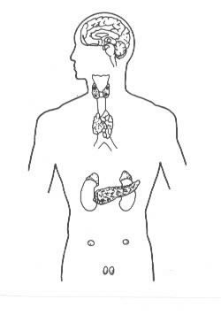
(only in women)
(only in men)

- Give an example of how the endocrine system regulates certain body functions.

- Describe how the hypothalamus and the pituitary glands control the endocrine system.

- How do insulin and glucagon affect the level of blood glucose?

Name:______________________________________ Per._____ Due_________ Assign #9
Unit 11 – Homeostasis, Excretion, Endocrine (Ch 32) Review Assignment

1. What is the difference between elimination and excretion?

2. List three examples of metabolic wastes and describe where they come from.
a. b. c.

3. Nitrogenous wastes come from the breakdown of which organic molecules?

4. Define the following terms

Metabolism –

Homeostasis –

- List four functions of the liver below

6. The nephron is the functional filtration unit of the human kidneys.

- What substances are normally filtered from the blood and become filtrate?

- What substances are reabsorbed?

- What substances are excreted in the urine?

7. How are the skin and lungs involved in excretion?

- Skin:

- Lungs:
8. Label the parts indicated in the diagram below of the human urinary system:
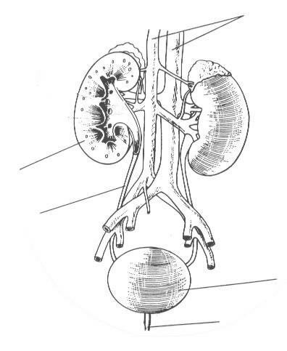

9. What is the difference between endocrine glands and exocrine glands? Name an example of each.

10. Why is the pancreas considered to be both an endocrine gland and an exocrine gland?
- It is an endocrine gland because…

- It is an exocrine gland because…

- Why doesn’t the secretion of hormones in the blood have an effect on all organs in the body?

- What is the difference between hormones utilizing the one-messenger model and the two-messenger model?

12. Explain how negative feedback controls the secretion of insulin and glucagon.

13. Fill in the table below.

Endocrine Gland | Hormones Secreted | Effects on Target Tissue
Pituitary Gland | Growth Hormone  FSH  TSH
Thyroid Gland | Thyroxin
Parathyroid Gland | Parathormone
Adrenal Glands | Adrenalin (epinephrine)
Pancreas | Insulin  Glucagon
Ovaries | Estrogen
Testes | Testosterone

- Describe the following disorders:
  - Diabetes

  - Gout

  - Hepatitis

Assign #10
Complete the CastleLearning Assignment :
Unit 11 - Excretion & Endocrine

