Name:______________________________________ Per._____ Due_________ Assign #1
Unit 10 – The Circulatory System (Chapter 30)

Read Chapter 30 pages 654-657 and define the terms and fill in the blanks.

- The human circulatory system functions to:
  - Deliver _________________ and _______________ to all body cells.
  - Transport __________________________ throughout your body
  - Carry ____________________ away from cells
  - Play a role in ________________________ tissues and protecting the body from __________________

- List the 3 main parts of a circulatory system AND briefly describe each:
A. ________________ : __________________________________________
B. ________________ : __________________________________________
- ________________ : __________________________________________

- Blood flows throughout your body via blood _________________, tubes that form a _____________ piepeline within the body (this is called a closed circulatory system). Your body contains about ______________ of blood. Under normal activity, it takes about _____________ for all that blood to make a complete circuit through the body.

- List the 3 types of blood vessels AND briefly describe each (p. 655):
A. _________________ : ______________________________________________________________
B. _________________ : ______________________________________________________________
C. _________________ : ______________________________________________________________

- Which blood vessels are microscopic? ______________________
- Which blood vessels have thick muscular walls and carry blood under high pressure AWAY from the heart (and toward body cells)? _________________________
- Which blood vessels contain valves that allow blood to flow in only direction (back toward the heart0? ______________________________

- Describe how does the lymphatic system return fluid to the circulatory system:
Name:______________________________________ Per._____ Due_________ Assign #2
Unit 10 – The Circulatory System (Chapter 30)

Read Chapter 30 page 656-658 and Read the paragraphs below and then answer the questions that follow.
Chemical Exchange Between Blood and Body Tissues

Capillaries are in close contact with the cells of your body. In fact, most cells in your body are no farther than 10 micrometers (µm) from a capillary and the blood inside it. Cells in body tissues are surrounded by interstitial fluid (also called intercellular fluid). Thus the substances in capillaries do not enter tissue cells directly. First these substances must enter the interstitial fluid, and then enter the cells. The exchange of substances between blood and the interstitial fluid occurs in several ways. Some small molecules, such as oxygen and carbon dioxide, diffuse across membranes. Larger molecules move across the membranes by exocytosis and endocytosis. Blood pressure also forces fluid through the capillary wall. At the artery end of a capillary, blood pressure forces water, small solutes, and some dissolved proteins through the gaps between cells. However, blood cells and larger proteins are too large to pass easily through these openings, so they remain in the capillary.
Your blood loses about 4 liters of fluid into the interstitial fluid each day. The lymphatic system collects and returns most of this fluid to the circulatory system. Like the circulatory system, the lymphatic system consists of capillaries and larger vessels. Once inside the lymphatic vessels, this collected fluid is called lymph. Like veins, lymphatic vessels are embedded in muscle tissue. Also like veins, lymphatic vessels have valves that prevent lymph from flowing back toward the capillaries. The combination of muscle contractions squeezing the vessels and the one-way valves helps fluid move through the lymphatic system. Eventually, lymph drains into the circulatory system near the heart, allowing the fluid to be reused.
Located at various points throughout the lymphatic system are enlargements in the lymph tissue called lymph nodes. Lymph nodes help defend the body against infection. The nodes contain cells that destroy some bacteria and viruses that may enter the body. Have you ever had "swollen lymph glands" in your neck when you've had a cold or the flu? These "glands" are actually groupings of lymph nodes, swollen with infection-fighting cells

QUESTIONS:
- All the cells of the body are bathed in a colorless, watery fluid called ___________________ fluid or interstitial fluid. What is its function?

- Describe how materials such as oxygen and nutrients move from the blood into a tissue cell:

- Excess fluids from intercellular spaces are returned to the blood by a system of vessels called the ____________________ system .

- How does the lymphatic system return fluid to the circulatory system?

- Fluid inside lymphatic vessels is called __________________ .
- Your blood loses about _______________liters of fluid into the interstitial fluid each day. The ___________________ system collects and returns most of this fluid to the circulatory system.

- What are lymph nodes and what is their job?

- What are “swollen glands”?

9. Study the diagram below. Draw an arrow to the capillaries.
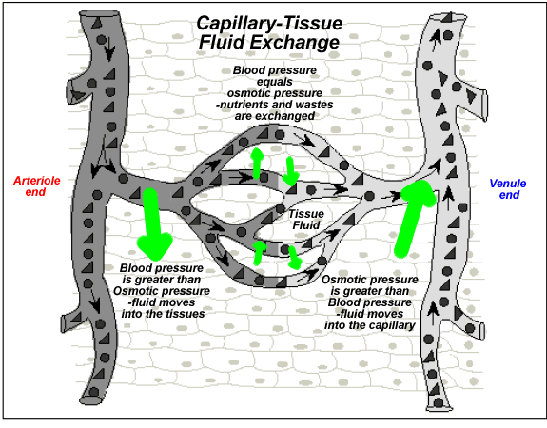

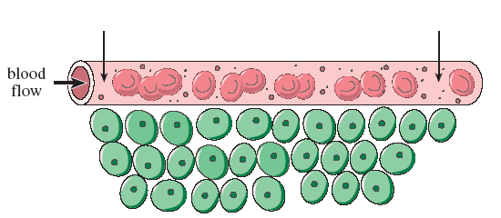
10. Refer to the diagram below. Label the capillary, a red blood cell and the tissue bed.
Name:______________________________________ Per._____ Due_________ Assign #3
Unit 10 – The Circulatory System (Chapter 30)

Read Chapter 30 page 658 and answer the following questions.

1. What is the pulmonary circuit?

2. Label the following schematic diagram using the following words: lung, heart, pulmonary artery, pulmonary vein

a. Which blood vessel is oxygen rich?

b. Which blood vessel is oxygen poor?

c. How do the pulmonary arteries differ from all other arteries in the body?

3. What type of blood vessel is the aorta? (vein or artery) Describe its function:

4. Describe the systemic circuit:

  - List some of the systems that are part of the systemic circuit:

  - Is the blood traveling to a system from the heart oxygen rich or oxygen poor?

Read Chapter 30 page 659 and COMPLETE the CHART and LABEL the diagram.

DESCRIBE each part of the heart and explain the FUNCTION of each.

Part | Description | Function
Atria

Ventricle

Valves

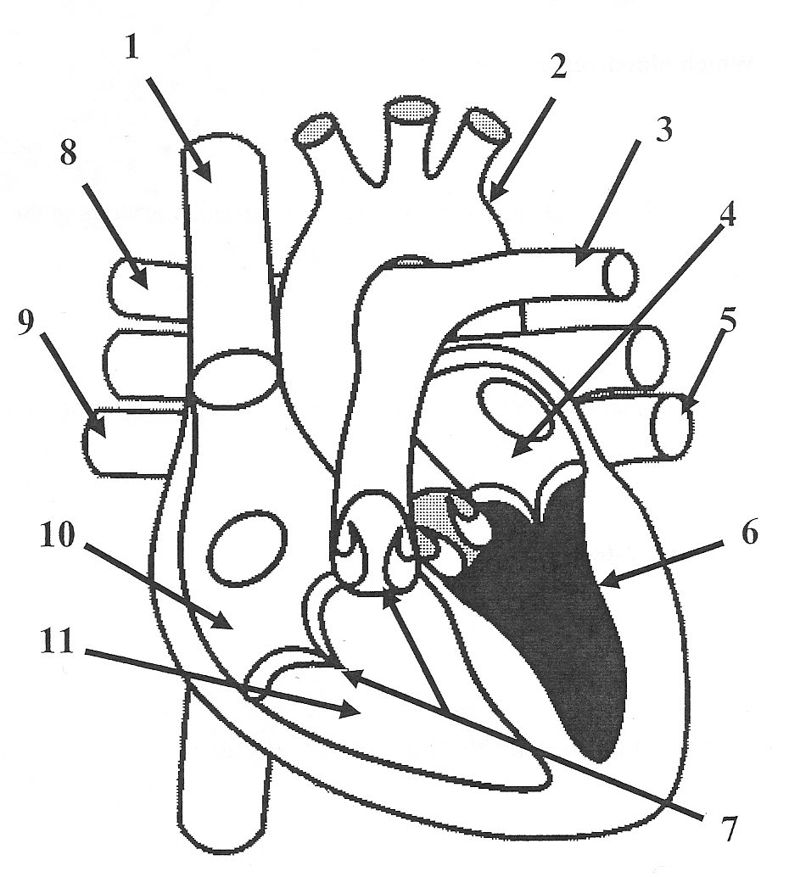
Label the heart diagram:

1. _____________________________
2. _____________________________
3. _____________________________
4.______________________________
5. _____________________________
6. _____________________________
7. _____________________________
8. _____________________________
9. _____________________________
10. _____________________________
11. _____________________________

Name:______________________________________ Per._____ Due_________ Assign #4
Unit 10 – The Circulatory System (Chapter 30)

Read Chapter 30 pages 659-660 and answer the following questions.
1. How many chambers do mammalian hearts have?

2. What are the upper chambers of the heart called? _________________
What is their job?

3. What are the lower chambers of the heart called?
What is their job?

4. Which chambers of the heart are the strongest and have the thickest walls?

5. What are the flaps of tissue in the heart that prevent blood from flowing backwards called?

Describe where they are located:

6. What is the familiar heart sound of “lub dupp” caused by?

7. What is the region of the heart that controls the RATE (speed) at which the heart contracts called?

Where is it located?

8. AFTER the rate is set, the impulses travel to what region of the heart?

What then contracts?

9. Blood pressure is measured in arteries. It is represented by TWO numbers.
a. The first number is the ____________________ pressure (it’s the higher number).
b. The second number is the ___________________ number.
c. An average blood pressure is ________ / ________

Name:______________________________________ Per._____ Due_________ Assign #5
Unit 10 – The Circulatory System (Chapter 30)

Read Chapter 30 pages 663-664 and answer the following questions.
- Blood has 4 main functions. List them:
a.

b.

c.

d.

- List the four components of blood and describe the function each:

- What are the most numerous blood cells? _________________
- What is another name for red blood cells? _________________
- What is the function of hemoglobin? ____________________________________
- Where are red blood cells produced? _________________
- As red blood cells mature, they lose their ___________ and _______________________.
- What is the typical life span of a red blood cell? _________________
- Which type of blood cells are also called leukocytes? _______________________
- When is the number of white blood cells unusually high?

- Which blood cells are involved in clotting? _________________
- Where are platelets produced? _________________
- Each drop of blood contains between _____________ and ______________ platelets.
Clotting:
  - The clotting process begins when platelets adhere (attach) where? _____________
  - The platelets break apart and release substances called __________________
  - The clotting factors make other nearby platelets ________________ and activate a series of reactions that result in the formation of a protein called ___________ .
  - Fibrin threads trap _______________ cells and additional _________________ .
  - The network of threads and cells builds up, eventually forming a clot that dries into a ____________ .

- Label the following diagrams. Identify platelets, red blood cells, and white blood cells:
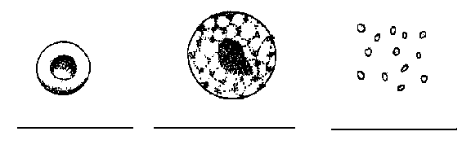

- List the blood components (platelets, red blood cells, and white blood cells) IN ORDER from MOST numerous to least.

a.

b.

c.

Name:______________________________________ Per._____ Due_________ Assign #6
Unit 10 – The Respiratory System (Chapter 30)

Read Chapter 30 pages 667-668 and answer the following questions.

1. List the pathway of air beginning with the intake of air through the nose and ending at the alveoli.
(use the diagram on p. 667)

2. What are alveoli? Describe how they function. Sketch an alveolus:

3. What is meant by the phrase “gas exchange?”

4. In what type of blood vessels does gas exchange occur?

5. What is the oxygen that we inhale used for in our cells?

6. Where does the carbon dioxide that we exhale come from?

Label the diagram on back!

On the lines provided, label the organs of the respiratory system that correspond to the numbers in the diagram.
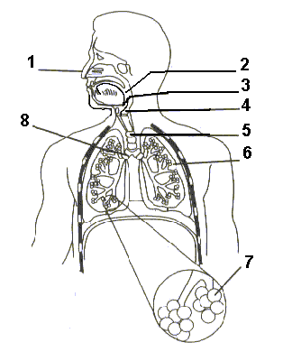

- _________________________

- _________________________

- _________________________

- _________________________
(also called voicebox)
- _________________________

- _________________________

- _________________________

- _________________________
Name:______________________________________ Per._____ Due_________ Assign #7
Unit 10 – The Respiratory System (Chapter 30)

Read Chapter 30 pages 667-669 & the passage below to answer the following questions.
PHASES OF HUMAN BREATHING
Breathing is the process by which air moves into and out of the lungs. On average, you breathe about 15 times a minute. The breathing process and the rate of breathing are mainly controlled by the respiratory center in the medulla of the brain. Nerves go from the respiratory center to the diaphragm and rib muscles. The respiratory center is sensitive to the concentration of carbon dioxide in the blood. When the carbon dioxide concentration rises, the respiratory center causes the rate of breathing to increase so that more oxygen enters the blood and more carbon dioxide is removed. When the carbon dioxide concentration decreases, the rate of breathing decreases.
The diaphragm is a large muscle that forms the bottom of the chest cavity. When the diaphragm contracts, it moves downward. The ribs also move up and out. This allows the lungs to expand, and air pressure inside the lungs drops. This causes air to rush in (because air moves from an area of high pressure to an area of lower pressure). This is called inhalation.
When the diaphragm relaxes, it moves upward. At the same time, the ribs move inward. This decreases your lung volume and forces air out through your mouth and nose. This is called exhalation.

1. Describe what happens during inhalation and during exhalation, including the changes in pressure that occur in the chest cavity. In addition, draw a picture to represent each.
Inhalation:
Exhalation:

2. How does the respiratory center in the brain control breathing rate?

3. Explain the effect of strenuous muscular activity on breathing rate.

4. Read page 669. How is breathing controlled?

5. Refer to your notes (p. 14)
How is oxygen transported in your blood? How is carbon dioxide transported in your blood?

Name:_____________________________________ Per._____ Due_________ Assign #8
Unit 10 – The Body’s Defense System (Chapter 31)

Read textbook pages 676-681 and answer the questions below.

1. What does the germ theory of disease state?

2. Which scientists contributed to the development of the germ theory?

3. What is a pathogen?

4. Name two examples of pathogen-caused diseases and explain how they are transmitted
a.

b.

5. Describe what is meant by each of the following:
a. The First Line of Defense:

b. The Second Line of Defense:

c. The Third Line of Defense:

6. Look at figure 31-5 at the bottom of page 679. Briefly describe what is happening in that picture:

7. Describe the body’s inflammatory response at a mosquito bite:

8. Explain the role of interferon in the second line of defense:

9. (Read the last paragraph on page 679)
Another type of white blood cell is called a _________________ killer cell (NK). Explain how NK cells work:

NK cells play a key role in defending against ________________ by killing ________________ cells before they can form a tumor.
Name:_____________________________________ Per._____ Due_________ Assign #9
Unit 10 – The Body’s Defense System (Chapter 31)

Read the text below and then answer the questions that follow:

THREE LEVELS OF DEFENSES AGAINST DISEASE
- The first line of defense consists of physical and chemical barriers that prevent pathogens from entering the body. It includes the skin, mucous membranes of the respiratory tract, and the hydrochloric acid of the stomach, all of which act to prevent microorganisms from entering the body tissues. These are all nonspecific defenses (meaning they do not distinguish one invader from another).

- The second level of defense is sometimes called Internal Nonspecific Defenses. It involves the phagocytic white blood cells (called macrophages), which can move to the site of infection in the body and engulf the invading microorganisms (a process called phagocytosis). When a macrophage encounters an invading pathogen, the macrophage engulfs the organism much as an ameba ingests food. The pathogen is drawn into the macrophage, where enzymes kill it.

The second line of defense includes the inflammatory response. This is a nonspecific defense characterized by redness, heat, swelling, and pain. For example, some body cells release a chemical called histamine which causes nearby blood vessels to dilate (expand). These expanded blood vessels increase the volume of blood flowing to the injured tissues. And the capillaries become more porous, letting more blood plasma leak into the extracellular fluid (ECF). This local increase in blood flow, fluid, and white blood cells produces the redness, heat, swelling, and pain in the injured area. The major functions of the inflammatory response are removing pathogens and cleaning injured tissues.

The second line of defense also includes specialized proteins, such as interferon, that either attack invaders directly or block their reproduction. The body can only produce interferon in small amounts, but recombinant DNA technology has enabled drug manufacturers to make enough interferon to be used to treat certain viral infections.

- The third level of defense is called Targeted Defense. When foreign substances enter the body tissues, they may act as antigens and stimulate certain white blood cells to produce proteins called antibodies. Antibodies are produced in the thymus gland (in children), lymph nodes, and spleen. Most substances that act as antigens are proteins. Each antigen causes the production of a specific antibody, and that antibody will react only with that particular antigen. The cells that make antibodies are called lymphocytes. Lymphocytes originate in bone marrow and may mature in the thymus gland. There are B and T lymphocytes.

Questions:

- Give an example of a way pathogens can get past your first line of defense.

- What are the three parts of the second line of defense?
  - Pathogen –destroying ______________ blood cells
  - The ______________________ response
  - Certain specialized _______________________

- Macrophages kill pathogens by the engulfing process called _______________________.

4. What is an antigen?

5. What is an antibody?

6. Describe how the shape of an antibody enables it to recognize a specific antigen:

7. Where are antibodies produced in the body?

8. What are the two types of lymphocytes? Describe their roles in the immune response:
a.

b.

9. Explain how T cells might protect against cancer:

10. What is a memory cell?

Name:_____________________________________ Per._____ Due_________ Assign #10
Unit 10 – The Body’s Defense System (Chapter 31)

Read the information below and use your notes to answer the following questions.

There are four major types of blood in humans—A, B, AB, and 0. Blood type is determined by the presence or absence of certain antigens on the surface of the red blood cells. Type A blood has A antigens. Type B blood has B antigens. Type AB blood has both A and B antigens. Type 0 blood has neither A nor B antigens.

In people with types A, B, and 0 blood their plasma contains blood type antibodies. In their plasma, people have antibodies that fight against any blood type antigen that they do NOT themselves have.

Type A plasma contains anti-B antibodies.
Type B plasma contains anti-A antibodies.
Type O blood contains both A and B antibodies
Type AB plasma contains neither of these antibodies. Why not?

During a blood transfusion the antibodies of the recipient (patient) react with the matching antigens in the transplanted blood. (A antibodies react with A antigens; B antibodies react with B antigens, etc). The reaction causes the blood cells to clump together in a process called agglutination.

Blood type is important when it comes to transfusions. People cannot be given blood of a type for which their own blood contains antibodies. For example, if a person with type A blood (they have anti-B antibodies) is given type B blood, their antibodies will react with the B antigens and the agglutination (clumping) could be fatal.

Plasma does not contain antigens; therefore plasma does not need to be typed. Plasma can be given to a person in an emergency (to restore lost blood volume). But eventually a person would need a transfusion of whole blood.

1. What determines blood type?

2. Fill in the blanks in the following table.
Blood Type | Antigens | Antibodies
A
B
AB
O

3. Fill in the blanks in the following table on transfusions.
Blood Type | Can safely  receive types | Can be safely  given to which types
A
B
AB
O
4. Which blood type is the universal donor?
______________________
Which type is the universal recipient?
________________________

5. What happens if a person with type A blood is given a transfusion of type B blood?

Review: Blood clotting (text page 664)

- The clotting process depends on small fragments called ________________- that originate in the bone marrow.

- The clotting process begins when platelets adhere (attach) where? _____________

- The platelets break apart and release substances called __________________

- The clotting factors make other nearby platelets ________________ and activate a series of reactions that result in the formation of a protein called ___________ .

- Fibrin threads trap _______________ cells and additional _________________ . The network of threads and cells builds up, eventually forming a clot that dries into a ____________ .

TRANSPLANTS (Text page 693)

Transplants involve the replacement of a diseased or injured organ or tissue with a healthy part from another individual. The most serious problems with transplants arise because the body of the recipient forms antibodies in response to the foreign proteins of the transplanted organ. This immune reaction results in the rejection of the transplanted organ. Today, to some extent, drugs may control rejection. These drug suppress (slow down) the immune system, so transplant recipients are at greater risk of infection. Transplants between identical twins are generally successful, because their body proteins are almost identical.

1. What causes the rejection of many skin grafts and organ transplants?

2. How can rejection of transplants be controlled?

3. Why are transplants between identical twins usually successful?

Name:_____________________________________ Per._____ Due_________ Assign #11
Unit 10 – The Circulatory & Repiratory System (Chapter 30) Review Assignment

Use your notes and textbook to answer the following questions.
1. List the three types of blood vessels and describe the FUNCTION of each.
a.
b.
c.
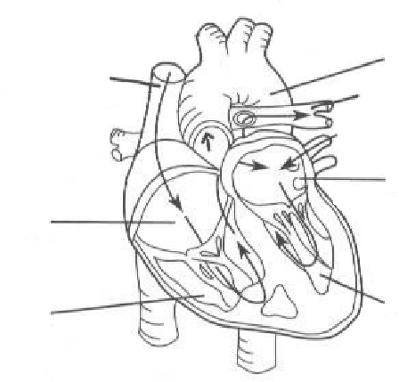
2. Label the picture of the heart:
D

A. _________________________

B. _________________________

C. _________________________

D. _________________________

E. _________________________

F. _________________________

G. _________________________

H. _________________________
E
A

F

G

B

H
C

3. What is the only artery that carries oxygen poor blood? ______________________
4. What is the only vein that carries oxygen rich blood? ________________________
5. What is the function of valves? _________________________________________
6. What is the largest artery of the body? ______________________
7. The thick-walled, lower chambers of the heart are called _____________________.
8. The period of contraction during the heartbeat cycle (systole or diastole) ______________________.
9. A large vein that collects blood from the upper half of the body and returns it to the right
atrium of the heart is the__ _vena cava.
10. A microscopic blood vessels that connect the smallest arteries to the smallest veins and is the site of gas exchange in all tissue are called ________________________
11. The system of vessels that returns excess fluid and proteins from the intercellular spaces to the blood is the _______________________ system.
12. A thick-walled blood vessel that carries blood away from the heart _________________
13. Thin-walled, upper chambers of the heart ___________________
14. A blood vessel that carries blood to the heart ____________________________
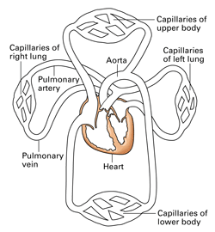
15. Study the diagram below and use red and blue colored pencils to follow the path of blood. Use blue when the blood is oxygen-depleted and red when the blood is oxygen-rich. (See text page 658).

16. The subdivision of the systemic circulation that supplies blood to the muscle of the heart is the
___________________ circulation

17. Subdivision of the systemic circulation that carries blood to/from kidneys is ____________circulation.
18. Label the parts indicated in the following drawing.

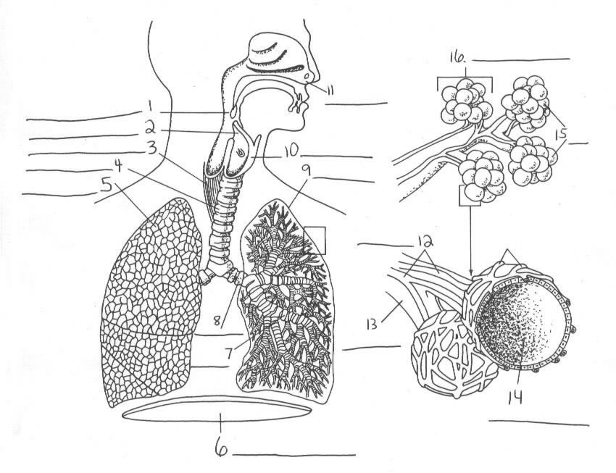
19. In humans, the respiratory surface is made up of the walls of the ________________, which are only one cell thick.

20. What are bronchioles?

21. The vocal cords are in the _____________________.

22. The large muscle that separates the chest (thoracic) and abdominal cavities is the_____________________.

23. The two subdivisions of the trachea that enter the lungs are the ________________.

24. The small tubes that branch off of the bronchi are called ________________________

25. Each bronchiole ends in grapelike clusters of tiny air sacs called ________________.

26. What is the purpose of mucus in the respiratory system? ________________________

Why don’t we get the same disease twice? How do Vaccines Work? (pp. 686-688)

27. What are the two kinds of lymphocytes? ________________________

28. Long-lasting lymphocytes are called ______________ cells.

29. How do vaccines work?

Allergies (page 690)
30. What is an allergy?

Autoimmune diseases (page 691)
31. Describe autoimmune diseases and give an example of one.

AIDS – A Disease of the Immune System (page 692)
32. How is AIDS related to the immune system?

Assign #12 Complete the Castle Learning Unit 10 Circ/Resp/Immunity Assignment

Name:____________________________________ Per._____ Due________ Extra Credit
Unit 10 – The Circulatory System (Chapter 30)

Read the article and answer the questions that follow.

What is a heart attack?
A heart attack occurs when the blood supply to part of the heart muscle itself-- the myocardium -- is severely reduced or stopped. The medical term for heart attack is myocardial infarction. The reduction or stoppage happens when one or more of the coronary arteries supplying blood to the heart muscle is blocked. This is usually caused by the buildup of plaque (deposits of fat-like substances), a process called atherosclerosis. The plaque can eventually burst, tear or rupture, creating a “snag” where a blood clot forms and blocks the artery. This leads to a heart attack. A heart attack is also sometimes called a coronary thrombosis or coronary occlusion. If the blood supply is cut off for more than a few minutes, muscle cells suffer permanent injury and die. This can kill or disable someone, depending on how much heart muscle is damaged.

What is angina pectoris?
Angina pectoris is the medical term for chest pain or discomfort due to coronary heart disease. Angina is a symptom of a condition called myocardial ischemia. It occurs when the heart muscle (myocardium) doesn’t get as much blood (hence as much oxygen) as it needs. This usually happens because one or more of the heart’s arteries (blood vessels that supply blood to the heart muscle) is narrowed or blocked. Insufficient blood supply is called ischemia. Typical angina is uncomfortable pressure, fullness, squeezing or pain in the center of the chest. The discomfort also may be felt in the neck, jaw, shoulder, back or arm. Many types of chest discomfort aren’t related to angina. (such as acid reflux (heartburn) and lung infection).

What is atherosclerosis?
Atherosclerosis (ath”er-o-skleh-RO’sis) comes from the Greek words athero (meaning gruel or paste) and sclerosis (hardness). It’s the name of the process in which deposits of fatty substances, cholesterol, cellular waste products, calcium and other substances build up in the inner lining of an artery. This buildup is called plaque. It usually affects large and medium-sized arteries. Some hardening of arteries often occurs when people grow older. Plaques can grow large enough to significantly reduce the blood’s flow through an artery. But most of the damage occurs when they become fragile and rupture. Plaques that rupture cause blood clots to form that can block blood flow or break off and travel to another part of the body. If either happens and blocks a blood vessel that feeds the heart, it causes a heart attack. If it blocks a blood vessel that feeds the brain, it causes a stroke.
Atherosclerosis is a slow, complex disease that typically starts in childhood and often progresses when people grow older. Many scientists think it begins with damage to the innermost layer of the artery. This layer is called the endothelium (en”do-THE’le-um). Causes of damage to the arterial wall include high blood pressure, tobacco smoke, diabetes, and elevated levels of cholesterol and triglyceride (tri-GLIS’er-id) in the blood. These damage and resulting buildup of materials thicken the endothelium significantly. The artery’s diameter shrinks and blood flow decreases, reducing the oxygen supply. Often a blood clot forms near this plaque and blocks the artery, stopping the blood flow.

What is High Blood Pressure?
High blood pressure, or hypertension (hi”per-TEN’shun), is defined in an adult as a systolic pressure of 140 mm Hg or higher and/or a diastolic pressure of 90 mm Hg or higher. Blood pressure is measured in millimeters of mercury (mm Hg). Normally the systolic pressure would be less than 120 and the diastolic pressure would be less than 80. High blood pressure directly increases the risk of coronary heart disease (which leads to heart attack) and stroke, especially along with other risk factors. High blood pressure can occur in children or adults. It’s particularly prevalent in African Americans, middle-aged and elderly people, obese people and heavy drinkers. People with diabetes, gout or kidney disease have hypertension more often.
High blood pressure usually has no symptoms. It’s truly a “silent killer.” But a simple, quick, painless test can detect it -- yearly blood pressure measurements. Early detection of high blood pressure will improve health care of children. Children who are overweight usually have higher blood pressure than those who aren’t overweight. Some children inherit the tendency from one or both parents who have high blood pressure. A prescribed special diet and regular physical activity may lower high blood pressure in overweight children.

What is a Stroke?
A stroke occurs when a blood vessel that brings oxygen and nutrients to the brain bursts or is clogged by a blood clot or some other mass. Because of this rupture or blockage, rart of the brain doesn’t pet the blood and oxygen it needs. Deprived of oxygen, nerve cells in the affected area of the brain can’t work and die within minutes. And when nerve cells can’t work, the part of the body they control can’t work either. The devastating effects of a severe stroke are often permanent because dead brain cells aren’t replaced. There are two main types of stroke. One (ischemic stroke) is caused by blood clots or other particles; the other (hemorrhagic stroke) is caused by bleeding. Bleeding strokes have a much higher fatality rate than strokes caused by clots. lschemic stroke is the most common type. It accounts for about 70-80 percent of all strokes. It occurs when a blood clot (thrombus) forms and blocks blood flow in an artery bringing blood to part of the brain. Blood clots usually form in arteries damaged by fatty buildups, called atherosclerosis.

*****************************************************************************************
QUESTIONS:

- What is a heart attack?

2. What are two other terms for a heart attack? __________________ or ______________________

3. What is a coronary artery?

4. What can block coronary arteries?

5. What is angina pectoris?

6. What is ischemia?

7. What is plaque?

8. What is atherosclerosis?

- What can happen if plaque blocks a blood vessel that supplies the heart? __________________

10. What can happen if plaque blocks a blood vessel that supplies the brain? _________________

11. What is another name for high blood pressure? ___________________________

12. What is a normal or average blood pressure? __________________

13. What is an example of a high blood pressure? _____________________________

14. High blood pressure directly increases the risk of _______________________________

15. High blood pressure is particularly prevalent in __ ____

16. What are the two main types of strokes? Which kind of stroke is more common?

Name:_____________________________________ Per._____ Due________ Extra Credit
Unit 10 – The Circulatory System (Chapter 30)

Read the article and answer the questions on the back.

What is Cholesterol, and why do I need to know about it?

Cholesterol is a soft, waxy substance found among the lipids (fats) in the bloodstream and in all your body’s cells. It’s an important part of a healthy body because it’s used to form cell membranes, some hormones and is needed for other functions. But a high level of cholesterol in the blood -- hypercholesterolemia -- is a major risk factor for coronary heart disease, which leads to heart attack.
Cholesterol and other fats can’t dissolve in the blood. They have to be transported to and from the cells by special carriers called lipoproteins. There are several kinds, but the ones to focus on are low-density lipoprotein (LDL) and high-density lipoprotein (HDL). Low-density lipoprotein (LDL) is the major cholesterol carrier in the blood. If too much LDL cholesterol circulates in the blood, it can slowly build up in the walls of the arteries feeding the heart and brain. Together with other substances it can form plaque, a thick, hard deposit that can clog those arteries. This condition is known as atherosclerosis. A clot (thrombus) that forms near this plaque can block the blood flow to part of the heart muscle and cause a heart attack. If a clot blocks the blood flow to part of the brain, a stroke results. A high level of LDL cholesterol (160 mg/dL and above) reflects an increased risk of heart disease. That’s why LDL cholesterol is called “bad” cholesterol. Lower levels of LDL cholesterol reflect a lower risk of heart disease.
About one-third to one-fourth of blood cholesterol is carried by HDL. Some experts believe HDL removes excess cholesterol from plaques and thus slows their growth. HDL cholesterol is known as “good” cholesterol because a high HDL level seems to protect against heart attack. The opposite is also true: a low HDL level (less than 40 mg/dL) indicates a greater risk of heart attack and stroke.
People get cholesterol in two ways. The body -- mainly the liver -- produces varying amounts, usually about 1,000 milligrams a day. Foods also can contain cholesterol. Foods from animals (especially egg yolks, meat, poultry, fish, seafood and whole-milk dairy products) contain it. Foods from plants (fruits, vegetables, grains, nuts and seeds) don’t contain cholesterol.
Typically the body makes all the cholesterol it needs, so people don’t need to consume it. Saturated fatty acids are the main culprit in raising blood cholesterol, which increases your risk of heart disease. Trans-fats also raise blood cholesterol. But dietary cholesterol also plays a part. The average American man consumes about 337 milligrams of cholesterol a day; the average woman, 217 mg. Some of the excess dietary cholesterol is removed from the body through the liver. Still, the American Heart Association recommends an average daily cholesterol intake of less than 300 mg (only 200 mg if you have heart disease). By keeping dietary intake of saturated fats low, you can significantly lower your dietary cholesterol intake. Foods high in saturated fat generally contain substantial amounts of dietary cholesterol.
Exercise increases HDL cholesterol in some people. A higher HDL cholesterol is linked with a lower risk of heart disease. Exercise can also help control weight, diabetes and high blood pressure. Exercise that uses oxygen to provide energy to large muscles (aerobic exercise) raises your heart and breathing rates. Regular moderate to intense exercise such as brisk walking, jogging and swimming also condition your heart & lungs. Tobacco smoke is one of the six major risk factors of heart disease that you can change or treat. Smoking lowers HDL cholesterol levels.

Name:_____________________________________ Per._____ Due_________

QUESTIONS:

1. Why is cholesterol important?

2. What is dangerous about a high level of cholesterol in the blood?

3. What do lipoproteins do, and what are the two major kinds?

4. Which lipoprotein is considered “bad” cholesterol? WHY?

5. What is atherosclerosis?

6. A high level of LDL cholesterol reflects an increased risk of _____________ ____________

7. Why is HDL cholesterol sometimes called “good” cholesterol?

8. What are the two ways that people get cholesterol?

9. How much cholesterol do you need to take in through your food? EXPLAIN.

10. You should try to lower the intake of what kinds of fats? WHY?

11. What increases HDL cholesterol in some people? __________________
A higher HDL cholesterol is linked with a lower risk of __________________ ________________.

12. _____________________ lowers HDL cholesterol levels and therefore increases risk of
heart disease.

