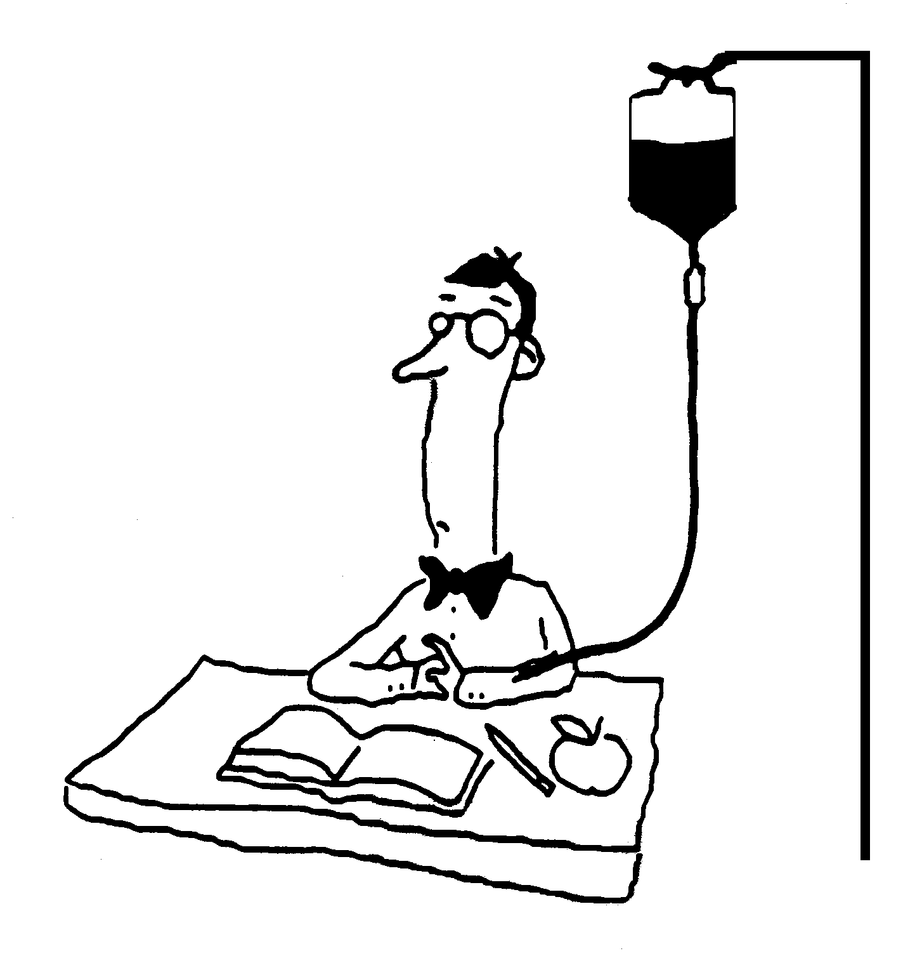
Circulatory & Respiratory Systems Name ________________________________
Chapter 30

I. Introduction to Transport

A. Why is transport needed?

B. How does transport relate to homeostasis?

C. What is transported in our blood?

 | From | To
Nutrients
Wastes
Oxygen
Carbon dioxide
Heat
Hormones

30.1 The circulatory system transports materials throughout the body.

A. 3 primary components of the circulatory system:

1. Heart

2. Blood

3. Blood vessels

Type of Vessel | Description | Function | Diagram
Arteries
Veins
Capillaries

B. Chemical Exchange between Blood and Body Tissues

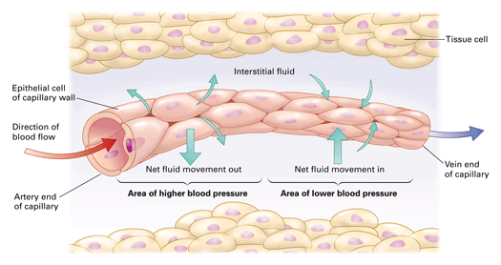

C. The Lymphatic System consists of a system of
- vessels that function to draw fluid from the extracellular spaces and return it to the circulatory system.
- organs serving in defense against disease.

Lymphatic Vessels
Just below the surface of your skin, as well as in your muscles and organs, lies a network of tiny tubes called lymph vessels. Lymph vessels have a structure very similar to that of veins. They are thin like veins and contain valves to prevent backflow.

Lymph Nodes
Lymph vessels the size of small veins enter lymph nodes in three areas of the body (armpit, groin and neck). These nodes are lymph-filtering stations and are an important part of the body’s defense system. When active in defending against infection, they become enlarged and tender to the touch. This is mistakenly called “swollen glands.”

Fluid (Lymph)
Lymph fluid is a colorless liquid in the lymph vessels that transports the water and proteins that can escape from the blood and the extra fluid that is in between cells back to the circulatory system. Diseases fighting white blood cells (lymphocytes) are also transported in the lymph fluid and they work to fight infection. The lymph fluid merges with the circulatory system (lymph is added to plasma) in the region of the lower neck at a point called the thoracic duct. This helps to maintain the plasma level of the blood. You will also see the lymph fluid collect in areas to “cleanse or rinse” such as when a blister forms.

The following three fluids are all very similar in composition. They are called by different names based on where they are located.

Interstitial fluid: Plasma: Lymph:
Fluid that surrounds all cells Liquid part of blood Fluid in lymph vessels
(also contains clotting proteins)

Organs
The principal lymphatic organs are the tonsils, the thymus and the spleen. The tonsils are masses of lymph nodes that play an important role in immunologic development during the preteen years. The thymus is a mass of nodes that lies above the heart in the mid-chest region of the body. T cells mature in the thymus and are important in immunity. The thymus is most active between birth and puberty and then it begins to shrink and its activity declines. The spleen is located in the upper left quadrant of the abdominal cavity. It filters blood and produces T and B cells that provide important immune protection.

Lymphatic Circulation

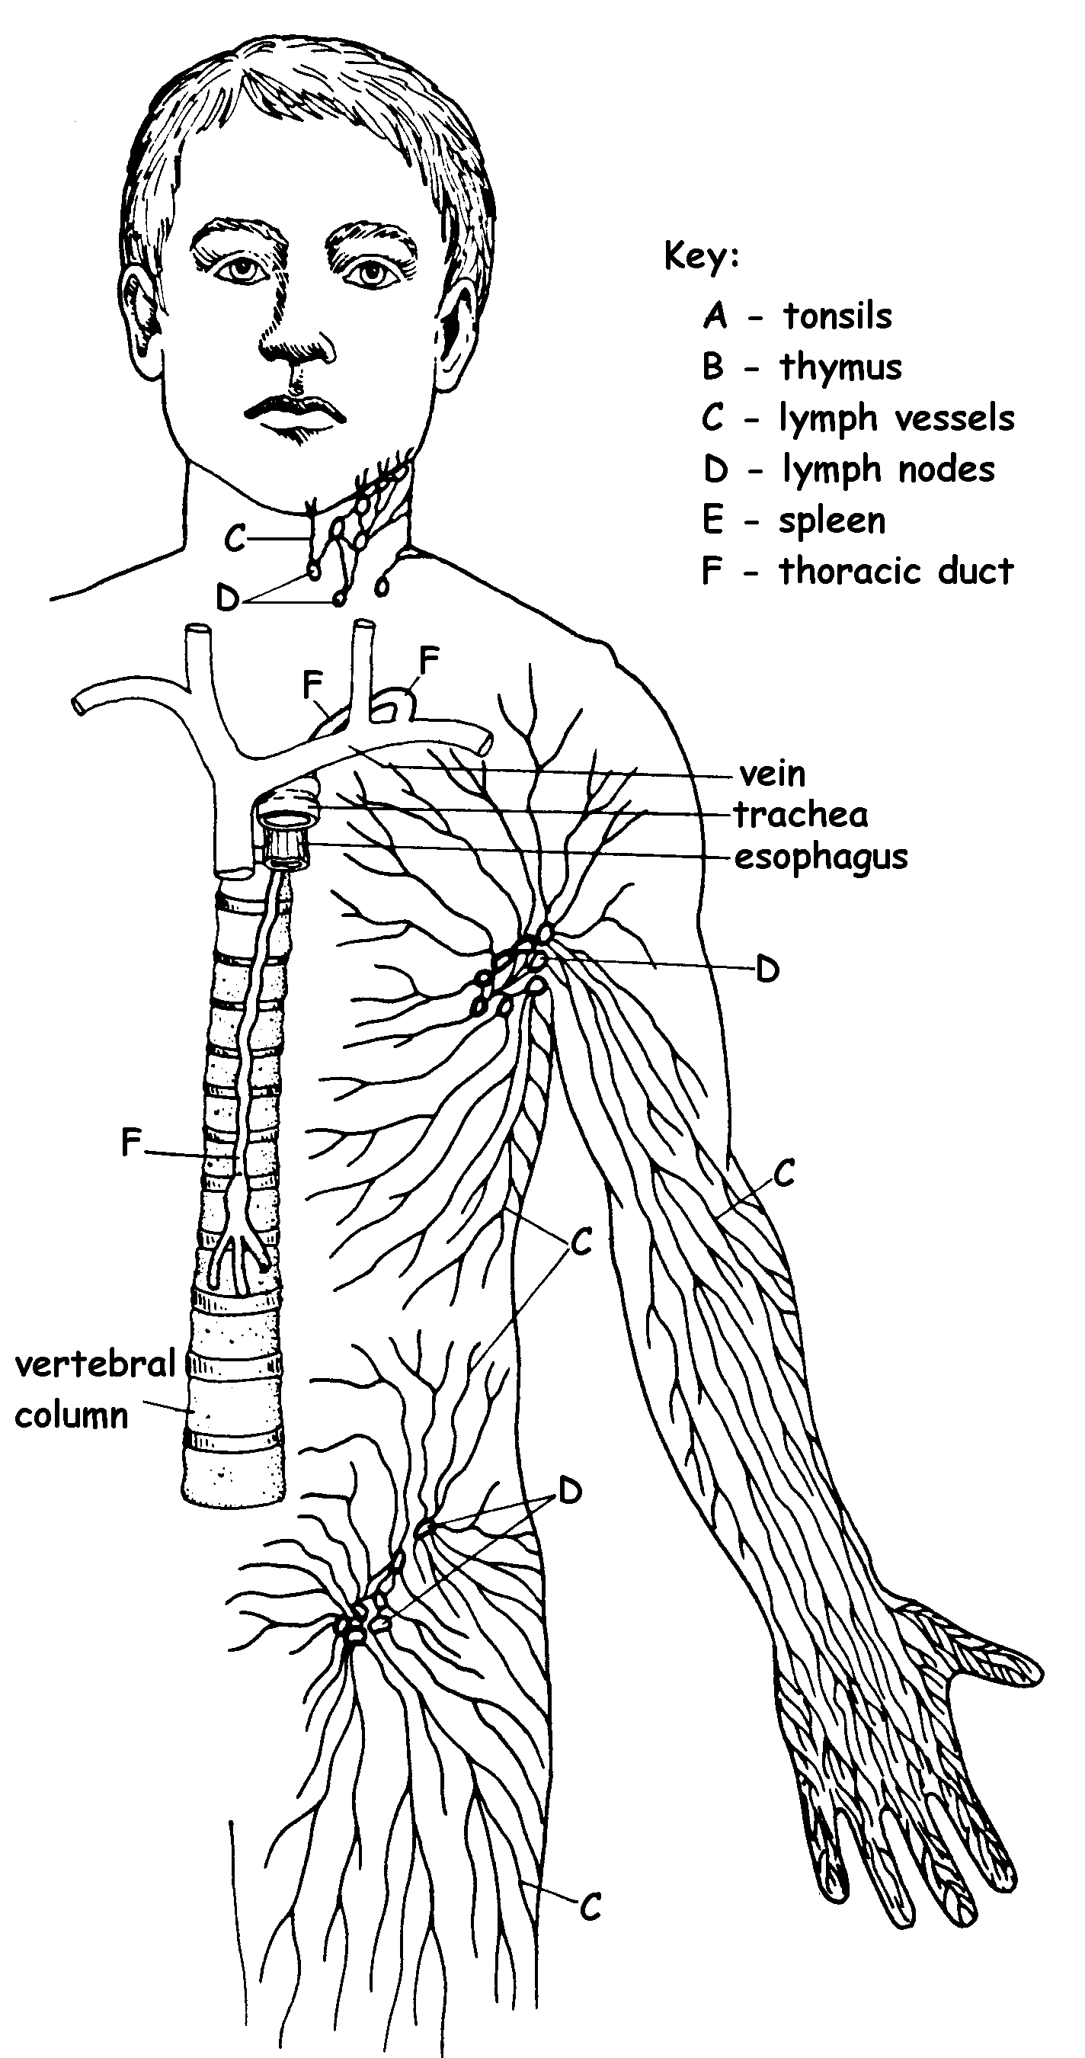

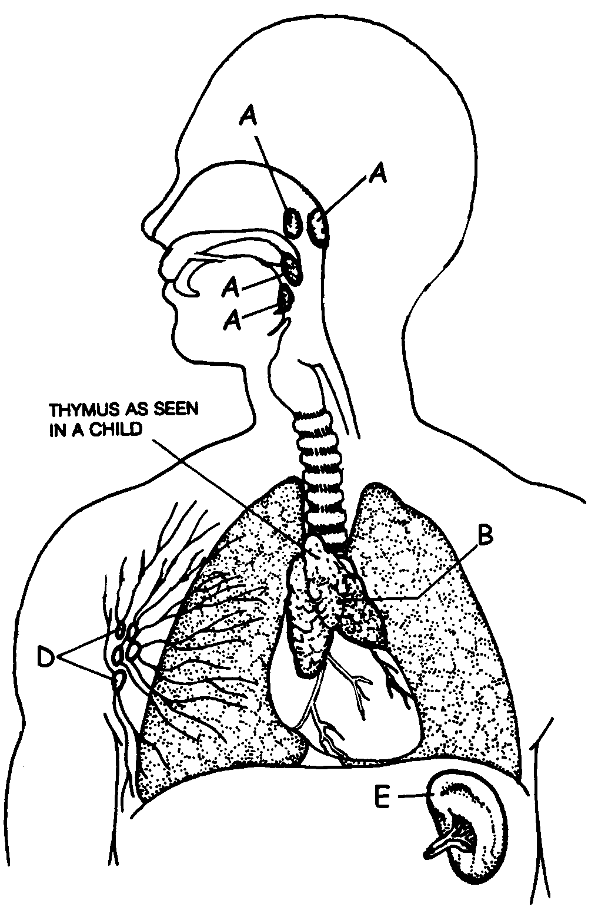

A capillary bed

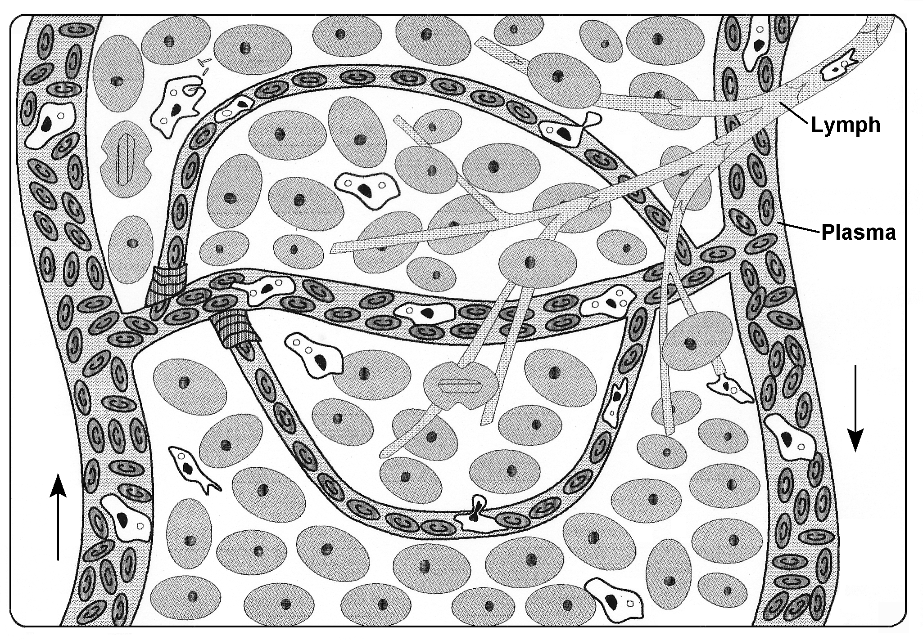
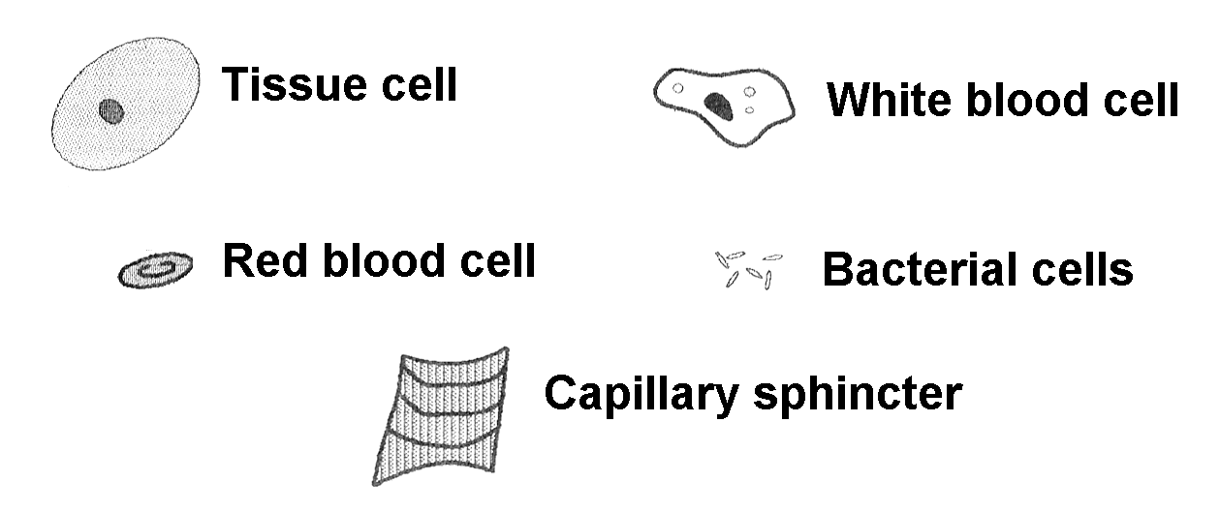

30.2 The heart pumps blood throughout the circulatory system

A. Two circuits of blood flow

1. Pulmonary circuit

Vessel | From | To | O₂ Content of Blood
Pulmonary artery
Pulmonary vein

2. Systemic circuit

Part of systemic circulation | 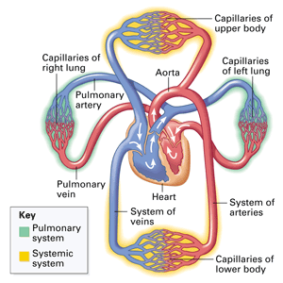  To and From the
Renal circulation
Cranial circulation
Hepatic circulation
Coronary circulation

3. Coronary Circulation

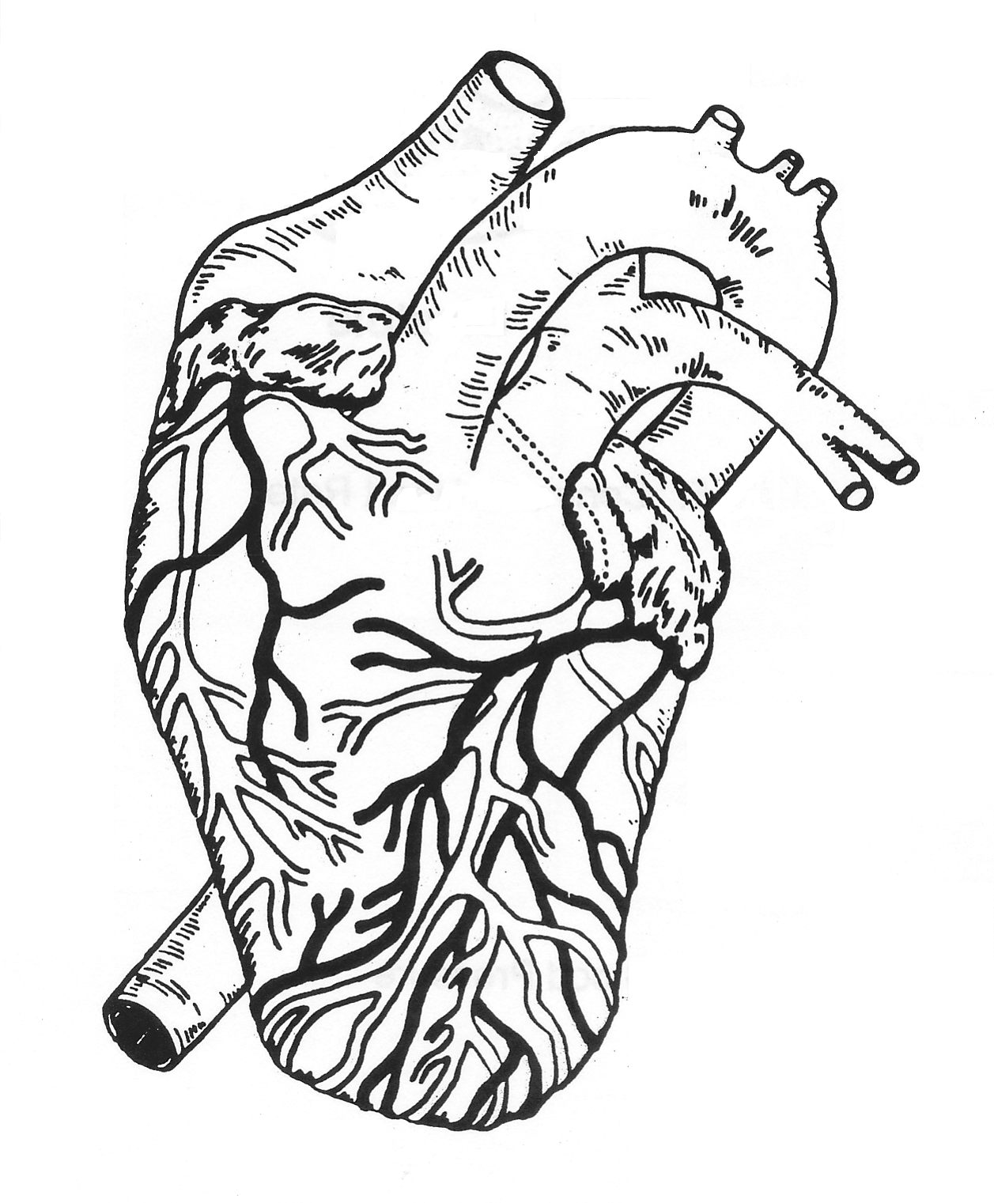
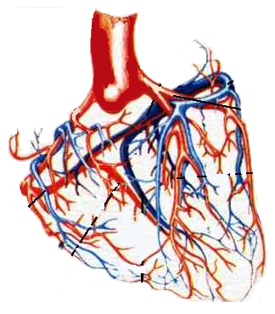

B. Anatomy of the Heart
1. Atrium (plural is atria)

Right Left

2. Ventricle

Right Left

3. Valves

4. Muscle tissue

5. Blood vessels

i. vena cava

ii. pulmonary arteries

iii. pulmonary veins

iv. aorta

6. Diagram:

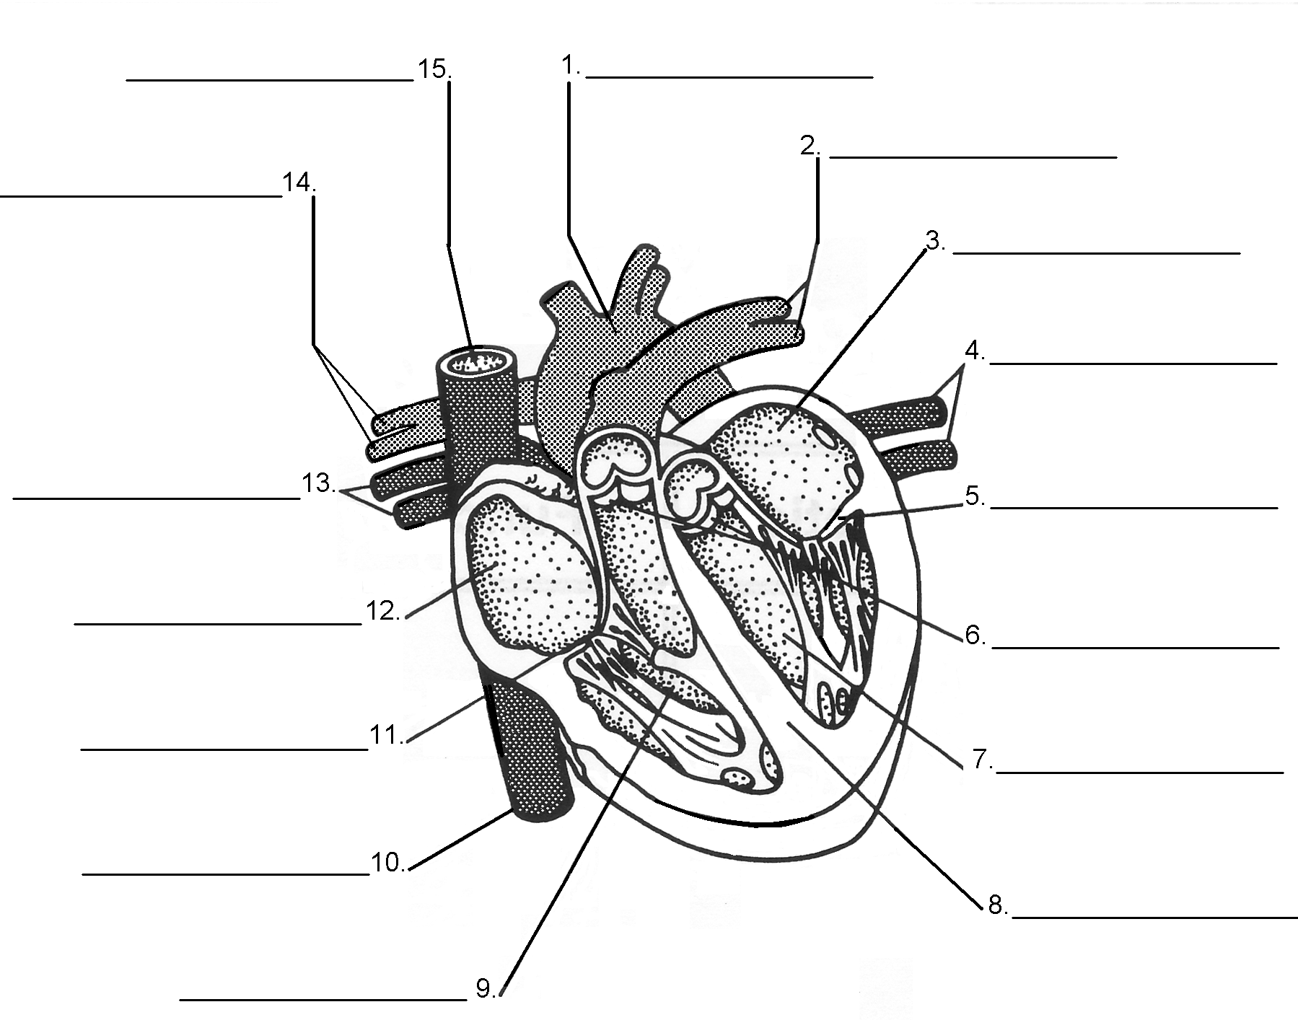

C. Regulation of the Heartbeat

1. Pacemaker

2. AV node

3. The Heartbeat Cycle

A. Diastole B. Systole

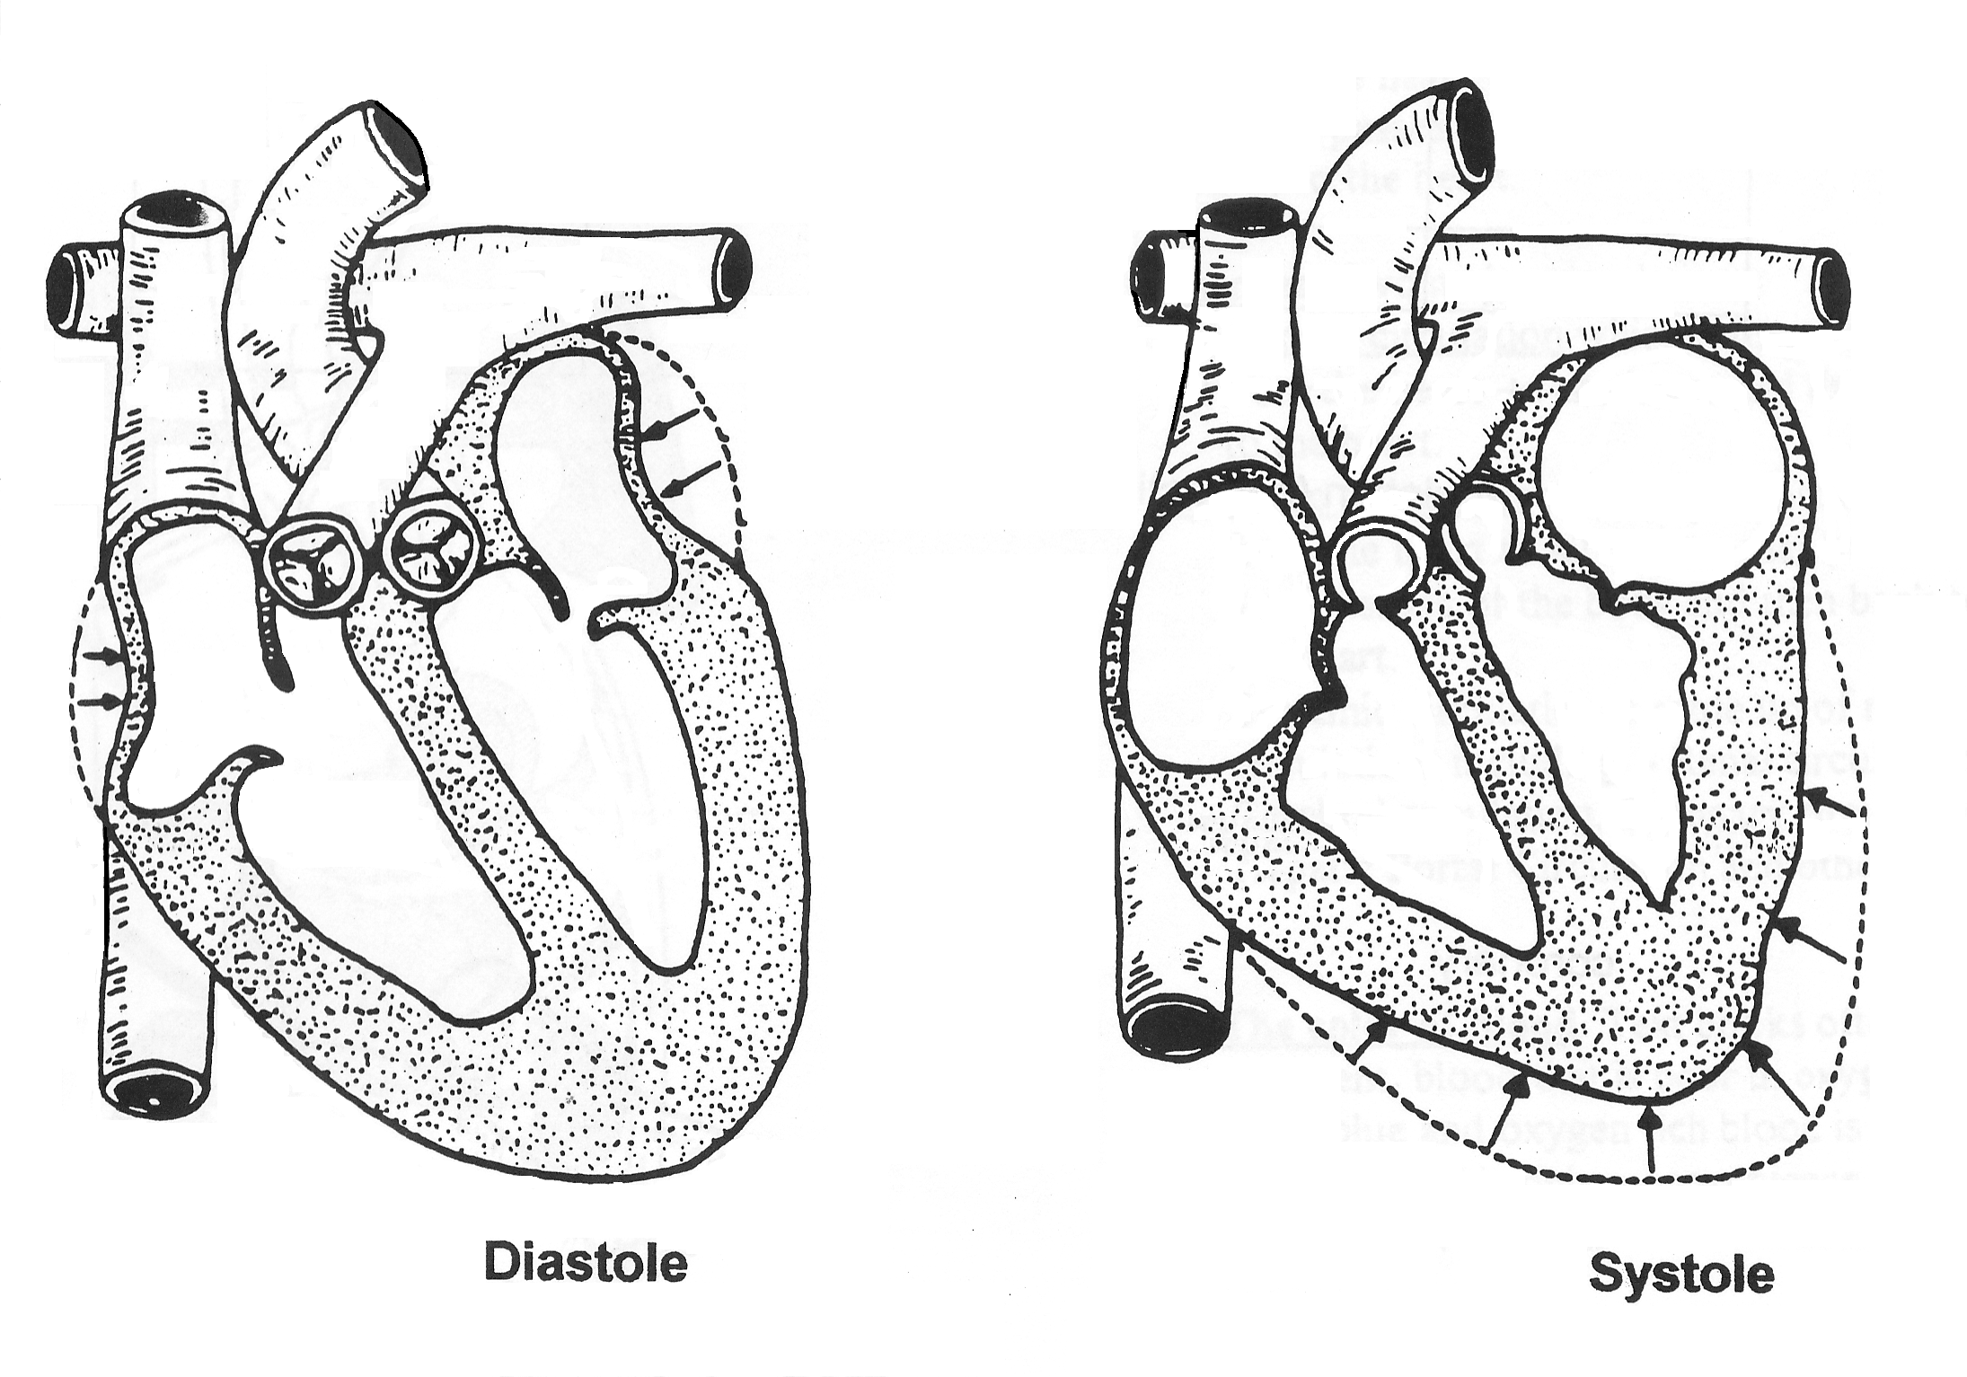

D. Measuring Blood Pressure

E. Pulse rate

30.3 Blood consists of cells suspended in plasma

A. The make-up of blood:

1. Plasma

2. Red Blood Cells

- hemoglobin

3. White Blood Cells

4. Platelets

i. Clotting

30.4 Cardiovascular disease is the leading cause of death in the United States

A. Heart Attack

B. Artherosclerosis

C. Hypertension (High Blood Pressure)

D. Stroke (brain attack)


30.5 The respiratory system exchanges gases between blood and air

A. Think about it….

1. Where does O₂ enter your body?

2. Where does O₂ enter your blood stream?

3. Where does CO₂ exit your body tissues?

B. Anatomy of the Respiratory System

1. Nasal passages

2. Pharynx

3. Larynx

4. Epiglottis

5. Trachea

6. Lungs

7. Bronchi

a. bronchioles

b. alveoli

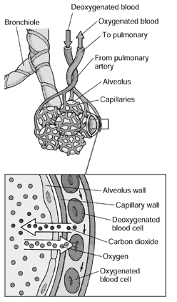
vein
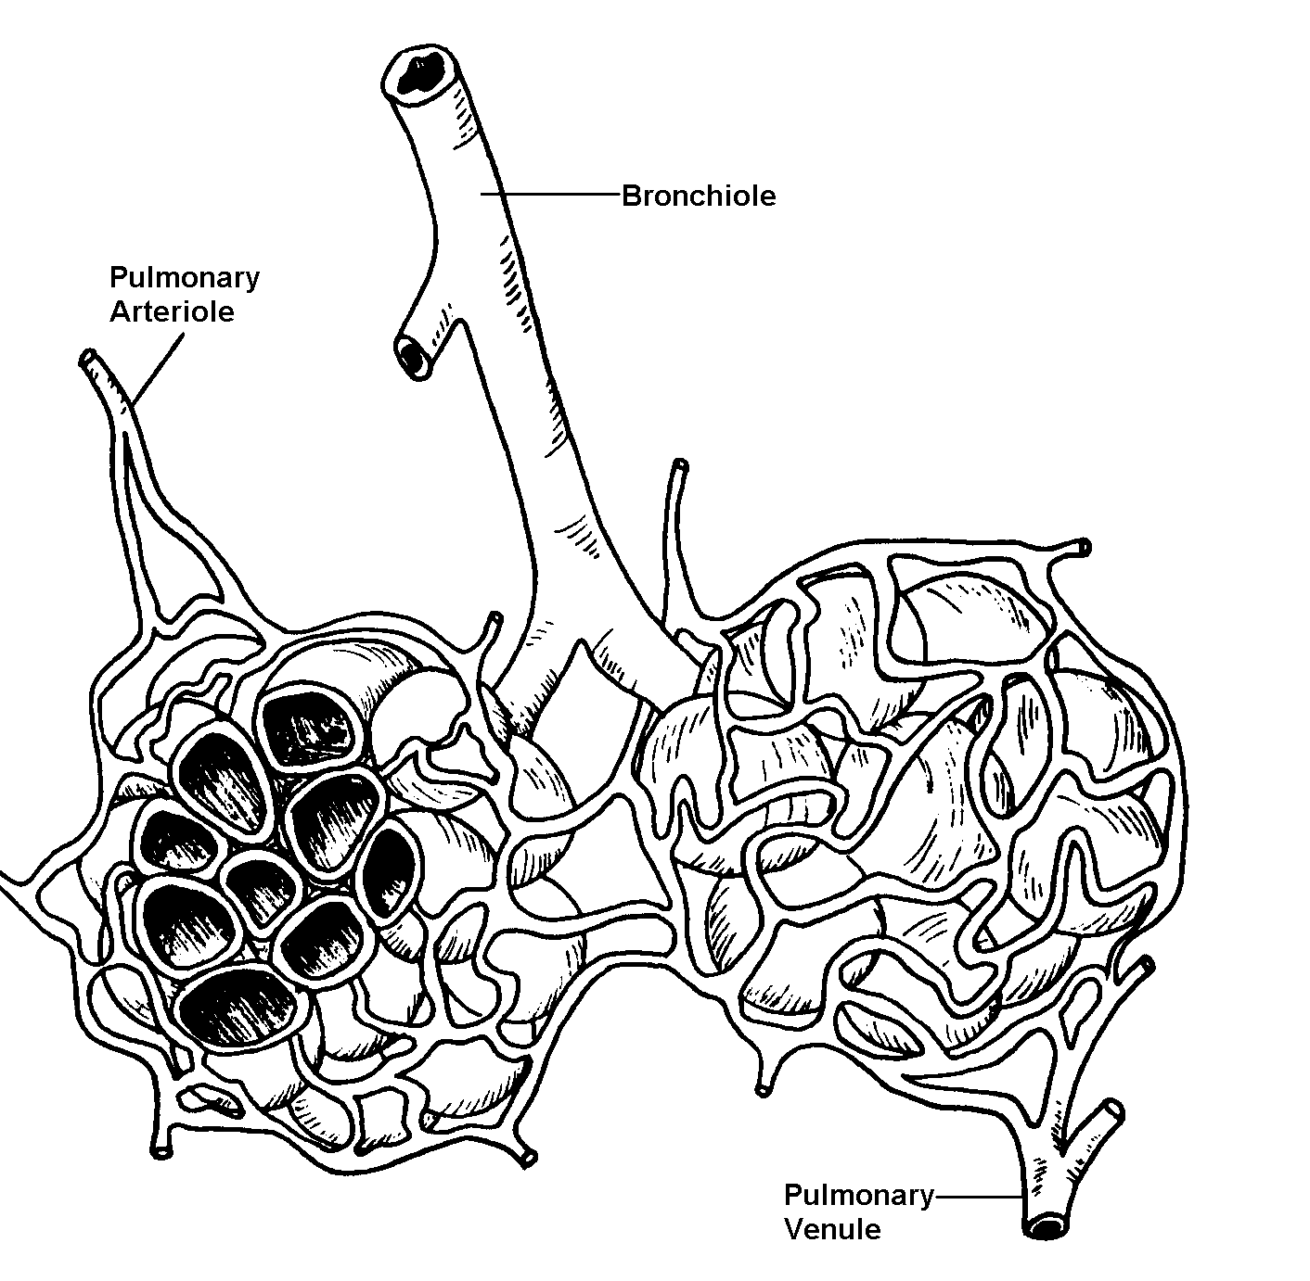

The Human Respiratory System
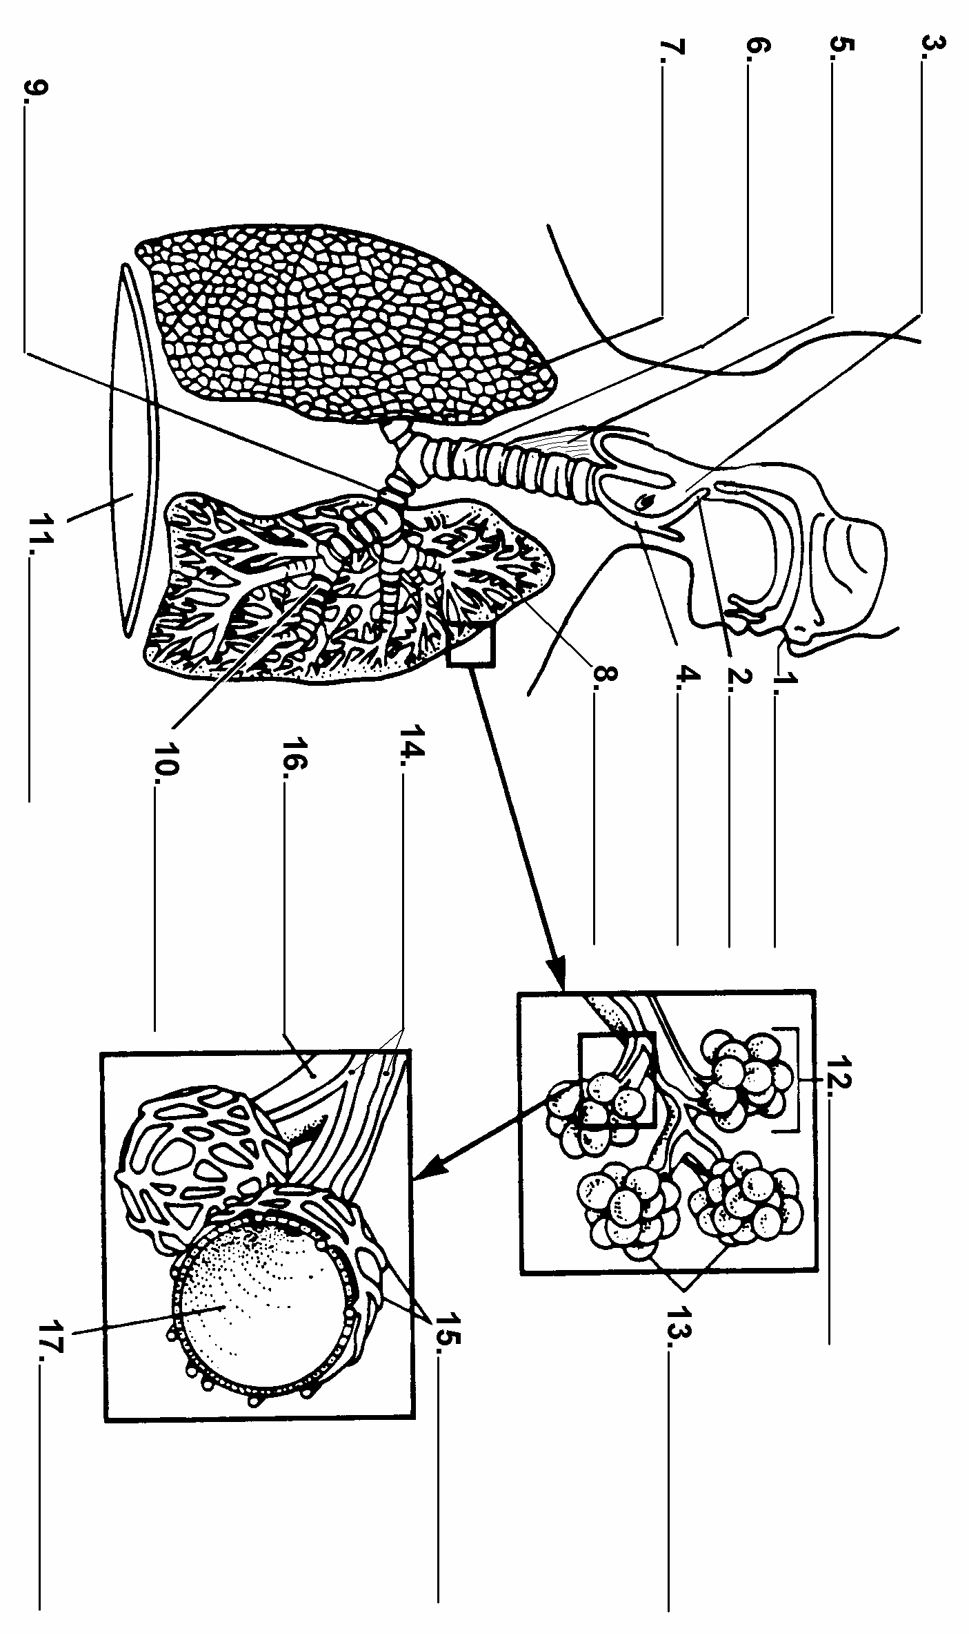

C. Breathing

1. diaphragm

a. inhalation

b. exhalation

On the diagram below:
- Indicate which is inhalation
- Indicate which is exhalation
- Label the diaphragm
- Draw arrows indicating the movment of air into or out of the nasal passages
- Label “relaxed diaphragm” and “diaphragm contracted”

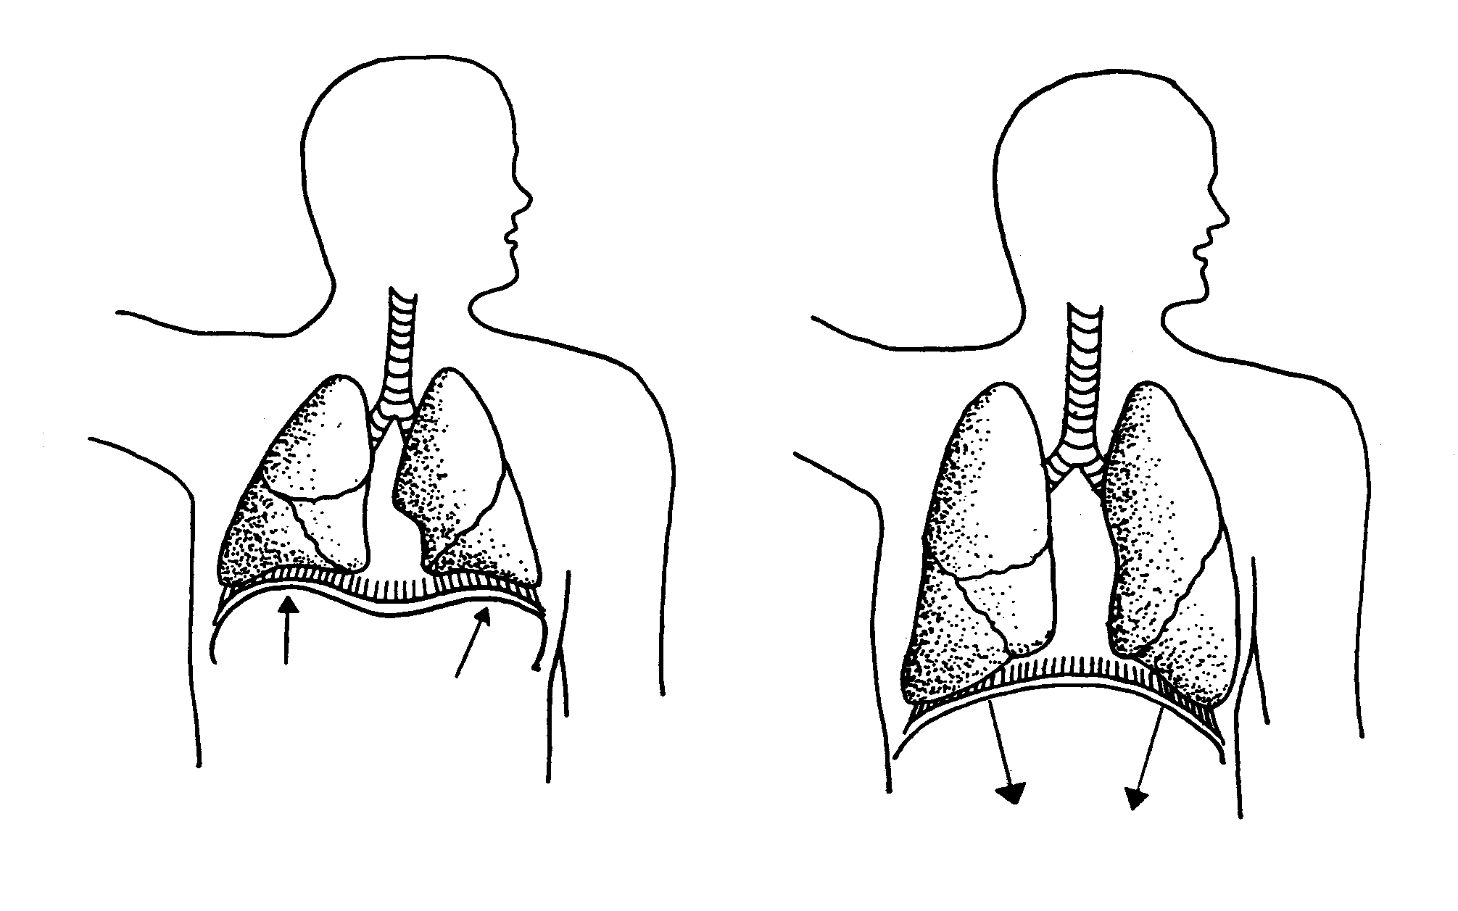
1
2

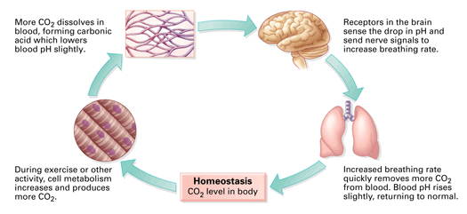
D. Regulation of Breathing: Carbon Dioxide

E. Gas Transport
1. How is oxygen carried in the blood?
Oxygen transport (oxyhemoglobin)

2. How is carbon dioxide carried in the blood?
Carbon dioxide transport (bicarbonate ions)

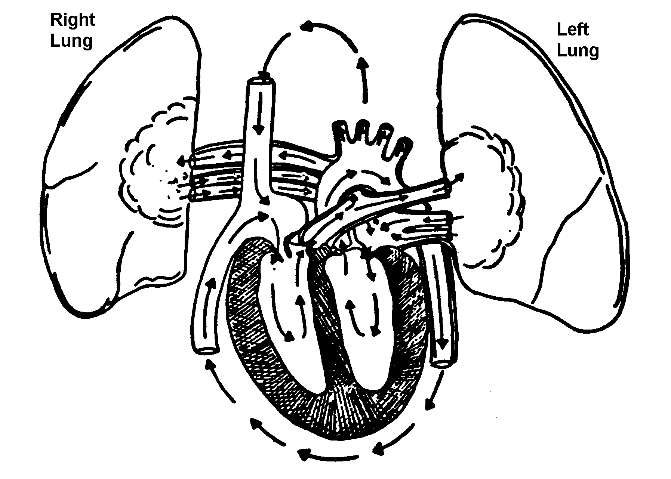
3. Review of pulmonary circulation:

Label the pulmonary artery,
Pulmonary vein, arota, left
Ventricle (LV), LA, RV, RA,
Vena Cava

30.6 Smoking damages the body and shortens life.

A. Emphysema

B. Lung cancer

C. Other Disorders:
- Asthma

- Pneumonia

- Bronchitis
Pulmonary and Systemic Circulations

A "circulation" refers to a path of blood that starts at the heart, travels to some tissue (where it passes through capillaries) and then returns to the heart.

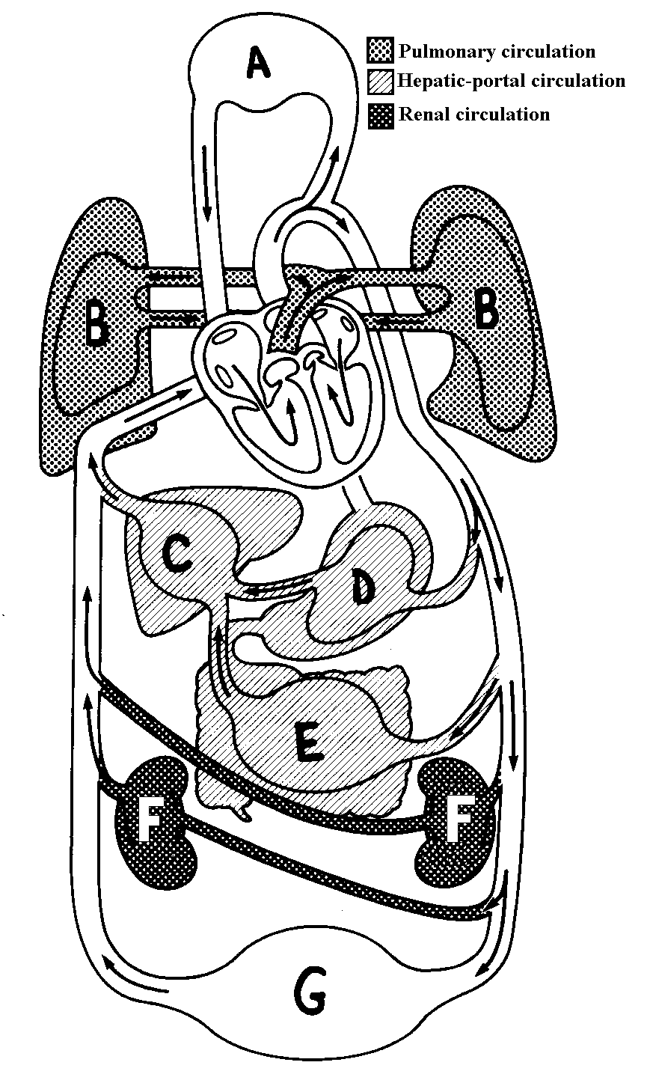
There are two major circulations:
Key:
Oxygen rich blood:

Oxygen poor blood:
Pulmonary circulation -- transports blood from the heart to the lungs and then back to the heart.

Systemic circulation -- transport blood from the heart to all of the other (non lung) tissues of the body and then back to the heart. Systemic circulation is made up of many circulations including - Renal circulation, Cerebral circulation, Coronary circulation, Hepatic Portal Circulation and others.

The color of blood Text books often represent blood that is poor in oxygen by using blue and oxygen rich blood is shown using red. This only a convergence, your blood is never blue.
Blood does change color Oxygen rich blood is bright red; oxygen poor blood is dark red or dull purple. The fact that the blood in veins appears blue through the skin in a phenomenon caused by how the light penetrates the skin. It is not a true representation of the contents of the vein.

Activity:
Choose two colors, one to represent oxygen rich blood and the other to represent oxygen poor blood. Fill in the key below.
1. Color the chambers of the heart that have oxygen rich blood with the appropriate color.
2. Color the chambers of the heart that have oxygen poor blood with the appropriate color.
3. Using the appropriate color follow the pathways of oxygen rich blood. Stop at the capillaries where the oxygen leaves the blood vessels to the tissues cells.
4. Switch to the color for oxygen poor blood and color the pathway of oxygen poor blood.

Hints: Where does the blood change from oxygen poor to oxygen rich? Be careful to change colors when you get to this tissue.

Name the arteries that contain oxygen poor blood? ________________________________

Name the veins that contain oxygen rich blood? ________________________________

Circulation Practice
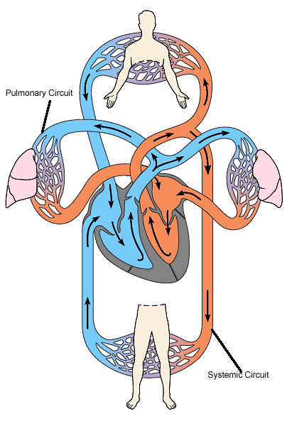

Fill in the table below to practice how blood flows through your body. Begin in the right atrium (#1) and travel through the heart, to capillaries in the brain, and back again to the heart. Use red to represent oxygen rich blood and blue to represent oxygen poor blood. Finish by summarizing the functions of each part of the circulatory system that is listed.

Part of Circulatory System | Sequence  number | Oxygen rich blood or oxygen poor blood | Function
Vein

Right ventricle

Left ventricle

Capillaries in the brain
Pulmonary arteries

Pulmonary veins

Right atrium | 1
Left atrium

Arteries

Aorta

Vena cava

Lungs

Pathway of Blood through the Heart
Chapter 30
Starting and ending with the letter “A”, determine the sequence that blood takes through the human heart.
- Draw arrows as shown below to show the direction of blood flow.
- Color the oxygen rich chambers and vessels red and the oxygen poor chambers and vessels blue.

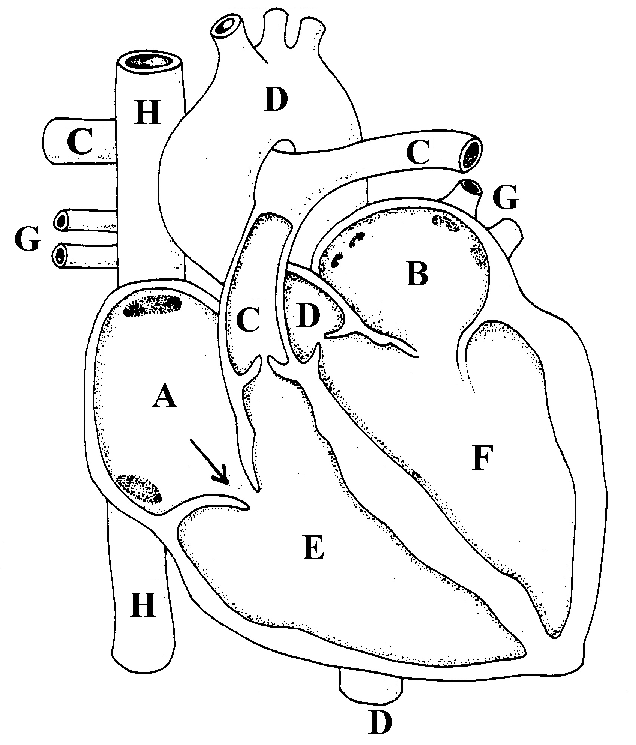 | 1. | A
 | 2.
 | 3.
 | 4. | Lungs:
 |  | Where O₂ is
 |  | &
 |  | CO₂ is
 | 5
 | 6.
 | 7.
 | 8.
 | 9. | Body Cells:
 |  | Where O₂ is
 |  | &
 |  | CO₂ is
 | 10.
 | 11. | A

Sing Along!
Pump, pump, pumps your blood.
The right atrium's where the process begins,
Where the C02 blood enters the heart
Through the tricuspid valve to the right ventricle
The pulmonary artery and lungs.
Once inside the lungs it dumps its carbon dioxide
And picks up its oxygen supply
Then it's back to the heart through the pulmonary vein
Through the atrium and left ventricle.
Pump, pump, pumps your blood.
The aortic valve’s where the blood leaves the heart
Then it's channeled to the rest of the bod
The arteries, arterioles, and capillaries too
Bring the oxygenated blood to the cells
The tissues and the cells trade off waste and CO₂
Which is carried through the venuoles and the veins
Through the larger vena cava to the atrium and lungs
And we're back to where we started in the heart.

