
Name: _______________________________ Per: ______ Test date: _______

Chapter 13: Frontiers of Genetics Biotechnology

13.1 Biologists have learned to manipulate DNA.
A. The Beginnings of DNA Technology

- Technology

Past Present

- Biotechnology

Past Present

3. Genetic Engineering

Biologists can genetically engineer plants and animals (Textbook 13.3)
- Genetically Modified Organisms (GMOs) and Their Useful Products

1. transgenic

2. plants

3. animals

B. Tools in Genetic Engineering

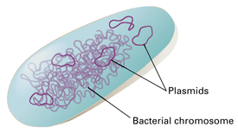
- Bacterial Plasmid

- Restriction Enzymes

Sticky Ends:

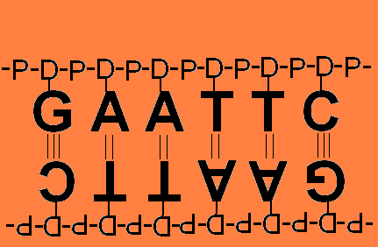
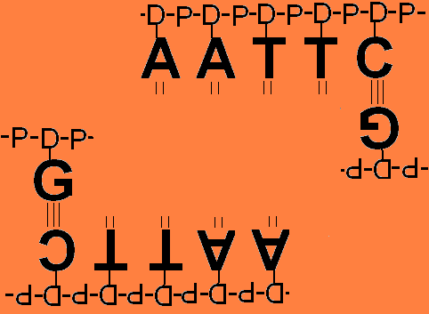

13.2 Biologists can engineer bacteria to make useful products.
Techniques In Genetic Engineering
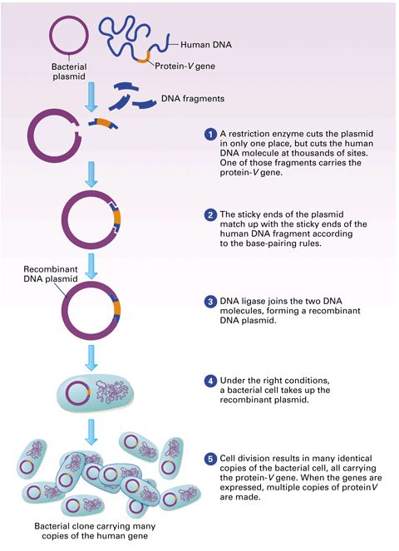
- Recombinant DNA Technology:

1. Gene splicing:

a. donor

b. restriction enzyme

c. plasmid

d. splice

e. host cells

f. vector

B. Cloning

- Unicellular

- Multicellular

-plants

-animals

C. Mass Producing DNA (Textbook 13.4)

Polymerase Chain Reaction (PCR):

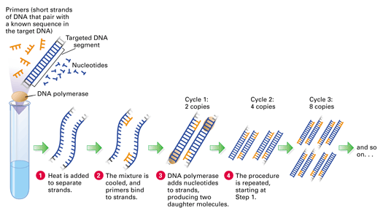

D. Comparing DNA

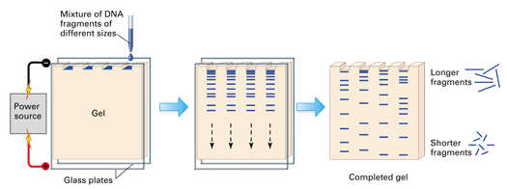

Gel Electrophoresis:

DNA fingerprint

E. Stem Cell Technology (Textbook 13.5)
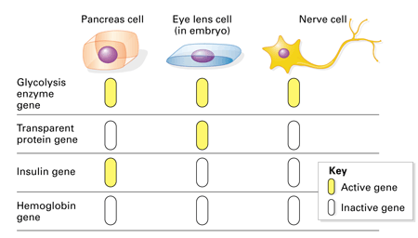
Cellular Differentiation

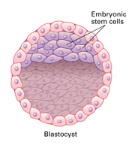

Stem Cells

Nuclear Potency
The Genes of the Zygote

Are all of the genes available for use even in a mature individual?

During embryonic development __________________ increases
and _______________________ decreases.

Stems cells are ____________________ cells

 | Genes pto* | Use | Example

Totipotent
Pluripotent
Multipotent
* pto – Permanently turned off.

Name:______________________________________ Per._____
Unit 7 –Frontiers of Genetics (Chapter 13)
Read the following article and answer the questions that follow.

Biotechnology: Overview and Brief History
Ann Murphy and Judy Perrella. Woodrow Wilson Foundation Biology Institute. "A Further Look at Biotechnology." Princeton, NJ: The Woodrow Wilson National Fellowship Foundation, 1993.

Biotechnology seems to be leading a sudden new biological revolution. It has brought us to the brink of a world of "engineered" products that are based in the natural world rather than on chemical and industrial processes.
Biotechnology has been described as "Janus-faced." This implies that there are two sides. On one, techniques allow DNA to be manipulated to move genes from one organism to another. On the other, it involves relatively new technologies whose consequences are untested and should be met with caution. The term "biotechnology" was coined in 1919 by Karl Ereky, an Hungarian engineer. At that time, the term meant all the lines of work by which products are produced from raw materials with the aid of living organisms. Ereky envisioned a biochemical age similar to the stone and iron ages.
A common misconception is the thought that biotechnology includes only DNA and genetic engineering. Biotechnology is NOT new. Man has been manipulating living things to solve problems and improve his way of life for millennia. Early agriculture concentrated on producing food. Plants and animals were selectively bred, and microorganisms were used to make food items such as beverages, cheese, and bread.
The late eighteenth century and the beginning of the nineteenth century saw the advent of vaccinations, crop rotation involving leguminous crops, and animal drawn machinery. The end of the nineteenth century was a milestone of biology. Microorganisms were discovered, Mendel's work on genetics was accomplished, and institutes for investigating fermentation and other microbial processes were established by Koch, Pasteur, and Lister.
Biotechnology at the beginning of the twentieth century began to bring industry and agriculture together. During World War I, fermentation processes were developed that produced acetone from starch and paint solvents for the rapidly growing automobile industry. Work in the 1930s was geared toward using surplus agricultural products to supply industry instead of imports or petrochemicals. The advent of World War II brought the manufacture of penicillin. The biotechnical focus moved to pharmaceuticals. The "cold war" years were dominated by work with microorganisms in preparation for biological warfare, as well as antibiotics and fermentation processes.
Biotechnology is currently being used in many areas including agriculture, bioremediation, food processing, and energy production. DNA fingerprinting is becoming a common practice in forensics. Similar techniques were used recently to identify the bones of the last Czar of Russia and several members of his family. Production of insulin and other medicines is accomplished through cloning of vectors that now carry the chosen gene. Immunoassays are used not only in medicine for drug level and pregnancy testing, but also by farmers to aid in detection of unsafe levels of pesticides, herbicides, and toxins on crops and in animal products. These assays also provide rapid field tests for industrial chemicals in ground water, sediment, and soil. In agriculture, genetic engineering is being used to produce plants that are resistant to insects, weeds, and plant diseases.
A current agricultural controversy involves the tomato. A recent article in the New Yorker magazine compared the discovery of the edible tomato that came about by early biotechnology with the new "Flavr-Savr" tomato brought about through modern techniques. In the very near future, you will be given the opportunity to bite into the Flavr-Savr tomato, the first food created by the use of recombinant DNA technology ever to go on sale.
What will you think as you raise the tomato to your mouth? Will you hesitate? This moment may be for you as it was for Robert Gibbon Johnson in 1820 on the steps of the courthouse in Salem, New Jersey. Prior to this moment, the tomato was widely believed to be poisonous. As a large crowd watched, Johnson consumed two tomatoes and changed forever the human-tomato relationship. Since that time, man has sought to produce the supermarket tomato with that "backyard flavor." Americans also want that tomato available year-round.
New biotechnological techniques have permitted scientists to manipulate desired traits. Prior to the advancement of the methods of recombinant DNA, scientists were limited to the techniques of their time - cross-pollination, selective breeding, pesticides, and herbicides. Today's biotechnology has its "roots" in chemistry, physics, and biology. The explosion in techniques has resulted in three major branches of biotechnology: genetic engineering, diagnostic techniques, and cell/tissue techniques.

Questions:

- In what year was the term “biotechnology” originally used? ___________________

- Man has been manipulating living things to solve problems and improve his way of life for millennia. List 3 examples of early biotechnology.

a.

b.

c.

- List 3 examples of current biotechnology

a.

b.

c.

- What is special about the Flavr-Savr tomato?

- List the 3 major branches of current biotechnology:

a.

b.

c.

