
Regents Biology Name _________________________
NOTES Period ____Test Date ____________
The Working Cell: Energy From Food CHAPTER 7 (Text pp. 134-157)
  - Sunlight powers life.
- Obtaining Food
- What is an autotroph?

Photosynthesis

Producers

- What is a heterotroph?

Consumers

- Harvesting the Energy in Food
Matter can be recycled, energy cannot. Energy is transferred during chemical reactions and is eventually lost as heat.

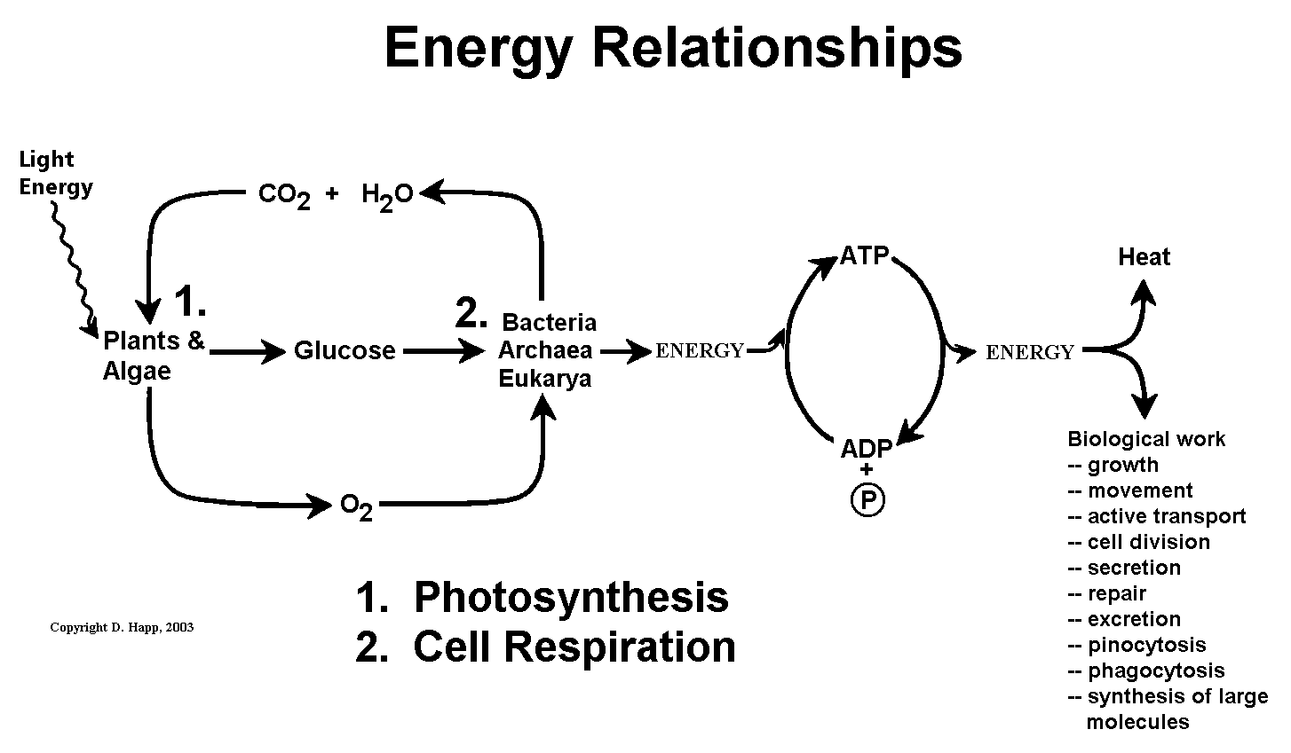


Written Summary:
7.2 Food stores chemical energy.
A. Chemical energy

B. Putting chemical energy to work

C. Calories: Units of Energy

  - ATP provides energy for cellular work.
A. How ATP Packs Energy
- When ATP is hydrolyzed it breaks a bond that releases energy.
- The energy is used to do biological work.

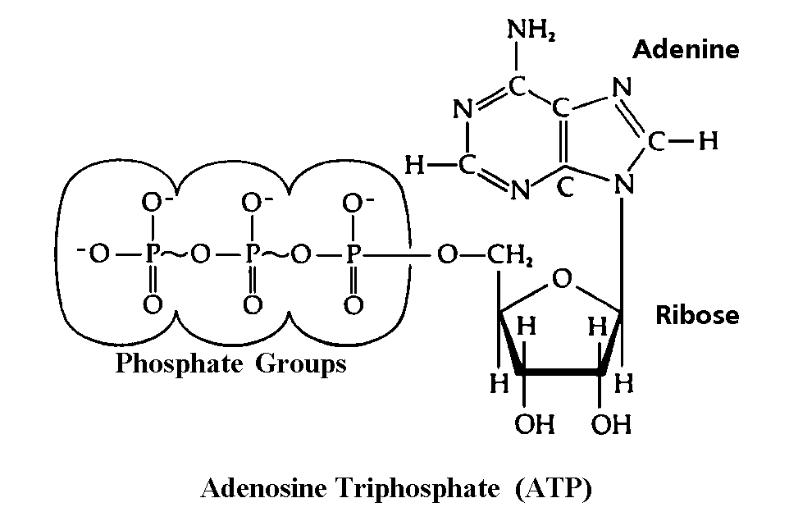

The Hydrolysis of ATP

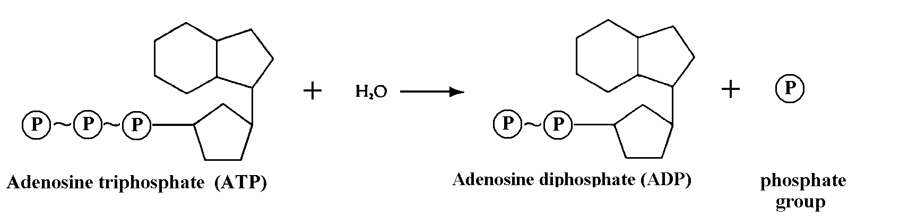

B. The ATP – ADP Cycle

ATP ADP + P

C. Cellular structures involved in cellular respiration.

      - Cell Membrane –

      - Cytoplasm –

      - Mitochondria –

- Glycolysis (glyco- ly- sis- )

Series of Steps:

- The Mitochondrial events
  - The Kreb’s cycle

  - Electron Transport Chain

Fermentation
Anytime that the pyruvic acid (product of glycolysis) is not able to enter a mitochondrion it is converted to some other product. The whole process from glucose to pyruvic acid to the product is called fermentation. All different types of fermentation have a few things in common.

Fermentation

Some special cases of fermentation.
  - Muscle cells in Oxygen debt (lactic acid).

  - Fermentation by bacteria in milk.

  - Fermentation by bacteria, producing vinegar.

  - Fermentation by yeast cells.

Anaerobic vs. Aerobic Respiration

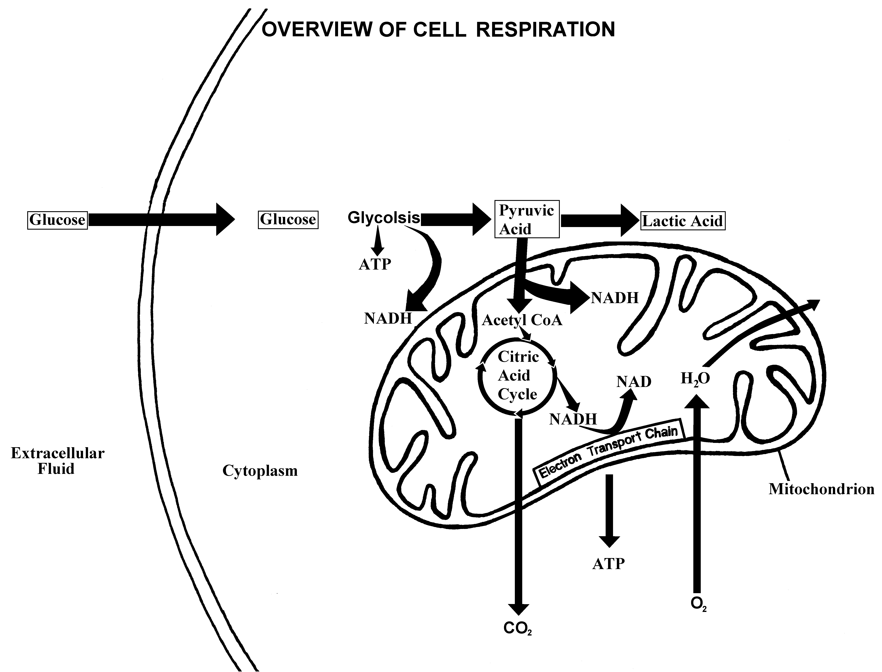

Amino Acids can be converted to Glucose:

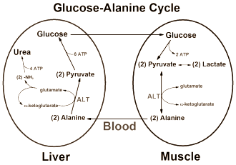

IMPORTANT RESPIRATION EQUATIONS

4. Where does (do) the reactant(s) come from?
5. What happens to the products?
6. Balance the equations by entering the coefficients on the
blank
A
For each equation:
1. Name the process
2. What kind(s) of organisms perform this process
3. Where in the organism does this process occur.

C₆H₁₂O₆ _____ Pyruvic Acid (C₃H₄O₃)

1. |  | [ ] anaerobic [ ] aerobic
2.
3.
4.
5.
___ADP + P ___ ATP

B

C₆H₁₂O₆ _____ CO₂ + ____ Ethyl Alcohol (C₂H₆O)

1. |  | [ ] anaerobic [ ] aerobic
2.
3.
4.
5.
___ADP + P ___ ATP

C

C₆H₁₂O₆ _____ Lactic Acid (C₃H₆O₃)

1. |  | [ ] anaerobic [ ] aerobic
2.
3.
4.
5.
___ADP + P ___ ATP

D

C₆H₁₂O₆ + ___ O₂ ____ CO2 + ____ H₂O
1. |  | [ ] anaerobic [ ] aerobic
2.
3.
4.
5.

___ADP + P ___ ATP

Evidence of Cell Respiration Demonstration

Living things use oxygen (O₂) and excrete carbon dioxide (CO₂) when they do aerobic cell respiration. The process occurs inside of cells and requires enzymes that are in the cytoplasm and mitochondria.
Bromothymol blue (btb) is a powder that easily dissolves in water resulting in a blue liquid. Btb reacts to acids by changing from blue to yellow (often showing shades of yellow green).
Carbon dioxide is an odorless colorless gas that readily dissolves in water. Some of the carbon dioxide molecules combine with water to form carbonic acid.
CO₂ + H₂O → H₂CO₃

EVIDENCE OF CELL RESPIRATION
Test  Tube | Column
Test  Tube | 1 | 2 | 3 | 4 | 5
Test  Tube | Contents | Color  on day 1.  (b/y) | Prediction:  Color  on day 2.  (b/y) | Observation:  Color  on day 2  (b/y) | Change  of [CO2]  (inc, dec, rts)
A
B
C
D

Summary:
Below is a diagram of an apparatus to demonstrate cell respiration in yeast cells.

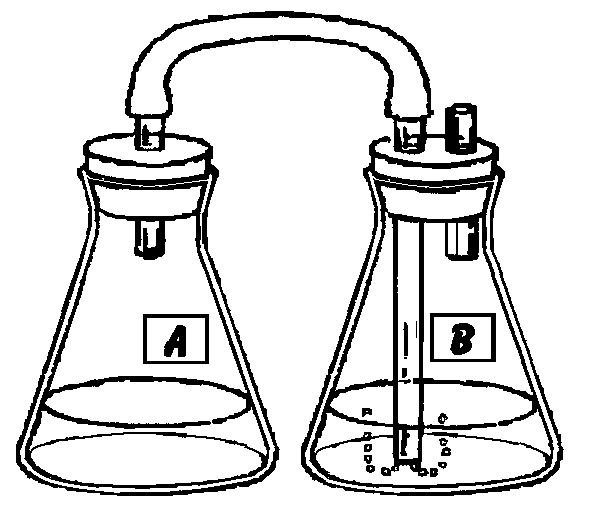
Contents of Flask B:
Contents of Flask A:

- What indicator is used in this demonstration?

- Why was glucose added to flask A?

- What do you predict will happen in Flask B?

- What is observed in flask B after 24 hours?

- Explain the change in flask B.

Aerobic Cellular Respiration

Overall Equation -

Stage 1 - ________________________ Cell Location - ________________

Stage 2 - ________________________ Cell Location - ________________

Stage 3 - ________________________ Cell Location - ________________

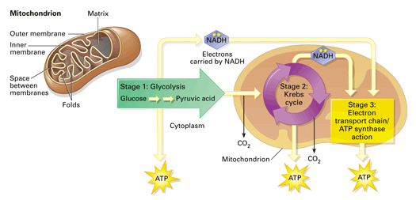

Stage 1 – Glycolysis
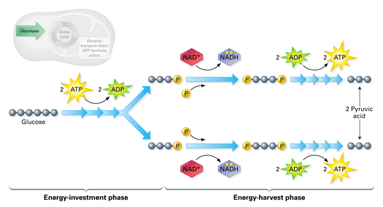

Summary: 1 Glucose molecule is broken down into 2 _________ acid molecules.
Net ATP molecules produced = ________
Energy is also stored in NADH, a coenzyme or energy ___________

Stage 2 – Krebs Cycle
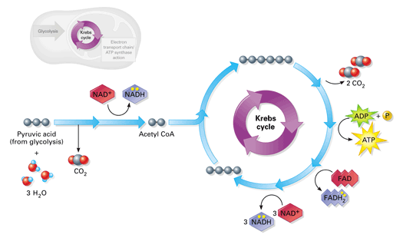

Summary: Pyruvic acid is converted into _________ CoA. Each turn of the Krebs cycle creates 2 ___________ molecules and 1 ATP. NADH and FADH₂ are produced as coenzymes or energy _____________.

Stage 3 – Electron Transport Chain
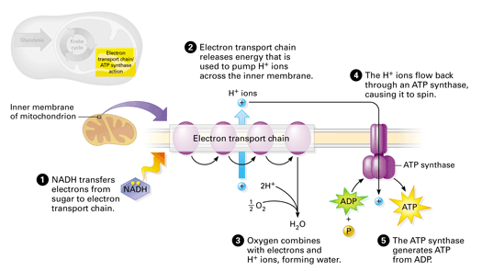

Summary: NADH transfers electrons to the ____________ ___________ ___________. Electron transport chain releases energy that is used to create 32-34 ________ molecules. Oxygen combines with H⁺ ions to form _____________.

Net Total ATP molecules produced from 1 molecule of glucose = _________
Chapter 7 Review

- What is an autotroph? Example?

- What is a heterotroph? Example?

- Write the chemical equation for photosynthesis

___________ + ___________ _________ + __________

- Write the chemical equation for aerobic cellular respiration

___________ + ___________ _________ + __________ + __________

- What is ATP used for?

- When energy is lost from ATP it becomes _______________

- Circle the inorganic molecules in the photosynthesis and aerobic cellular respiration equations you filled in above. What kind of molecules are left uncircled?

- List the three stages of Aerobic Cellular Respiration below. Where does each occur in a cell?

Stage 1.

Stage 2.

Stage 3.

- What is another name for anaerobic cellular respiration?

- What organisms carry out lactic acid fermentation? Ethyl alcohol fermentation?

- What causes muscle fatigue?

- How many net ATP’s are made from fermentation? Aerobic cellular respiration?

- What specific proteins are necessary for all of the steps of cellular respiration to occur?

- Identify the following chemical reactions using the following, aerobic cellular respiration, anaerobic cellular respiration (fermentation), glycolysis:

Glucose Ethyl Alcohol + Carbon Dioxide + net 2 ATP

Glucose Pyruvic Acid + net 2 ATP

Glucose + Oxygen Carbon Dioxide + Water + net 36-38 ATP

Glucose Lactic Acid + net 2 ATP

- What indicator can be used to determine if cellular respiration is taking place in a container?

- Explain how the indicator named previously can be used to determine if cellular respiration is taking place in a test tube?

Name: _________________________________ Per. ______
Cellular Respiration Matching Activity

Refer to the Overview of Cellular Respiration diagram and your notes to complete the matching below. Write the correct number from the diagram next to the appropriate description of the events involved in cellular respiration

- ____________NADH is produced to carry energy.

- ____________Carbon dioxide is produced and leaves the mitochondria

- ____________The first stage of both aerobic and anaerobic cellular respiration takes place in the cytoplasm of the cell.

- ____________C₆H₁₂O₆ diffuses from the extracellular fluid into the cytoplasm of the cell through the selectively permeable membrane.

- ____________A muscle cell that is oxygen depleted will produce this molecule that causes muscle fatigue during anaerobic respiration.

- ____________Oxygen enters the mitochondria and picks up a hydrogen forming water.

- ____________Pyruvic acid molecules enter the mitochondria and Acetyl CoA is produced.

- ____________NADH delivers H⁺ ions and energy to the 3rd stage of aerobic cellular respiration.

- ____________Many ATP molecules are produced.

- ____________The 2nd stage of aerobic cellular respiration begins.

- ____________2 Net ATP molecules are produced in the cytoplasm of the cell.

