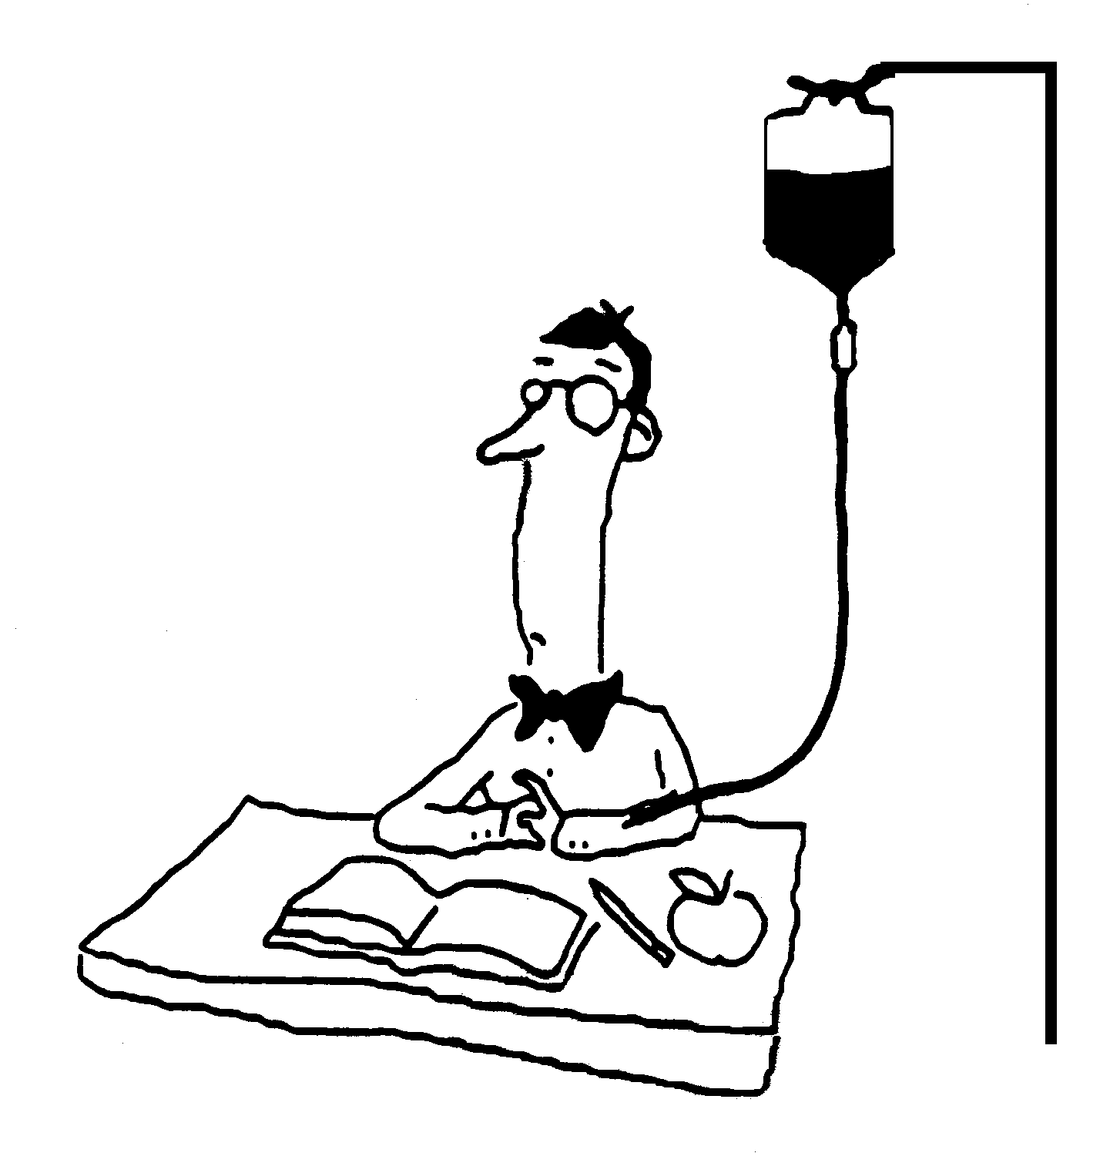
Blood and Immunity Name ________________________________
Chapter 31

31.1 Infectious diseases are caused by pathogens.

A. The Germ Theory of disease

1. Pathogen

B. Transmission of Infectious Disease

31.2 The human body has three lines of defense against infections.
A. The First Line: Barriers

B. The Second Line: Internal Nonspecific Defenses
1. White Blood Cells

2. Inflammatory Response

3. Specialized Proteins

C. The Third Line: Targeted Defense

31.3 The immune system recognizes specific invaders (The Third Line Cont.).
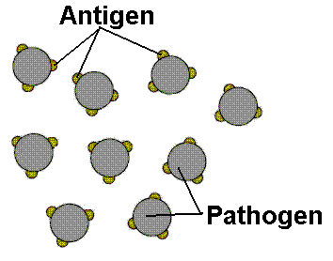
A. Antigens:

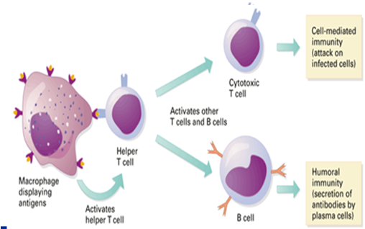
B. Macrophage

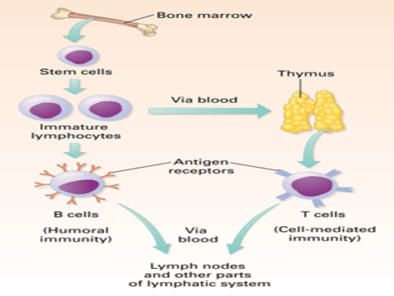
C. Helper T Cell Lymphocytes:

D. B Cell Lymphocytes:
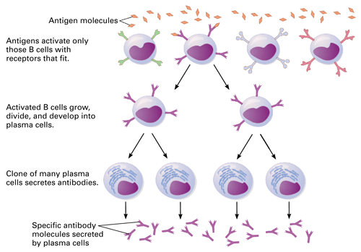

E. Antibodies Attach to Antigens:

Antibodies:

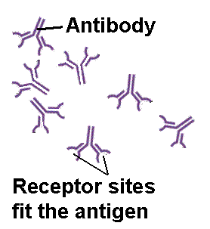
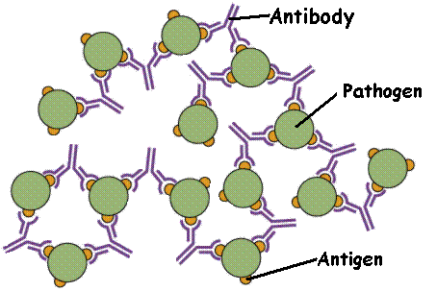

F. Cytotoxic T Cell Lymphocytes (Killer Ts)

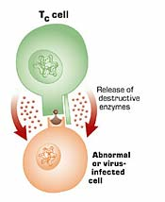

G. Memory cells

A Summary of the Immune Response
The Third Line of Defense

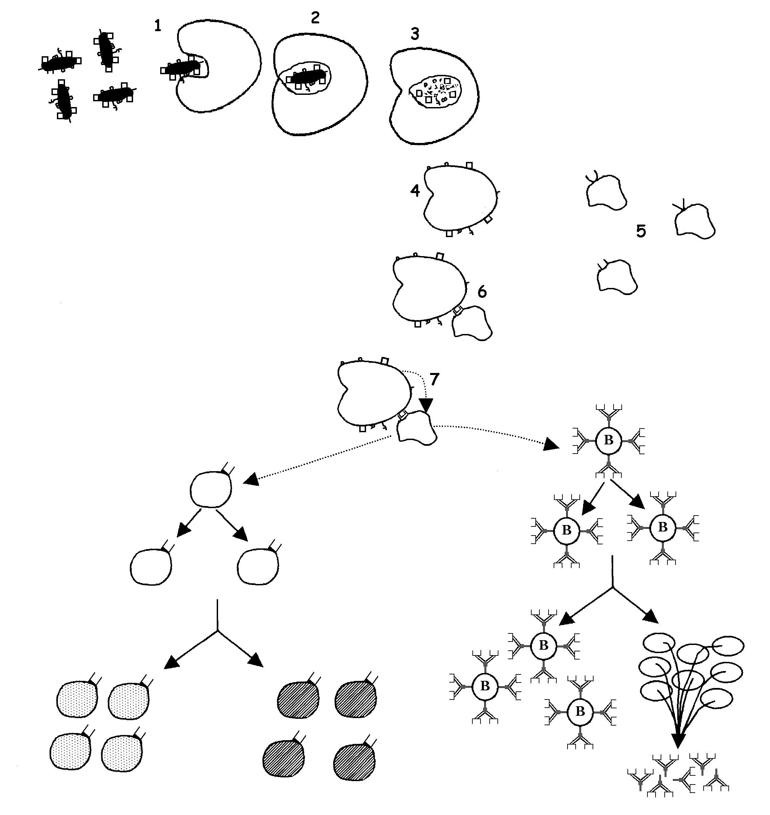
8
9
10
11
12
13
14
15

C. Antigens in the Human body (see blood typing activity at end of packet)

  - ABO Blood Groups

Type AB
RBC
Type O
RBC

On the RBCs above, indicate how the antigens of of Type AB and Type O blood would look
Type O blood.

RBC Antigens Present | Blood Type | Antibodies Present in Plasma | Can Receive Type(s)  (Cross out the ones that create problems) | Can Donate to Type(s)  (Cross out the ones that create problems)
A |  |  | A B AB O | A B AB O
B |  |  | A B AB O | A B AB O
A & B |  |  | A B AB O | A B AB O
neither A nor B |  |  | A B AB O | A B AB O
Organ Transplants:

31.4 Vaccines stimulate the immune response.

A. Vaccines

B. Active and Passive Immunity
1. Active Immunity

    - Previous infection

    - Vaccines

  - Passive Immunity

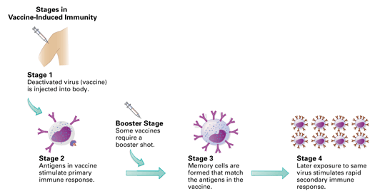

31.5 Disorders of the immune system are major health problems.
Using your textbook, determine which of the following disorders each statement is describing. Use the word bank below and place your answer in the space provided. You will use each word 3 times.

AIDS Allergies Autoimmune Disease Anemia Leukemia

________________ 1. Antibodies are produced to fight against regular “self” cells.

________________ 2. Symptoms are caused by the release of histamine from the body cells at the site of the immune reaction.

________________ 3. A condition in which a person has too few rbcs, hemoglobin, and lack of iron in their diet.

________________ 4. Attack and destruction of the helper T-cells cause a malfunction of the body’s defense system.

________________ 5. This disorder involves abnormally high production levels of only some type of wbcs.

________________ 6. In juvenile diabetes, antibodies destroy the cells in the pancreas that produce insulin.

________________ 7. A rapid over reaction to an antigen that is not normally harmful.

________________ 8. Cells in the body do not receive enough oxygen.

________________ 9. Cancer of the cells that produce wbcs.

________________ 10. In multiple sclerosis, antibodies attack the outer layer of nerve cells.

________________ 11. Some symptoms may include a runny nose, swollen eyes and sneezing.

________________ 12. One type of this disorder is inherited and caused by the production of an abnormal form of hemoglobin.

________________ 13. The cause of this virus is called the human immunodeficiency virus.

________________ 14. This disorder is one type of cancer.

________________ 15. Transmitted from an infected person with the exchange of body fluids.

Human blood is grouped into four types: A, B, AB, and O. Each letter refers to a kind of antigen, or protein, on the surface of red blood cells. For example, the surface of red blood cells in Type A blood has antigens known as A-antigens.

The Rh Factor
Each blood type is also grouped by its Rhesus factor, or Rh factor. Blood is either Rh positive (Rh+) or Rh negative (Rh-). About 85% of Americans have Rh+ blood.
Rhesus refers to another type of antigen, or protein, on the surface of red blood cells. The name Rhesus comes from Rhesus monkeys, in which the protein was discovered.

Blood Transfusions
Blood types become very important when a blood transfusion is necessary. In a blood transfusion, a patient must receive a blood type that is compatible with his or her own blood type—that is, the donated blood must be accepted by the patient's own blood. If the blood types are not compatible, red blood cells will clump together, making clots that can block blood vessels and cause death.
Type O– blood is considered the “universal donor” because it can be donated to people of any blood type. Type AB+ blood is considered the “universal recipient” because people with this type can receive any blood type.

Blood Type | Percent of Americans with this type | Who can receive this type
O+ | 37% | O+, A+, B+, AB+
O– | 6% | All blood types
A+ | 34% | A+, AB+
A– | 6% | A+, A–, AB+, AB–
B+ | 10% | B+, AB+
B– | 2% | B+, B–, AB+, AB–
AB+ | 4% | AB+
AB– | 1% | AB+, AB–

Did You Know?
- Blood type is inherited, just like eye color.
- Certain blood types are more common in certain countries. In China, over 99% of the population has Rh+ blood.
- Different kinds of animals have different kinds of blood. Dogs have 4 blood types; cats have 11; cows have about 800.
- Some people think blood type tells about personality. Legend has it that Type A is calm and trustworthy; Type B is creative and excitable; Type AB is thoughtful and emotional; and Type O is a confident leader.
- In Japan, the idea of blood type as personality type is so popular that Japanese ask “What's your blood type?” about as often as Americans ask “What's your sign?”

THE BLOOD TYPING GAME
http://nobelprize.org/educational_games/medicine/landsteiner/

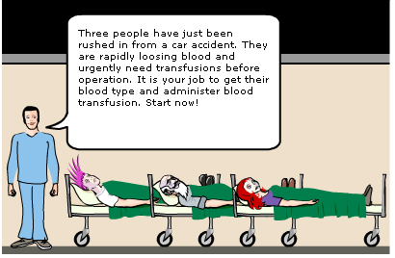
Below are pictures and explanations of the different blood types found in humans.
The presence of any type of red blood cell antigen (A, B or Rh) is determined by the information that a person receives from their parent. You can’t change your blood type.

Determine the Patient’s Blood Type:
To determine someone’s blood type you need to determine which antigen(s) are present on their rbcs.

If the A antigen is present, but the B antigen is not present then they have blood type A.
If the B antigen is present, but the A antigen is not present then they have blood type B.
If the A antigen and the B antigen are both present then they have blood type _____.
If the A antigen and the B antigen are both absent then they have blood type _____.
If the Rh antigen is present then their blood is referred to a being Rh+.
If the Rh antigen is absent then their blood is referred to a being Rh-.
Antibodies from plasma are used as tools to determine if a certain antigen is present.

A blood testing kit contains three tubes. Each test tube shown in the diagram contains serum to determine someone’s blood type. It contains one type of antibody that will cause the clumping of a certain type of rbc.

Test Tube A contains Anti A antibodies that will clump rbcs that have the A antigen on their surface.
Test Tube B contains Anti B antibodies that will clump rbcs that have the B antigen on their surface.
Test Tube Rh contains Anti Rh antibodies that will clump rbcs that have the Rh antigen on their surface.

Anti A antibody will cause cells with the A antigen to clump.
Anti B antibody will cause cells with the B antigen to clump

to clump.
Anti Rh antibody will cause cells with the Rh antigen to clump.

When we add a patients blood to each test tube:
If test tube A clumps, the blood contains the _______ antigen.
If test tube B clumps, the blood contains the _______ antigen.
If test tube Rh clumps, the blood contains the _______ antigen.

Patient #1

Take the patient’s blood type first.

A few drops of the patient’s blood are put into each of the test tubes.

After adding blood to test tube A: clumping no clumping (circle one)

After adding blood to test tube B: clumping no clumping (circle one)

After adding blood to test tube Rh: clumping no clumping (circle one)

This patient has type __________ blood.
A+ | A-
B+ | B-
AB+ | AB-
O+ | O-
Circle the blood types that this patient could receive:

Patient #2

After adding blood to test tube A: clumping no clumping (circle one)

After adding blood to test tube B: clumping no clumping (circle one)

After adding blood to test tube Rh: clumping no clumping (circle one)

This patient has type ________ blood.
A+ | A-
B+ | B-
AB+ | AB-
O+ | O-

Circle the blood types that this patient could receive:

Patient #3

After adding blood to test tube A: clumping no clumping (circle one)

After adding blood to test tube B: clumping no clumping (circle one)

After adding blood to test tube Rh: clumping no clumping (circle one)

This patient has type ________ blood.
A+ | A-
B+ | B-
AB+ | AB-
O+ | O-

Circle the blood types that this patient could receive:

